Requirements of SCAM for 4-Laser Operations

Version 2.0 (April 5, 2016)

Contact J. Grames
grames@jlab.org

Introduction

The SCAM (Service Building Catch All Module) is a programmable interface to the Laser Macropulse chassis to select the desired laser beam modes. The previous SCAM module supported 3-laser operation and both polarized and thermionic sources. This version supports 4-laser operation and only a polarized source.

Functional Description

Laser control is partitioned in 5 ways: Master, Laser A, Laser B, Laser C and Laser D. The Master partition limits the accessible modes of the individual Lasers (A, B, C, D).

Each partition allows 5 beam modes of user selected laser operation, where the User mode is the highest order.

- Off mode
- Viewer mode
- Tune mode
- Continuous mode
- User mode

Beam modes are defined:

- Off mode
In this mode the user can turn the beam off to any Laser individually. The user can turn all Lasers off by setting the Master to Beam Off Lasers by setting the Accelerator mode to Beam Off.

- Viewer mode
In this mode the user can individually set any Laser to Viewer mode, provided the Master mode is of equal or higher value. Lasers of order higher than Master mode will automatically be set to the Master mode. The SCAM will generate the same macro-pulse structure for each laser. The macro-pulse structure is nominally generated at a variable time from 347-354us after Beam Sync with variable pulse width duration from 250ns-10us in 250ns increments. The macro-pulse frequency may be adjusted to free-run from a crystal oscillator in the range of 57-63 Hz in steps of 1 Hz.

- The step size drives the number of combinations required in firmware implementation. Roger will discuss with Scott if software can generate the combinations to allow efficient assembly of finer frequency step size, e.g. 0.1 Hz.

- Tune mode
In this mode the user can individually set any Laser to Tune mode, provided the Master mode is of equal or higher order. Lasers of order higher than the Master mode will automatically be set to the Master mode. The SCAM will generate the same pulse structure for each laser. The macro-pulse structure is triggered at Beam Sync and is a fixed time length of 250 us with variable beam-on period from 100–250 us in 10 us increments, a “Beam-off” time period from 97-104 us in 250 ns increments, and marker pulse width duration from 250 ns – 10 us in 250 ns increments. The macro-pulse frequency may be adjusted to free-run from a crystal oscillator in the range of 57-63 Hz in steps of 1 Hz.

- The step size drives the number of combinations required in firmware implementation. Roger will discuss with Scott if software can generate the combinations to allow efficient assembly of finer frequency step size e.g. 0.1 Hz

- Continuous mode
In this mode the user can set individually any Laser to Continuous mode, provided the Master mode is of equal or higher order. There is no macro-pulse structure; the continuous-wave microstructure of the beam is generated.

- User mode (UM)
In this mode the user can set individually any Laser to User mode, provided the Master mode is of equal or higher order. The following User modes are defined:

  - UM#1 Variable Square Wave
In this mode the user can set individually any Laser to produce a 500-1000 Hz square macro-pulse in steps of 100 Hz with duty factor ranging from 10-100% in steps of 10% synchronous with Line Sync.

- The step size drives the number of combinations required in firmware implementation. Roger will discuss with Scott if software can generate the combinations to allow efficient assembly of finer step sizes, e.g. 1Hz or 1%.

  - UM#2 Staggered Beam Sync
In this mode the user can set individually any laser to produce Beam Sync and Viewer or Tune mode in a sequence (10-100) of successively larger delays (integral units of 100-500 us), dwelling at each delay (4-6 seconds). Total delays will span from 1-50ms spanning up to three successive Line Sync periods and with a total cycle period lasting up to 40-600 seconds.

- Michael, please confirm that UM#2 achieves your desired mode.

I/O Interface

In order to provide the above functionality and requisite CEBAF safety features the SCAM will have the following interfaces.

- Line Sync Input
- Beam Sync Output
- Pre-Trigger Output
- Beam Mode Outputs
- VME bus I/O
- Master Fast Shut Down (FSD) Input

We define the interfaces below. For clarity a timing diagram is shown in Fig. 1 and an interface diagram is shown in Fig. 2. The text “x4” refers to four independent channels for Laser A, B, C, D.

- Line Sync Input
The SCAM will receive on fiber a Beam Sync Input derived from the zero crossing of the AC line.

- Beam Sync Output
The SCAM will provide on fiber a one-microsecond pulse of Beam Sync Input.

- Pre-Trigger Output
The SCAM will provide a diagnostic pre-trigger synchronous to Beam Sync on two TTL outputs with EPICS controlled variable time (90-110 us before Beam sync) and pulse width (1-500 us) with 100 ns resolution.

- Kevin - TTL or Fiber ???

- A phase stable Pre-Trigger from Line Sync requires that SCAM generates Beam Sync for ALL elements, i.e. Line Sync cascades to Pre-Trigger and then cascades to Beam Sync and subsequent pulses. The Pre-Trigger can be done from from clock 57-63 MHz in either case. Roger will check on Line Sync distribution.

- Beam Mode Outputs
The SCAM will provide drive signals (x4) by fiber to the Laser Macropulse chassis enabling the Beam modes of laser operation.

- VME Bus I/O
The SCAM will have a VME bus interface. The user will access control and status registers through this interface in order to select the modes of the SCAM. The SCAM will identify itself by version identification through a register.

- Master Fast Shut Down (FSD) Input
The SCAM will receive a courtesy copy of the same MPS FSD input delivered to Laser Macropulse chassis. SCAM will provide both live and latched status for EPICS readback. The functional FSD signal is provided directly to the Laser Macropulse chassis.

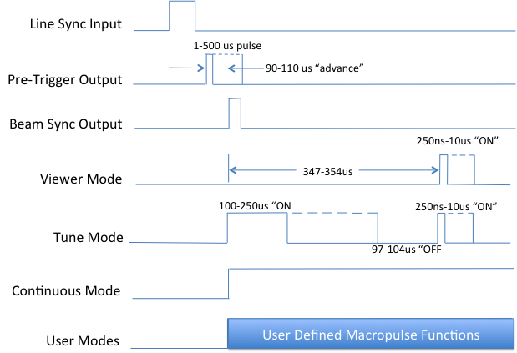

Fig. 1. The SCAM Line Sync input, Digital outputs (Pre-Trigger, Beam Sync) and laser control signals (Viewer, Tune, Continuous, User) are shown relative to one Line Sync input pulse.

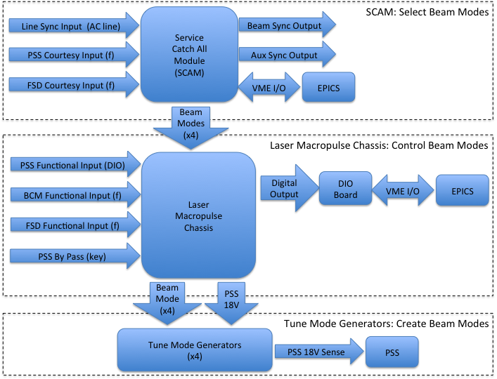

Fig. 2. Shown is the interface diagram of the SCAM, Laser Macropulse Chassis and Tune Mode Generators along with I/O dependencies and interface to the EPICS control system.

