Production of Magnetized Electron Beam from a DC High Voltage Photogun*
M. A. Mamun†, P. Adderley, J. Benesch, B. Bullard, J. Delayen¹, J. Grames, J. Guo, F. Hannon, J. Hansknecht, C. Hernandez-Garcia, R. Kazimi, G. Krafft¹, M. Poelker, R. Suleiman, M. Tiefenback, Y. Wang¹, S. Zhang, Thomas Jefferson National Accelerator Facility, Newport News, VA-23606, USA
S. Wijethunga, Old Dominion University, Norfolk, VA 23529, USA
¹also at Old Dominion University, Norfolk, VA 23529, USA

Abstract
Bunched-beam electron cooling is a key feature of all proposed designs of the future electron-ion collider, and a requirement for achieving the highest promised collision luminosity. At the Jefferson Lab Electron Ion Collider (JLEIC), fast cooling of ion beams will be accomplished via so-called 'magnetized cooling' implemented using a recirculator ring that employs an energy recovery linac. In this contribution, we describe the production of magnetized electron beam using a compact −300 kV DC high voltage photogun with an inverted insulator geometry, and using alkali-antimonide photocathodes. Beam magnetization was assessed using a modest diagnostic beamline that includes YAG view screens used to measure the rotation of the electron beamlet passing through a narrow upstream aperture. Magnetization results are presented for different gun bias voltages and for different laser spot sizes at the photocathode, using 532 nm lasers with DC and RF time structure. Photocathode lifetime was measured at currents up to 4.5 mA, with and without beam magnetization.

* Authored by Jefferson Science Associates, LLC under U.S. DOE Contract No. DE-AC05-06OR23177. Additional support comes from Laboratory Directed Research and Development program. The U.S. Government retains a non-exclusive, paid-up, irrevocable, world-wide license to publish or reproduce this manuscript for U.S. Government purposes.
† mamun@jlab.org

Inroduction
The process “electron cooling” is an important feature of proposed designs of the nation’s future Electron Ion Collider (EIC) [1]. Electron cooling is used to transfer unwanted transverse motion of individual ions within ion bunches to a sacrificial “cold” electron beam. When implemented, ion bunches occupy a smaller volume in space and time, resulting in improved luminosity when the ion bunches eventually collide with the electron bunches of a physics beam. Electron cooling has been implemented at a number of laboratories, such as Fermi Lab [2], but not under the extremely demanding conditions required by the EIC [1]. An innovative cooling method promises to meet EIC cooling requirements by delivering an electron beam to a long solenoid magnet through which the ion beam passes [3, 4]. Inside the solenoidal field, the electrons would follow small helical trajectories thereby increasing the interaction time with ions and improving the cooling efficiency by up to two orders of magnitude over previously demonstrated cooling techniques. But delivering the electron beam into the cooling solenoid represents a significant challenge. The fringe field immediately upstream of the cooling solenoid “kicks” the electron beam, introducing a large deviation from the desired trajectory of the electron beam inside the solenoid. It is expected that the ill-effects of this fringe field can be cancelled if the electron beam is born in a similar field, and passing through a fringe field at the exit of the photogun that produces a beam motion “kick” in the opposite direction, such that the two “kicks” cancel.
In this work an electron beam was generated from a dc high voltage photogun where the bialkali antimonide photocathode was immersed in a solenoidal field – so called “magnetized beam” and characterized for beam magnetization as a function of solenoid field involving beam size and beam rotation measurements using slit and viewer method for different laser spot sizes and locations. The experimental results are compared to prediction. Lifetime of magnetized and non-magnetized beam was also assessed and reported.

Experimental setup
The magnetized electron source consists of bialkali antimonide photocathode, gun HV chamber, gun solenoid,
532 nm DC and RF laser, and beamline with beam diagnostics (Fig. 1).
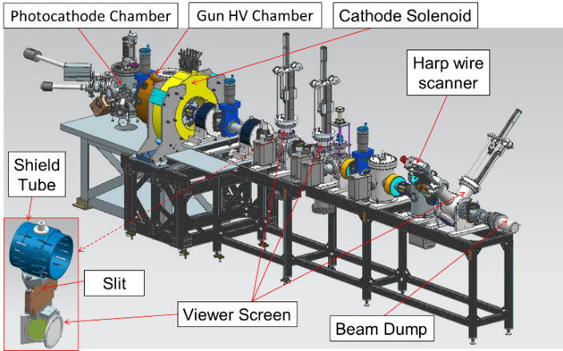
Figure 1: Beamline setup, slit and view screen (inset).

Photocathode Deposition Chamber
A load-lock type bialkali antimonide photocathode deposition chamber was built and installed behind the high voltage gun chamber. The technical details of key components of the deposition system and process are similar to as detailed in Ref [5]. Chamber vacuum of ~ 9 × 10⁻¹⁰ Pa was achieved and maintained with the help of nonevaporable getter (NEG) pumps, ion pumps backed up by turbomolecular pump and following ~ 100 h vacuum bake at 190 °C. The vacuum was continuously monitored using the ion pump current. The deposition chamber was equipped with an RGA mass spectrometer (SRS model RGA200) to continuously monitor the vacuum gas composition and it also served as a deposition monitor for the photocathode chemical species. Pure elemental sources of Sb, Cs, and K were thermally evaporated and deposited on p-doped <110> GaAs substrates mounted on molybdenum “pucks”. The deposition chamber was equipped with two resistive heaters inserted in two long stalks and mounted on linear translation manipulators: one at the bottom and the other at the top of the chamber. The bottom heater was used for heat cleaning the substrate at 400 − 450 °C for at least 18 h, while the top heater was used to maintain the surface deposition temperature at ~ 120 °C while the puck is mounted on it in face down fashion. A heater controller with feedback mechanism was employed to control the substrate temperature. Both heaters were pre-calibrated for input current and output substrate temperature with estimated uncertainty of ± 10%. The top heater was mounted on a short ceramic nipple that electrically isolated the substrate from the ground and enabled maintaining negative bias with low voltage (−280 V) during activation process to monitor photoemission evolution. During deposition the substrate was lowered from the parking position to a working distance of 3 cm from the source.
The photocathode was activated in two step process where a thin Sb film deposition is followed by simultaneous deposition of alkalis from an effusion source. The Sb source was resistively heated by supplying 25 A current through the tungsten wire around the Sb pellet containing alumina crucible. The Sb deposition time was varied from 10 to 20 min to vary the Sb film thicknesses. Photocurrent was continuously monitored using a low power (4 mW) 532 nm green laser during alkali deposition. The alkali deposition was discontinued when the photoemission current reached a maximum. Typical quantum efficiency (QE) values achieved in the range of 5 to 8% at 532 nm. A mask with 3 and 5 mm aperture sizes was used when limited area activation was desired over full area (13 mm dia.) activation. Limited active area is desired to reduce beam halo, minimize vacuum excursions and high voltage arcing, and prolong photogun operating lifetime. Once a photocathode was prepared, it was quickly transferred to the photogun cathode electrode via a magnetic sample manipulator.

DC High Voltage Photogun
A load-lock type compact DC high voltage photogun with inverted insulator and spherical cathode electrode with a screening shed was designed, built and installed for this study. The compact design helped in reducing outgassing load and the screening shed electrode helped lower the electric field strength at the triple point junction from 100 MV/m to less than 10 MV/m at −350 kV. The screening electrode also helped to linearize potential along the tapered insulator which was 17.8 cm long and made of 97% purity alumina. The spherical cathode electrode and the screening shed electrode were centrifugal barrel polished to achieve a mirror-like surface finish in just one hour compared traditional sand paper and diamond paste polishing that requires 30 days. The cathode − anode gap in the gun was 9 cm. The gun components were SRF cleaned, assembled and baked at 190 °C for ~ 100 h. The gun was equipped with NEG pumps and ion pump and the post-bake vacuum was maintained at ~ 2 × 10⁻¹¹ Pa. A −500 kV dc Cockcroft-Walton SF₆ gas–insulated high voltage power supply with a 300 MΩ conditioning resistor in series was employed to energize the photogun. The gun was high voltage conditioned and Kr gas processed to eliminate field emitters. The photogun was conditioned at −350 kV and operated at or below −300 kV. Further details on this photogun is reported in Ref [6].

Cathode Solenoid Magnet
For magnetizing the electrons born at the photocathode, a cathode solenoid magnet designed to fit at the front of the gun chamber, 0.2029 m away from the cathode. It is made of water cooled bare magnet coil with no cylindrical steel shield. The Solenoid dimenstion is 11.811″ ID, 27.559″ OD, 6.242″ width (z) and comprised of 16 layers by 20 turn copper conductor with a cross section area of 0.53 cm² and total length of 500 m. The conductor has 0.18 Ω resistance (65 °C average T). The solenoid was energized with a spare CEBAF Dogleg magnet power supply (400 A, 79 V) and can provide magnetic field of 1.5 kG at 400 A on photocathode. A magnetic model using Opera was developed for gun solenoid and the other magnetic components along the beamline. The effect of the steel solenoid casings on the focusing beamline solenoids was observed in the first three solenoids and even affected the others slightly. From the model it was concluded that magnetic field distribution [7] was distorted by the beamline solenoid steel casings, and small differences in proximity can have large integrated field effect. First trials of energizing cathode solenoid with photogun at high voltage resulted in new field emission and vacuum activity. Later a procedure was developed and followed to energize cathode solenoid without exciting new field emitters.

Diagnostic Beamline
The beamline extends ~ 4.55 m from the gun photocathode and includes beam modest beam diagnostic tools. Relevant beam diagnostics include two fluorescent YAG screens in combination with slit and a third YAG screen located at 1.5, 2.0 m, and 3.75 m respectively from the cathode to measure the transverse density profile and to trace the beam rotation angles. The beamline has seven steering magnets (from Radiabeam) to steer the beam, and and four focusing solenoids to compensate space-charge emittance growth and transport the beam to the Faraday Cup beam dump for photocathode lifetime measurements at milliampere beam current. A 532 nm green rf-pulsed drive laser was used for all measurements (374 MHz bunch repetition rate, and ~ 35 ps pulsewidth FWHM). The laser beam temporal profile was Gaussian and the laser spot size was varied using focusing lens in the laser transport.
The beam size and beam rotation angle were measured as a function of solenoid field (up to 1.5 kG) by varying solenoid supply current up to 400 A. The rotation angle was obtained by passing a beamlet through an inserted slit at either of the first two view screen locations and measuring the orientation of drifted beamlet at a downstream view screen. Magnetized and nonmagnetized beam (at 300 kV and with all beamline focusing solenoids set off) were investigated for different laser spot sizes (0.1 and 0.3 mm rms) and radial locations (0 and 5 mm from center of cathode). Recorded image data were post-processed using MATLAB curve fitting tool to determine angular rotation. Lifetime of milliamp beams (up to 4.5 mA) were studied under different gun bias voltages, laser spot sizes, and beam currents.

RESULTS and Discussion
Figure 3 illustrates representative beam images on two view screens (apart by 0.5 m) and the corresponding drifted beamlet for nonmagnetized and magnetized beam (1.5 kG).
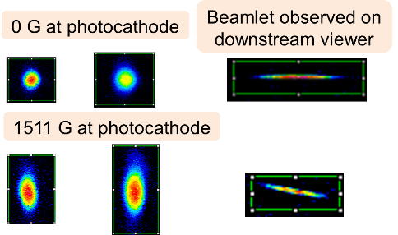
Figure 3: Image of beam and beamlet on viewers.
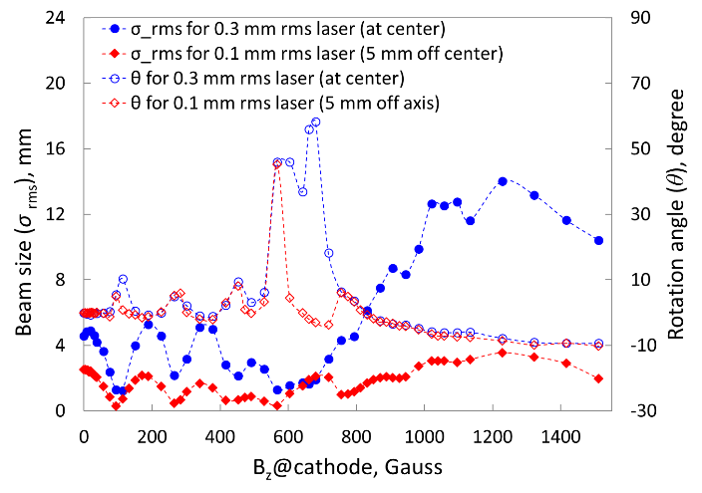
Figure 4: Beam rms size (at view screen 2) and rotation angle (slit 1 to view screen 2) of electron beam measured on as a function of magnetic field on the photocathode.
Figure 4 summarizes the measurement at second YAG screen for the beam sizes and corresponding beamlet rotation angles using 1st slit. A non-uniform cathode magnetic field causes a non-uniform Larmor oscillations and results in mismatch oscillations [8]. The imbalance between initial emittance force and applied magnetic force on photocathode that results in repeated focusing inside the solenoid field has influenced the beam size at the exit of the solenoid field and resulted in varying beam expansion rate in the field free region. Above behaviour is evident from the observed oscillating beam profiles and the corresponding beam rotation. The measured data were further used for modelling the beamline and simulation results are reported in Ref [78].

A charge lifetime of 164.2 C for the magnetized beam (1.5 kG at cathode) is estimated from a 7 h run of 4.5 mA when QE decreased gradually from 7.5−4.5 % [8]. The limited lifetime might be attributed to the poor thermal conductivity of GaAs substrate. Further measurement of charge lifetime from twenty two 1 h long runs of 3−4.5 mA beams from a 0.3 mm rms laser spot under different conditions (200−300 kV gun HV, and 0−400 A cathode solenoid current) revealed no correlation between lifetime and gun HV, magnetization effect, or run sequence. However, better lifetime is observed at lower beam current, good initial QE, and lesser laser power. We experienced sudden QE loss due to arcing and it happened 3 times only with non-magnetized beam. Strong focusing effect of cathode solenoid that might have helped keeping ions stay away from e-beam.

CONCLUSION AND FUTURE PLAN
In summary the magnetized beam was generated from a 300 kV DC photogun and characterized with a modest diagnostic beamline. Beam magnetization was studied as a function of applied magnetic field (up to 1.5 kG) on cathode by measuring beam sizes and beam rotation angle using view screen and slit. Non-uniform magnetic field instigated the mismatch oscillation. Consequently, focusing of beam was observed in addition to magnetization, and the rotation angle was influenced by Larmor oscillation. Future measurements of beam emittance versus magnetic fields and beam sizes at photocathode will help to evaluate angular momentum. Magnetized beam of 4.5 mA was demonstrated and a limited charge lifetime of 164.2 C was obtained. Further lifetime will be studied soon for the photocathode on molybdenum substrate which is expected to enhance charge lifetime due to better heat dissipation. We plan to run high current beams with bunch charge up to 3 nC using the regenerative amplifier laser and characterize the effect of space charge on beam magnetization. We also plan to implement non-invasive magnetic momentum monitoring using a TE011 Cavity.

ACKNOWLEDGMENTS
Authored by Jefferson Science Associates, LLC under U.S. DOE Contract No. DE-AC05-06OR23177 and supported by Laboratory Directed Research and Development funding. The U.S. Government retains a non-exclusive, paid-up, irrevocable, world-wide license to publish or reproduce this manuscript for U.S. Government purposes.

REFERENCES
[1] Accardi et al., Electron-Ion Collider: The next QCD frontier, arXiv:1212.1701 (2012).
[2] A. Shemyakin, and L. R. Prost, “The Recycler Electron Cooler,” 2013.
[3] Ya.S. Derbenev, Nucl. Instr. and Meth. A 441, 223 (2000).
[4] P. Piot et al., Generation and Dynamics of Magnetized Electron Beams for High-energy Electron Cooling, FERMILAB-CONF-14-142-APC
[5] M. A. Mamun et al., J. Vac. Sci. Technol. A 34, 021509 (2016), doi: 10.1116/1.4939563
[6] Y. Wang, et al., “300 kV DC High Voltage Gun with Inverted Insulator Geometry & CsK₂Sb Photocathode”, in IPAC’18, Vancouver, Canada, May 2018, SUSPF028.
[7] S. Wijhetunga, et al., “Simulation Study of the Magnetized Electron Beam”, in IPAC’18, Vancouver, Canada, May 2018, SUSPF086.
[8] M. Reiser, Theory and Design of Charged Particle Beams (Wiley, New York, 2008).

