Phase I Progress Report: 5/3/2017
Transverse Polarimetery:
The magnetic tuner assembly for the coaxial deflectometer is complete. The assembly allows one to tune the resonant frequency of the deflectometer from the outside of the vacuum chamber. Sliding the magnetic assembly over the vacuum tube slides coaxial shorts within the vacuum enclosure. Below are the components of the assembly.
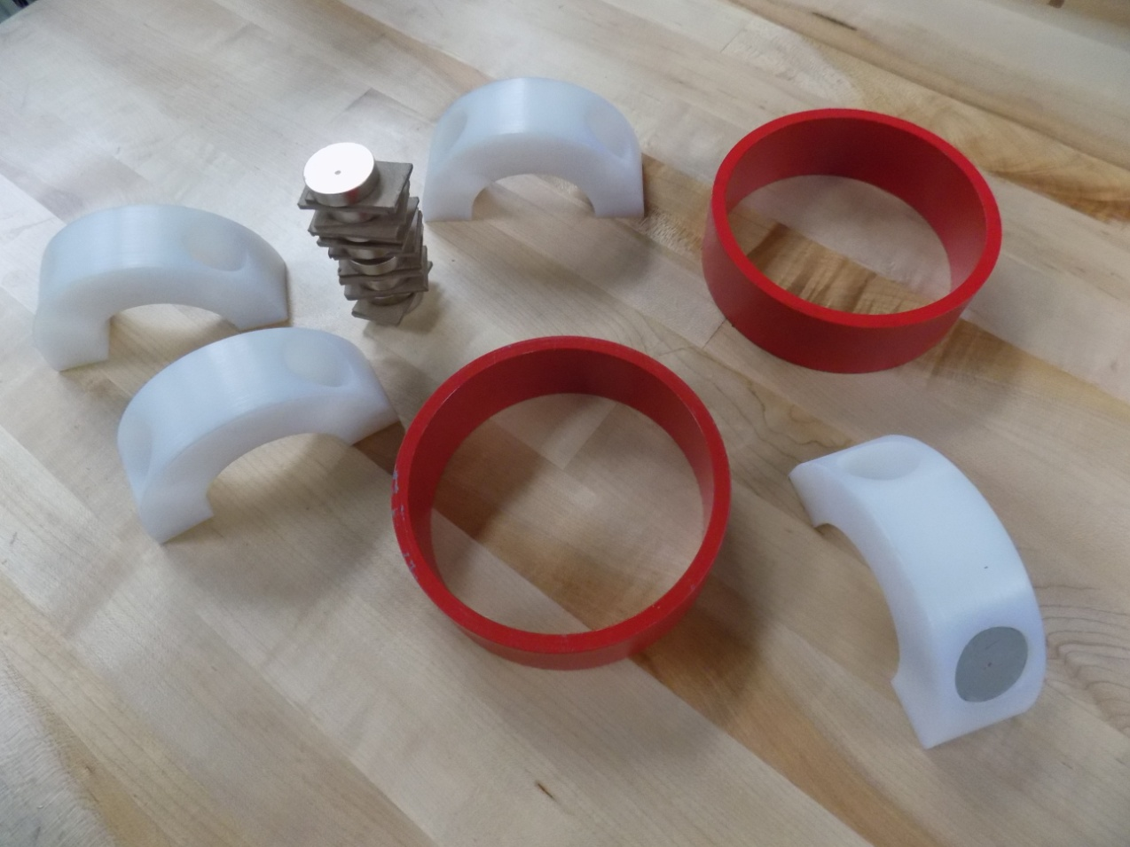
The red rings are painted steel and provide a flux return for four stacks of three NdFeB magnets. Each stack of three magnets sits within a radial pocket in the white polyethylene spacers. Each of these pockets is populated with three magnets; one filled pocket is shown in the lower right of the photograph. Each stack of magnets is radially arranged with alternating magnetic polarity and is contained by the white polyethylene spacers, creating a magnetic quadrupole with flux return paths through the steel liner of the coaxial tuner (inside the stainless steel vacuum tube). Each magnet is 1.15” inches in diameter and .28” thick, each stack of three magnets is .84” thick and is made of NdFeB with an energy product of 40 MGOe ,manufactured by Hitachi Magnetics. The completed tuner assembly works very smoothly, the polyethelyne slides over the stainless steel while the coaxial tuner follows within the vacuum assembly.
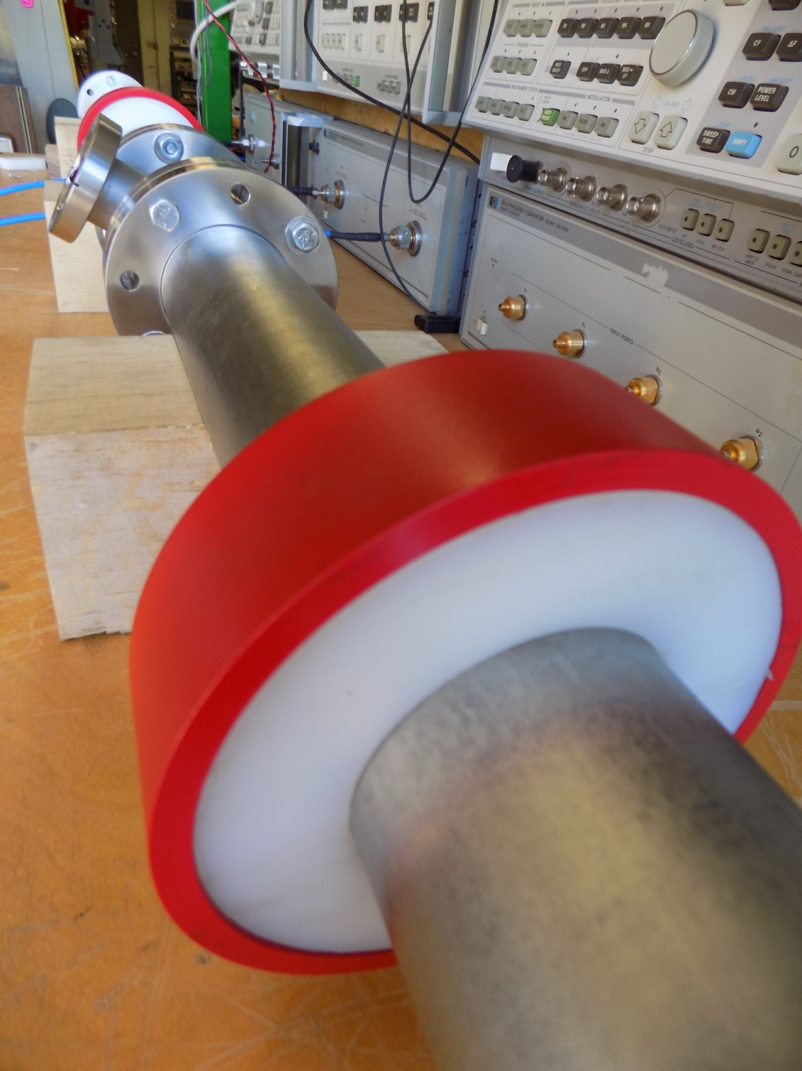
The quadrupole magnet arrangement uses the steel coaxial tuner as a return flux path creating a rigid coupling between the magnet assembly outside of the tube, and the co-axial tuner inside the vacuum. The polyethylene magnet assembly slides smoothly over the stainless tube in unison with the magnetically captured coaxial tuner assembly within the vacuum pipe.

Longitudinal Polarimetery: Ring Coupled Resonant Polarimeter
Prototype II; Proposed Design.
The construction and testing of the pre-phase I ring coupled resonant polarimeter prototype revealed many opportunities to improve in the cavities physical design and in the receiver’s electronic design. More significantly, feedback from the Jlab/Cornell Stern-Gerlach polarimetery group has identified two ways to fundamentally improve performance. The 2nd prototype ring-coupled resonant polarimeter will:
- Implements Reza’s concept of using two 249.5 MHz lasers to create a 499 MHz beam of alternating longitudinal polarity.
- Responds to Riad’s concern that the detection frequency of the first protototype, 2.495 GHz, is a harmonic of the bunch charge. While the TE011 mode is orthogonal to the fields of the beam and ideally would not excite the mode, the proximity of the beam to the antenna will likely have some coupling, and could mask the desired signal.

Additional improvements:
- Replace Teflon spacers with a UHV compatible material SiC.
- Improve high order mode suppression. Silicon Carbide is an RF absorber and will be used as spacers and high order mode suppression.
- Use a ring diameter that JLAB is comfortable with.
- Uses a hybrid of heterodyne and direct conversion I/Q demodulator receiver that will work over the range of the Pockels cells, DC to 1 kHz.

New Frequency of Operation: (Thanks to Reza and Riad.) When a longitudinally polarized electron bunch travels through a metal ring, a ring current is induced by Faraday’s Law, in the orientation dictated by Lenz’s law. The ring current creates a magnetic field that opposes the electron bunch’s travel through the ring as it enters, and then the ring current reverses direction creating a magnetic field that attracts the bunch as it the ring. The energy coupled to the ring is extracted from the forward motion of the bunch. The ring sits at location within a TE011 cavity so that a frequency component of the ring current excites the cavities resonant mode. The first prototype selected the 5th harmonic of a 499 MHz beam to detect beam whose polarity was flipped by the Pockels cells. The 2nd Prototype will detect a harmonic of the bunch flip rate using a beam prepared using Reza’s recommendation, with alternating longitudinal polarization.
Estimating the current induced in a small metal ring from a passing polarized electron bunch.
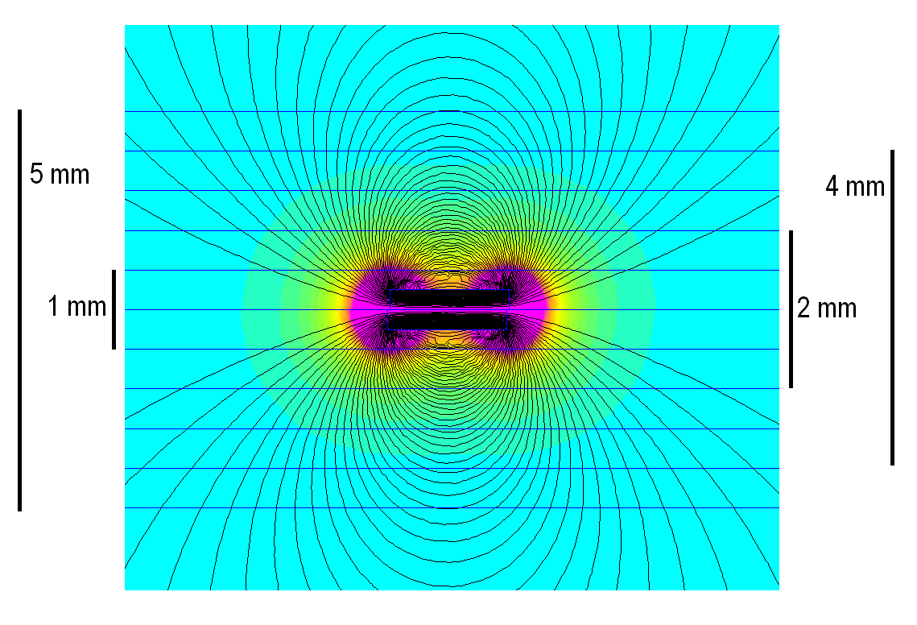
The picture above is a magnetostatic model (FEMM) of a magnetized cylinder .5 mm X 2mm. By measuring the radial component of the magnetic field along a blue horizontal line provides an estimate of the current induced in the ring from a passing magnetic dipole. Converting length to time (1ft = 1 ns for example), a rough estimate of the current waveform be produced for two cases, a longitudinally polarized beam (Normal Beam), and an alternating polarity (Reza beam).

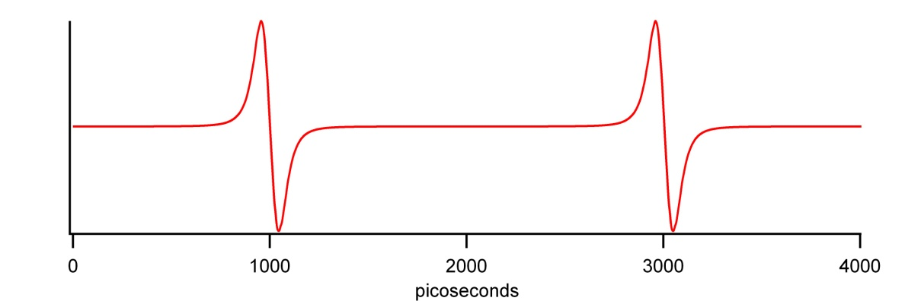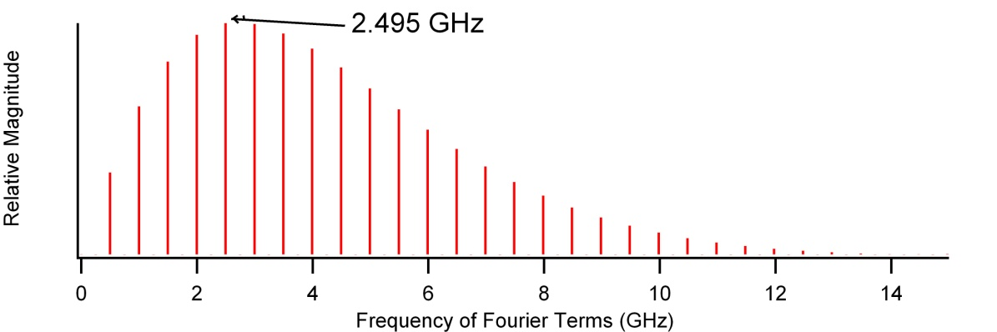
The waveform is ring current vs. time for a 499 MHz polarized electron beam and the magnitude of its Fourier series, it contains only 499 MHz harmonics. 2.495 GHz is the resonant frequency of the 1st prototype ring coupled cavity.
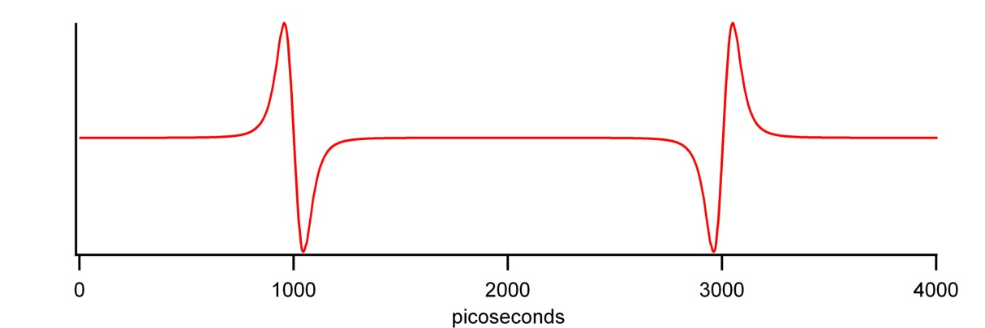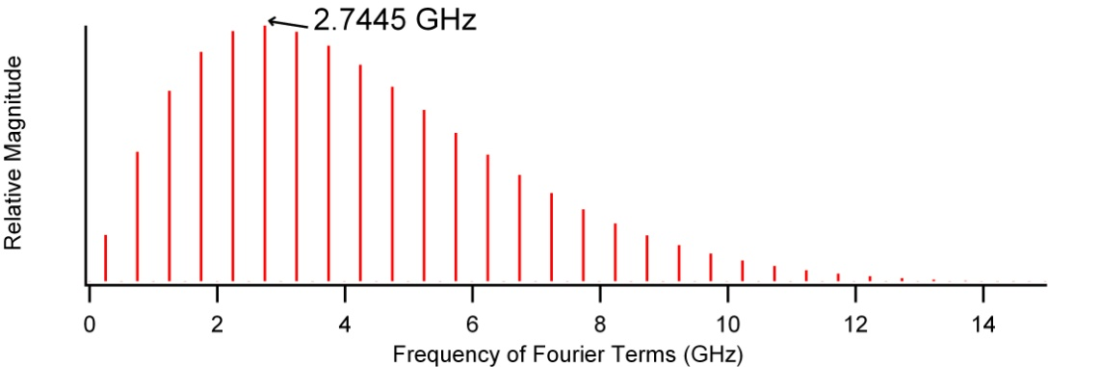
The Reza beam is composed of odd 249.5 MHz harmonics. The proposed detect frequency of the 2nd prototype is 2.7445 GHz. A receiver circuit is shown below.
