Here’s are input conditions, from PR’s, drawings, as-founds, e-mails:

- Schneedle
  - JLAB dwg 200-3000-0219
  - Dimameter 0.742” to 0.744”
- Moly Puck
  - JLAB dwg JL0047248
  - Keith uses drawing as-is
- Indium Foil
  - PR = https://misportal.jlab.org/reqs/prs/293572#ShowItemsTab
  - Thickness from PR = 0.002”
  - Keith used thickness = 0.001”
- Wafer (micron)
  - AXT (from PR) = 625 +/- 25
  - SVT (spec) = 625
  - UCSB = 625
  - RIT = 350
  - Keith uses 650 um = 0.026”
- Tantalum cup
  - Drawing JLAB dwg 32709 indicates 0.005” thick
  - Keith uses as-found measurement says 0.004” thick

Keith created a 3d model of the stackup of a photocathode on a puck with a schneedle with highlighted values above.

The distance from left face of Ta cup (green) to Puck crown is 0.001”
- Ideally, we’d like this to be close to zero, so pretty close
  - If puck 600 um => gap = 0.003”
  - If puck 625 um => gap = 0.002”
  - If puck 650 um => gap = 0.001”
The distance from right face of Ta cup (green) to Puck (orange) is 0.0066” = 168 um, which is greater than any of the stack-up tolerances
- Our wafers sit proud of the orange piece, although too high and this can lead to cracking the wafer.
- Do we recall the design goal?:
- My intuition says make that gap as short as possible given tolerances
Finally, we should have a design for a “625” and “350” micron thick.

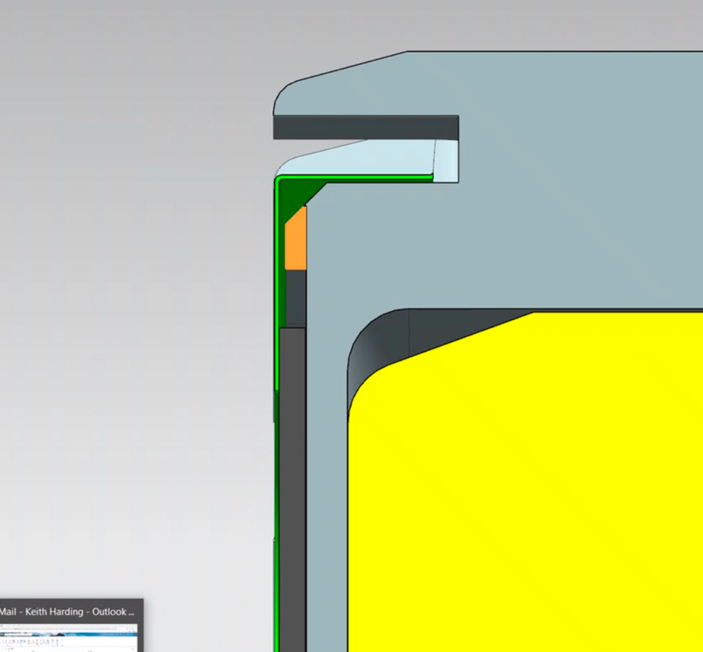

Schneedle
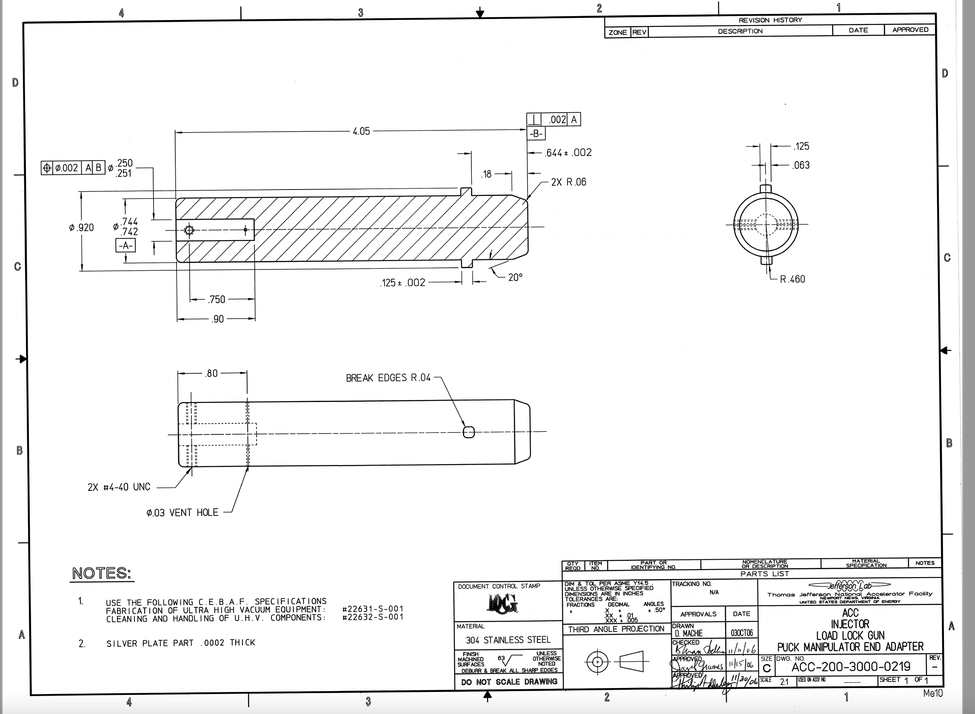

Marcy’s mark-up of Moly puck dwg
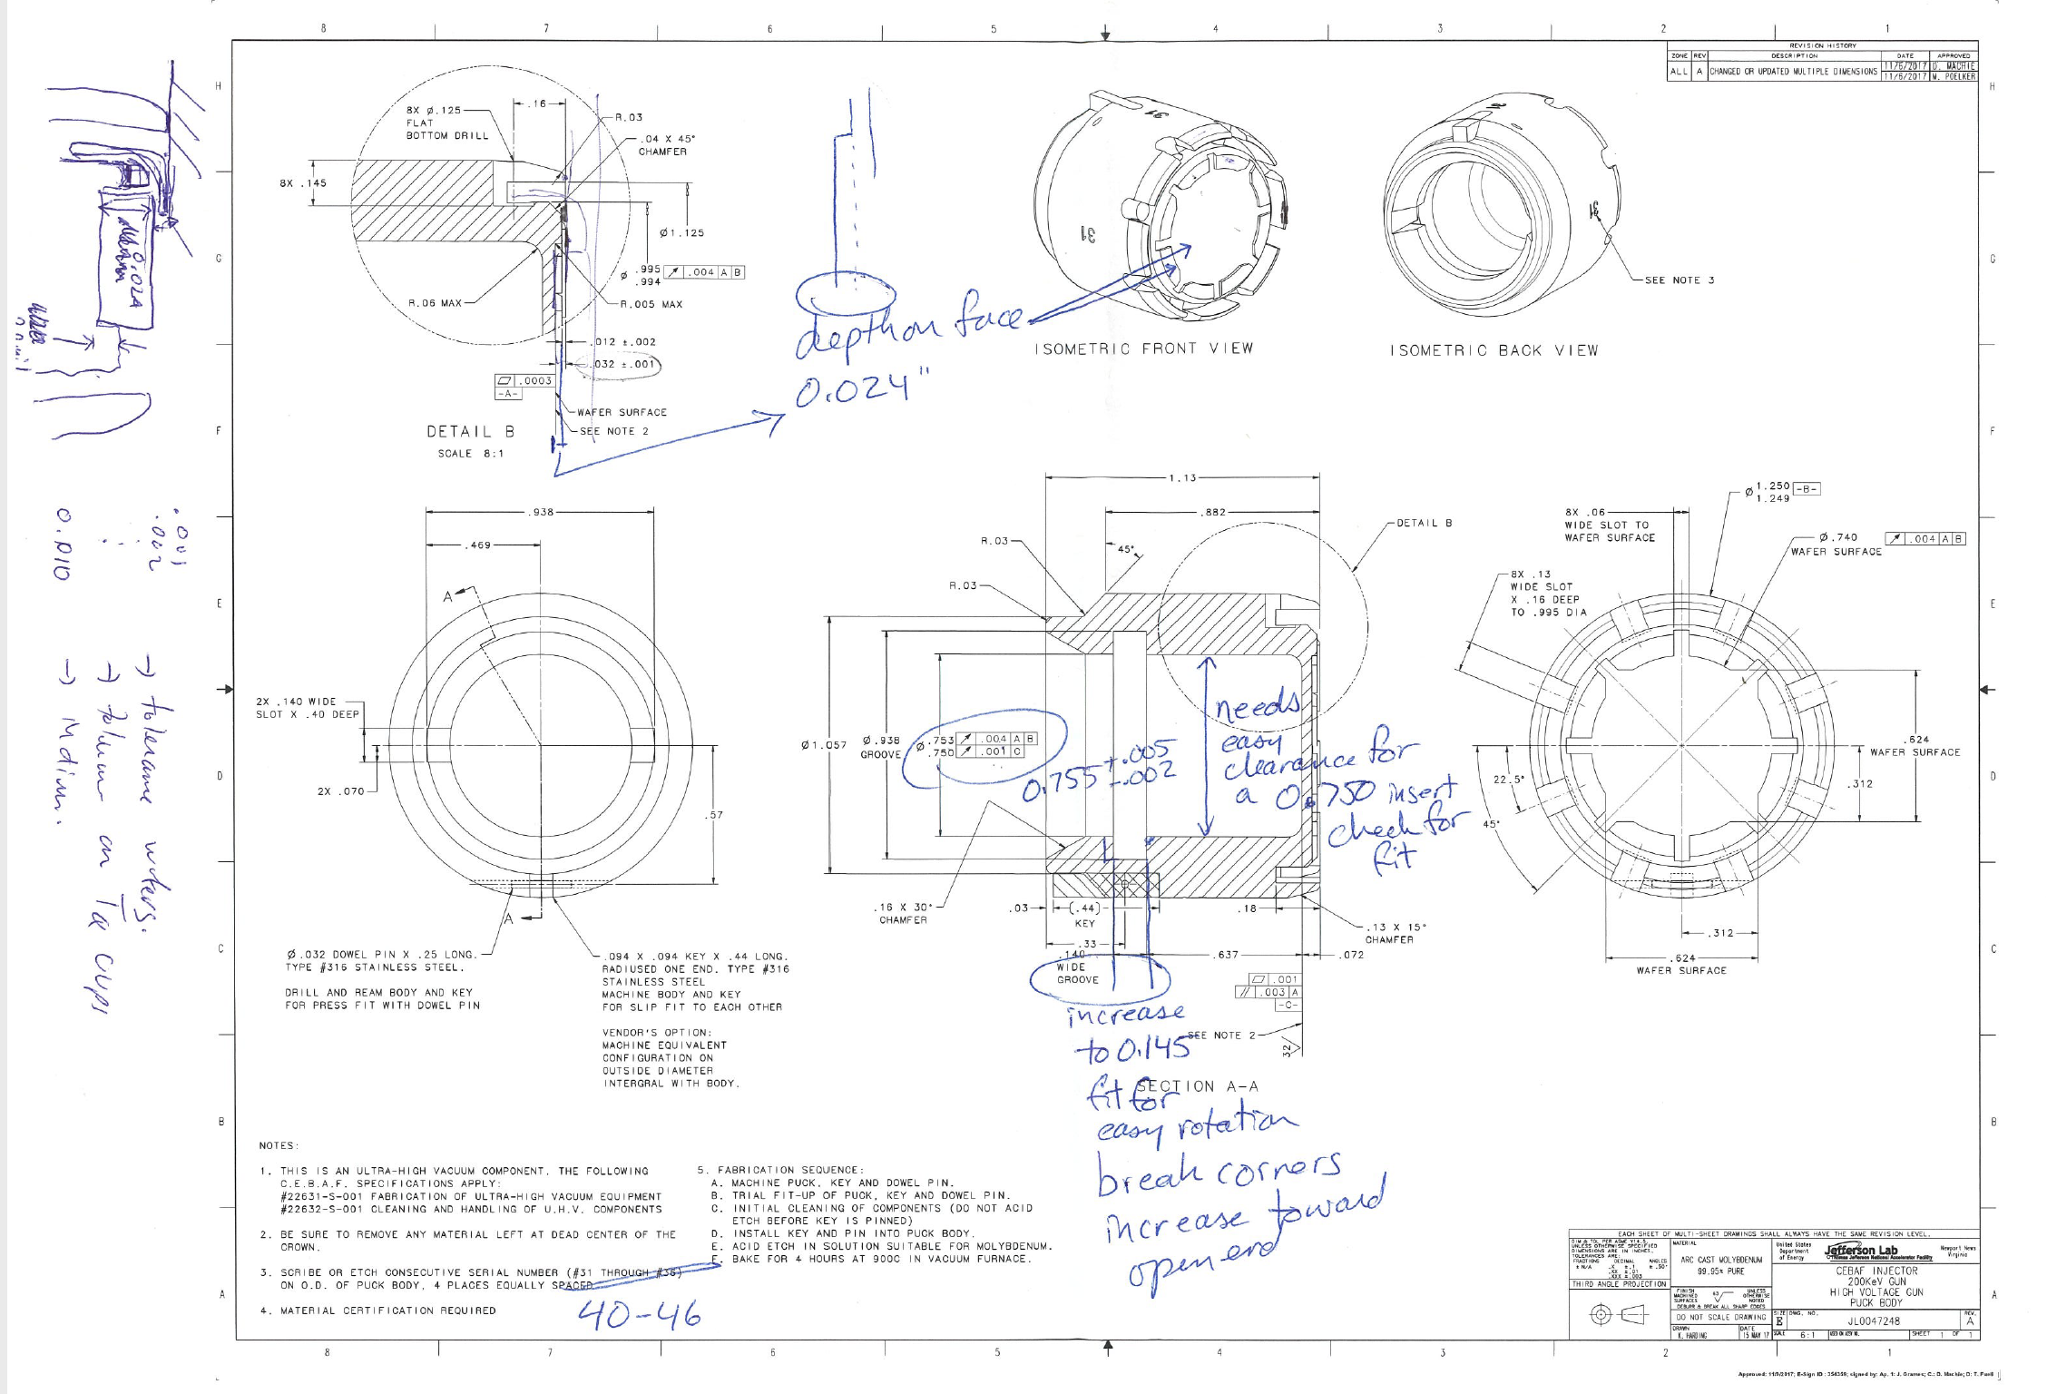

Tantalum cup print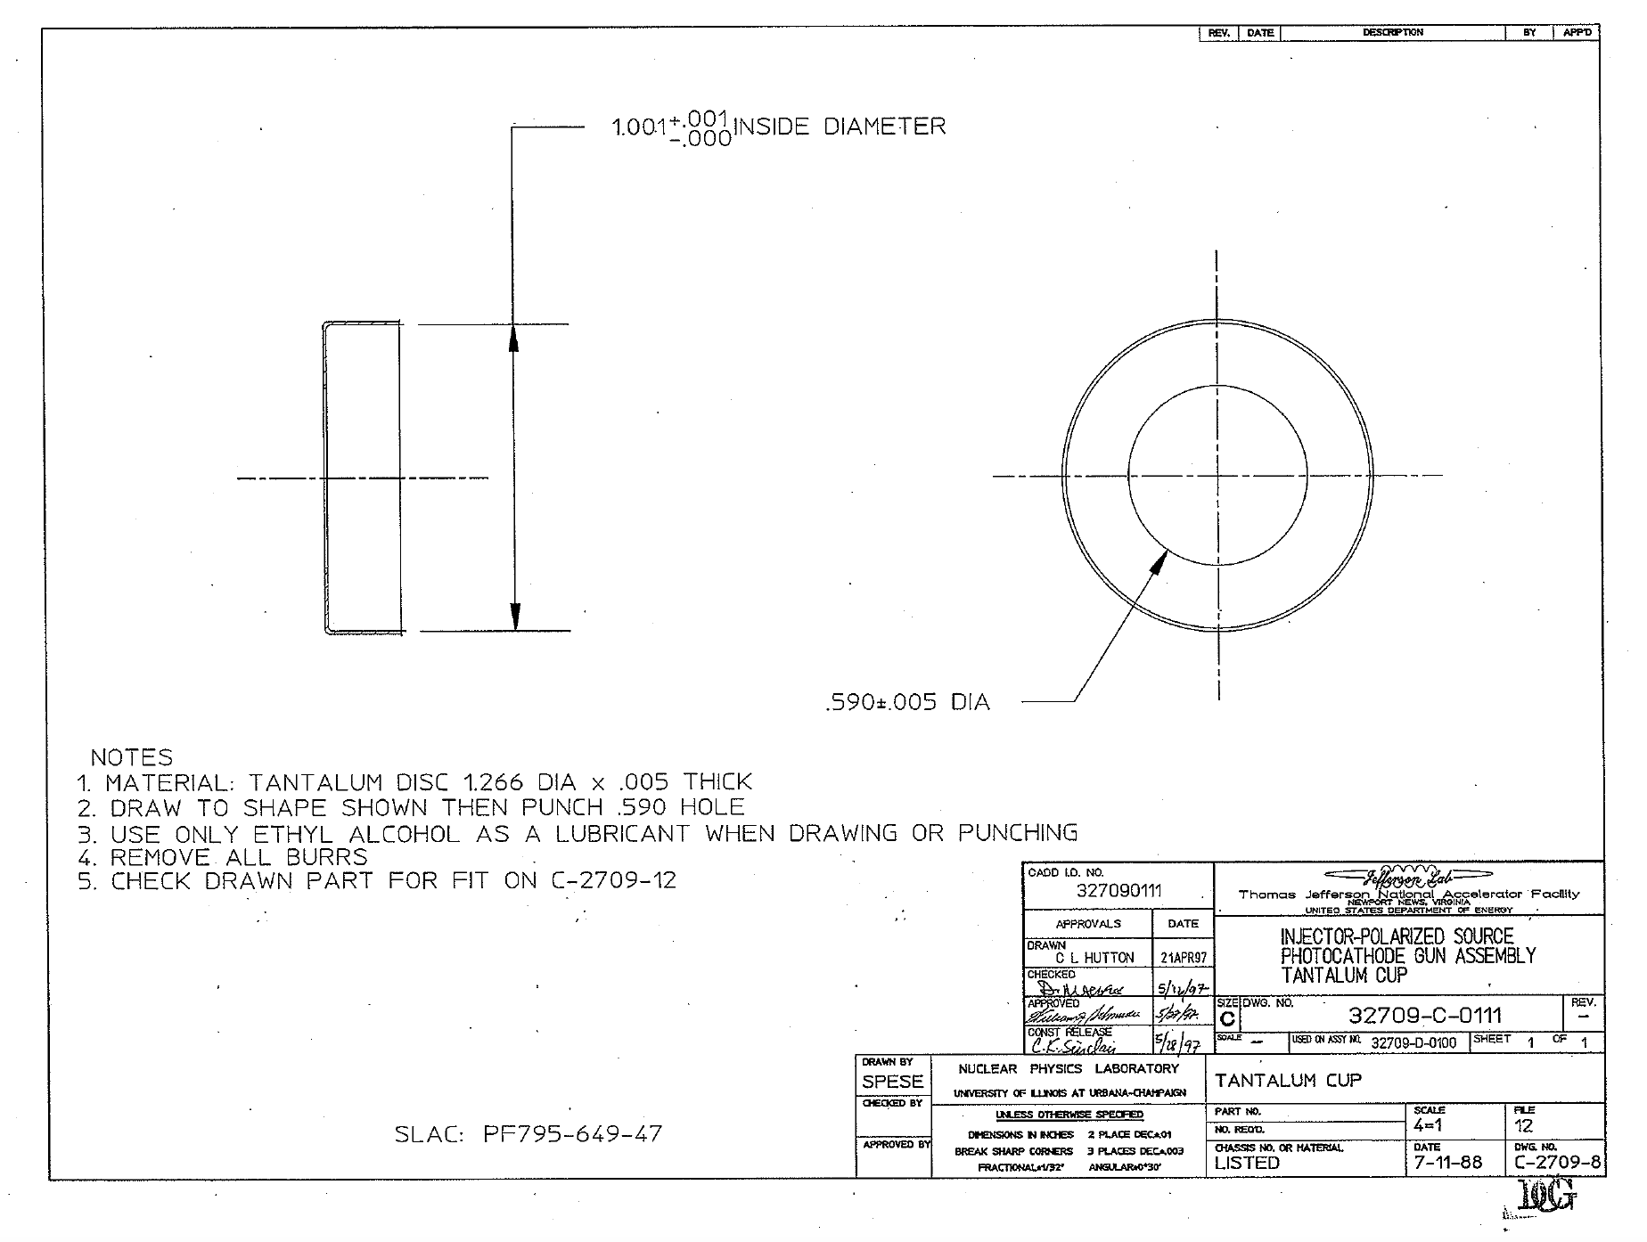

CIS-TN-18-01
March 1, 2018

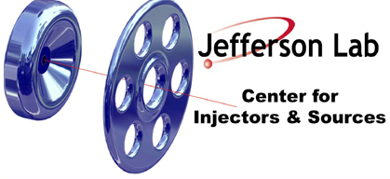

FABRICATION OF MOLYBDENUM PUCK BODY

CIS

Jefferson Lab

This note summarizes the steps for fabricating the molybdenum “PUCK BODY” as described in drawing JL0047248.

- Machine and Assembly Steps
  - Machine puck, key and dowel pin
  - Trial fit-up of puck, key and dowel pin
  - Initial cleaning of components with micro and acetone rinse (do not acid etch before key is pinned)
  - Install key and pin into puck body

- Acid Etch Steps
  - Remove indium if needed (isopropyl + indium ball to get indium off)
  - Moly Etch Aqua Regalis (1:3 HCl:Nitric), 10 seconds, rinse, check surface, repeat for 10 more seconds if needed, rinse, check surface
  - Ultrasonic cleaning in DI water after (USC twice to ensure removal of acid from around ear)
  - Rinse, air dry in hood, bag for heat treatment

- Vacuum Bake Steps
  - Use a vacuum oven to degas puck.
  - Use a ramp rate of 10-15 degrees Celsius per minute.
  - Ramp to 900 degrees Celsius.
  - Soak for 120 minutes, recording pressure every 30 minutes.
  - Ramp and cool to room temperature
  - Bag puck, if possible in GN2.

