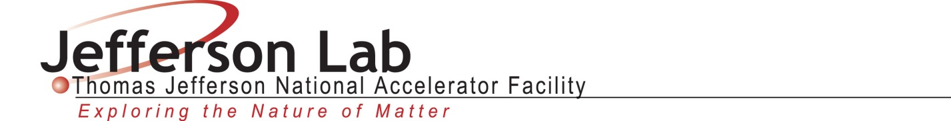

Laboratory Directed Research and Development Proposal
Title: Electron Vortex Beam Source for Nuclear Research

Lead Scientist or Engineer: | DR. JOSEPH GRAMES
Phone: | (757) 269-7097
Email: | grames@jlab.org
Date: | April 28, 2016
Department/Division: | Center for Injectors and Sources / Accelerator Division
Other Personnel: | Dr. Dipangkar Dutta, Mississippi State University  Dr. Benjamin McMorran, University of Oregon  Dr. Yoshitaka Taira, AIST-Japan
Proposal Term: | From: 10/2016  Through: 10/2019  If continuation, indicate year (2nd/3rd):

Division Budget Analyst
Phone:
Email:

This document and the material and data contained herein were developed under the sponsorship of the United States Government. Neither the United States nor the Department of Energy, nor the Thomas Jefferson National Accelerator Facility, nor their employees, makes any warranty, express or implied, or assumes any liability or responsibility for accuracy, completeness or usefulness of any information, apparatus, product or process disclosed, or represents that its use will not infringe privately owned rights. Mention of any product, its manufacturer, or suppliers shall not, nor it is intended to imply approval, disapproval, or fitness for any particular use. A royalty-free, non-exclusive right to use and disseminate same for any purpose whatsoever, is expressly reserved to the United States and the Thomas Jefferson National Accelerator Facility.

Abstract
This LDRD proposal aims to develop a new type of accelerator electron source that provides Nuclear Physics Users with beams composed of quantized orbital angular momentum (OAM) electrons. Development of a vortex beam source and a vortex beam diagnostic is proposed.

Summary of Proposal

Description of Project
Electron vortex beams, comprised of freely propagating electrons with helical wave functions, provides an entirely new and unexplored degree of freedom for use in high energy physics - quantized orbital angular momentum (OAM). The goal of this new project is to build an electron vortex beam source, use it to explore the OAM dependence of nuclear Mott scattering experiments, and test it as a new type of electron source at the Thomas Jefferson National Accelerator Facility (JLab).

We would use this source for example to explore the fundamental question of how the proton’s spin is built up from the spin and orbital angular momentum of the constituent quarks and gluons. Answering this question has been a vigorous and global effort in nuclear and particle physics. The whole enterprise began with the availability of spin-polarized beams that provided new degrees of freedom and observables. Over the last three decades, tremendous progress has been made in unraveling the proton’s spin structure with advances in experimental techniques, theoretical models and lattice calculations. As a result of these advances there is currently a sizable effort to quantify the contribution from the quark's orbital angular momentum, however, there are no direct observables. The advent of vortex electrons with quantized OAM puts us on the cusp of a new revolution that could open up new degrees of freedom allowing direct measurements of the quark OAM.

[DIPANGKAR – CAN YOU BOLSTER THE MOTIVATION…]

Electrons with OAM have already been produced…

[BEN – CAN YOUR PROVIDE BACKGROUN TEST, HOW YOU CREATE AND DETECT VORTEX ELECTRONS, DETAIL ON THE GRATINGS]

One phase of this project is to use an electron microscope source to produce 100-300 keV vortex electrons and perform Mott scattering measurements from a thin foil target. Theoretical calculations predict that there are significant differences in the Mott scattering cross section between plane wave electrons and vortex electrons. If Mott scattering measurements can verify these predictions it would provide a scattering-based tool for monitoring vortex electrons. Such a tool would allow us to verify the OAM-preserving acceleration of vortex electrons and eventually lead to high-energy electron beams carrying quantized OAM.

The OAM quality of the diffracted electrons depends upon the spatial coherence of the incident electron plane waves. So far OAM electrons have been generated only from electron diffractive sources, such as electron microscopes. Interest in compact accelerator electron diffractive sources has motivated recent R&D to develop dc high voltage photoguns with very low emittance, and thus high spatial coherence. The lower emittance is achieved by lowering the mean thermal energy of the photoemitted electrons, by cooling the photocathode to cryogenic temperature. Additionally, the cathode-anode electric field profile and laser conditions are optimized to minimize the emittance. Such work has recently demonstrated emittance X from unpolarized Cs2KSb photocathodes cooled to Y Kelvin.

A second phase of this project is to modify a dc high voltage photogun to provide cooling of the cathode electrode at high voltage. Calculations and multi-variation optimization simulations will be used to optimize the design and laser conditions and will be benchmarked using emittance measurements of spin-polarized GaAs and unpolarized Cs2KSb photocathodes. If to achieve low emittance and characterize a low emittance source using a dc high voltage pho produce vortex electron beams from a dc high voltage photogun modified to produce.

Expected Results
- Jefferson Lab will have direct experience generating electrons with orbital angular momentum.
- Learn how to implement cryo-cooling to a dc high voltage photogun to lower the beam emittance
- Learn how to optimize dc high voltage photogun to achieve ultra-low emittance electron beam
- Benchmark calculations of low emittance from photocathodes for nuclear physics
- Benchmark OAM simulation tools.

Proposal Narrative

Purpose/Goals
The three main goals of this LDRD are to a) detect vortex electrons by Mott scattering, b) build a low-emittance photogun with high spatial coherence, and c) using the photocathode diffract electrons and detect by Mott scattering. The Mott scattering experiment will test theoretical predictions and provide a benchmark for modeling OAM simulation and calculation, and provide a beam quality diagnostic. The cryo-cooled photogun will test the ability to measure and compare the low-emittance beams from Cs2KSb and GaAs/GaAsP. The combined final experiment will test the ability to produce, and quality of, OAM electrons from a low-emittance photogun. These simulations and measurements will provide insights on ways to optimize the OAM quality, and help us design the appropriate vortex electron source. Ultimately we seek a research program to develop a vortex electron source with similar characteristics of the CEBAF polarized electron source.

Approach/Methods
The projected cost of the project will be approximately $XXX spread evenly over three years. Procurement funds are needed to produce OAM gratings, modify a photogun, build a diagnostic and perform the experiment. Labor funds are needed for a full time graduate student, travel support for collaborators, and for Jefferson Lab labor.

In Year 1 we modify a 225kV electron source for photocathode cooling and commission for high voltage operation. OAM gratings for the experiment will be fabricated and tested in a 300keV FE source at the University of Oregon. Planning for year 2, modeling and simulations of the beam line and Mott scattering experiment will be performed. The feasibility to test the production of OAM gamma rays by inverse Compton scattering of OAM laser photons with the high-energy GeV CEBAF beam will be theoretically explored.

In Year 2 we design and install a vacuum chamber that provides the capability for MTE characterization of GaAs and alkalai-antimonide photocathodes and the OAM gratings. We characterize photocathodes vs. temperature, wavelength and bunchlength, then illuminate the OAM grating with spatially coherent electron beam to create and image a vortex electron beam using photogun for first time. The Mott experiment conditions are finalized and development for detector and analysis prepared. An experiment to test OAM gamma ray production will be considered and if feasible proposed/discussed.

In Year 3 we produce OAM vortex electron beam with photogun and perform Mott scattering experiment in 100-225 kV energy range. Depending on progress/success we may propose to attach OAM photogun to demonstrate MeV beam acceleration through cryounit, e.g. at UITF or CEBAF. If OAM gamma ray production test is planned large focus .

Table 1. Summary of activities by year and by collaborator.

 | Year 1  2016-2017 | Year 2  2017-2018 | Year 3  2018-2019
JLab

UO

MSU

AIST

Specific Location of Work
At the University of Oregon an electron vortex source capable of providing a steady beam of electrons in 100% pure OAM modes will be used to test the predicted Mott scattering sensitivity to OAM. Many of the components needed for the test – the vacuum system, high voltage controls, charged particle optics – are already available. A Due to the high spatial coherence requirements of electron vortices, the instrument will use a field emission electron source. UO will nano-fabricate diffractive optical elements for electrons to holographically imprint OAM onto the beam, and then using the field emission source will verify and measure the OAM. Jefferson Lab will loan UO the keV-Mott scattering chamber and electronics for the measurements. Once tested these gratings will be provided to Jefferson Lab, and later the Mott scattering chamber returned to Jefferson Lab for final tests with the photogun.

[BEN – CAN YOU ADD A FIGURE HERE TO SHOW PROPOSED TEST STAND AT UO?]

At Jefferson Lab an electron gun high voltage chamber will be modified to include photocathode cooling utilizing an existing closed-loop cryogenic cooling system. A short beam line consisting of a chamber to insert and orient the OAM grating, an MTE diagnostic and an existing Mott scattering chamber polarimeter will be attached to the electron source. Both spin-polarized GaAs and unpolarized alkalai-antimonide photocathodes will be characterized versus cooling temperature, laser wavelength and laser pulse length. An existing 100-300 keV Mott polarimeter and detection system exists and will be used to demonstrate a free-electron OAM beam suitable for acceleration.

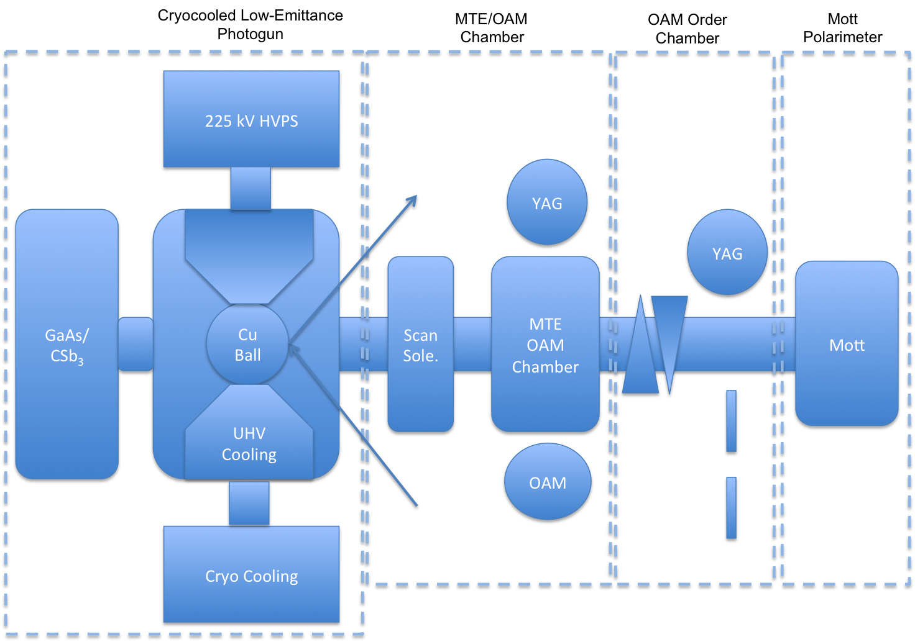
Fig. 1. Schematic shows the major components of the project; a) HV photogun with cryocooling and optimized electrode to minimize MTE, b) a scan/drift/YAG emittance monitor to measure MTE vs. photocathode temperature, laser wavelength and laser bunchlength and quantify beam at OAM grating, c) an OAM Order chamber to image the OAM pattern and then select an order through a slit, and d) a Mott scattering polarimeter to test the feasibility to detect OAM in free-electron beam. Laser path TBD.

Anticipated Outcomes/Results
The main product of this project will be a low-energy (100-300 keV) source of electron vortices in 100% pure OAM states. The results of this project will consist of a thorough study of Mott scattering of electron vortices from thin foil targets as compared to theory and theory and simulation, and the first demonstration of accelerating vortex electrons to higher energy in an electron accelerator.

VITA (Lead Scientist)
JOSEPH GRAMES
Thomas Jefferson National Accelerator Facility
Newport News, VA 23606

Office Phone: (757) 269-7097 e-mail: grames@jlab.org
Rank: Staff Scientist III DISCIPLINE: Polarized electrons sources

- Education
B.S., Physics, Stevens Institute of Technology, Hoboken, NJ, May 1992
M.S., Physics, University of Illinois, Urbana-Champaign, IL, May 1994
Ph.D., Physics, University of Illinois, Urbana-Champaign, IL, Dec 1999

- Appointments
1999-present: Staff Scientist and Deputy Group Leader Center for Injectors and Sources, Thomas Jefferson National Accelerator Facility

- Recent Journal Publications
- M. BastaniNejad, A. A. Elmustafa, E. Forman, J. Clark, S. Covert, J. Grames, J. Hansknecht, C. Hernandez-Garcia, M. Poelker, R. Suleiman, "Improving the Performance of Stainless-Steel DC High Voltage Photoelectron Gun Cathode Electrodes via Gas Conditioning with Helium or Krypton", Nuclear Instruments and Methods in Physics Research A 762 135 (2014).
- R. Mammei, R. Suleiman, J. Feingold, P. A. Adderley, J. Clark, S. Covert, J. Grames, J. Hansknecht, D. Machie, M. Poelker, T. Rao, J. Smedley, J. Walsh, J. McCarter, M. Ruiz-Osés,"Charge Lifetime Measurements at High Average Current Using a K2CsSb Photocathode inside a DC High Voltage Photogun", Phys. Rev. ST Accel. Beams, 16, 033401 (2013).
- J. Grames, R. Suleiman, P. A. Adderley, J. Clark, J. Hansknecht, D. Machie, M. Poelker, and M. L. Stutzman, “Charge and fluence lifetime measurements of a dc high voltage GaAs photogun at high average current”, Phys. Rev. ST Accel. Beams 14, 043501 (2011).
- P. A. Adderley, J. Clark, J. Grames, J. Hansknecht, K. Surles-Law, D. Machie, M. Poelker, M. L. Stutzman, and R. Suleiman, “Load-locked dc high voltage GaAs photogun with an inverted-geometry ceramic insulator”, Phys. Rev. ST Accel. Beams 13, 010101 (2010).

- Professional Activities
- Member - American Physical Society and Division of Beams
- Referee - Phys. Rev. Accelerators and Beams and IEEE

- Committees
- Convener, Intense Electron Beam Workshop at Cornell U., Ithaca NY (2015)
- Organizer, Int’l Workshop on Positrons at Jefferson Lab, Newport News, VA (2009)
- Organizer, Workshop on Polarized Electrons Sources, Newport News VA (2008)

Budget Explanation
To be able to perform the proposed measurements, budget is required for the following procurements:
  - Fabrication costs for the nano-gratings that impart orbital angular momentum to plane wave electrons.
  - Shipping costs to loan Mott scattering chamber to the University of Oregon to test free-space vortex electrons.
  - Purchase a “cold finger” to cool cathode electrode (note, we already have the cryogenic compressor and water chiller from another project)
  - High voltage chamber: machine and polish copper electrode, adapt cold finger for cooling (note, we already have a high voltage chamber, high voltage power supply and preparation chamber)
  - OAM chamber: nano-grating support, camera, vacuum window
  - MTE chamber: (1) YAG crystal screen, slit camera, vacuum window (note, we already have scanning solenoid0
  - Laser/optics to control spot size
  - Graduate student

Work performed outside the gun group will need to be paid for with additional budget:
1. OAM and MTE chamber engineering design

.

References
Include here (starting on a new page), as appropriate, citations to pertinent publications.

Attachments
Include here (if desired), starting on a new page for each, additional information in the form of attachments.

