Procedure for assembling the electrode on an R30 inverted ceramic
C. Hernandez-Garcia and D. Bullard
October 27, 2015

The electrode assembly is intended to be used with an R30 size inverted ceramic insulator for the GTS gun, and for the UITF gun. The electrode accepts a puck and has a Pierce geometry front-end electrode plate.

The ball electrode and the shed must be polished (Diamond Paste Polishing), then clean with solvent following UHV standards, and finally vacuum degassed prior to assembly. We noticed that after the vacuum degas at 900 C, the electrodes come out with a “haze” that shows the electrode weld very clearly.

Below is a picture of the parts and tools needed for the assembly.
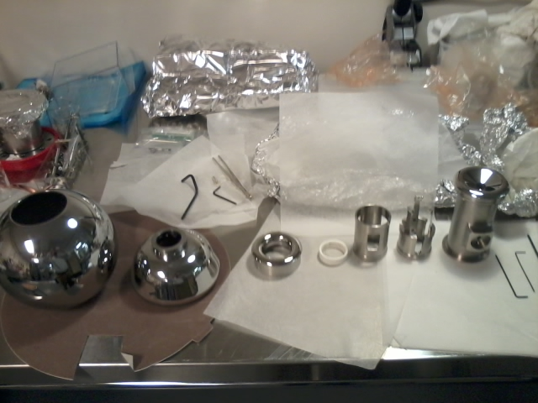
Form left to right: Ball cathode, shed, back-end electrode ring, ceramic ring, puck retainer spacer, puck retainer with sapphire rolls, and “T”.

Procedure:

- Insert shed set screws. Make sure they do not stick out. The set screw end with where the Allen wrench is used needs to be pointed towards the center of the shed shaft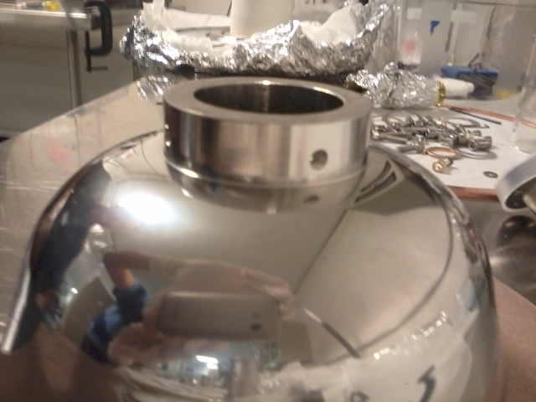.
- Attach shed to ball electrode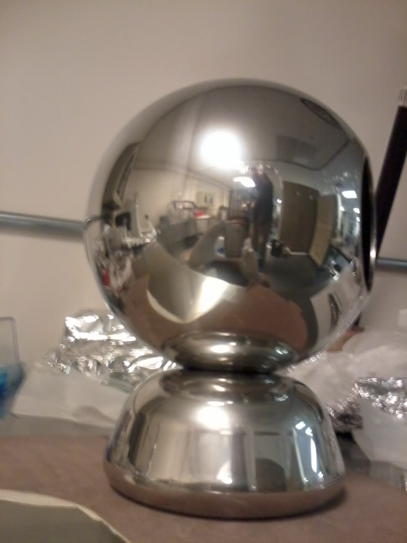. It will take some time to tighten all four set screws because the Allen wrench does not have much swing. Be careful not to touch the shed with the Allen wrench while tightening the setscrews.
- Attach front end electrode Pierce plate to the “T”. The T has two different ends. The front end electrode goes on the top side shown in the picture below. 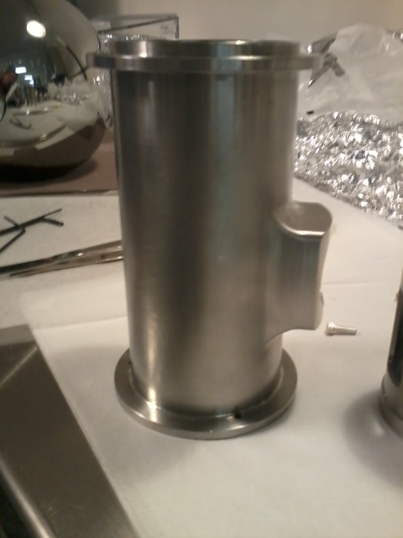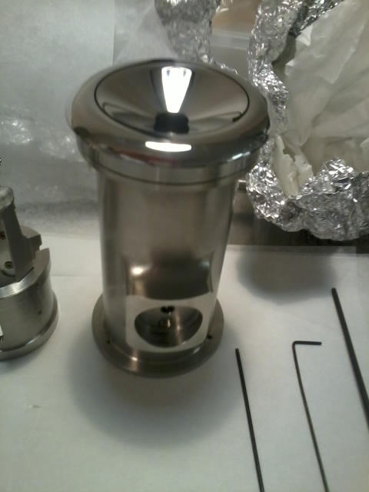. The T+front end electrode assembly goes inside the ball+shed assembly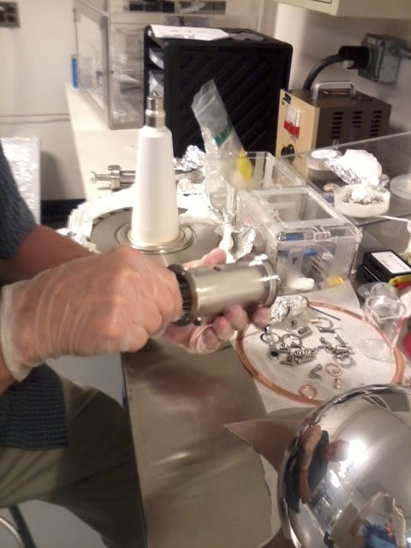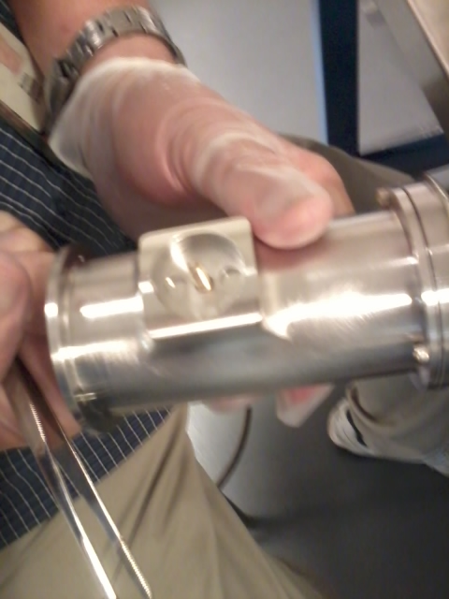.
- Insert the T assembly into the ball+shed assembly. It is easier to place the ball+shed assembly horizontal to insert the T from the top. Please note the T is not secured to the ball. The T will be secured to the ceramic with a screw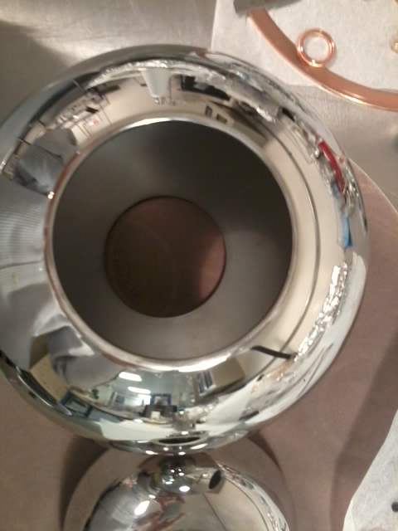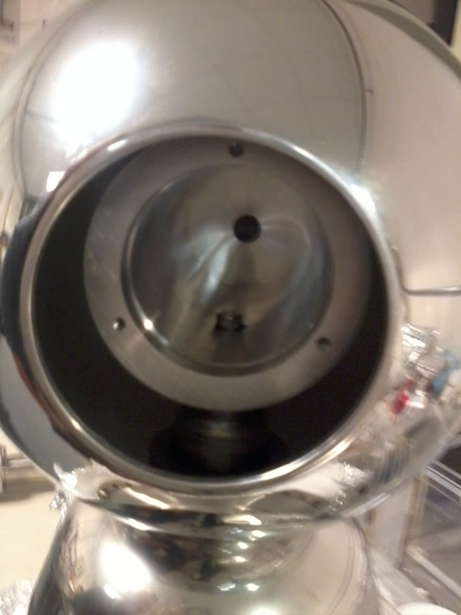.
- Place a ~1/16” washer ton the ceramic tip, this is to prevent the shed from touching the ceramic as shown in the picture below. This spacer will help to move the triple point (ceramic, metal and vacuum) further inside the shed helping with voltage holdoff.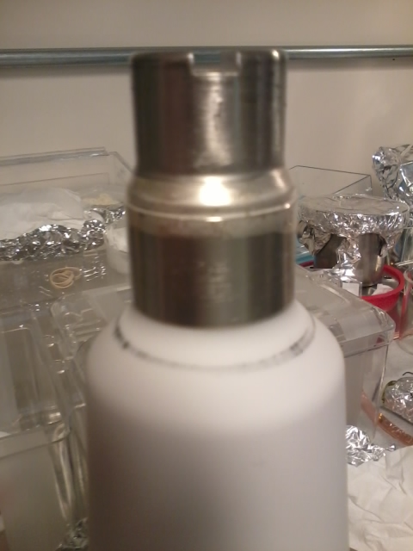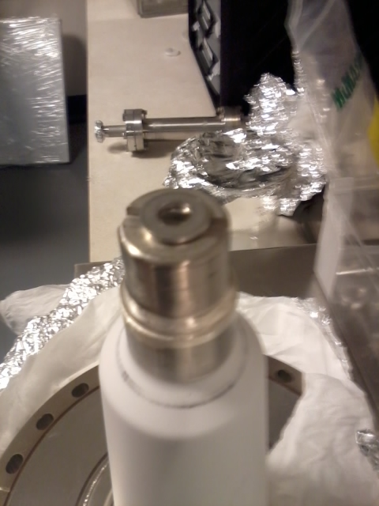
- Lift the assembly with care and place it on top of the ceramic. With one hand, hold the T inside the ball, which has to line up with the ceramic tip as shown below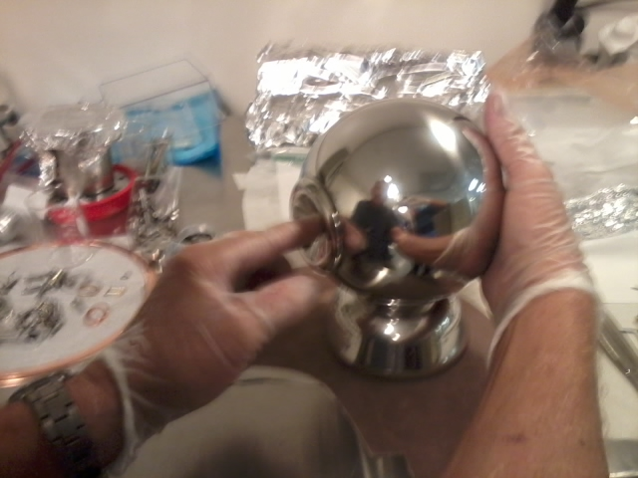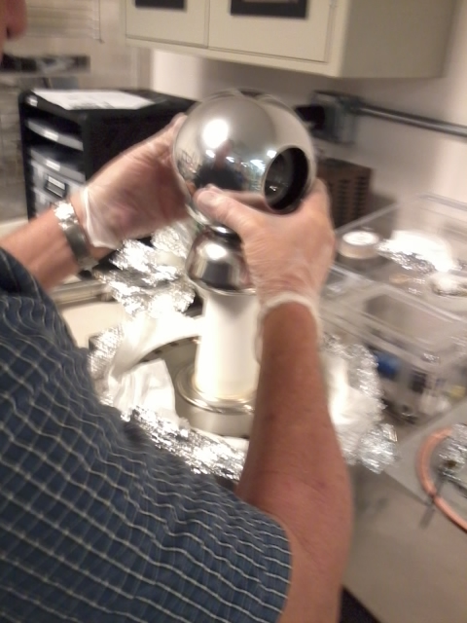. This is how the front electrode plate looks like when the T is resting on the ceramic tip. Notice that the ball-shed assembly is ‘floating’ as shown in the picture below. It will be firmly secured only when the front and back end electrodes capture the ball securing it to the T.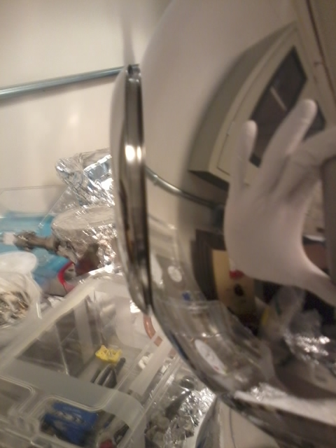.
- Place the screw through the opening of the T. Use these two Allen wrenched to snug the screw 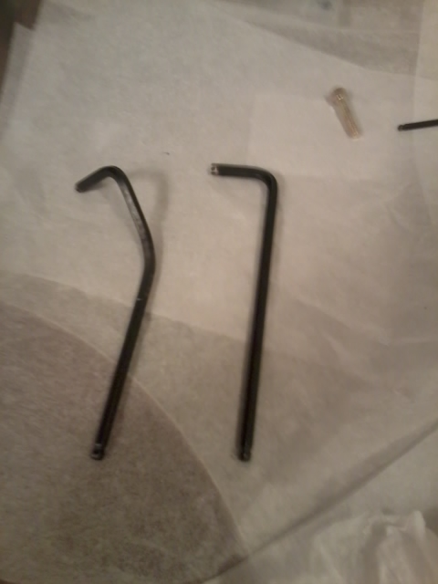. NOTICE: Once the screw is snug, the ball cathode assembly must be aligned (rotated) with respect to the hole pattern on the 10” flange to which the insulator is welded. To do this, the aperture for the photocathode (face of the wafer once puck is inserted) needs to point in between two holes in the flange, the two that are 90 degrees from the leak check groove: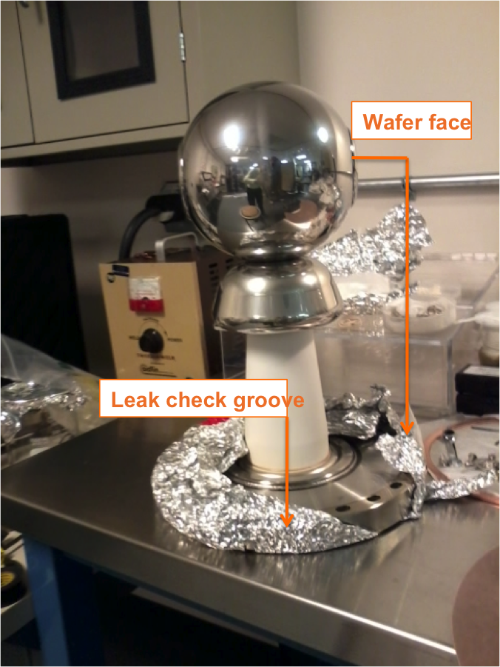
Tighten the screw, but be aware that because there is very small swing angle through the opening, you will have to alternate between these two wrenches to tighten the screw. Ensure the screw is firmly secure and double check the alignment of the electrode with respect to the hole pattern on the 10” flange.
- The puck retainer consists of a ceramic ring that register the puck in its final position, a spacer, and the puck retainer with the sapphire rollers that push the puck and hold it into position for nominal operations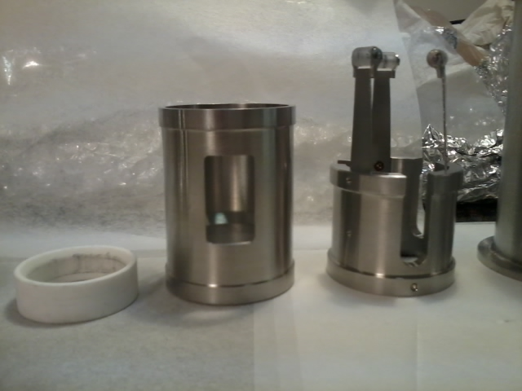. To prevent rotation, the spacer and the puck retainer have been tack welded together, ensuring that the sapphire rollers line up with the slots in the spacer so that the rollers can spring out when the puck is being inserted. This is how the puck retainer looks like assembled and tack welded. 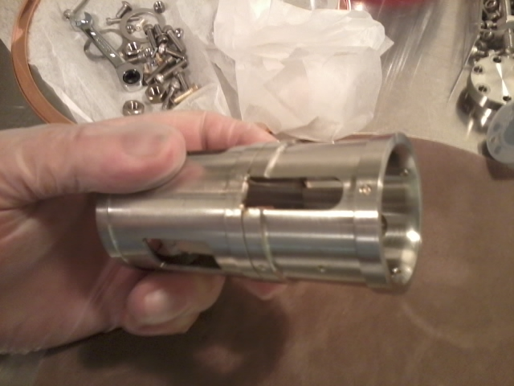Mount first the ceramic to the spacer, ensuring that the flat face of the ceramic ring matches the flat face of the puck retainer spacer. The rounded end of the ceramic rings faces the sapphire rollers then, to guide the puck into its final position. 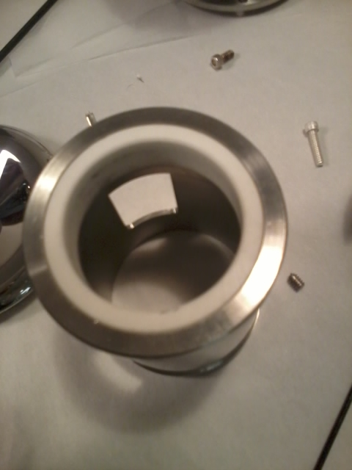. Then slide the spacer into the T. Ensure that two rollers line up on the bottom when the full electrode assembly is in the gun. This means that during assembly, when the ball electrode is upside down, one roller has to be on the bottom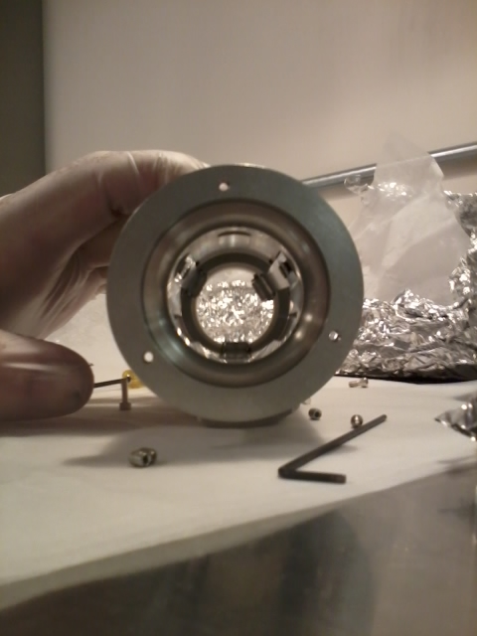. NOTE: this picture is for illustration only. The puck retainer assembly must be put together inside the T is inside the ball firmly secured to the ceramic as shown in the picture below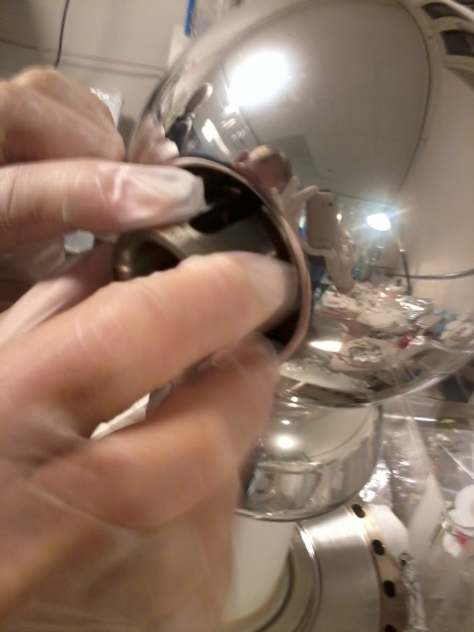. While pushing the assembly in, tighten the setscrews as much as possible. The setscrews go into a groove preventing the puck retainer assembly from sliding during puck insertion and extraction.
- The back end ring electrode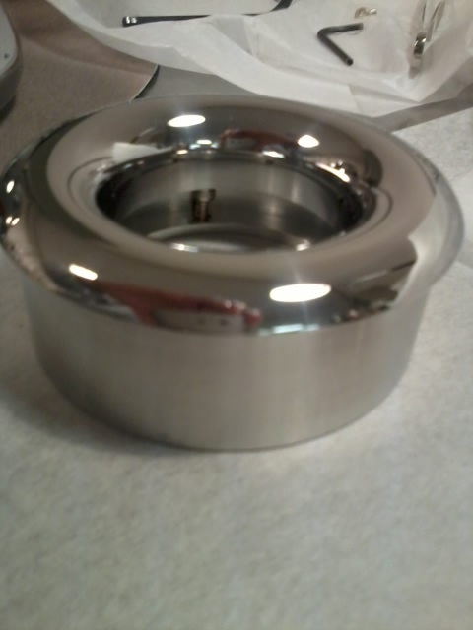goes last and is the most difficult piece to assemble because access to the screws is very limited, requiring a combination of this specially bent Allen wrench and tweezers 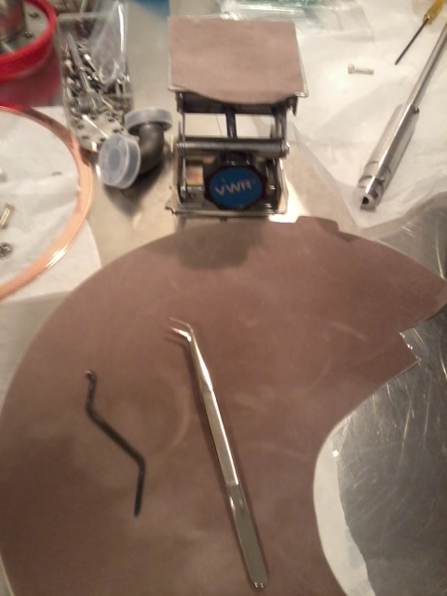. First, insert the screws using the tweezers 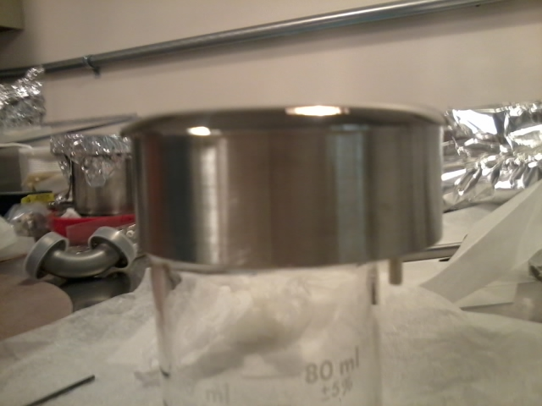. Then use the lab jack shown in the picture to lift the back end of the ball to line up the ball with the T. This will also keep the assembly in place 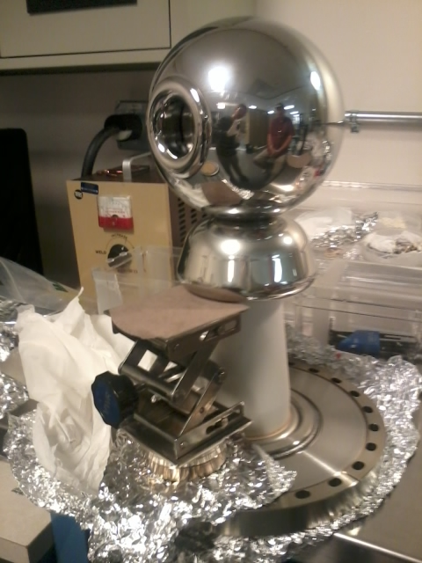. Then, it is easier to place the entire assembly horizontal. Please use polishing cloth on the table to avoid scratching the electrode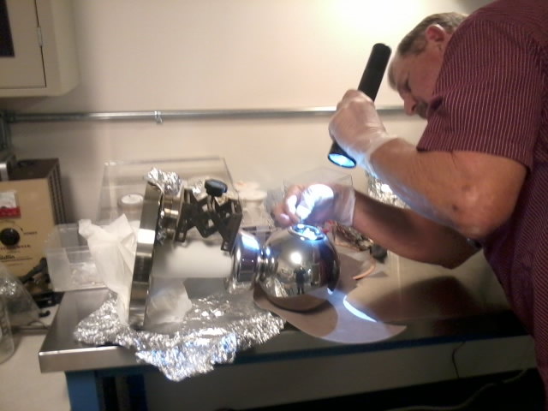. This will also help pushing the front plate electrode against the ball, therefore registering the ball with respect to the T. Before inserting place the screws in the back end electrode ring, this will be easier using the tweezers. Ensure that the screws are well tight. The ball is captured between the front end and the back end electrodes. Therefore, the back end ring electrode’s screws must be well tight. The assembly is complete