Redesign of Electrical Connections for the PSS Fast Beam Kicker Assembly

The PSS beam kicker system has been the source of false trips to Power Permit in the North LINAC. The kicker magnet assembly was found to have a loose connection that intermittently caused a fail-safe fault. A requirement for robust electrical connections is the primary criteria for redesigning the connections.

Present Kicker Design

The present configuration of the kicker assembly includes connections between the kicker control chassis and the magnets via two terminal strips located on the X+ and Y- coil housing (Figures 1, 2, and 3). There are no quick disconnects or pin-type connectors on the assembly.

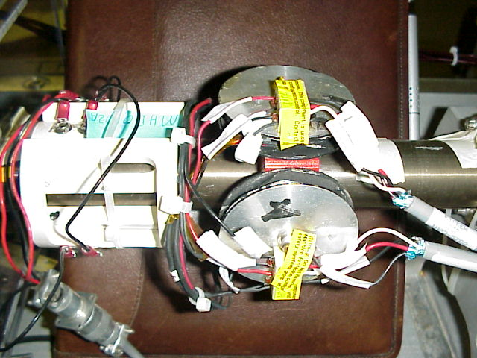
Electrical cables to the Control Chassis

Figure 1. Kicker Magnet Assembly

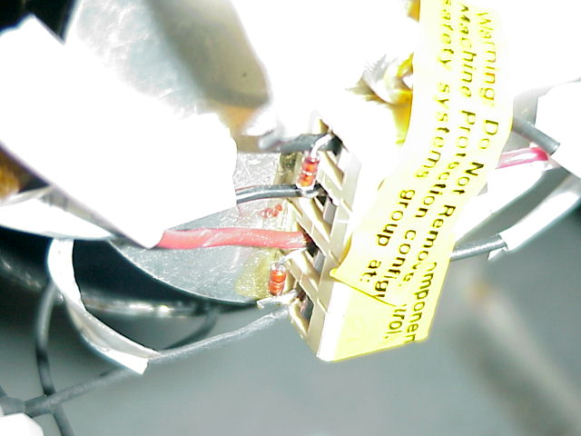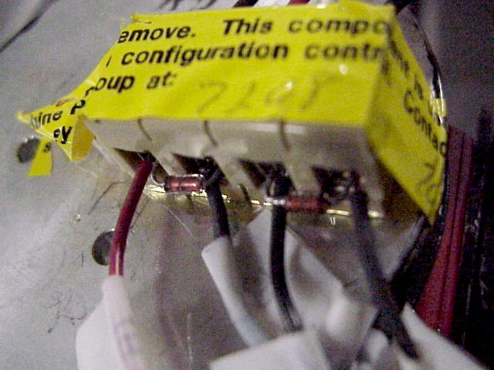
Figure 2. Terminal Strip on Y- winding Figure 3. Top-aft view of X+ terminal strip

Problem areas in the present kicker design contributed directly or otherwise to the fail-safe fault. The problem areas include:
- Lack of quick disconnects
  - The only electrical connect points are at the two terminal strips.
- Different gauge wire connected to the same points
  - Some of the magnet core wires are extended length-wise using a larger gauge wire in order to reach the terminal strips. The remaining core wires are connected directly
- Security of core wires
  - High-speed diodes (1N914) are connected to the same side as the core windings on the terminal strips. Ideally, the core windings should be isolated and secured.

Redesign Ideas

Presently, maintenance and repair actions can include disconnecting the wires or diodes from the terminal strips. This results in unnecessary wear on the magnet core wires that are attached to the same side of the terminal strips. Moving the diodes to the opposite side of the terminal strips would remove that problem while providing stability to the core wires. Adding an electrical quick disconnect to the configuration would also improve access to the system. This would require adding a disconnect point or a mounting bracket to the assembly.

Using a beam corrector bracket as a prototype, we can design a similar bracket to mount a new electrical connector for the kicker assembly (Figure 4). This bracket can be installed using pre-drilled holes in the kicker assembly’s mounting block (Figure 5). Dimensions for the magnet coil housing and beam mounting block are shown in Figures 11 and 12.

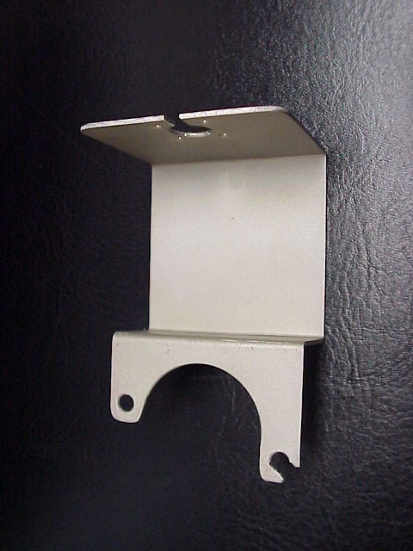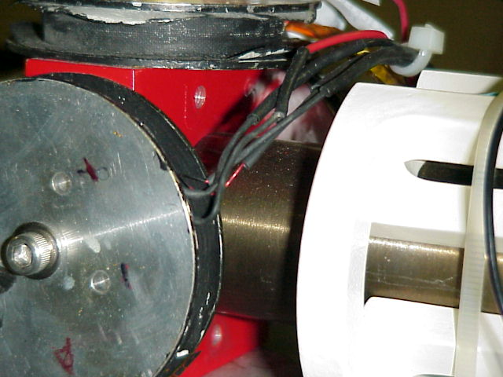

Figure 4. Corrector magnet bracket Figure 5. Assembly block has threaded holes

A prototype of the redesigned electrical connections and bracket are shown installed on a beam, corrector. The assembly is placed on a yellow bench-top vise for demonstration purposes (Figure 6).

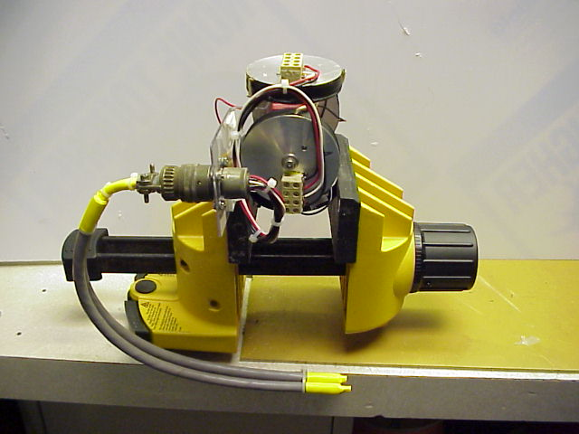
Proposed quick-disconnect from the Control Chassis cables

Figure 6. Electrical configuration on prototype mounting bracket

With the addition of the mounting bracket and an electrical connector, the kicker can be disconnected from the system without disturbing the magnet coil wires on the terminal strips. The connector would eliminate problem 1 listed previously in this report.

Another consideration in the redesign of the electrical connectors is the requirement to protect the short the short magnet coil windings. The terminal strips initially provided stress relief for the coil wires. However, subsequent maintenance and repair actions requiring the tightening or disconnecting of the coil wires have almost negated that function. The problem of having different gauge wires and devices connected to the same point can be remedied by matching the wire size on both sides of the terminal strips. Securing and stabilizing the coil wires (problem 3) is made possible by moving the diodes to the opposite side of the terminal strips. The proposed configuration isolates the magnet coil wires on one side of the terminal strips and places the diodes on the same side as the electrical disconnect (Figures 7 and 8).

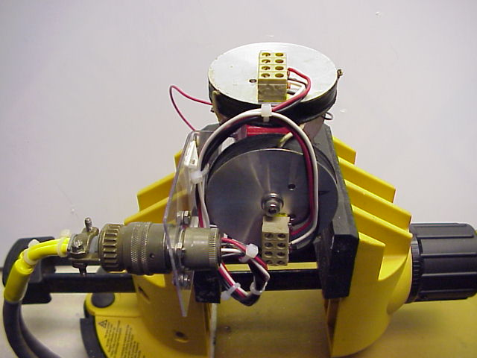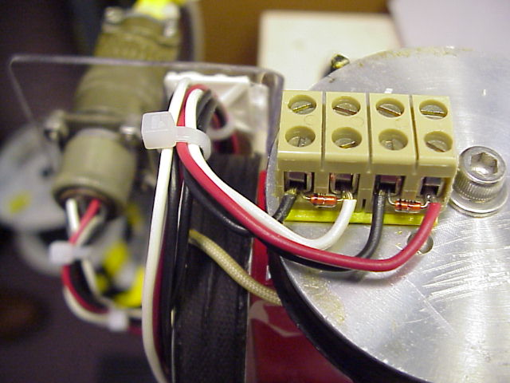
Figure 7. Proposed configuration Figure 8. Top view of prototype
Diodes moved to opposite of coil wires
Magnet core wires to be isolated here
The additional electrical connector and its mounting bracket can be installed using existing space adjacent to the kicker assembly (Figure 9 and 10). Ideally, the bracket would extend approximately four inches to the left of the Y- magnet coil housing (bottom side of Figure 10 where connector cable and terminal strip are located). The redesign flows with the present configuration, maximizes use of existing hardware, and the changes can be made quickly once the bracket is manufactured. More importantly, the primary criterion of a robust connection is met. The redesign also facilitates future maintenance and repair of the kicker by providing a quick disconnect and minimizes wear on critical parts.

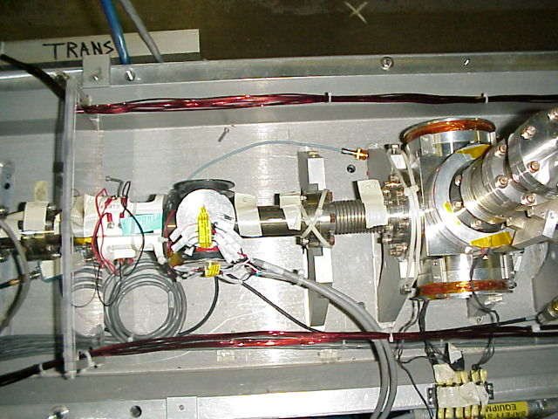
Placement of mount bracket for the electrical connector
Figure 9. Top view of present installation

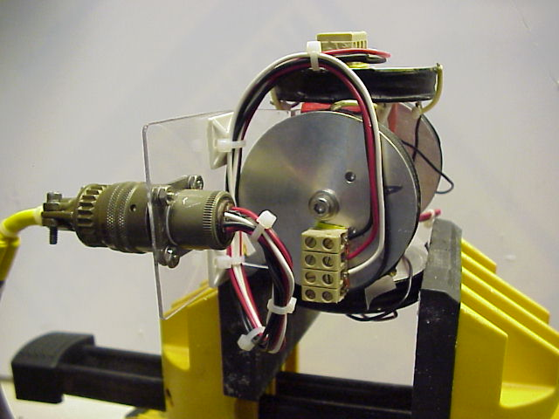
Figure 10. New configuration fits in available space

Beam Magnet Corrector/Kicker Assembly Dimensions

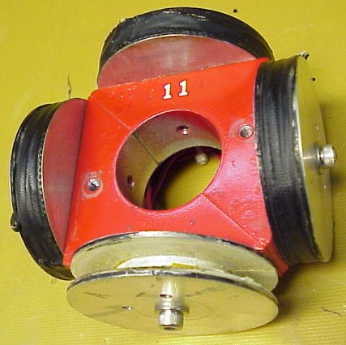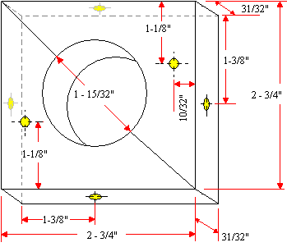

Figure 11. Beam Line Mount (block comprises 2 diagonal halves)

Magnet Coil Housing

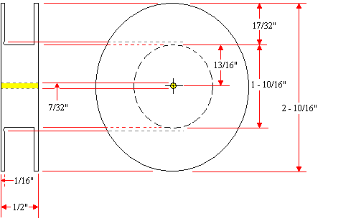

Figure 12. Magnet Coil Housing (4 each)

Notes: Screw holes (in yellow) are threaded for size 10-32 x ½” Allen heads.
All materials must be non-magnetic.

Reference

K. Mahoney, O. Garza, E. Stitts, H. Areti, M. O’Sullivan. “Jefferson Lab Personnel Safety Fast Beam Kicker System”, Thomas Jefferson National Accelerator Facility, Newport News, Virginia 23606

