**Status of Highly Spin-Polarized Photocathodes for the US DOE Program**

L. Cultrera1, J. Grames2, M. Poelker2, T. Rao2, M.L. Stutzman1, E. Wang1

1 Brookhaven National Laboratory, Upton, NY

2 Thomas Jefferson National Accelerator Facility, Newport News, VA

*Abstract*. Highly spin polarized electron beams produced from GaAs photocathodes used at electron accelerator facilities are essential to the US DOE mission, and similarly to facilities world-wide. In this report, the evolution of spin-polarized GaAs photocathode technology for particle accelerator is introduced, followed by a status on the health of the US supply chain and on-going US R&D. The report ends by describing the future needs for the US DOE program and makes recommendations to help inform developing a strategic road-map to meet the Nation’s interests.

1. ***Introduction***

Since the first demonstration of polarized electron beams from GaAs in 1976 [Ma-92] accelerator programs have come to rely heavily on GaAs based photocathodes. There is a long rich history, with breakthroughs and lessons learned that lead to the strained superlattice GaAs/GaAsP photocathodes like those used at Jefferson Lab (JLab) today, which provide near 90% polarization and possess ~1% QE. Maruyama *et al.*, working with samples grown at the University of California Berkeley were the first to break the 50% theoretical limit of bulk GaAs, by growing InGaAs on GaAs. The lattice mismatch between the two compounds introduces the desired strain to break the valence band energy level degeneracy, with splitting large enough to achieve polarization ~70% but with very small yield, or quantum efficiency (QE). Soon after, similar demonstrations were reported by groups at Nagoya University in Japan [Na-91], and St. Petersburg Technical University in Russia [Ma-91]. Accelerators around the world were quick to install these so-called “strained-layer” photocathodes, with reports of beam polarization approaching 80% but with QE only of the order 0.1%.

The single, relatively-thick, strained-layer photocathode suffered from the give and take of polarization versus QE. Higher QE could be obtained using a thicker strained-layer but at the expense of polarization. There was a limit to how thick the top strained layer could be – too thick and the strain would relax, with polarization returning to the typically low value of bulk GaAs. The problem of strain relaxation was overcome by growing superlattice photocathodes composed of thin-layer pairs of lattice-mismatched material. The combination of many thin-strained layers yielded both high polarization and high QE. The same institutions that pioneered single strained layer photocathodes were also the ones to pioneer strained superlattice photocathodes – SLAC, Nagoya University and St. Petersburg Technical University [Na-98, Ma-04, Ma-08, Na-09].

But it wasn’t until researchers at SLAC teamed with commercial vendors via the SBIR/STTR program that reliable sources of high polarization photocathode material became commercially available: first with SPIRE/Bandwidth Semiconductor [Sp-01] to grow single strained layer photocathodes, and then with SVT Associates [Sv-01] to develop the strained-superlattice photocathode which now represents the benchmark for success. Both of these photocathodes are based on GaAs grown on GaAsP. Examples of polarization and QE from both photocathode types are shown below in Figure 1 [Ba-05]. Besides exhibiting higher polarization and QE, the strained-superlattice photocathode is preferable because peak polarization can be obtained at 780 nm which is accessible with inexpensive telecommunications lasers.

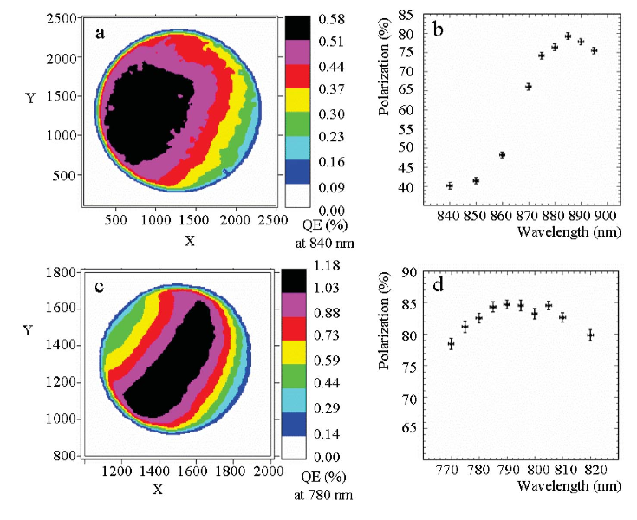

Fig. 1. Quantum efficiency and polarization versus wavelength for commercial photocathodes: (top) Single-strained layer GaAs/GaAsP photocathode fabricated by SPIRE/Bandwidth Semiconductor, (bottom) strained-superlattice GaAs/GaAsP photocathode fabricated by SVT Associates.

Another noteworthy achievement resulting from the commercial R&D program is the demonstration of high polarization and significantly higher QE obtained by growing the “standard” strained-superlattice photocathode atop a distributed Bragg reflector (DBR) [Li-16]. Light penetrating the surface of the photocathode can be trapped within a storage cavity etalon formed by the DBR and front surface of the photocathode (see Figure 2), enhancing light absorption and resulting in 6x increase in photocathode QE. This photocathode – with six times the QE of the standard strained-superlattice photocathode (Figure 3) would relax the requirements for the drive laser and offer longer operational lifetime.

One might expect that we ought to be well positioned to meet planned US DOE mission needs and poised for even greater future activities. However this is not the case. In the next two sections the need of high polarization photocathodes is described, followed by a discussion of our present challenges in having them readily available. In the last two sections on-going US led R&D is described and then recommendations are made for developing a strategic road-map to meet the Nation’s need for providing high polarization electron beams.

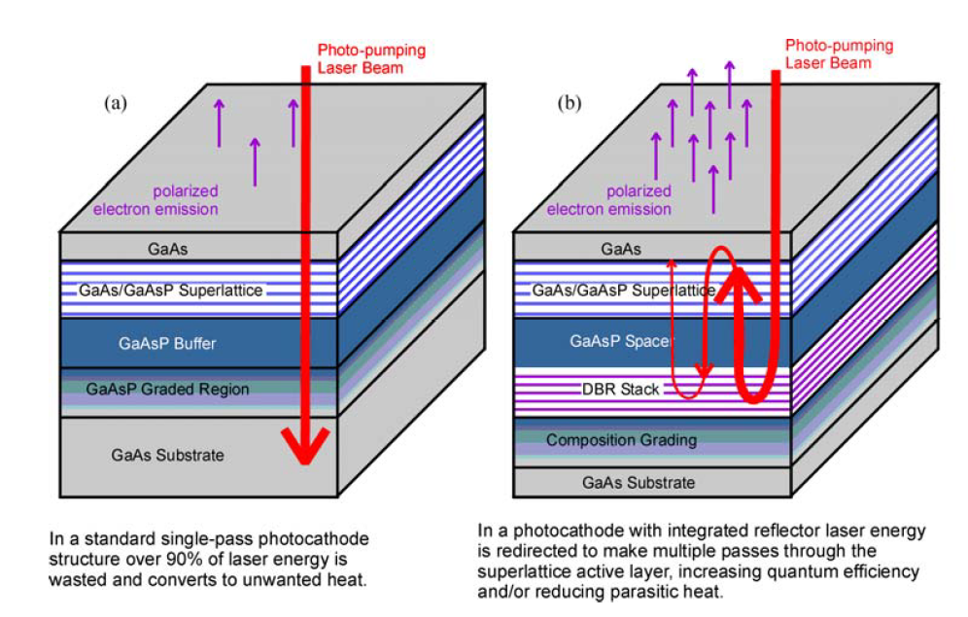

Fig. 2. Illustrations of standard strained-superlattice GaAs/GaAsP photocathode (left) and the standard strained-superlattice GaAs/GaAsP photocathode grown atop a distributed Bragg reflector (DBR). An optical storage cavity is formed by the DBR and front surface of the photocathode resulting in significantly more light absorption and higher QE. These photocathodes were manufactured by SVT Associates.

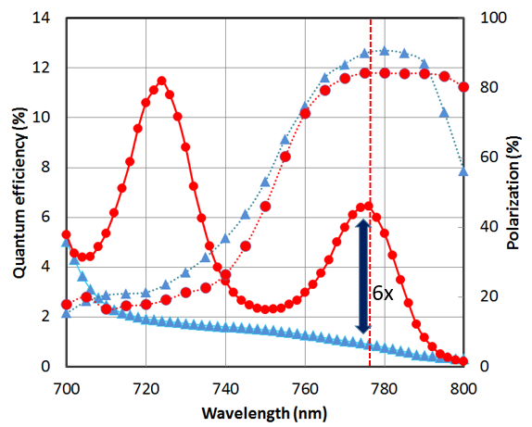

Fig. 3. Photocathode QE and polarization, comparing the standard strained-superlattice GaAs/GaAsP and the similar photocathode grown atop a distributed Bragg reflector providing 6 times the QE at the wavelength of peak polarization. Photocathodes manufactured by SVT Associates.

1. ***GaAs Photocathodes for the US DOE Mission***

***2.1 Jefferson Lab – Continuous Electron Beam Accelerator Facility (CEBAF)***

Polarized electrons have been key to some of the highest impact results of the JLab/CEBAF science program, including: measurements of the strangeness distribution in the nucleon (HAPPEX [An-06] and G0 [Ar-05]); precision tests of the Standard Model (QWeak [An-13]); a measurement of the neutron radius of 208Pb (PREx [Ho-01]); and the accurate determination of the ratio GE/GM for the proton [Pu-17] using the polarization transfer technique.

During the life of the “6 GeV Program”, the quality and intensity of polarized beams has evolved remarkably (see Figure 4). Between the first experiment in 1995 and the shutdown in May of 2012 for the start of the 12 GeV Upgrade the Figure of Merit (P2I) improved by a factor of 42 (from 30 A beams with 35% polarization to 200 A beams with 89% polarization) [Li-16]. Experiments that are performed today would simply not have been practically possible to do without the improved photocathode performance over the last ~25 years.



Fig. 4. A decade of well-funded R&D has paid ample dividends by providing CEBAF users very high spin polarization beams for most of the last twenty years.

The outlook for polarized electron beams at JLab/CEBAF 12 GeV is no less demanding. The high impact flagship Moller [Mo-14] and SoLID [So-14] parity-violation experiments are expecting to receive high intensity and high polarization beams well into the 2030s; further, all experiments at CEBAF receive beam from the same photocathodes, accounting nominally for 35 weeks of 24/7 operation delivering beam currents up to 200 A.

Jefferson Lab has been a good custodian of the photocathodes received from SVT, continuing to improve “best methods” for photocathode management and extending the operating lifetime while used in DC high voltage photoguns. However, with only one expectedly “good” spare wafer in storage (at JLab one 2” dia. wafer provides 4 photocathodes) this has meant exhaustively using each of the prior photocathodes for as long as possible. Using a photocathode repeatedly is possible, however, earlier damage due to ion back bombardment is not fully removed – this leaves less of each photocathode “available” for photoemission and the areas that are available are more likely to have a non-uniform QE, leading to degraded electron beam quality.

Further, while only one photocathode may be used at any time, the CEBAF photogun can was designed as a load-lock vacuum system, so that it could store and deploy up to 5 photocathodes, however without a fresh supply of materials we cannot leverage this option to improve beam quality. Case in point, rapid capability would be of great value to the parity-violation experiments, whereby to further minimize helicity correlated intensity and position differences one could plan a more timely replacement of fresh photocathode material to deliver more successful experiments.

Beyond the CEBAF program, the lack of additional high polarization wafers curtails research and development that rely on spin polarized photocathodes; ironically this limits our abilities to test new techniques which may further improve their performance or reliability. Examples of important R&D include studies to improve the operation of parity violation experiments [Ad-22]; studies to evaluate improved operation in high voltage photo-guns needed for JLab [Gr-17] or EIC [Wa-21] or ILC [Br-17]; using high polarization beams to achieve sub-percent accurate electron polarimeters [Gr-20]; and the development of linac-based spin polarized positron beams using the bremsstrahlung of highly spin polarized electron beams [Ab-16].

Even a modest annual supply of one or two wafers per year would support reliable operation at CEBAF and provide for programmatic studies to improve beam performance, while an annual supply of three or more wafers per year would provide a significant boost to what Jefferson Lab may accomplish on a broader front for the Jefferson Lab NP mission. At the level of four or more wafers per year opportunities to expand polarized beam programs Jefferson Lab’s Upgraded Injector Test Facility (UITF) or Low Energy Research Facility (LERF) would certainly be possible.

***2.2 Brookhaven National Lab – Electron Ion Collider (EIC)***

To date, a global program of precision measurements with high energy spin-polarized particle beams has begun to quantify how the intrinsic spins and orbital momenta of quarks, anti-quarks, and gluons each contribute to the characteristic spins of observed particles, but the mechanism by which this complex system results in the characteristic spin-1/2 of the nucleon is not yet understood. The EIC is designed with the capability to answer this question. The Department of Energy’s Nuclear Science Advisory Committee’s 2015 Long Range Plan for U.S. Nuclear Physics, acknowledged the “qualitative leap in technical capabilities” required for the EIC, and identified an EIC as “the highest priority new facility construction following the completion of FRIB”. In 2018 this program was endorsed by the National Academies of Sciences Committee on U.S. Based Electron Ion Collider Science Assessment.

Highly polarized electron beams are planned for a comprehensive study of the nucleon structure including their spin. High values of polarization reduce the uncertainties in determination of these spin correlations. High polarization of electron and light ion beams with arbitrary spin patterns, with time-averaged polarization of ≈70% at collision point, as required by the Long Range Plan. Polarized electron bunches carrying a charge of 7 nC are generated in a state-of-the-art polarized electron source. The beam is then accelerated to 400 MeV by the electron injection LINAC and injected into the rapid cycling synchrotron (RCS) that is also located in the RHIC tunnel. Half of the bunches will have polarization anti-parallel to the magnetic guide field, the other half parallel. The Sokolov-Ternov effect tends to polarize the electron beam in the direction anti-parallel to the main dipole field, upwards in the ESR. Therefore, the initial high polarization electron source is essential for EIC project.

The EIC polarized electron source needs to provide 56 nA average current, up to 7 nC bunch charge with the polarization above 85%. To fully meet the goal of the EIC polarized source requirement, BNL polarized gun R&D program requires 2 photocathodes per year. The electron source and pre-injector commissioning will start from late 2025 and continue to 2029. The commission plan will require 2 photocathodes per year.

From 2030, the EIC will transition to operation. The EIC budgeted 20 SL-GaAs wafer for 10 years operation. More photocathodes may be needed in reserve as a safety margin.

***2.3 Mainz Microtron (MAMI) – Germany***

The Mainz Microtron (MAMI) operated for more than a decade providing a continuous wave, high intensity, polarized electron beam with an energy up to 1.6 GeV for parity violation and electron scattering experiments. The accelerator is presently undergoing a major upgrade to become MESA (Mainz Energy Recovery Superconducting Accelerator) which expects first beam operations in 2023. US collaborators will be some it first users, requiring high polarization and high intensity beams to successfully perform the P2 parity violation experiment.

Dr. Kurt Aulenbacher, leader of the MESA accelerator project estimates MESA may need up to 6 wafer per year to operate (see attached letter of support).

***2.4 International Linear Collider (ILC) – Japan***

The International Linear Collider (ILC) is highly anticipated to measure physics beyond the Standard Model, as well as describe interactions and identify new particles within the standard model. The US is a major partner of the ILC global effort and can play a significant role in various accelerator technologies, including the supply chain of spin polarized photocathodes and dc high voltage polarized electron photoguns.

Dr. Shin Michizono, Head of the CASA KEK-High Energy Accelerator Research Organization and Working Group 2 Chair of the ILC International Development Team projects the ILC may need more than 12 wafers per year to operate (see attached letter of support).

1. ***Supply Chain Challenges for High Polarization GaAs Photocathodes***

Unsurprisingly, without a sufficiently high demand for photocathodes, the company SVT Associates no longer sells them. The safety and equipment hazards working with flammable phosphorous, as well as the small market for these photocathodes, is generally unfavorable to a commercial vendor without a financial commitment. The authors estimate it will likely take a commitment of ~2 M$ and 2 FTE to restore this commercial capability in the US.

A major challenge for industrial leadership is that there are presently few commercial applications of polarized beams from GaAs photocathodes. The commercial market is predominantly for particle accelerators performing fundamental science. Historically, government funding has been supporting the initial capital and R&D costs, but there has been an insufficient demand for industry to maintain a labor force and sustain equipment maintenance costs. The number of partnerships with industry remains small, determined and limited by the number of potential customers (i.e. accelerator facilities).

The lack of an industrial application makes it difficult to attract interest and effort from the industry to enter a market which is not seen as profitable. Operating and maintaining a dedicated thin film growth facility capable of growing superlattice photocathodes based on GaAs/GaAsP has a large cost in terms of initial investment, training of personnel and maintenance. The combination of the large effort and cost required to setup and maintain a photocathode growth facility with a low revenue forecast and from a limited size market has likely been the main reason curtailing a stable chain of supply of photocathode for spin polarized electron beams in the US and elsewhere.

As described above the SBIR/STTR programs were successful because of the immediate and sustained funding to address the urgent need to better support and sustain fundamental science programs at US accelerators. While successful to ‘save the day’ this approach had the unintended consequence to fail commercially because of the small demand of photocathode materials; a) “successful” vendors were effectively forced out of production due to low market demand, and b) “new” vendors could not be funded to reproduce the same successful product, in spite of this being precisely what was needed.

With many decades of experience using polarized electron beams at accelerators world wide a renewed strategic approach for developing a commercial program to meet the US mission needs is sensible. One model to restore the US capability is by strategic industrial investment. Another could be cultivating a partnership of shared resources (labor and/or capital equipment) between industry and accelerator facilities and/or universities to develop new partnerships which support university training of scientists and technicians specifically directed toward photocathode research, who would then enter the industrial workforce. This could be in the form of fellowships for both graduate students or post-docs pursuing careers in industry.

Without the unlikely development of an industrial market on the short time scale of the CEBAF/JLAB and EIC/BNL programs one must develop a rapid manufacturing plan, to that either a) stockpile photocathodes or b) plan on continued federal support. Critical technologies must have a strategy for committed funding. This might take place by a) taking “ownership” of the technology and production at DOE facilities, or ) through long-term performance based contracts with industry. Useful metrics over short term are performance and over long term reliability and availability. Ultimately, there is a growing need for polarized photocathodes. The US could take the initiative to be the world leader in the production and the opportunity to industrial vendors in the sale of GaAs based photocathodes. This will take US leadership and financial support.

1. ***Potential role of new R&D***

An alternative to the commercial approach is for the national laboratories to `team up’ with one another and/or universities to develop a reliable approach, or one that is viable to eventually sustain within then national laboratory complex, or one that is viable to eventually commercialize.

***4.1 Molecular Beam Epitaxy (CINT User Project 2020AU0006)***

Leveraging the opportunities offered by Center for Integrated Nanotechnology at Sandia National Laboratory to external users a project was submitted and approved for developing a GaAs/GaAsP superlattice based photocathode structure for high spin polarization and high quantum efficiency. This work intends to leverage a design in which the structure consisting of 84 layers, is fully strain compensated aiming at minimizing the defect density and hence maximizing the spin polarization and quantum efficiency. The structure designed represents a natural evolution of the demonstrated high efficiency structure based on the use of a Fabry-Perot resonator enabled by the use of DBR layers. Details of the structure as designed are reported in figure 5.

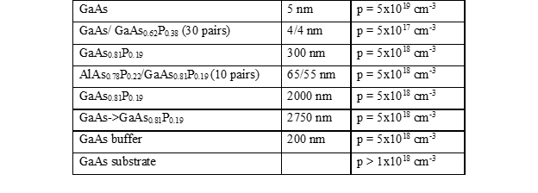Fig. 5. The layout of the SL-DBR strain compensated structure which has been proposed and grown at Sandia National Labratory as part of the user project 2020AU0006.

The first photocathode structure has been recently grown on a 3” wafer by Sandia National Laboratory researchers using MBE and it is now at BNL to characterize the photoemission properties. The first sets of measurements indicate that QE of several percent are achieved with electron spin polarization of about 80%. There are still large non-uniformities on the 3” wafer with only a small region near the center of the wafer achieving large QE and polarization at the same wavelength. This is likely due to non-uniform temperature of the wafer during the growth which resulted in a non-uniform phosphorus incorporation during the growth of the layers. This issue can be likely solved using a different MBE reactor equipped with a dual zone substrate heater that can yield a better temperature uniformity over the whole substrate area. An MBE reactor fulfilling such requirement is already available at Sandia National Laboratory.

***4.2 Chemical Beam Epitaxy (US DOE PROJ ID: 000001.04.05.027.001)***

An alternative to MBE is to explore the growth of GaAs-GaAsP strained superlattice photocathodes using Chemical Beam Epitaxy (CBE) instead. CBE is uses low pressure gas precursors, which can lead to less variability over the width of a wafer, while allowing sharp layer transitions with no stagnant gas boundary layer at the growth surface as can be found in MOCVD (Metal-organic chemical vapor deposition).

The project provides funding to Jefferson Lab and the Palmstrøm group at University of California Santa Barbara (UCSB) are working to grow and test strained superlattice photocathodes using CBE. The goal is to grow photocathodes to the composition developed by SVT Associates and currently in use at JLab, with the first generation and newer GaAs/GaAsP strained superlattice growth formulas shown below.

Work is progressing steadily in preparation for growth of the first strained superlattice samples at UCSB. Growth rates of GaAs and GaAsP0.35 have been calibrated, a computer controlled flowmeter system for accurate and adjustable growth, as is needed for the graded dopant density layer, has been commissioned, and alternatives to tri-ethyl gallium are being investigated as precursor gasses since tri-ethyl gallium has a high vapor pressure byproduct when used with phosphine. X-ray diffraction tests of calibration samples are being used to determine crystallinity and optimize growth temperature and RHEED is being used in situ during growth to monitor the process. RHEED can also determine surface roughening effects due to strain relaxation during growth and can be used to help optimize growth temperature.

The goal of the CBE growth program for strained superlattice photocathodes is to be able to develop a new fabrication method for the photocathode material most commonly used at CEBAF and determine if this method is comparable to MBE growth of the GaAs/GaAsP strained superlattice photocathodes in terms of polarization, QE and lifetime. If this method proves to be a viable alternative and high polarization, low analyzing power photocathode can be delivered, it has advantages over MBE when scaling to larger wafer sizes. The goal of the program is to deliver test samples first, and upon good performance, deliver up to 10 x 2” diameter high polarization SSL photocathode wafers to JLab for evaluation and potential use at CEBAF and the EIC.

Older formula: currently in CEBAF (ref: https://slideplayer.com/slide/13206077/)

|  |  |  |
| --- | --- | --- |
| GaAs | 5 nm | p=5x1019/cm3 |
| GaAs/GaAsP SL | (3.0/3.0 nm) x 16 | p=5x1017/cm3 |
| GaAs0.64P0.36 | 2500 nm | p=5x1018/cm3 |
| Graded GaAsPx  (x=0~0.36) | 2500 nm | p=5x1018/cm3 |
| GaAs buffer | 200 nm | p=2x1018/cm3 |
| p-GaAs substrate (p>1018/cm3) | | |

Newer formula: delivered with DBR photocathodes

|  |  |  |
| --- | --- | --- |
| GaAs | 5 nm | p=5x1019/cm3 |
| GaAs/GaAsP SL | (3.8/2.8 nm) x 14 | p=5x1017/cm3 |
| GaAsP0.35 | 2750 nm | p=5x1018/cm3 |
| Graded GaAsPx  (x=0~0.35) | 5000 nm | p=5x1018/cm3 |
| GaAs buffer | 200 nm | p=2x1018/cm3 |
| p-GaAs substrate (p>1018/cm3) | | |
|  | | |

***4.3 Metal Organic Chemical Vapor Deposition (US DOE FOA ID)***

Experts claim good photocathodes can be fabricated using either method, but it is often stated that MBE provides the required precise control of the strained superlattice photocathode, where layers are only 3 to 4 nm thick. However, some other studies have shown that the quality of the MOCVD grown photocathodes might be better due to the fact that that carrier build-up near photocathode surface in the MOCVD device is more efficient compared to the MBE device.

This project provides funding to revisit the fabrication of 14-pair 3.8 nm GaAs / 2.8 nm GaAs0.65P0.35 strained superlattice via Metal Organic Chemical Vapor Deposition (MOCVD). Furthermore, 12-pair 54 nm GaAs0.65P0.35 / 64 nm AlAs0.6P0.4 DBR by MOCVD will be studied as well. The polarization and QE of samples will be characterized by JLab and BNL Mott polarimeter. The project is aiming to develop the knowledge to fabricate next-generation photocathodes (DBR- SL-GaAs) with the best process possible, MOCVD or MBE, which we will do in the future as a collaborative effort between JLab, BNL, and ODU.

***4.4 Exceeding polarization of NEA GaAs technology***

If dedicated R&D can identify other materials that can replace the ones belonging to the III-V family and be grown with less expensive to maintain equipment or that can be shared also for other applications, there is a chance that more industrial partners can take over the production and re-establish a chain of supply of photocathodes. About 50 years of R&D on the technology to produce spin polarized electron beam based on photoemission from III-Vs semiconductor structures have resulted in photocathodes that can yield very high spin polarization, larger than 90% level, and with very high quantum efficiency (several percent) [Pi-75, Ma-92, Ma-04, Ji-14, Li-16].

There are still *two main limitations of the technology related to the use of III-Vs* that remain unsolved. The first one is related to the Negative Electron Affinity condition that must be established at the vacuum interface to allow extraction of highly spin polarized electron beams. The Cs-O based layers that are required to generate the NEA condition are not stable. They can be damaged by a number of processes: chemical poisoning, ion back bombardment and thermal desorption induced by heating from the drive laser [Ch-14, Ii-10, Si-07] . The second aspect is related to the intrinsic difficulty to realize the complex multilayered structures that are required to maximize at the same time the spin polarization and the quantum efficiency: often is not possible to maintain the nanometer scale uniformity of deposition over a large substrate area spanning several inches in diameter.

Limited by their sensitivity to chemical poisoning the *III-Vs has only be successfully operated in high voltage DC guns.* Here the large volume of the gun vessel allows hosting large amount of vacuum pumping elements allowing the reach of extreme vacuum environment required for their operation. Unfortunately, the DC gun allows the generation of accelerating gradients one order of magnitude lower than the ones currently possible in photoelectron guns based on RF structures carrying with that all the beam dynamics related limitations on the achievable beam brightness [Ba-09]. It is likely that future accelerators will seek electron beams with increased brightness that will be difficult if not impossible to produce without removing the actual limitations on the electric field gradients by operating the photocathodes in RF or SRF guns.

The consequence of the extremely tight requirement for the growth uniformity of multilayered structure over the whole surface of a few inches diameter substrate wafer is that often only a small fraction of the photocathode surface is matching the design properties. Because of these limitations the *III-Vs photocathodes yielding high QEs and high spin polarization are quite difficult to synthesize* and require the use of complex growth systems (like MBE or MOCVD) that carry large cost of operation and maintenance and must be often dedicated only to the growth of this class of materials because of the arsenic and phosphorus contamination.

The number of research groups in the scientific community which are directly participating to efforts aimed at developing spin polarized electron sources is limited. Only recently, with a larger contribution from the material science community, we have seen a new influx of ideas and results that can point at finding alternatives to the III-Vs technology. These directions can be considered viable nowadays because the community can leverage the knowledge obtained in many years of large R&D investments in other fields like microelectronic, spintronics and photovoltaics. Here we summarize some of possible direction for the R&D on spin polarized electron beam sources. Is worth not note that some of these direction can be actively pursued today because of other recent technological advancements: laser sources with continuously tunable emission wavelength from UV to IR to drive the photocathodes are now commercially available ; recent advancement in SRF technology (a larger number of superconducting RF guns are being developed, with some of the existing ones already routinely operated with cryocooled photocathodes, increased progresses on Nb3Sn technology allowing to reduce the burden of handling complex cryogenic plants to operate SRF cavities) and on cryocooled DC gun can be leveraged to operate a new class of magnetic materials that can produce highly spin polarized electrons [Ko-20, Le-18].

The R&D required to advance the status of the electron sources for spin polarized production must include all the following aspects: an increased engagement of the material science community to assist with the design, synthesis and preliminary characterization of the materials, a sustained effort to develop electron guns operating with the cathode at cryogenic temperatures to leverage the reduced spin depolarization rates [Li-17] and that can be used as test stand to measure the photocathode performances in realistic gun environment.

In principle, the breaking of the energy degeneracy between heavy and light hole valence bands leading to the energy selective excitation of only one spin orientation can be achieved not only in III-Vs but in any semiconductor. The family of III-Nitride materials (GaN, InN, AlN) and their ternary alloys (AlGaN, InGaN and AlInN) offer a wide range of R&D opportunities. The spectral region of the achievable band gap ranges from UV to IR. Materials and structures based on these materials are routinely grow by industry because of their widespread use in LED technology and high-power electronics. The III-Nitrides materials can be synthesized in two different crystalline phases: the stable wurtzitic (or hexagonal) and the metastable zinc blende (or cubic). Both crystal lattice configurations offer advantages from the point of view of the photoemission: in the wurtzitic phase internal polarization field can be used to generate NEA condition without the use of Cs [Ma-18], in the metastable zincblende the absence of these fields increases by on order of magnitude the relaxation time of electron spins with respect to III-Vs [Bu-13]. The recent development of GaN single crystal substrates commercially available has removed an important obstacle to perform the growth of III-Nitrides structures with a reduced defect density [Ku-20].

Spin-filter materials have been extensively studied in spintronics to form tunneling barrier where the heights of the barrier depend on the electron spin orientation allowing injection of highly polarized current in electronic devices. Most of these materials require to be operated at cryogenic temperatures to preserve the magnetization of electrons in the 4f orbitals that is at the origin of the band splitting and that allows controlling the spin direction in the tunneling currents. The spin-filter material EuS has demonstrated already in 1972 the generation of highly polarized electron beams (89±7%) during field emission experiments when cooled down to about 20 K, close to its Curie temperature [Mu-72].

Half-metals belong to a class of material that behave as metal for on spin orientation and as semiconductor for the other and because of that they can theoretically produce spin polarization of 100%. One of the materials belonging to this class is the chromium dioxide. CrO2 can by synthesized using several different growth techniques [Iv-09, He-07] and while the surface of CrO2 is not as stable and energetically favored as the Cr2O3, a stable CrO2 surface can be usually achieved or recovered by annealing the sample in a relatively high pressure of oxygen [At-08]. An interesting property of the CrO2 is that the reported Curie temperature of the material is relatively high (118 C) making these materials interesting for exploring its spin polarized photoemission properties already at room temperature [De-00]. Is worth noting that CrO2 it also has already seen industrial applications and in the late 80s early 90s was used in the production of magnetic tapes for recording and it has already demonstrated photoemission of electron with spin polarization close to 100% [Ka-87].

II-VI semiconductor materials have been deeply investigated for application in photovoltaics cells. Similarly to other semiconductors the heavy hole an light holes band can be separated by properly strain the active layer and recent measurements in quantum structures based on II-VI semiconductors indicate that spin relaxation times can be ranging from few hundreds of ps up to few tens of ns [Tr-03, As-06]. Layered structures based on p-n junction like the one used in solar cells can be realized in the attempt of leveraging the internal fields to accelerate the electrons towards the vacuum interface and enhance the quantum efficiency of the photocathodes [34]. The possibility to activate the surface of these materials to NEA conditions using Cs in a way all similar to the one used in III-V semiconductors has not yet been explored and could represent another venue for future developments.

1. ***Report Recommendations***

Creating a virtuous environment supporting the production of photocathodes for high spin polarized electron beams essential for the success of CEBAF and EIC experiments that can also easily adapt to unpredictable future needs, must develop all three Short, Medium, and Long Term strategies.

***Short Term (1-3 years)***

In the immediate future (~1-3 year) know capable industrial partner (like SVT) or even resources that are internal to the DOE structure (like Sandia National Laboratories) must be engaged to explore their possible involvement in a dedicated short term effort aimed at the production of a batch of known GaAs/GaAsP photocathode structures that can fulfill the requirement for the already planned operation of CEBAF and EIC. These photocathodes should be stockpiled for future operation of CEBAF and EIC. This is a critical step that must be taken so that the CEBAF and EIC early operational success in not anymore at risk of being jeopardized by the lack of commercially available photocathodes.

***Medium Term (1-5 years)***

Relying on a single vendor/source is of course not ideal. If anything were to happen preventing the sole source of GaAs/GaAsP photocathodes to keep up the production the chain of supply might break again. In the medium term (~1-5 years) via a renewed engagement of multiple industries, national labs and academia different routes for the fabrication methods should be explored: the aim of this effort should be to explore more versatile growth techniques (so that the grow facilities can be also shared with other applications), the use of grow facilities less expensive than MBE to maintain (like MOCVD, CBE) or that can yield improved performances of the existing photocathode configuration should also be investigated. Such an approach may attract more vendors in the business if the number of spin polarized applications should increase. In doing so, should future programs require additional GaAs/GaAsP photocathodes for spin polarized electron beams production, there will be a number of possible paths available to procure them.

***Long Term (1-10 years)***

A longer term program (~1-10 years) should be also funded to perform extended R&D on alternative materials that can outperform and eventually replace the GaAs technology. A number of venues are already available offering possible alternative to the GaAs technology. Some of the known GaAs intrinsic limitations cannot be overcome simply by a continuous cathode replacement - like is the case of high average photocurrent required for LHeC. In order to overcome such obstacles there is the need of exploring alternative material and technology. A strong collaboration with the academia must be sought so that results produced by decades of research for synergistic applications in different branches of materials science and can be leveraged to their full extent taking advantage also of the recent notable progresses in laser and SRF technology which provide extended parameter space for the operation of photocathodes.

***References***

[Ab-16] (PEPPo Collaboration) D. Abbott et al. Phys. Rev. Lett. **116** (2016) 214801

[As-06] G. V. Astakhov et al., *Phys. Stat. Sol. B* **243**, pp.858–862 (2006)

[Ad-22] P. A. Adderley et al., “CEBAF: an electron accelerator for parity-violating electron scattering experiments” *manuscript in preparation* (2021)

[An-06] K.A. Aniol, et al., Phys. Rev. C **69,** 065501 (2004), K.A. Aniol, et al., Phys. Lett. B **635**, 275 (2006), K.A. Aniol, et al., Phys. Rev. Lett. **96**, 022003 (2006)

[An-13] D. Androic, et al., Phys. Rev. Lett. **111**, 141803 (2013)

[Ar-05] D. S. Armstrong, et al., Phys. Rev. Lett. **95**, 092001-1-5 (2005)

[At-08]J. J. Attema et al., *Phys. Rev. B* **77**, p.165109 (2008)

[Ba-05] M. Baylac, *et al.*, “*Effects of atomic hydrogen and deuterium exposure on high polarization GaAs photocathodes*”, *Phys. Rev. ST Aceel. Beams*, vol. 8, pp. 123501-1–123501-11, December 2005

[Ba-09] I.V. Bazarov et al., *Phys. Rev. Lett.* **102**, p. 104801, 2009

[Br-17] A. Brachmann, J. E. Clendenin, E. L. Garwin, K. Ioakeimidi, R. E. Kirby, T. Maruyama, C. Y. Prescott, J. Sheppard, J. Turner, and F. Zhou, The Polarized Electron Source for the International Collider (ILC) Project, AIP Conference Proceedings 915, 1091 (2007); https://doi.org/10.1063/1.2750959

[Bu-13] J. H. Buß et al., *Proc. of SPIE* **8623,**p.86230B (2013)

[Ch-14 ] N. Chanlek et al., *J. Phys. D: Appl. Phys.* **47**, p.055110 (2014)

[De-00]W. J. DeSisto et al., *Appl. Phys. Lett.* **76**, p.3789 (2000)

[Gr-17] Joe Grames, Phil Adderley, John Hansknecht, Reza Kazimi, Matt Poelker, Daniel Moser, Marcy Stutzman, R. Suleiman Shukui Zhang "Milliampere beam studies using high polarization photocathodes at the CEBAF Photoinjector", Polarized Sources and Targets Workshop, Daejon, South Korea (2017)

[Gr-20] J. M. Grames, C. K. Sinclair, M. Poelker, X. Roca-Maza, M. L. Stutzman, R. Suleiman, Md. A. Mamun, M. McHugh, D. Moser, J. Hansknecht, B. Moffit, and T. J. Gay, Phys. Rev. C **102**, 015501 (2020)

[He-07] N. F. Heinig et al., *Appl. Phys. Lett.* **91**, p.253102, (2007)

[Ho-01] C. Horowitz, et al., Phys. Rev. C **63**, 025501 (2001)

[Ii-10] H. Iijima et al., *Proc. of IPAC’10*, Kyoto, Japan, pp.2323-2325 (2010)

[Iv-09] P. G. Ivanov and K. M. Bussmann, *J. Appl. Phys.* **105**, p.07B107 (2009)

[Ji-14] X. Jin et al., *Appl. Phys. Lett.* **105** p.203509, (2014)

[Ka-87] K. P. Kämper et al., *Phys. Rev. Lett.* **59**, 2788 (1987)

[Ko-20] R. Kostin, “Conduction cooled SRF photogun for UEM/UED applications”, Virtual International Workshop on Nb3Sn SRF Science, Technology, and Applications, 10-13 November 2020, <https://indico.classe.cornell.edu/event/1806/>

[Ku-20] R. Kucharski et al., *J. Appl. Phys.* **128**, p.050902 (2020)

[Le-18] H. Lee, et al., *Rev. Sci. Instr,* **89**, p.083303 (2018)

[Li-16] Wei Liu, Yiqiao Chen, Wentao Lu, Aaron Moy, Matt Poelker, Marcy Stutzman, and Shukui Zhang, "*Record-level quantum efficiency from a high polarization strained GaAs/GaAsP superlattice photocathode with distributed Bragg reflector*", Appl. Phys. Lett. **109**, 252104 (2016)

[Li-17] W. Liu et al., *J. Appl. Phys.* **122**, p.035703 (2017)

[Ma-18 ] J. Marini et al., *J. Appl. Phys.* **124**, p.113101 (2018)

[Pu-17] A. J. R. Puckett, et al., Phys. Rev. C **96** (2017) 055203, and references therein to earlier measurements

[Ma-04] T. Maruyama, D.-A. Luh, A. Brachmann, J.E. Clendenin, E.L. Garwin, S. Harvey, J. Jian, R.E. Kirby, C. Y. Prescott, R. Prepost, and A.M. Moy, “*Systematic study of polarized electron emission from GaAs/GaAsP superlattice photocathodes*”, *Appl. Phys. Lett*. **85**, 2640 (2004)

[Ma-08] Yu. A. Mamaev, L. G. Gerchikov, Yu. Y. Yashin, D. A. Vasiliev, V.V. Kuzmichev, V.M. Ustinov, A.E. Zhukov, and V.S. Mikhrin, “Optimized photocathode for spin-polarized electron sources”, *Appl. Phys. Lett*. **93**, 81114 (2008)

[Ma-91] Yu. A. Mamaev, Y. & Yashin, Y. & Subashiev, A. & Galaktionov, M. & Yavich, B. & Kovalenkov, Oleg & Vinokurov, D. & Reichert, E. & Plutzer, S. & Drescher, P. & Schemies, M. *“Spin-polarized electrons from the surfaces of GaAsP strained films*”, 10.1109/IVMC.1996.601918

[Ma-92] T. Maruyama et al, “*Electron-spin polarization in photoemission from strained GaAs grown on GaAs1-xPx*”,*Phys. Rev. B*, **46**, 4261 (1992)

[Mo-14] Moller Collaboration, “The MOLLER Experiment: An Ultra-Precise Measurement of the Weak Mixing Angle Using M{\o}ller Scattering”, arXiv:1411.4088

[Mu-72] N. Müller et al., *Phys. Rev. Lett.* **29**, p.1651 (1972)

[Na-09] Nishitani, M. Tabuchi, Y. Takeda, Y. Suzuki, K. Motoki and T. Meguro, “*Superlattice photocathode with high brightness and long NEA-surface lifetime*”, AIP Conf. Proc., vol 1149, 2009, pp 1047-1051

[Na-91] T. Nakanishi, *et al.*, “*Large enhancement of spin polarization observed by photoelectrons from a strained GaAs layer*”, Physics Lett. A., **158**, 345-349, 1991

[Na-98] T. Nakanishi, *et al.*, “*Highly polarized electrons from superlattice photocathodes*”, in AIP Conf. Proc., vol. **421**, 300-310 (1998)

[Pa-15] N. R. Paudel, J. D. Poplawsky, K. L. Moore and Y. Yan, IEEE Journal of Photovoltaics **5**, 1492-1496 (2015)

[Pi-75] D.T. Pierce, F. Meier, P. Zürcher, *Phys. Lett.* *A* **51**, pp.465-466 (1975)

[Si-07] C.K. Sinclair et al., *Phys. Rev. ST Accel. Beams*, **10**, p.023501 (2007)

[So-14] J.P. Chen, H. Gao, T.K. Hemmick, Z.-E. Meziani, P.A. Souder, the SoLID Collaboration, “A White paper on SoLID (Solenoidal Large Intensity Device)”, arXiv: 1409.7741

[Sp-01] SPIRE Semiconductor, L.L.C., 25 Sagamore Park Drive, Hudson, NH 03051, <https://www.spirecorp.com/spire-bandwidth-semiconductor>

[Sv-01] SVT Associates, Inc., 7620 Executive Drive, Eden Prairie, MN 55344, <http://www.svta.com>.

[Wa-21] E. Wang et al., “Polarized Electron Source R&D for the EIC” International Workshop on Future Linear Colliders LCWS2021 (2021)

