Harmonically resonant cavity as a bunchlength monitor
Mahmoud, Alicia, Brock, Kazimi, Grames, Poelker (and anyone else I have forgotten)
Abstract:
Outline:
Introduction:
Review bunchlength monitor technology, with a focus on which technique is good for which bunch length range. Mention cost and overhead associated with each technique. Discuss where the harmonically resonant cavity technique fits in this overview (i.e., good for bunches > 35ps fwhm, very compact, relatively inexpensive).

Bunch length techniques
Bunch length measurement is very important for accelerators to ensure that the beam parameters are well defined, this leads to a high beam quality which helps in performing the physics experiments. There are many techniques used for determining the bunch length. These techniques can be classified into destructive techniques such as transverse deflecting cavity [1, 2, 3] and Synchrotron Light Monitors (SLM) [4] or non-destructive techniques such as streak camera [5,6, 7], electro-optical sampling [8, 9, 10], frequency domain techniques (interferometers and spectrometers) [11, 12, 13, 14] and wall current monitors [15].
Destructive techniques:
1- Transverse deflecting cavities:
Assuming that an electron bunch with bunch length ${(σ}_{z})$ enters a transverse cavity and the bunch will be very close to the zero crossing. The cavity will kick the bunch and the longitudinal profile changes into a transverse profile (vertical beam size) at a screen that is adjusted at a suitable position. The measured beam size on the screen is given by
$σ_{y}^{2}= β_{S}ε_{0}+ σ_{z}^{2}β_{cav}β_{s}K^{2}{\left(sinψ\right)}^{2}{\left(cosϕ\right)}^{2}$ (1)
Where $σ_{y}$is the measured beam size on the screen, $β_{s}$ is the beta function at the screen position, $ε_{0}$is the normalized vertical emittance, ($β_{s}ε_{0}$) is the initial vertical beam size, $σ_{z}$is the longitudinal bunch length, $β_{cav}$ is the beta function at the deflecting position,$ψ$ is the betatron phase advance, $ϕ$ is the cavity phase and $K=\frac{2πeV}{λE}$ where e is the electronic charge, V is the deflecting voltage, E is the electric field and $λ$ is the RF wave length.
The advantage of this technique is that fast, accurate and at large deflecting voltage and short wavelengths, the cavity will give a strong kick that provide a higher resolution, while the disadvantage of this technique is that it is a destructive technique and can be costly.

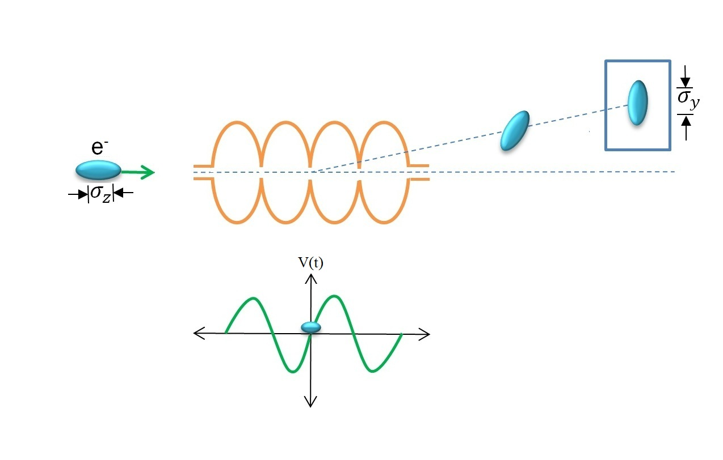
Figure (1): Transverse deflecting cavity

2- Synchrotron Light Monitor:
In this technique the bunch length can be determined by using the Synchrotron radiation with the aid of RF cavity and a monitor. This technique should be used in a high dispersive region usually in arcs after a bending magnet. In the beginning, the Linac RF phase is crested and the beam size is measured on the screen (monitor). Then increases the RF phase a small amount (off-crest) and determine the dispersed beam size from the same screen. Doing it again with changing the RF phase but with opposite sign and determine the dispersed beam size. Plotting the beam size as a function of RF phase change and doing a parabola fitting, the bunch length can be determined using $σ_{z}$= $\frac{\sqrt{A}}{|aK|}$ where A is one of the parabolic coefficient fit, K is the RF wave number and a is the calibration slope and is given by - e V₀ η sin (φ) / E₀ where e is the electronic charge, V_{o} is the peak accelerating voltage, η is the dispersion, φ is the RF phase and E₀ is the nominal energy after the linac section. The mathematical back ground is described elsewhere [4]
The advantage of this technique is that it is fast, cheap and easy to implement while the disadvantage is that it is a destructive technique and the accuracy of the measurement depends on the monitor resolution.
Non-destructive techniques:
1- Streak camera:
Streak camera can measure bunch length until 200 fs but the cost increases; its principle depends on converting the temporal profile of the bunch into a spatial profile by using the radiation which comes from the electron beam (Diffraction radiation, transition radiation, synchrotron radiation…..etc.). The light passes through a slit followed by a photocathode where the light converted into electrons proportional to the light intensity. The electros pass through an accelerating mesh to increase their kinetic energy, and then they go into a sweeping circuit. The sweeping circuit consists of positive and negative electrodes. Electrons arrive at different times and deflect in different angles before they go through Micro-channel plate (MCP). The number of electrons is increased as they pass the MCP and then they hit a phosphor screen. The brightness of the phosphor image is proportional to the incident light intensity and the images appear on the screen from top to bottom where the electron come first go to the top. The vertical axis acts as time and the horizontal axis acts as the space (horizontal distance) for the incident light. The incident light intensity can be determined from the phosphor image while the time and position can be determined from the location of the phosphor image.
The advantage of streak camera is that it can be used for a wide range from x-ray to near infrared while its disadvantage is due to the high cost, limitation of the sweeping electric field and limitation by the initial spread of the photoelectrons.
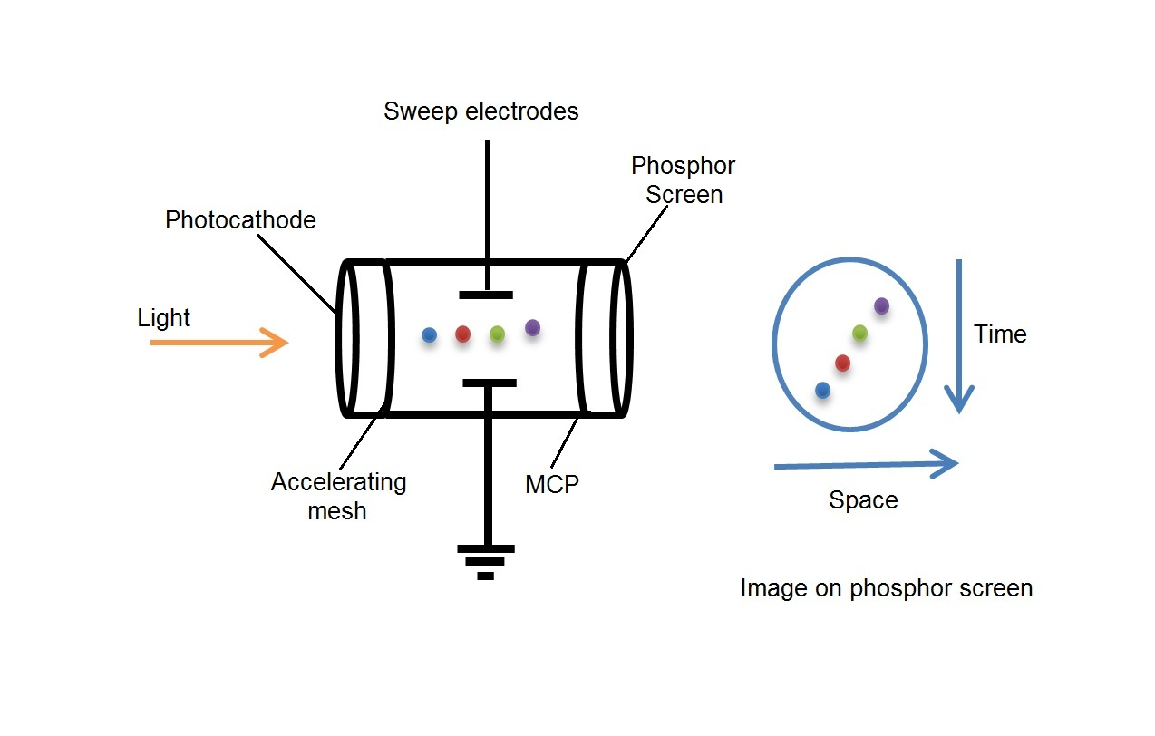
Figure (2): Streak Camera

2- Interferometers:
This technique depends on the light which comes from the beam. The light path can be split into two paths and through successive reflections through a number of mirrors. The two paths recombine into one path before they reach the detector (Golay cell or Peyro-electric). The measured energy is recorded as a function of path length difference and by using Fourier transformation the time domain can be converted into a frequency domain where the bunch length is determined. The simplest type of the interferometers is the Michelson interferometer shown in fig. (3).The advantage of this method is that it is cheaper than other techniques but its disadvantage is due to the band width limitation, the physical properties of the detector and missing phase information. Using Kramers-Kronig formulas the phase can be constructed from the form factor.
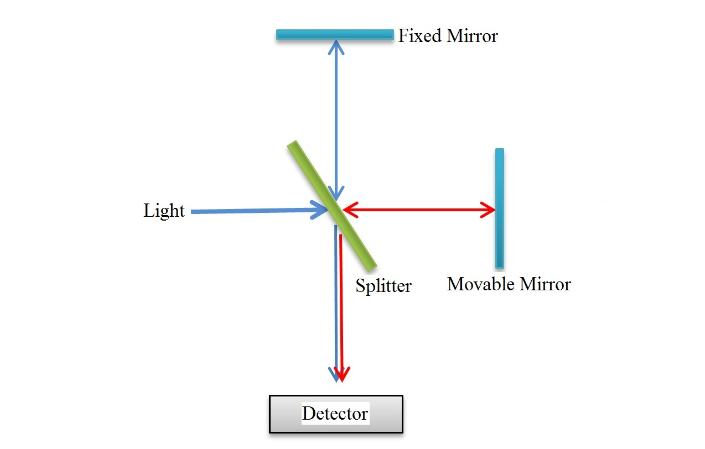
Figure (3): Michelson Interferometer

3- Electro-optic sampling:
The electric field of a high relativistic electron is almost perpendicular to the direction of motion. When the relativistic electron moves in a tube, there will be an image charge created in the tube. Installing an electro-optic crystal such as GaP, ZnTe and LiTaO₃ in the tube very close (few millimeter) to the electron bunch, the electric field of the bunch will produce a birefringence in the electro-optic crystal. Using a chirped laser pulse that propagates through the crystal, the polarization of the chirped laser pulse will rotate a different amount according to the bunch electric field. The amount and direction of rotation is proportional to the amplitude and the phase of the electric field.
The laser chirped laser signal is recorded with and without the moving electron bunch. The time profile is determined by the difference in the two recorded signals and the bunch length is equal to the width of the temporal profile as shown in fig. (4). The electron bunch longitudinal distribution can be determined from the shape of the temporal profile. The advantage of this method is that it is a non-destructive technique and can measure the bunch length to about 50 fs while the disadvantage is that the resolution at high energy beam is limited by the bandwidth of the crystal and the resolution at low energy beam is limited by the relativistic factor coefficient ($γ$) according to the relation $\frac{2r}{γ}$ where r is the distance from the electron bunch to the crystal.
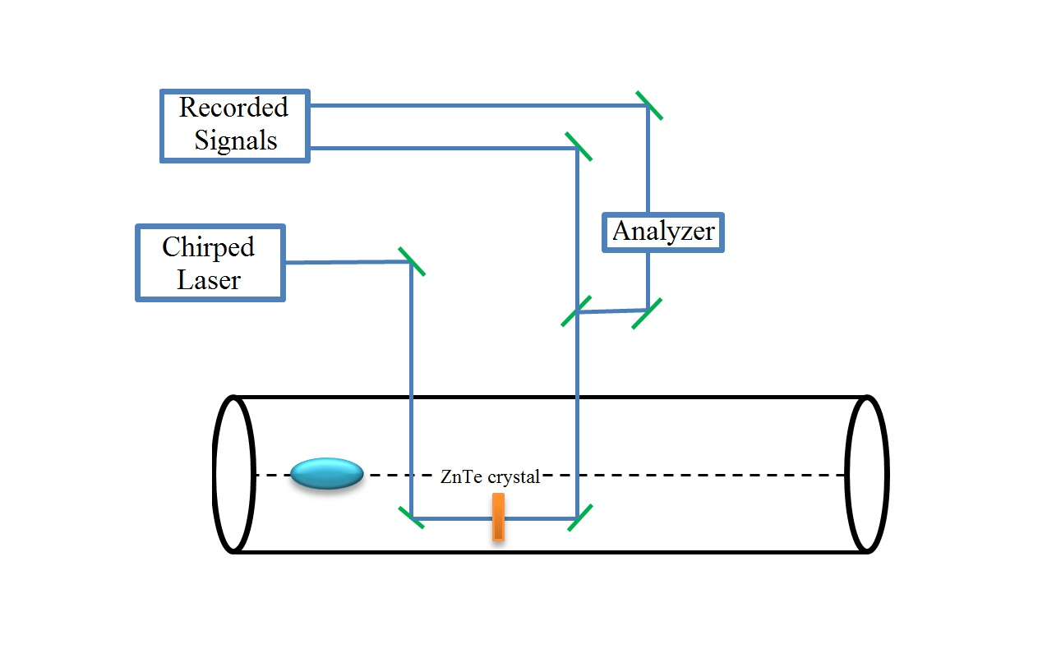
Figure (4): Electro-optic sampling

4- Wall current monitors:
As the electrons accelerated in a conducting tube, an image charge is formed on the inner tube wall which produces a current equal to the beam current. If the wall current passes across a resistor (R), the voltage pulse can be determined via an oscilloscope. To measure the beam current, the beam pipe is cut and a resistive ceramic gap is used as shown in fig. (5). Ferrite cores are used to allow the current to pass through the resistance instead of passing in other conducting parts and the ceramic gap is used to interrupt the vacuum chamber conduction which prevents the wall current to pass across the resistor. This description is valid only if the following relation is fulfilled [16]
$σ_{t}≫ \frac{r}{γ\sqrt{2}}$ (2)
Where $σ_{t}$ is the rms bunch length, r is the tube radius and $γ$ is the relativistic Lorentz factor.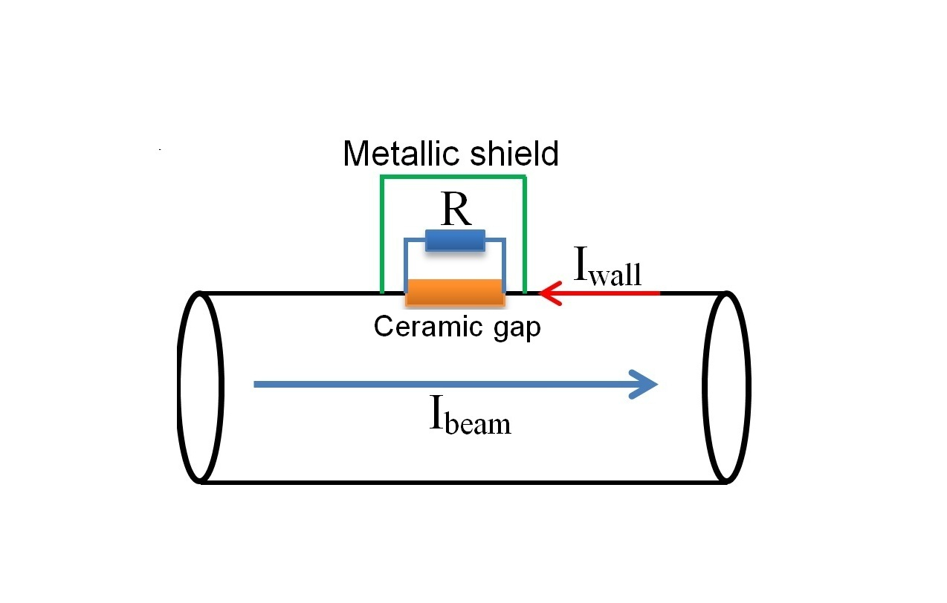
Figure (5): Wall current monitor

The wall current monitor should be designed to keep the wall current in high and low frequency domains. The ceramic gap acts as a capacitor (C_{gap}) and it shorts the circuit at frequencies above $F_{hf}$. The circuit low frequency cut off ($F_{lf}$) and high frequency cut off $F_{hf}$are given by
$F_{hf}= \frac{1}{2πRC_{gap}}$ (3)
$F_{lf}= \frac{R}{2πL}$ (4)
The wall current monitor is usually used to determine the bunch length for proton accelerators and it is rarely used in the determination of electron bunch length because the electron bunch length is usually very small. Wall current monitors are limited by its band width which is usually around a few GHz. Recently a high wall monitor band width (200 kHz – 20 GHz) is used for CTF3 [17].

References
- Sub-picosecond compression experiments at Los Alamos national laboratory, B. Carlston et al., AIP Conf. Proc. 367,21(1996).
- Bunch length measurements using a transverse RF deecting structure in the SLAC linac, R. Akre et al., EPAC 2002.
- K. Bane et.al. Phys. Rev. ST Accel. Beams 12, 030704 (2009)
- Fast, absolute bunch length measurements in a linac using an improved RF phasing method, P. Emma et.al., Proc. of FEL 2012.
- Precise measurement of sub picosecond electron single bunch by the femtosecond streak camera, M. Uesaka et.al. Nucl. Instr. Meth. A 406 (1998).
- Bunch length measurements at the TESLA test facility using a streak camera, K. Honkavaara et.al. Proc. of PAC 2001.
- Streak camera measurements of the SOLEIL bunch length, M. Labat et.al. Proc. of DIPAC 2007.
- Single shot electron beam bunch length measurements, I. Wilke et al., Physical Review Letters, Volume 88, Number 12, 2002.
- Picosecond electron bunch length measurement by electro-optic detection of the wake field, M. Fitch et al., PAC 1999.
- Electro-optic time profile monitors for femtosecond electron bunches at the soft x-ray free-electron laser FLASH, B. Steffen et.al. Phys. Rev. ST Accel. Beams 12, 032802 (2009)
- Generation and measurements of 50-fs (rms) electron pulses, P. Kung et.al. Phys. Rev. Lett. 73, 967 (1994)
- Bunch length measurements at JLab FEL using coherent transition and synchrotron radiation, P. Evtushenko et al., BIW 2006.
- Demonstration of a real-time interferometer as a bunch-length monitor in a high-current electron beam accelerator, J. Thangaraj et.al. The Review of scientific instruments, vol. 83, 043302 (2012.)
- A multi- channel THz and infrared spectrometer for femtosecond electron bunch diagnostics by single-shot spectroscopy of coherent radiation, S. Wesch et.al. Nucl. Instr. Meth. A 665 (2011) 40-47.
- Intra-beam scattering measurements in RHIC, W. Fischer et.al. Proc. of EPAC 2002.
- Beam current monitors, J. Denard, CERN accelerator school on beam diagnostics 2008.
- High band width wall current monitor for CTF3, A. D’Elia et.al. Proc. of EPAC 2008.

Mention that a prototype was tested previously, with encouraging results. However, there was no way to cross check early results against a calibrated bunchlength monitor
In this paper, we compare the bunchlength measurements obtained using an invasive rf-deflector cavity technique against those from non-invasive harmonically resonant cavity, with predictions from Generalized Particle Tracker code serving as our benchmarking tool.

The cavity:
Describe the cavity, particularly how it differs from our prototype. Do we have RF/bench measurements we want to include, for example Q’s and resonance frequencies, for old and new cavities?
Mention that the antenna is sensitive to the magnetic field of bunch, which is 90 degrees out of phase with electrical field representative of electron bunch shape. Show representative scope trace, and describe the method for converting it to bunch shape. Comment on cavity imperfections that produce the “wiggles” we see. Address this in detail later….
The Experiment:
Beam generated at CEBAF injector. Measurements take place using the first X meters of the injector. Describe synchronous photoinjection, describe the beamline including the chopper, buncher, capture section, and spectrometer dump beamline. For these measurements, we studied 130kV beam (no bunching, no RF acceleration), and we studied 500kV beam (bunching and acceleration). We need a drawing.
Describe bunchlength measurement using RF deflector (aka chopper).
Describe GPT results.
Mention harmonically resonant cavity not located in the exact Z location as rf-deflector, so bunches continue to grow in-transit to harmonically resonant cavity monitor. Our method relies on benchmarking GPT against accurate rf-deflector technique, and then to compare harmonically resonant cavity results against GPT. A = B and B = C, so A = C
Results:
Chopper slit scan results: bunchlength vs beam current. Compare to GPT results. Also use GPT to compare the bunch distribution. Does GPT indicate the “hump” we see at higher current?
Now provide the Harmonically Resonant Cavity bunchlength results vs current, and compare to GPT. Just take FFT of scope trace and fit a Gaussian to the result. By this I mean, don’t implement the “correction”, unless you convince me otherwise.

Secondary Results to include:
- Compare cavity sensitivity at 130 and 500kV. Does sensitivity scale as expected, we need Joe’s help on this.
- Use narrow-bunch 500kV beam and GPT prediction of its bunchlength, to evaluate specific imperfections in the cavity (i.e., what we have been calling the “correction”). Is there consistency between rf-bench measurements and the message gleaned from applying corrections (e.g., spectrum analyzer shows 20 modes, cavity mode n*f is not perfectly resonant…. )
- Do we include the harmonic cavity measurements obtained by varying the bunchlength using the chopper slit? Yes, I think so. The point of this would be to make one of the following statements: the cavity has too little bandwidth to distinguish a temporal beer can pulse, or the cavity has sufficient bandwidth but a temporal beer can distribution quickly evolves to a Gaussian distribution, at least at 130kV energy. Can GPT be used to help us say which scenario is more likely true?
- Cavity signals when two independent bunch trains pass through… a good phase monitor that can help us set the phase of our three-laser optical pulse trains. But how to present this?

Conclusion:
Results are good, we are installing a bunchlength monitor behind emittance aperture A1, where it will be used to non-invasively monitor beam delivered to the halls. The cavity will help us set laser phases, prebuncher phase and amplitude.
Are there other benefits to this cavity, as non-invasive diagnostic?
Cavities like this could also be useful at higher energy sections of machine, where bunches are shorter than our resolution limit (< 35ps). Why? Help me here, just brainstorming… We will obtain very strong signals at 5 MeV, 1 GeV, etc., based on extrapolating the sensitivity plot at 130kV and 500kV. Does this represent a BCM with better signal to noise ratio than cavities that resonate at only the fundamental?
Can specific harmonics provide some information on helicity correlated beam size variations, or other beam characteristics that are hard to know using conventional techniques? Brock, maybe your Superfish guy can help with this?

Related Useful Results and images:

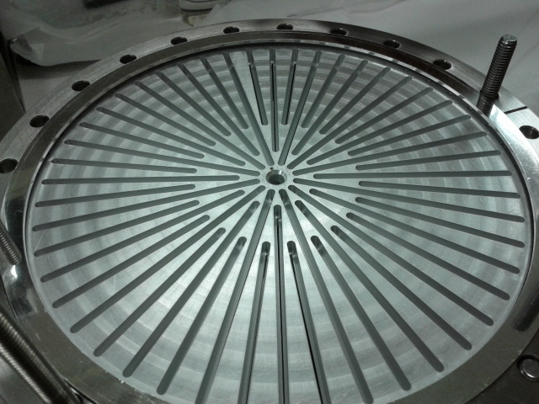

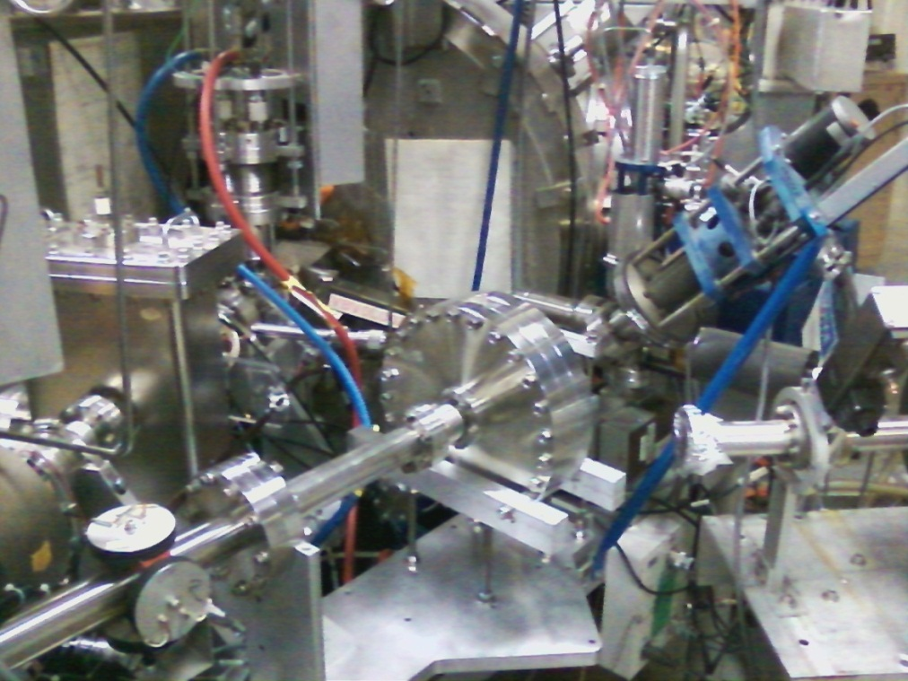

A representative scope image, with an FFT image, and a Gaussian fit to the FFT.
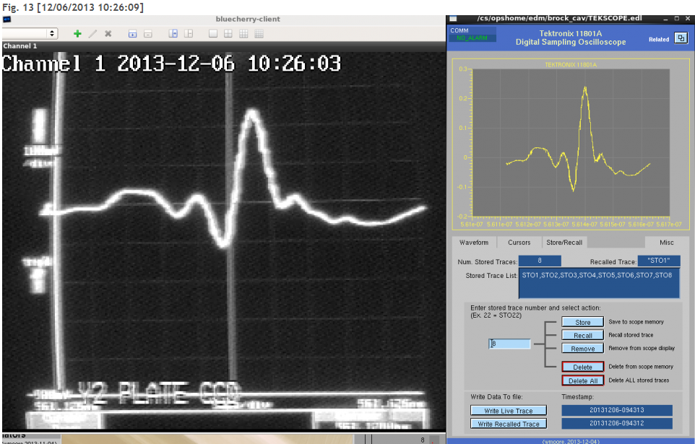
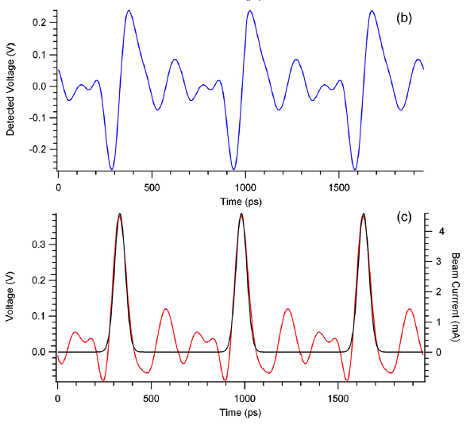
We want something like this, scope trace on top, and FFT and fit below.

We will want something similar, to help describe our front end:

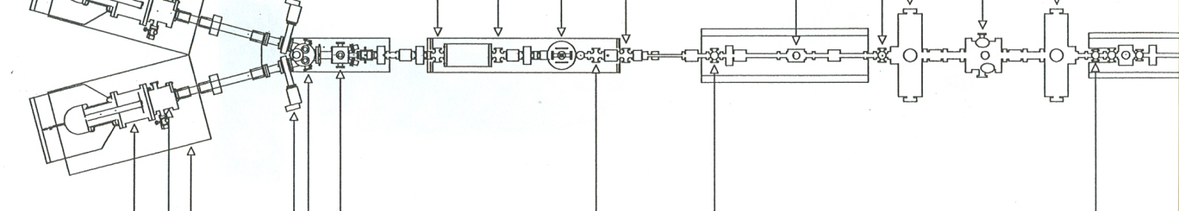

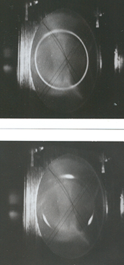

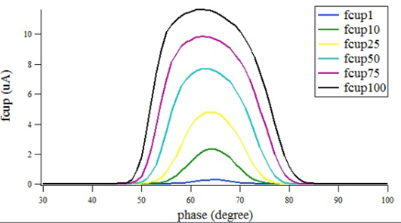
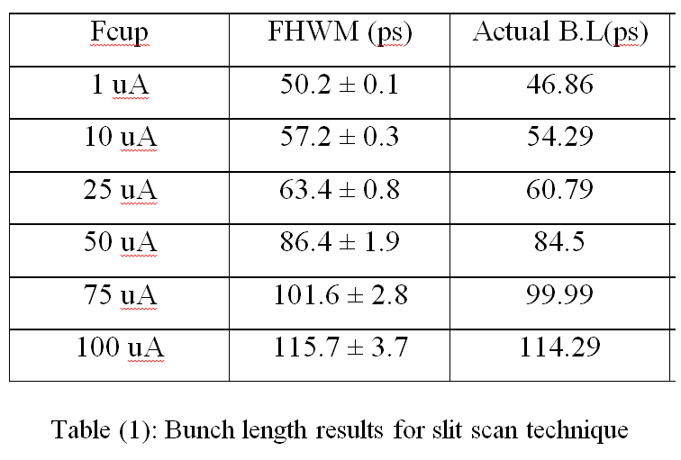
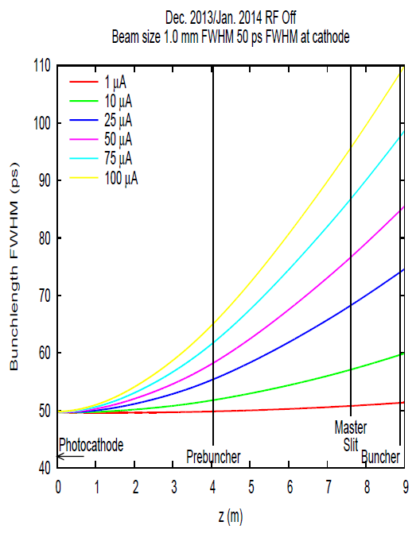
GPT results to compare to chopper slit scan results, we want the GPT results using 1mm FWHM laser beam. Need GPT bunch distributions too. Would be great if GPT predicted observed bunch distortion…

Now comparing measurement and simulation….
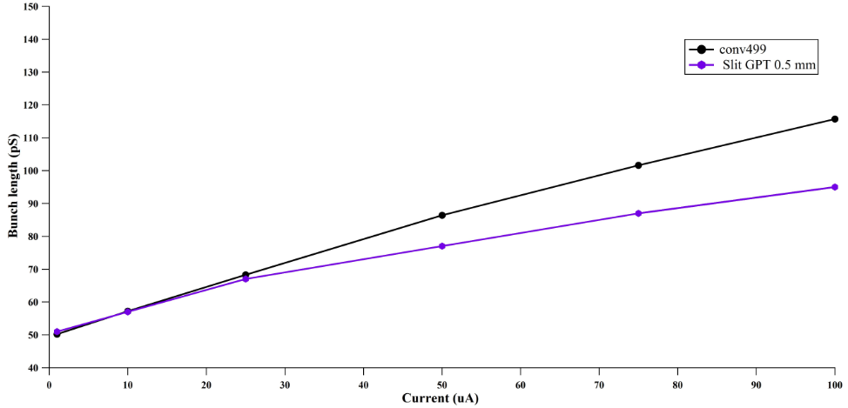
Here is our A = B result. Replace GPT 0.5mm results with 1mm results. This will push purple GPT results up higher, a small amount. Mahmoud needs to plot actual FWHM and not the Gaussian fit to measurements…this will push black dots higher.. how to add “error bars”?

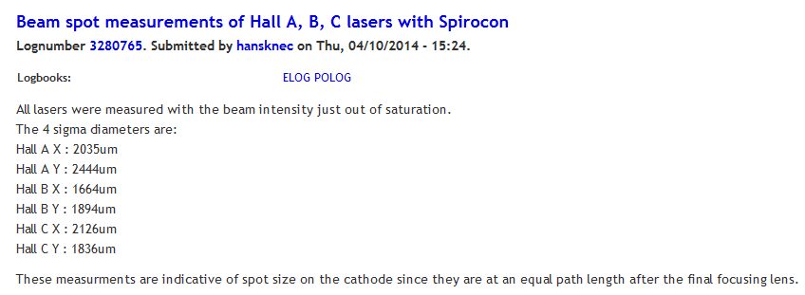
Proof that we have ~ 1mm dia laser beams, FWHM. Hall A laser diameter, 4 sigma (average of x and y) = 2.2mm. Divide by four to get 1 sigma = 0.56mm, and multiply by 2.35 to convert to FWHM gives…1.3mm, which is close enough to 1mm….

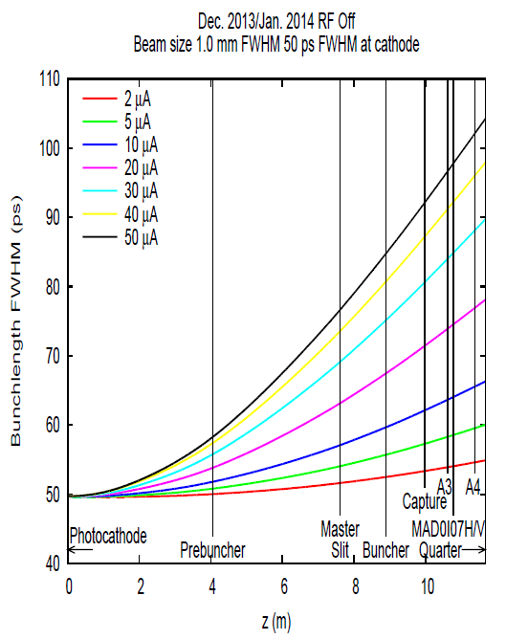

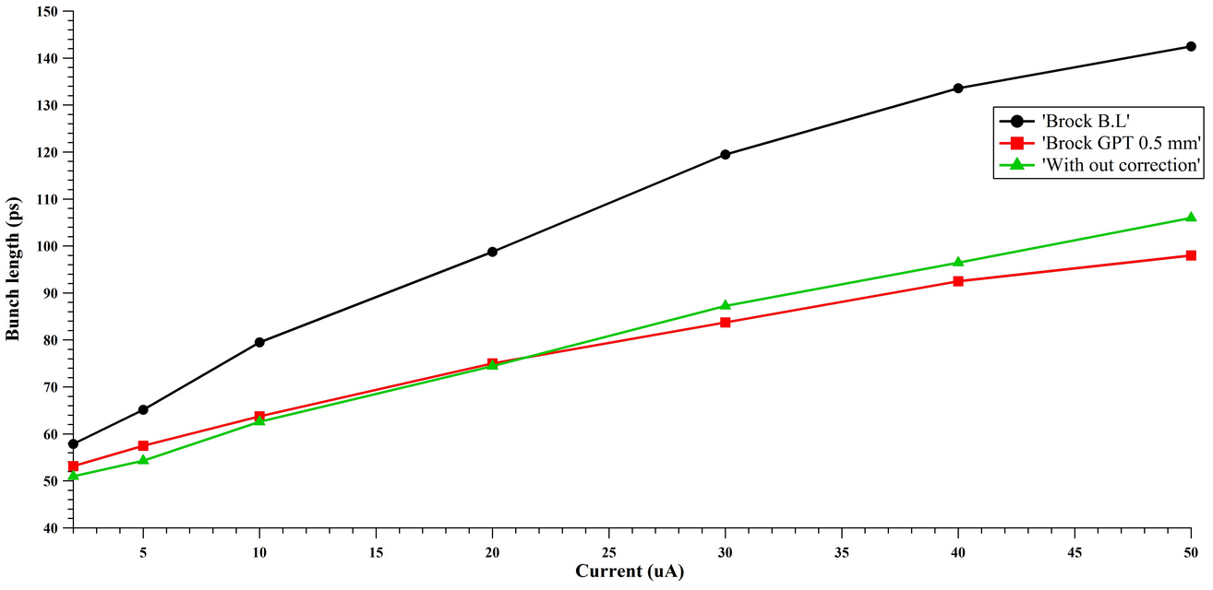
Screams….don’t apply “correction”…. This is our B = C result. Therefore, A = C, i.e., Brock cavity calibrated against chopper slit scan technique, with GPT providing the connection between two methods.
From Brock’s recent July 2014 write up….
Current (uA) | FWHM measured with slit/scan (Picoseconds) | FWHM measured with a harmonic cavity (Picoseconds)
2 | 44.96 | 50.8
5 | 48.62 | 55.16
10 | 54.97 | 59.8
20 | 65.87 | 69.63
30 | 78.85 | 81.8
40 | 86.32 | 95.94
50 | 93.15 | 103.34

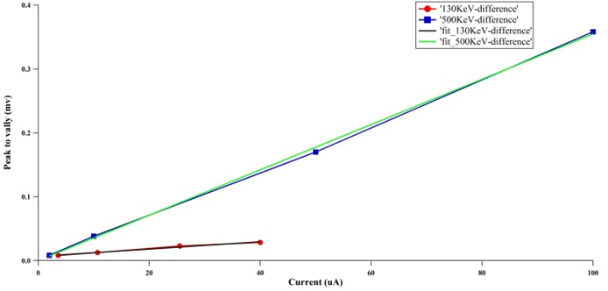
Cavity sensitivity plot. How does this cavity sensitivity compare to a cavity that resonates only at fundamental? There’s a relativistic formula Joe cites that predicts how antenna voltage will scale for beam at different energies. Can we predict antenna voltage for 6.3 MeV beam?

Use GPT to estimate the bunchlength at 500kV, with prebuncher OFF, buncher ON and Capture ON, to identify cavity imperfections (what we’ve been calling the “correction”). Alicia to shift buncher phase by 180 degrees to see if the four plots predict similar bunchlength at A4 (what my intuition says you should see).
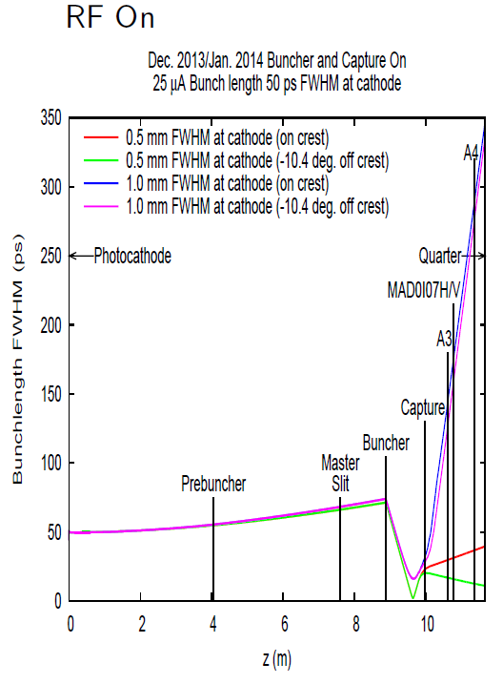

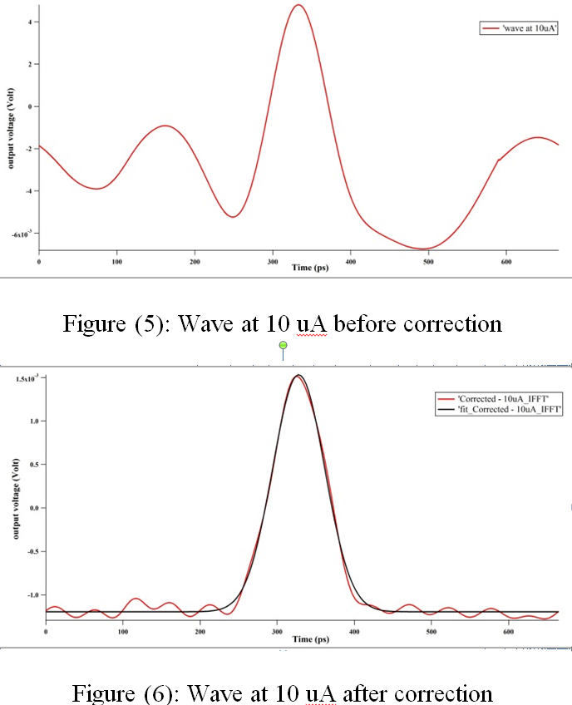
Some image to help us describe the “correction” technique, which I hope tells us specific information about the cavity bandwidth and subtle imperfections related to each mode…..

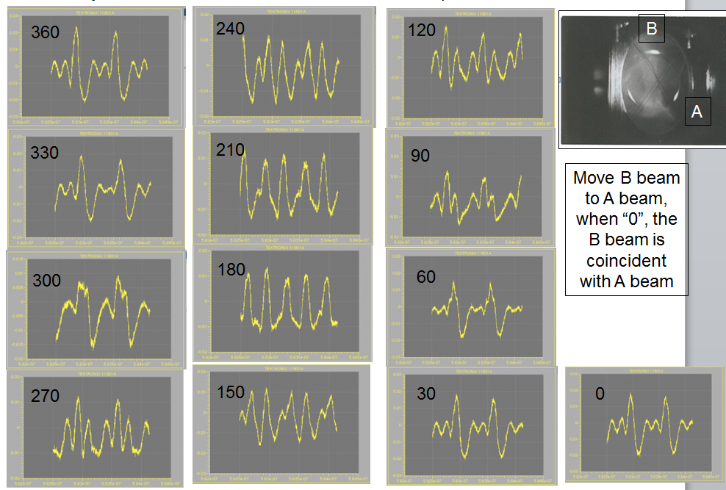
An image to help us explain our test with multiple beams, and cavity as phase monitor. There must be a better way to present this information, in support of our claim that the cavity provides useful phase information.

From Brock:

Beam Measurements with Harmonic Cavities at CEBAF.

Harmonic cavities are designed to resonate many axially symmetric modes with frequencies that are integer multiples of a beams bunch frequency. When a periodically bunched beam passes through a harmonic cavity, the modes of the cavity are excited by the beam, and the superposition of these excited modes is a voltage vs. time waveform that can be measured at the cavities’ antenna output.
Any periodic function, like current vs. time of a train of electron bunches, can be represented by a Fourier series. The compact trigonometric form of the Fourier series is the simplest representation¹, each harmonic term is described by its amplitude and relative phase. The beam current as a function of time, $i_{b}$, can be represented by its Fourier series, $I_{b}$.

Eq. 1: $I_{b}$= a₀ + a₁ cos (ω_{o}t + θ₁) + a₂ cos (2ω_{o}t + θ₂) + a₃ cos (3ω_{o}t + θ₃) …

Each (a_{n} ) term is amplitude , each frequency term is harmonic, an integer multiple of the bunch frequency (ω_{o} , 2ω_{o} , 3ω_{o} ,…). (a₀ ) is the average current.

When periodic electron bunches pass through a harmonic cavity whose resonances are the same frequency as the beam’s Fourier terms, the beam induces these cavity modes to resonate. The relative amplitude and phase of these modes are a manifestation of the beam’s Fourier series. The superposition of these modes, on axis, is a voltage vs. time waveform that ideally represents current vs. time of the beam that induced it.

In 2012 a prototype harmonic cavity was used by Jab to measure a continuous 1500 MHz bunchstream at the Center for Injectors and Sources (CIS) experimental beamline at the Jefferson Lab (Jlab). The cavities detected output waveform was not an ideal voltage vs time representation of bunch profile. The raw oscilloscope data was a family of bipolar pulses rather than electron bunch shapes . The peak to peak voltages and peak to peak spacing of the bipolar pulses were measured and tracked the beams current and voltage. The magnitude of the Fourier series (the an’s) of the detected waveform demonstrated that twelve harmonic TM0N0 modes of the prototype harmonic cavity were excited by the beam.

The Jlab staff also measured a beam with 1/3rd the bunch frequency. In this configuration, the modes of the harmonic cavity were still excited by the beams Fourier series, but by every third term. Interestingly, the harmonic cavity’s detected output had similar waveforms with a decrease in detected voltage. (This phenomenon is explored further on page 3).
During Phase I, a new 1497 MHz harmonic cavity was installed on CEBAF’s injector beamline providing an opportunity to relate the cavities measured waveform with an accepted beam bunch measuring technique using more controllable electron guns. The new cavity exhibited increased bandwidth and produced a raw data waveform that is more suggestive of an electron bunchshape. The waveform in fig. 3 is the cavities response to a 500kV 499 MHz beam measured at the cavities antenna with a sampling oscilloscope (Tektronix 11801b). The Gaussian fit to this data has a full-width half-max of 34 picoseconds. The Fourier Transform of the raw data implies the relative magnitude of the TM0N0 modes excited in the cavity by the beam.
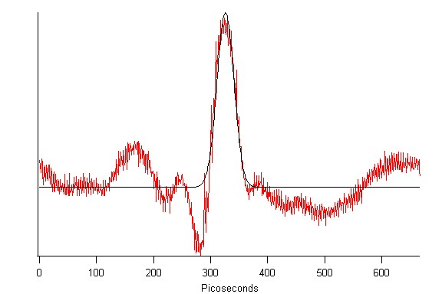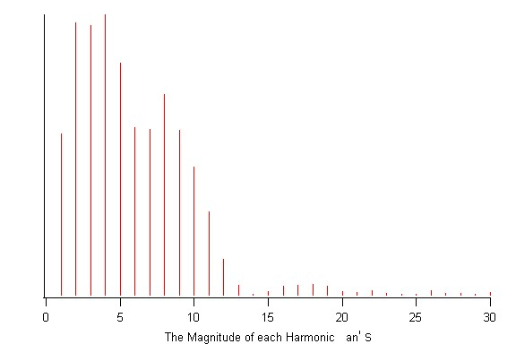
Figure 1: Raw data measured by a 500kV 499Mhz beam with a Gaussian fit. Figure 2: The magnitude of the terms of the waveforms Fourier series.

Accuracy of the Harmonic Cavity used as a Bunch Length Monitor:
Bunch lengths of a 130 kV beam was measured as a function of current using the slit scan technique. The FWHM of a Gaussian fit to the raw data measured by the harmonic cavity overestimates the bunch width by about 10%

Current (uA) | FWHM measured with slit/scan (Picoseconds) | FWHM measured with a harmonic cavity (Picoseconds)
2 | 44.96 | 50.8
5 | 48.62 | 55.16
10 | 54.97 | 59.8
20 | 65.87 | 69.63
30 | 78.85 | 81.8
40 | 86.32 | 95.94
50 | 93.15 | 103.34

The CEBAF Injector Beamline:
The CEBAF accelerator has three 499 MHz electron photoguns guns whose beams are combined and interleaved to create a 1497 MHz electron bunch stream. Experiments were conducted on this beam line to measure bunch properties, and to measure the relative phasing of two electron guns. Beam monitoring experiments measured a single gun producing a 499 MHz bunch stream. The phase monitor experiment used two guns, both producing the same expected bunch shape and bunch currents, one stepped in phase by ten degree increments, of 499 Mhz, relative to the other.
In 2012, the staff of CIS experimentally confirmed that a harmonic cavity could measure a beam with a bunch frequency 1/3rd of the cavities design frequency, but the phenomenon was not explored further. The beam measurements made during phase I at CEBAF were all 499 MHz beams made with a 1497 MHz harmonic cavity. The 1497 MHz cavity actually never measured a 1497 MHz beam in this series of experiments.
Consider the difference in the interaction between a 1497 MHz harmonic cavity and beams with a bunch frequencies of and 499 MHz and 1497 MHz. A 1497 MHz beam has harmonic terms that match the resonant frequencies of the cavity. The cavities modes are excited with relative amplitudes and phases that represent a scaled Fourier series of the beam. The antennas output is a superposition of these modes creating a voltage vs time waveform that represents current vs time through the cavities bore.
At the CEBAF injector, the cavity resonates at harmonics of 1497 Mhz, but each gun fires at 499 MHz. The beam from a single gun has harmonic terms in its Fourier series that are multiples of 499 Mhz. The Harmonic cavity in this configuration can only respond to every third term of the beams Fourier series of a single gun.
Measuring a 499 MHz beam with 1497 MHz harmonic cavity:
A simulation was conducted in IGOR to determine how an ideal 1497 MHz harmonic cavity would react to a 499 MHz beam. The single rectangular bunch shape (fig. 2) was created on a 2004 picoseconds landscape, the period of a 499 MHz beam. The Fourier transform of this periodic wave shape produces a list of complex numbers, the terms of the beams Fourier series (eq.1). Each third term of the list was copied to create a new Fourier series, one third the length of the original. This cut and paste represents the misalignment between the harmonics of 499, and the resonances of the 1497 Mhz cavity. Miraculously, the inverse Fourier Transform of the new Fourier series produces an identical waveshape, with the same height and area, on a 668ps landscape, the period of 1497 Mhz. Other wave shapes produced similar results.
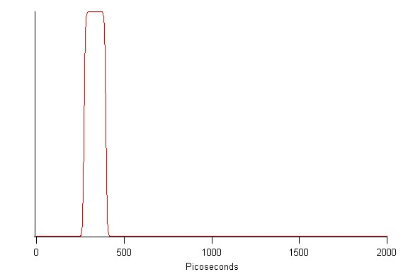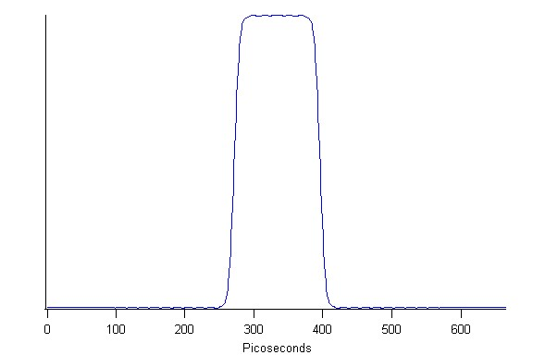
Figure 3. The hypothetical measurement of 499 MHz beam with an ideal 1497 MHz harmonic cavity.

The Phase Monitor experiment was designed to determine how a 1497 MHz harmonic cavity would respond to two interleaved 499 MHz beams. This experiment was also be simulated in IGOR as measured by an ideal harmonic cavity. Two Gaussians were created on a 2004 ps landscape, the period of 499 MHz, spaced one 1497 MHz wavelength apart. The beams were created to be spaced as they were in the experiment, two guns were fired separated by one period of 1497, the second gun was then stepped in 10 degree increments of 499Mhz, or about 56ps. Each colored line represents a different experiment. The Fourier series of each two bunch waveform was calculated, and similarly each third term was copied to create a new Fourier series one third the length of the original. The inverse Fourier transform of these New Fourier series revealed a similar result to the first experiment. The two bunches are projected from a 2004 ps frame to a 668ps frame. The 10 degree separation of the electron guns translates into a 30 degrees shift in the detected waveform, however the bunch spacing in time remains the same. The large blue detected waveform is the superposition of the A and B guns while in the same phase at 1497 Mhz.

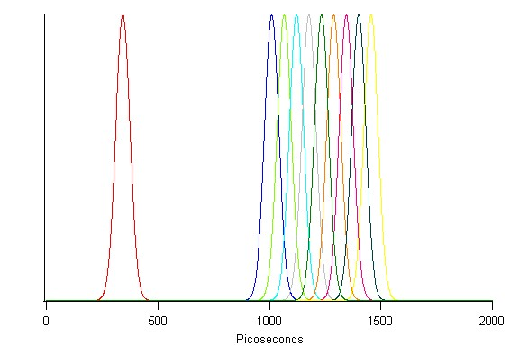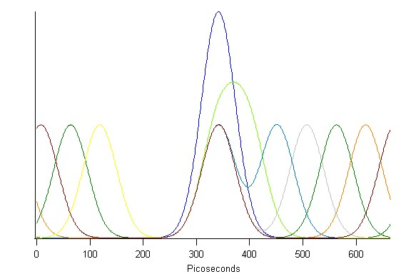
Figure4: The relative phasing of the electron guns used in the phase monitor experiment. Figure5: The response of a hypothetically ideal harmonic cavity.
Distortion:
Harmonic cavities are designed to have many axially symmetric modes with resonant frequencies that are the same as the harmonic terms of the beams Fourier series. Ideally, when a beam passes through the cavity, these modes resonate in phase, and with amplitudes proportional to the beam. The superposition of these modes is measured at the antennas output and represents current vs. time through the cavities’ bore.
In practice, the cavities detected waveform is distorted (figure 1). Imperfections in the cavity and antenna coupling cause misalignments between the resonant modes and the beams Fourier terms, resulting in phase and amplitude errors in the response of each cavity mode. The superposition of all of the cavities resonances, including these errors, is the detected waveform.
Distortion Correction:
Consider a single mode of a harmonic cavity. If its resonant frequency is slightly off design frequency, the beam can still excite the mode as long as its Fourier term is not outside of the modes resonance curve. Driving a mode on the shoulder of its resonance curve causes a decrease in detected amplitude as well as a phase shift between the beam and the excited mode. The phase and amplitude shift of this mode is systematic, and can be corrected with a single complex multiplier that un-shifts its phase and scales its amplitude to represent the beams true Fourier series. A series of complex multipliers, one for each mode of the cavity can be created to represent the errors of each mode. This series can be in the form of equation 1 and is called the cavities Transfer Function.
Transfer Function:
The beam, cavity, and detected waveform complete a system that include an input$x\left(t\right)$, an output $y\left(t\right)$ and the cavities temporal response. The cavities response in the Fourier domain is its transfer function $H\left(f\right)$and is calculated by multiplying and dividing Fourier series.
$$F\left(x\left(t\right)\right)=X\left(f\right), F\left(y\left(t\right)\right)=Y\left(f\right)$$
$$Y\left(f\right)=H\left(f\right)X(f)$$
$$H\left(f\right)=\frac{Y(f)}{X(f)}$$
If both the input bunch shape$x\left(t\right)$, and an output waveform $y\left(t\right)$ are known, the cavities transfer function can be created simply by dividing the Fourier series of the data by the Fourier series of the known bunch shape. The transfer function can then be used to correct for the cavities systematic errors in subsequent data, independent of new bunch shapes .
Undistorted bunch shape of new data, $x(t)_{new}$ can be calculated from new measured waveforms, ${y\left(t\right)}_{new}$ by dividing the Fourier transform of new data by the cavities transfer function, and then calculating its inverse Fourier transform. $F\left(y\left(t\right))_{new}\right)=Y\left(f\right), X\left(f\right)=\frac{Y(f)}{H(f)} , F^{-1}\left(X\left(f\right)\right)=x(t)_{new}$

Estimating the Cavities Transfer Function: The phase monitor experiment was conducted with two photoguns, each producing 130kV, 20 uA beam. This beam was measured with the slit scanning technique and was determined to be Gaussian with a 66 ps full width half max. This is sufficient information to calculate an estimate of the cavities transfer function.
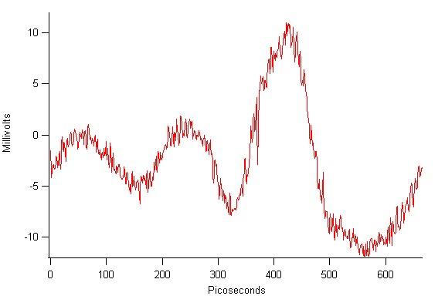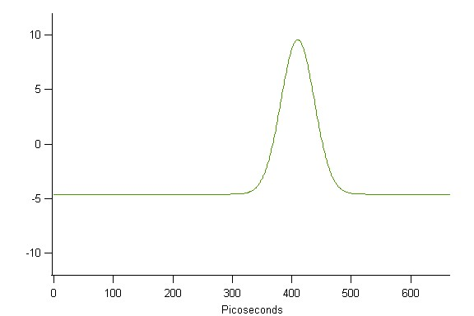
Figure 6: The measured waveform of a 66 ps Gaussian Electron bunch from Gun A. Figure7: A 66 ps Gaussian used to create an estimate of the cavities transfer function.
The waveforms shown in Figure 6 and 7 can be used to create an estimate of the cavities Transfer function$H\left(f\right)$. The measured waveform of photgun A is $y\left(t\right)$and the input$x\left(t\right)$, is assumed to be a 66ps Gaussian, as measured by the slit scan technique. Photogun A was selected to create transfer function because it remains stationary relative to the scope trigger for the entire experiment. Calculating the FFT of the waveforms produces $Y(f)$ and $X(f)$ and in practice it is convenient to calculate the inverse transfer function.
$${H\left(f\right)}^{-1}=\frac{X(f)}{Y(f)}$$
Oscilloscope traces were captured for the A beam alone, and with both the A and B beam. Data was acquired with the two beams firing at 499 MHz but in relative phase at 1497 MHz, and also with the B beam stepped in ten degree increments. The Fourier Transform of each of these captured traces was calculated. The inverse transfer function calculated above was then multiplied with the Fourier transforms of all of the scope traces, and the inverse Fourier transform of each was calculated producing the processed data.

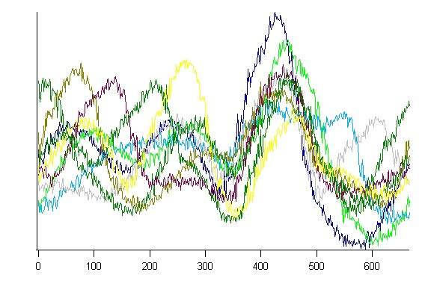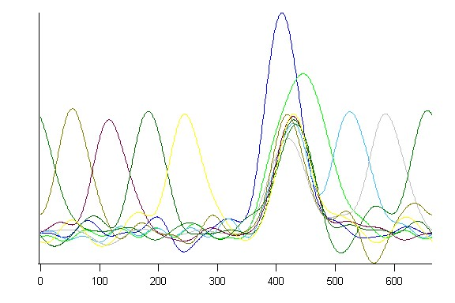
Figure8: The raw data waveforms of the Phase Monitor experiment. Figure 9: The same data processed with an estimate of the cavities transfer function.
A transfer function was also created for data taken while a beam was scanned across a slit, trimming its bunch width. This transfer function was estimated using a low current waveform of this experimental series, and its Gaussian fit:
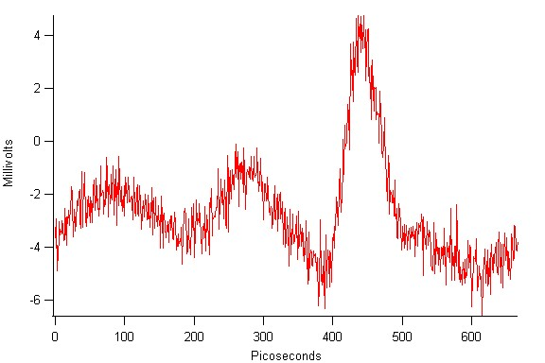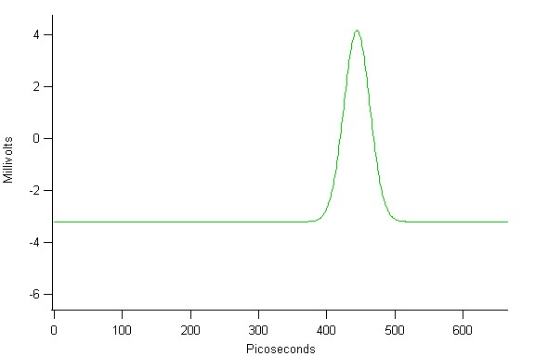
Figure 10: Raw data of a low current bunch in the slit scan experiment. Figure 11: A Gaussian fit to the raw data that was used as an assumed bunch shape to calculate an estimate of the cavities transfer function.
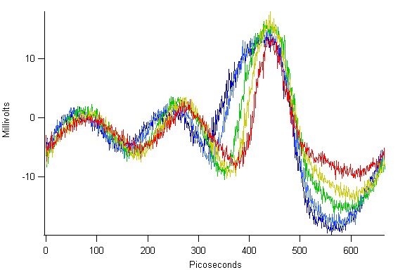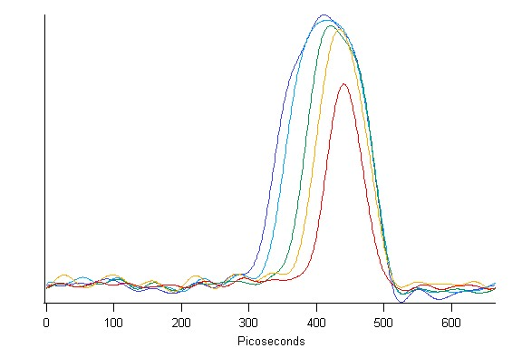
Figure 12: Raw slit scan data. Figure 13: The same data processed with an estimation of the cavities transfer function.
Properties of Transfer Functions:
This distortion correction process simply transforms one waveform into another. If the assumed waveform is a good representation of true bunch shape, clear and accurate representations of new data can be obtained. If the assumed bunch shape is not a good representation of the actual bunch shape, subsequent data will be distorted. The accuracy of the transfer function can be gauged by its adherence to reality. A rolling baseline created when processing new data indicates errors in the transfer function. The selection of assumed bunch shape has a profound effect on the processed data. An assumed bunch shape with a larger area, will scale the area of the processed data. A skinnier assumed bunch shape produces skinner processed data and visa, versa. A time delay between the measured waveform and the assumed waveform results in a time shift in the processed data. If raw data (Figure 1.) is missing a harmonic (check the 14th) then it provides no information for this mode. Division of this series into the series of a Gaussian, that has a nonzero 14th harmonic can cause this term to become large, projecting 14th harmonic on the processed data. In general the harmonic content of the waveforms must be similar to the detected waveform to prevent divide by zero effects. A transfer function created with a slow waveform cannot process faster data because does not include information about higher harmonics. A Gaussian fit to the data is a reliable starting point to estimate the cavities transfer function. The Gaussian fit was determined to be about 10% larger than the true bunch shape. Processing data using its own Gaussian fit results in a wider than expected processed bunchshape.

A transfer function can be used to extract hidden information. Using the 2012 data a transfer function was created with a brief bunch shape produced using a superlattice photocathode and its Gaussian fit. The application of this transfer function to data acquired in the same conditions but with a bulk Gallium Arsenide photocathode may show a tail on the processed bunch shape.
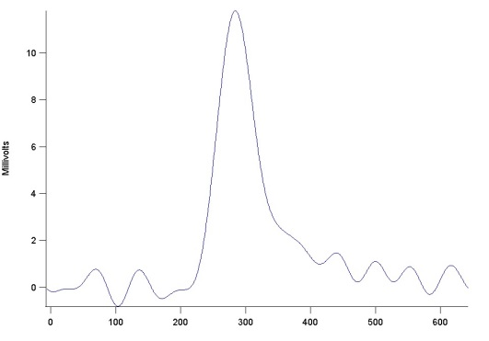

Suggestions for Moving Forward:
An experiment to accurately measure the transfer function of new cavities could be designed and executed. One technique might be to capture many waveforms that smoothly map the detected waveform as the beam transitions from operational characteristics that have known bunch shapes.
The bandwidth of harmonic cavities must be improved to measure shorter bunch lengths.
A 499 MHz cavity should be developed so that the A, B and C beams can be imaged simultaneously.

