**Harmonically resonant cavity as a bunchlength monitor**

B. Roberts[1]2, F. Hannon[2]1, M. Ahmad3, R. Kazimi [3]1, A. Hofler [4]1 , W. Moore[5]1, M. Pablo[6]2, M. Poelker[7]1, A. Sanchez [8]2, D. Speirs [9]2

1: Thomas Jefferson National Accelerator Facility, 12000 Jefferson Ave., Newport News, VA 23606  2: Electrodynamic, 4909 Paseo Del Norte Ne suite D, Albuquerque, NM 87113 3: Department of Physics, Old Dominion University, Norfolk, Virginia 23529

**Abstract:** A compact, harmonically-resonant cavity was used to evaluate the temporal characteristics of electron bunches ranging in width from ~ 45 to 150ps (FWHM) produced by a 130kV dc high voltage spin-polarized electron source at the CEBAF photoinjector. The antenna of the harmonically-resonant cavity was connected directly to a sampling oscilloscope, providing a signal sensitivity of 1mV/uA. The oscilloscope waveform has a direct relationship to the Fourier series representation of the electron bunch pulse train. Relatively straightforward post-processing of the waveform provided a near-real time representation of the electron bunches, revealing bunchlength and bunch-shape information, as well as relative phasing of interleaved electron beams. The non-invasive measurements from the harmonically-resonant cavity were in close agreement with measurements obtained using an invasive RF-deflector-cavity technique and with predictions from the particle tracking code ASTRA.

**Introduction:**

In 2012, we reported the performance of a prototype harmonically-resonant cavity installed on a simple test beamline [1]. These early measurements were encouraging, indicating that an electron pulse train could efficiently excite the fundamental and harmonic modes of a compact harmonically resonant cavity representative of the Fourier transform of the pulse train, thereby revealing important temporal features of the beam including bunchlength and bunch shape. However, a valid criticism of past measurements was that the simple test beamline included no means to calibrate the device to provide an accurate assessment of the cavity’s bandwidth, and therefore the minimum bunchlength resolution, and verification that pulse shape characteristics were genuine. In this work, we describe the characterization of an improved harmonically-resonant cavity installed at the photoinjector of the Continuous Electron Beam Accelerator Facility (CEBAF). We compare temporal measurements made using this device to those made using an invasive RF-deflecting cavity, and to predictions made using the particle tracking code, ASTRA (A Space Charge Tracking Code) [2]. Good agreement was found between both measurement techniques and to model predictions, thus validating the accuracy of the harmonically-resonant cavity bunchlength measurement technique. Besides providing useful near-real time information on temporal characteristics of the electron beam, the device also provides useful phase information related to interleaved pulse trains.

***The Harmonic Cavity:***

Any periodic function, like the time varying current of an electron pulse train, *Ib*, can be represented by a Fourier series:

***= a0* + *a1* cos *(ot + 1)* + *a2* cos *(2ot + 2)* + *a3* cos *(3ot + 3) …*** Eq.1

where the coefficient ***a0*** represents a dc offset that is absent from beam produced at CEBAF photoinjector. The bunch repetition rate is given by ***o*** and higher order frequency terms represent harmonics. Each term in the series has a characteristic amplitude coefficient and phase, given by ***an*** and ***n***, respectively. The number of terms present in the series is inversely proportional to the length of the electron bunch, with amplitude and phase terms describing the bunch shape.

The central idea behind the harmonically-resonant cavity bunchlength monitor, was to build a cavity sensitive to each term of the electron pulse train’s Fourier series expansion. When the beam passes through the harmonically-resonant cavity, the beam excites each mode. The relative amplitude and phase of these modes are ideally a manifestation of the beam’s Fourier series. The cavity antenna detects the superposition of these modes providing a voltage versus time waveform that represents current versus time of the beam that induced it. A “perfect” electron bunch detector would be equally sensitive to every term of the Fourier series. Since it is impossible to manufacture a device with infinite and uniform bandwidth, a “near-perfect” electron bunch detector would have known sensitivities to each resonance mode. In sections below, we describe how the sensitivities to each cavity mode were determined.

The design of the harmonically-resonant cavity relied on three criteria. Firstly, the cavity design excludes TE modes. This was accomplished by noting that TE modes resonate at frequencies *≥ c/2h* where *h* is the cavity length along the beam’s direction of motion. A short, pancake-shaped cavity excludes TE modes with frequencies below several tens of GHz. Secondly, radial slits were cut into the cavity walls to remove unwanted TM modes. The TM0N0 modes have purely radial wall currents and are unaffected by these slits while the TMMNP modes with azimuthal mode numbers (M) less than the number of discontinuities are removed from the cavity’s mode spectrum. Finally, the shape of the cavity was tuned such that the TM0N0 modes are harmonic. This was accomplished by iteratively modifying the cavity’s geometry and solving for the TM0N0 mode frequencies with the field solver POISSON/Superfish [3]. TM0N0 cavity modes are axially symmetric and have a field maximum on the cavity axis, i.e., along the direction of the moving electron beam.

At CEBAF, three independent 499 MHz pulse trains are extracted from a single photocathode inside a dc high voltage photogun [4]. These pulse trains are interleaved in time, and delivered to three experiment halls, using accelerating cavities that oscillate at 1497 MHz. One approach to evaluating temporal characteristics of electron pulse trains at CEBAF would be to use a harmonically-resonant cavity with a 499 MHz fundamental resonance frequency, identical to the 499 MHz electron pulse train, however, the radial dimension for such a cavity is approximately XX cm. A cavity this large was deemed too cumbersome for these tests, so a harmonically-resonant cavity was constructed based on a 1497 MHz fundamental frequency. At 1497 MHz, the cavity radial dimension was just X cm, allowing the cavity to fit within a 10” double-sided knife edge Conflat flange. A cut-away view of the cavity is shown in Figure 1, with an exaggerated gap between the two clam-shell cavity surfaces to help illustrate the antenna, together with a photograph of the as-built cavity nested inside the Conflat flange. Conflat reducer flanges on each side of the double-sided knife edge flange, form a UHV-compatible vacuum vessel. This comparatively compact cavity provided less signal strength compared to one having a fundamental resonant frequency equal to the 499 MHz electron pulse repetition rate, however, as noted below in the Results section, the 1497 MHz cavity still provided enough signal to resolve electron pulses at just 1uA average current. Moreover, a compact 1497 MHz cavity was comparatively easier to machine, and likely provided more precise control over achieving the required resonance conditions for each higher order mode.

The electron beam passes through a 1 cm diameter hole of the cavity bore, along its axis of symmetry. The loop antenna was attached to an SMA vacuum feedthrough with vendor specified 3 dB bandwidth to 20 GHz. The antenna …The antenna …. *Mention that the antenna is sensitive to the magnetic field of bunch, which is 90 degrees out of phase with electrical field representative of electron bunch shape*.

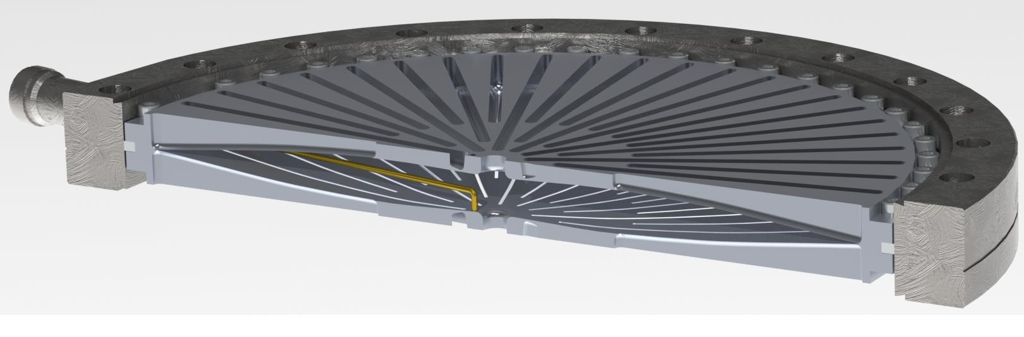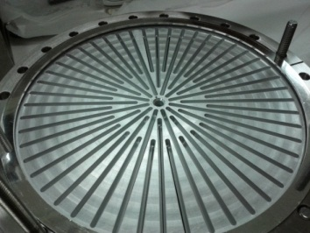

**Figure 1: (left) cut-away view of the harmonically-resonant cavity. The gap between adjacent clam shell surfaces was enhanced by a factor of two to exaggerate the curvature of the cavity surfaces, and clearly denote the antenna. (right) a photograph of the cavity nested inside the bore of a 10” double-sided knife edge Conflat flange. Two additional 10”Conflat flanges attach to either side to form the UHV-compatible vacuum vessel.**

**The Experiment:**

The first 15 meters of the CEBAF photoinjector are shown in Figure 1. Pulsed-laser light illuminates a strained-superlattice GaAs photocathode biased at 130kV inside the high voltage chamber of a load locked photogun [5]. Because the photocathode is thin (100 nm), the photoemitted electrons form bunches with temporal profiles that resemble, to first order, the laser pulses that produced them. However, as bunches accelerate across the cathode/anode gap, and then travel the roughly 14 meters of beamline before reaching the first radio-frequency accelerating cavity, space charge forces serve to alter the temporal distribution of the bunches. The behavior can be dramatic, even at relatively low average current (few uA) and bunch charge (< 1pC). The dynamic nature of bunch evolution, and a lack of full understanding of how these dynamics change, for example, as the photocathode ages, provided a strong motivation for this work.

Electron beams exit the gun and are bent 15 degrees using an air-core dipole magnet. Two Wien filters and spin rotating solenoids can be used to orient the spin direction at any angle but for this experiment, the Wien filters were not energized. Solenoid magnets create beam waists at the 15 degree bend magnet, the first Wien filter, an RF bunching cavity, and at an aperture that was once use to define the emittance of beam produced by a thermionic gun that has since been removed. Downstream of this aperture, two rf deflector cavities originally were used to produce rf structure on the dc beam produced by the thermionic gun, mentioned above, but now mainly serve to ensure the proper arrival time of electrons at downstream rf components, by “chopping off” the head and tail of electron bunches that extend beyond the temporal acceptance of the 130 keV photoinjector. For this experiment, the RF-deflector cavities were used as a diagnostic, to invasively measure the electron bunchlength, as the means to calibrate and validate the non-invasive measurements from the harmonically-resonant cavity.

The chopping system, as it is referred to, uses a pair of 499 MHz TM210 mode rf deflecting cavities [6]. Each cavity was driven in two (degenerate) orthogonal transverse deflecting modes, phased to sweep beam in a circle with a revolution frequency of 499 MHz. Six tuners on each cavity assured that the fields of the two deflecting modes were orthogonal and resonant at 499 MHz. Beam at the center of the first cavity was imaged to the center of the second cavity by a pair of counterwound solenoid lenses immediately before and after the chopping apertures, located midway between the two cavities. The amplitudes and phases of the fields in the second cavity were set to completely remove the rf kick from the first cavity. A fully open chopping aperture can transmit a bunch with maximum duration of 111 ps, but for bunchlength measurements reported here, the chopping aperture width was reduced to transmit just 18 ps of beam. The temporal profile of an electron bunch was mapped by moving the bunch across this narrow aperture, by incrementally adjusting the phase of the laser with respect to the deflection cavities, while measuring the transmitted current delivered to a downstream Faraday cup.

Under typical CEBAF operating conditions, electron bunches passing beyond the rf deflecting cavities would then be bunched and accelerated to 500 kV using a warm rf capture cavity, and then accelerated to 6.2 MeV using superconducting radio frequency cavities inside the “1/4 cryomodule”. However for this work, these devices were not energized. Instead, 130 keV beam was delivered to a spectrometer beamline (30 degree bend) where the harmonically resonant cavity was placed, near a fixed beam dump.

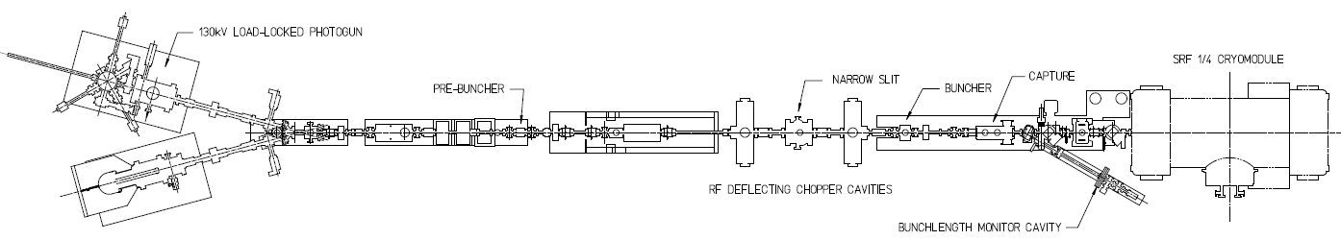

**Figure 1: the CEBAF 130kV injector. Note the location of the rf-deflector cavities, and the harmonically-resonant cavity bunchlength monitor.**

**Results:**

***Bunch length measurements using the RF–deflector technique****:*

One of the CEBAF drive lasers [7] was used to produce rf-bunched beam at 499 MHz, which was then delivered to the rf-deflector cavities (mid-plane of cavity pair X m from photocathode). The average beam current was adjusted from 1 to 100uA by simply adjusting the power of the drive laser light. For each beam current, bunches were moved across the narrow chopping aperture by incrementally adjusting the laser phase relative to the rf-deflector cavities, in one degree steps. The electron beam passing through the slit was monitored using a downstream Faraday Cup, thereby providing a measure of the electron bunchlength and shape. The results presented in Figure 3 illustrate the extent to which space charge forces influence the electron bunchlength and shape, with bunchlength (full width half maximum, FWHM) increasing from 48 to 125 ps, as current increased from 1 to 100uA. The laser pulsewidth was measured using a fast photodiode and sampling oscilloscope, and found to be 45 +/- 2 ps, which is consistent with the electron bunchlength measurement at 1uA. The electron bunch profile was Gaussian at low current but became distorted at higher current.

To calculate the bunchlength values included in the legend of Figure 3, the width of the chopper slit was deconvolved from raw data. This was accomplished using the software program IGOR, which provided results in close agreement with the simple calculation $t= \sqrt{t_{meas}^{2}-{18}^{2}}$, where *tmeas* describes the width of raw-data trace (FWHM) and 18 ps represents the width of the narrow slit. To assign errors to the results, the width of the narrow slit was assumed to possess some uncertainty, +/- 1 ps, that would result due to improper chopper setup, for example by not driving the rf deflector cavities or nearby solenoid magnets at design values.

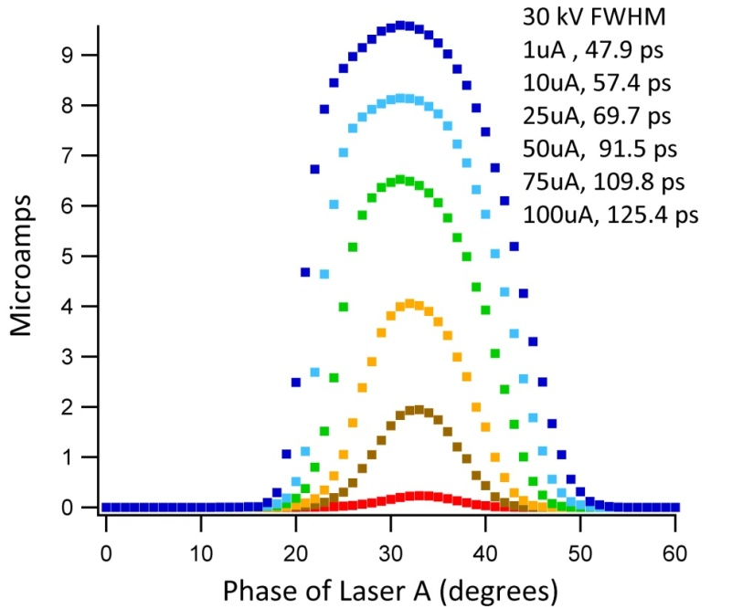

**Figure 2: Electron bunchlength measurements using the rf-deflector cavities, for rf-bunched beam at 499 MHz, for average beam current ranging from 1 to 100uA. Beam current was varied by changing the laser power. The laser pulsewidth was constant and measured to be ~ 45 ps using a fast photodiode and sampling oscilloscope. The legend lists the bunchlength (FWHM) at each current.**

***ASTRA predictions:***

The harmonically-resonant cavity was located approximately 4 meters downstream of the rf-deflector cavities and bunches traveling beyond the rf-deflector cavities are expected to grow due to space charge forces. To tie together the measurements of both devices, the modeling program ASTRA was used to predict the electron bunchlength at both locations. Agreement between ASTRA predictions and the bunchlength measurements using the rf-deflector cavities was deemed essential, to validate the ASTRA predictions of bunchlength measurements at the location of the harmonically-resonant cavity.

ASTRA tracks macro-particles through user-defined external fields while including the effects of space charge forces on the particle cloud. Three dimensional field maps of complex components (i.e., asymmetric) can be used, but for simple, cylindrical elements such as RF cavities and solenoids used at the CEBAF photoinjector, basic on-axis field maps provide a good approximation with reduced computation time. Bending elements such as dipoles can be included but the reference axis does not change with the average direction of the bunch and defining realistic fringe fields is difficult. Calculations show dipole magnets at the CEBAF injector contribute less than 0.01% increase in the bunchlength, due to the beam’s very low energy spread. For this reason bending magnets (dipoles and steering magnets) were ignored in the simulation. The RF deflecting cavities were also ignored because the impact of these elements effectively “cancel out” when beam is returned on axis.

The root-mean-square laser spatial profile at the photocathode was 0.25mm, determined using a CCD camera with Spiricon software. The thermal emittance of the photocathode was assumed to be X, based on the measured laser spot size and reference X [Cornell data]. Electron bunches emitted from the photocathode were assumed to mimic the temporal profile of the drive laser pulses. As noted earlier, the laser pusewidth was measured to be 45+/-2ps (FWHM), but unknown temporal shape due to limited bandwidth of the fast photodiode and oscilloscope sampling head. For our simulation, we described the temporal shape of the laser pulse using a super-Gaussian formula; $y=B+Ae^{-{{\left(x-x0\right)}^{n}}/{s^{n}}}$ with *A, B,n, s* and *x0* as free parameters. The order, *n*, of the distribution sets the laser pulse shape, with *n*=2 describing a Gaussian temporal profile and *n*>>2 describing a more uniform “top hat” temporal profile. The best agreement between the measured bunchlength values obtained using the rf-deflector cavity and the ASTRA simulation, was obtained using a super-Gaussian laser temporal profile of order *n=7*, and with a 43 ps laser pulsewidth FWHM (Figure 3). The largest deviation between measurement and simulation was 2.5%.

**Figure 3: Electron bunchlength as a function of current, with measurements obtained using the invasive rf-deflecting cavity technique. Data points represent the bunchlength values shown in the legend of Figure 2. The overlaid fit to the data represents ASTRA model predictions using a super-Gaussian laser temporal profile of order n=7 and 43 ps pulsewidth (FWHM). The inset shows variations in laser temporal profile, with *n=2* describing a Gaussian temporal profile and *n*>>2 describing a more-uniform “top hat” temporal profile.**

***Bunchlength measurements using the harmonically-resonant cavity:***

Beam that had previously been evaluated using the rf-deflector cavities was allowed to drift to the harmonically-resonant cavity (11.36 m from the photocathode), without applied bunching or acceleration. The rf-deflector cavities were energized but temporal apertures were removed, ensuring that bunches were not trimmed in time. Figure 4a shows a representative oscilloscope trace from the harmonically-resonant cavity for beam at XX uA. As mentioned above, the antenna detects the magnetic field induced by the beam, which is phase delayed by 90 degrees from the electric field. To obtain the electric field versus time waveform, the cavity signal was post-processed (or *transformed*, as it will be referred to in the future) by applying a Fast Fourier Transform (FFT) using the software program Igor [12], yielding a complex output. In the complex plane, multiplication by *i* results in a 90-degree phase rotation. The complex output of the waveform’s FFT was then multiplied by *-i* and its inverse FFT was computed. This yields the temporal profile of the electron bunch, as shown in Figure 4b, which includes “distortions” that stem from small imperfections in the cavity geometry, and as a result of imperfect antenna coupling to all cavity modes. Slightly off-resonant cavity modes, combined with non-uniform antenna coupling, result in phase and amplitude differences between the measured response of each cavity mode and ideal modes representative of the beam’s Fourier series. The distortions observed in the oscilloscope waveforms are systematic and can be corrected using the cavity’s transfer function, and by applying straight-forward math in the frequency domain, as described in detail below. Figure 4b includes an overlaid trace (blue) that represents this “corrected” signal. Figure 4c shows the frequency content of the signal from the as-built harmonically-resonant cavity (red), and the frequency content of the corrected signal (blue).

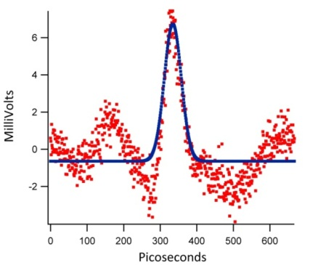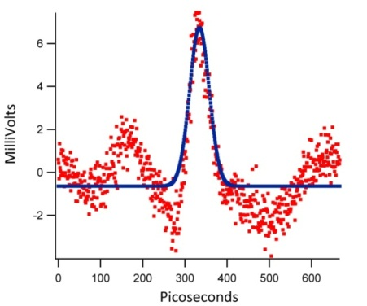 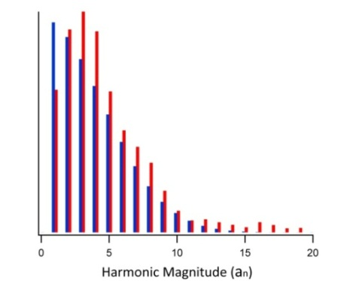

**Figure 4: a) the raw oscilloscope trace for XX uA beam through the harmonically-resonant cavity, b) the FFT of the raw signal from the harmonically-resonant cavity bunchlength monitor, together with overlaid signal, corrected for cavity imperfections and non-uniform antenna coupling, c) relative signal strength for each resonant mode of the harmonically-resonant cavity - red: cavity-as-built, and blue, the prefect cavity.**

***Estimating the Cavity Transfer Function to correct waveform distortion***

If the resonant frequency of an individual cavity mode is slightly off design, the beam can still excite this mode provided the beam’s Fourier term is not outside the mode’s resonance curve. But driving a cavity mode off the resonance peak causes a decrease in detected amplitude, and it introduces a phase shift between the beam and the excited mode. The error associated with this mode can be corrected using a single complex multiplier that “un-shifts” the phase offset and scales the detected amplitude. A series of complex multipliers - one for each cavity mode - can be created. This series has a functional form similar to equation 1 and it is called the cavity transfer function. The beam’s true Fourier series representation, $Y(f)$**,** can be obtained by multiplying each term of the Fourier series of the detected signal, $X(f)$, by each term of the cavity transfer function, $H\left(f\right)$,

$Y\left(f\right)=H\left(f\right)X(f)$ Eq. 2

The challenge associated with this approach relates to the fact that the cavity transfer function is not explicitly known, rather it must be deduced in a sensible manner. However, once the transfer function is known, it can then be used to correct the cavity systematic errors for all subsequent data, independent of new bunch shapes.

To generate a sensible cavity transfer function, beam was delivered to the harmonically resonant cavity with bunches of varying length, created using a variable width temporal aperture. Specifically, an arrowhead-shaped aperture that resides between the two rf-deflector cavities was inserted into the beam, to trim away the head and tail of bunches delivered from the photogun, to a varying extent. For these measurements, the temporal aperture ranged from 10 to 133 ps. The beam current from the photogun was maintained constant at 50uA at 499 MHz repetition rate, corresponding to a condition that produced ~ 90 ps bunches FWHM, with a Gaussian- temporal profile, at the chopping aperture. Immediately downstream of the temporal aperture, bunches would possess a truncated Gaussian temporal profile. Figure 5a shows transformed oscilloscope waveforms, for a variety of aperture settings that served to trim more/less from the original electron bunch profile. A transfer function was obtained by closely evaluating the condition depicted by the red trace, corresponding to chopper setting that passed beam within a 10 ps window. The narrow bunch created by this 10 ps temporal aperture grows en route to the harmonically-resonant cavity. The program ASTRA was used to estimate the amount of bunchlength growth (more below), but for this exercise, we also implemented a blind deconvolution. For beam passing through the narrow 10 ps temporal aperture, we assumed the true electron bunchlength at the harmonically-resonant cavity must be within some range of values, and that these bunches would possess a Gaussian temporal profile. A Fourier series was created for each of these “guessed” bunchlengths, from 40 to 60 ps, in 2 ps increments. Candidate transfer functions were then calculated by dividing the Fourier series of the guessed profiles by the Fourier series of the actual measured waveform. Each of these candidate transfer functions was then used to correct the waveforms of measurements of longer bunches arriving at the harmonically resonant cavity. Most of these transfer functions did a poor job of correcting waveform distortions. The transfer function deemed most accurate was one that generated the least amount of signal outside the central bunch. It produced the corrected waveforms shown in Figure 5b, where distortions and wiggles outside the central bunch were effectively minimized. This transfer function corresponded to a delivered bunch 45 ps FWHM, for beam produced using the 10 ps temporal aperture. This empirical blind deconvolution approach was validated using ASTRA which also predicted a 45 ps bunch FWHM at the harmonically resonant cavity, with Gaussian temporal profile, for beam produced at the chopper system using a 10 ps temporal aperture. Figure 5c shows the ASTRA predicted bunchlength values, for beam delivered to the harmonically resonant cavity, with conditions set by the temporal aperture of the variable width slit between the rf-deflector cavities.

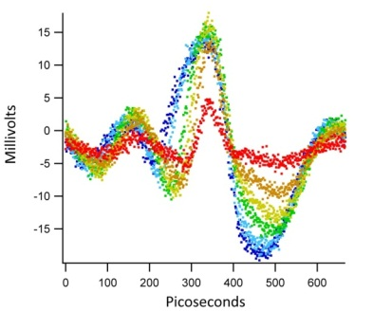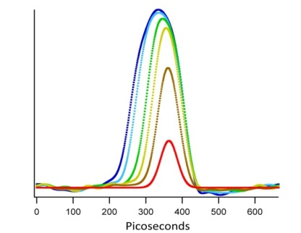

**Figure 5: Electron bunchlength plots for bunches shaped by the variable temporal aperture midway between the rf-deflector cavities: a) post-processed oscilloscope waveforms, b) the same waveforms corrected using the cavity transfer function, and c) ASTRA predicted bunch profiles, for beam passing through different temporal apertures of the chopping system.**

***Harmonically resonant cavity: Bunchlength versus Beam Current:***

After determining the harmonically-resonant cavity transfer function, the temporal apertures were removed from between the rf-deflecting cavities, which remained energized, and beam was delivered to the harmonically resonant cavity at current ranging from 2 to 50uA. Higher currents were not studied because beam loss grew appreciably at higher currents, and it could not be reduced to a machine-safe level with available solenoid magnets (under normal CEBAF photoinjector operating conditions, the capture rf-cavity provides focusing). Figure 6a shows transformed and corrected temporal bunch profiles. Electron bunchlength (FWHM) versus beam current is plotted in Figure 6. As expected, bunchlength grows with current due to space charge forces, with values ranging from 60 to 150 ps. The ASTRA predictions are in good agreement with measured values.

To investigate this discrepancy, the buncher and capture rf cavities were energized and 500 keV beam was delivered to the harmonically-resonant cavity at currents from X to Y uA. Waveforms were transformed and corrected using the same transfer function that was used to correct 130 keV waveforms. Each measurement indicated a 35 ps bunchlength (FWHM). Under these typical CEBAF operating conditions, the bunchlength downstream of the capture rf cavity is believed to be a few picoseconds, implying that the measured bunchlength value of ~ 35 ps represents the bandwidth-limited resolution of the harmonically resonant cavity. Therefore, the observed discrepancy between measured bunchlength at 130 keV and current below 10uA, disagree with ASTRA predictions.

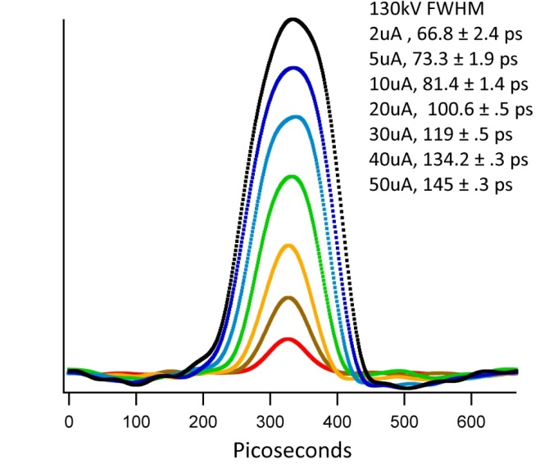

**Figure 6: a) Electron bunches produced by adjusting laser power to produce different beam currents. b) These waveforms processed with transfer functions using assumed bunch shapes ranging from 45-50 ps FWHM Gaussian bunch shapes.**

***Phase Detection:***

Finally, two lasers were used to create interleaved 499 MHz pulse trains, each with 20uA average current. These beams were delivered to the harmonically-resonant cavity, while leaving the phase on one laser constant, and adjusting the phase of the other in 20 degree increments. Figure 7 shows a series of transformed and corrected waveforms, with the vertical position of the waveforms offset to better distinguish each waveform. It is clear that the harmonically resonant cavity can

The measured waveforms have the same period as the 1497 MHz harmonic cavity. As the 499 MHz beam is stepped in 10 degree increments, the measured response steps the beam same time step, which is 30 degrees of a cycle of 1497 MHz. As an electron bunch steps off the single wavelength plot, it re-enters on the other side. When the two beams are at the same relative phase of 499 MHz, they superimpose in the cavity’s 1497 MHz measurement. These peculiarities are a result of using a 1497 MHz cavity to measure a 499 MHz beam. The cavity modes reacts to the every third term of the beams Fourier series. This behavior can be demonstrated by calculating a Fourier series of a waveform, deleting all but every third term and calculating its inverse Fourier series of the remaining terms.

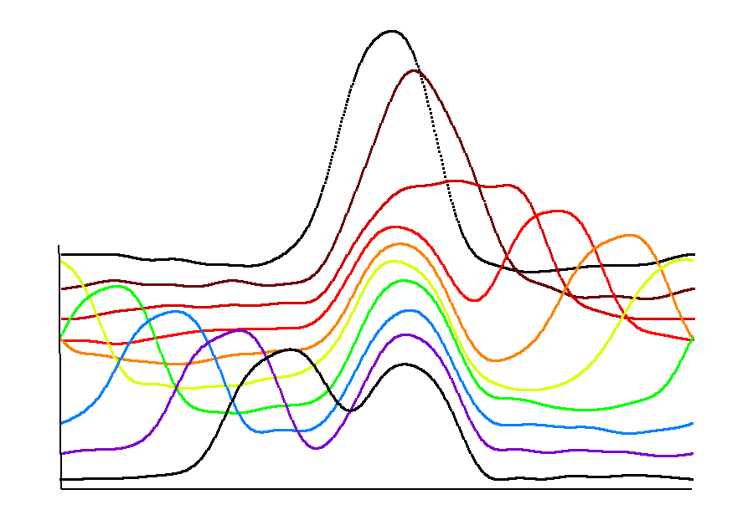

**Figure 7: a) Each curve in this waterfall plot shows two 499MHz beams measured using the 1497 MHz harmonic cavity. The data in figure 10 processed with the cavities estimated transfer function.**

**Conclusion:**

A compact harmonically-resonant cavity was installed the CEBAF photoinjector and used to evaluate the electron bunchlength of 130 keV beam. The minimum detectable bunchlength was found to be XXps. Results were in good agreement with ASTRA predictions, at least for beam current > 10 uA. This agreement was considered to validate the accuracy of the technique, in the sense that the ASTRA model accurately predicted the bunchlength measurements using a conventional rf-deflector cavity technique.

used to non-invasively measure the electron bunch length at the 130 keV photoinjector at (CEBAF). A sampling oscilloscope connected directly to the harmonic cavities antenna measured 130 kV bunch streams with near 1mV/uA sensitivity as the beam passed through its bore. The harmonic cavities transfer function was estimated and used to process these measurements, revealing information on bunch length, bunch shape, and the relative phasing of two interleaved beams. These measurements were compared to those obtained using an invasive RF-deflector cavity bunch measuring technique and predictions from the particle tracking code ASTRA. Measurements using both experimental techniques, and the ASTRA predictions were consistent, indicating that harmonic cavities can be used to accurately resolve bunch length, bunch shape, and bunch phasing, in near real-time, and non-invasively. This cavity and transfer function provides an accurate measure of bunch length for bunches > 45 ps FWHM, a useful regime for CEBAF front end. In normal operation the CEBAF accelerator runs all three beams with evenly spaced bunches. Monitoring this beam with a 1497 MHz harmonic cavity would superimpose their measurements. A 499 MHz harmonic cavity could be used to resolve all three beams simultaneously and is currently in development. There is a plan to install a harmonic cavity monitor at emittance aperture A1 (Figure 1), where it will be used to non-invasively monitor beams delivered to the halls. The cavity will help us set laser phases, prebuncher phase and amplitude and is a useful device to benchmark particle tracking codes.

**Acknowledgement**

Authored by Jefferson Science Associates under U.S. DOE Contract No. DE-AC05-84ER40150 and with funding from the DOE Office of High Energy Physics and the Americas Region ILC R&D program. The U.S. Government retains a non-exclusive, paid-up, irrevocable, world-wide license to publish or reproduce this manuscript for U.S. Government purposes.

Electrodynamic is funded by the DOE’s SBIR programDE-SC0009509

## References

1. B. Roberts, R.R. Mammei, M. Poelker, J.L. McCarter, "*Compact non-invasive electron bunch-length monitor*", [Phys. Rev. ST Accel. Beams **15**, 122802 (2012)](http://prst-ab.aps.org/abstract/PRSTAB/v15/i12/e122802)
2. ASTRA reference
3. K. Halbach and R. F. Holsinger, "SUPERFISH -- A Computer Program for Evaluation of RF Cavities with Cylindrical Symmetry," Particle Accelerators 7 (4), 213-222 (1976)
4. C. K. Sinclair, M. Poelker, P. A. Adderley, B. M. Dunham, J. C. Hansknecht, P. Hartmann, J. S. Price, P. M. Rutt, W. J. Schneider, and M. Steigerwald, “A High Average Current Polarized Electron Source with Long Cathode Operational Lifetime,” [Phys. Rev. ST Accel. Beams 10, 023501](http://prst-ab.aps.org/abstract/PRSTAB/v10/i2/e023501) (2007)
5. [P. A. Adderley](http://publish.aps.org/search/field/author/Adderley_P_A), [J. Clark](http://publish.aps.org/search/field/author/Clark_J), [J. Grames](http://publish.aps.org/search/field/author/Grames_J), [J. Hansknecht](http://publish.aps.org/search/field/author/Hansknecht_J), [K. Surles-Law](http://publish.aps.org/search/field/author/Surles_Law_K), [D. Machie](http://publish.aps.org/search/field/author/Machie_D), [M. Poelker](http://publish.aps.org/search/field/author/Poelker_M), [M. L. Stutzman](http://publish.aps.org/search/field/author/Stutzman_M_L), and [R. Suleiman](http://publish.aps.org/search/field/author/Suleiman_R), “Load-locked dc high voltage GaAs photogun with an inverted-geometry ceramic insulator,” *Phys. Rev. ST Accel. Beams* 13, 010101 (2010)
6. D.-X. Wang, G. A. Krafft, and R. Abbott, Jefferson Laboratory Technical Note TN-94-054
7. J. Hansknecht and M. Poelker, “Synchronous Photoinjection Using a Frequency-Doubled Gain-Switched Fiber-Coupled Seed Laser and ErYb-Doped Fiber Amplifier,” *Phys. Rev. ST Accel. Beams* 9, 063501 (2006)
8. R. Webber, “Longitundinal Emittance: An Introduction to the Concept and Survey of Measurement Techniques Including Design of a Wall Current Monitor,” AIP Conference Proceedings on Accelerator Instrumentation, No. 212, pp. 85-126 (1889)
9. C. A. Balanis, *Advanced Engineering Electromagnetics*, John Wiley and Sons, Inc. 1989, New York
10. D. T. Pierce, F. Meier, and P. Zürcher, “Negative electron affinity GaAs: A new source of spin-polarized electrons”, *Appl. Physics Lett.*, vol. 26, pp. 670-672, June 1975; D. T. Pierce and F. Meier, “Photoemission of spin-polarized electrons from GaAs”, *Phys. Rev. B*, vol. 13, pp. 5484-5500, June 1976
11. Igor Pro Version 6.2, Wavemetrics Inc, Lake Oswego, OR 97035 [www.wavemetrics.com](http://www.wavemetrics.com)
12. S. M. Sze, “Physics of Semiconductor Devices: 2nd ed,” Wiley, New York (1981)

1.
2. 1
3. 1
4. 1 
5. 1
6.
7. 1
8.
9. Blind convolution section.

   To simulate the conditions of the blind convolution test, the bunch profile measurement at the chopper for 50uA was used to create a longitudinal distribution for particle tracking to the bunchlength measurement cavity. For each slit position, the 50uA profile is truncated temporally about the peak, and the charge in this portion of the bunch calculated, see table x.x. The transverse and longitudinal momentum particle properties for the simulation were taken from the 50uA particle distribution at the slit location. The new distribution was propagated to the position of the bunchlength cavity. The FWHM of the distribution was calculated as before and is shown in table x.x and figure x.x.

   |  |  |  |  |
   | --- | --- | --- | --- |
   | Slit position (mm) | Slit width (ps) | Remaining charge (%) | FWHM @ bunchlength cavity (ps) |
   | 20 | 10.31 | 11.4333 | 47.4179 |
   | 30 | 33.47 | 36.7295 | 50.4087 |
   | 40 | 56.63 | 60.1449 | 61.306 |
   | 50 | 82.12 | 79.8501 | 78.7489 |

  