A Non-Invasive Magnetic Moment Monitor Using a TE011 Cavity*
J. Guo#, J. Henry, M. Poelker, R. A. Rimmer, R. Suleiman, H. Wang, JLAB, Newport News, VA 23606, USA
Abstract
The Jefferson Lab Electron-Ion Collider (JLEIC) design relies on cooling of the ion beam with bunched electron beam. The bunched beam cooler complex consists of a high current magnetized electron source, an energy recovery linac, a circulating ring, and a pair of long solenoids where the cooling takes place. A non-invasive real time monitoring system is highly desired to quantify electron beam magnetization. The authors propose to use a passive copper RF cavity in TE011 mode as such a monitor. In this paper, we present the mechanism and scaling law of this device, as well as the design of the prototype cavity which will be tested at Jlab Gun Test-Stand (GTS).

Introduction
Non-invasive measurement of the magnetic moment of a charged particle beam has long been on the wish-list of beam physicists. The previous efforts were mainly focused on measuring the beam polarization [1, 2, 3], which is in the order of $ℏ/2$ per electron or proton. Enhanced by the Stern-Gerlach polarimetry, the RF signal in the cavity generated by the beam is still extremely hard to measure.
The magnetic moment per particle of the magnetized beam is typically a few orders of magnitude higher. As a demonstration of the source for the JLEIC e-cooler, the magnetized beam generated at JLab GTS [4] can have a magnetic moment M=200 neV-s or 3.0×10⁸ $ℏ$. The JLab GTS beam also has a typical energy of 300 keV and a low γ, as well as a beam current of 5mA. These parameters make the magnetic moment more likely to be detected with an RF cavity.

Interaction between Pillbox TE011 Mode and Magnetized Beam

The angular momentum and magnetic momentum of a charged particle is determined by its motion in azimuthal direction, as shown in Fig. 1, left.
$\begin{matrix}L=γmρ^{2}\dot{φ} \\ M=L\frac{e}{2mc}\end{matrix}$ (1)
In a perfect pillbox RF cavity, the electric field of TE011 mode has only azimuthal component, and will be zero in other directions (radial or longitudinal), as shown in Fig. 1, right. For a pillbox with thickness d and radius a, when ρ/a<0.3, the TE011 mode azimuthal E-field’s amplitude can be approximated (within 1% error) as

* Authored by Jefferson Science Associates, LLC under U.S. DOE Contract No. DE-AC05-06OR23177 and supported by Laboratory Directed Research and Development funding. The U.S. Government retains a non-exclusive, paid-up, irrevocable, world-wide license to publish or reproduce this manuscript for U.S. Government purposes
#jguo@jlab.org

$E_{φ}={{\sin\left({πz}/d\right)jηρkH}_{0}}/2$ (2)
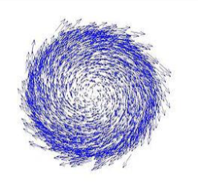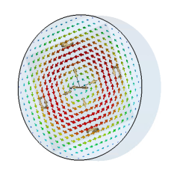
Figure 1: Left: Transverse motion of a longitudinally magnetized beam; Right: Transverse electric field in TE011 mode of a pillbox cavity
TE011 mode will only have energy exchanging interaction with the azimuthal motion of a particle, making it an ideal candidate for magnetic moment measurement. To estimate the excited RF power analytically, we assume that the beam-cavity interaction has negligible perturbation on beam trajectory. By integrating E-field tangential to the particle trajectory, the cavity transverse R/Q can be calculated as
$\frac{R_{⊥}}{Q}=\frac{{V⊥}^{2}}{ωU}=\frac{{\left(\frac{1}{2βc}cos\frac{ωd}{2βc}\left(\frac{1}{\left(\frac{π}{d}-\frac{ω}{βc}\right)}-\frac{1}{\left(\frac{π}{d}+\frac{ω}{βc}\right)}\right)\right)}^{2}{\left(\dot{φ}ρ^{2}\right)}^{2}}{ωJ_{0}^{2}\left(3.832\right)\frac{ϵa^{4}πd}{8×{3.832}^{2}}}$ (3)

When the beam’s bunch rep-rate is on resonance with the TE011 mode, the total power deposited into the cavity will be
$P_{tot}=\frac{R_{⊥}}{Q}I^{2}Q_{loaded}∝〈{\left(\dot{φ}ρ^{2}\right)}^{2}〉I^{2}$ (4)
The power of the extracted RF signal is
$P_{emitted}=P_{tot}\frac{Q_{loaded}}{Q_{ext}}∝I^{2}\left\langle {\left(M/γ\right)}^{2}\right\rangle$ (5)
The extracted RF power is proportional to the square of the total magnetic moment in the beam, and will be maximized if the cavity has critical coupling. If we choose cavity frequency of f=1497 MHz and beam velocity β=0.78, we can optimize the cavity dimensions to d=0.1530 m (≈0.98βλ for 300 keV electrons) and a=0.1615 m to maximize cavity impedance ${R_{⊥}}/{〈{\left(\dot{φ}ρ^{2}\right)}^{2}〉}$, although the transit time factor (TTF) in such case will be low at 0.352. For such a copper cavity with critical coupling, with typical Jlab GTS beam parameters M=200 neV-s and I=5 mA, the emitted power will be 3.45 μW (-24.6 dBm).
For typical beam with β=0.78 and M=200 neV-s, such a cavity has a very small transverse impedance, with ${R_{⊥}}/Q$ of only 8.6μΩ. The major challenge for this cavity is to minimize the excitation of TE011 mode from non-magnetized beam significantly. The longitudinal R/Q of this mode needs to be controlled to ~100nΩ level with careful coupler design and fabrication precision. The “rotation” of beam center trajectory relative to the cavity’s electric center axle will also excite TE011 mode signal, and the beam needs to be well aligned the cavity center. The wire stretching technique [5] can be used to find the cavity’s electric center.

CAVITY RF DESIGN AND SCALING
From Eq. (3, 4, 5), when the cavity scales with constant aspect ratio, the emitted RF power scales as
$P_{emitted}∝ω^{1.5}ρ^{4}{\dot{φ}}^{2}$. (6)
If the cavity beampipe size is not the limiting factor of the beam’s maximum angular moment, $P_{emitted}∝ω^{1.5}$, so a smaller cavity with higher frequency will be more sensitive to the beam magnetization. With scaled fabrication error, small cavities also have lower longitudinal impedance. However, if the cavity beampipe size limits the beam’s size and maximum angular momentum, a larger cavity can produce more RF signal with the same beam current.

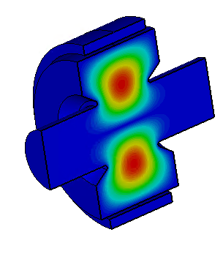
Figure 2: Electric field in the 2994MHz TE011 cavity
We initially designed the cavity by adding 2.375” beampipes to the 1497 MHz pillbox. Fringe field reduces the transverse impedance significantly, so nosecones are added to supress the fringe field. As we proceed to the mechanical design, we found that small cavities could pass the mechanical stress requirement with much thinner wall and would be much easier to fabricate. Our final design has a frequency of 2994 MHz, but with the same 2.375” beampipes. The larger relative size of the beampipes resulted in stronger fringe field and cancelled the impedance gained from the reduced cavity size. For M=200 neV-s β=0.78 beam, the 2994 MHz cavity ${R_{⊥}}/Q$ improves to 15.6 μΩ; with critical coupling, the transverse impedance $R_{⊥}$=286 mΩ is almost the same as the 1497 MHz version, with ~3.6μW extracted power for 5 mA beam. The magnitude of the electric field in the cavity is shown in Fig. 2, and Fig. 3 shows the E-field tangential to the beam trajectory seen by a particle with β=0.78 rotating along the cavity longitudinal axle.
Figure 3: Tangential E-field seen by a beam with x’=50 mrad, y0=0.01 m, equivalent to M=2127 neV-s

Cavity Coupler design
The coupler design strategy for this cavity to achieve low longitudinal impedance is to preserve the longitudinal mirror symmetry and the cylindrical symmetry as much as possible. We chose a design similar to the SLAC X-band wrap-around rectangular waveguide TE10 to circular TE01 mode launcher [6, 7]. As shown in Fig. 4, the cavity has four equally 90º spaced longitudinal slots coupling to the wrap-around waveguide, and a matched lip combining the two branches of the waveguide. The waveguide width is adjusted so the slot spacing equals λ_{g}. To make the waveguide width slightly smaller than the optimized cavity length, the number of slots has to be chosen at four. A matched coax pickup will couple to the instruments. The slot size is designed to achieve slightly overcouple based on ideal copper conductivity, budgeting for conductivity loss and mismatch in the coax pickup.
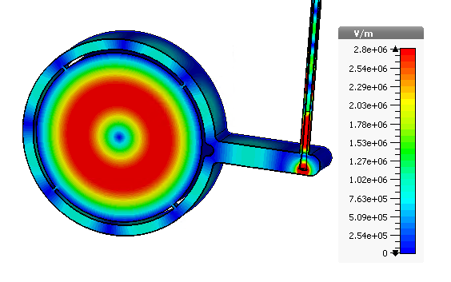
4 coupling slots
coax pickup
Figure 4. E-field in the coupler
The four slots coupler design will be sensitive to TE(4N)xx modes, and rejects the other modes. This helps to filter out most of the noises from the unwanted modes. The frequencies of TE411 and TE811 modes can be tuned away from possible bunch excited frequencies. For the prototype, the only damping mechanism for the other HOMs and LOMs is the cavity wall loss, which could be sufficient for the purpose of proof-of-principal. For a device to be installed in an operating accelerator, beampipe dampers can be added.

Cavity mechnical design
The main cavity body contains four parts machined from two blocks of OFHC copper, including two end-plates, the inner cavity wall, and the outer wrap-around waveguide wall, as shown in Fig. 5. To minimize the deformation and preserve the symmetry, the four copper parts and two stainless steel beampipes will be brazed together, as shown in Fig. 6. Fig.7 shows the inside of the cavity. RF bench measurement can be done by clamping the parts together before the final braze..
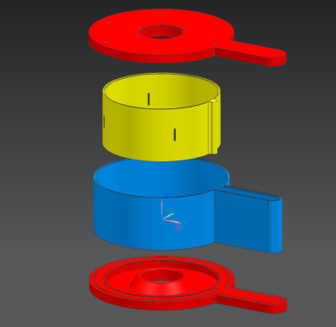
Figure 5. Exploded view of the cavity’s copper parts
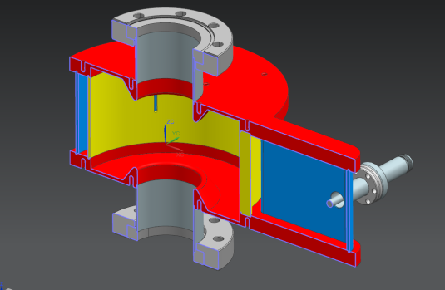
Figure 6. Cut view of the assembled cavity
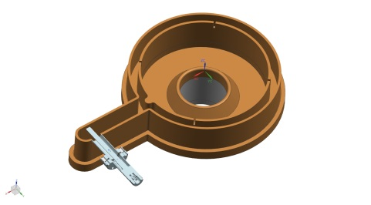
Figure 7. Cut view of the brazed cavity
Vacuum pressure analysis results showed that with 3mm wall thickness, the 2994 MHz design with 3 mm wal thickness easily passed the criteria on all types of stress set by ASME Boiler and Pressure Vessel Code, while the 1497 MHz design failed even with 5 mm endplate thickness.
Frequency tuning is not required in the prototype, as we can tune the laser rep-rate to resonate with the cavity frequency in the JLab GTS. However, we reserved the capability to add tuners in the future.

Summary
We proposed and designed a Beam Magnetic Momentum Monitor using an RF cavity in TE011 mode. The RF signal power excited by the beam is theoretically proportional to the square of the beam’s magnetic momentum. For low velocity beam, the cavity could provide sufficient signal strength and low noise. The cavity fabrication will start soon. Such a cavity could also be adopted for Stern-Gelach polarimetry, with possible improved sensitivity and noise level compared to previous attempts.

AcknowledgemenTs
The authors need to thank J. Armstrong, F. Fors, D. Machie, L. Turlington, S. Williams, for their help in the mechanical design and analysis of this cavity. We also need thank Ya. S. Derbenev and R. Li for the discussion regarding the dynamics of this cavity.

References
[1] Ya. S. Derbenev, “RF-resonance Beam Polarimeter: Part 1. Fundamental Concepts” NIM A 336, p.12-15 (1993).
[2] M. Conte et al, “The Stem-Gerlach Interaction between a travelling particle and a time varying magnetic field”, arXiv:physics/0003069v1
[3] P. Cameron et al., “Proposal for a Cavity Polarimeter at MIT-Bates”, PAC’01, Chicago, 2001, WPAH136; http://www.JACoW.org
[4] M. Mamun et al., “Production of Magnetized Electron Beam from a DC High Voltage Photogun”, THPMK108, these proceedings
[5] G. Park et al., “Improvement of Wire-Stretching Technique to the RF Measurements of E-Center and Multipole Field for the Dipole Cavities”, THPML095, these proceedings
[6] S. Tantawi et al., “The Generation of 400-MW RF Pulses at X-Band Using Resonant Delay Lines”, IEEE Trans. on MTT, Vol. 47, No. 12, Dec. 1999
[7] C. Nantista, “Overmoded Waveguide Components for High-Power RF”, 6th Workshop on High Energy Density and High Power RF, Berkeley Springs, West Virginia, 2003. https://doi.org/10.1063/1.1635127

