Magneto-Optic Kerr Effect in a Magnetized Electron Gun

Benjamin M. Hardy
Research Experience for Undergraduates Accelerator and Nuclear Physics Old Dominion University and Jefferson Laboratory

Bowling Green State University, Bowling Green

Thomas Jefferson National Accelerator Lab

Prepared in partial fulfillment of the requirement of the Department of Energy’s Office of Science, National Science Foundation, Old Dominion University, and Thomas Jefferson National Accelerator Lab under the direction of Joseph Grames in the Center for Injectors and Sources at Thomas Jefferson National Accelerator Laboratory.

Participant: __________________________________
Signature

Research Advisor: ______________________________
Signature

Outline
- Abstract
- Introduction
  - Motivation: the magnetized electron Gun
    - Electron ion cooling techniques
    - Magnetized bunched electron beams
    - Magnetized sources and gun environment
  - Kerr effect
    - Possible characteristics of polarized of light
    - Magnetized reflection of polarized light
    - Kerr rotation and Ellipticity
- Method
  - Set up
    - Artificial magnetic field
    - Permanent magnets
    - Linear Stage
    - Magnetic field as a function of distance
  - Foil development
    - Fe characterization as a Kerr reflector
    - Unpolished vs polished
    - Mounted puck
  - Testing configurations
    - Fixed polarization
    - Modulated polarization
- Results
  - Fixed Polarization
  - Modulated Polarization
- Discussion/Conclusions
  - Solenoid Magnet Trials
  - Kerr calibration
- Acknowledgments
- References

Abstract
Direct current high voltage photoguns like that of the Gun Test Stand at Jefferson Lab, successfully generate electron beams in order to advance studies in Nuclear physics. Magnetized electron beams result from electron production via photoemission within a solenoid magnetic field. As opposed to non-magnetized electron beam sources, magnetized sources have the potential to improve ion beam cooling efficiency significantly. The beam magnetization depends critically on the applied magnetic field. At the Gun Test Stand at Jefferson Lab, a solenoid magnet will be installed adjacent to the photogun to magnetize the electron beam. Due to the photocathode operating in a vacuum chamber, measuring and monitoring the magnetic field at the beam source location with conventional probes is impractical. The Magneto-Optical Kerr effect (MOKE) describes the change on polarized light by reflection from a magnetized surface. The reflection from the magnetized surface may alter the polarization direction, ellipticity, or intensity, and depends linearly upon the surface magnetization of the sample. By replacing the photocathode with a magnetized sample such as pure iron and reflecting polarized light from the sample surface we infer the magnetic field at the beam source location. A controlled MOKE system has been assembled on an optical bench to test the magnetic field on site. It consists of a low power laser, polarizers to define and analyze polarized light, a photo-elastic modulator that supplies a high frequency modulation of the laser polarization to improve the signal to noise ratio of the measurements, and a polished iron foil. Control tests using strong rare earth magnets to imitate the intended 0.15 Tesla solenoid field. Calibration of the solenoid magnet is performed at the Magnetic Measurement Facility at Jefferson Lab, by comparing the MOKE signal with magnetic field measurements. Once calibrated the “Kerr-mometer” will be available as an in-situ diagnostic of the magnetic field strength and uniformity of the photocathode within a vacuum chamber, providing an adequate description of the field at electron beam source. The report summarizes the method and results of controlled tests and calibration of the MOKE sample with the solenoid magnet field measurements.

Introduction

Motivation
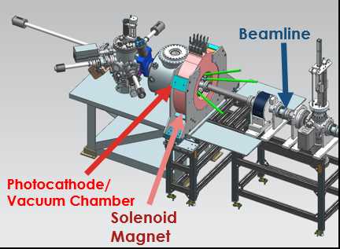
The Jefferson Lab Electron Ion Collider (JLEIC) is one of the next major foci of study at the Continuous Electron Beam Accelerator Facility. Design studies and research and development by staff and outside sources have been continuously advancing for the more than 10 years ¹. Recently, bunched beam electron cooling has been proposed and approved as an electron cooling technique for JLEIC². In general, electron ion cooling is the result of a friction force between the motion of an ion beam and an electron beam where both beams are moving at the same average velocity. A more efficient cooling technique known as Magnetized Electron Ion Cooling uses the same concept but increases ion electron interaction times as the electrons trajectories follow small helices around magnetic field lines ³. The Center for Injectors and Sources (CIS) plans to accomplish this by using a strong solenoid magnet at the photocathode, the electron beam source. Magnetic field at photocathode is an important quantity for characterization of magnetized beam and photocathode condition under high magnetic field. However, conventional probes are impractical in this case and would require breaking vacuum to obtain magnetic field measurements since electron source (photocathode) is in vacuum chamber⁴.
Figure 1: Gun Test Stand in the Low Energy Recirculating Facility at Jefferson Lab. Center of Solenoid is 22 cm from photocathode
The Kerr Effect
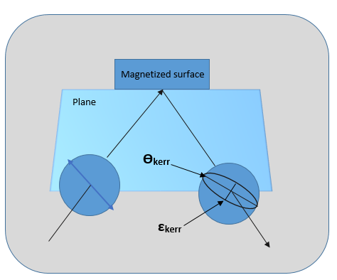
In this work we build and calibrate a system to measure magnetic field in vacuum at the photocathode using the Magneto-Optical Kerr Effect (MOKE). MOKE describes the induced circular birefringence of polarized light wave by its interactions with a magnetized surface^{5,6}. Polarized laser light travels into the vacuum chamber, reflects off the magnetized surface of the photocathode, and is then analyzed to extract the Kerr signal of the reflected light polarization, ellipticity, and intensity of the reflected laser light. Three different “geometries” are included in MOKE when it comes to magnetic field with respect to surface plane. Longitudinal MOKE describes the magnetic field as parallel to the plane of incidence and the reflective surface. Transverse MOKE describes magnetic field as normal to reflective surface but only P-Polarization shows an effect on reflection. Polar MOKE describes magnetic field as normal to the reflective surface and is the most studied because it is the only geometry MOKE can be observed at normal incidence⁷.
M
Figure 2: A visual interpretation of MOKE. Ellipticity is described as the dividend of the major axis over the minor axis.

Materials and Methods

Setup
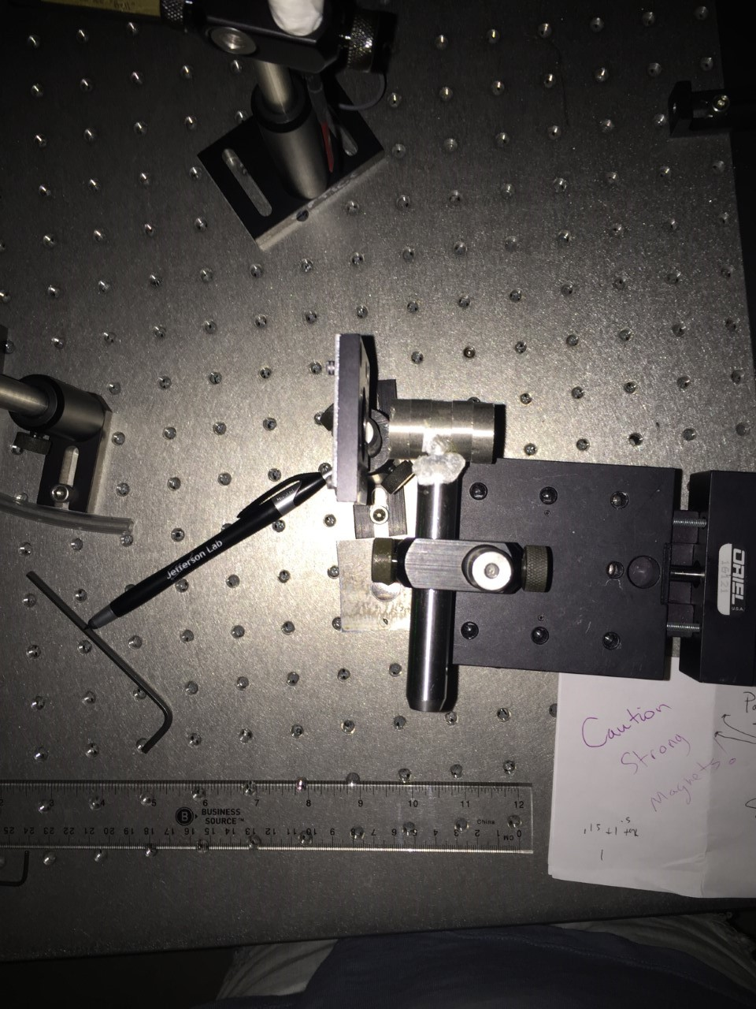
In order to understand MOKE, initial experiments off the basic properties of polarized light were conducted. Using highly magnetic neodymium magnets, a bench setup was assembled in order to observe the Kerr rotation and ellipticity of the polarized light of red (633 nm) and green light (532 nm). The permanent magnets mimic the magnetic field we would expect from the solenoid magnetic field and provided up to 3 kGauss. Mounted on a micrometer, systematic tests were conducted by moving magnet closer/farther to increase/decrease magnetic field at reflection surface. The surface in this case is a polished 99.9% iron foil. MOKE requires the surface to be magnetic in order for the light wave to be altered by the magnetic field. For bench setups, magnetic field strength at foil surface was measured relative to magnet distance. Data was plotted in order to have a fairly certain understanding of field strength in relation to magnet distance.
Figure 3: Permanent Magnets mounted to a post on a micrometer used to increase the magnetic field at surface for bench tests.
Rare earth Magnets
Graph 1: A conglomeration of magnetic field data taken with a probe at different distances from surface. 0 mm is foil surface.

Foil Development
Pure iron has been well investigated in terms of polarization and experimental data relating to magnetism. Its saturation at 2.2 Tesla and lack of oxidization make it a feasible choice for a ferromagnetic reflective surface for the diagnostic⁵.
Initial bench tests used an unpolished pure iron foil. At an incident angle of 14⁰-+ .5⁰, 633 nm 5 mW laser light traversed through the bench setup. Only 10% of the light reached a power meter with an unpolished foil reflection. With a polished foil, 16% of the light was able to reach the power meter. This 6% increase is important as later experimentation will imply larger incident angles or longer laser paths making every microwatt of power important for sensitive measurements.
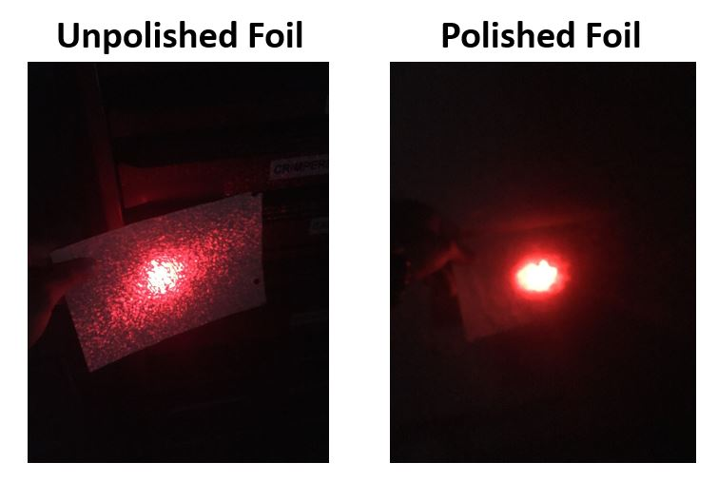
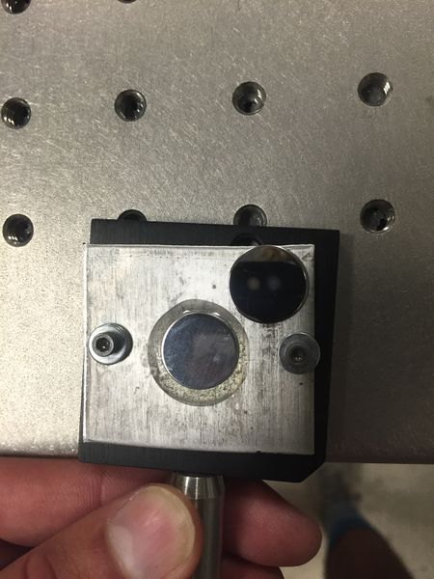
Unpolished foil
Polished foil
Figure 4 (Left): Polished foil reflection of red laser light at 20 -+5 feet from reflection Figure 5 (Right): Polished foil has a visible clarity in comparison to the haze of the unpolished

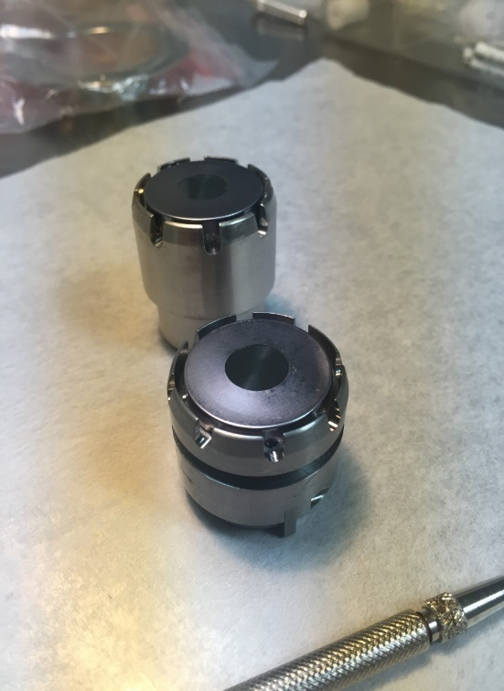
The pure polished iron foil will be on a placebo photocathode within vacuum chamber. Two types of mounts or “pucks” were investigated in order optimize magnetic field at photocathode surface. A non-magnetic “short” molybdenum puck, and magnetic steel "tall" 1006 steel puck. Iron foils were attached to pucks using indium foil. Then tantalum retaining rings with internal diameter of 11mm were crimped around the inside edges of the pucks to ensure stability at higher temperatures. In order to understand magnetic field and the influence on magnetic field model. Models were made with and without both pucks at nominal photocathode location.
Graph 2 (Left): Mapping of magnetic field on Z-axis approaching center of puck. Steel has a noticeable peak of magnetic field at surface.

Figure 6 (Right): Pucks after Fe foil mount

Pure Fe foil
(polished)
Steel Puck
Molybdenum Puck
puck position. These were later confirmed with measurements performed at the magnetic measurement facility.
Testing Configurations
Initial testing consisted of laser, 2 polarizers, reflective iron surface, rare earth magnets, and a power meter. The experiment demonstrated light rotation from MOKE and therefore power increasing or decreasing relative to analyzing polarizer axis.
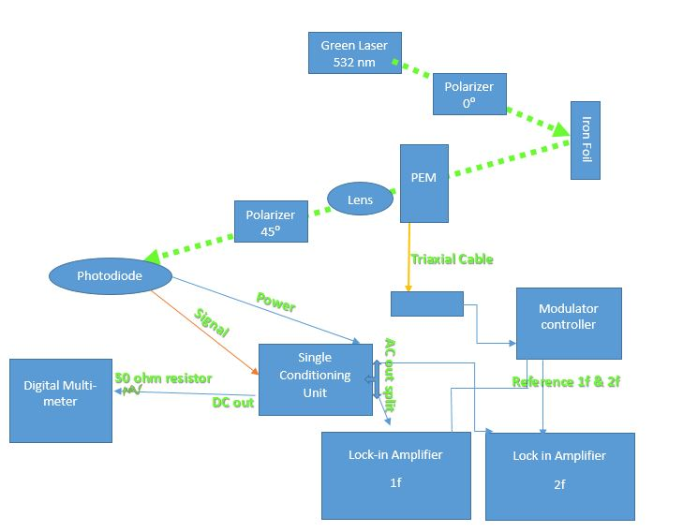
A more advanced approach to observe Kerr signals consisted of a different optical setup. Laser light polarization is set at 0⁰ (horizontal plane). Light reflects off magnetized iron surface. Light is modulated by a Photo-Elastic Modulator (PEM). Passes through a focusing lens, into a 45⁰ analyzer, and finally reaches the biased photodiode with built in pre-amplification system. The PEM modulates the laser light at 42 kHz using applied stress at resonant frequency (≈42. kHz) to the silica crystal. The photo-elastic effect occurs in the crystal as it induces circular birefringence of the incident light. Lock-in Amplifiers, “lock” on to the detected signal from the photodiode of frequencies of 42 kHz (1f) and 84 kHz (2f) and then report their amplitudes. From these amplitudes and the DC Voltage amplitude reported by a digital multimeter, we are able to extract the Kerr signals of ellipticity (ε) and rotation (Ө).
Figure 7 (Right): Schematic of modulating set-up. This layout was also used for the calibration of Kerr signals in the Magnetic Measurement Facility. Blue lines represent BNC cables. Other colored lines imply specific cables with equipment.

Kerr rotation (Ө) and ellipticity (ε) can be calculated using the following 2 equations,
Equation 1^{7, 8}

$$θ_{kerr}= \frac{√2}{4J_{2}}\frac{V_{2f}}{V_{DC}}$$

Equation 2^{7, 8}

$$ε_{kerr}= \frac{√2}{4J_{1}}\frac{V_{1f}}{V_{DC}},$$

where V_{2f} is the reported amplitude of the Lock-in Amplifier (2f), V_{1f} is the same only for the 1f frequency. V_{DC} the reported amplitude by the digital multi-meter. J₁ and J₂ are the spherical Bessel functions with a fixed value of 2.405 radians. 2.405 radians is the retardation amplitude set by the PEM controller. This value of 2.405 nulls the J₀ coefficient to convenience the calculation.

Results

Bench Tests
Three bench trials are reported below. Two trials show the relationship of Ө and ε with magnetic field strength calculated using equations 1 and 2. Negative magnetic field was accomplished by reversing the polarities of the magnets by simply flipping them over.
Graph 3: There is an 8% difference between Bench test 1 and 2 (the blue and orange lines). Mirror measurement is relatively flat.

Graph 4: Error Bars in Kerr ε are quite large.

Solenoid Tests
Solenoid tests were first performed fairly close to the solenoid field with an angle between laser and photodiode of 38.6⁰ -+ 2.4⁰. Tests were running somewhat smoothly when a measurement ramping up 25 Amp increments as opposed to 50 amp increments reported a significantly different slope (Green slope).
Graph 5: Bench/Calibration tests along with first trials (Blue, Yellow) performed in high B fields and ≈38.6⁰ reflection. Green plot shows instability of Kerr signal.

A measurement with laser dot off-center of puck read a very unstable slope as well.
Graph 6: The obvious non-linear pattern and signal drift here demonstrates system issues. Performed near solenoid and at ≈38.6⁰ reflection

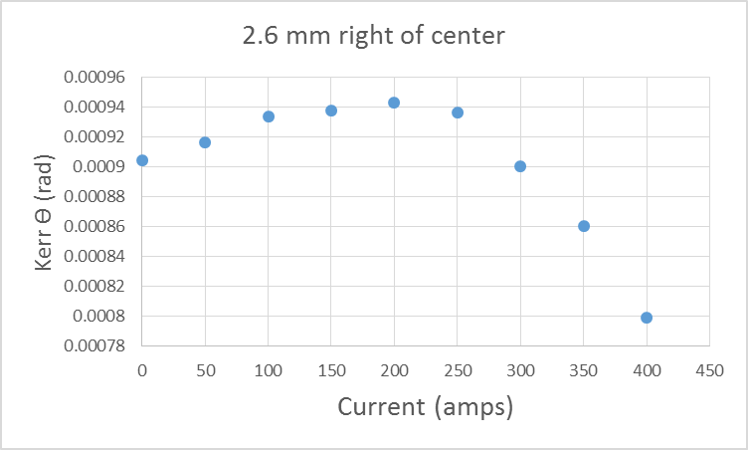

Since high magnetic field from solenoid magnet was engulfing our equipment, this was our immediate suspected cause for incorrect slopes. However, the puck holding device was a possible cause as well. Using optics equipment we tightened the puck down to ensure as little movement as possible during increase of magnetic field.
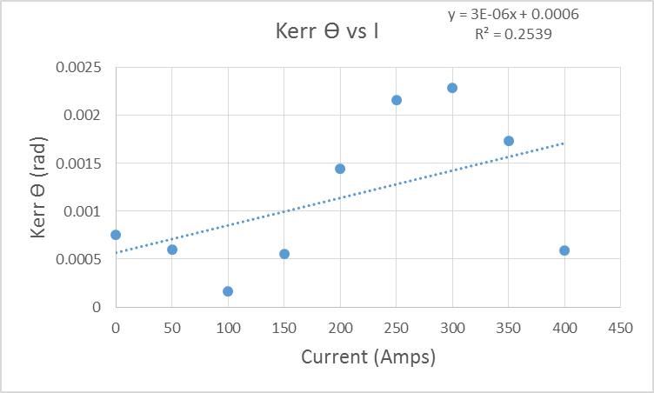
Graph 7: Laser DC voltage was very stable with this trial, only changing .2 V as opposed to 2 V in Graph 5 and 4

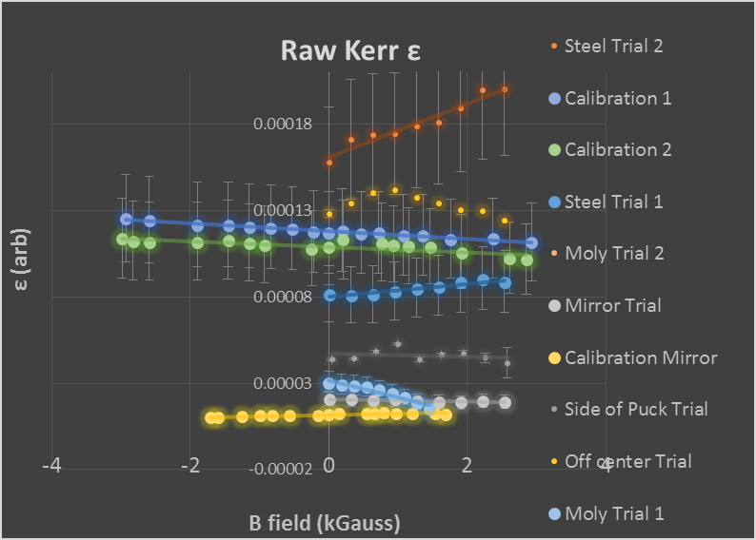
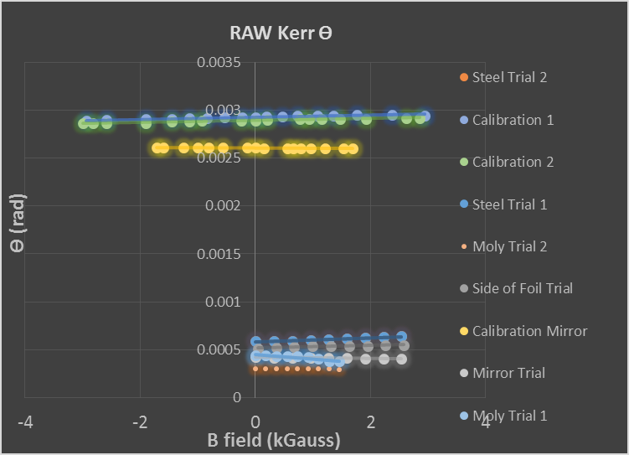
With the same puck holding device, we moved the whole optics stage far away from magnetic fields. A seemingly more stable slope was reported. The following graphs describe the measurements performed at less than 50 Gauss of magnetic field on all equipment with an angle of 5.31⁰ -+.45⁰ between laser and photodiode. Steel pucks, Moly pucks, and mirrors were used.
Graph 9: Steel trial 1, Moly Trial 1, Near stage side of puck, all follow expected Kerr signal closest.

Graph 8: Raw data including bench trials labeled Calibration 1 and 2. No offsets except for the calibration mirror.

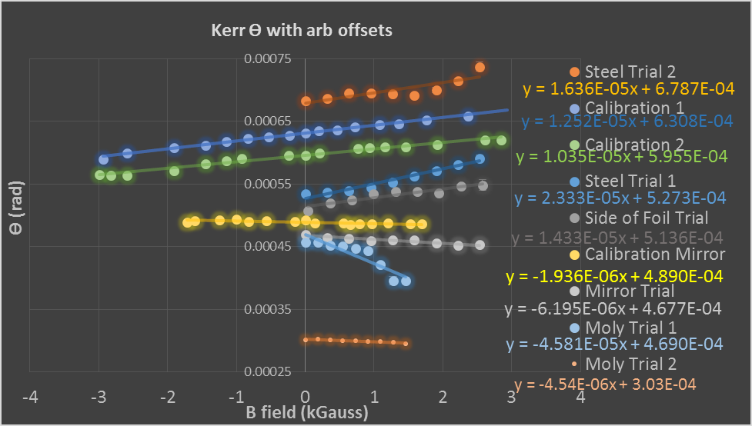

Graph 10: Arbitrary offsets are necessary to observe all the data reasonably. Slope is the only value we are concerned with.

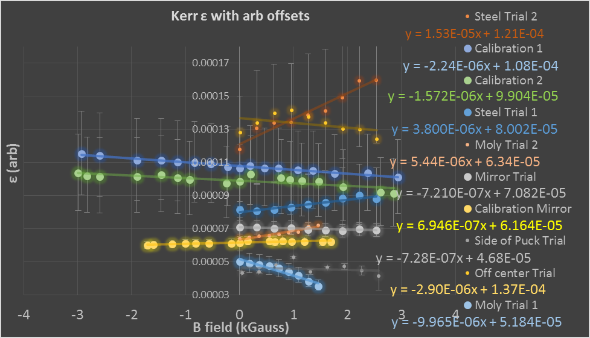

Graph 11: Kerr ε in this case was not very consistent with expected slope values.

Conclusions/Discussion

Bench test Kerr signal slopes imply the experiment works within a controlled magnetic field. From the data taken from a farther distance from the solenoid, it is possible to conclude setup needs to be out of reach of strong magnetic fields. This is supported by graph 7. The laser moved only enough to see a .2 change in DC voltage. With a very stable power there was still an unusual variance in signal, with the only suspect of magnetic field. Exactly how much magnetic field or specifically what piece of equipment needs to be free from magnetic field is still to be found out.
Along with disturbance of equipment by magnetic field, puck stability is a very important necessity. 5 mm diameter photodiode light acceptor doesn’t leave much space to miss the target. puck stability is crucial in order for successful experimentation. This is supported by Graph 10 and the Steel trial 2 measurement. DC voltage changed almost 2 V as opposed to only a .2 V change in the Steel trial 1 measurement.
Overall, the MOKE method is an extremely sensitive diagnostic and under the right conditions could be used to quantify magnetic field at the photocathode surface and possibly even surface uniformity of field.

Acknowledgments

All of precluding research was accomplished on site at Thomas Jefferson National Accelerator facility. I would like to thank my mentor Joe Grames for being a friend and someone that I can count on to push me further as a physicist. Hari Areti for his care and giving me the chance to work at Jlab for the summer. The Center for Injectors and Sources for all of their support. Riad Suleiman for his willingness to help. Shukui Zhang for always being available to assist in our experimentation by loaning equipment and advice. Jay Benesch for the magnetic model graph. Matt Poelker for his encouragement. Bubba Bullard for polishing the foils. Mike Beck and Joe Meyers for their help and enthusiasm in the MMF. Lisa Surles-Law for her energy and encouragement. I’m also thankful for the National Science foundation and Old Dominion University for administrating funding this Research Experience for Undergraduates.

References

¹ Y. Zhang, Ya. Derbenev, D. Douglas, et al. “Advance in MEIC Cooling Studies,” Proceedings of COOL2013, Murren, Switzerland, TUAM2HA04, 68-72 (2013).
² R. Suleiman and J, Grames (private communication).
³ P. Piot , Y.-E Sun, “GENERATION AND DYNAMICS OF MAGNETIZED ELECTRON BEAMS FOR HIGH-ENERGY ELECTRON COOLING,” FERMILAB, 142, (2014).
⁴ Mammei, R. R., R. Suleiman, J. Feingold, et al. "Charge Lifetime Measurements at High Average Current Using a K 2 CsSb Photocathode inside a Dc High Voltage Photogun." Phys. Rev. ST Accel. Beams Physical Review Special Topics - Accelerators and Beams 16.3 (2013).
⁵ Stephan Robinson, “Kerr Measurements of Electron Polarization,” Inaugural Dissertation, University of Basel, (1994).
⁶ Matthias Loppacher, “Moller Polarimetry for CEBAF Hall C,” Inaugural Dissertation, University of Basel, (1996).
⁷ Dr. Theodore C. Oakberg, “PhotoElastic Modulators; the Magneto-Optic Kerr Effect,” Hinds Instruments, (2000).
⁸ Kliger, Lewis and Randall, Polarized Light in Optics and Spectroscopy, Academic Press, 1990.

