RTP Installation Meeting) – Oct 12, 2019

- We have about 2 weeks in January for laser work, but sharing w/ PSS after Jan 7.

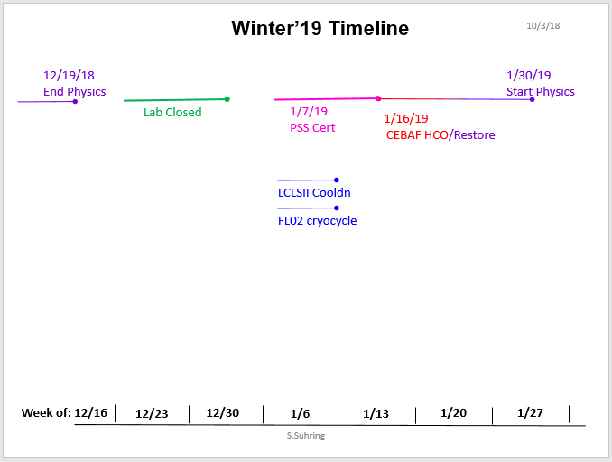

- Items for UVA RTP installation
  - UVA RTP Pockels cell in UVA mount, on existing translation stage
  - UVA PS (four + and four -), installed in rack
  - JLAB DAC (four + and four -), EDM screen
  - Modify laser cover (LSOP?), pull cables
  - Convey channel names to Halls (for recording if they want)

- Configuration/Alignment
  - Grounding, of opposing plates?
  - Which switches are we going to use (electrical, optical=falcon,dragon?)
  - Remote PC on/off

- Performance
  - (thermal) stability studies at UVA
  - plan for tracking stability and tests during SPRING 2019 run (pre-PREX/CREX

- KDP Backout Plan
  - Store cell in existing mount
  - Retain KDP DAC channels/cables tied off
  - Retain EDM interface

- JLAB RTP System
  - Raicol large aperture crystal, metalized (spare when makes sense)
  - RTP Mount
  - HVPS

