CIS-TN-18-02
February 27, 2018

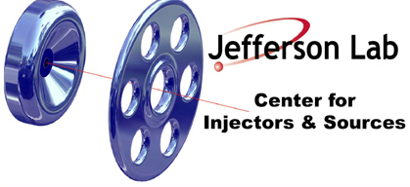

PHOTOCATHODE MOUNTING ON MOLYBDENUM PUCK BODY

CIS

Jefferson Lab

This note summarizes the steps to mount photocathode to molybdenum puck body described in drawing JL0047248.

- Collect items
  - Mo puck, photocathode removed
  - Tantalum cup, choose ID
  - Photocathode (nominal 600um thick)
  - Ta cup recessed pressing tool
  - Ta cup crimping tool
  - Indium foil
  - Indium tweezers (only touch indium foil)
  - Non-indium tweezers (only touch photocathode or moly puck)
  - Pliers to lift puck from hot plate

- Dry fit tests
  - Place photocathode on puck recess, ensure it fits, then remove
  - Place Ta cup on puck, ensure fit is not too tight or loose, carefully use Ta cup pressing tool if helpful, but do not dent Ta cup
  - Carefully remove Ta cup

- Mount photocathode under GN2 glove box
  - Cut indium square, place on puck center
  - Place puck on heater, start heater, indium will melt 156 C. Note - thermocouples typically read over 200C due to temperature gradients
  - Place photocathode on indium, press flat on edges
  - Check that puck is well seated, flat; excess indium is OK, remove later
  - Remove puck from heater using pliers, to cooling plate

- Mount Ta cup (once cool, outside glove box)
  - If indium ‘ball’ remove w/ vertical force, don’t push photocathode
  - Place Ta cup on puck
  - Press down with recessed pressing tool if required/desired
  - Place crimping screws on puck, thumb screw until uniform circle
  - Place crimping cylinder over puck/screw
  - Test Ta cup well seated (add/remove crimping cylinder)
  - Turn opposing pairs of thumb screws 1 turn at a time, until Ta cup is sufficiently crimped to puck body; note – turning until stopped will make Ta cup removal difficult
  - Remove Ta crimping tool
  - Use Ta cup recessed pressing tool if desired

