Source Group Status
5/16/2018 (Poelker)
CEBAF-related
CEBAF #1 (today):
The polarized source performed very well through the Spring 2018 physics run. Very little down time, and only related to drooping power from the Hall A laser preamplifier. Shukui to address this issue using polarization maintaining fibers, parts ordered. The photogun lifetime was markedly better than the previous physics run, with charge lifetime increasing from 200C to 800C. We speculate this is a result of using the Vertical Wein filter to orient the spin polarization, with Wien electrodes acting as ion precipitators.
Bubble Chamber: the engineering run with C3F8 target fluid went very well. Some issues include: accurate beam energy measurement and time it takes to make the measurement, background rates a bit too high, maintaining defined beam position at radiator through all the energy changes. Despite these issues, Argonne folks seem optimistic the run will produce an interesting physics result, and approval from Patrizia Rossi to conduct the formal PAC-approved physics experiment with 16O.
200kV gun installation: Next week we will replace the photogun electrode with one that protects the triple-point-junction, to allow reliable operation at 200kV. And we will install a new 350 kV Glassman high voltage power supply interfaced to the PSS. The extra voltage will allow us to process-out field emitters. We will install a krypton tank and plumbing for inert gas processing if needed. Along with gun electrode, we are installing a new NEG-coated beampipe with two BPMs, which should help us conduct PREx, CREx and Moller.
Following the bakeout, we could perform numerous beam tests in Injector-Segment mode, beam to Faraday Cup1. Lifetime at 130kV and 200kV. Precipitator lifetime studies with voltage applied to anode and both Wien filters. Lifetime runs at milliampere currents using the DBR photocathode. Wien filter studies to assist the Wien filter upgrade for 200kV beam, chopper rf commissioning for 200 keV beam.
We want to squeeze into the SAD one week of beam studies with K. Paschke and C. Palatchi of UVa, to test their new polarization controller with low voltage RTP cells. And one more test of the TE011 RF cavity polarization monitor? But this cavity might need to get pulled to use the 200kV/500kV spectrometer line.
CEBAF #2 (preparing for 2019 SAD): Gabriel Palacios will continue to perform electrostatic modeling of the 200 kV gun, specifically to determine if a triple-point-junction shield is needed for the insulator/ground interface. He will also model the Wien filter, to upgrade it for 200keV beam. MIT Bates sent us an old Wien filter which we can modify and test before installation at CEBAF. Unfortunately, Jeff Dale left the machine shop before building our Wien magnets.
Need to finalize the baked beamline layout of the re-configured Two Wien Spin Flipper. Danny has a good first-pass layout but need girders, etc., And we need to model the new layout with a particle tracking code. Are the bpms in the right place, to permit accurate Helicity Correlated position asymmetry measurements?
How long is the length of 2019 SAD, will it be long enough to rebuild the Two Wien Spin Flipper baked beamline?
Prepare for Bubble Chamber experiment with N2O, the actual PAC-approved astrophysics experiment. Improve our energy measurement technique, emittance and energy spread techniques. Setup the beam in advance of the experiment, save the files to speed the energy changes. Muon detector to veto bubbles produced by cosmic rays?
CEBAF #3 (assorted): I asked Ken Law to provide a pressure assessment of the entire CEBAF machine, to help Pavel D. and Vashek estimate radiation produced via brehmsstrahlung when our electron beams collide with residual gas within the beamline. Electron beam scattering on residual gas will generate brehmstrahhlung radiation that could trip BLMs. And perhaps enough energy loss that electrons strike the beampipe.
Josh Yaskowitz will also attempt to estimate the target represented by residual gas in beamline, for brehmsstrahlung radiation. In addition, he will consider ion production, and the possibility that ions get trapped by the potential of the beam, enhancing brehmsstrahlung. Ions could be removed using precipitators (e.g., a biased wire on a BPM) and an ion clearing gap. The BLMs in the spreader recombiner regions could be used to evaluate the benefits of removing these ions.
Support Richard Milner and MIT develop their Dark Light proposal, 50 MeV beam delivered to a target at the 123 MeV spectrometer beamline at CEBAF.
UITF: MeV beam delivered to waist-height beam dump before the end of the fiscal year. It is looking increasingly difficult to meet this “deadline”. To-do tasks include:
- Finish the waist-height MeV beamline, with dump and spectrometer
- Commission the cold QCM with RF (need approved OSP and klystons)
- Develop and the PSS BCM credited control
- Documentation: OSP QCM commissioning with RF, OSP Buncher, UITF Accelerator Operations Directive (UITF AOD), Conduct of Operations, Accelerator Readiness Review
- Shielding, work with Vashek to define it, install it all, with RCD labels affixed
- Commission the buncher, how much energy could the buncher provide to the beam? Shieling concerns…
- Build a new 200 kV gun, after moving the UITF gun to CEBAF (need the machine shop to finish the electrode, then it needs to be polished)
- Make photocathodes with high QE
- Demonstrate long lifetime operation with keV beamline
- Design the elevated beamline
- HDIce layout, dump, vacuum, work platform
- BPMs capable of seeing 100pA beam (for HDIce)
- Cultivate/identify UITF Users: fast kicker tests, Nb3Sn-coated cavities to support Grigory Early Career Award, non-invasive polarimeter, positron production and material science, JLEIC magnetized beam, polarized target fabrication, water purification, etc.,
GTS: Wrap up the LDRD magnetized beam project, deliver on all the promised deliverables. Then install the rf-pulsed thermionic gun being constructed by sbir-partner Xelera, make magnetized beam with it.
- Finish photogun repair, demonstrate reliable operation at 200 kV without field emission
- Rotation/drift emittance measurements versus laser spot size and magnetic field
- Lifetime with RF structure at 4.5mA
- Emittance versus photocathode recipe, surface morphology
- 32 mA operation: lifetime and beam properties
- laser with high pulse energy, regenerative amplifier
- nC bunches
- CsK2Sb, Cs3Sb, NaK2Sb photocathodes, compare lifetime
- RF cavity to measure beam magnetization
- rf-pulsed thermionic gun
Photocathodes: Repair the electrical shorts at the Channel Electron Multipliers, install bulk GaAs and verify functionality by obtaining result similar to Wei Lui. Train Shukui to use retarding field Mott polarimeter. Perform these photocathode tests:
- Nanostructure GaAs photocathode
- Topological insulator tests
Lasers: Build the regenerative amplifier for nC bunch generation at GTS. Evaluate the laser that QPeak is building (532 nm, 780 nm, and 1064 nm).
Vacuum: demonstrate -13 Torr vacuum!!! Conclude something about the cryopump tests
Novel photoguns (just ideas, nothing really happening):
Black Photogun: A photogun with internal components coated with AlTiNi would appear black, which could improve lifetime by absorbing ambient light. And the coating could reduce vacuum outgassing, providing lower base pressure.
Build a true 500 kV dc high voltage photogun using the large inverted insulators purchased by the FEL years ago. Apply voltage to cathode using plastic R350 receptacle with intervening region filled with SF6. This gun could drive the LERF, with alkali-antimonide photocathodes.
Use the harmonic cavity for rf gun, drive cavity with 10 harmonic modes to create short and powerful E-field, with alkali-antimonide photocathode. Tiny warm rf gun, making CW beam with rf structure, albeit low energy.
Papers
- Yan Wang, Sajini, Mamun, Shukui and Fay submitted IPAC18 papers
- NEG coating paper published in JVST
- Wei Lui submitted paper on GaAsSb/AlGaAs superlattice photocathodes to Applied Physics Letters, rejected. Editors recommended AIP Advances, we re-submitted and now waiting to hear back.
- Gabriel and Carlos have a completed draft of the COMSOL electrostatic modeling paper, ready for submission to IEEE journal
- 5 MeV Mott paper: Charlie claims to be making good progress on the paper, he is working on the systematic studies section, Joe agreed to work with Marty to summarize the GEANT modeling section
- Joe working on PSTP proceedings describing lifetime measurements made with mA polarized beams, a good beginning for detailed PRAB paper.
- Shukui writing paper describing green-light laser that uses gain switched master oscillator and fiber amplifiers
- Poelker writing 300 kV inverted gun paper
- Mamun and Riad and Fay should start working on the first description of magnetized beam from a dc high voltage photogun
- Poelker (intermittently) working on a CEBAF injector update paper
- Nanostrucutre photocathode
- Wei thesis, edit the English version
- PEPPo technique for ILC?

2018 SAD plans, pretty firm now that we have reduced the length of SAD, thanks to extra $ to run CEBAF and enhance the physics program.
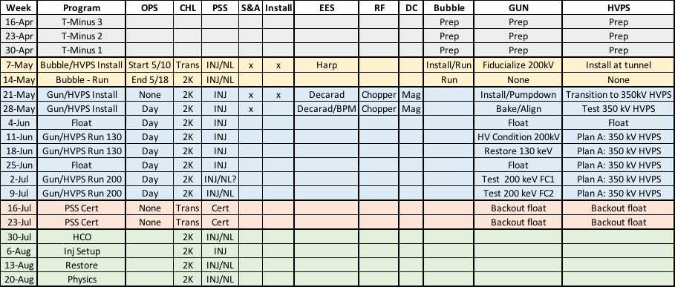
All of CIS obligations:
- CEBAF full energy upgrade: 200kV gun, 200 kV Two Wien Spin Flipper, new QCM
- CEBAF parity program: assist UVa with fast polarization flipper
- JLEIC: document preparation, gun development
- Isotope project at LERF? Need new gun and drive laser
- Bubble Chamber collaboration
- Milner Dark Light collaboration
- HDIce
- Students: Yan Wang, Sajini, Mark Steffani, Gabriel Palacios, Josh Yoskowitz
- Summer students
- Postdoc Mamun
- SBIR Partners:
  - QPeak 532, 780 and 1064 nm laser
  - Electrodynamic non-invasive polarimeter and magnetometer
  - Electrodynamic harmonic arbitrary waveform generator, fast kicker, energy booster
  - Raytum polarization controller
  - Xelera rf-pulsed thermionic gun
  - Muons Inc, maybe
- LDRD magnetized beam: finish year 3, hopefully delivering on all promises
- Richard Talman
- Charlie Sinclair
- Tim Gay
- Eric Voutier/Hugh Montgomery ILC PEPPo
- BNL (Thomas Tsang, Smedley, Erdong, Ferdinand)
- Darmstadt Max Herbert
- Grigory Eremeev, test the coated ¼ CM

