SAD 2023: March 20 through July 10 (~ 16 weeks)
Injector Upgrade part of the SAD
Goals:
- New 200kV gun
- Viewer that won’t charge up near A2
- Booster installation
- LLRF3.0
- New bunchlength monitor chassis
- New laser RF system
- Lots of mods to PSS to accommodate new gun voltage, absence of capture

Groups involved:
- Gun Group
- Injector Group
- Ops
- Cryo
- Survey and Alignment
- I&C
- DC Power
- Installation and Vacuum
- RF
- SRF
- SSG
- Software

Below, the focus is on tunnel work, where some coordination is required, and where we intend to perform clean work, then dirty work, then clean work to wrap up. In the ISB, yes, coordination is required too, but groups can expect to “do their thing” without as much fretting. Of course, if you need to drop cables into the tunnel, this work must wait for penetrations to be opened. E.g., I&C can remove all the digitels early in the process, RF Group can pull the klystron for the capture section early in the process, etc.,

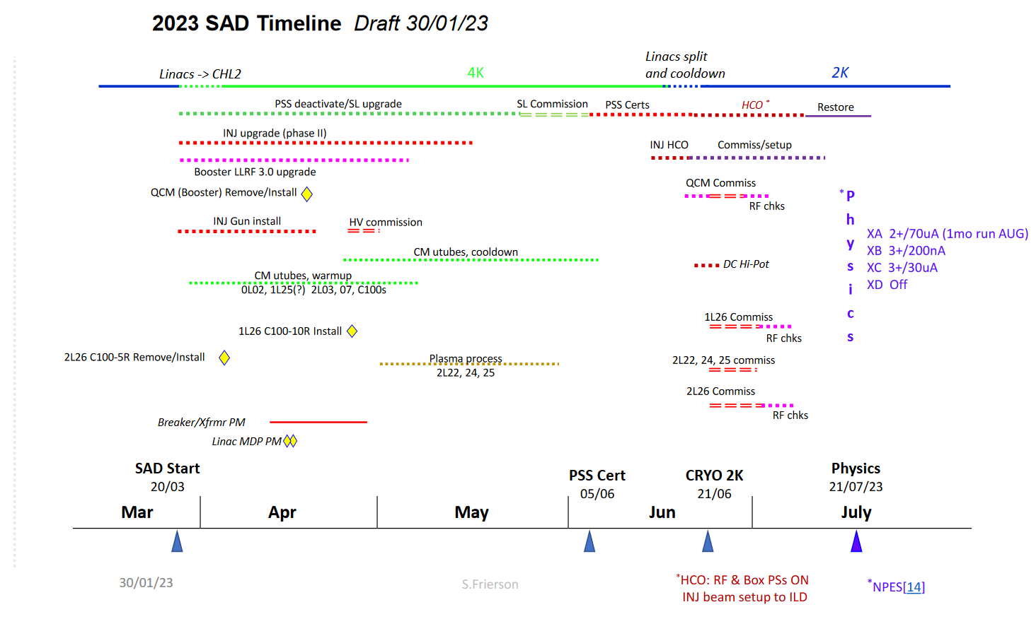

Important Dates/Milestones (suggestions, open for discussion):
7 April Gun bakeout complete
21 April Gun HV commissioning complete (work happening swing shift under OSP, no PSS)
(one month to install gun, bake it, and apply HV)
7 April ¼ CM removed
21 April Booster set in place
(one month to remove ¼ CM and set booster in place)
25 April power outage at injector?

19 May Injector vacuum work complete
19 May All survey and alignment complete (injector, west arc, dumps)
(two months to set new beamline in place, recover vacuum throughout and have all things aligned – west arc and 123 MeV dump can happen later)

2 June All I&C work complete
All DC power complete
Penetrations filled
RF work complete
(seems to me I&C, DC power and RF groups have till 6 June to finish injector work, that’s when PSS certification happens. If we stick to the dates above re: gun work and booster installation and alignment, that gives you ~ 3 weeks without interference)
6 June PSS certification begins

21 June Cool booster to 2K
22 June RF commissioning
? keV beam through chopper to FCup1
? MeV beam to 123 MeV dump
10 July Hand off to Ops for machine spin up

First two weeks (March 20 to March 31):
Survey and Alignment: as-founds phase1 and phase2 beamlines, west arc, 123 MeV dump, etc.,
CM warm up, pull utubes from ¼ CM
Vacuum Installation group: pull dump and west arc magnets, beamline
Gun Group overarching goals: gun swap, setup for bakeout, viewer/harp repair
- Make things safe (close valves, prevent them from opening, etc.,)
- S&A as-founds?
- Bring stuff to tunnel, craned in through hatch (clean room, new gun)
- Setup clean room over gun for clean disconnect, pull old gun, bring to test lab
- Install new gun, setup bakeout
- Add top hat to viewer near A2 + required mods to the harp to avoid collisions
- Add a blank off to downstream side of chopper2
- Pump down the choppers
I&C: start disconnecting phase2 beamline devices. Help make things safe re: vacuum and valves, ion pumps that need to be ON stay ON, ion pumps that need to be OFF are disconnected, valves that need to be CLOSED are closed and cannot be opened. Pull digitels? We can setup local ion pump power supplies in the tunnel…
DC Power: safe the magnet racks and start disconnecting magnets from phase2 beamline. Check cable labels.
Magnet Measurement: remove MBO dipole magnet and take back to Magnet Measurement for mapping (work with SSG to make sure we don’t damage the hall probes)
SSG: MBO magnet, hall probes, supervise their removal
Pull out the capture water skid
Remove the 1D spectrometer line, bring back to 1137 and assemble components on girder3
SRF/Vacuum Installation: setup the clean hoods on either side of quarter, close valves, disconnect ¼ CM from beamline.
SRF/Vacuum Installation can remove the downstream warm girder for parts cleaning, clean room assembly

Week 3 and 4 (April 3 - 14):
Disconnect any remaining “stuff” attached to ¼ CM: cables, insulating vacuum turbo, RF waveguides
With ¼ CM valves closed, blanked off, pull the ¼ CM from beamline and bring it to the test lab. Make sure ion pumps get powered UP when it arrives at new home. Pinch-off added to the valves instead of blank offs? Why not?
In clean manner, bring, buncher, FCup1, diff pump can, A3, A4 to TL1137 and assemble them on new girders. MBO magnet too, do this soon, to check that it fits on new vacuum chamber.
Align A3 and A4 upstairs somewhere, set insertion depth and left/right position….(A3 and A4 are on upstream warm girder, girder2)
Although we don’t have plans to re-use the capture cavity, we will pull it cleanly too. Store under vacuum at UITF, with the water skid.
Can we pull the capture cavity along with the big aluminum beam is sits ON?
With the gun bakeout complete, blankoff added to chopper2, choppers under vacuum, and “important” items from phase2 beamline removed and delivered to TL, our clean period1 ends….
Finish making the disconnects of the residual phase2 beamline
Clear out residual beamline, including the old stands
S&A to locate new stands
Installation Group hilti the new stands in place
With ¼ CM gone, time to drop stone (just one penetration, we think, near 5 MeV Mott)
I&C group can start threading new cables to beamline components

Week 5 (April 17 - 21)
I&C can continue threading new cables to beamline components…
Bring the booster to CEBAF and set in place, but blanked OFF, under vacuum
Set booster position: 1 day to pre-align (2A before vacuum hook-ups) and 1 day for finals (2B once the line is pumped down).
once booster in place, the west arc and 123 MeV spectrometer can be put back together
“dirty work” ends ~ here….although penetration(s) can still be OPEN.

Week 6 and 7 (April 24 to May 5)
Install the two new phase 2 girders, connecting chopper2 to the new booster:
Girder 1, Phil Adderley, no clean room
Girder 2, Adderley + SRF Vacuum Installation Group, using clean room practices. Might need to add A3 and A4 to beamline from inside the clean room.
Downstream warm girder delivered and installed by SRF Vacuum Installation Group
Booster now attached to beamline, clean rooms can be removed now…
(Can SRF Vacuum Installation rebuild the dif pump station? thinking we can include the dif pump station rebuild with new NEGs as a stretch goal? Dif pump station pulled, cleaned and rebuilt with new WP1250 NEG pumps, or leave the dif pump cans in place, pull top flanges with NEG modules attached, vacuum out cans, assemble top flanges with new NEGs in a clean room, bring to tunnel and install)
Spectrometer girder3 installed last: install and pull vacuum from choppers to booster, leak check.
Activate all the NEGs on the beamline, one section at a time, verify acceptable vacuum (not planning to bake the beamline. This means cable connections can be made relatively quickly, but not before good leak check performed)
Leak check phase2 beamline again after NEG activation
Would like ion pumps on epics Gamma supplies as soon as possible, for vacuum monitoring
S&A doing alignments as needed, final alignment happens this period
Can stab utubes whenever it is convenient, I guess

Weeks 8 and 9 (May 8 to 19)
I&C can cable up devices and check functionality (harp, viewers, current readbacks, water flow interlocks). Identify issues that will require venting the beamline sooner rather than later.
DC power can attach magnets and cable up, check polarities
RF Group can attach waveguides to booster, start functional checkout
SSG checking out hall probes on MBO spectrometer dipole magnet
Software check out of all devices as we go, in earnest now

So by mid-May,
all injector vacuum work complete,
S&A done at the injector
Status of I&C work, DC power, SSG work, RF group? Need to consult, see below

Need help estimating end date for these jobs, although to some extent, this work just needs to finish up before PSS certification June 6:
RF work
I&C work
Software
New laser RF evaluated very early in shutdown?
Gun HV conditioning (in parallel with work listed above, on swings?)
SSG tasks

Scattered thoughts…
Gun Group making keV beam when? To check out gun functionality, deflection studies, kicker tests, Wien studies, chopper setup
Injector group hopes to start making MeV beam on?
PSS certification presently scheduled to start June 6
When is it possible to cool the booster to 2K? June 21
RF commissioning of the booster when? Low level testing before 2K, then RF commissioning, then more low level testing after. So guess June 23 for RF commissioning

Gun HV conditioning happening in parallel, on swings?

Cool the booster and RF-commission it
Stab u-tubes, with mods to u-tubes if necessary
Cool booster to 2K
Lock up and perform RF commissioning in SEL mode, compare performance to that from 2016
The need to prioritize RF commissioning of the various CMs: booster, NL, SL CMs. Selfishly, I suggest we RF commission the booster first, and then let Gun and Injector Groups get to work making beam.

Wrapping up:
Cable up components and HCO as you go, working to ensure accurate CED
Do we imagine needing to pump the insulating vacuum “all the time” like we do at UITF?
When to re-fill penetration(s) with stone?
Gun HV conditioning via OSP (and non-functioning PSS?)
Making beam along the way, to get a jump on restoration? But with incomplete beamline and not all components ready? keV beam operations to where? Viewer limited, beam dumped on valve downstream of Chopper 2? Any beam production requires a certified PSS?
Power outages that might impact bakeouts?

Beam tests:
Gun at 200 kV, deflection studies, new laser RF checkout, kicker tests, Wien studies, chopper setup, find good orbit and transmission
Chopper setup for 200 keV beam
MeV beam and setting phases

