Progress Report:
The 15,219.579 MHz waveguide slot coupled TE011 cylindrical cavity, the 31.5th harmonic of 499.0026 MHz, are done.
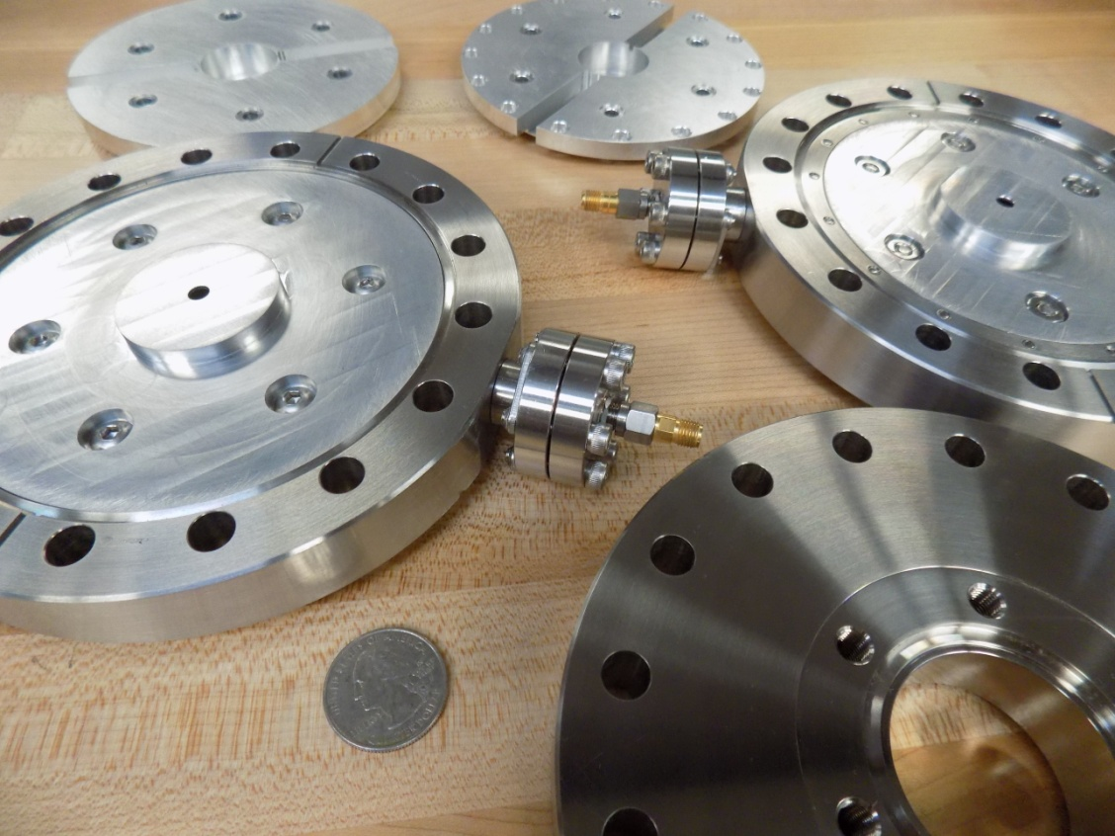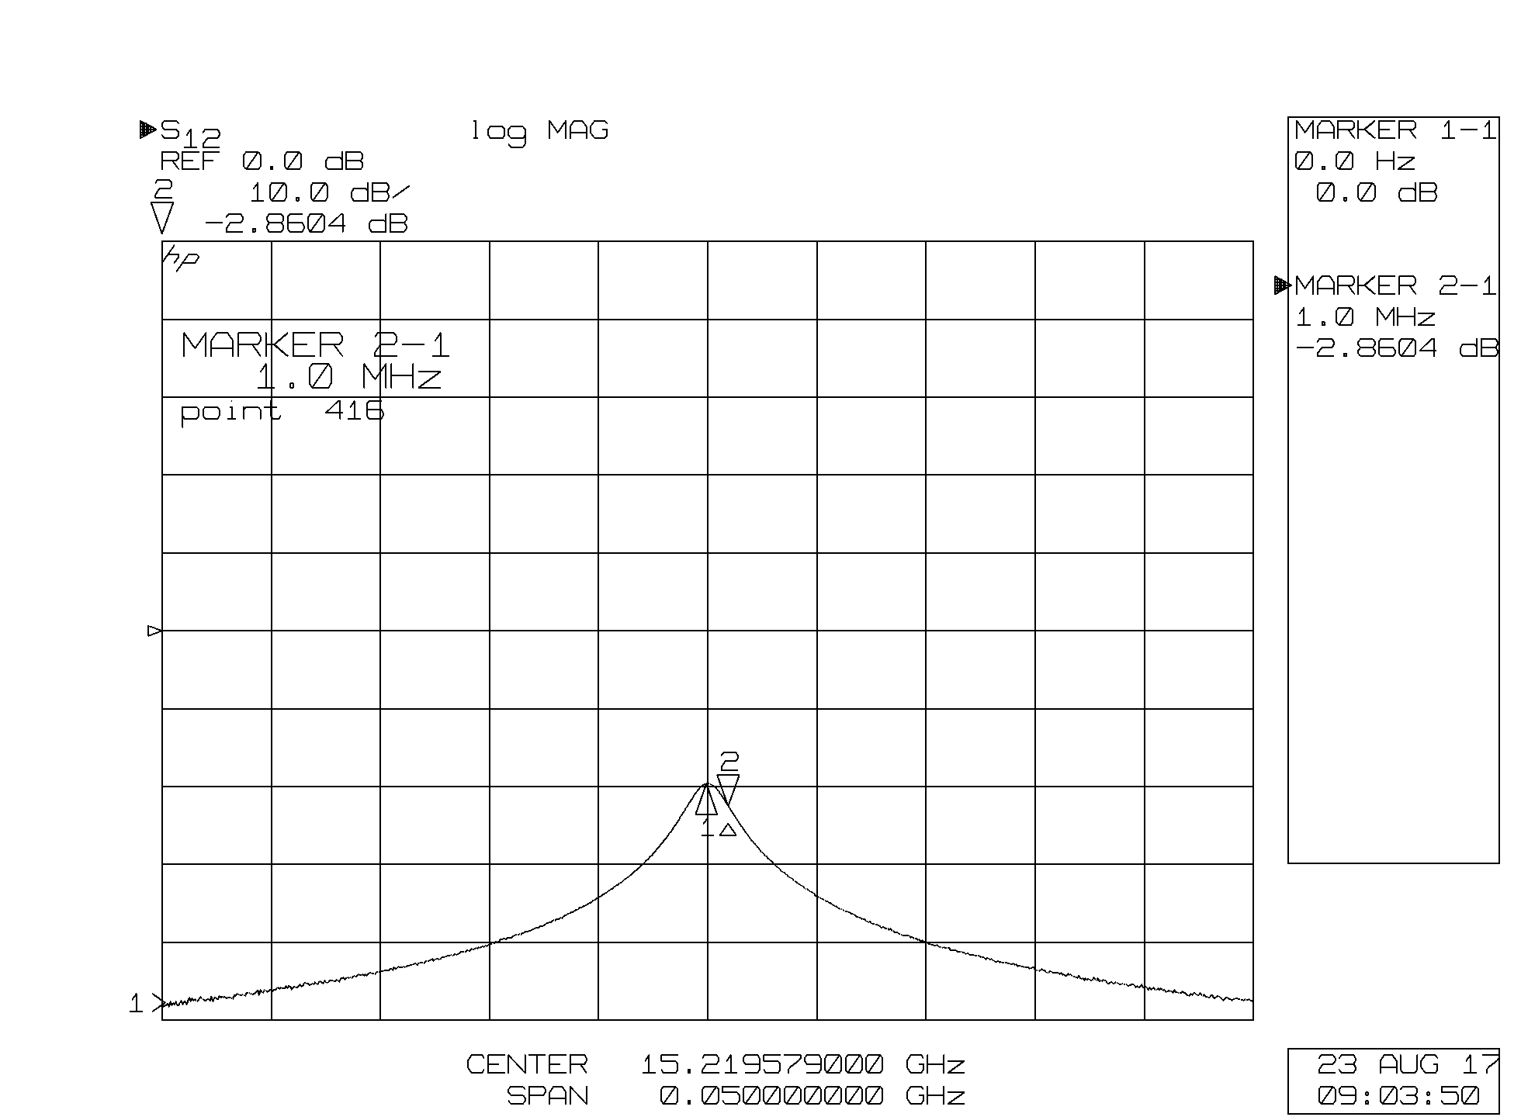
The cavities were constructed in two halves and bolted together. The waveguide is WR-62 (that is .62 inches wide) and spans the frequency range of 12-18 GHz. The bore is 5mm.
The cavity has a measured QL of 7,609. Because the coupler is matched, the unloaded Qo is twice this or 15,219.
Nice things about this design:
- The design is scalable to any harmonic desired.
- The TE waveguide and slot coupler appears to exclude all TM modes.
- The cavity is a perfect cylinder, there are no antenna’s or rings inside making it easy to model.
- The design is composed of only two parts that are made in one CNC setup. The cavity is very frequency stable and robust.
- This assembly fits within a 6” conflate flange.
- The coaxial feedthrough easily transitioned to a loop antenna waveguide coupler.
The Receiver is almost complete: The photograph below shows an I/Q demodulator that is optimized to work at 249.5 MHz and 499 MHz. The pile of hardware in the upper left corner of the picture is hardware that will be located near the cavity, and includes a low noise amplifier and filter for 15.219.6 GHz, a 14.970 GHz local oscillator generated from the 499 MHz accelerator clock, a down converting mixer and a 249.5 MHz amplifier.
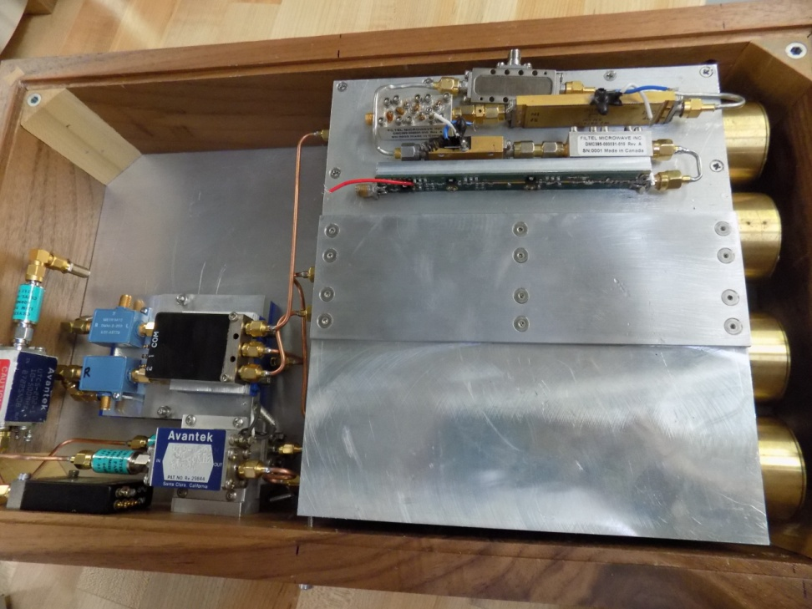

Split-Cylinder Resonant Electron Polarimeter:
An initial prototype has been constructed, and tested.
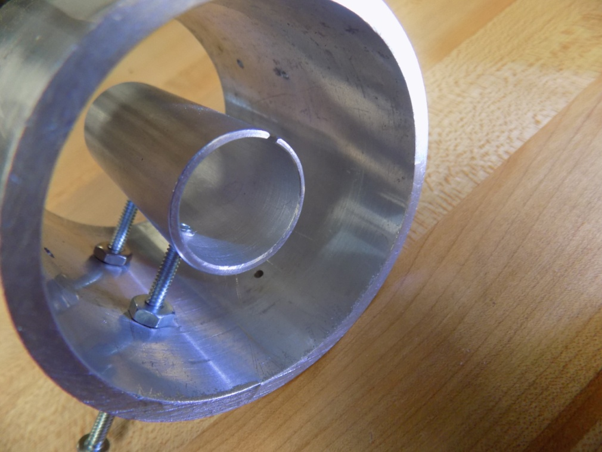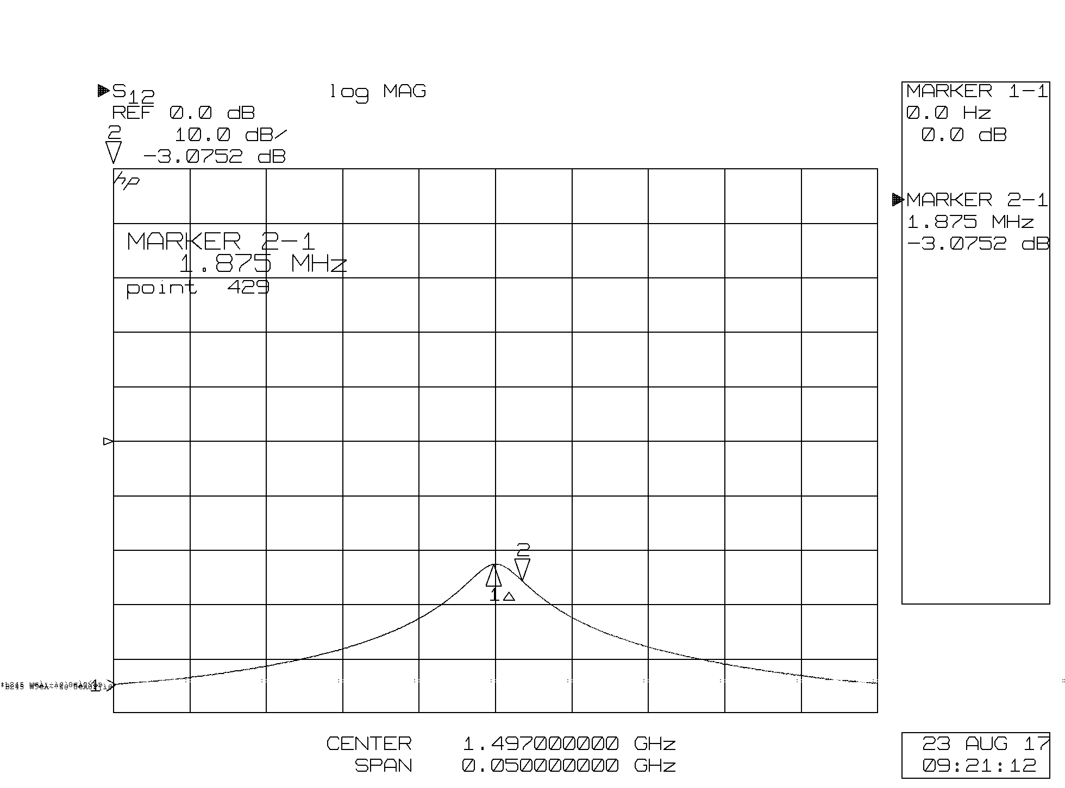

Outer cylinder ID: 2.36”, OD: 2.64, Length: 2.8”
Inner split ring resonator ID: .85” OD .98”, split width .062”, length: 2.13”
The split ring resonator is serendipitously resonant a 1497 MHz and has a QL of 400, unloaded Q= 800. The Q is undoubtedly lowered due to radiative loss and could be improved with end walls, or several split rings in an enclosed tube. The resonator was easy to excite with a loop antenna on axis, simple to build and frequency stable.

Ring Coupled Cavity Polarimeter @ 2.7445 GHz:
Progress has been made in constructing the 2nd generation ring coupled cavity polarimeter. The Silicon Carbide spacers have been cut and ground and the antenna 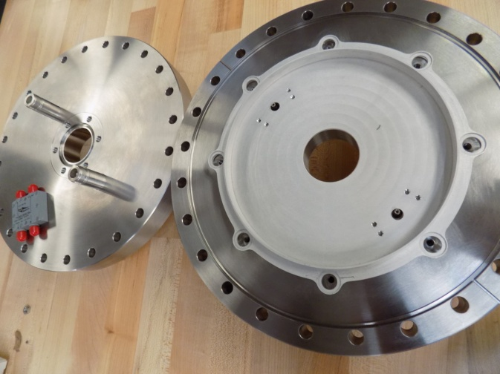 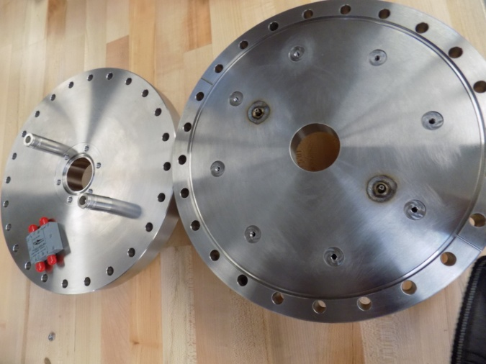
feedthroughs have been welded. Two cavities are under construction.
The 2nd generation ring coupled cavity has two improvements over the first prototype, its frequency is a multiple of 249.5 so that Reza’s beam of alternating polarization can be measured, and it has two antenna ports. It is envisioned that two identical antenna’s with opposite orientations will be recombined with a 180 degree combiner. This could help reject non-resonant coupling between the passing charge and the antenna. A second antenna port will also allow one to verify operation while the cavity is mounted on the beamline.

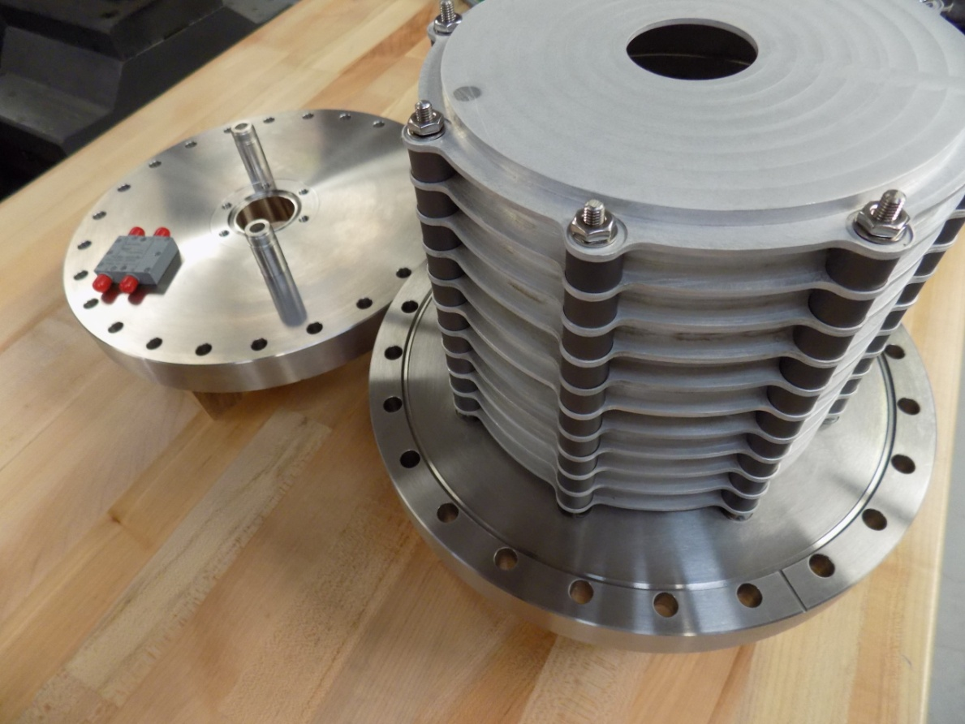

Not complete: need to trim cavity to tune its frequency of operation, build its antennas, and build a down converter from 2.7445 GHz to 249.5 MHz for I/Q detection.

Charge exclusion experiment: a charge exclusion cage was installed within a spare 14.970 GHz cavity.
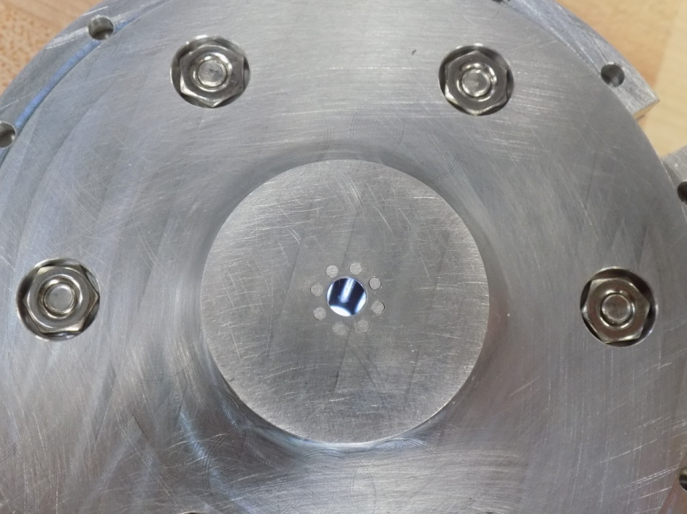
The TE011 mode shifted frequency by 10 MHz or so, but the operation of the mode seemed unaffected by the rods. The purpose for this modification was to try and reduce the coupling of the charge signal into the cavity, or the excitation of the resonance by a slanted beam. Experimentation with driving this mode with external antennas seems to indicate that one can still drive the mode with a slanted antenna, so while interesting it does not immediately appear to be a solution.

