CEBAF QE cathode scan procedure
C. Hernandez-Garcia & J. Grames
December 1 , 2021

Preconditions

1. Anode is connected to:
a) 1000 V bias power supply, or
b) Gun2 picoammeter
2. Laser PSS bypass key stored in the MCC
3. Gun long manipulator (LM) retracted into cathode prep chamber
4. Cathode prep chamber gate valve closed
5. Laser (can be any laser, Hall A, B, C or D) in Beam Sync Mode
6. Injector segment PSS either in Power or in Beam permit

Procedure Overview

The procedures consists of four basic tasks. The first two tasks take place in the injector service building. The last two tasks take place in the injector tunnel.

- Enable ability to open/laser shutter while injector segment PSS is in either controlled or restricted access.
- Bias anode with battery box and through the QE scan picoammeter to collect photocurrent during the scan
- Ground the photocathode with the long manipulator to close the photocurrent circuit
- Execute the cathode QE scan in EPICS

TASK 1 steps: Laser bypass key to open/close laser shutter

1. Call SSO x7050 and request to bring injector segment PSS in either control or restricted access, depending on what was agreed with the Program Deputy

2. Request from the Crew Chief Laser bypass key # 13
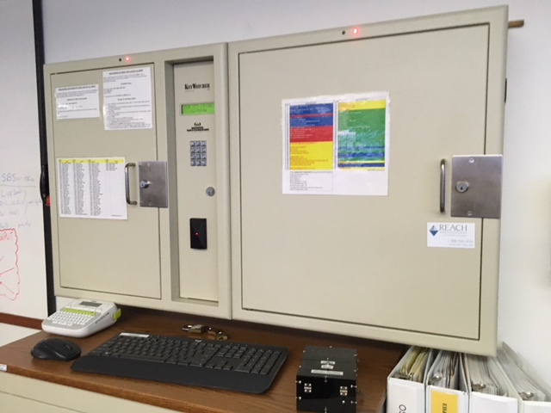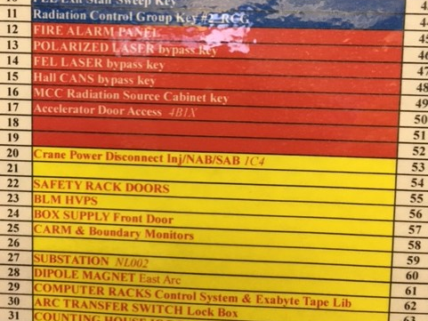

3. Take laser bypass key to the Injector Service Building
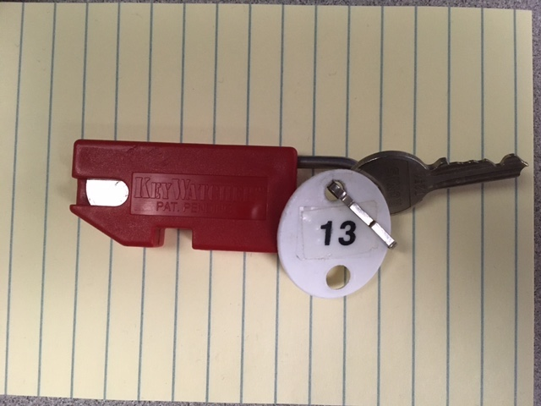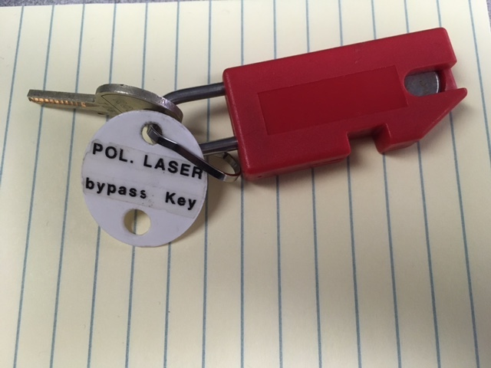

4. Open the PSS Laser Interface lid. The lid opens upon turning the key already inserted.
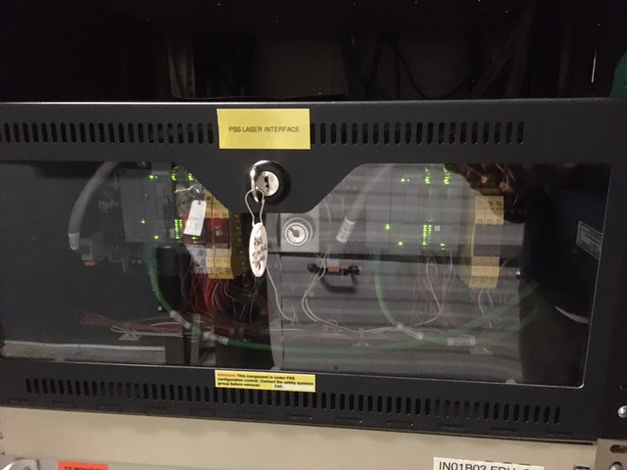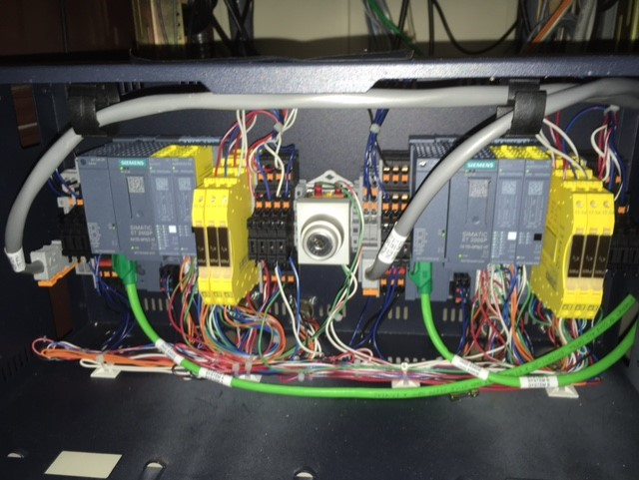

5. Insert the Laser bypass key and turn it to the right. This will enable the laser shutter to be opened while the injector segment PSS is in Controlled or Restricted access. There is a 30 seconds wait time before the bypass activates
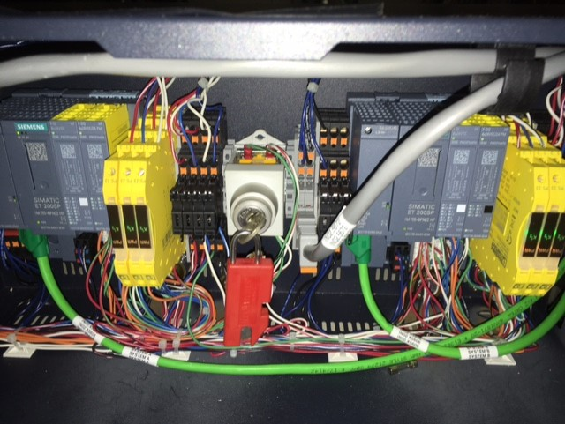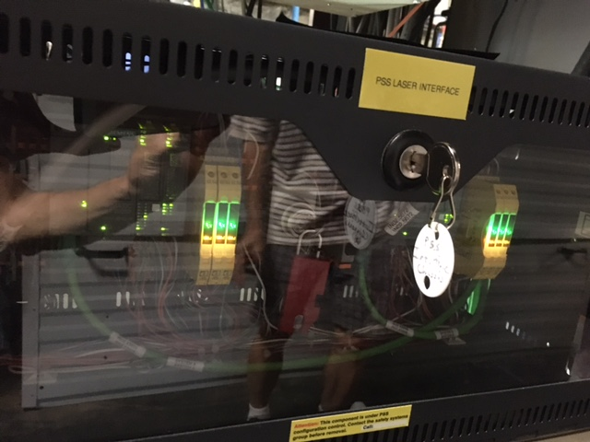

This concludes TASK 1.
TASK 2: Bias anode with battery box and though QE picoammeter to measure photocurrent during the scan

There are 3 ways to connect the anode.:

- To the GUN2 picoammeter with the over-current protection box during operations without biasing:
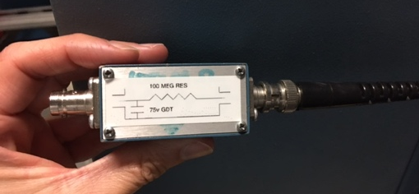

- To a high voltage power supply for biasing during beam operations to prolong photocathode QE lifetime:
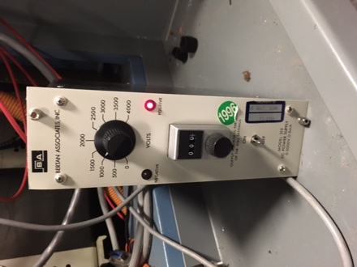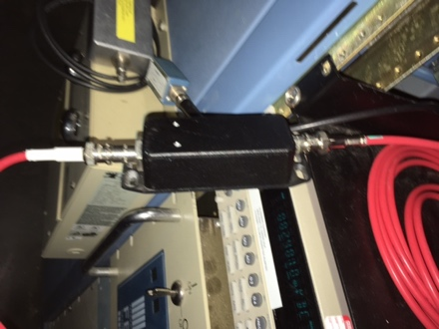

- Or to the battery box and QE scan picoammeter:

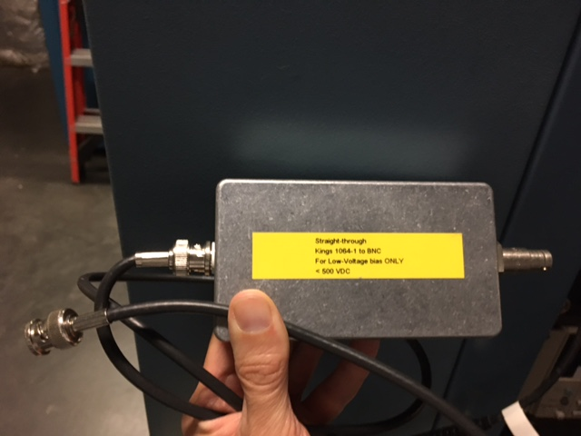

Most likely the anode is connected to the biasing high voltage power supply.
Steps:

1. Turn off the anode HV biasing power supply. The box is located in the back of the QE Scan panel rack. Simply flip the ON/OFF toggle switch located at the bottom of the power supply
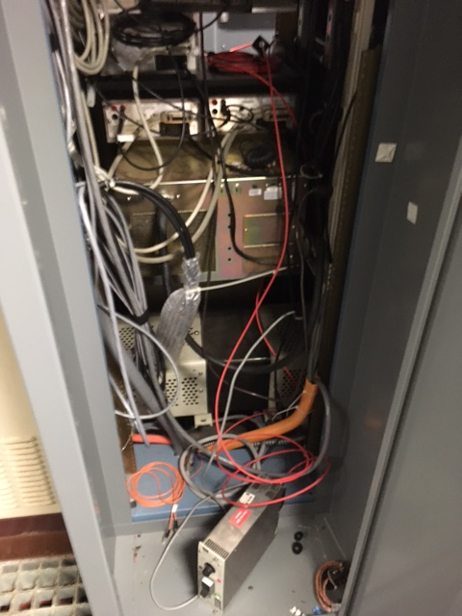

2. Unplug the red SHV cable labeled “To anode…” from the black junction box. Ensure the cable that goes to the tunnel is the one to be disconnected, by following the cable looking in the back of the rack.
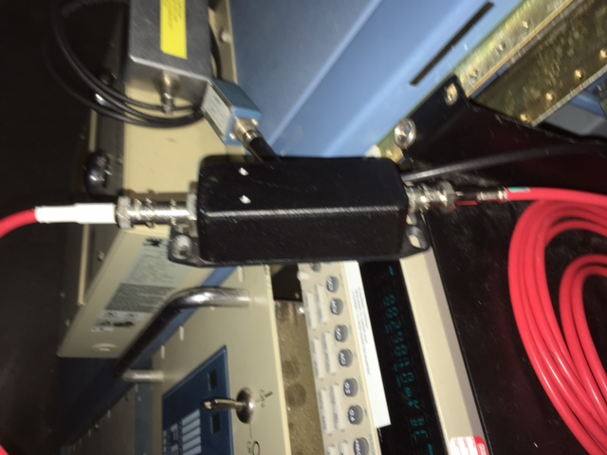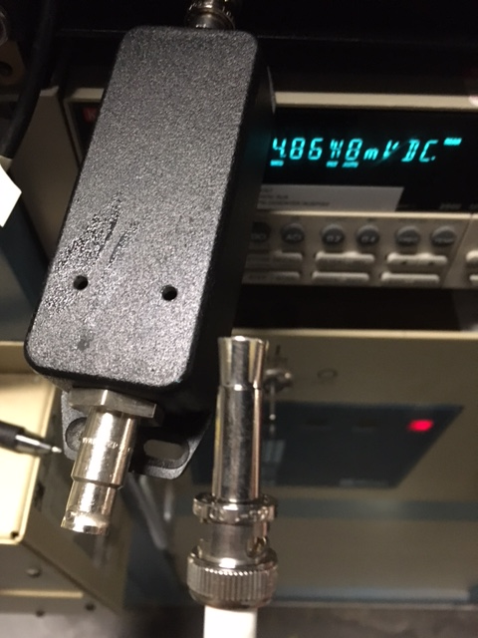

3. Connect this SHV cable (the one that goes to the tunnel) to the gray straight-through SHV-BNC junction box
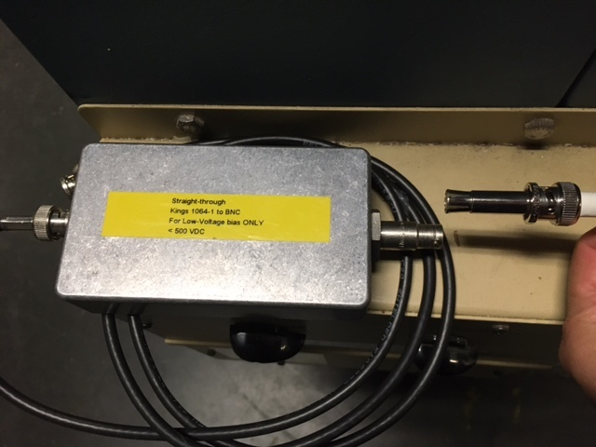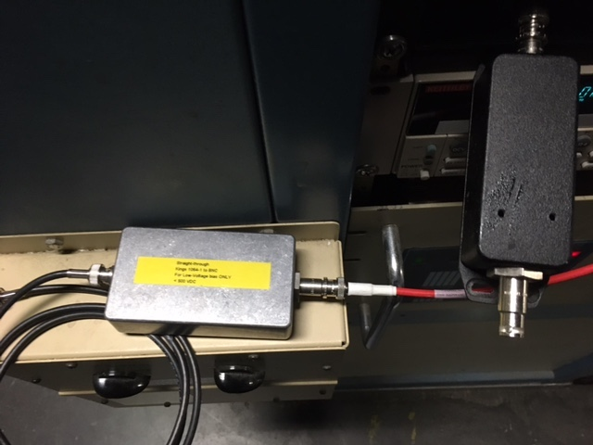

4. Connect the BNC cable from the straight-through junction box to the “POS ANODE” BNC connector in the QE Scan panel
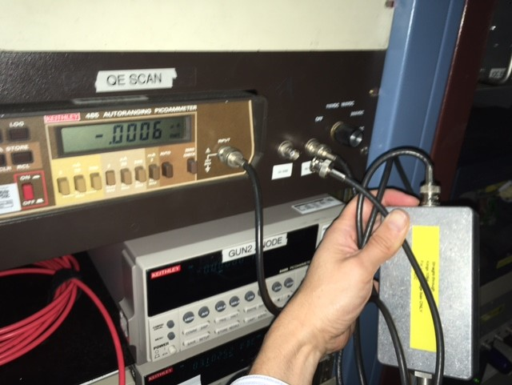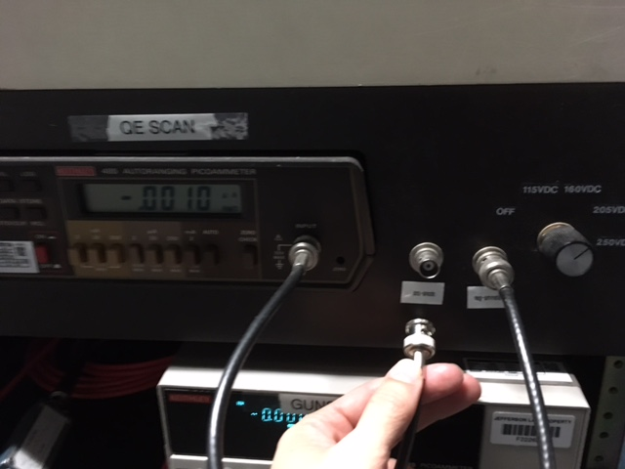

5. Ensure the QE picoammeter is connecter to the “NEG ammeter” BNC in the QE Scan panel and that the battery selector is set to 205 VDC
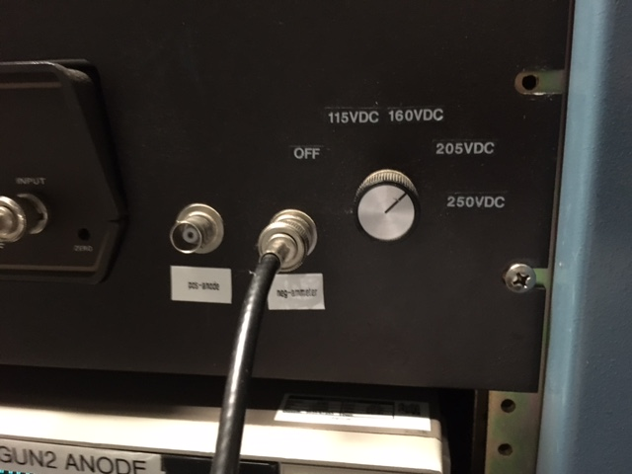

This concludes TASK 2. The anode is now biased with the battery box and through the QE picoammeter ready for the QE scan.

TASK 3: Ground the photocathode with the long manipulator to close the photocurrent circuit and do a QE Scan

The photocathode is in electrical contact with the gun electrode which is connected to the gun high voltage power supply through the high voltage cable. Although the power supply is grounded when being OFF (the power supply cannot be turned ON when the injector segment PSS is in Controlled or Restricted access), it is not sufficient to effectively ground electrically the photocathode. There is some current leakage through the supply current metering resistor, and thus, to measure an accurate photocurrent during the QE scan, the photocathode must be electrically ground.

Steps

1. Proceed to the injector tunnel and use the computer terminal
2. Open Injector > Gun/Laser > PGUN Main
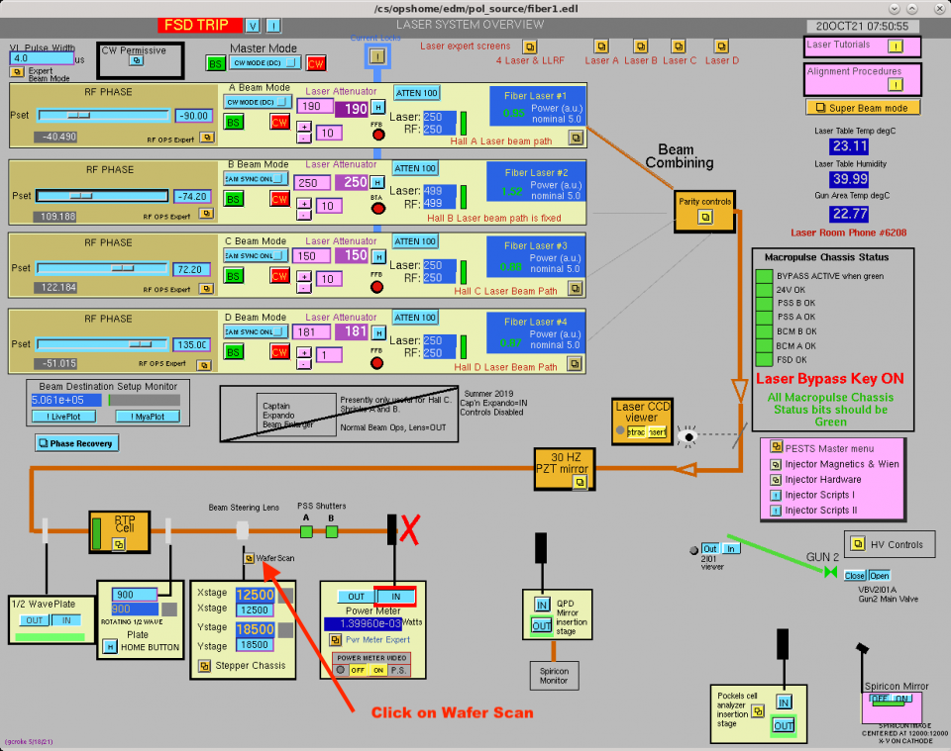

3. In PGUN Main screen, click on WAFER SCAN
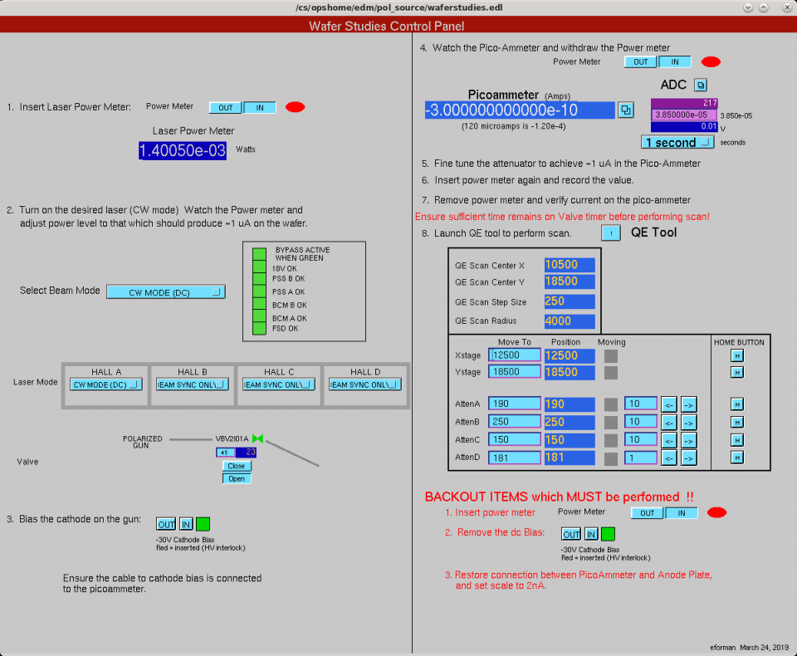

4. Once in the Wafer Scan Screen, insert Power Meter
5. Select Beam Mode CW
6. Choose Hall A laser (for example), set it to CW mode
7. Note power reading. For example: 1.39 mW
8. In PGUN Main, open gun gate valve (Need to add gun valve name here)
9. Open prep chamber-gun gate manual valve. Check VIP2I00c gun vacuum. Should not change baseline except during the opening of the manual gate valve.
10. Ensure long manipulator ears are HORIZONTAL (because the puck slots for the LM ears are VERTICAL, thus we do not want to engage the puck with the LM).
11. Insert the long manipulator gently until it touches the back end of the cathode puck. Do not push.
12. In the Wafer Scan Controls Screen, retract laser power meter.
13. Fine tune attenuator to obtain ~ 1uA current in the Picoammeter
14. Insert laser power meter. Note power, for example: 2.64 mW
15. Launch QE Tool screen
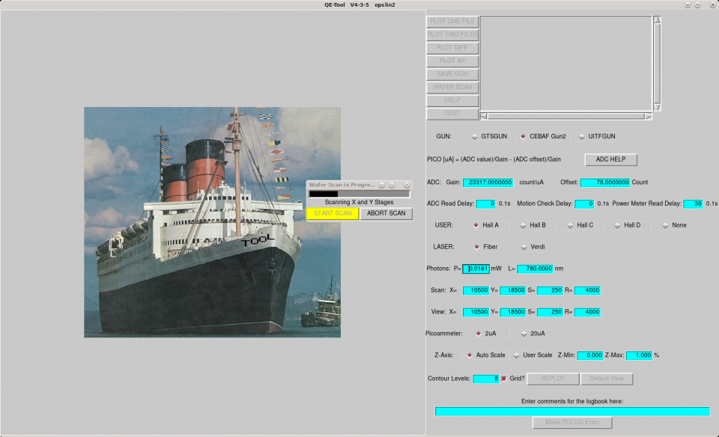

16. Note XSTAGE, YSTAGE. For example: XSTAGE=12500, YSTAGE=18500
17. Click Wafer Scan. This will insert power meter. Use the power meter read value for the QE scan. Enter this value in the “Photons P=_________mW”
18. Click Start Scan. Observe XY stage number changing to ensure scan is working.
19. When the scan is complete and the QE map appears on the screen, entered the measured laser power in “Photons P=_________mW”, from our example, it should be: P=2.64 mW.
20. Click REPLOT. This should adjust the QE scale on the QE map.
21. Click SAVE GUN
22. Click Make POLOG entry
23. Retract smoothly the long manipulator all the way back, keeping ears orientation.
24. Close the manual gate valve between the gun and the cathode preparation chamber.
25. Close terminal screens

TASK 3: Return anode and gun back to nominal configuration

1. Return to the Injectors Service Building.
2. Unplug the BNC cable from the “POS ANODE” BNC connector in the QE Scan panel. The other end of this cable comes from the gray straight-through junction box.

3. Unplug the SHV read cable from the gray junction box

4. Connect the SHV read cable back to the black junction box. This step connects the biasing power supply back to the anode.

5. Turn back on the anode bias power supply
6. Remove the laser bypass key
7. Close and lock the PSS laser interface lid
8. Return laser bypass key to crew chief

QE scan procedure complete

