Near Term Goals at GTS 6_15_2017
Poelker

Characterizing the new photogun (Yan’s thesis chapters 1, 2, and 3)
- Gun electrode electrostatic design
- Barrel polishing and gun HV conditioning results
- Photocathode deposition chamber results
- Measure beam emittance, validate the measurement via multiple techniques: a) solenoid scans with viewers, b) slit plus viewer, and c) harp
- Emittance versus laser spot size, like Cornell paper, to quote a thermal emittance value (slope of line)
- Map beam emittance across the entire photocathode to detect a field non-uniformity inside the cathode-anode gap that might result from application of voltage from the side
- Lifetime vs beam current up to 5 mA, precipitator ON
- Lifetime vs beam current vs gun voltage, precipitator ON/OFF
- Lifetime measurements with RF pulse laser
- Lifetime measurements with 225kV supply, up to 32 mA
- HV condition to ~ 400kV, make beam at 350kV
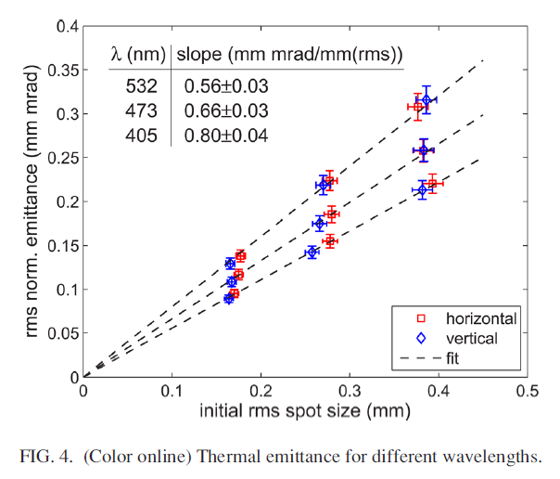
Particle tracking code simulations to predict the size of beams at viewers, and to estimate emittance growth due to space charge forces.
POISSON electrostatic field map of the 350kV gun with ~ 9cm cathode/anode gap. Do we have the correct electric field map in our ASTRA and GPT models of the GTS?
Does the particle tracking code assume a photocathode thermal emittance? I assume the answer is YES. What value are we using in the models? Of course it would depend on the laser illumination wavelength.

Photocathode Study (chapter 4 Yan’s thesis)
Measure emittance vs Sb layer thickness. As Mamun determined previously, a thick Sb layer can be rough, and consequently we expect emittance will be large compared to photocathode with smooth surface

Relevant and interesting ancillary measurements
Emittance across the transverse profile of the beam (look for the “hot” beam center, to explain why the beam divergence is different depending on which viewer you use)
Emittance versus gun voltage
Emittance vs beam current using the harp up to 30uA (is there ever a beam current range where emittance is flat, constant?). This will help us as a group better appreciate the effects of space charge, particularly when we compare DC and rf-pulsed beam
Precipitator tests: does the precipitator really improve photocathode lifetime, limit arcs and HVPS trips? How to quantify?
Biased anode studies, anode as precipitator?
Magnetized Beam
- Demonstration of magnetized beam at 300kV and 5mA
- Measured and predicted rotation, for three laser spot sizes and at different gun voltages. How many solenoids need to be ON? Observed rotation is very small right now, just 10 degrees. Tweak something to see cause and effect (i.e., laser spot size, gun voltage)
- Compare rotation with magnetic puck
- Demonstrate magnetized beam with rf structure at 5mA, then 32mA at 225kV
- Test the TE011 cavity as magnetization monitor
Particle tracking code simulations to predict the size of beams at viewers, and to predict the x/y rotation of beams through beamline solenoids.
How many solenoids need to be ON for this comparison?
The table is a source of great confusion. As written, it makes no sense. Over-focusing might explain the sign changes, but simply making negative angles positive doesn’t help. Why doesn’t beam magnetization increase in some expected fashion as the magnetic field is increased at the photocathode? Can the rotation angle exceed 360 degrees between intervals? Particle tracking simulations might help us explain this table….