CIS-TN-18-01
March 1, 2018

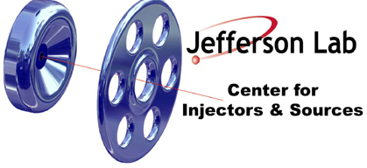

FABRICATION OF MOLYBDENUM PUCK BODY

CIS

Jefferson Lab

This note summarizes the steps for fabricating the molybdenum “PUCK BODY” as described in drawing JL0047248.

- Machine and Assembly Steps
  - Machine puck, key and dowel pin
  - Trial fit-up of puck, key and dowel pin
  - Initial cleaning of components with micro and acetone rinse (do not acid etch before key is pinned)
  - Install key and pin into puck body

- Acid Etch Steps
  - Remove indium if needed (isopropyl + indium ball to get indium off)
  - Moly Etch Aqua Regalis (1:3 HCl:Nitric), 10 seconds, rinse, check surface, repeat for 10 more seconds if needed, rinse, check surface
  - Ultrasonic cleaning in DI water after (USC twice to ensure removal of acid from around ear)
  - Rinse, air dry in hood, bag for heat treatment

- Vacuum Bake Steps
  - Use a vacuum oven to degas puck.
  - Use a ramp rate of 10-15 degrees Celsius per minute.
  - Ramp to 900 degrees Celsius.
  - Soak for 120 minutes, recording pressure every 30 minutes.
  - Ramp and cool to room temperature
  - Bag puck, if possible in GN2.

