Using measured thicknesses, with uncertainty on thickness as –
uncertainty^2 = (measured uncertainty by FSEM)^2 + (0.05*measured thickness)^2
ie taking into account in quadrature the absolute target thickness uncertainty in a given batch as quoted by Lebow.

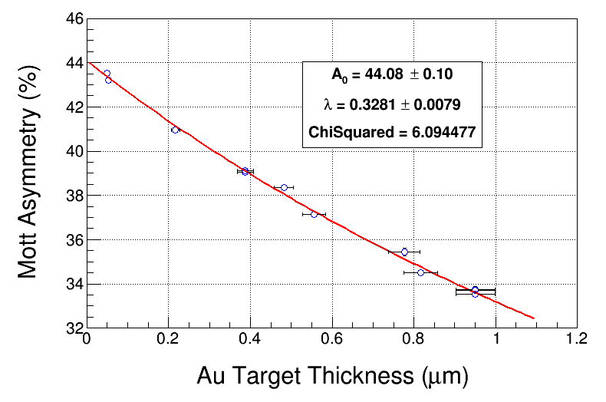

ToF: mean +/- 1.0 sigma

E: mean +/- 1.0 sigma

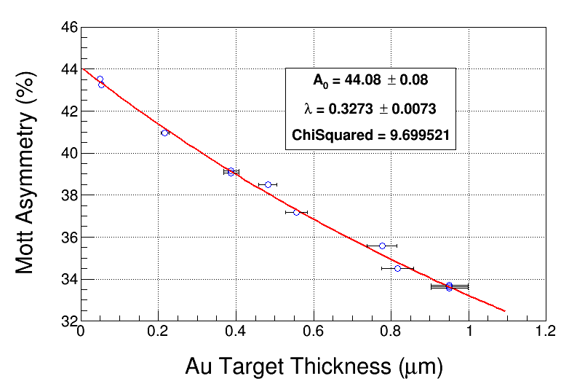

ToF: mean +/- 2.0 sigma

E: mean +/- 1.0 sigma

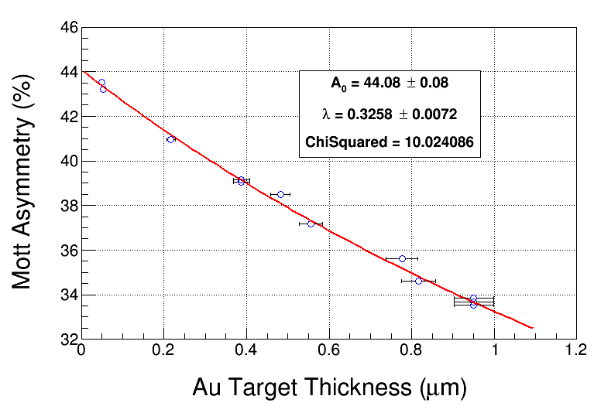
ToF: mean +/- 3 sigma E: mean +/- 1 sigma

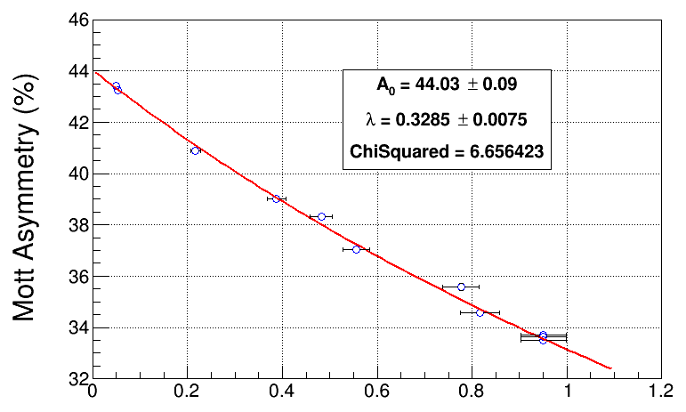
ToF: mean +/- 1 sigma E: mean +/- 2 sigma

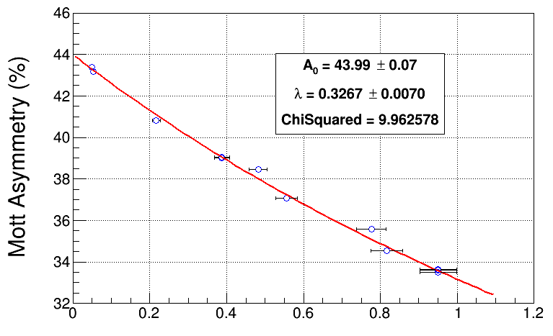
ToF: mean +/- 2 sigma E: mean +/- 2 sigma

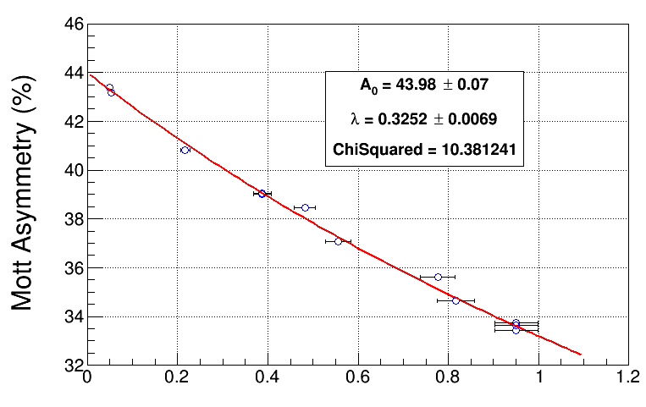
ToF: mean +/- 3 sigma E: mean +/- 2 sigma
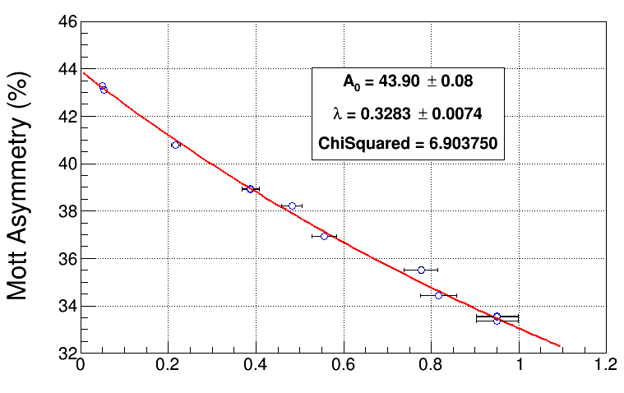
ToF: mean +/- 1 sigma E: mean +/- 3 sigma
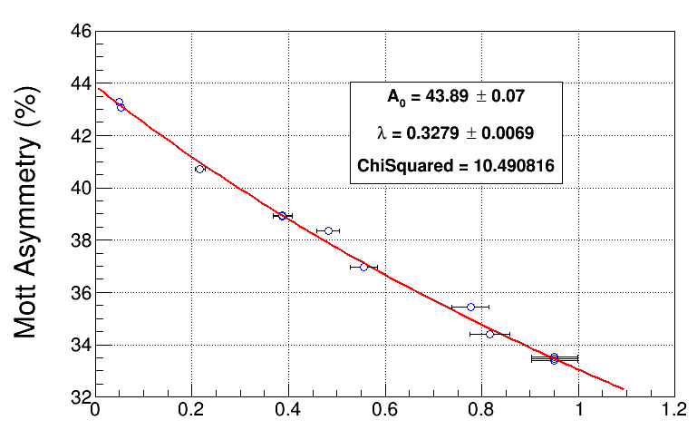
ToF: mean +/- 2 sigma E: mean +/- 3 sigma
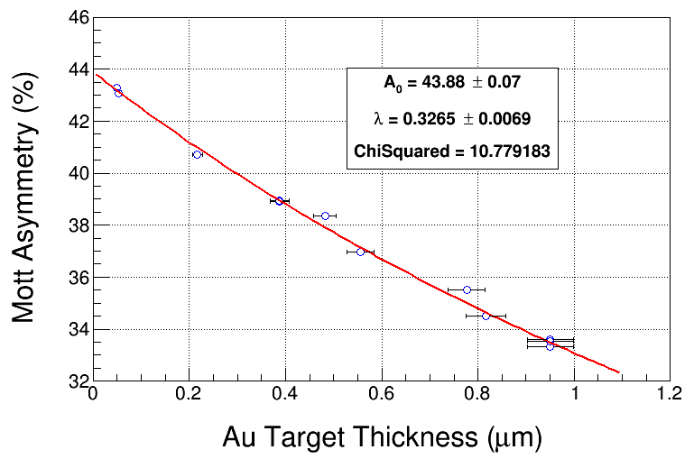
ToF: mean +/- 3 sigma E: mean +/- 3 sigma

