Laboratory Directed Research and Development Proposal
Title: pre-conceptual design of a cw positron source for jlab

Lead Scientist or Engineer: | Co-pi’s: Pavel degtiarenko, joe grames
Phone: | x6274, x7097
Email: | pavel@jlab.org, grames@jlab.org
Date: | APRIL 26, 2013
Department/Division: | ESH&Q, ACC
Other Personnel: | NEW HIRE POST-DOC, DR. ERIC VOUTIER
Proposal Term: | From: January 1, 2014  Through: December 31, 2015  If continuation, indicate year (2nd/3rd):

Division Business Manager:
Phone:
Email:

This document and the material and data contained herein were developed under the sponsorship of the United States Government. Neither the United States nor the Department of Energy, nor the Thomas Jefferson National Accelerator Facility, nor their employees, makes any warranty, express or implied, or assumes any liability or responsibility for accuracy, completeness or usefulness of any information, apparatus, product or process disclosed, or represents that its use will not infringe privately owned rights. Mention of any product, its manufacturer, or suppliers shall not, nor it is intended to imply approval, disapproval, or fitness for any particular use. A royalty-free, non-exclusive right to use and disseminate same for any purpose whatsoever, is expressly reserved to the United States and the Thomas Jefferson National Accelerator Facility.

Abstract
There is recent and growing interest for positron beams for Nuclear Physics at Jefferson Lab. This proposal aims to develop a Pre-Conceptual Design Report for an accelerator driven positron source with integration to existing Jefferson Lab facilities (CEBAF/FEL), what might be a so-called “Positron Upgrade”. The scope of the design would be linked to physics motivated User beam requirements for CEBAF, and potentially an MEIC or dedicated facility. The proposed design studies benefit from recent positron R&D activities at Jefferson Lab, but focus on a critical challenge, the optimized positron beam quality as it relates to the management of the driving electron beam power. Our approach would evaluate candidate positron source scenarios and also employ a powerful Multi-Object Genetic Algorithm (MOGA) in the design to globally optimize parameters, which include scientific, engineering and economic challenges. Such a report would provide critical information and timely advice if a positron accelerator were further pursued at Jefferson Lab. The work itself would span the Accelerator, Engineering and ESH&Q Divisions, International Collaboration as well as to attract and develop a New Postdoctoral Scientist at Jefferson Lab.

Summary of Proposal

Description of Project
The motivation for positron beams at Jefferson Lab has broad interest (see Table 1, Letters of Support Attachments [1-4] and Refs. [1-8]), demonstrated by CEBAF User Group members, design studies of a Medium Energy Electron-Ion Collider (MEIC), and in novel proposals such as a Dark Matter Search and a Slow Positron Facility at the FEL.
Table 1. Physics interest in positrons at Jefferson Lab (Refs. [1-8]).
Physics interest | positron intensity
Two Photon Exchange | 10 – 50 nA
Positron Proton Elastic Scattering | 20 – 40 pA
GPD’s and DVCS with Positrons | 8 – 40 nA
Inclusive Structure Functions | 100 – 250 nA
U-Boson Dark Matter Search | 20 nA
MEIC with Positrons | 1 – 10 µA
Slow Positron Facility | 10 – 100 pA
However, a suitable positron source design, and possibly with multi-User operation (CEBAF, MEIC, Slow Positrons), is challenging. The combination of constraints and requirements for positron production, collection and delivery schemes would likely result in a positron source and acceleration scheme unique to any yet constructed. Unique issues involve continuous-wave operation, low-emittance without the use of a damping ring and high polarization with rapid helicity reversal.
Any positron source design concept must rely on a sound engineering basis, and will necessarily include as a critical element the design of high power target(s), capable of absorbing and converting extreme beam power of the order of hundreds of kilowatts. We propose to investigate possible engineering solutions that would satisfy thermal and radiological constraints of such designs. New designs based on the recent JLab patents [9-10] addressing these issues will be included in the consideration, and optimized solutions worked out for candidate scenarios of a positron source at Jefferson Lab.

Expected Results
The ultimate deliverable of this proposal is a technically well-developed Pre-Conceptual Design Report based upon physics-motivated User input, with alignment and feasibility to the existing CEBAF and FEL facilities, and including an optimization and technical review of candidate design schemes.
We believe this proposal is well aligned to the Jefferson Lab Strategic Plan and highly compatible with LDRD funding criteria, by exploring a new avenue for future Nuclear Physics at Jefferson Lab.

Proposal Narrative

Purpose/Goals
As a world-leading nuclear physics research facility, the experimental program at Jefferson Lab both motivates and benefits from the unique and exceptional electron beam quality of CEBAF; this is exemplified in the characteristics of continuous-wave beam structure, dynamic range of intensity, small emittance and energy spread, high spin polarization and its manipulation. A complementary positron beam would encounter similar requirements, and its implementation at Jefferson Lab would be unique from preceding positron sources where pulsed beam production and collection, emittance damping rings and self-polarization are staple techniques.
With the motivation of the Physics community in mind, R&D efforts at JLab have been supported in recent years, with University and Laboratory collaboration or in-kind support (LPSC, IAC, JFU, HU, ODU, NCSU, Princeton, DESY, SLAC). These are exemplified by the steady and successful completion of these recent activities,

- 2009 – International Workshop on Positrons at Jefferson Lab, supported by the Physics, Accelerator and Theory divisions, the Laboratory of Subatomic Physics and Cosmology (LPSC), Grenoble and the Idaho Accelerator Center (IAC),
- 2010 – PhD thesis of Serkan Golge, Old Dominion University (ODU) to study the feasibility of a CW positron beam for CEBAF,
- 2011 – PhD thesis of Jonathan Dumas, Joseph Fourier University (JFU) to study transfer of polarization from low energy MeV electrons to positrons,
- 2012 – PEPPo, PAC A-rated experiment to test transfer of polarization to positrons in a conventional target using the CEBAF injector electron beam (polarization ~85% and energy ~8MeV), supported by LPSC, HU, ODU, IAC, DESY, SLAC.

The goal of this proposal is the effective and timely evolution to the next stage, to develop a pre-conceptual design. This activity addresses the main issues for providing a positron beam: high electron beam power conversion, efficient positron collection with suitable high quality beam acceleration.

Approach/Methods
The Team (Years 1 – 2)
The work plan as detailed below will be distributed over a team of 5 persons, with responsibilities listed here,

- Pavel Degtiarenko – lead on high power absorbers/converters
- Joseph Grames – lead on positron beam optimization
- Eric Voutier – lead on User driven physics motivation
- Mechanical Engineer II – lead on thermal and mechanical analyses
- New Postdoctoral Scientist – lead on overall source design
Physics Motivation (Year 1)
We would meet with Users who are interested to explore and document positron beam requirements for possible experiments, with focus on Nuclear Physics at CEBAF, the FEL or within the vision of a Medium Energy Electron-Ion Collider. The point is to develop, for example, a version of Table 1 that identifies a more complete set of positron beam parameters for these experiments (intensity, emittance, momentum spread, polarization, time-structure), similar to what one would specify in a PAC proposal or evaluate at a TAC.
Within a coordinated User effort we intend to develop, in many cases already existing, physics ideas to conceptual experiments that would address beam quality requirements for completion. In addition, we would discuss with the community of interested Users of Slow Positrons (<1 MeV) in order to ascertain mutual synergy and benefits, and define beam requirements for their use. This effort would take the form of a Workshop and of joint meetings with the Jefferson Lab User Group, the Medium Energy Electron-Ion Collider study group, division Leadership and potential Collaborators.
Candidate Scenarios / High Power Radiators (Years 1 – 2)
We would develop candidate positron source scenarios based upon User motivated beam specifications, consistent within the capabilities of CEBAF, the FEL or proposed MEIC. A critical feature not yet explored at Jefferson Lab is the integration of high-power conversion from the electron drive beam to positron physics beam. We believe such an effort and its analysis are critical links necessary to evaluate a realistic implementation of a future positron source capitalizing upon Jefferson Lab accelerators.
There are several major options for selecting the electron drive beam:
- A low energy (below 10 MeV) beam from an Injector - advantages include practical absence of material activation. Disadvantages include relatively low efficiency of positron production and lower average energy of positrons, which make extraction and capture challenging for acceleration. Achieving high intensity of a positron beam would require handling of very high local energy deposition in the conversion target/radiator, very near SRF accelerating structures,
- Use of higher electron beam energy of about 100 MeV - found at injection to the CEBAF North Linac, or at the FEL facility. There's clear advantage of higher positron yield per unit beam power, but material activation in the conversion target/radiator region adds to beam power management,
- Use beam energy up to the CEBAF 12 GeV Upgrade - different scenarios will be considered, including the possibility to use a beam extracted at the Beam Switch Yard area, or constructing a new beam extraction facility at the end of North Linac, or others. The opportunity to use GeV-range energies for the electron drive beam opens new opportunities for designing the positron production station. The average energy of produced positrons is higher, the production efficiency is relatively higher, and the positron collection schemes adjust at higher energy due to the forward boost of all particles in the electro-magnetic shower. However, material activation is severe.
However, in all energy ranges we believe an important step is to explore the paths for either Single-target or Double-target converter configurations, the latter of which functionally separates the bremsstrahlung radiator from the positron converter.
In any scenario, production of a high intensity positron beam would require a high power energy absorber that would function as a target, radiator, or positron converter. Total power deposition as well as beam power density in such devices is expected to be extreme, and design of such a system would require careful considerations on material selection, and on the type of engineering solutions implemented. The present state-of-the-art solutions for the high power beam absorbers include a beam raster, use of liquid metal targets, or designs with moving and cooled targets. We plan to investigate a range of such solutions, taking into account the requirements of optimal positron production. Depending on the electron drive beam energy, different approaches can be used. In particular, at high energies there might be advantages of using the two-stage positron production scheme. The drive beam of such a scheme is directed onto the radiator, optimized to produce maximum flux of bremsstrahlung radiation. This radiation then interacts in a dedicated positron production target, optimized for maximum positron yield. One of the advantages of such scheme is the possibility to isolate the radiator in a separate cooled and shielded enclosure, and ease the thermal and radiation load requirements on the positron production and capture hardware. Another advantage may be the ability to isolate beam power which otherwise contributes to “halo” in the resultant collected positron beam.
In the list of possible engineering solutions for the high energy absorbers we plan to include the methods specified in the recent JLab patents [9,10]. The first patent describes a new type of heat exchanger for a high power target moving in vacuum. The second presents a new type of mechanism for suspending, and moving the absorber without friction in the flow of gaseous or liquid coolant.
MOGA Optimization (Years 1 – 2)
Beam physics intrinsically deals with sophisticated systems of many variables and their specifications. The Genetic Algorithm is a powerful method that implements principles employed in biological evolution to optimize multi-dimensioned non-linear problems. Introduced into accelerator physics relatively recently (1992) the Multi-Object Genetic Algorithm (MOGA) has been increasingly employed, first for optimizing the design of magnets and RF cavities, and later in increasingly sophisticated problems, such as determining the operating parameters to achieve the highest brightness high-current electron photo-injector ever, at Cornell University [11], to optimize luminosity in the International Linear Collider design [12] and to optimize design and operating costs for an SRF linac [13].
The strength of this technique with respect to the proposed work is the capability to globally judge desirable or dominant traits such as positron yield, beam brightness (yield/emittance), figure of merit (yield x polarization²), and so on. While some parameters readily optimize (e.g. one may always benefit from an electron drive beam with highest polarization), it is possible with a large parameter base for design-bias or local optimization (meaning, a subset of parameters in the system) to mislead.
In this work, a MOGA optimization would be considered to evaluate candidate scenario strengths, and would be used in the final pre-conceptual design to study and optimize the complicated phase-space relationships in regard to the spatial, temporal, momentum, and/or polarization optimization with respect to radiator configuration. While not all candidates may practically be explored this way, the MOGA approach is a powerful utility for the conceptual design to proceed pragmatically and would be used when relevant to distill optimal specifications, from a clearly broad set of “parent” parameters:
- Electron Drive Beam (energy, intensity, radiation, polarization)
- Single- & Double-Targets (bremsstrahlung and e+/e- converters)
- Electron Beam Power (radiation, activation, thermal management)
- Positron Collection (adiabatic matching, acceleration, optics)
- Positron Beam (emittance, damping, transport, acceleration)
- Positron Polarization - (PEPPo concept, Sokolov-Ternov self-polarization)
Finally, the proposed work would be synergistic with existing expertise at Jefferson Lab in applying the Genetic Algorithm to problems in accelerator physics [13]. Specifically, the infrastructure for applying the GA using simulation codes (Astra, G4Beamline and Elegant) useful for the proposed work exists at Jefferson Lab.

Technical Review (Year 2)
We would hold a technical review in the second year (about the time of the annual LDRD reporting). The purpose of the review would be to consider and scrutinize candidate solutions studied in the first year. Internal reviewers spanning JLab divisions, lab management and at least two external experts would be invited. The charge of the review would be to assess our candidate scenarios, make recommendations and select one candidate, which would be evolved in the second year to the pre-conceptual design. At this review we would also summarize our findings of the physics motivations for positron beams, and their detailed beam requirements.
Pre-Conceptual Design Report (Year 2)
The remainder of the project would focus on developing the pre-conceptual design report for the prioritized candidate scenario. The shift in effort here would be similar in moving from experiment concept to experiment design. The scope of the engineering would be limited to design and analysis; as the level of effort requested in the proposal is not sufficient nor intended for the fabrication of any component.
Finally, we would deposit a report summarizing,
  - Physics program
  - Electron driver and facility integration
  - Positron source systems (targets, magnets, SRF, vacuum, shielding)
  - Positron beam specifications and delivery to User
  - Resource requirements, prototype engineering plan, resources
  - Risk assessment, critical path R&D
At the end of the work proposed we would publish this Pre-Conceptual Design Report and discuss with leadership the merit and potential plans for extended, specific R&D engineering and/or prototyping of a suitable high power positron conversion target.

Specific Location of Work
The work by Jefferson Lab employees will be performed at Jefferson Lab. The work by Dr. Eric Voutier, Laboratory of Sub-Atomic Physics and Cosmology, Grenoble, France will be divided each year with 4 weeks in the US and the remainder in France.

Anticipated Outcomes/Results
The ultimate deliverable of this proposal is a pre-conceptual design report for a continuous-wave positron source at Jefferson Lab. This “Positron Upgrade” concept would effectively capitalize on recent positron R&D activities and provide in some reasonable detail how a positron source and resultant beam may be integrated with the CEBAF or FEL facilities. Primarily, the design effort will address the efficient conversion of electron beam power to a quality positron beam. The design goal specifications will be motivated by a physics case for a positron beam, foremost for CEBAF 12 GeV and also with consideration to potential MEIC or Slow Positron facilities. The report will conclude with recommendations on how one may proceed toward a Conceptual Design Report to the DOE, particularly highlighting the engineering, development and risks associated with the effort. As stated earlier, we believe this proposal is well aligned to the Jefferson Lab Strategic Plan and highly compatible with LDRD funding criteria, by exploring a new avenue for future Nuclear Physics at Jefferson Lab.

VITA (Lead Scientists)
CO-PI: PAVEL DEGTIARENKO (DEGTYARENKO) | (757) 269 6274 | pavel@jlab.org

Institute of Theoretical and Experimental Physics (ITEP), and Moscow Institute for Physics and Technology, Moscow, Russia
Ph.D. (Kandidat of Sciences) in Experimental Physics 1987
Dissertation: "Correlations of hadrons with small relative momenta produced in hadron-nucleus reactions" based on publications in Yad.Fiz. and Phys.Lett.
Moscow Institute for Physics and Technology, Moscow, Russia
M.S. (Diploma) in Physics and Engineering 1978
Thesis: "Correlations between secondary particles in pion-nucleus interactions" based on publications in JETP Letters.

Staff Scientist III, Radiation Control Department
Provide Radiation Physics expertise in the Radiation Control Department at JLab, including radiation background estimates for the upcoming experiments, shielding design and optimization, evaluation of radiation damage to detectors and other experimental equipment, development of the JLab-specific radiation monitoring systems. Provide statistical analysis of data on environmental radiation around the Jefferson Lab site; responsible for the semiannual environmental radiation reports from the Radiation Control group. Participate in development of the Physics models for use in Monte Carlo software simulation tools needed at JLab.

Highlights
- Calculations of energy deposition in materials,
- Finite element analysis to study thermal characteristics of beam deposition,
- Calculations of radiation in electron accelerators, modeling and optimizing design solutions,
- Neutron transport calculations in realistic geometries,
- Experience with the CERN program packages such as GEANT for complex detector simulation and PAW for data analysis and presentation, including programming in KUIP macro language.
- Experience with the finite element analysis program packages ANSYS and ALGOR.

Select References
- Series: "Radiation dose rates resulting from the Experimental Program at JLab" by P. Degtiarenko Internal semiannual or quarterly JLab reports (Radiation Control Department Notes) 1996-2012
- "Moving Core Beam Energy Absorber and Converter" by P. Degtiarenko, United States Patent 8,334,523 B1 2012"
- New Techniques of Low Level Environmental Radiation Monitoring at JLab" by P. Degtiarenko and V. Popov IEEE Transactions on Nuclear Science, Vol. 57, No. 5 2010
- "Cooled Particle Accelerator Target" by P. Degtiarenko, United States Patent 6,904,957 B1 2005
- "Heat Exchange Apparatus" by P. Degtiarenko United States Patent 6,604,575 B1 2003
- "Recent Skyshine Calculations at Jefferson Lab" by P. Degtyarenko in: Proceedings of the Third Workshop on Simulating Accelerator Radiation Environment (SARE3), 7-9 May 1997, KEK, Tsukuba, Japan, p. 264-273 1997
- "Multiple hadron production by 14.5 GeV electron and positron scattering from nuclear targets" by P. Degtyarenko et al. (12 co-authors) Phys.Rev.C, 50, R541-R545 1994
- "Monte Carlo program for nuclear fragmentation" by P. Degtyarenko and M. Kossov Preprint ITEP-11, 1-18 (1992)

CO-PI: JOSEPH GRAMES | (757) 269-7097 | grames@jlab.org
University of Illinois at Urbana-Champaign, Champaign, IL
Ph.D. Physics (2000), M.S. Physics (1994)
Measurement of a Weak Polarization Sensitivity to the Beam Orbit of the CEBAF Accelerator
Stevens Institute of Technology, Hoboken, NJ
B.S. Physics, Minor Mathematics (1992) with High Honors
Honors Thesis Measurement of Thermo-luminescence of Y₂O₃:Eu⁺

Staff Scientist III, Electron Injector Scientist, Deputy Center for Injectors and Sources
Responsibility is successful managment of CEBAF injector to meet challenging Nuclear Physics research program. Key toolset is accelerator physics, photogun technologies (lasers, extreme-high vacuum, high voltage, materials), and control/measurement of spin polarized electron beams used in precision experiments. Activities involve design, installation and commissioning, and managing resources. R&D focus is extending JLab physics reach by extending state-of-the-art in spin polarized electron sources, as well as their novel application, as exemplified in polarized positron R&D.

Highlights
- Completed PAC “A” rated E11-105 (Co-PI) “Polarized Electrons for Polarized Positrons” proof-of-principle production of spin polarized positrons (2012)
- Published multi-year study on sustained milli-Ampere electron beam production from highly spin-polarized GaAs-photocathodes (2011)
- Thesis student J. Dumas defended PhD on PEPPo concept, France (2011)
- Completed CEBAF upgrade with Two Wien Filter Spin Flipper for PREX (2010)
- Workshop Organizer Positrons at Jefferson Lab (2009), Polarized Electrons Sources and Polarimeters (2008)

Select References
- S. Abrahamyan et al. (PREX Collaboration), “Measurement of the Neutron Radius of ²⁰⁸Pb through Parity Violation in Electron Scattering”, Phys. Rev. Lett. 108, 112502 (2012).
- J. Grames et al. (PEPPo Collaboration), “PEPPo, a Proof-of-Principle Experiment”, to appear in Proc. of Workshop on Polarized Positrons, Zeuthen-DESY, Germany (2012)
- J. Grames et al., “Two Wien Filter Spin Flipper (TUP025)” 2011 Particle Accelerator Conference, New York, NY (2011)

D. Androić et al. (G0 Collaboration), “Transverse Beam Spin Asymmetries at Backward Angles in Elastic Electron-Proton and Quasielastic Electron-Deuteron Scattering”, Phys. Rev. Lett. 107, 022501 (2011)

J. Grames, et al., “Charge and fluence lifetime measurements of a dc high voltage GaAs photogun at high average current”, Phys. Rev. ST Accel. Beams 14, 043501 (2011)

P. A. Adderley et al., “Load-locked dc high voltage GaAs photogun with an inverted-geometry ceramics insulator”, Phys. Rev. ST Accel. Beams 13, 010101 (2010)
- D. Androić et al. (G0 Collaboration), “Strange Quark Contributions to Parity-Violating Asymmetries in the Backward Angle G0 Electron Scattering Experiment”, Phys. Rev. Lett. 104, 012001 (2010)
- J. Grames et al., “Polarized Positron Driver for CEBAF”, 13th International Workshop on Polarized Targets, Sources and Polarimetry, Ferrara, Italy (2009)

Budget Explanation
All budget numbers include estimated burden and overheads.
Funds Use | Year 1 | Year 2  (if requested) | Year 3  (If Requested)
Staff (FTE/$k) | 1.3 / $177.778k | 1.3 / $183.113k | --
M&S ($k) | $1.600k | -- | --
Equipment ($k) | -- | -- | --
Travel ($k) | $23.696k | $18.396k | --
Services and Subcontracts | -- | -- | --
Other (specify) | -- | -- | --
The G&A rate calculation is an estimated 50% for all three years.
Staff: The work is proposed as a 2-year project. The LDRD funds would support a full-time postdoctoral physicist for this term. Co-PI’s Pavel Degtiarenko and Joseph Grames would each contribute 10% of their time to supervise the post-doc, organize workshop and technical review and participate in design studies. Mechanical Engineering support is proposed; 11% in the first year to begin thermal analysis and technical support, and 11% in the second year to develop complete competitive analysis, prepare for the technical review and prepare the Pre-Conceptual Design Report.
M&S: A computer for the full-time postdoctoral physicist.
Equipment: N/A.
Travel:
- French collaborator to spend 4 weeks each of the two years at JLab. His salary and travel are the responsibility of his home institution LPSC in Grenoble, France. We would provide per diem, residence facility room and rental car for his time at JLAB
- Funds to interview candidates for the postdoctoral physicist position
- Travel for the postdoctoral physicist
- Workshop (1 or 2 days)
- Travel for 2 technical reviewers to come to JLab
Services and Subcontracts: N/A.
Other: N/A.
The budget is:
$203.074k – Year 1
$201.509k – Year 2
$404.583k – Total

References
[1] A. W. Thomas, “Positrons at Jefferson Lab”, AIP Conf. Proc. 1160 (2009) p. 3-7.
[2] J. Arrington, “Two-photon exchange measurements with positrons and electrons”, AIP Conf. Proc. 1160 (2009) pp. 13-18.
[3] L. B. Weinstein, “Electron- and positron-proton elastic scattering in CLAS”, AIP Conf. Proc. 1160 (2009) pp. 24-28.
[4] V. D. Burkert, “Deeply Virtual Compton Scattering with Positron Beams at Jefferson Lab”, AIP Conf. Proc. 1160 (2009) pp. 43-48.
[5] M. E. Christy, “Estimates of inclusive cross sections and structure functions at JLab using positron beams”, AIP Conf. Proc. 1160 (2009) pp. 60-63.
[6] B. Wojtsekhowski, “Searching for a U-boson with a positron beam”, AIP Conf. Proc. 1160 (2009) pp. 149-154.
[7] S. Abeyratne et al., “Science Requirements and Conceptual Design for a Polarized Medium Energy Electron-Ion Collider at Jefferson Lab”, arXiv:1209.0757, JLAB-ACC-12-1619.
[8] D. Cassidy, “Physics with Cold Polarized Positronium”, AIP Conf. Proc. 1160 (2009) pp. 138-145.
[9] P. Degtiarenko, "Cooled Particle Accelerator Target", U.S. Patent No.6,904,957 B1, Jun. 14, 2005.
[10] P. Degtiarenko, "Moving Core Beam Energy Absorber and Converter", U.S. Patent No. 8,334,523 B1, Dec. 18, 2012.
[11] I.V. Bazarov, C.K. Sinclair, "Multivariate optimization of a high brightness dc gun photoinjector", Physical Review Special Topics - Accelerators and Beams, Vol. 8, 034202 (2005).
[12] I.V. Bazarov, H. Padamsee, "Multivariate optimization of ILC parameters", Proceedings of the 2005 Particle Accelerator Conference, IEEE 0-7803-8859-3 (2005) 2188-2190.
[13] I. V. Bazarov and H.S. Padamsee, in Proceedings of the 21st Particle Accelerator Conference, Knoxville, 2005, pp. 1736-1738.
[14] A. Hofler, et al., Phys. Rev. ST Accel. Beams 16, 010101 (2013).

Attachments
Please find the following attachments:

Attachment 1 – Letter of Support, Dr. Volker Burkert – CEBAF 12GeV
Attachment 2 – Letter of Support, Dr. Yuhong Zhang - MEIC
Attachment 3 – Letter of Support, Dr. Alessandro Variola – Future Positron Sources
Attachment 4 – Letter of Support, Dr. Kelvin Lynn – Slow Positrons
Attachment 5 – Curriculum Vitae, Dr. Eric Voutier

Attachment 1 – Letter of Support, Dr. Volker Burkert – CEBAF 12GeV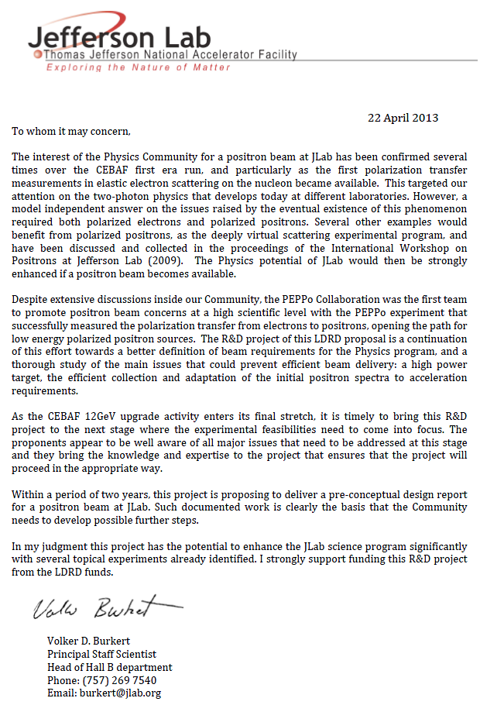
Attachment 2 – Letter of Support, Dr. Yuhong Zhang - MEIC
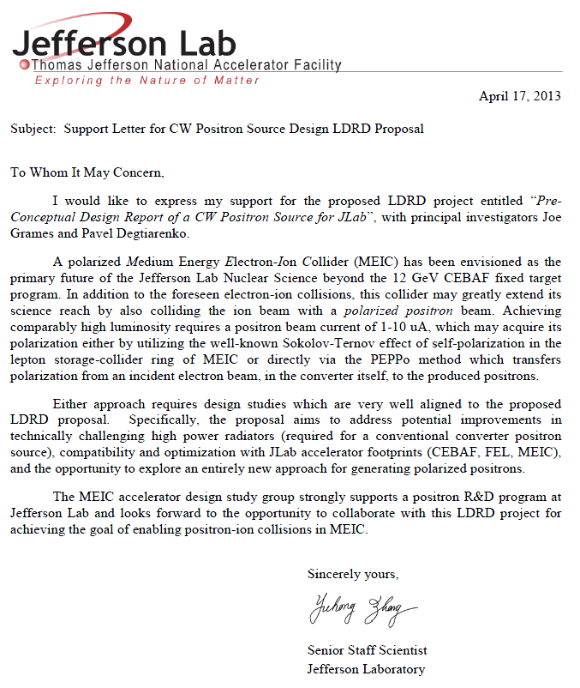

Attachment 3 – Letter of Support, Dr. Alessandro Variola – Future Positron Sources
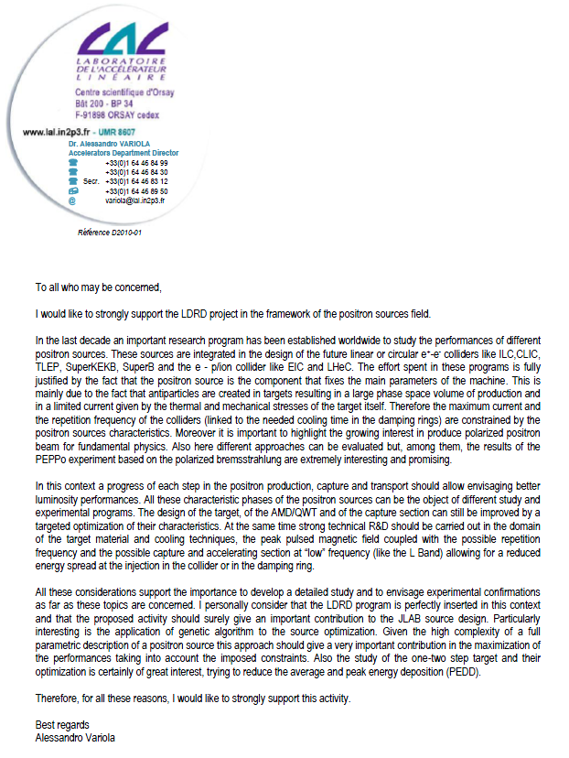

Attachment 4 – Letter of Support, Dr. Kelvin Lynn – Slow Positrons
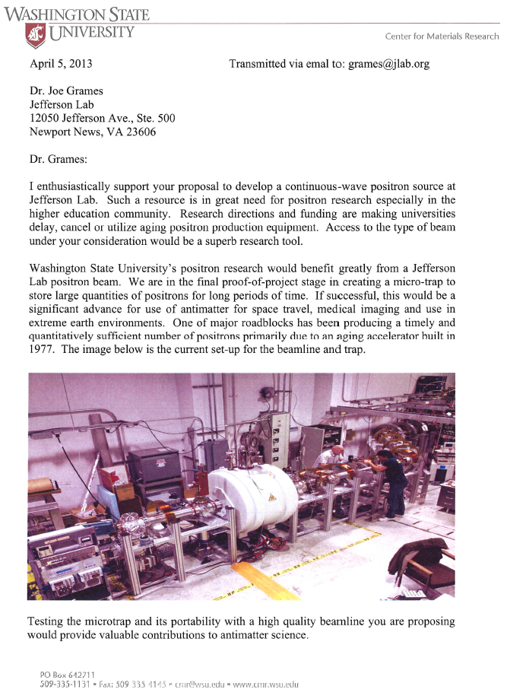
Attachment 4 – Letter of Support, Dr. Kelvin Lynn – Slow Positrons, Cont’d

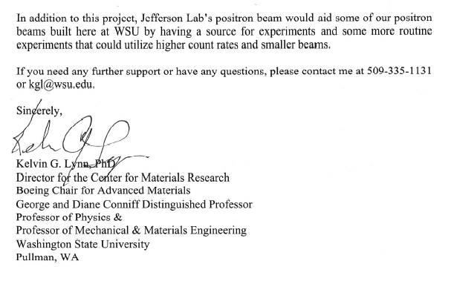

Attachment 5 – Curriculum Vitae, Dr. Eric Voutier
