A new "5 MeV" dipole
Jay Benesch

Introduction

Drawing 27100-D-0001, Beam transport recirculator 5 MeV dipole magnet, is the assembly drawing for what we call the "5 MeV dipole". As the drawing name implies, it was initially designed for the injector recirculation experiment. It was then re-oriented and used to direct beam left to either the 5 MeV beam dump for energy measurement or the Mott polarimeter. For beam to CEBAF, BdL was set to zero, straight ahead. Finally, for the PEPPo experiment with a new beamline to the right, the magnet was rotated so the pole faces were normal to the CEBAF NL axis, allowing for roughly equal field inhomogeneity to all off-normal beam lines. The field inhomogeneity is insufficient for the approved bubble chamber experiment, so I was asked to design a replacement. Since there will be a new cryounit capable of providing beam of 16 MeV KE in 2015, it seems to me prudent to put enough steel in the magnet to provide for bending this beam since the increase is only 0.85cm in thickness.

Models

The TOSCA model of the existing 5 MeV dipole is shown in figure 1. The model of the proposed new model is shown in figure 2. The pole width increases from 4" to 14 cm to increase the region with field flat to better than 0.1% by 3 cm. There is no tolerance for pole parallelism on 27100-D-0001. The pole separation is given as "1.068" +- 0.015" assembly variance". This is fine for a one-time recirculation experiment but intolerable for a magnet intended to measure energy. The existing coil is 350 turns of #17 wire, random wound directly on the pole pieces. Joe Grames was not able to locate piece part drawings, only the assembly drawing.

Pole gap now will be 2.6-2.70 cm. The pole faces should be flat and parallel to 10 microns at the outside. This will require grinding the parts, but they are small so the expense will not be too great. Steel should be annealed for stress release before machining. If fabricated in six pieces steel stock is assumed to be 1.125" with final thickness at least 2.75 cm. Top and bottom plates of the magnet shall be full width with ground inner surfaces. The shorter side plates shall be ground top and bottom only, the mating surfaces, to set the pole separation. Pole pieces shall be ground top and bottom so the parallelism and spacing requirements may be met. If a magnet vendor has a piece of low carbon steel 3" x 10" x 10" the entire yoke could be machined/ground as a unit, cut into two pieces 12.5 cm long, assembled with slide fit pins for registration, and secured with two bolts on each joint. The dimensions in the model are minimum material condition: 2.70 cm gap, 2.75 cm thick steel sections. If one is starting from 3" x 10" x 10" stock the outer dimensions can grow as long as the outside surfaces are flat and parallel/perpendicular to 100 microns. Three or four threaded holes for mounting will later be specified for the bottom. Pole corners have a 1 cm radius to keep the stress in the conductor under 10%.

Coils are to be wound of #14 square copper wire with heavy film insulation, 14 layers of 14 turns each. The maximum material condition of the insulated conductor is 0.177 cm square so this results in a maximum coil size of 2.478 cm square exclusive of any interlayer or external fiberglass. Coil pockets are 2.75 cm square in the model, which should suffice when fiberglass is added. If more volume is needed, ask. Hmm, I suppose the coil pockets are maximum material condition. If the stock is larger than needed to accomodate 2.75 cm minimum steel thickness, coil pocket may be increased. Coils may be wound directly on the poles or or separate forms. In the latter case a slide fit over the poles is preferred and the manufacturer should provide some sort of coil spacer which will keep the coils rigidly seated in the pocket. The coils may be a bit larger and wrapped in EPDM rubber http://en.wikipedia.org/wiki/EPDM_rubber A coil spacer will still be required.

 | x=0 | x=1 | x=2 | x=2.5 | x=3 | x=3.5 | x=4
1965 amp-turns | -27279.9 | -27277 | -27264.3 | -27251.5 | -27234.1 | -27205.4 | -27159.4
BdL ratio to x=0 |  | 0.9999 | 0.9994 | 0.9990 | 0.9983 | 0.9973 | 0.9956
Table 1. BdL values for z=[-20,20] along indicated x locations, y=0. 320 A/cm2 used in the coil; this is twice the requirement for a 9.1 MeV KE electron at 25 degrees bend. Ratios of BdL(x=0)/BdL(x_other) are shown in the bottom line of the table. As seen in figures below, the beam in in high homogeneity regions for most of its path.
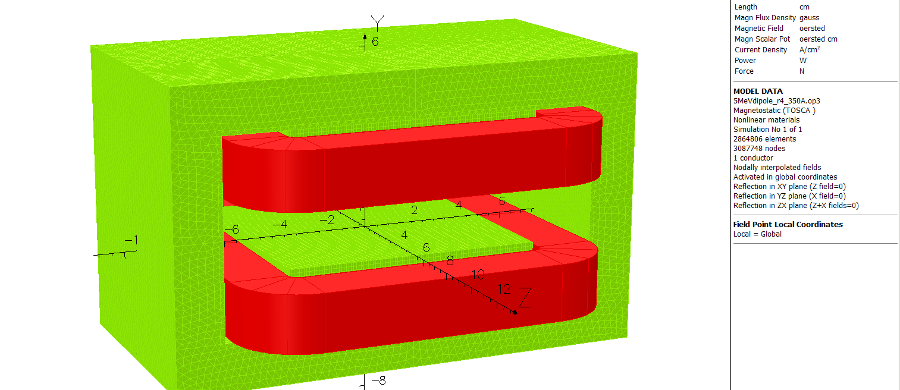
Figure 1. Original 5 MeV dipole
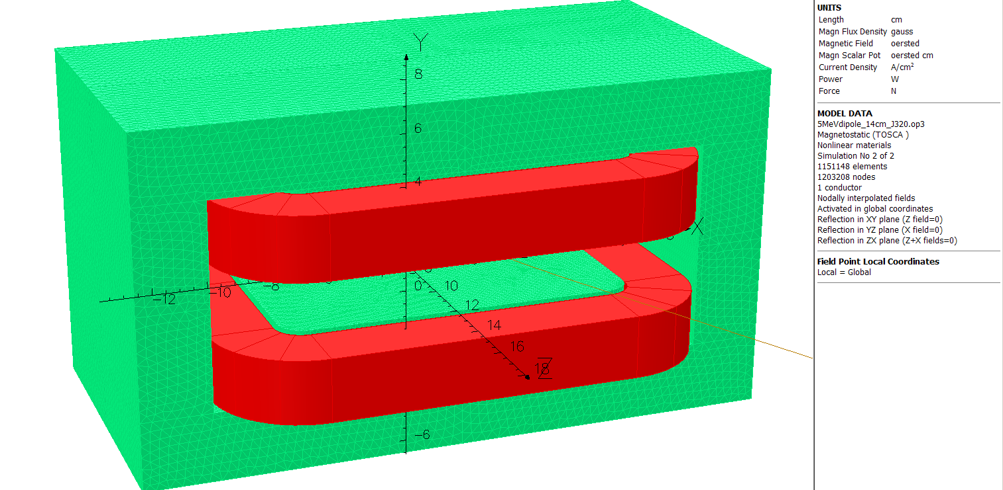
Figure 2. Proposed 5 MeV dipole 14 cm wide poles vs 4", 12.5 cm long vs 4"
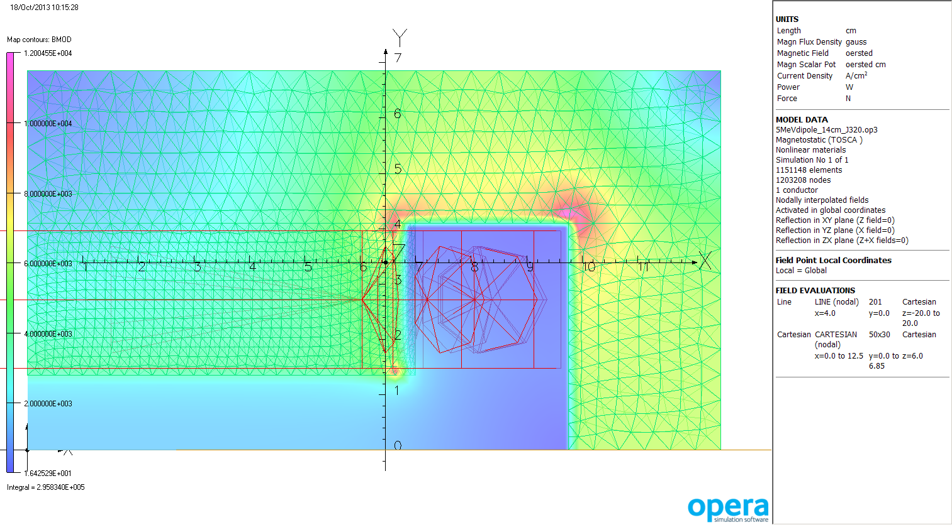
Figure 3. Bmod at z=6 cm so one can see the field peak in the radiused pole as well as in the return steel. J=320 A/cm², which will bend a 19 MeV KE electron 24.7 degrees.
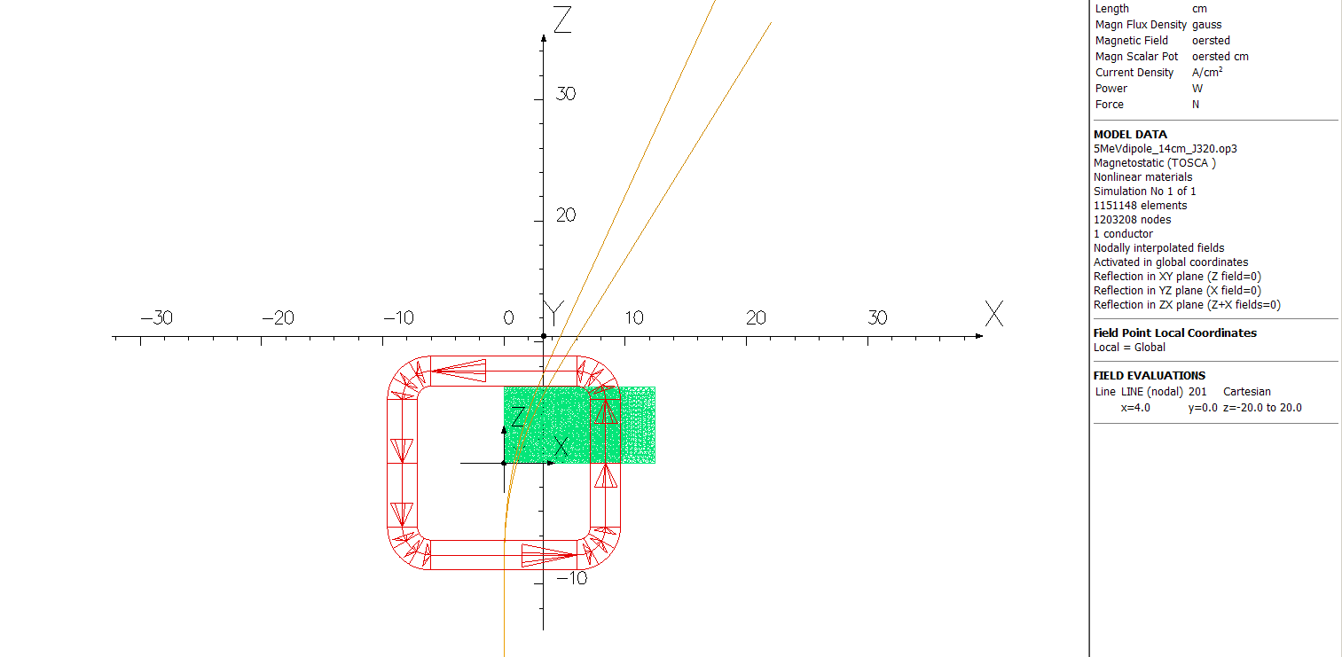
Figure 4. Trajectories of 15 MV KE (outer) and 19 MV KE (inner) in model with J=320 A/cm². Angles measured between z=15 and z=35 cm are 31.6 and 24.7 degrees respectively. This magnet has lots of excess capacity and could be shortened to 10 cm pole length from 12.5 cm pole length if 3"x10"x8" stock is available and 3"x10"x10" stock is not. 10.025 A in the conductor, ~1.7 ohms, so ~170W. 733 cc in coil pair, so ~0.25 W/cc. This shouldn't be an issue for convective cooling. Certainly half the current, one fourth the power, won't be.
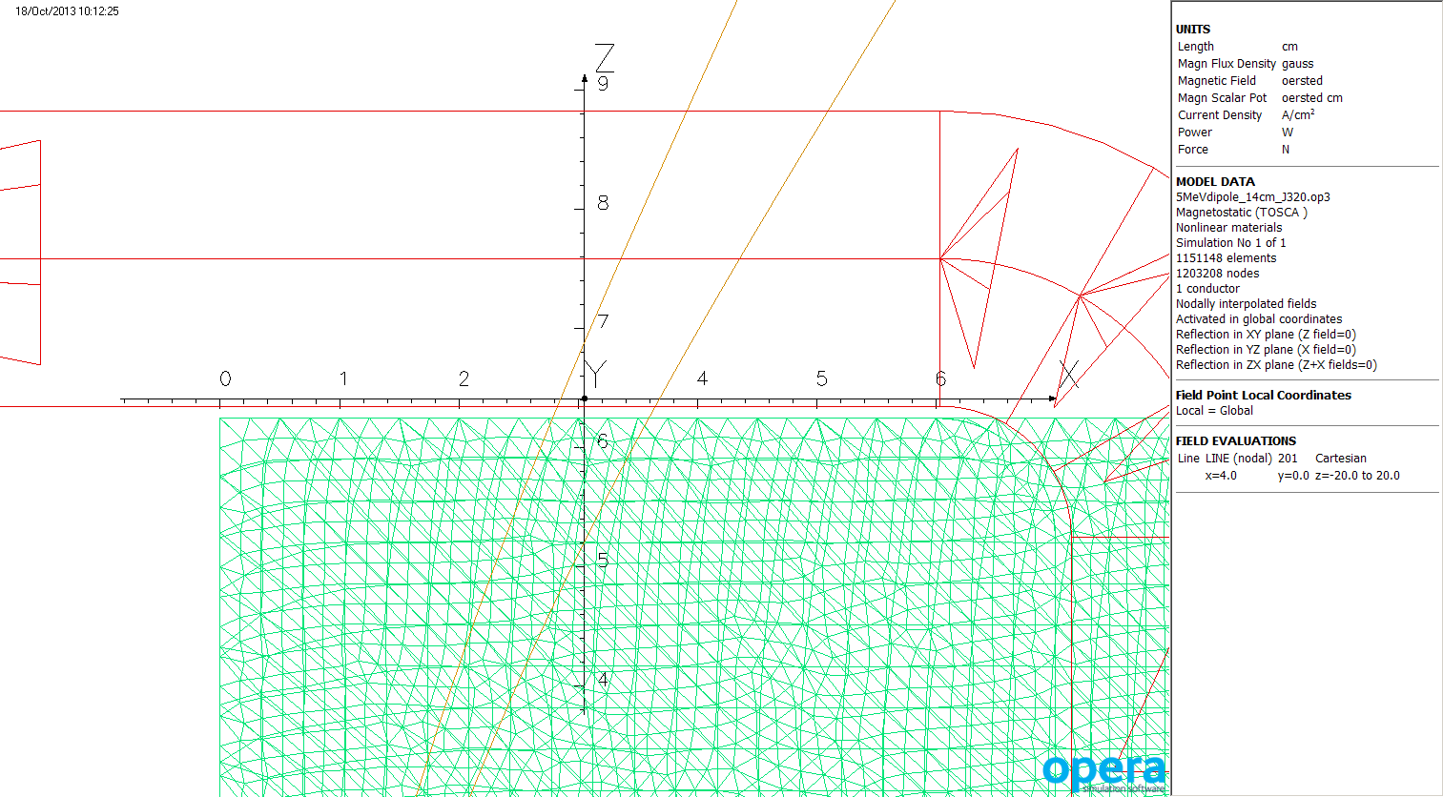
Figure 5. Close-up of trajectories in figure 4 so one can see where the particles cross the steel and coil boundares.
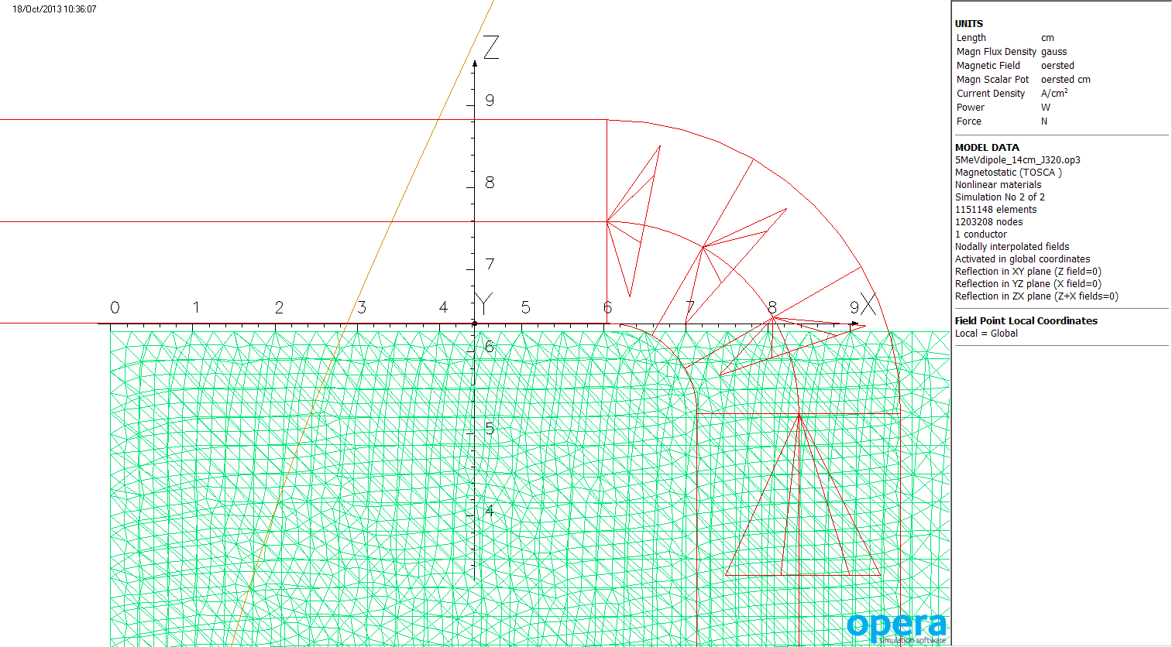
Figure 6. Trajectory of a 9.1 MV KE electron in a model with half the current density, 5.012 A in the conductor.
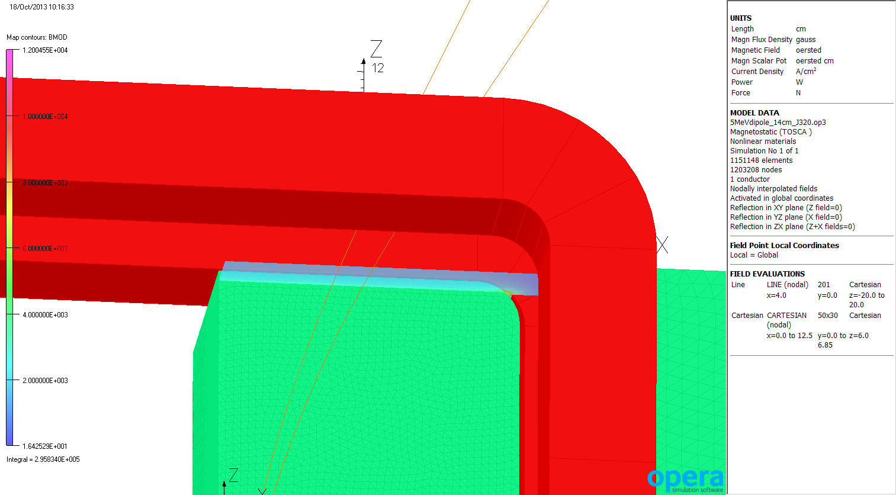
Figure 7. Bottom view of model showing pole corner radius and ~1mm spacing to coil in the model. The Bmod plane view of figure 3 is seen sticking out of the pole in this view, as are the trajectories of figure 5.

Steel dimensions in model, with no symmetry assumed, unlike most of figures above:

part | x1 | x2 | y1 | y2 | z1 | z2
poleT | -7 | 7 | 1.35 | 4.1 | -6.25 | 6.25
poleB | -7 | 7 | -1.35 | -4.1 | -6.25 | 6.25
top | -12.5 | 12.5 | 4.1 | 6.85 | -6.25 | 6.25
bottom | -12.5 | 12.5 | -4.1 | -6.85 | -6.25 | 6.25
sideL | -12.5 | -9.75 | -4.1 | 4.1 | -6.25 | 6.25
sideR | 9.75 | 12.5 | -4.1 | 4.1 | -6.25 | 6.25

as discussed on page 1, pole faces should be flat and parallel within 20 microns. Spacing may be 2.65-2.7 cm. Top surface of top plate and bottom surface of bottom plate shall be referenced to the pole datums parallel and flat to 50 microns (preferred), 100 microns (allowed if cost reduction > 5%). Pole Z faces shall be perpendicular to pole face datums at 100 microns. If magnet is machined in two halves from 3" stock instead of from six pieces of 1.125" stock, AbsVal(y2) may increase from 6.85 to 7.5 cm to reduce machining. Overall width may also increase from 25 cm to 25.4 cm. Coil pocket may grow from 2.75 cm square to 2.9 cm square if convenient for manufacturer as long as steel thickness remains 2.75 cm minimum throughout top and side. Coil envelope increase for manufacturing convenience would drive pocket changes.

Possible issue: The vacuum chamber was designed with the angled arms referenced to the center of a magnet 4" long. There is room for a 5" long magnet on the chamber and the final angles will be OK but the region where the four arms diverge may show a closer approach than is desired. As mentioned in the figure 4 caption, the magnet has lots of excess capacity and so could be shortened to 10 cm pole length without issue. Coil current and heating will go up 25% and 56%, but this should still be OK. Layout showed that the displacement of the coil center 1.25 cm moved the beams 1.7 cm in Z, placing them far too close to the vacuum walls.

10 cm long magnet: October 24, 2013

After a collaboration meeting 10/23 I developed a magnet which differs from that shown above only in the pole extent, z=[-5,5] cm vs z=[-6.25,6.25]. This would eliminate the mechanical issue above. Current density increases 25% for a given BdL. For 400 A/cm², 12.53A in the conductor and sufficient to bend a 20 MeV KE electron 24.5 degrees, the peak field in the steel is under 15 kG. Since the rule of thumb is that air cooling suffices under 500 A/cm², this magnet still has plenty of margin. Data will be presented for 5.5A in the conductor as this should be just about the current needed for an 8.5 MeV KE electron. We'll see.
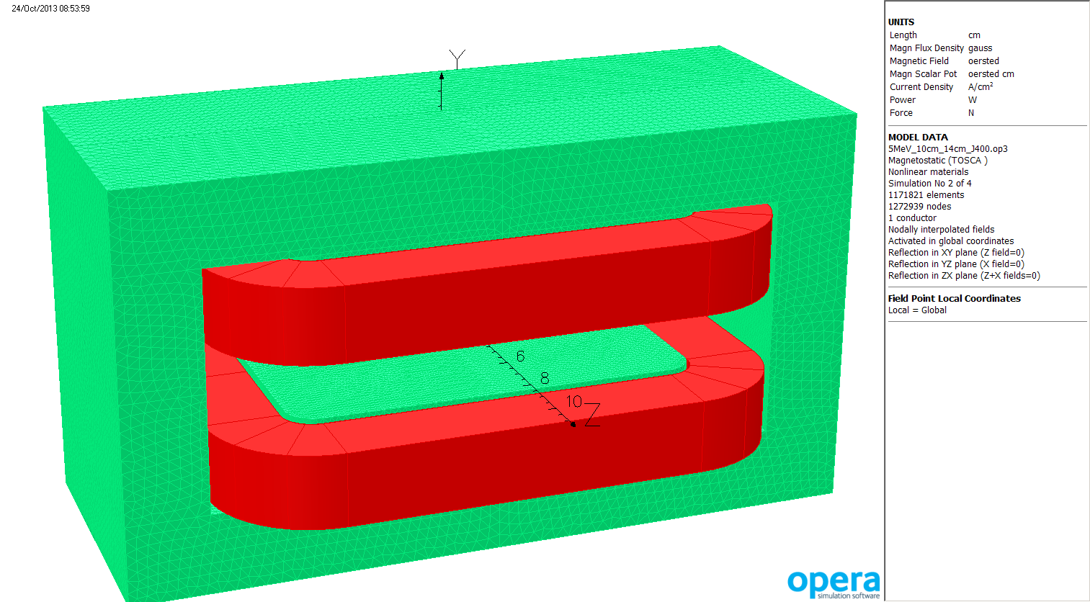
Figure 8. 14 cm wide by 10 cm long pole with 1 cm radius on corners. 1010 steel BH curve used.

Figure 9 on the next page shows that I got the current slightly wrong: 5.5A yields a 24.54 degree bend for an 8.5 MeV KE electron. So I'll run the model again with 5.6A and show those results hereafter. Resistance around 1.62 ohms for the shorter coil, so ~51W in 671 cc of copper, or 76 mW/cc. Not a problem for unsupplemented convective air cooling.

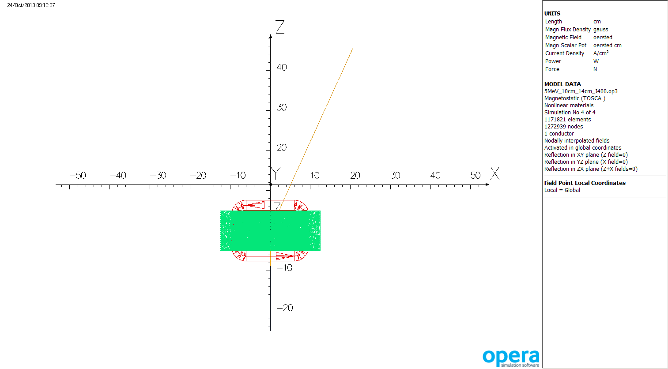
Figure 9. Trajectory of an 8.5 MeV KE electron launched at z=-25cm. (x,z) positions (6.7,15) and (20.4,45) give an angle of 24.54 degrees. 5.5A is not quite sufficient. The steel is fine at 12.5A so headroom isn't an issue. At 5.604A the (x,z) values are (6.85,15) and (20.86,45) or 25.03 degrees, close enough. Simulation 5.
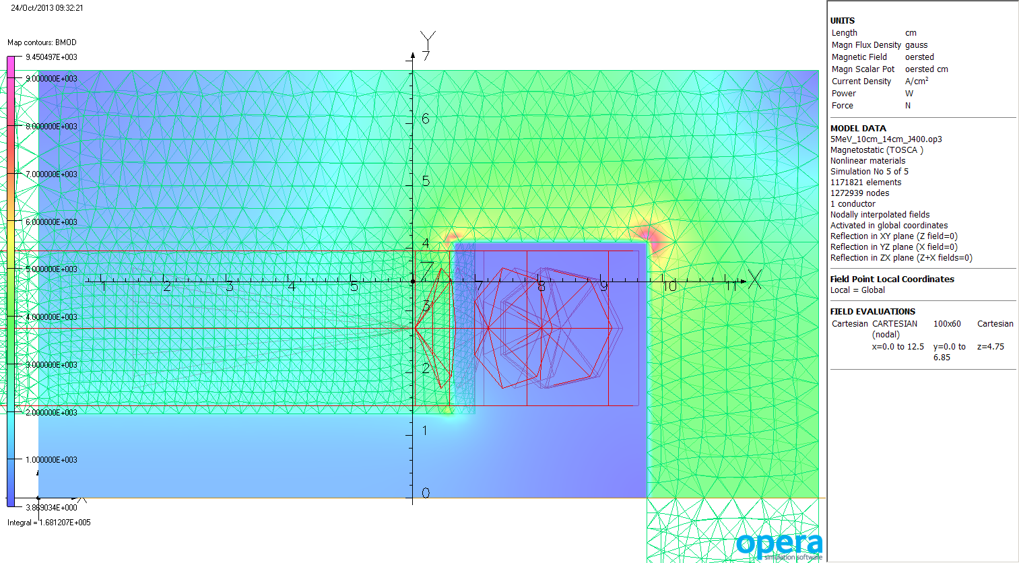
Figure 10. Bmod in steel at Z=4.75 cm, 0.25 cm from the end of the pole. One sees a little bit of yellow at (7,1.35) because of the radiused pole. 9.5 kG peak in the steel. If 3" stock is used the field will redistribute in the top plate and remain the same in the side return, since that thickness wouldn't change. One sees in this figure that I used 2.5mm mesh in the pole and 5mm in the return steel. Air under the pole and around the coil 2.5mm mesh, not shown.
 | x=0 | x=1 | x=2 | x=2.5 | x=3 | x=3.5 | x=4
1965 AT, 12.5 cm | -27279.9 | -27277 | -27264.3 | -27251.5 | -27234.1 | -27205.4 | -27159.4
BdL ratio to x=0 |  | 0.9999 | 0.9994 | 0.9990 | 0.9983 | 0.9973 | 0.9956
1098.4 AT, 10 cm | -12725.9 | -12723.5 | -12716.4 | -12709.5 | -12699.5 | -12683.4 | -12658.1
BdL ratio to x=0 |  | 0.9998 | 0.9993 | 0.9987 | 0.9979 | 0.9967 | 0.9947
Table 2. BdL values for z=[-20,20] along indicated x locations for the 12.5 cm long poles and 10 cm long poles. The latter is slightly less uniform due to end effects.

As one sees in Table 2, the 10 cm long magnet has slightly less flat field width than the one with 12.5 cm long poles. The vertical return legs are 2.75 cm thick. They could be cut to 2.45 cm thick and the pole increased in width to 14.6 cm, remaining within the assumed 10" wide stock. The return steel would then limit the peak field in the magnet but would still suffice for 15 MeV electrons from the new cryounit.

This magnet uses relatively large conductor and has low resistance to preclude water cooling. It may be necessary to put a 5 ohm, 250W resistor in series with the thing to get the power supply into a voltage range where the voltage noise specification doesn't dominate the current noise spec.

Model 3, October 25, 2013

Given the layout showing that a 12.5 cm long magnet doesn't work and the slight decrease in homogeneity shown in table 2, I built a third model with 14.6 cm wide, 10 cm long poles. This proved to be less homogeneous than the 12.5 cm long model at the 50 ppm level inside x=2.5 cm but more homogeneous outside that x location, 105 ppm more at x=3.5 cm. The increased pole width improved homogeneity in comparison to model 2, also 10 cm long, by 700 ppm at x=3.5.

Steel dimensions in model, with no symmetry assumed, unlike most of figures above:

part | x1 | x2 | y1 | y2 | z1 | z2
poleT | -7.3 | 7.3 | 1.35 | 4.1 | -5 | 5
poleB | -7.3 | 7.3 | -1.35 | -4.1 | -5 | 5
top | -12.5 | 12.5 | 4.1 | 6.85 | -5 | 5
bottom | -12.5 | 12.5 | -4.1 | -6.85 | -5 | 5
sideL | -12.5 | -10.05 | -4.1 | 4.1 | -5 | 5
sideR | 10.05 | 12.5 | -4.1 | 4.1 | -5 | 5
Again, 1 cm radius on pole corners and Y2 for top and bottom can go to 7.5 cm.

Peak field in steel at 400 A/cm2 or 12.53A in conductor is shown in figure 11. Acceptable for a 19 MeV KE electron bent 25 degrees, so there remains ample technical margin. Figure 12 shows the field in the XZ plane at y=1.45 cm, 0.1 cm into the pole face, at the excitation needed to bend an 8.5 MeV KE electron 25.16 degrees. There's no issue with a peak under 5 kG.
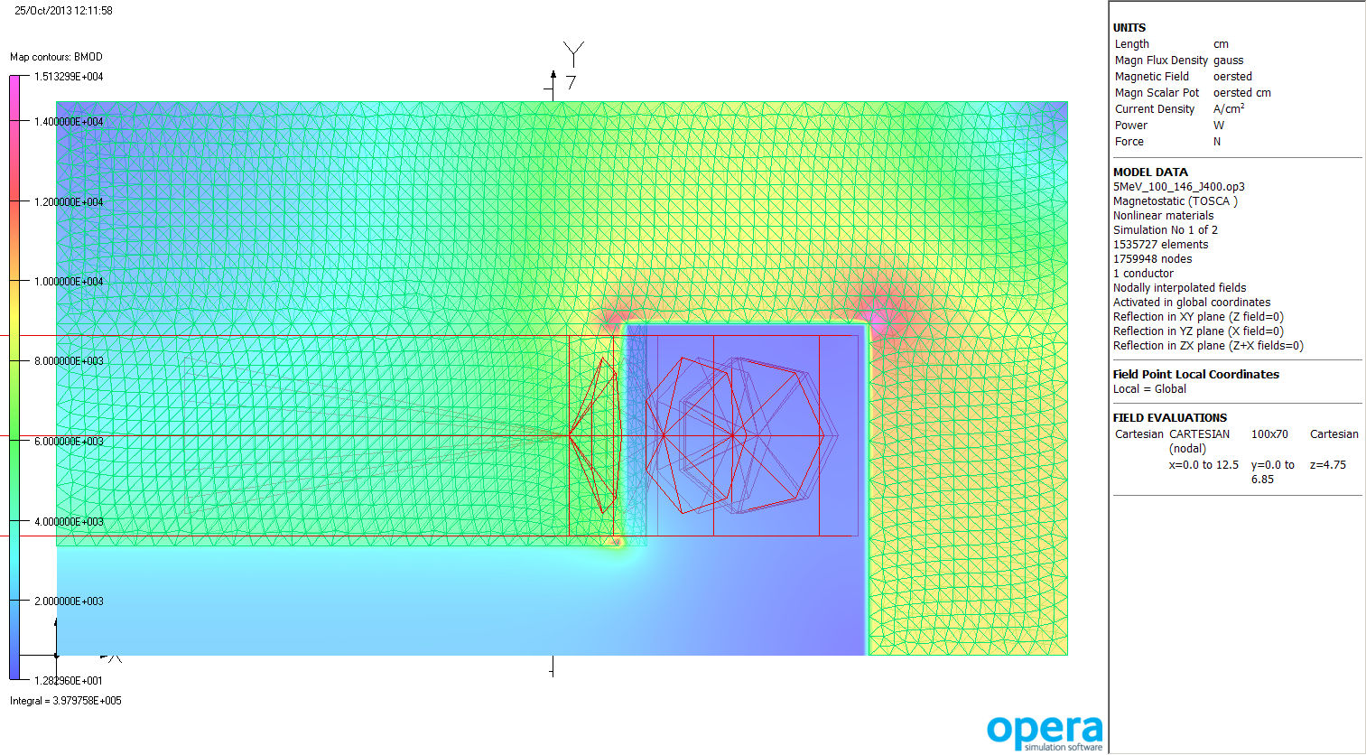
Figure 11. Flux at z=4.75 cm, 0.25 cm from the face and well into the pole radius, with 12.53A in the coil. This will bend a 19 MeV KE electron about 25 degrees.
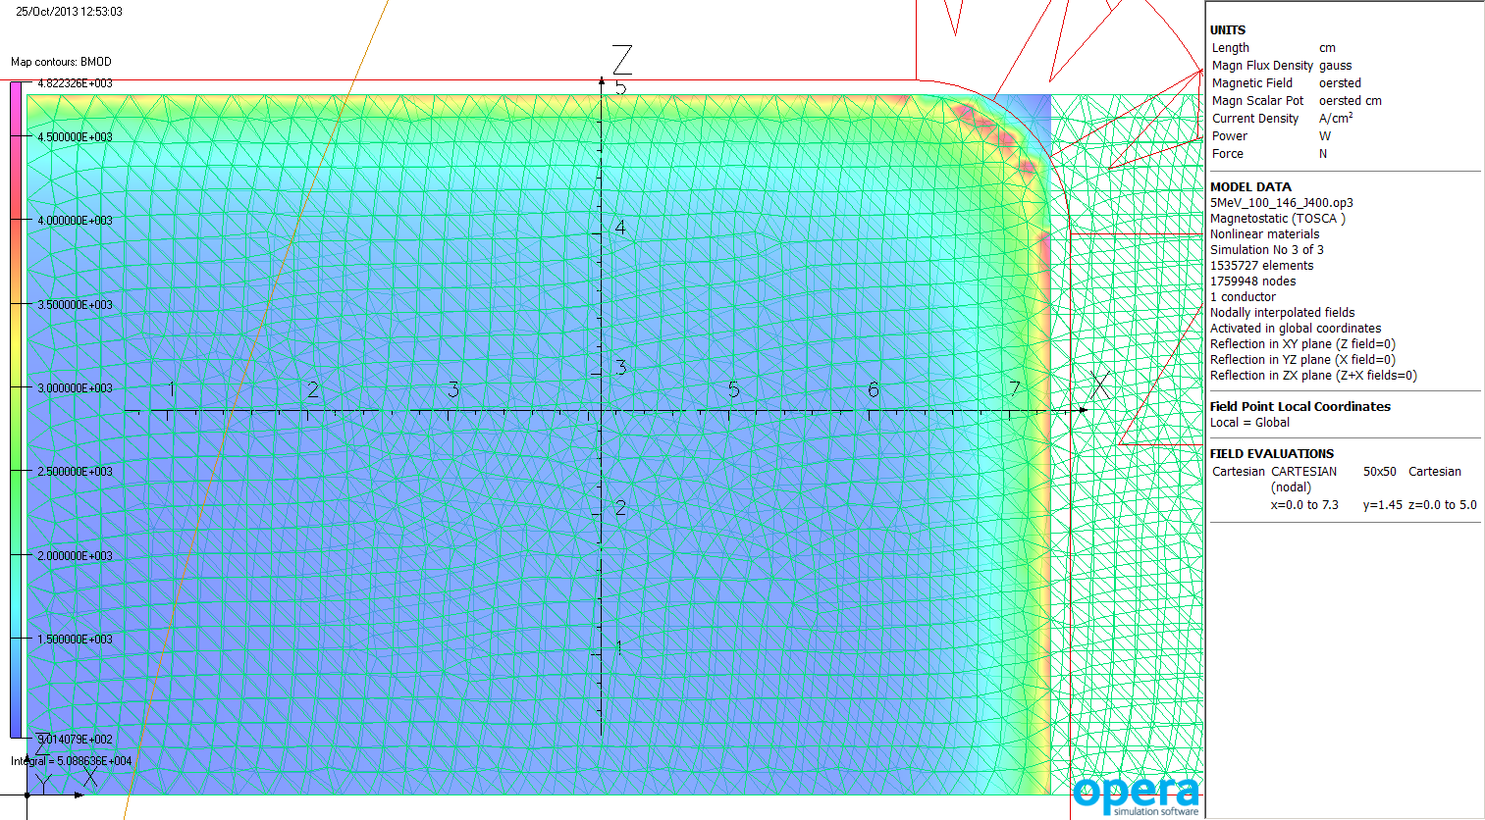
Figure 12. Flux 1 mm into the pole face viewed from below. Excitation here is 5.64A, sufficient to bend an 8.5 MeV KE electron 25.16 degrees as the curved line shows. Peak is under 5 kG. Orbit crosses edge of pole at x=2.3 cm.

1105 amp-turns | x=0 | x=1 | x=2 | x=2.5 | x=3 | x=3.5 | x=4
BdL G-cm | -12789.6 | -12787.6 | -12781.8 | -12776.5 | -12768.4 | -12756.1 | -12737.8
BdL ratio to x=0 |  | 0.9998 | 0.9994 | 0.9990 | 0.9983 | 0.9974 | 0.9959
Table 3. BdL values at y=0, indicated x, z=[-20.20] cm and the ratios to the central BdL
Model 4 - November 14, 2013

Tommy Hiatt found a piece of rusty 3" thick 1006 steel in the "boneyard". George Biallas tells me it's about two foot square. I inspected the existing magnet. I measured 3.3" (8.38 cm) from the magnet centerline to the bolts on the adjacent flange. I increased the half-length of the steel to 5.3 cm. The nominal coil excursion is 2.6 cm with maximum 2.95 cm so stack-up totals 7.9-8.25 cm, sufficient clearance with same bend center.

Steel dimensions in model, with no symmetry assumed, unlike most of figures above:

part | x1 | x2 | y1 | y2 | z1 | z2
poleT | -8 | 8 | 1.35 | 4.2 | -5.3 | 5.3
poleB | -8 | 8 | -1.35 | -4.2 | -5.3 | 5.3
top | -13.7 | 13.7 | 4.2 | 7.05 | -5.3 | 5.3
bottom | -13.7 | 13.7 | -4.2 | -7.05 | -5.3 | 5.3
sideL | -13.7 | -10.85 | -4.2 | 4.2 | -5.3 | 5.3
sideR | 10.85 | 13.7 | -4.2 | 4.2 | -5.3 | 5.3

Again, 1 cm radius on pole corners and Y2 for top and bottom can go to 7.5 cm. That dimension will be set by how much rusted steel must be removed from the 3" slab to get flat surfaces top and bottom.
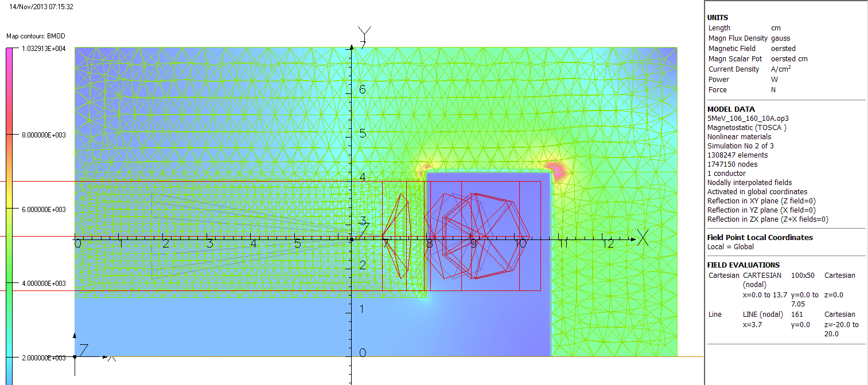
Figure 13. Field at Z=0 with 5.4A in coil. This will bend an electron with 8.63 MeV KE 25 degrees. At 15A in the coil the field is 0.9983 times the linear projection from 10A, so just beginning to saturate. At 15A the magnet will bend a 25 MeV KE electron 24.82 degrees.

1058.4 amp-turns | x=0 | x=1 | x=2 | x=2.5 | x=3 | x=3.5 | x=4
BdL G-cm | -12900.9 | -12900.1 | -12896.2 | -12892.9 | -12888.3 | -12881.7 | -12870.9
BdL ratio to x=0 |  | 0.99994 | 0.99964 | 0.99938 | 0.99902 | 0.99851 | 0.99767
Table 4. BdL values at y=0, indicated x, z=[-20.20] cm and the ratios to the central BdL

Model five -November 18, 2013

The rusty steel is defined by drawing 07134-E-1003. It is trapezoidal, 23.45" long, 16.44" narrow end, 19.64" wide end, 2.92" thick before it started rusting. Dave McCay informs me that kerf plus wander on cutting this would be ~0.1". 2" must be cut off the narrow end to remove several large holes; this piece can be machined to increase the gap in the magnet intended for "sweep" use. The next 10.9" can be cut into four pieces 104 mm x 276 mm, leading to finished pole size 102 mm x 274 mm. Same width and thicknesses as in model four, but 4 mm shorter. An 8.5 MeV KE electron is bent 25.1 degrees by 5.5 A in this model. The magnet is only 1.5% into saturation at 20A so it can likely serve above 30 MeV/c if water cooled.

1078 amp-turns | x=0 | x=1 | x=2 | x=2.5 | x=3 | x=3.5 | x=4
BdL G-cm | -12741.5 | -12740.6 | -12737.1 | -12733.9 | -12729.1 | -12721.9 | -12711.5
BdL ratio to x=0 |  | 0.99993 | 0.99965 | 0.99940 | 0.99903 | 0.99846 | 0.99765
Table 5. BdL values at y=0, indicated x, z=[-20.20] cm and the ratios to the central BdL

Steel dimensions in model 5, with no symmetry assumed:

part | x1 | x2 | y1 | y2 | z1 | z2
poleT | -8 | 8 | 1.35 | 4.2 | -5.1 | 5.1
poleB | -8 | 8 | -1.35 | -4.2 | -5.1 | 5.1
top | -13.7 | 13.7 | 4.2 | 7.05 | -5.1 | 5.1
bottom | -13.7 | 13.7 | -4.2 | -7.05 | -5.1 | 5.1
sideL | -13.7 | -10.85 | -4.2 | 4.2 | -5.1 | 5.1
sideR | 10.85 | 13.7 | -4.2 | 4.2 | -5.1 | 5.1

Again, 1 cm radius on pole corners and Y2 for top and bottom can go to 7.4 cm. Coil in the model is 1 mm from the pole but can be wound to a slip fit. Increased pocket size (2.85 cm square) allows for insulation beyond the heavy film if the fabricator chooses. It also allows for the cooling plate discussed below.

Ripple and water cooling

Assume the power supply is three phase. It will have some ripple at 360 Hz. Eddy currents in the steel poles and stainless steel vessel will reduce the ripple seen by the beam by about a factor of eight versus that present in the current at the power supply terminals. This may be reduced another order of magnitude by placing a 3 mm copper shorting turn under the coil, completely filling the coil pocket. If one wants to use a high frequency switching supply, less copper as skin depth much less. OTOH, the copper turn may be pressed into service as a future heat sink. A 30 cm long, 6mm OD copper tube may be soldered to the 3mm copper under the coil pocket and terminated for future use. The coil supports which would have been designed to press the coils into their pockets will press against the copper plate instead, avoiding the tube. If a future experiment needs 15 MeV/c beam, increasing the power in the magnet to 200W, hook up cooling water.

Measuring Magnetic fields

Claudio Ugalde emailed a question about field measurement, picking up the statement I made that the remanent field was going to be one of the larger systematic errors. He asked why this would be so if we put a Hall probe in the bore. It is possible to put a probe in a flat field region given the shape of the vacuum chamber (good). The problem is that Hall probes have accuracy and temperature coefficient issues. For about $10K one can buy a hall probe system with claimed accuracy 0.01% and temperature coefficient 10 ppm/C. For about $6K one gets accuracy 0.03% with 100 ppm/C temperature coefficient. See GMW's web site:
http://www.gmw.com/magnetic_measurements/Group3/DTM-151.html
For $30K GMW sells an NMR system with 5 ppm accuracy and very low tempco.

Claudio also asked about water cooling to stabilize response. The fifth model has ~725 cc of copper so 60W total isn't going to heat it much. A possible heat sink is described in the previous section.

Conclusions

Five models have been created for a new 5 MeV dipoles. A piece of 1006 magnet steel 3" x 11" x 16.7" has been obtained so two copies of the fifth model can be built with two E-cores each to provide a very flat field spectrometer magnet if toleranced properly and fabricated to tolerance.

Steel plate

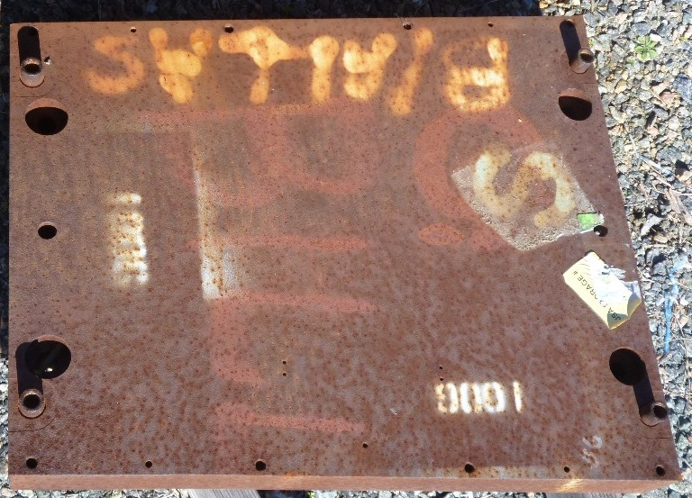

 |  | BdL along indicated x, y=0, z=[-20,20] |  |  |  |  |  |  | ratio to x=0 line
pole size, corner shape | amp-turns | x=0 | x=1 | x=2 | x=2.5 | x=3 | x=3.5 | x=4 | x=1 | x=2 | x=2.5 | x=3 | x=3.5 | x=4
4" wide x 4" long square | 1000 | -11833.2 | -11825 | -11803.8 | -11781.2 | -11735.1 |  |  | 0.99931 | 0.99752 | 0.99561 | 0.99171
5" wide x 5" long square | 1500 | -17687.3 | -17685 | -17674.6 | -17664.5 | -17647.9 |  |  | 0.99987 | 0.99928 | 0.99871 | 0.99777
14 cm wide x 12.5 cm long, radiused | 1965 | -27279.9 | -27277 | -27264.3 | -27251.5 | -27234.1 | -27205.4 | -27159.4 | 0.99989 | 0.99943 | 0.99896 | 0.99832 | 0.99727 | 0.99558
14 cm wide x 10 cm long, radiused | 1098.4 | -12725.9 | -12723.5 | -12716.4 | -12709.5 | -12699.5 | -12683.4 | -12658.1 | 0.99981 | 0.99925 | 0.99871 | 0.99793 | 0.99666 | 0.99467
14.6 cm wide x 10 cm long, radiused | 1105.3 | -12789.6 | -12787.6 | -12781.8 | -12776.5 | -12768.4 | -12756.1 | -12737.8 | 0.99984 | 0.99939 | 0.99898 | 0.99834 | 0.99738 | 0.99595
16 cm wide x 10.6 cm long, radiused | 1058.4 | -12900.9 | -12900.1 | -12896.2 | -12892.9 | -12888.3 | -12881.7 | -12870.9 | 0.99994 | 0.99964 | 0.99938 | 0.99902 | 0.99851 | 0.99767
15 cm wide x 10.6 cm long, radiused | 1058.4 | -12905.2 | -12904 | -12899.2 | -12894.5 | -12887.7 | -12877.4 | -12861.4 | 0.99991 | 0.99954 | 0.99917 | 0.99864 | 0.99785 | 0.99661
16 cm wide x 10.2 cm long, radiused | 1078 | -12741.5 | -12740.6 | -12737.1 | -12733.9 | -12729.1 | -12721.9 | -12711.5 | 0.99993 | 0.99965 | 0.99940 | 0.99903 | 0.99846 | 0.99765
Summary table of field integrals along lines parallel to the Z axis for all the models discussed, and the ratios of the offset lines to that along the Z axis (aka x=0, y=0)

