Using measured thicknesses and uncertainties – same exact data as that presented July 14th, with chi-squared values added.
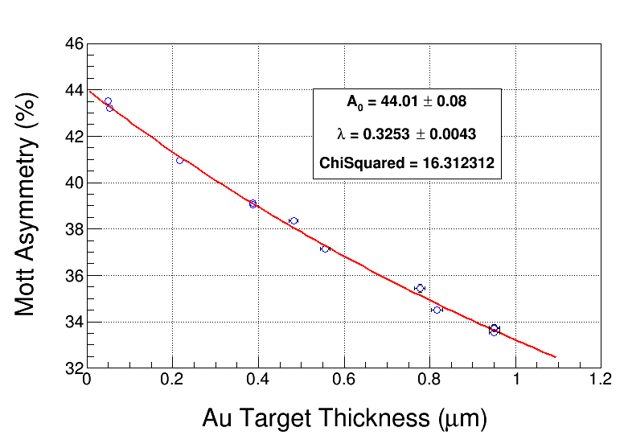

ToF: mean +/- 1 sigma
E: mean +/- 1 sigma

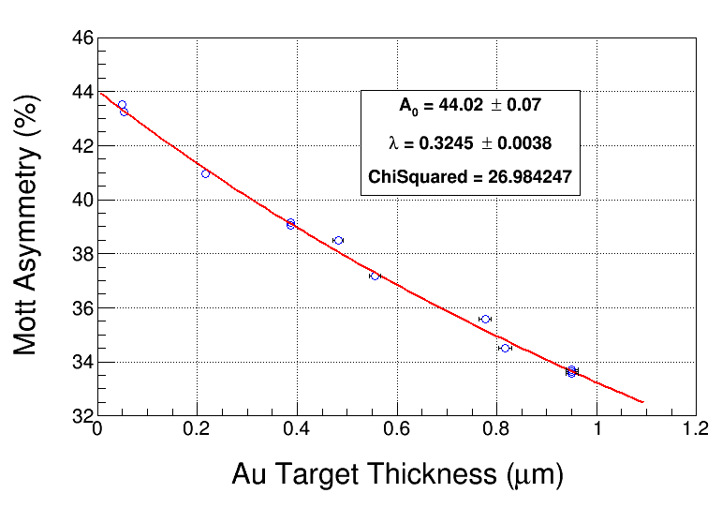

ToF: mean +/- 2 sigma

E: mean +/- 1 sigma

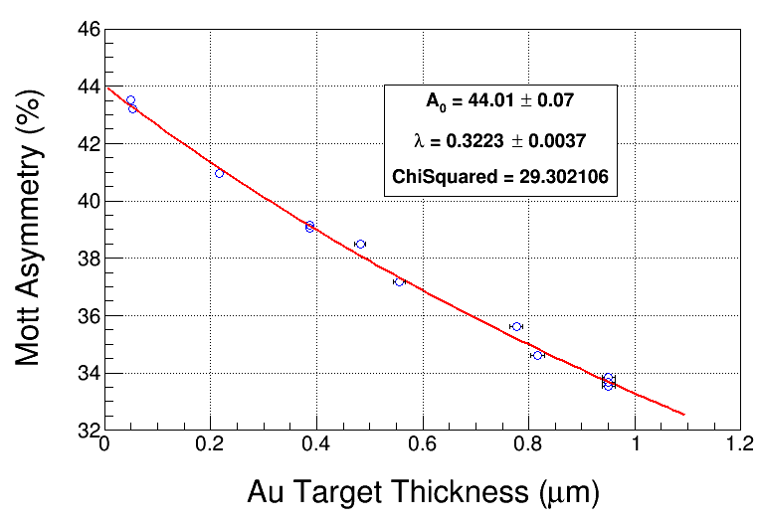
ToF: mean +/- 3 sigma E: mean +/- 1 sigma

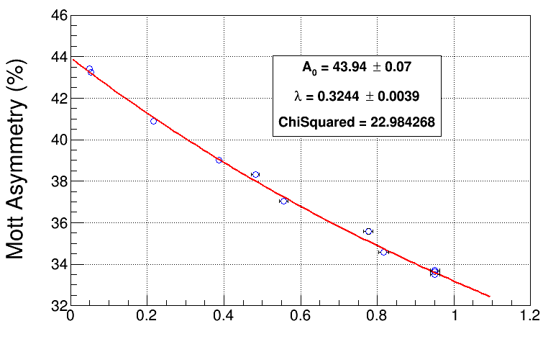
ToF: mean +/- 1 sigma E: mean +/- 2 sigma

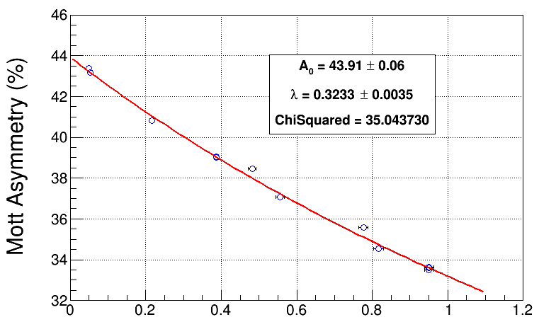
ToF: mean +/- 2 sigma E: mean +/- 2 sigma

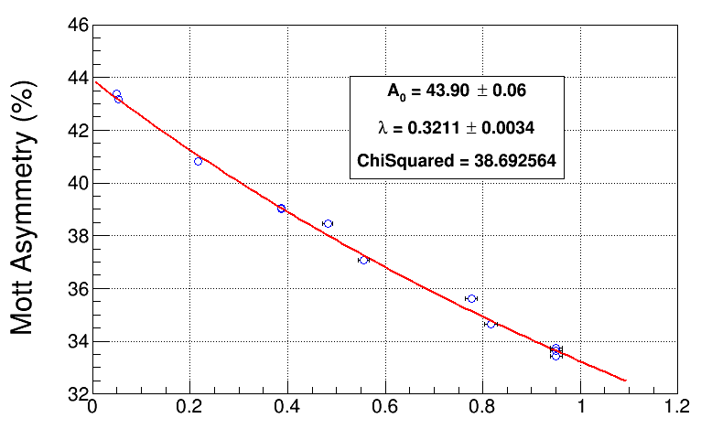
ToF: mean +/- 3 sigma E: mean +/- 2 sigma

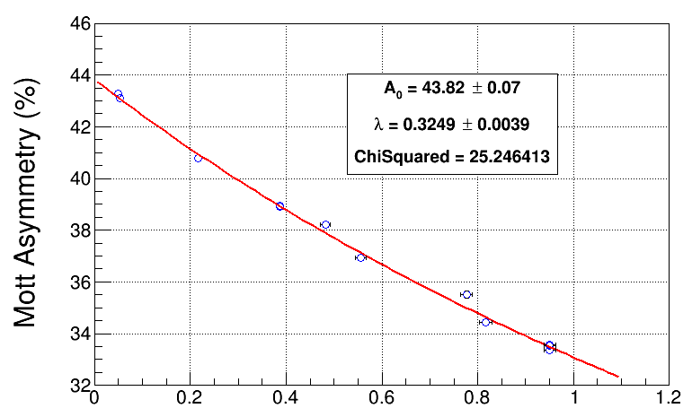
ToF: mean +/- 1 sigma E: mean +/- 3 sigma

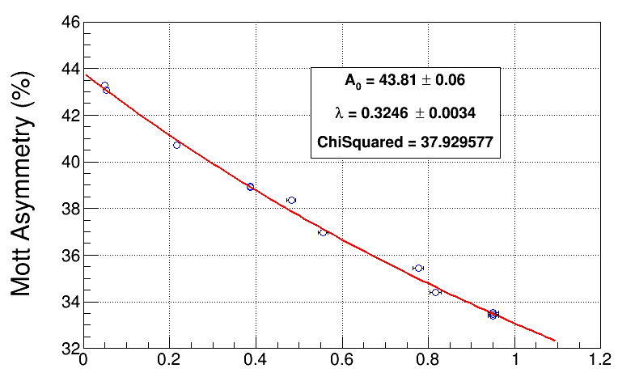
ToF: mean +/- 2 sigma E: mean +/- 3 sigma

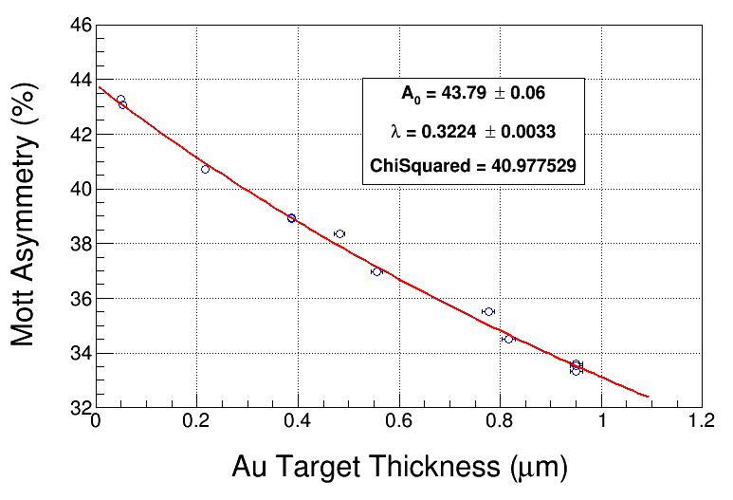
ToF: mean +/- 3 sigma E: mean +/- 3 sigma

