high voltage studies of inverted-geometry ceramic insulators for a 350kV polarized electron gun

C. Hernandez-Garcia ^{a)}, J. Hansknecht, and M. Poelker

¹Thomas Jefferson National Accelerator Facility, 12000 Jefferson Ave, 23606, Newport News, VA, USA

Jefferson Lab is constructing a 350 kV DC high voltage photoemission gun that employs a compact inverted-geometry insulator. This photogun will be used to produce polarized electron beams at an injector test facility designed to conduct low energy nuclear physics experiments, and to assist the development of new technology that will be employed at the Continuous Electron Beam Accelerator Facility (CEBAF). At 350kV bias voltage, the photogun will produce bright beams that are relatively insensitive to space charge forces, and this reduces the complexity of the injector design. However, reliable photogun operation at 350 kV necessitates solving serious high voltage problems related to breakdown and field emission. This study focuses on developing effective methods to avoid breakdown at the interface between the photogun insulator and the commercial high voltage cable that connects the photogun to the high voltage power supply. Three types of inverted insulators were tested, in combination with two electrode configurations. Our results indicate that tailoring the conductivity of the insulator material, and/or adding a cathode triple-junction screening electrode, effectively serves to increase the breakdown hold-off voltage from 300kV to more than 375kV. Electrostatic field maps suggest these configurations serve to produce a uniform potential gradient across the insulator.

I. INTRODUCTION
Many high-energy and nuclear physics experiments are conducted using spin-polarized electron beams produced by illuminating a GaAs photocathode inside a DC high voltage photoelectron gun with circularly polarized light [Poelker, book Rao and Dowell editors]. The vacuum conditions within the photogun must be superb (pressure < 10⁻¹¹ Torr) to maintain a reasonable photogun operating lifetime [Grames, Riad]. At most facilities worldwide, the photocathode is biased at approximately 100 kV. Higher bias voltages would serve to improve beam quality, but historically, attempts to operate DC high voltage polarized photoguns above 100kV have proven very difficult, primarily due to field emission within the gun that degrades vacuum. Radio frequency electron guns produce beams at much higher energy (> MeV) but their operating vacuum conditions preclude the use of GaAs photocathodes [x]. Recent worldwide interest in developing bright accelerator-based light sources has renewed efforts to operate DC high voltage photoguns at considerably higher voltages (500kV or more). At Jefferson Lab, an inverted-geometry insulator approach has been adopted [x], where the term “inverted” describes an insulator that extends into the vacuum chamber. This design does not require a long electrode support structure commonly used on photoguns that employ large-bore cylindrical insulators. This helps to reduce field emission within the gun because there is considerably less metal biased at high voltage. However, the inverted-insulator geometry introduces a new problem compared to other photogun designs [x, y, z], namely, how to effectively apply high voltage to the cathode electrode without encountering high voltage breakdown inside the relatively small inverted insulator.
The first photogun to employ an inverted-insulator design was developed at SLAC [Breidenbach et al. Nucl Instr Meth A 350 (1994) 1-7]], with reported operating voltage ~ 120 kV (must check). Their design relied on three hollow cylindrical insulators: two served to provide cathode cooling and one as a conduit to apply the high voltage. Now we must mention other inverted guns….this might only be the Bonn ELSA gun which operates at just 50kV. The Jefferson Lab inverted insulator design employs one conical-shaped insulator that extends into the vacuum chamber. The insulator is a common component of medical x-ray devices, with the commercial designation “R28”, which specifies the length and angle of the interior conical shape. Because these insulators are widely used, they are relatively inexpensive, and they mate to commercial high voltage cables. In recent years, two photoguns were constructed at Jefferson Lab using the R28 insulator: one provides spin-polarized electron beams at CEBAF at 130kV bias voltage, and the other is used at a test facility to produce beam at 200kV and at beam currents up to 4 mA [riad, PAC].
The objective of this work was to develop an inverted-ceramic/electrode geometry capable of reaching 375kV, without electrical breakdown. Three types of inverted insulators were tested: pure alumina, a bulk insulator material with a vendor-proprietary dopant that provides a small level of conductivity, and a pure alumina insulator coated with ZrO which also was intended to provide a small degree of conductivity. Most tests were performed using a insulators with the R30 designation, which are longer than R28 insulators. In addition, the insulators were evaluated using a screening electrode near the insulator triple junction. All tests were conducted using a spherical stainless steel electrode that was mechanically polished to mirror-like finish to minimize field emission. The test electrode did not employ a photocathode. All tests employed commercial high voltage cables attached to a 580 kV high voltage power supply within a pressure vessel that was filled with SF6 at 10 psi. Results show that the electrode could be biased to higher voltages without breakdown at the insulator/cable interface, when the potential gradient across the insulator is made more uniform. Two test configurations provided a means to reach our bias voltage goal.

II. EXPERIMENTAL SETUP AND PROCEDURES
High voltage tests conducted with electrodes inside vacuum chambers often lead to field emission which produces x-rays. As such, all measurements were conducted using equipment within a concrete-shielded room and via remote control. Access to the room was prohibited when the high voltage power supply was energized, using interlocks that were part of an engineered personnel safety system.
A. Apparatus
Inverted-geometry insulators were welded to 10” Conflat flanges that mate to a stainless steel photogun vacuum chamber (Fig. 1a). Most tests were conducted using R30 insulators composed of 97.7% alumina and approximately 19 cm long. These insulators position the cathode electrode in the middle of the vacuum chamber. For an actual photogun, the cathode electrode would possess additional holes to accommodate a photocathode that could be inserted or removed from the electrode using a vacuum sample manipulator, however for these tests a “dummy” electrode was used. The dummy electrode was spherical (15 cm dia.), without the means to accept a photocathode. It was manufactured from two hemispheres of hydroformed 304 stainless steel sheet that were welded together and polished by hand using silicon carbide paper to obtain a mirror-like surface finish. Toward the end of the experiment, while waiting for the arrival of a machined component, time was available to polish the dummy electrode further using diamond grit. In retrospect, diamond-paste polishing was not required. The anode for these measurements was simply the grounded vacuum chamber wall that provided a typical cathode/anode gap of 15 cm.
As mentioned above, most tests were performed using R30 insulators however one experiment was conducted using an R28 insulator just 11.4 cm long. This insulator was composed of 94.4% alumina and doped with a proprietary formulation that served to reduce the insulator bulk resistivity. Ideally, tests would have been conducted using a longer, R30 version of this insulator, however it was not available. The insulators and electrode configurations are described in more detail below.
The photogun high voltage chamber was cylindrical (46 cm dia.) with a flat-front plate and dish-head back plate, made of 304 stainless steel that was previously vacuum baked at 400C for 100 hours to reduce outgassing from the chamber walls [x]. Vacuum pumping was provided using a small ion pump and a non-evaporable getter (NEG) pump module positioned where the anode electrode would normally reside. After assembling each insulator/electrode test configuration, the chamber was evacuated using a turbo pump cart and the entire system baked within an oven at 250C for 48 hours. The bakeout served to eliminate water vapor from the vacuum apparatus and to partially activate the NEG module. Vacuum in the low -11 Torr was routinely achieved and a residual gas analyzer (200 amu resolution) was used to verify the system was free of vacuum leaks.
Commercial industrial high voltage cables with appropriate R28 or R30 terminations were used to attach the photogun high voltage chamber to the high voltage power supply. Cables were typically X meters long, with capacitance of uF/m, providing stored energy of …. One end of the cable was attached to an R28 or R30 inverted-geometry insulator at the photogun vacuum chamber, and the other end of the cable was attached to a molded epoxy receptacle at the SF6 pressure vessel (10 psi) where the Cockcroft-Walton 580kV, 5 mA DC high voltage power supply (HVPS) was located. The epoxy receptacles were also commercial components with R28 and R30 designations. The final electrical connection between the high voltage power supply and the epoxy receptacle was made within the SF6 pressure vessel, via a 300 Mega-Ohm conditioning resistor. The conditioning resistor served to limit the available stored energy that could be applied to the dummy electrode, and also serves to protect the electrode via a negative feedback mechanism – as current increases, a larger voltage drop occurs across the resistor, reducing voltage at the electrode.
Before inserting high voltage cables into insulators and receptacles, a thin layer of silicone “grease” ( ~ 2 mm) was applied to each cable termination. Cable terminations were secured by applying an appropriate level of torque sometimes occurred, leading to costly cable repairs.
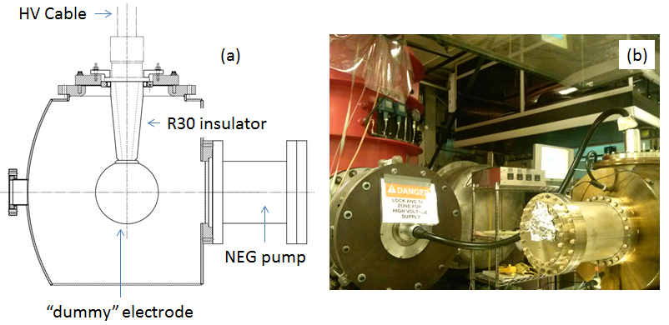
FIG. 1: a) Schematic representation of the photogun high voltage vacuum chamber, showing the “dummy” test electrode attached to an R30 inverted-geometry insulator. A non-evaporable getter (NEG) pump was positioned where the anode electrode would normally reside, when the photogun is configured to provide an electron beam. For reference, the insulator is attached to a 10” CF flange, and the vacuum chamber diameter is 18”. b) photograph of the high voltage test chamber attached via high voltage cable, to the power supply that resides within an SF6 tank.

B. Materials and configurations
A total of five insulators were tested: three R30 insulators composed of 97.7% alumina, one R30 insulator coated with ZrO , and one R28 insulator composed of 94.4% alumina and doped with a proprietary formulation that served to reduce the insulator bulk resistivity. All of the insulators were purchased from Solutions in Ceramic Technologies (SCT-France). Each ceramic was delivered with a brazed molybdenum end piece at the narrow end of the taper to provide vacuum isolation as well as mechanical and electrical contact to the electrode on the vacuum side, and to the cable plug on the air side. The outer rim of the ceramic on the wide end of the taper was brazed to a kovar ring that was welded (vacuum tight) to a 10-inch diameter Conflat flange.
Two insulator/electrode configurations were evaluated. The majority of tests were conducted using a mounting cup with a rounded collar, which provided a means to attach the electrode to the insulator. The mounting cup was affixed to the electrode using four set screws that protrude from the cup and press against the interior of the sphere. The other configuration employed a screening electrode, or “shed” [x], intended to alter the field lines…..The collar and shed were both manufactured from 304 stainless steel and mechanically polished…..
Talk about specifics of silicon carbide polishing. All of the metal components that were biased at high voltage (dummy electrode, collar, and shed) were cleaned between polishing steps in an ultrasonic bath of concentrated degreaser diluted in de-ionized water, followed by ultrasonic baths in de-ionized water, acetone, and methanol. The dummy electrode was also vacuum baked as a final step prior to installation at 900 C for 240 minutes. After the electrode was attached to the insulator, the electrode and insulator were cleaned using a high-speed jet of CO₂, prior to mounting the assembly into the vacuum chamber. Mention bakeout once again.?
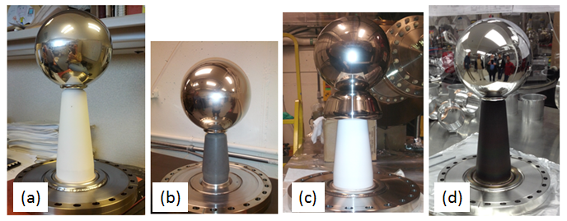
Fig. 2 Photographs of insulators and electrode configurations. The same spherical “dummy” electrode (15 cm dia.) was used for every test. a) R30 pure alumina, b) R28 lower bulk resistivity, c) R30 pure alumina with shed electrode, and d) R30 pure alumina with ZrO coating on the vacuum side.

C. High voltage gas conditioning

Key to the success of these high voltage measurements was gas conditioning [x], performed using krypton gas. Gas conditioning serves to eliminate field emitters from the cathode electrode through ion bombardment and resultant sputtering and ion implantation. Gas conditioning is more reliable than vacuum conditioning [x], and more importantly, limits the damage to photogun components that can often result from unregulated field emission and breakdown… To implement gas conditioning, krypton was introduced into the vacuum chamber using a leak manual leak valve, at a pressure of ~ 1e-5 Torr. Gas conditioning was always implemented each time a new insulator or electrode configuration was tested. introduced into the vacuum chamber via a bakeable leak valve, and pumped using the turbo pump, with the ion pump not energized. The high voltage power supply was operated in over-current trip mode, typically set to 400 uA.
Once 375kV voltage set point was achieved in Kr conditions without field emission, the ceramic-electrode configuration was let to soak at that voltage for several hours to determine the stability (robustness) of the configuration. Approximately 100 hours of high voltage processing were required to achieve those conditions for each tested configuration. Afterwards, the voltage was decreased to zero, the krypton gas evacuated and once vacuum conditions were below 1x10⁻¹⁰ Torr, the voltage was slowly increased again to 10 kV lower than the maximum achieved in Kr conditions, this is the typical gap we have observed voltage-induced gas desorption under vacuum conditions after Kr processing, and the reason why 375kV was chosen as the maximum voltage in Kr: to obtain 365kV in vacuum, for nominal operation at 350kV. The high voltage conditioning procedure is described in

III. RESULTS AND DISCUSSION
- High voltage performance for each insulator-electrode configuration
Evaluating the performance of each high voltage configuration involved monitoring the high voltage power supply current, the levels of x-ray radiation near the vacuum chamber, and the vacuum pressure as a function of applied voltage. Measured power supply current could be due to leakage or breakdown at the interface between the high voltage cable and the inverted-geometry insulator, or it could be related to field emission from the biased cathode electrode. A correlation between measured x-ray levels was used to distinguish between the two possible current sources.
1. R30 pure alumina insulator
During high voltage processing of the first R30 pure alumina insulator with Kr and at 315 kV, evidence of excess current was observed with no associated field emission activity, which is represented by the Geiger monitor signal (green trace), indicating that the observed increase in current was associated with events outside the vacuum environment. An example of field emission processing inducing a current surge is characterized by the radiation levels sudden decrease seen between minutes 34:00 and 36:00 in figure 4.
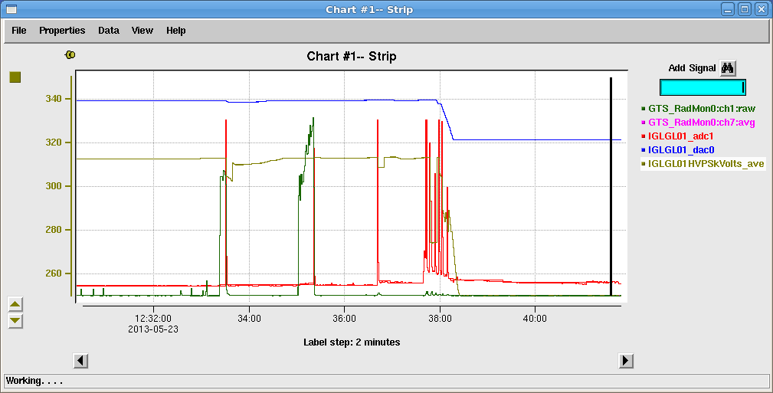
FIG 4. Diagnostic signals as a function of time during high voltage processing. Gold trace is the HVPS voltage in kV. Red trace is the HVPS current from 0 to 0.5 mA. Green trace is the Geiger monitor output, from 0 to 10,000 counts per second.

As high voltage processing continued, occasional increases in the cold cathode gauge that monitors Kr, from nominal 2.x10⁻⁷ Torr to 4x10⁻⁵ Torr were observed. Despite the increase of more than two orders of magnitude, the vacuum recovered in a few seconds, making dubious the presence of a leak. The R30 pure alumina insulator reached 329kV with no evidence of field emission for a few minutes before the HVPS tripped off on over-current. That voltage could not be recovered. Upon removing the cable plug for inspection, the insulator showed tracking from the high voltage end to approximately 5 cm above the high voltage cup, then it stopped on a ‘crater’. A Helium leak check proved in fact this was a puncture. Figure 5 shows the state of the R30 pure alumina insulator after failure. Notice that the tracking did not span the length of the insulator, from high voltage to ground on the plug-ceramic interface, (where the Silicon grease is applied), but rather it went up from the high voltage end, through the ceramic, and found the path to ground via the vacuum side of the ceramic.
A second R30 pure alumina insulator tested, field emission processing took place at 275kV under Kr conditions. The voltage was then slowly increased up to 300kV with no evidence of field emission or excess current. A few minutes later the HVPS tripped off on over-current at 300kV. Similarly as with the first R30 insulator tested, that voltage could not be recovered. Upon inspection, the insulator showed signs of tracking from the high voltage end to the ground end as shown in figure 6. There was no evidence of puncture.
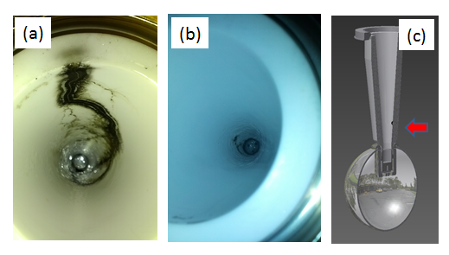
FIG. 6. Tracking on second R30 pure alumina insulator after failing at 300kV. The tracking spans the total length of the insulator. a) Picture of the damaged R30 insulator, plug side, showing the breakdown track starting from the high voltage end and terminating about 5 cm above. b) cartoon representing the location of the puncture coinciding with the termination of the breakdown track.

2. R30 pure alumina insulator with shed electrode

The fourth test was a third new pure alumina R30 insulator but this time with a modified electrode shape, achieved by adding a triple-point shield structure called a shed, shown in figure 8. Field emission levels during high voltage processing were three orders of magnitude higher than those observed in the R28 insulator test. Despite tens of hours of processing, field emission could not be eliminated. However, under Kr conditions, the R30 pure alumina insulator reached 375kV without breakdown, and sustained 370kV for a few hours (the predetermined length of testing), the only difference being the additional shed electrode structure. Under vacuum conditions (figure 9), the R30 insulator & shed configuration was let at 350kV for a few hours, albeit exhibiting field emission in the order of 10,000 counts per second, compared to 20 counts per second exhibited by the R38 less resistive insulator without the shed at the same voltage and vacuum conditions. Given that the target voltage was achieved and in order to preserve the R30 insulator sample, the voltage was not further increased.
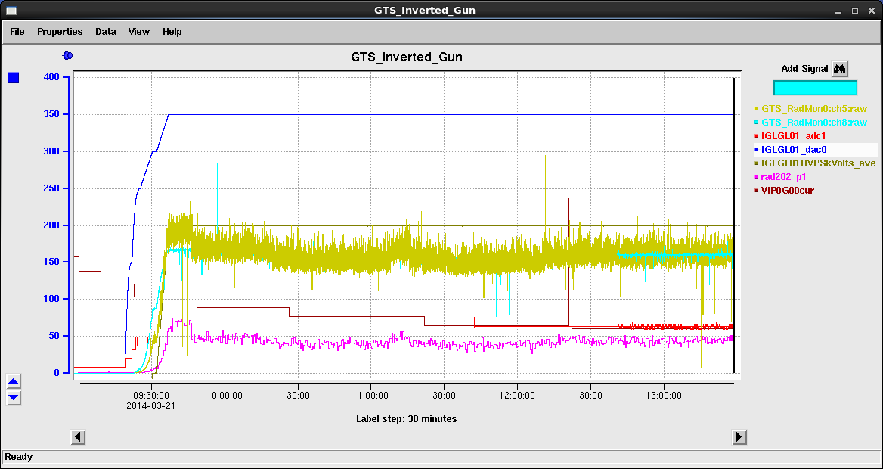
FIG. 9. High voltage performance of the R30 pure alumina insulator with shed configuration in a multi-hour test at 350kV under vacuum conditions. Blue trace is the HVPS voltage in kV, red trace is the HVPS current from 0 to 0.5 mA, the golden trace is the signal from the Geiger monitor from 0 to 20,000 counts per second. The maroon trace is the vacuum signal from the ion pump 1x10⁻¹² to 1x10⁻¹⁰ Torr.

3. R30 pure alumina insulator, ZrO coated vacuum side

The last insulator tested was a third R30 pure alumina ceramic coated with a Zirconium Oxide (ZrO) film on the vacuum side. With the purpose of isolating the performance of the coating, the electrode configuration was chosen without the shed, but the spherical electrode was further polished by hand starting with 320 grit and ending with 600 grit before transitioning to diamond paste 9 micron, then 6 micron and finally with 1 micron. The electrode was chemically cleaned in ultra-sonic baths as described in section B.
High voltage processing under krypton conditions proceeded similarly to those for the lower resistivity R28 insulator with comparable levels of field emission, around 20 counts per second. At 336 kV, voltage induced gas desorption was observed without field emission. At 340kV, the HVPS tripped off on over current. Upon recovering the voltage, field emission was observed at 200kV, but processed out at 240kV. At 300kV, the HVPS tripped off again on over-current, but in this instance the reading on the Pirani cold cathode gauge increased two orders of magnitude, in similar fashion as with the first test of the R30 pure alumina insulator. Upon inspection, the breakdown track originated about one quarter of the ceramic length on the high voltage side, and ended just below the ground end of the ceramic. Two punctures at that location can easily be seen in figure 10.
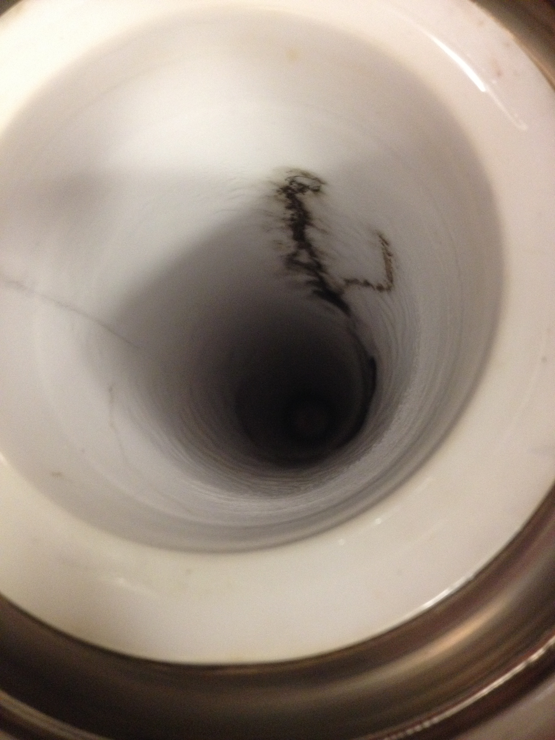a)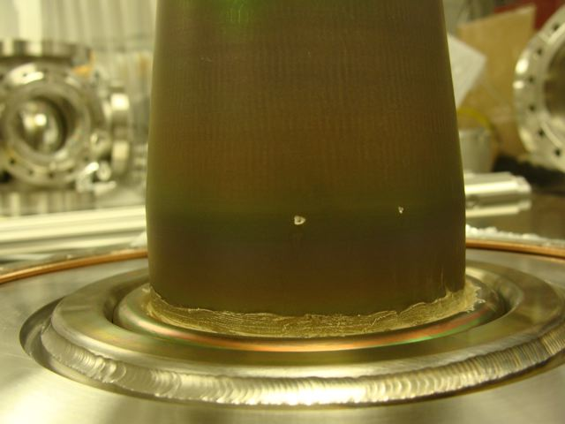b)
FIG. 10. Picture of the R30 insulator with ZrO coating on the vacuum side. a) the breakdown tracking on the plug side ends at 2 cm from the ground end. b) two punctures on the vacuum side coincide with the location of the tracking end on the plug side.

4. R28 lower bulk resistivity insulator
The final test used a shorter R28 insualtor, black in color, and with lower bulk resistivity than the R30 (see Table I). The high voltage conditioning procedure was the same as for the R30 insulators, observing typical field emission processing, and voltage induced gas desorption [Ref]. Excess current with no associated field emission was never observed, indicating that events such as tracking on the cable plug were not present. Despite being shorter, this insulator reached 365 kV sustained for several hours and without field emission under Kr conditions. The voltage was not increased any further with the intention to preserve the integrity of the insulator and cable plug. Under nominal vacuum conditions, the voltage was set to 350kV for several hours, in more than three separate instances, with no evidence of field emission. Figure 7 shows an example of those instances under vacuum conditions.
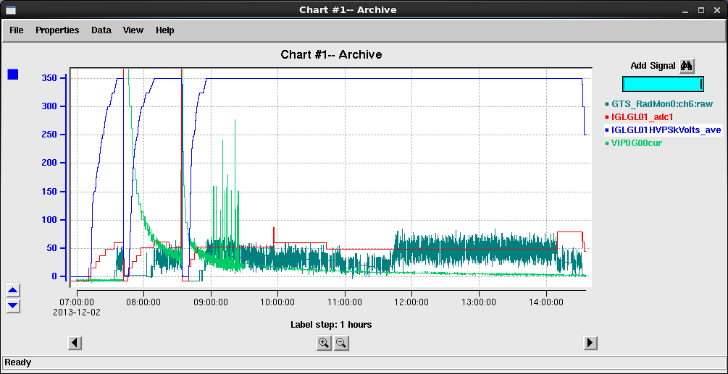
FIG. 7. High voltage performance of the R28 insulator in a multi-hour test at 350kV under vacuum conditions. Blue trace is the HVPS voltage in kV, red trace is the HVPS current from 0 to 0.2 mA, dark green trace is the signal from the Geiger monitors in counts per second from 0 to 100. The bright green trace is the vacuum signal from the ion pump from 1x10⁻¹² to 1x10⁻¹⁰ Torr.

6. High voltage performance summary

Table I. Material properties with associated electrode configuration for each tested insulator and corresponding high voltage performance. R30 white corresponds to 97.7% alumina, and R28 black corresponds to 94.7% alumina for lower bulk resistivity, as provided by manufacturer.

Insulator | Resistivity ^{(a)}  (Ohm-cm) | Dielectric constant ⁽*⁾, ε/ε₀ | Electrode configuration | Performance
R30 | 5.0x10¹⁵ | 9.1 | Sphere | Breakdown and puncture at 329kV
R30 | 5.0x10¹⁵ | 9.1 | Sphere | Breakdown at ~ 300 kV
R30 | 5.0x10¹⁵ | 9.1 | Sphere & Shed | Sustained multi-hour operation at 370 kV
R30, with ZrO coating | 5.0x10¹⁵ | 9.1 | Sphere | Breakdown and puncture at 340kV
R28 | 7.4x10¹¹ | 8.4 | Sphere | Sustained multi-hour operation at 360kV
ªProvided by the manufacturer.

B. Electrostatic modeling

Since dimensions and geometry of the vacuum chamber, insulators and electrode were defined and built prior to commencing high voltage tests; the objective of electrostatic modeling was originally to study the gradient on the test electrode, as well as the electric field and potential distributions along the insulator at 350kV. For example, the R28 insulator is based on a commercial product for X-ray tubes, while the R30 is a larger customized version of similar product. As testing progressed, electrostatic modeling results were also correlated with high voltage performance. From Figure 2, one can see that the symmetry axis of the inverted-geometry conical ceramic insulator is perpendicular to the vacuum chamber symmetry axis, therefore electrostatic modeling would require simulation codes capable of three-dimensional analysis. As a first approximation, and due to inaccessibility to such codes, simulations were performed utilizing POISSON [Ref LANL], even though that code assumes cylindrical symmetry around user-specified axis and does not permit material resistivity choosing, a much-desired characteristic based on the manufacture’s specifications listed in Table I.
For all simulations cylindrical symmetry was defined around the vertical axis (z) with Neumann boundary conditions on the left (z axis), top and bottom, while the vacuum chamber dimensions define Dirichlet boundary conditions on the right (figure 11). Watanabe et al. performed similar simulations of an inverted geometry ceramic insulator utilizing the finite element method [J. Vac. Sci. Technol, A 5 (1), Jan/Feb 1987] at 100kV but does not provide details on the ceramic or the cable plug dielectric constant and resistivity. A 0.25 cm radius vertical rod connecting to the spherical electrode models the cable central conductor. The cable plug with dielectric constant ε₁/ε₀ set to 2.37 for vulcanized rubber fills the space between the central conductor and the insulator. The dielectric constant for each ceramic insulator case is set in the simulations accordingly to the parameters listed in Table I.
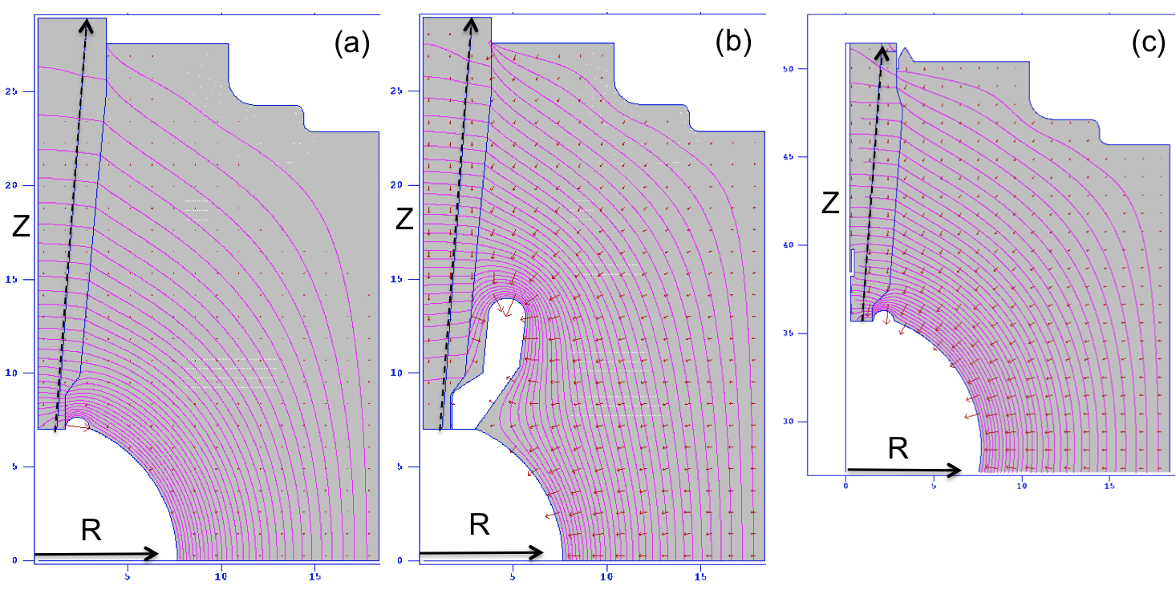
FIG 11. Electrostatic modeling results at 350kV for (a) R30 pure alumina insulator, (b) R30 pure alumina insulator with shed electrode and (c) R28 lower bulk resistivity insulator. The equipotential lines are shown in pink. Red arrows represent the electric field. The black dotted arrow represents the distance along the ceramic indicating the starting and ending coordinates to generate the potential (V), parallel (Ez) and radial (Er) electric field profiles along the interface (air-side) between the rubber plug and the insulator. R represents the radial coordinate. Dimensions are in cm.

Figure 12 is the radial electric field along the interface between the cable rubber plug and the insulator, represented by the dotted line in figure 11. Similarly, figure 13 is the parallel electric field and figure 14 is the potential. Since the R28 is shorter than the R30 insulator, the length of the dotted line has been normalized.
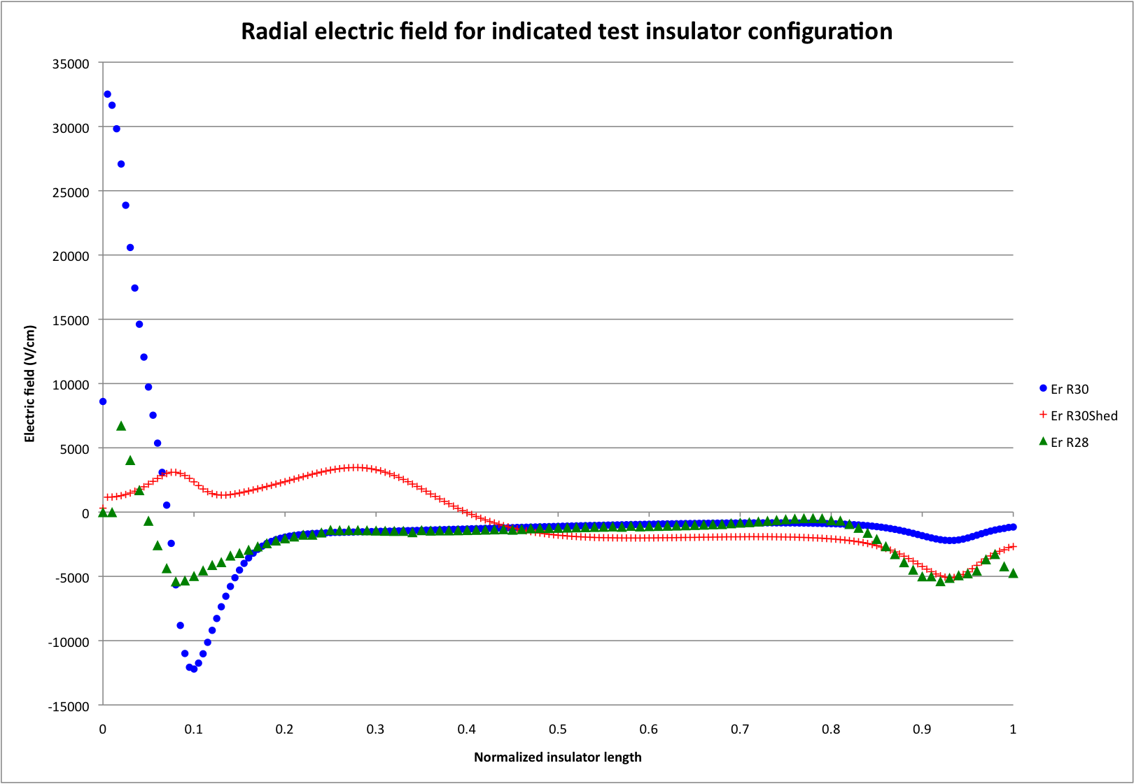
FIG. 12. Radial electric field along the dotted line shown in figure 11 for each case listed.
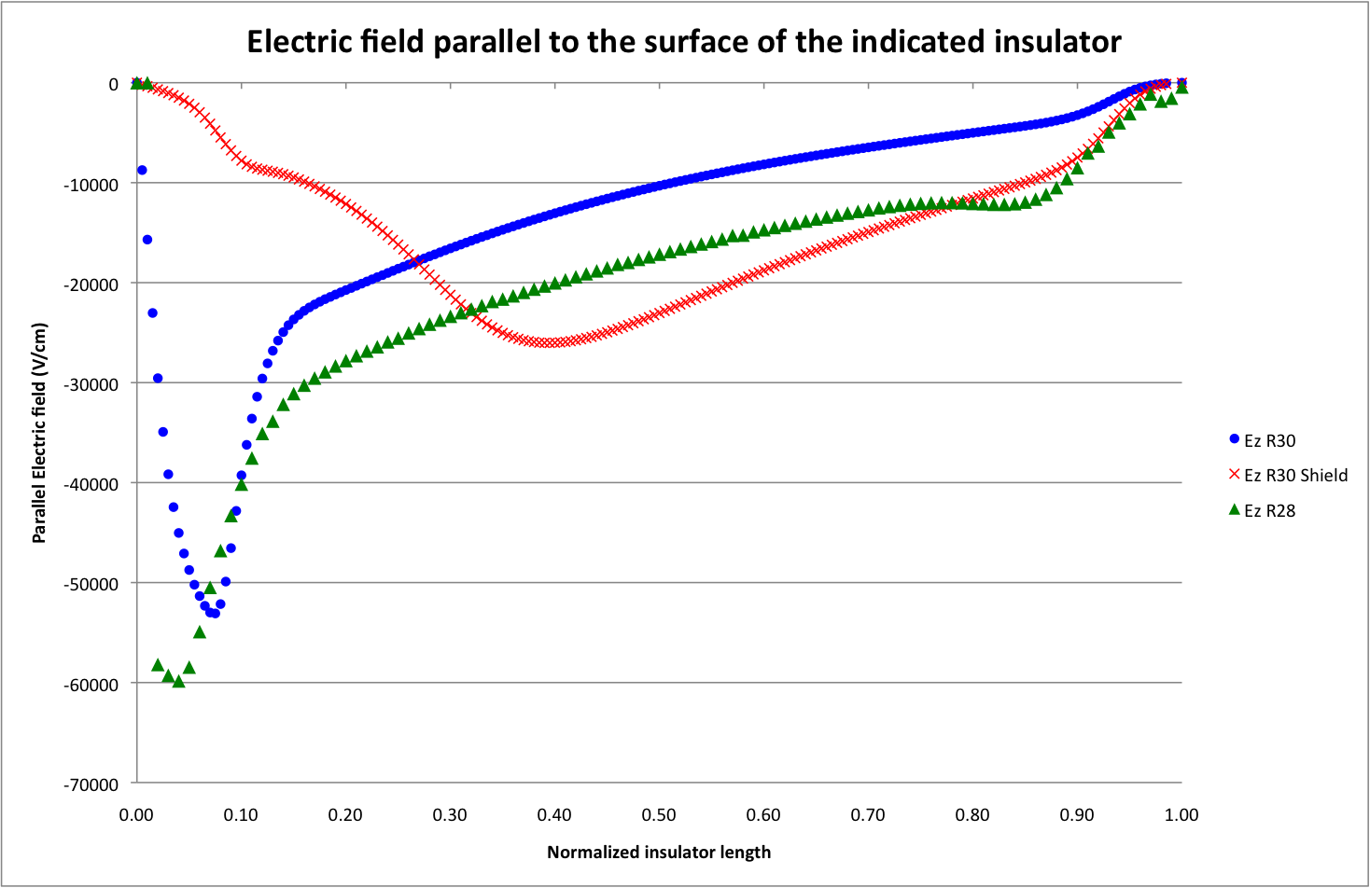
FIG. 13. Parallel electric field along the dotted line shown in figure 11 for each case listed.
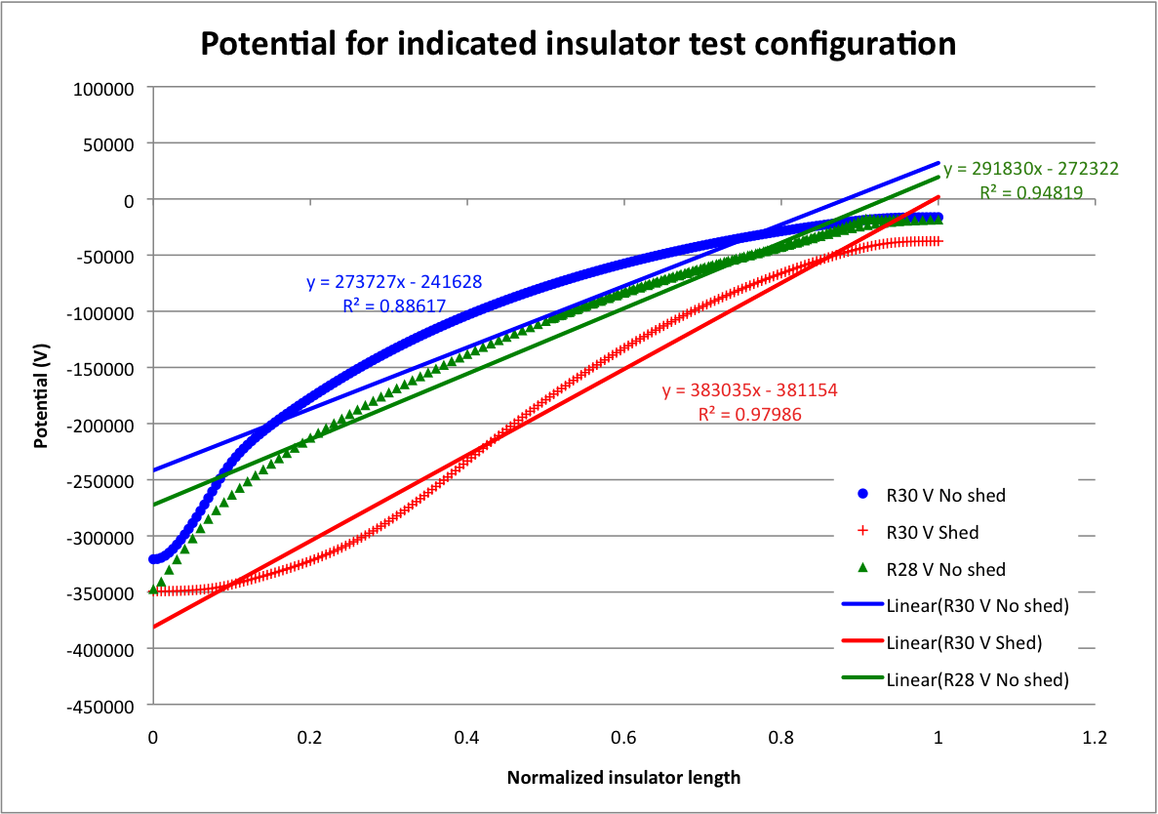
FIG. 14. Potential along the dotted line in figure 11 for each case listed. Solid lines represent linear fit for illustrating the degree of linearity (R²) in the potential in each indicated case.

C. Observations and analysis
The R28 94.7% alumina insulator was tested up to 365kV, while the R30 97.7% alumina insulator suffered breakdown at 300 kV, despite being longer by nearly 8 cm. Besides the difference in length, the R28 transverse bulk resistivity is about four orders of magnitude lower than the R30 97.7% alumina insulator (Table I). It has been observed that doped alumina formulation with various concentrations of Mn, Ti, and Cr – which intrinsically lower the resistivity in otherwise pure alumina – serves to dissipate trapped charges increasing voltage hold-off [Liebault, Jaitly and Sudarshan]. This effect might be one of the reasons for the better performance of the shorter R28 insulator compared to the longer R30 insulator. Additionally, the potential is slightly more linear as shown in figure 14, likely to the fact that the spherical electrode is closer to ground. Reducing the R28 insulator dielectric constant in the electrostatic POISSON simulations did not show a significant effect in linearizing the potential. While POISSON does not offer the capability to adjust the bulk resistivity of dielectric materials, simulations performed in 2009 utilizing Micro-Wave studio [ref] for a conical shape, inverted geometry ceramic insulator show that the potential becomes more linear with decreasing bulk resistivity [Hannon IPAC 2010], as shown in Figure 15.

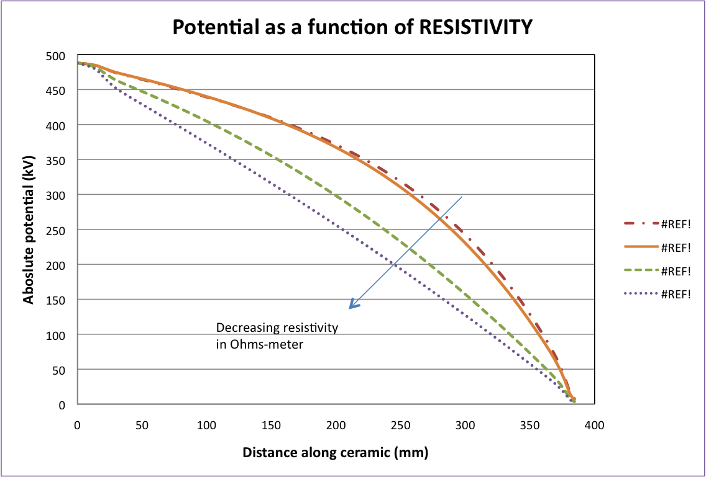
FIG 15. Simulations of an inverted-geometry ceramic insulator performed with the software Micro wave studio show that the potential becomes more linear with decreasing resistivity. Credit: Fay Hannon, 2010 [IPAC 2010].

In the case of the R28 insulator, the potential seems to become more linear due to two factors, a) the spherical electrode is closer to ground, and b) the ceramic material has lower resistivity than the R30 insulator. It is not clear which of the two factors has a larger contribution in linearizing the potential, or which of the two factors determines the good performance of the R28 insulator; the potential being more linear, or the material having some degree of conductivity that contributes to dissipate trapped charges. The potential being more linear might not be sufficient to explain the better performance of the R28 insulator, since the parallel field is slightly larger than that for the R30 insulator as shown in figure 13, but more detailed simulations would be required to answer this question. To provide more insight, the R28 insulator geometry would have to be modeled in Micro Wave Studio comparing the potential along the insulator for the two bulk resistivity values given by the manufacturer (Table I). In contrast with the performance of the R28 insulator, an experiment with the Jefferson Lab Free Electron Laser DC photoemission electron gun [Hernandez PAC 2005] was conducted in 2008 for testing a 60 cm long, 25 cm internal diameter cylindrical insulator made with proprietary doped alumina (Wesgo Advanced Ceramics) and assembled with triple-junction shield electrodes at the high voltage end and at the ground end. The doped alumina insulator suffered punctures at 440 kV during high voltage conditioning that rendered it unusable. The test was performed to determine if the lower resistivity ceramic could dissipate trapped charges that often lead to punctures in the platinum-implanted pure alumina insulators [Liu and Brown, PAC 1997] when attempting to condition the electron gun for 500kV operations. This type of insulators is routinely conditioned to 400kV for nominal operations at 350kV[Siggins et al NIM]. No signs of tracking have ever been observed in this type of cylindrical insulators.
To test if the R28 94.7% alumina insulator higher hold-off voltage was due solely to the potential being more linear, and in pursue of a configuration capable of withstanding 375kV without breakdown, a shed was added to the spherical electrode to make a new configuration with the R30 97.7% alumina insulator (figures 8 and 11b). The R30 insulator with shed was tested successfully up to 375kV without breakdown, albeit significant levels of field emission were observed. Field emission was expected prior to the test since the electric field is enhanced on the crown of the shed (figure 11b), being more than 12 MV/m at 350kV, compared to 7 MV/m at the same bias on the spherical electrode. Since the objective of the shed was to improve performance of the R30 insulator, further optimization of the shed shape and size would be required to reduce field enhancement in combination with additional polishing steps to minimize field emission. The addition of the shed electrode improved the high voltage performance of the R30 insulator from 300 kV to at least 375 kV. In this configuration, the R30 insulator is recessed into the now larger cathode electrode, resembling those tested by Yanlin et al. [C. Yanlin, X. Wei, and L. Ming, IEEE transaction on plasma science, Vol., 41, NO. 8. August 2013]. The configuration, although in much larger scale in terms of the insulator length, also resembles that of a single ceramic-shield ring assembly in the cylindrical segmented insulator from the DC photoemission electron gun at KEK-JAEA that was conditioned up to 550kV without breakdown [Nishimori et al, Phys. Rev. Aceel Beams 17, 053401].
Our electrostatic simulations show that radial field at the triple-junction is about 32 times lower compared to that without the shed (figure 12). The parallel field is nearly zero for both cases at the triple-junction, but at about 1/10th of the insulator length, it is a factor of 5 lower with the shed (figure 13), supporting our experimental results and in agreement with Pillai and Hackam whom report that the enhancement of the electric field at the cathode and anode junctions play a significant role in decreasing hold-off voltage [J. Appl. Phys, 54, 1302 (1983)] and that the parallel field is greatly reduced at the triple-junction in recessed electrodes [J. Appl. Phys, 61, 4992 (1987)] since it is generally accepted that pre-breakdown current is initiated by field-emitted electrons from the triple-junction (cathode-vacuum-insulator) for sufficiently high fields [J. P. Brainard and Dal Jensen, J. Appl Phys, 45, 3260 (1974)]. Yanlin et al have also reported an increase in pulsed flashover voltage hold-off when a triple-junction screening cathode is utilized instead of a plate cathode [C. Yanlin, X. Wei, and L. Ming, IEEE transaction on plasma science, Vol., 41, NO. 8. August 2013]. Notice from figure 8 that the exposed length of the R30 insulator with shed is comparable to that of the shorter R28 insulator. The shed also seems to shift the location of the parallel field peak, from near the electrode to about half the length of the insulator, and makes the potential more linear than the R28 insulator, as seen in figure 14. Although from our experimental results, it is not clear then if the performance of the R30 with shed is due to the potential being more linear, to the fact that the shed is acting also as a triple-junction shield suppressing conditions for pre-breakdown current [Yanlin, Brainard], or a combination of both, Jaitly and Sudarshan report that the surface charge distribution became liner at the conditioned voltage, for which the equivalent surface potential is also linear along the insulator. It is interesting to note that Brainard and Jensen experimental setup is similar in geometry to the inverted conical ceramic in the sense that there is vacuum on one surface of the insulator, and a dielectric on the opposite surface.
Pillai and Hackaman [J. Appl. Phys 56, 1372 (1984)] report that dc flashover voltage is larger for a conical insulator with non-linear potential at 45° than for a cylindrical insulator (0°) with linear potential. This is in contradiction with our observations about potential linearity, but their tests were done with 2 mm thick samples, compared to 120 mm long ceramic insulators in our case. Since electrode shape, size and bulk resistivity also influence the linearity of potential, it is difficult to directly compare our results with those from Pillai and Hackman. However, our simulations agree with their observations about field enhancement at the narrow end (negative angle in their paper, corresponding also to the narrow end where the electrode is attached to the inverted-geometry insulator in our experiments).
The last test in this report involved a new R30 97.7% alumina insulator sample without the shed, but coated with zirconia. The intent was to test if a surface layer with lower resistivity than the insulator would increase the voltage hold-off [N. C. Jaitly and T. S. Sudarshan, J. Appl. Phys 64, 3411 (1988)]. In our case, the zirconia coating did not improve the voltage hold-off, as the insulator suffered breakdown with puncture at 340kV. In this instance, the puncture was near the anode, rather than near the cathode as in the case of the R30 insulator sample 1 test (figure 5). Since the insulator was coated by a third-party source, there was no control over the mechanical or electrical properties of the zirconia film; additionally this being a single test, it is difficult to draw a conclusion about the effectiveness of the coating for the configuration tested in this work. However, experiments performed by Jaitly and Sudarshan with solid insulators (0.9 cm long) placed between two electrodes immersed in vacuum conditions, show that oxide coatings increase the voltage hold-off. In their proposed flashover model, a surface layer on the insulator with lower resistivity and lower secondary electron yield improves the voltage hold-off by reducing the positive charge buildup at the cathode that suppresses the pre-breakdown current process [N. C. Jaitly and T. S. Sudarshan, J. Appl. Phys 64, 3411 (1988)]. In our experiments, the 19 cm long R30 inverted-geometry ceramic insulator have the outer surface immersed in vacuum, while the inner surface is in contact with the cable plug, via a thin layer of silicon grease, utilized to minimize trapped air. Since breakdown occurred in the interface between the cable plug and the insulator, perhaps a coating similar to that tested by Jaitly and Sudarshan might be beneficial if applied on both insulator surfaces.
In addition to the high voltage tests described in this work, the electrical resistance between high voltage and ground ends was measured for each ceramic insulator type. The measurements were performed with the ground-end insulator flange electrically isolated from the grounded chamber and connected to a Keithley electrometer. The electrometer current was recorded as a function of applied voltage, up to 70kV. At that voltage, the current increased non-linearly. Two sets of measurements were taken for each ceramic type, under vacuum conditions at 1x10⁻⁹ Torr, and later at 740 Torr with Nitrogen. For the R30 97.7% white alumina insulator, no measurable current was observed up to 70 kV. For the Zirconia coated R30 insulator, the resistance was measured at 850 Giga-Ohms, and for the 94.4% R28 black alumina insulator, the resistance was measured at 20,000 Giga-Ohms. These results confirm that the resistivity of the 94.4% R28 black alumina insulator is indeed lower than that for the 97.7% R30 white alumina insulator. Based on the resistance of the zirconia coated R30 insulator, which is even lower than the R28 insulator, one would expect similar performance. However, one significant difference is that the coated R30 has low surface (vacuum side) resistivity, while the R28 has low bulk resistivity. If breakdown is due solely to surface effects, the low resistivity zirconia coated R30 insulator would have performed better, but as Liebault et al report, dopant species and micro-structural parameters determine the capability to trap, and to dissipate charges in the bulk of the ceramic insulator, supporting our observations of the better performance of the R28 with bulk low resistivity, compared to the zirconia coated R30 insulator with low surface resistivity.
It is not clear from our experiments the mechanism leading to the punctures in the R30 sample 1 and in the R30 zirconia coated, while in the R30 sample 2 the voltage breakdown caused a track on the cable plug / ceramic interface from cathode to ground (figure 6). It appears as if the current path in sample 1 started at the cathode, continued through the silicon grease between plug and ceramic, then through the ceramic wall into the vacuum and ended at the ceramic ground end, vacuum side (figure 5). A similar path is observed in the zirconia-coated sample, with the track being longer ending near the ground end at the puncture site (figure 10). Our simulations show that if an air gap or small volume is placed between the plug and the ceramic, the radial field is significantly enhanced at that location. It could be that the results are driven by the cable plug installation procedure, but it might be difficult to draw a conclusion due to lack of statistics, i.e. breakdown was observed in three out of three tests with identical ceramic-electrode configuration, with two of them showing punctures.

IV. FUTURE WORK
A new batch of R30 insulators made with bulk resistivity value comparable to that of the 94.7% alumina black R28 insulator is presently under manufacturing. A high voltage test of this insulator will de-couple the effect of the shed from the effect of the material properties. As a backup option and to be performed in parallel, electrostatic simulations utilizing LANL’s POISSON will continue for optimizing the shape and size of shed, with the goal to minimize field enhancement on any surface of the shed, but continue to provide linear potential and screening of the triple-junction. Refining electrostatic simulations with more accurate geometries utilizing software capable of 3D modeling and with capacity to define material properties will be pursed in the near future to provide further insight into the remaining questions of this work.

V. CONCLUSIONS
The objective of this work is to develop a reliable ceramic-electrode configuration for nominal operation at 350kV without field emission for a new DC electron photoemission gun presently under development at Jefferson Lab.
Three types of customized inverted-geometry ceramic insulators in combination with two electrode configurations were tested. Our experimental results and analysis indicate that the hold-off voltage is a combination of the following factors:
- Linearity of potential, that depends on electrode geometry, ceramic length and ceramic bulk resistivity,
- Dissipation of volume trapped charges that depends on ceramic bulk resistivity, and
- Shielding of the triple-junction achieved by adding a screening electrode.

Two configurations were found to be successful in terms of voltage hold-off under vacuum conditions. A 12 cm long R28 94.4% alumina insulator doped for lower bulk resistivity achieved up to 365kV without breakdown and without field emission and sustained 350kV in multi-hour test runs. The second successful configuration was a 19 cm long R30 97.7% alumina insulator with higher bulk resistivity, but with an additional screening electrode achieved up to 375kV and sustained 350kV in multi-hour test, albeit with significantly high levels of field emission.
Even though the breakdown occurred in the interface between the plug and the insulator, our observations show that altering the electric field and potential along the insulator in that interface was possible by manipulations done on the vacuum side of the insulator with the screening electrode or with the ceramic material choice. One significant difference between our work and most reported elsewhere, is that our insulator has one side exposed to vacuum conditions, and one side open in contact with the vulcanized rubber cable plug through a thin silicon grease layer.
Future work will focus on testing R30-size insulators presently under manufacturing with bulk resistivity comparable to that of the shorter R28 insulator, and on optimizing the screening electrode size, morphology and surface finish to minimize field emission. Since goal voltage has been achieved and to preserve the insulator samples, voltages higher than those quoted were not pursued in search of maximum voltage hold-off.

ACKNOWLEDGMENTS
Notice: Authored by Jefferson Science Associates under U.S. DOE Contract No. DE-AC05-84ER40150 and with funding from the DOE Office of High Energy Physics and the Americas Region ILC R&D program. The U.S. Government retains a non-exclusive, paid-up, irrevocable, world-wide license to publish or reproduce this manuscript for U.S. Government purposes.
.

REFERENCES
I need to add the references here in the proper format.

TABLE III. This table provides instructions on how to prepare references.
The author’s use of a reference style should be consistent throughout the paper. References to books and journal articles, listed at the end of the paper, should appear in one of these formats:

(1) Numerical: By number, in the order of first appearance, giving the names of the authors, the journal name, volume, year, and first page number only, as in:

⁵³V. Bargmann, Proc. Natl. Acad. Sci. USA 38, 961 (1952).

This paper will be listed as the 53rd in the list of references and cited as 53.

(2) Bibliographic: In alphabetical order according to the first author's last name, giving, in addition to the name, volume, year, and first and last page, also the title of the paper cited, as in:

Bargmann, V., "On the number of bound states in a central field of force,"' Proc. Natl. Acad. Sci. USA 38, 961–966 (1952).

Within the body of the paper, this reference will be cited as "Bargmann (1952)." If there are several articles by the same author(s) and the same year, they should be distinguished by letters, as in (1952a).

(3) Numerical Bibliographic: Alphabetically listed references (with full titles and page ranges) may be numbered according to their alphabetical order and cited by their number.
¹Berger, A., "Instabilities and waves on a columnar vortex in a strongly stratified and rotating fluid,"' Phys. Fluids 25, 961–966 (2013).

- Articles “submitted to” or “accepted for publication” (but not yet published) in a journal must include article title: When possible, these references should be updated in the galley proof.

Samples of Numerical References:
Books: List authors and editors. Must include publisher, city and year of publication, and the page numbers (unless the entire book is being cited).
²R. J. Hunter, Zeta Potential in Colloid Science (Academic, New York, 1981) p.120.
AIAA Papers: AIAA Papers: The usual format is: {Author’s names}, {Paper Title}, AIAA Pap. {usual formats are 99-1111 or 2004-2222}, {year -- corresponds to numbers on left side of paper number}..
³M.S. Narayan and A. Banaszuk, “Experimental study of a novel active separation control approach,” AIAA Paper No. 2003-0060, 2003.
Conference proceedings: Include the list of authors, the title of the proceedings, the city and year of the conference, the name of the publisher (cannot be a laboratory or institution), city and year of publication (or the words “to be published”), and the page numbers. Include the full list of editors, if they are given.
⁴R. K. Ahrenkiel, in Gallium Arsenide and Related Compounds 1993: Proceedings of the 20th International Symposium on Gallium Arsenide and Related Compounds, Freiburg, Germany, 29 August–2 September 1993, edited by H. S. Rupprecht and G. Weimann (Institute of Physics, London, 1994), pp. 685–690.
Government publications: Format as for a book citation. Each must include the author(s), title of the publication, name of the publisher, city and year of publication, and page numbers (unless the entire publication is being cited).
⁵D. Nunes, The Brillouin Effect (U.S. Department of Energy, Washington, DC, 1992).
Journal citations: Include authors (see author rule above), volume number, beginning page number, and publication year:
⁶J. D. Kiely and J. E. Houston, Phys. Rev. B 57, 12588 (1998).
Laboratory report: May only be used if first deposited with a national depository such as the National Technical Information Service. (Check with the NTIS librarian at 703-605-6000.) Materials or reports in electronic form—codes, data tables,etc.—may be uploaded as supplemental material files (see Sec. XIII). If the paper is on deposit with NTIS, use the following format:
⁷See National Technical Information Service Document No. DE132450 L. (R. Newchuck, SESAME Tables, LANL Rep. 23453, 1983). Copies may be ordered from the National Technical Information Service, Springfield, VA 22161.

MOLPRO:
⁸H.-J. Werner, P. J. Knowles, R. Lindh, F. R. Manby, M. Schütz, et al., Molpro, version 2006.1, a package of ab initio programs, 2006, see http://www.molpro.net
Multiple citations are acceptable:
⁸D.-Y. Choi, S. Madden, A. Rode, R. Wang, and B. Luther-Davies, J. Non-Cryst. Solids 354, 3179 (2008); J. Appl. Phys. 104, 113305 (2008).
(same authors, different journals)
or
⁹J.Scaroni and T. Mckee, Solid State Technol. 40, 245 (1997); M. G. Lawrence, Bull. Am. Meteorol. Soc. 86, 225 (2005).
(two completely different references)
or
¹⁰Y. de Carlan, A. Alamo, M. H. Mathon, G. Geoffroy, and A. Castaing, J. Nucl. Mater. 283–287, 762 (2000); M. H. Mathon, Y. de Carlan, G. Geoffroy, X. Averty, A. Alamo, and C. H. de Novion, ibid. 312, 236 (2003).
(different authors, same journal)

