Appendix A: Detailed JLab report

Report Period of Performance:
07/1/2022 –09/30/2022

Co-Principal Investigator:
Riad Suleiman, with Joe Grames and Matt Poelker (Jefferson Lab), and Eric Voutier (IJCLab, Orsay, France)

Work-scope Highlights:
Jefferson Lab’s contribution to this project is to provide a Compton Transmission Polarimeter, which will be used to measure beam polarization when SRF photogun employs a GaAs photocathode. IJCLab is contributing to Jefferson Lab’s effort.

Q4 FY22 Brief summary of activity issues, concerns, successes:

Activity successes:
- We installed the polarimeter at the Upgraded Injector Test Facility (UITF) by October. Figure 1 shows the layout at the UITF.
- The portable data acquisition system is ready. Figure 2 shows the portable rack.
- The beam polarization at the UITF has been measured to be about 37% from bulk GaAs using the keV Mott polarimeter.
- We started the beam commissioning of the Compton Transmission Polarimeter On October 3, 2022.
- Graduate student Greg Blume is being trained of all aspect of polarimetry from simulation to data taking and analysis.

Issues and concerns: none

Milestones
- Polarimeter is ready. We started commissioning on October 3, 2022.
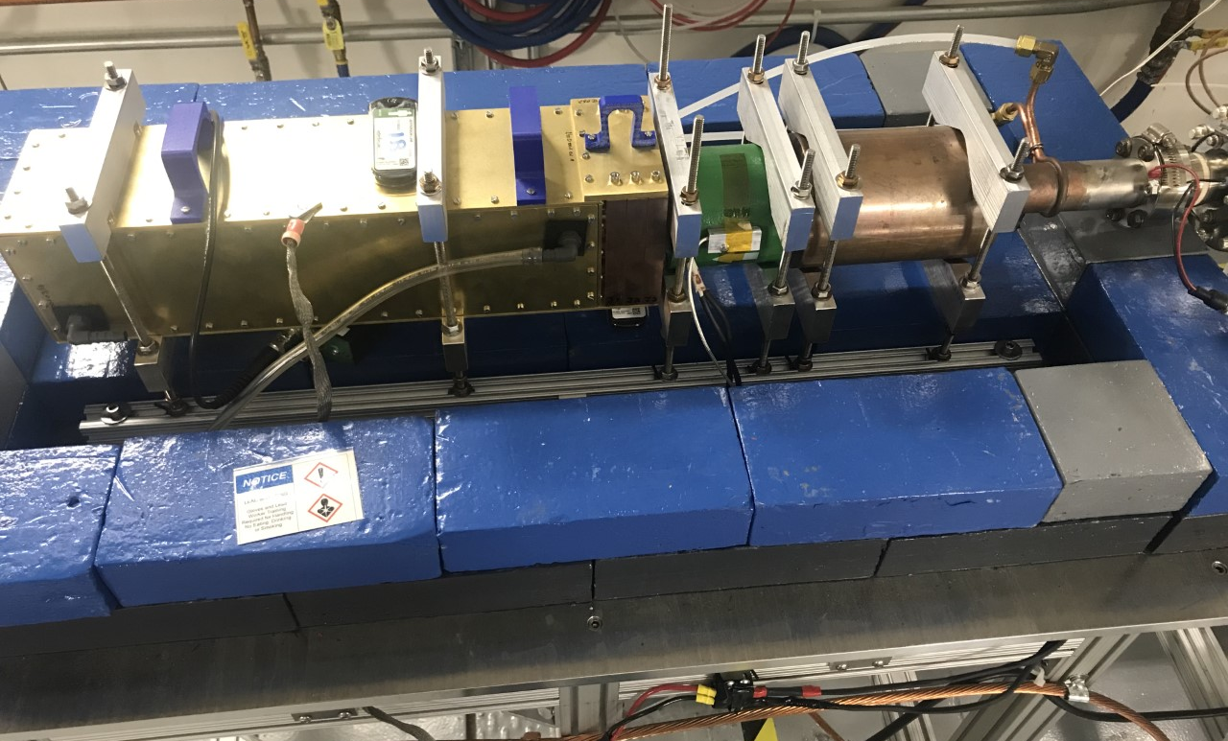

Figure 1: Layout of the Compton Transmission Polarimeter. From right to left, shown are the radiator, copper collimator, magnet and the detector box. Electron beam is coming from the right.
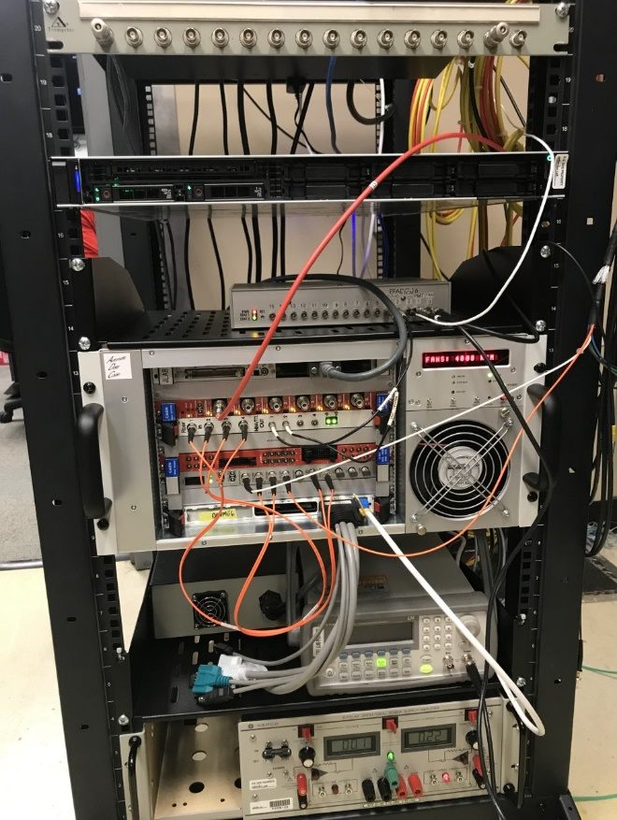
Figure 2: The portable data acquisition system.
Budget

Summary of total expenditures:

ID # | Item/Task | Baseline  Total Cost  (AY$) | Costed &  Committed  (AY$) | Estimate  To Complete  (AY$) | Estimated  Total Cost  (AY$)
COMTRA | Compton Trans Polarimeter | $400,200 | $310,161 | $90,039 | $400,200
 | Totals: | $400,200 | $310,161 | $90,039 | $400,200
Notes:
- Costed and Committed numbers are as of September 30th, 2022.

Summary of expenditures by fiscal year (FY):

 | FY 2020 | FY 2021 | Total
a) Funds allocated | $200,100 | $200,100 | $400,200
b) Actual costs to date | $200,100 | $76,149 | $276,249
c) Uncosted commitments | $0 | $33,912 | $33,912
d) Uncommitted funds | $0 | $90,039 | $90,039

