**Safety Systems**

**For Upgrade to Injector Test Facility**

**July 30, 2014**

**PSS for UITF**

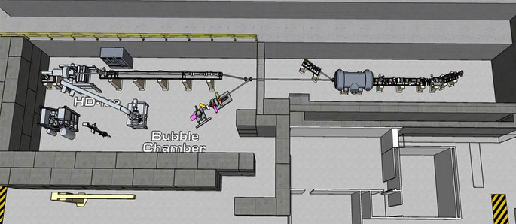



1. Only Two Doors Exist.



* 1. The back door is for Exit Only. No Door knob on the outside and a crash bar on the inside.
  2. The front door is for Entry and Exit and is fitted with Kirk_Key system
  3. Both Doors have interlocks
     1. Gun HV cannot be turned on if either door is open (PSS Logic Inputs BACK_DOOR_LOCKED, FRONT_DOOR_LOCKED)

1. Only Two States Exist: Entry and No Entry
   1. Entry means
      1. Gun HV is Off (PSS Logic input: HV_ON) **AND**
      2. RF Power is Off (PSS Logic Input: RF_ON) **AND** Radiation is absent as indicated by functioning CARMs and CARMs (Rapid Access system similar to the one in the CEBAF Injector, administrative just as in CEBAF)
   2. No Entry means, either
      1. GUN HV is on **OR**
      2. RF Power is ON **OR**
      3. Rapid Access System indicates radiation (Administrative, just as in CEBAF)
2. Sweep Arming Switch (PSS Logic Input: SWEEP_ARMED)
3. ODH is ignored because of the powerful ventilation and the two halves of the caves are connected though a large opening
4. No RUN/SAFE Boxes because the Front and Back Doors act as Run/Safe boxes and are within reasonable reach

To turn Gun HV ON and RF ON

SWEEP_ARMED .AND. BACK_DOOR_LOCKED .AND. FRONT_DOOR_LOCKED



To crash Gun HV and RF (For normal operations, do a controlled turning off of Gun HV and RF)

FRONT_DOOR_OPEN .OR. BACK_DOOR_OPEN .OR. !SWEEP_ARMED

**Procedure**

After sweep is complete, Front Door is locked which releases the Kirk_Key. The Kirk_Key is used in the control room to turn on SWEEP_ARMED. The Kirk_Key on the front door lock allows emergency exit from the test facility. See the figures below)



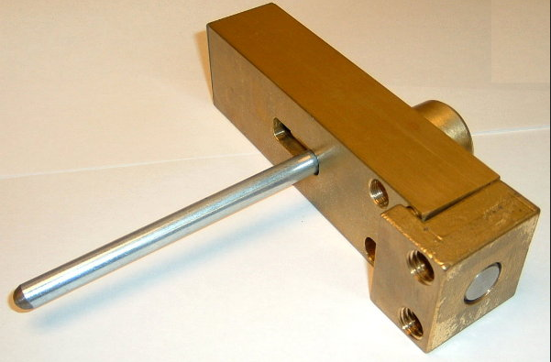 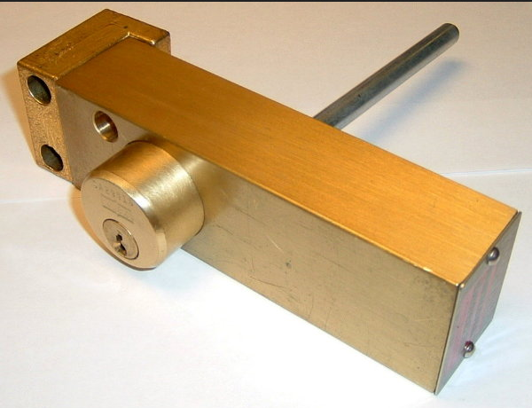



In order to enter the cave, Kirk_Key has to be removed from the control room. This negates SWEEP_ARMED and both HV and RF will go off, if they are not already off.

Rapid access system should be checked before entering the cave. This switch is next to the kirk-key box in the control room.



**Implementation**

With an eye to the future needs, we should have enough wires for 32 signals.

Propose to use the magnet interlock chassis to provide HV_ON and RF_ON signals (This is what we use in the Injector service building). The chassis will accept the signals from Front and back doors and the sweep arm switch.

Propose to use one CAMAC or VME 32-channel I/O board to read the status of Front and back doors, sweep arming switch, HV, RF, Laser (any other statuses).



**MPS for UITF**





The most likely sources of beam loss are at the 150 bend. However, in order to protect the ¼ cryo, we should place a detector near the ¼ cryo. Past the ¼ cryo, we have a chicane and to place another detector would be wise. The BCM (part of the nano-amp BPMs) would protect the HD-Ice target from higher than intended current (~nA). We may need a vacuum interlock.

The inexpensive choices for BLMs are PLIC (Panofsky Long Ion Chamber, Andrew’s suggestion) and RD2014 PIN diode units. In the low energy area (or even in the high energy area, protected by some shielding) the PIN diodes may be the simplest solution. They operate at low voltage, provide TTL signals (which could be counted and a threshold set) and are less than $150/unit. PLIC will need a power supply (between 100 - 500V) and we have to make the unit, unless SLAC can donate a couple of them along with the electronics.

**Implementation (assuming RD2014, by Teviso.com)**

Just as for the PSS system, with an eye to future, we should have wiring to accommodate 32 channels. The RD2014 will need counters and 5 V supplies. The counters are either VME or CAMAC with the requirement that they can be gated and generate an overflow signal when the counter overflows. The OR’d overflow signals with the BCM would be used to turn HV off. (For both PSS and MPS, I wonder whether we could use PC104s which have all we need).