PROGRESS REPORT ON UNM SUPPORT OF ELECTRODYNAMIC DOE CONTRACT DE-SC0017120 -
NON-INVASIVE SPIN POLARIZATION MONITORING
Ahmed Elshafiey
12/31/17
Spin Polarization Simulation
Introduction:
The principal goal of our PIC simulations using LSP is to model the Electrodynamic-designed non-invasive diagnostic to measure electron beam polarization. Briefly, the diagnostic consists of a ring inside a cavity, where the beam of polarized electrons passes through it and the polarized component of the electron beam induces a current within the ring, which in turn, would excite a mode within the cavity. This signal would then be proportional to the polarization of the beam passing through the ring. Such a system is being developed/implemented for laser-produced polarized electron beams at Jefferson Laboratory.
Initially there were no PIC codes that could ‘simulate’ or generate polarized electrons. Dale Welch (LSP support at Voss Scientific) mentioned that a new package could be developed that would indeed be able to generate and track polarized electrons relatively quickly. Our initial attempts focused on using a surrogate beam polarized electron beam by utilizing electrons with artificial spin. This was done by injecting electrons with a slight angle in a constant applied external magnetic field causing the electrons to gyrate around the field lines, hence, self-generating a z-component of magnetic field, similar to that produced by polarized electrons. The issue with this approach was matching the generated magnetic field causing the gyrating electrons to that of the intrinsic magnetic moment of the polarized electrons. In addition, the gyration was beam wise rather than particle wise.
This report details the efforts invested to-date using the spin polarization package developed by Voss Scientific in an attempt to measure the energy exchange between the polarized beam and the ring.
Simulation setup:
A 3-D cylindrical simulation was carried out with the parameters below in order to simulate the interaction of a polarized beam with a copper ring.
Functions:
A current function was used in LSP with the injection model with a current of 100 $μ$A and a Gaussian distribution with a FWHM of 100 ns
The following is what the current function looks like:
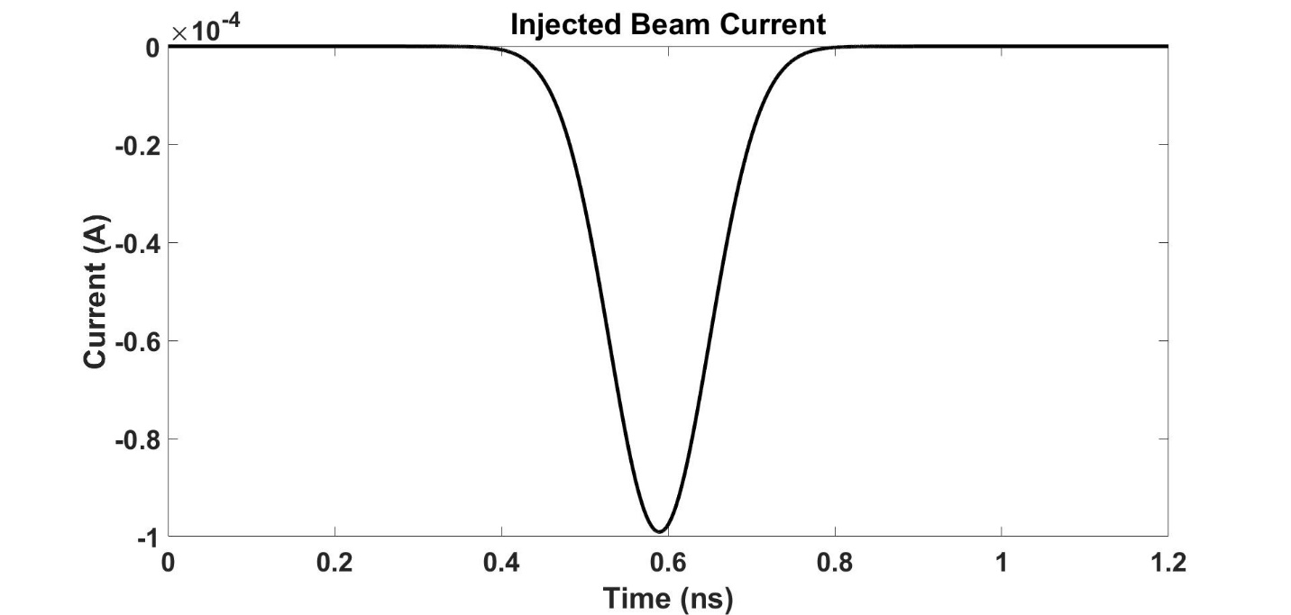
Figure 1. Injected beam current in LSP.

Objects:
Only one object was used, which is a ring made of copper.
The inner hole of the ring was varied in size starting from a radius of 0.5 mm to 2.5 mm.
The units of LSP are in CGS so the conductivity of copper was in the units of inverse seconds.
The following was used to convert from SI to CGS:
Resistivity $ρ$ =$1 Ω ∙m = {10}^{11} s.$
The resistivity of copper is ${1.6*10}^{-8} Ω∙m$, hence 1600 seconds.
Conductivity is the inverse of resistivity so 1/1600 = $6.250e^{-04}$ inverse seconds.
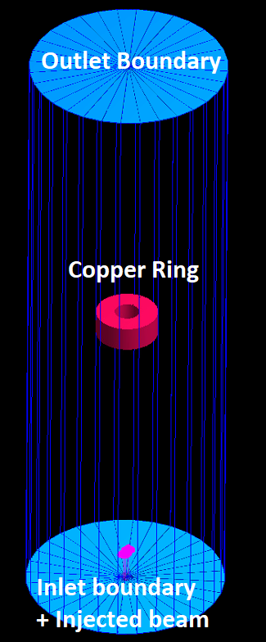
Figure 2. Simulation setup.

Boundaries:
Three boundaries were used
1) Inlet, where the injection of the polarized electron beam takes place.
2) Outlet to provide an exit for the electromagnetic waves and the particles.
3) Periodic boundary so that electrons leaving the interaction space from either the 0-theta direction or the 2$π$ direction will be reintroduced from the other side. For example, a particle leaving at 0 theta direction will be reintroduced in the 2$π$theta direction and vice versa.
Particle creation:
A beam injection model was used and linked to the current density function defined earlier. The electrons were injected with a 140 kev energy (0.76 constant speed normalized to the speed of light). In other words, I assumed that electrons reached terminal velocity under a 140 kV potential difference before entering the ring. The injection diameter was 1 mm (the injected beam radial diameter).
Probes:
A magnetic flux probe was used to measure the magnetic flux in the z-direction. The probe was placed right at the center of the ring with a surface area equivalent to the hole size used; for example, if the inner hole of the ring was 1 mm in diameter, then the probe was also 1 mm in diameter.
Along the with B flux probe, an M flux probe was used at the same location; this probe gives the total magnetization of the particles (sum of all dipole moments).
Of course, in real life there is no way to isolate the magnetic dipole moments from magnetic fields from other sources. However, LSP treats each in a separate manner, and that is why we are using two probes. In other words, LSP has three fields: M, B, and E, each requiring a different probe. This is a key point to be able to follow through the remainder of the report.
External fields:
An external magnetic field in the z-direction was used to align the electron spin in the z-direction. In addition, the spin code provided by Voss Scientific was modified to force an up spin only. The value of the external applied magnetic field was higher than any other self-generated magnetic field within the simulation to ensure that the electrons do not realign themselves as the final spin direction is based on the net direction of the magnetic field.
For example, if there is a self-generated magnetic field by the beam which is higher than the external magnetic field in amplitude, and if it is in a direction other than the +z-direction, then the electrons will choose to spin in its direction.
Results: (all results shown are for a 1 mm diameter ring hole)
As mentioned earlier, the units used in LSP are CGS, so the B flux probe unit is Gauss ${∙cm}^{2}$ and the units of the M flux probe is Oersted $∙{cm}^{2}$.
The probe size is 1 mm in diameter, so its surface area is 0.1256 ${cm}^{2}$ or $1.256e^{-05}$ $m^{2}$.
The total net flux $ϕ$ is = B_$ϕ$ probe + M probe * $μ$ (again because LSP treats M and B as different fields, so the total field is the sum of the two. The M probe is just the total magnetic dipole moment of the beam, the B probe is the induced magnetic field from the current in the ring along with other sources of magnetic field as will be dicussed later on).
EMF = -(d$ϕ$/dt)
The induced current in the copper ring Is = EMF/R.
I started by converting everything to SI first.
To convert from Gauss to Tesla a multiplication factor of ${10}^{-4}$ was used.
To convert from Oersted to A/m a factor of $(1/4π){10}^{3}$ was used [ =79.5].
The value of $μ$ for free space is $4π*{10}^{-7}$ H/m.
The following are images of the probes as taken from LSP before performing any calculations.

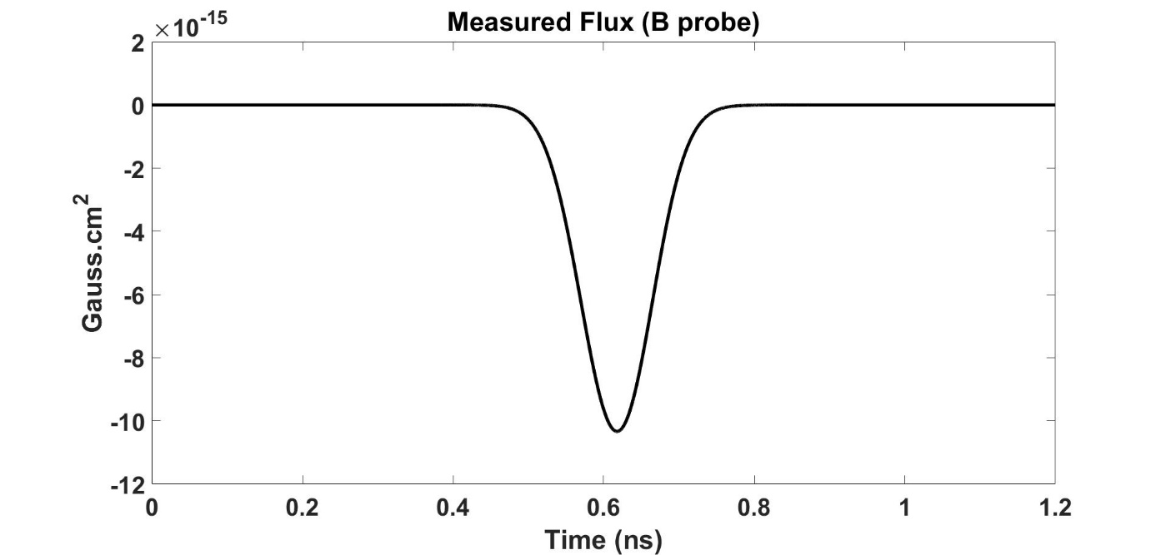
Figure 3. Magnetic flux probe at the center of the ring.
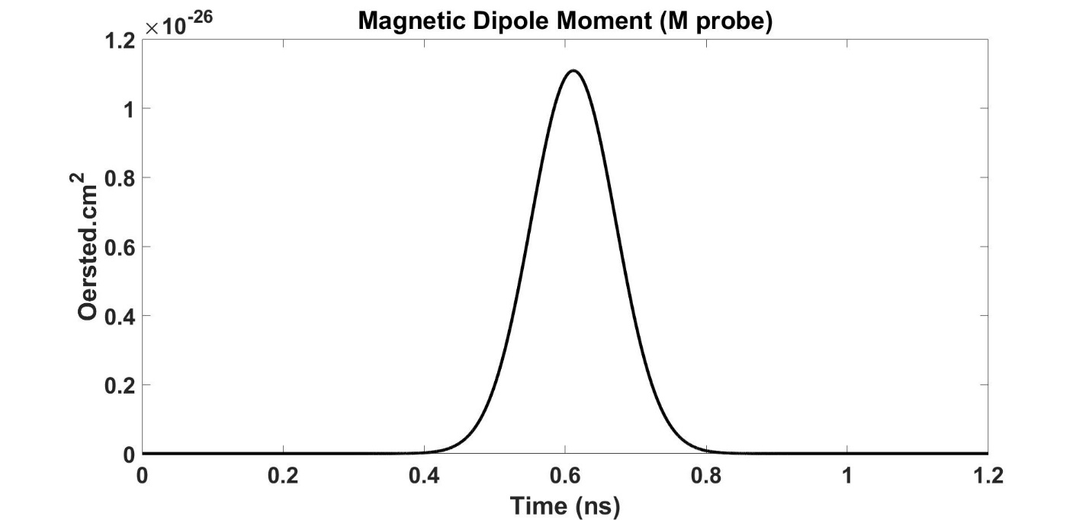
Figure 4. Magnetic dipole probe at the center of the ring.

I started by making the units Gauss$∙m^{2}$ and Oersted$∙$ instead of ${cm}^{2}$ (since I know the surface area of the probe used).
I then converted Gauss$∙m^{2}$to Tesla$∙m^{2}$ by using the ${10}^{-4}$ conversion factor.
After that I converted Oersted$∙m^{2}$ to $\frac{A}{m}∙m^{2}$ using the 79.5 multiplication factor, then multiplied by $μ \frac{H}{m}$,
which results in the following relations
[Total flux] = (Tesla$∙m^{2}$) + ( $\frac{A}{m}∙m^{2}$* $\frac{H}{m}$).
[Total flux] = Tesla$∙m^{2}$+ A*H.
Tesla is $\frac{V.s}{m^{2}}$.
Henry is $\frac{V.s}{A}$.
Hence, [Total flux] = $V∙s$ + $V∙s$.
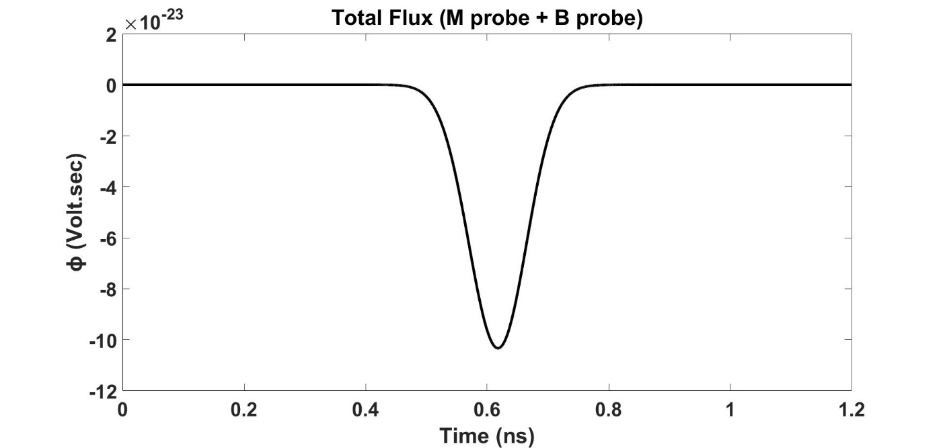
Figure 5. Calculated total flux.

Taking the negative derivative with respect to time of the flux yields the EMF in units of voltage. Thus, the math works out.
The following is the calculated voltage.
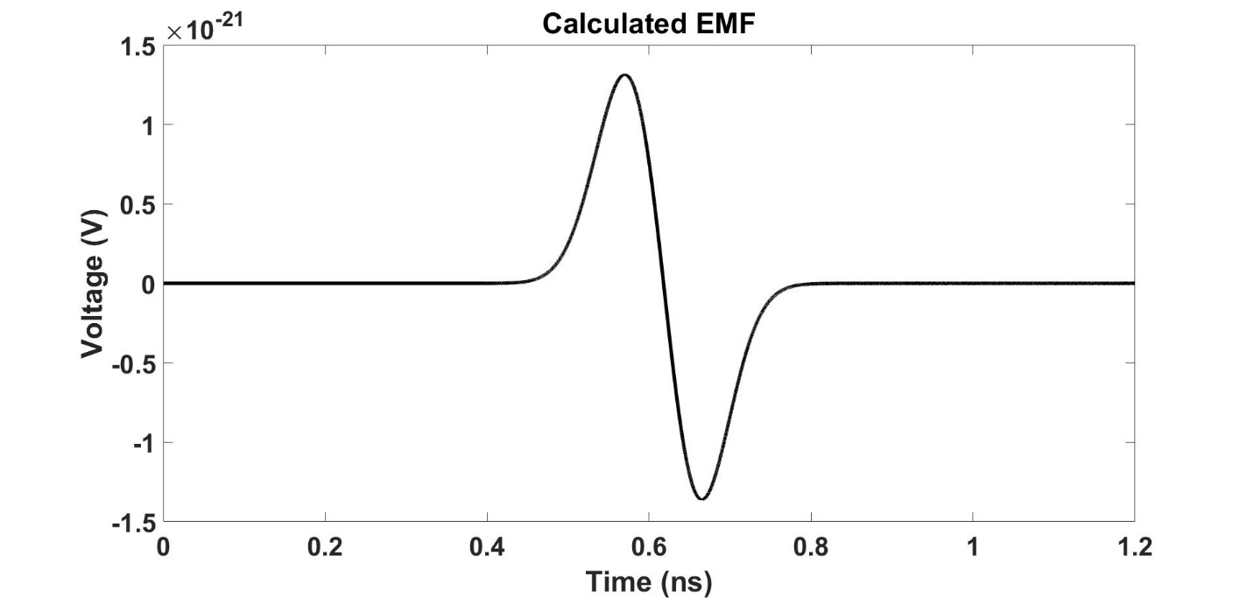
Figure 6. Calculated EMF.

The induced current is = V/R.
The resistance of the ring is about $8.785e^{-05} Ω$, which was calculated using
R =$ρ\frac{L}{A}$.
The calculated current is shown below.
Figure 7. Calculated current (Induced current).

Discussion:
The total flux, induced EMF, and current calculated from our simulation are inverted compared to the images below which are taken from Griffith’s Introduction to Electrodynamics for a magnet moving through a ring:
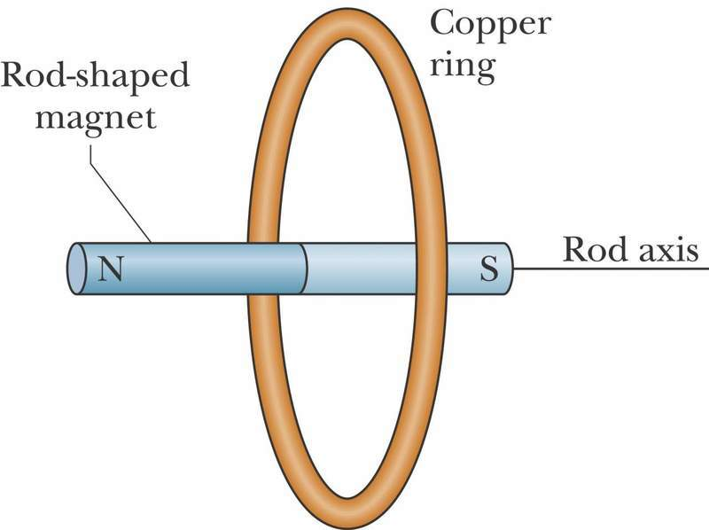
Figure 8. Magnet moving through a ring.
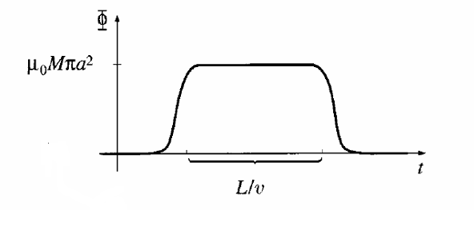
Figure 9. Flux of a magnet falling in a ring.

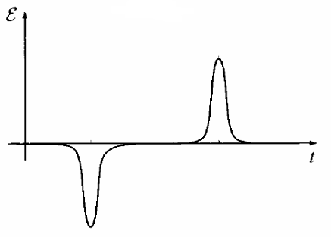
Figure 10. Induced EMF due to a magnet.

Note in Figure 9, Griffiths ignored the induced current as he said its insignificant in value, so basically, Griffith said that the total flux is = B flux + M flux, because B flux is insignificant.
So why are our results inverted?
For a beam of electrons moving at a relativistic speed, the beam goes through Coulomb expansion as well as scattering, causing the momentum of the electrons to have r- and $θ$ components instead of just a z-component as defined at the beginning of the simulation. Therefore, the B flux probe is measuring very large signals from the beam which are more significant in value than the flux due to the polarization of the electrons, which in turn cause the total flux, induced EMF, and current signals to be inverted.
To further explain this point, the total flux is the summation of what is measured from the M probe (which is positive, as the electron spin is in the negative z-direction) with what is measured by the B probe (which is negative and greater in magnitude than the M probe as obtained from the simulation). Hence, the total flux is negative overall (instead of being positive as in the case of a magnet moving through a ring from the Griffiths book)
I contacted Dr. Robert from Voss Scientific and sent him all my results and the following was his response:
“I’m not sure why you would expect the B flux to be on the same level as the M flux. M is not the source of all B fields. A nearly-relativistic beam of charged particles is going to create very strong magnetic fields, and unless the beam is of perfectly uniform density, infinitely long, and exists forever, some portion of these magnetic fields will be in the plane that you are measuring flux through. I would expect that the contribution of the aligned spin dipoles would be small in comparison, precisely as you have shown.

That being said, I tried running a small test problem over here and didn’t get what I expected either. I may have done my calculations wrong, but it is also possible there is a small bug in the fields portion of the spin code. It is, after all, a beta version of the spin model. Also, much more time was put into making sure the particle dynamics were right, since it was expected that the field contribution would be negligible in any problem of interest. Your problem certainly falls outside of our expected range of problem sets.”
This is the current status of the simulations.

