High-gradient Wien spin rotators at Jefferson Lab*
G. Palacios-Serrano†, C. Hernandez-Garcia, P. Adderley, J. Grames, M. Poelker,
Thomas Jefferson National Accelerator Facility, Newport News, VA 23606, USA

Abstract
Nuclear physics experiments performed in the Continuous Electron Beam Accelerator Facility (CEBAF) at Jefferson Laboratory (JLab) require spin manipulation of electron beams. Two Wien spin rotators in the injector keV region are essential at CEBAF to establish longitudinal polarization at the end station target, and to flip the polarization direction by π rad to rule out false asymmetries. In a Wien filter, the homogeneous and independent electric and magnetic fields, along with the velocity vectors of the electrons that traverse it, form a mutually orthogonal system. The magnitude of the electrostatic field, established by biasing two highly-polished electrodes, defines the desired spin angle at the target yet deviates the beam trajectory due to the Lorentz force. The beam trajectory in the injector is then re-established by adjusting the magnetic field, induced by an electromagnet encasing the device vacuum chamber. This contribution describes the evolution design and high voltage testing of Wien filters for spin manipulation at increased beam energies in the keV injector region, required by high precision parity violation experiments like MOLLER.

INTRODUCTION
The planned MOLLER [1] experiment at the Jefferson Lab (JLab) Continuous Electron Beam Accelerator Facility (CEBAF) requires 75 µA current, 80% longitudinally-polarized, and highly stable GeV electron beam. To fulfil these stringent requirements the CEBAF photogun was upgraded to be capable of producing 200 keV electron beam [2] in the low energy section. Wien filters have been used at JLab in a spin-rotator configuration at 130 keV to provide precise control of the beam spin orientation in the CEBAF injector [3] and recently in a test-bed accelerator with 180 keV beam energy. The operation parameters of the Wien filters (based on the original design by SLAC [4]) are inextricably related to the beam energy, therefore it was necessary to upgrade the capabilities of the JLab Wien filters for the higher photogun beam energy. The upgrade modification process consisting of 3-dimensional modelling using Solidworks, electrostatic CST-EM studio simulations, and magnetostatic Opera simulations are described in a previous contribution [5] and briefly described in this document. Initial tests of the CEBAF Wien filters modified for higher electrode voltage, but retaining original brazed electrodes manufactured for 100 keV operation, showed ion pump current bursts while ramping up to twice the original bias electrode voltage (20 kV). This behaviour was hypothesised to be related to gas trapped during the bracing process of the electrode fabrication and released during the HV tests. After installation in the upgrade CEBAF injector beamline, and following vacuum bake out, the Wien filters were high voltage conditioned and eventually the ion pump current bursts receded. The Wien filters are currently operational for 130 keV beam out of the photogun for CEBAF operations, and are deemed ready for 200 keV when the program moves to that energy next year.
A third Wien filter based on the CEBAF version upgraded for higher beam energy was constructed, but the brazed electrodes were replaced with electrodes machined from single-piece stainless steel pieces, aiming at eliminating the ion pump current bursts observed with the original brazed electrodes. Foreseeing the need of beam energies out of the photogun ~ 300 keV for the Electron Ion Collider (EIC) [6] and the International Linear Collider (ILC) [7], a smaller gap between electrodes (13 mm vs previous 15 mm) was implemented, which in combination with higher electrode voltage increases the electric field between electrodes by ~ 2.5 from the CEBAF Wien filter (at 130 keV) resulting in the highest-gradient Wien filter to date.

Device description
The Wien filters initially used at CEBAF based on the original SLAC [4] design were modified to operate with the 100 keV beam energy [8]. They consist of two stainless steel parallel plates biased inside a vacuum chamber, thus creating an electric field in the gap (15 mm). A magnetic field orthogonal to the electric field is produced by a current circulating through a pair of window frame coils outside the vacuum chamber, whereas a magnetic shell encasing shapes its profile. The Rogowski geometry of the electrodes was carefully designed for best possible match with the magnetic field profile. Later on, the CEBAF injector Wien filters were operated with 130 keV beam using a slightly bigger version of the original coil design. The electrode Rogowski geometry was also improved to increase the matching between field profiles, paramount to obtain proper beam transmission. To provide ±π/2 rad + 10% spin rotation, the electrode voltage had to be increased from 12 kV to 20 kV for 15 mm electrode gap. This required re-designing the high voltage feedthroughs as described in [5].
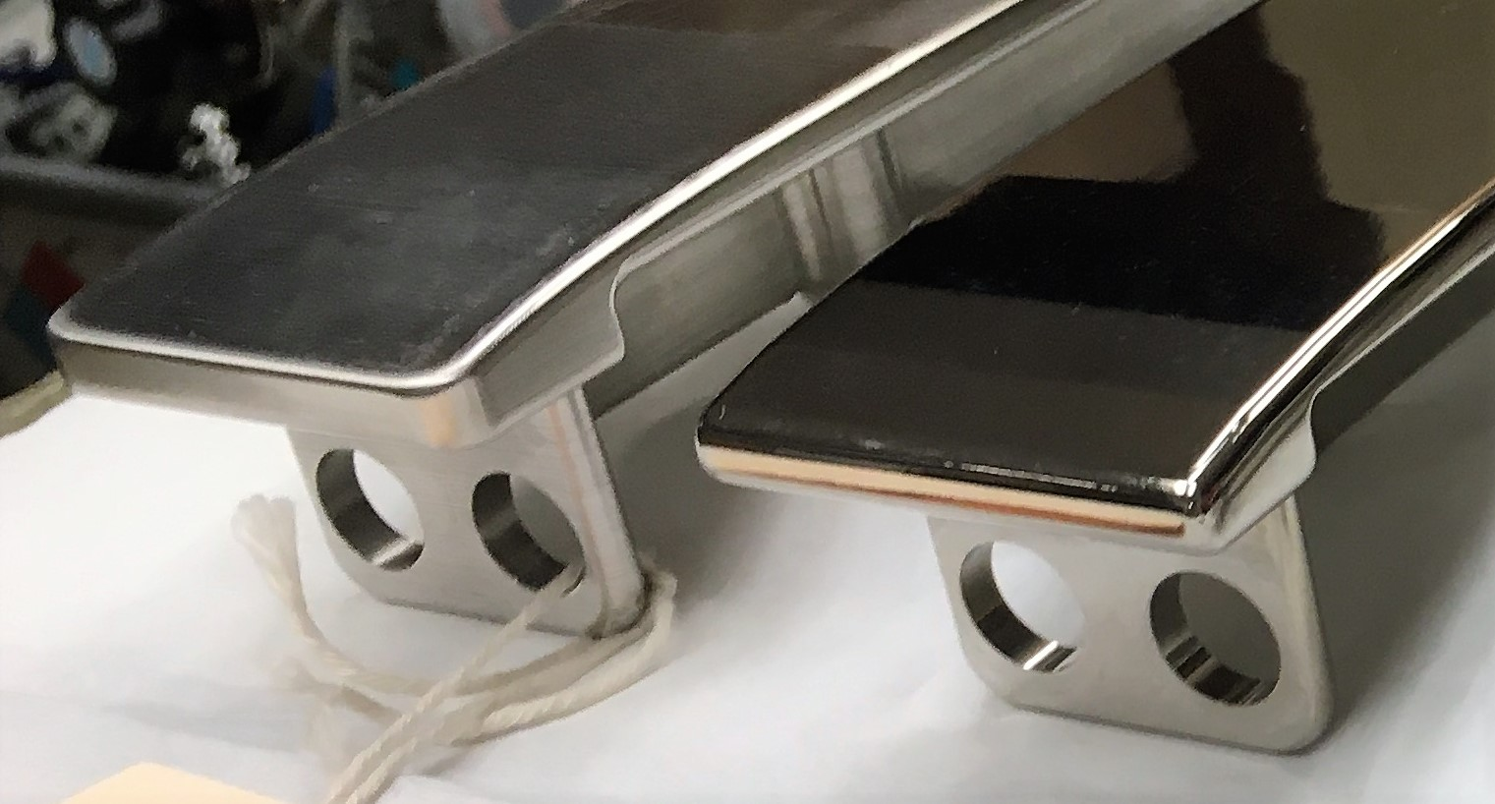
Figure 1: Wien filter electrode Rogowski profile.

* Work supported by U.S. Department of Energy, Office of Science, Office of Nuclear Physics under contract DE-AC05-06OR23177
† gabrielp@jlab.org.
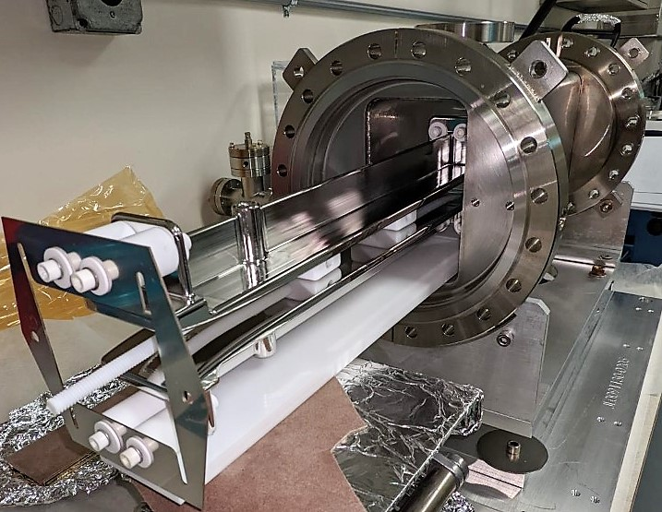
Figure 2: Picture taken during Wien filter assembly.
A third Wien filter was built for the Upgrade Injector Test Facility at JLab. Based on the higher voltage version of the CEBAF Wiens, this Wien filter features electrodes machined from a single piece of 304 stainless steel. The single-piece electrodes were improved over the original design with a spline profile (compared to the original ‘terrace’ profile) (Fig. 1) between their flat region and the Rogowski profile, aiming to more accurately match the electric and magnetic fields. The electrode gap was also reduced from 15 mm to 13 mm by modifying the mounting Inconel frame, used to attach the electrodes to the vacuum chamber. This modification resulted in a maximum electric field of 3.9 MV/m (with +/- 25.6 kV per electrode), which combined with the corresponding magnetic field of 17.0 mT provides the conditions to rotate the spin angle by ±π/2 rad of a 300 keV electron beam. The procedure to obtain these values is described in the following section.

Operation parameters
Through the evolution of CEBAF, three versions of the Wien filter design were produced to rotate the spin angle to a maximum of π/2 rad plus a 10% head room, compatible with 130, 200, and 300 keV, respectively. The operational parameter that corrects the trajectory, namely the magnetic field, has been historically obtained [9] by imposing an equilibrium condition to the total force that the electrons experience as they traverse the device, yielding:
$$\frac{E_{y}}{-B_{x}v_{z}}=1$$
And the magnitude of the electric field, related to the spin rotation angle through an approximation arising from the Thomas-Bargmann-Michel-Telegdi (Thomas-BMT) equation, can be obtained as reported in [10]:
$$θ=\frac{eL}{m_{0}cβγ^{2}}\left[\frac{E_{y}}{v_{z}}\right]$$
Where $θ$ is the spin rotation angle, $e$ is the electron charge, $m_{o}$ the particle rest mass, $c$ is the speed of light, $B_{x}$ and $E_{y}$ are the magnetic and electric field magnitudes, $β$ is the velocity normalized to the speed of light, $L$ is the effective length of the Wien filter, $v_{z}$ the particle velocity, and $γ$ the Lorentz factor. Solving these two equations simultaneously for a π/2 rad + 10% (100 deg) spin rotation angle, and given that all other parameters are known, the magnitudes of the fields were obtained for 130 keV energy with a 15 mm gap between plates, and for 200 keV and 300 keV beam with a 13 mm gap, as shown in Table 1:

Table 1: Wien filter operation parameters for π/2 [rad] + 10% spin rotation angle
Parameter | 130 [KeV] (15 mm gap) | 200 [keV] (13 mm gap) | 300 [keV] (13 mm gap)
E_{y} [MV/m] | 1.6 | 2.7 | 4.3
Electrode bias [kV] | 12.4 | 17.5 | 28.5
B_{x} [mT] | 9.1 | 13.0 | 18.8
Coil current [A] | 10.47 | 14.84 | 21.56

Experimental methods

Assembly
The single piece electrodes were polished with sand paper to remove tooling marks, with final polishing in a tumbler as described in [Ref. Carlos paper]. After polishing, the electrodes were cleaned in an ultrasonic bath of diluted degreaser solution followed by rinsing in another ultrasonic bath of deionized water. Finally, the electrodes were vacuum degassed at 900 C for ~ 4 h. The device was assembled in a class 1000 clean room, following the same protocol and with the same components described in [5] used for the 130 keV Wien filter, with the exception of the reduced gap Inconel frame, used to hold the electrodes in place and shown at the left side of Fig. 2. Two different HV tests were performed this: an initial standalone test where a 20 l/s ion pump was connected to one vacuum chamber end, while the other end was closed with a flange. The cross used to mount the ion pump was also connected to a turbo pump. In this case no windows were installed, and a 200 °C vacuum bake was performed during 48 hrs reaching a vacuum level of ~10⁻⁸ Torr after cool down. For the second test, the device was installed in a test bed accelerator at Jefferson Lab, followed by a 175 °C vacuum bake for 48 hrs, reaching a vacuum level of ~10⁻¹⁰Torr after cool down. Two 20 l/s ion pumps were installed on crosses at the entrance and exit of the Wien filter location along the beam line.

High voltage evaluation
For the initial test, and following a HV processing of each electrode, the magnet current was brought to a value of -14.8 A in a period of 15 minutes, then the voltage on both plates was increased 1kV at the time every 0.5 min until reaching the operation value of ±17.6 kV, where the plus-minus sign represents the voltage polarity on each electrode respectively. The device voltage was held at these values for 2 hrs, showing a 54% increase in the ion pump current level during this time, used as a proxy to measure vacuum conditions, as shown on Fig. 3.
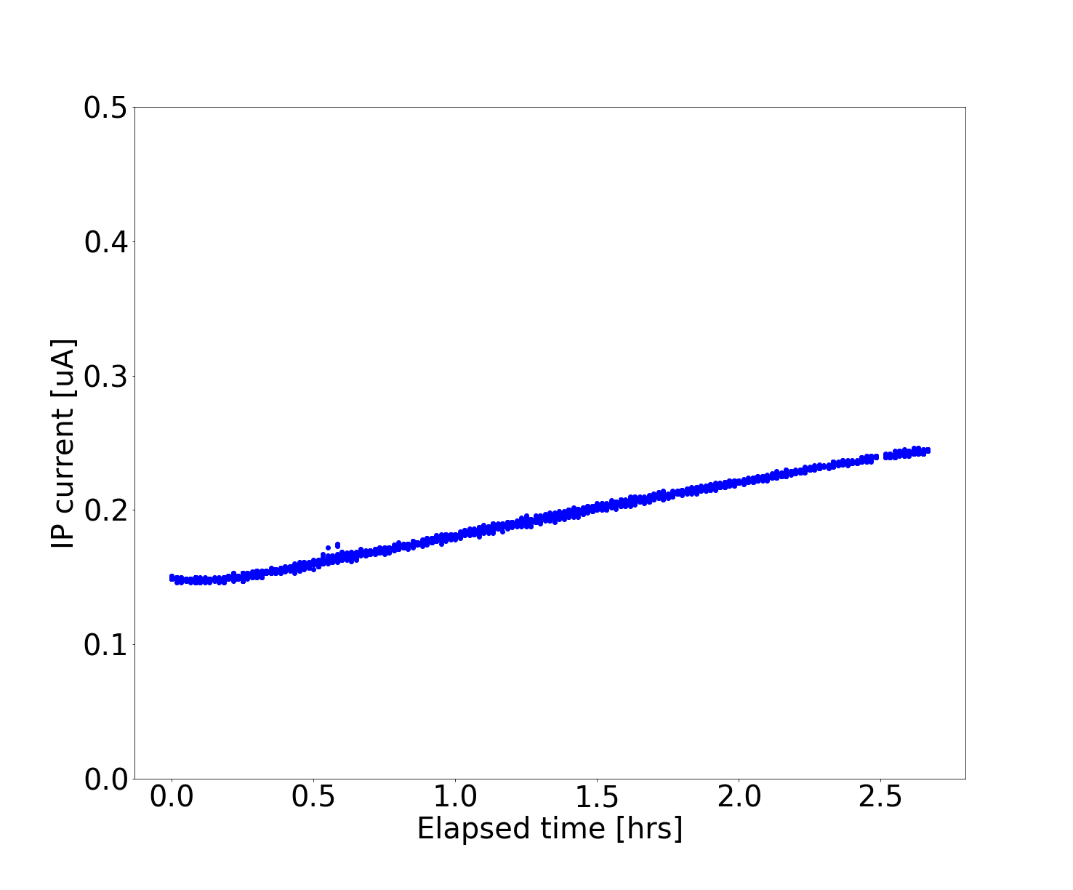
Figure 3: Ion pump current as a function of elapsed time for the initial test.
As second test, the magnet was turned off and the voltage on each plate was brought to ±26 kV to evaluate the device response to the HV parameters capable of rotating the spin of a 300 keV beam by π/2 rad on a 24 hr period. A few events perturbed the vacuum, probably related to the development of field emitters, as shown in Fig 4. Nevertheless, the general response to this conditions represents, to the best of our knowledge, the highest gradient Wien filter achieved to date. The results were deemed acceptable for moving to the next experimental phase, were the installation of the device in the test bed accelerator beam line was expected to benefit from the improved vacuum conditions in the beamline, necessary to keep the vacuum perturbations at a minimum.
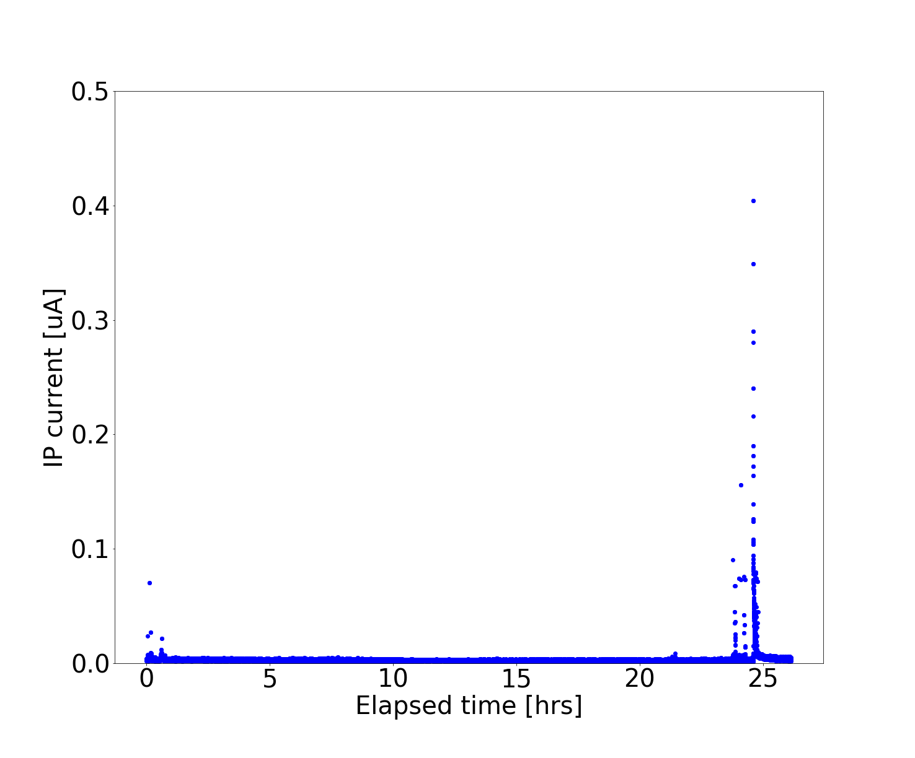
Figure 4: Ion pump current as a function of elapsed time with both plates biased at 26 kV.
After the device was assembled in the test bed accelerator beam line, a test was conducted by applying ±21 kV to each plate respectively, which represents the operation bias (plus 20% processing margin) to rotate the spin by π/2 rad + 10% (100 deg) of a 200 keV beam. As shown in Fig. 5, as the voltage was increased in steps of 500 V every ~3 minutes, the ion pumps showed no perceptible change in vacuum conditions over a total of two hours.
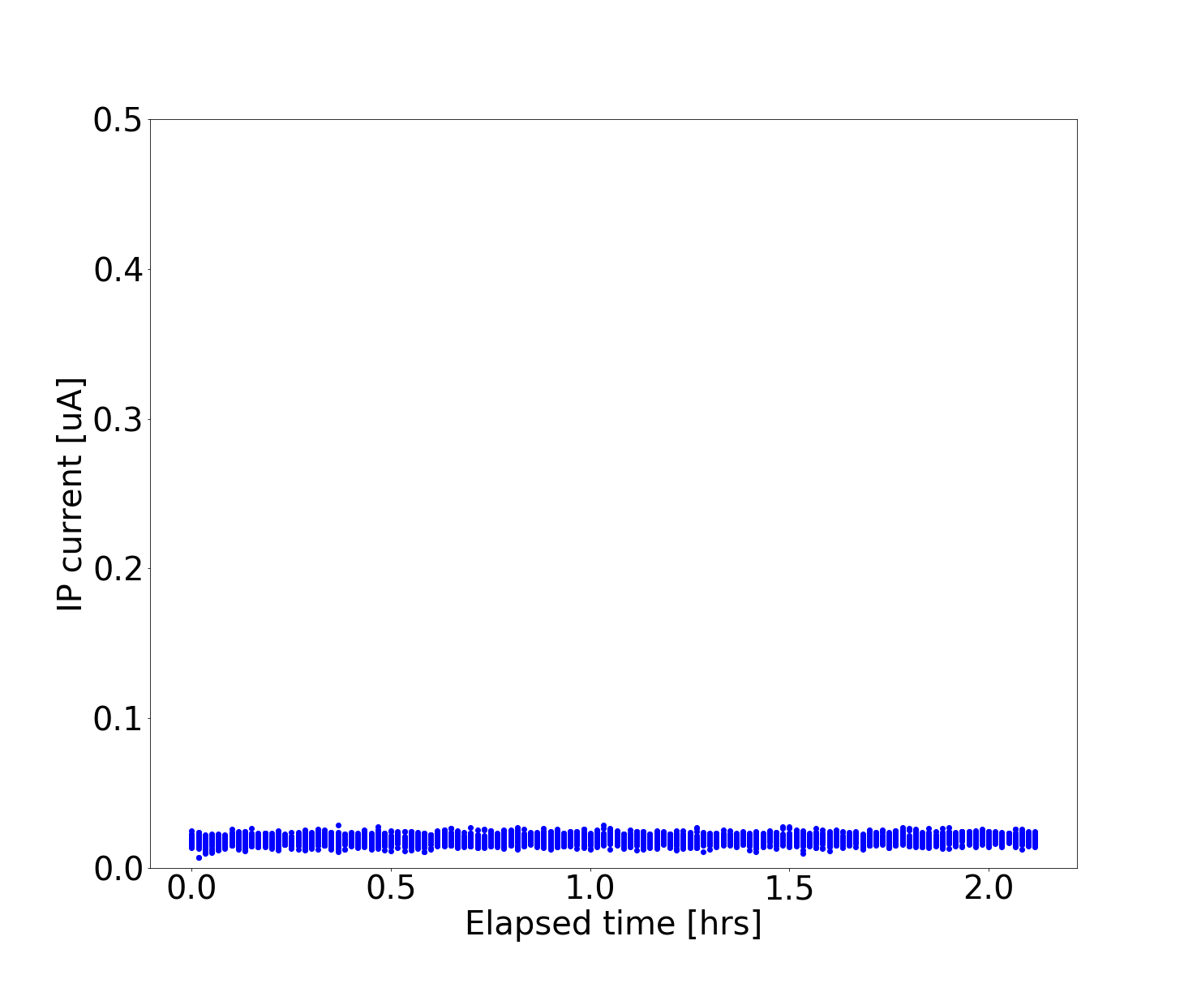
Figure 5: Ion pump current as a function of elapsed time with both plates biased at 21 kV.
Finally, a test was conducted with 180 keV (low current < 10-9 A) beam to ensure that operation parameters allowed the trajectory to be corrected. As shown in Fig 6, while applying 14 kV per electrode, corresponding to π/2 rad spin rotation at 180 keV, the Wien magnet required 12.3 mT to restore the trajectory. The white dot inside the green dashed box shows the electron beam position after the trajectory was corrected.
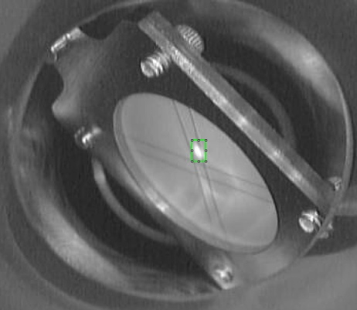
Figure 6: Picture of a beam viewer located downstream of the Wien filter.

Conclusions
A Wien filter spin rotator was developed using single piece stainless steel electrodes with 13 mm electrode-gap (2.7 MV/m). The device is operational in a 180 keV test bed accelerator providing spin rotation by π/2 rad measured at a Mott polarimeter with imperceptible impact in beamline vacuum conditions. This Wien filter was tested without beam to 3.9 MV/m, the highest gradient achieved to date, capable of rotating the spin of a 300 keV electron beam by a maximum of π/2 rad.

Acknowledgments
The authors wish to thank D. “Bubba” Bullard, J. Benesch, M. Stutzman, and the injector group. Best group ever.

REFERENCES
[1] Juliette Mammei (for the MOLLER Collaboration), “The MOLLER Experiment”, in arXiv preprint arXiv:1208.1260, 2012. https://doi.org/10.48550/arXiv.1208.1260
[2] G. Palacios-Serrano et al., “Electrostatic design and conditioning of a triple point junction shield for a -200 kV DC high voltage photogun”, in Rev. Sci. Instrum., vol. 89, no. 10, p. 104703, Oct. 2018. doi: 10.1063/1.5048700
[3] J. M. Grames et al., “Two Wien Filter Spin Flipper”, in Conf. Proc. C, vol. 110328, p. 862-864, 2011.
[4] C. K. Sinclair et al., “A high intensity polarized electron source for the Stanford linear accelerator”, in AIP Conf. Proc., 1976. doi: 10.1063/1.30984
[5] G. Palacios-Serrano et al., “High Voltage Design and Evaluation of Wien Filters for the CEBAF 200 keV Injector Upgrade”, in 12th Int. Particle Acc. Conf., 2021. doi:10.18429/JACoW-IPAC2021-MOPAB324
[6] https://www.bnl.gov/eic/
[7] https://linearcollider.org/
[8] J. M. Grames et al., “Unique electron polarimeter analysing power comparison and precision spin-based energy measurement”, in Phys. Rev. ST Accel. Beams, vol. 7, 2004.
[9] V. Tioukine and K. Aulenbacher, “Operation of the MAMI accelerator with a Wien filter based spin rotation system”, in Nucl. Instrum. Methods. Phys. Res. B NUCL INSTRUM METH A, ol. 568, no. 2, pp. 537–542, Dec 2006. doi:10.1016/j.nima.2006.08.022
[10] B. Steiner et al, , “Wien Filter as a Spin Rotator at Low Energy”, in Proc. 22nd Particle Accelerator Conf. (PAC'07), Albuquerque, NM, USA, Jun. 2007. pp. 170-172. doi: 10.1109/PAC.2007.4440148

