Parity beam line work 9/21 update

- Hall A beam modulation system
Air core coils in multiple positions along the beam line to tweak the beam
- Electronics hardware, coils and software are still installed and functional. Thanks Pete Francis, Simon Wood, Jay and Bob.
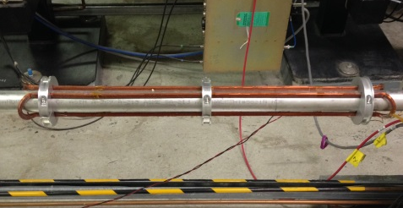

- Beam charge monitoring
2 XYQ cavities and their enclosures located on the aluminum girder upstream of the target.
- XYQ cavities near the target are installed and are equipped with new electronics and temperature controls.
- Install new XYQ cavity
- Cavity assembly has been installed between the two existing cavities on the aluminum girder upstream of the target.
- Supporting cables are being installed but controls for this cavity assembly have not been installed at this time.
- Install temperature controls.
- Run 3 signal cables and one control cable to Hall A counting house. Done
- Still needs to be aligned
- Still needs leak check

- Qweak halo monitor
- Installed and aligned
- Cables for controls are installed and operational Thanks Tony Dela Cruz.
- Detectors need cables and controls. Need specs on cables for procurement
- Will use old mounts for actuator and detector as much as possible.
- Still needs new target
- Still needs alignment
- still needs leak check

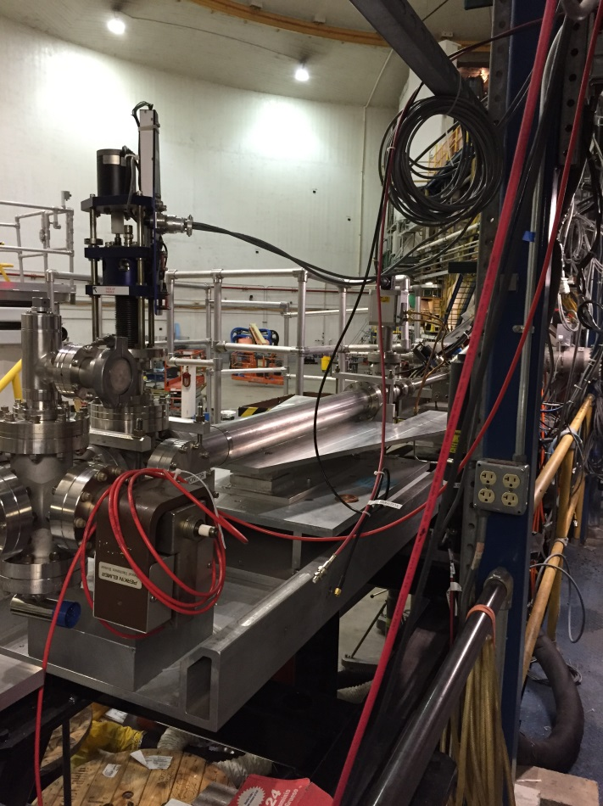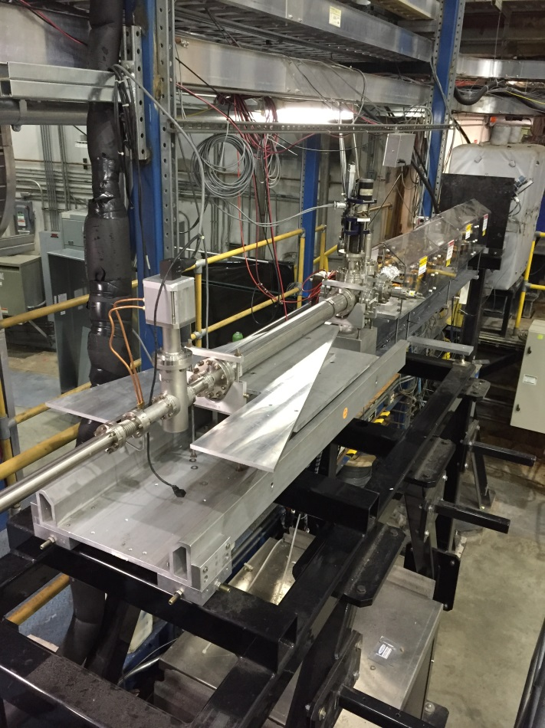

- Cryogenic Moller Polarimeter
This is a new self-contained cryogenic magnet. It has been tested and set up Ethan and Javier.
- The rest of this is on hold for operational Hold for operational Cryogenic Moller Polarimeter Magnet is currently in magnet test being mapped
- Disassemble old Moller target.
- Remove upstream girder
- Install new support
- Re-install upstream girder
- Install new Moller Polarimeter
- Align magnet
- Rout and connect magnet and target power and controls
- In place operational checkout of mechanism
- Close up beam line and leak check
- Align target
- Cool down and operational checkout of magnet in place

- Raster.
- Existing tubes have been removed and installed in Hall C
- New tubes need to be coated in September/ October and installed
- If problems arise with ceramic tubes we have a SS tube to install in the interim/
- Coils need to be reinstalled and tested
- Will need leak check
- Will need to be aligned

