

Laboratory Directed Research and Development Proposal  
Title: development of jleic polarized electron/positron injector

|  |  |
| --- | --- |
| **Lead Scientist or Engineer:** | dr. joseph GRAMES (COORDINATING SCIENTIST)  DR. JIQUAN GUO  DR. FANGLEI LIN  DR. VASILIY MOROZOV |
| **Phone:** | 757-269-7097 |
| **Email:** | [GRAMES@JLAB.ORG](mailto:GRAMES@JLAB.ORG) |
| **Date:** | APRIL 18, 2016 |
| **Department/Division:** | CENTER FOR INJECTORS AND SOURCES / ACCELERATOR |
| **Other Personnel:** | NEW POSTDOC |
| **Proposal Term:** | **From:** 10/2016  **Through:** 10/2019  **If continuation, indicate year (2nd/3rd)**: |

|  |  |
| --- | --- |
| **Division Budget Analyst** |  |
| **Phone:** |  |
| **Email:** |  |

This document and the material and data contained herein were developed under the sponsorship of the United States Government. Neither the United States nor the Department of Energy, nor the Thomas Jefferson National Accelerator Facility, nor their employees, makes any warranty, express or implied, or assumes any liability or responsibility for accuracy, completeness or usefulness of any information, apparatus, product or process disclosed, or represents that its use will not infringe privately owned rights. Mention of any product, its manufacturer, or suppliers shall not, nor it is intended to imply approval, disapproval, or fitness for any particular use. A royalty-free, non-exclusive right to use and disseminate same for any purpose whatsoever, is expressly reserved to the United States and the Thomas Jefferson National Accelerator Facility.

Abstract

This proposal aims to generate polarized positron beams and perform critical tests to demonstrate the feasibility of a full scale positron beam injector for JLEIC, providing luminosity ~1033 cm-2s-1 and with positron polarization greater than 40%. Simulations and corresponding measurements for the production of the desired polarized positrons are described. Three key areas of research include the polarized electron source/injector, the electron accumulator ring, and the polarized positron conversion source.

# Summary of Proposal

## Description of Project

Similar to the physics motivations of electron-ion collisions there is an interest for positron-ion collisions at JLEIC. A sample of motivating physics cases are described below followed by a suitable polarized positron bunch train that achieves a positron-ion luminosity ~1033 cm-2s-1, and with positron polarization greater than 40%.

*Lepton beam polarization asymmetry in neutral current (NC) deep inelastic scattering*

The difference between the NC cross-sections for leptons with different helicity states, predicted in the Standard Model, arises from the chiral structure of the neutral electroweak exchange. The lepton charge asymmetry of the NC cross sections can be used to measure the structure function xF3 using a combination of the unpolarized cross sections.

The charge-dependent longitudinal polarization asymmetries of the NC cross sections are defined as

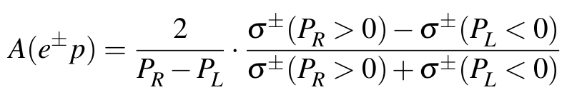

The HERA results for polarization asymmetries are shown in Fig. 1. A variation of the lepton beam charge allows the structure function xF3 to be measured using the unpolarized data. The structure function xF3 can be obtained from the cross section difference between electron and positron data.

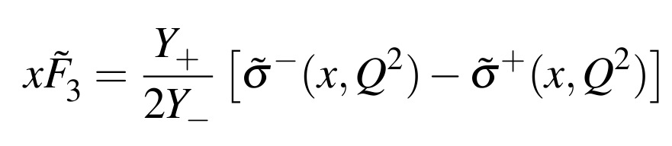

The dominant contribution to xF3 arises from the γZ interference, which allows xF3γZ to be extracted according to xF3γZ ≃ −xF3 /kae by neglecting the pure Z exchange contribution. The xF3γZ measurement is directly sensitive to the valence quark distributions [CH10].

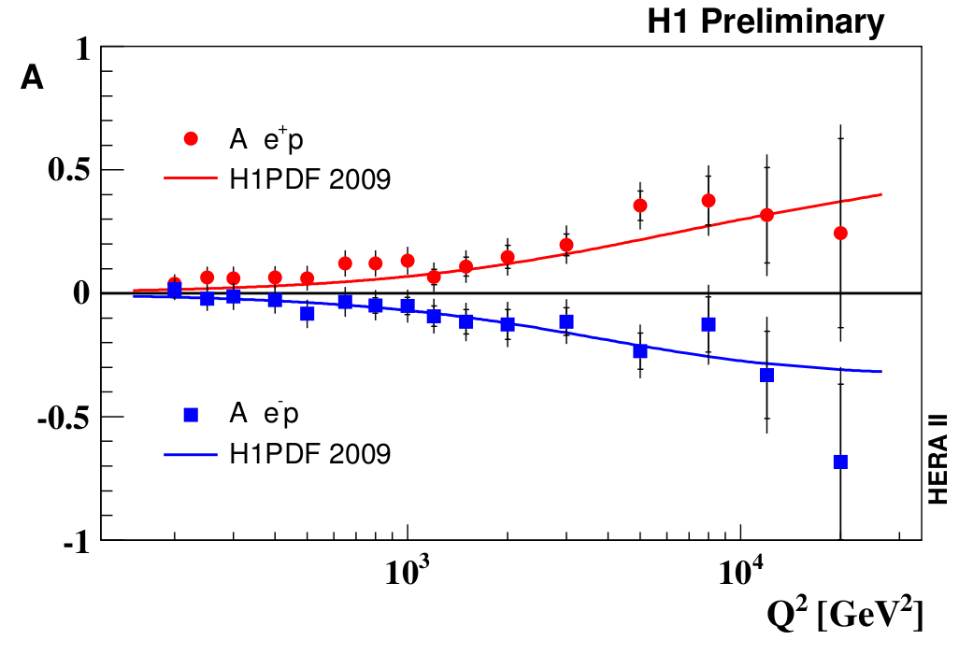

Figure. 1. Measurements of polarization asymmetry versus Q2 for e+p and e−p NC interactions at HERA.

*Charged current deep inelastic scattering (CC)*

The cross section for charged current (CC) deep inelastic scattering (DIS) depends linearly on the longitudinal polarization of the lepton beam [ST05]. Since the Standard Model does not predict right-handed charged currents, the cross section for electron(positron)-proton charged current DIS is predicted to be zero at polarization +1(-1). Measuring the total cross section as a function of polarization allows the Standard Model to be tested through searches for right-handed charged currents and setting limits on the right-handed W-boson exchange. The linear dependence of the CC cross sections on Pe is shown in (Fig 2, left).

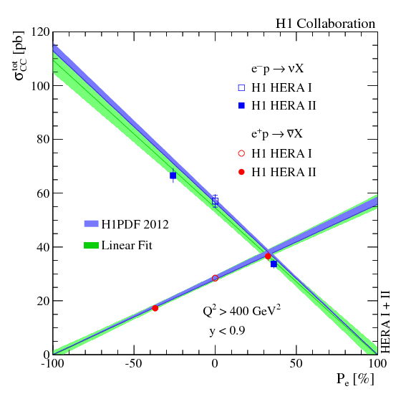 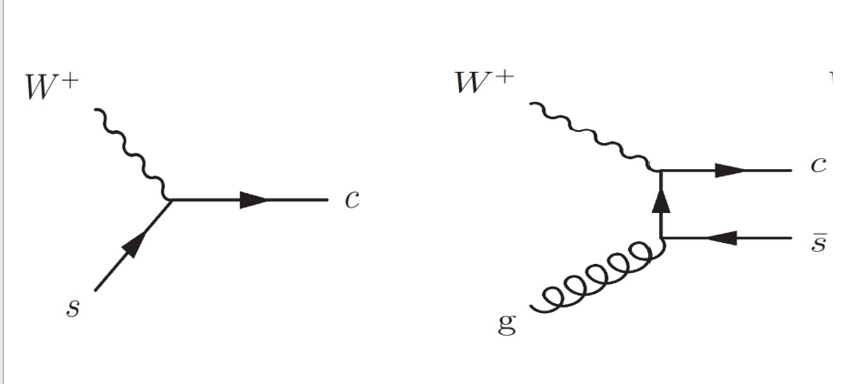

Figure 2. Dependence of the e±p CC cross sections on the longitudinal lepton beam polarization Pe (left). Feynman diagrams for Charm production in (e+p) CC DIS (right).

*Charm production in Charged Current DIS*

Charm production in charged current (CC) deep inelastic scattering (DIS) is the best way to obtain information on the strange sea density [ZH13]. Fig. 2 (right) shows Feynman diagrams contributing to charm production in charged current reactions up to O(αs) a) Born level, b) boson-gluon fusion. With the Standard Model, the Charm production in positron-proton (e+p) CC DIS is charge asymmetric, namely only the charm and no anti-charm quark is produced in the hard process.

*Beyond the Standard Model*

Longitudinally polarized positron beam offer extra sensitivity for some searches for physics beyond the Standard Model since chiral couplings are often involved in the production of new particles [BA96]. For example excited leptons require chiral couplings between ordinary left(right)-handed and excited right(left)-handed (anti)leptons. In addition, for squark production in R-parity violating SUSY models only left(right)-handed electrons (positrons) contribute, so polarized electron(positron) beams will give increase of sensitivity in these searches. Conversely for lepto-quarks, where chiral states with coupling to left or right handed leptons are possible, a different lepton beam polarizations will allow a selective increase in sensitivity for different lepto-quark-types.

*Proposed JLEIC Positron Bunch Train*

Similar to the electron bunch train proposed for JLEIC [AB15], a train of polarized positron bunches has been suggested (Fig. 3), based on a primary estimation of

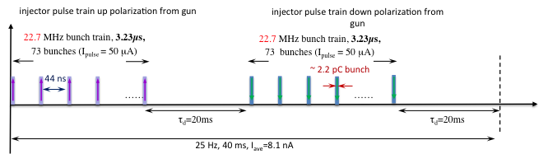

Figure 3. Possible scheme for polarized positron injector bunch structure for JLEIC.

the luminosity for a full acceptance detector (Table 0) [ZH15]. Considering the polarization design with two polarization states coexisting in the electron/positron collider, two long, oppositely polarized positron bunch trains are injected in to the collider. The time interval of 20 ms between the two bunch trains allows the injected beam to damp to the closed orbit and should be long enough for the source to change the laser helicity and flip the polarization.

In the JLEIC baseline design, the PEP-II 476 MHz RF system is reused in the electron/positron collider ring. Note that, 7/22 of the CEBAF linac frequency of 1497 MHz is 476.3 MHz. This frequency is well within the operational range of the PEP-II cavities and klystrons. Unlike the 476 MHz collision frequency for electron beams, the collision frequency for positron beams is chosen to be 159 (=476/3) MHz. By doing this, one can lower the stored positron beam current in the collider to reduce the injection time, but still reach the required luminosity. To synchronize the two bunch trains between the CEBAF and the collider ring, the polarized positron source operates at 22.7 MHz repetition rate (1/21 of the collider ring and 1/66 of the CEBAF SRF frequencies). Then the similar injection scheme for electron beams [AB15] can be applied to positron beams, except that positron beams only occupy 1/3 of the RF buckets in the collider ring.

Table 0. Initial estimation of the luminosity for a full acceptance detector.

|  |  |  |  |  |  |  |  |
| --- | --- | --- | --- | --- | --- | --- | --- |
| CM energy | GeV | **33.5** | | **40** | | **52.9** | |
|  |  | *p* | *e+* | *p* | *e+* | *p* | *e+* |
| Beam energy | GeV | 70 | 4 | 100 | 4 | 100 | 7 |
| Collision frequency | MHz | **476/3=159** | | **476/3=159** | | **476/3=159** | |
| Particles per bunch | 1010 | 1.8 | **0.59** | 1.8 | **0.59** | 2.0 | **0.59** |
| Beam current | A | 0.46 | **0.15** | 0.46 | **0.15** | 0.5 | **0.15** |
| Polarization | % | >70% | **~40%** | >70% | **~40%** | >70% | **~40%** |
| Bunch length, RMS | cm | 2 | 1.2 | 2 | 1.2 | 2 | 1.2 |
| Norm. emitt., vert./horz. | μm | 0.5/0.25 | 36/18 | 0.5/0.25 | 36/18 | 0.5/0.25 | 190/95 |
| Horizontal & vertical *β\** | cm | 4/2 | 5.8/2.9 | 2/4 | 4.1/2.0 | 7.1/3.55 | 2.4/1.2 |
| Vert. beam-beam |  | 0.002 | 0.15 | 0.002 | 0.15 | 0.002 | 0.03 |
| Laslett tune-shift |  | 0.056 | small | 0.028 | small | 0.03 | small |
| Det. space, up/down | m | 3.6/7 | 3/3.2 | 3.6/7 | 3/3.2 | 3.6/7 | 3/3.2 |
| Hour-glass reduction |  | 0.89 | | 0.87 | | 0.82 | |
| Lumi./IP, w/HG, 1033 | cm-2s-1 | **0.9** | | **1.2** | | **0.7** | |

However, the creation of polarized positrons and with sufficient intensity is particularly challenging. Radioactive sources can be used for low energy positrons [ZI79], but the flux is severly restricted. Storage or damping rings can be used at high energy, taking advantage of the self-polarizing Sokolov-Ternov effect [SO64], however, this approach is generally not suitable for continuous wave injection facilities. In the context of the International Linear Collider project, recent schemes for polarized positron production rely on the polarization transfer in the e+e−-pair creation process from circularly polarized photons [OL59, KU10], but use different methods to produce the polarized photons. Two techniques have been investigated successfully: the Compton backscattering of polarized laser light from a GeV unpolarized electron beam [OM06], and the synchrotron radiation of a multi-GeV unpolarized electron beam travelling within a helical undulator [AL08]. Both demonstration experiments reported high positron polarization, confirming the efficiency of the pair production process for producing a polarized positron beam. However, these techniques require the use and management of high-energy electron beams and challenging technologies.

A new approach, referred to as the Polarized Electrons for Polarized Positrons (PEPPo) technique [BE96, PO97], has been investigated at the Continuous Electron Beam Accelerator Facility (CEBAF) of the Thomas Jefferson National Accelerator Facility (JLab). Taking advantage of advances in high polarization, high intensity electron sources [AD10] it exploits that polarized photons generated by the bremsstrahlung radiation of low energy longitudinally polarized electrons within a high-Z target produce polarized e+e−-pairs. It is expected that the PEPPo concept can be developed efficiently with a low energy (10-100 MeV/c) and high polarization (>80%) electron beam driver, opening access to polarized positron beams to a wide community. Results recently submitted for publication in [AB16] demonstrate highly efficient transfer of polarization from 8.19 MeV/c electrons to positrons (Fig. 4).

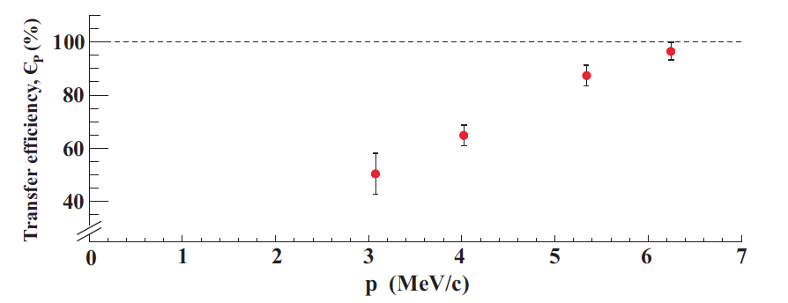

Figure 4. Polarization transfer from 8.19 MeV/c polarized electron beam to positrons.

While the polarization transfer by bremsstrahlung and pair creation is similarly efficient for *any* incident electron energy the yield of positrons is not. Rather, positron yield scales approximately with beam energy. For example, at the Stanford Linear Accelerator Center a 35 GeV electron beam was used to produce and collect 220 MeV positrons with e+/e- efficiency ~1 [CL89], whereas at the APosS system at Argonne National Laboratory a 12-20 MeV electron beam was used to produce and collect moderated slow positrons with efficiency ~10-7 [JO08].

The strategy we propose to compensate for the low positron efficiency is to accumulate charge. However, rather than accumulating “hot” positrons after conversion we propose to accumulate “cold” electrons before conversion. A high-level diagram of a possible positron injection scheme is shown in Fig. 2.

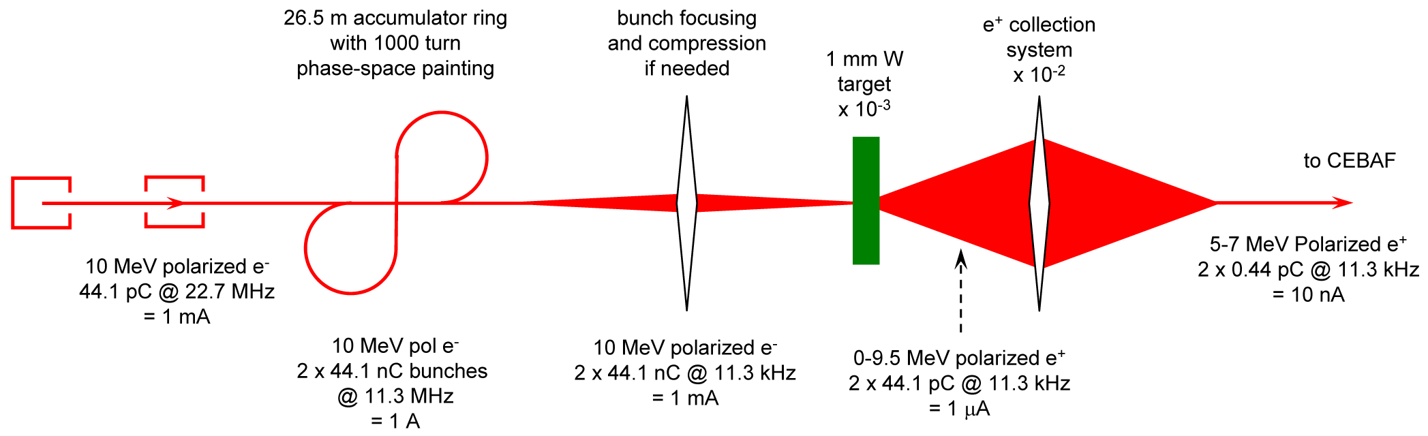

Figure 5. A 10 MeV polarized electron injector provides bunches that are accumulated 100-1000 turns in a figure-8 ring to preserve polarization before extracted to a positron conversion target, where polarized positrons are created and collected to a beam of about 5 MeV.

Accumulation of polarized positrons in the JLEIC electron collider ring requires an average polarized positron current of about 10 nA. Assuming polarized positron production and collection efficiency of about 10-5 demonstrated by PEPPo with a 10 MeV polarized electron beam, the required polarized electron current is about 1 mA. The positron production efficiency improves with increase in the electron energy. However, 10 MeV electrons have the advantage of being below the neutron production threshold and produce no activation. 1 mA average current is within the reach of a polarized electron gun. However, injection into the electron collider ring in a CW fashion is not possible because injected bunches need on the order of 20 ms to damp near the cores of the stored bunches. Therefore, injection requires very low-duty, relatively high-current macro bunch structure with low average current. Thus, the key of polarized positron injection is accumulation of low-current CW beam from the positron source into high-current, low duty-factor macro pulses.

Our proposed scheme for positron beam formation is illustrated in Fig. 5. Lowering of the duty factor is done in two steps. First, the frequency of the electron gun is lowered as much as practically possible. This is why experimental investigation of the electron gun performances at different repetition rates and bunch charges is one of the goals of our proposal. The second step is collection of the beam coming out of the source in an accumulator ring.

There are a number of techniques that are conceivable for beam accumulation. One may consider using damping rings for accumulation of a few GeV electrons or positrons. However, such damping rings are usually large complicated devices. At low energies of a few MeV, one cannot rely on synchrotron radiation for cooling. Another cooling technique, ionization cooling, even if feasible, results in large equilibrium emittances, which make the beam difficult to accelerate. Thus, we are left with the phase-space painting as, perhaps, the only applicable accumulation technique. The phase-space painting does not increase the local phase-space density but accumulates the beam at the expense of increasing its 6D emittance. For this reason, trying to accumulate polarized positrons with a low phase-space density would probably not be efficient. On the other hand, electron bunches can be generated at the photo cathode with very low emittances and can be efficiently stacked in the accumulator ring.

Finally, we optimize the positron production target region. Its design is a balance of the production and collection efficiencies. In fact, similar work has been done in the context of radiator region design for isotope production [Amy Sy reference]. The target region design is one of the key components for production of a CW polarized positron beam. That is why, after completion of the electron gun experimental tests, we will focus on optimization and experimental testing of the positron collection system.

It is meaningful to note that besides JLEIC the motivation for positron beams at Jefferson Lab has broad interest (see Table 1 and Refs. [13-19]), as evidenced by User Group members for positrons at CEBAF, inclusion of positron beam parameters in Electron Ion Collider documents, and recent proposals for a Dark Matter Search and Slow Positron Facility at the LERF. A summary of possible physics interests [TO09] and required average positron intensity is provided in Table 1 with references.

Table 1. Physics interest using positrons at JLab in recent years.

|  |  |
| --- | --- |
| **Physics interest** | **positron intensity** |
| Two Photon Exchange [AR09] | 10 – 50 nA |
| Positron Proton Elastic Scattering [WE09] | 20 – 40 pA |
| GPD’s and DVCS with Positrons [BU09] | 8 – 40 nA |
| Inclusive Structure Functions [CH09] | 100 – 250 nA |
| U-Boson Dark Matter Search [WO09] | 20 nA |
| Slow Positron Facility [GO11] | 10 – 100 pA |

## Expected Results

We propose to develop supporting simulation and experimental results of a polarized positron injector for JLEIC. Specifically, three critical topics will be addressed in this LDRD,

1. Low-Frequency, High-Charge Polarized Electron Source and Injector
   1. Operate for the first time a highly spin-polarized GaAs/GaAsP superlattice photocathode in a photogun with voltage > 200 kV,
   2. Develop and test an rf synchronous laser providing 780 nm light with low-frequency <50 MHz and high peak power by digital gain switching,
   3. Measure quantum efficiency, operational lifetime, beam emittance and bunch length as a function of laser spot size, high voltage and bunch charge,
   4. Perform multivariate optimization for acceleration of bunch train to ~10 MeV and test operation for high bunch charge and low repetition rate acceleration; characterize beam at 10 MeV.
2. 10 MeV Polarized Electron Accumulator
   1. Design and simulate accumulation ring with high gain (>100) and spin preserving figure-8 construction,
   2. Design and simulate suitable injection/extraction (<100 ns),
   3. Develop proof-of-principle experiment proposal with cost estimate.
3. Polarized Positron Source
   1. Simulate and optimize positron distribution from possible pair-creation targets and collection with various magnetic geometries,
   2. Construct source and diagnostic line to characterize incident electron beam properties and resulting positron beam properties such as yield, energy spread, emittance, bunch length and polarization.

# Proposal Narrative

## Purpose/Goals

The goal of this LDRD is to simulate, test and measure the production of polarized positrons for JLEIC. This is accomplished within the context of accumulating a high bunch charge of polarized electron necessary for producing the required polarized positron macro-pulse structure suitable for acceleration and injection into the ion collider. These simulations and measurements will provide insights on ways to optimize the JLEIC polarized positron injector, and help us design the appropriate electron source, accumulator ring, pair-production and positron collection method. Please refer to Attachment X for a detailed description of quarterly goals.

## Approach/Methods

*High Bunch Charge and Low Repetition Rate Polarized Electron Source*

The operation of superlattice GaAs/GaAsP in dc high voltage photoguns has been successfully tested at Jefferson Lab with voltage up to 200kV and current up to 4mA. Table 2 summarizes two ~mA-level measurements, our first ~1 mA [GR07] run and the most recent ~4 mA [SU11] record. While encouraging, these measurements were performed at low bunch charge, high repetition rate and correspondingly low gun voltage.

Table 2: Two Polarized High Current Records

|  |  |  |
| --- | --- | --- |
| Parameter | Value | Value |
| Laser Rep Rate | 499 MHz | 1500 MHz |
| Laser Pulse Length | 30 ps | 50 ps |
| Laser Wavelength | 780 nm | 780 nm |
| Laser Spot Size | 0.45 mm | 0.35 mm |
| Photocathode | GaAs/GaAsP | GaAs/GaAsP |
| Gun Voltage | 100 kV | 200 kV |
| Beam Current | 1 mA | 4 mA |
| Run Duration | 8.25 hour | 1.4 hour |
| Extracted Charge | 30.3 C | 20 C |
| Charge Lifetime | 210 C | 80 C |
| Fluence Lifetime | 132 kC/cm2 | 83 kC/cm2 |
| Bunch Charge | 2.0 pC | 2.7 pC |
| Peak Current | 67 mA | 53 mA |
| Peak Current Density | 42 A/cm2 | 55 A/cm2 |

However, for JLEIC new and more challenging source conditions are required, not only for the proposed positron driver of this LDRD, but also for the baseline polarized electron source bunch scheme (Fig. 6).



Figure 6. Time structure of the polarized electron beam injection at 6 GeV with the PEP-II 476.3 MHz RF system.

Table 3 summarizes the anticipated polarized electron source parameters of the the JLEIC electron-ion collider and positron-ion collider described in this LDRD proposal. It is noteworthy that the Jefferson Lab FEL operated with high bunch charge (>100 pC), low repetition rate (<100 MHz) and at high voltage, however, using unpolarized bulk GaAs in a non-inverted gun geometry. In this LDRD we propose testing and operating with a superlattice GaAs/GaAsP in a dc high voltage photogun with inverted geometry and at lower-repetition rate (<62 MHz), higher bunch charge (>10 pC), and correspondingly high gun voltage (>300 kV).

TABLE 3. Parameters assume GaAs/GaAsP with QE~0.5% and P>80%

|  |  |  |  |
| --- | --- | --- | --- |
| Parameter | unit | jleic e- | jleic e+ |
| Laser/Bunch Frequency | MHz | 476.3 | 22.7 |
| Electron Bunch Charge | pC | 13.0 | 44.1 |
| Average Current (DF=100%) | mA | 6.2 | 1.0 |
| Laser Power @ 780nm (DF=100%) | W | 2.0 | 0.32 |
| Laser Pulse Length @ 780 nm | pS | 30.0 | 30.0 |
| Laser Pulse Period @ 780 nm | pS | 2100 | 44,050 |
| Laser Peak Power @ 780 nm | W | 868 | 470 |
| Laser Peak Power @ 1560 nm | W | 1736 | 940 |

In particular, high average current and/or high bunch charge applications benefit from the operation of the photogun at very high voltage, which serves to minimize the ill-effects of space charge forces which degrade the emittance and introduce beam loss leading to a diminished photogun charge lifetime. Guns with higher high voltage allow for compact, less-complicated injectors. Higher HV would also increase QE by lowering the potential barrier (Schottky effect) [HO73] and suppresses the surface charge limit [MU01]. As an added benefit, operation at very high bias voltage may enhance the operating lifetime of the photogun by quickly accelerating the beam to energy with very small ionization cross section.

In particular, imperfect vacuum leads to ion bombardment, the mechanism where residual gas is ionized by the extracted electron beam and transported backward to the photocathode where the ions adversely affect photocathode yield. Ions with sufficient kinetic energy penetrate the surface of the photocathode, where they might damage the GaAs crystal structure or serve as trapped interstitial defects that reduce the electron diffusion length. Impinging ions might also sputter away the chemicals (Cs and F) used to reduce the work function at the surface of the photocathode.

In this LDRD we propose to extend our low-repetition rate capability by building a frequency-doubled fiber amplifier laser to provide high power 780 nm light and using the method of digital gain switching to enable ready control of low-frequency repetition rate. The low frequency requires that we work with a vendor to purchase a laser amplifier of suitably high >1 kW peak power capability.

Presently, two new dc high voltage photoguns with inverted geometry are being developed. The first was constructed at the Gun Test Stand and successfully high voltage processed to >300kV, where it will be used over the next ~two years for the LDRD Magnetized Electron Gun Cooling experiment nominally using an unpolarized Cs2KSb alkali-antimonide photocathode. The second is now being constructed and will be commissioned this Fall at the Upgrade Injector Test Facility with initial high voltage operation planned at ~200 kV and producing low bunch charge (<0.1 pC) and high repetition rate (750 MHz) for commissioning of the Hall B HDIce target.

In this LDRD we propose to integrate into the UITF HDIce schedule to further develop this gun, to high voltage condition for operation at >300 kV, integrate the new laser and characterize photogun operation and GaAs/GaAsP photocathode performance. We would measure quantum efficiency, operational lifetime, beam emittance and bunch length as a function of bunch charge, high voltage and laser spot size. The UITF beam line would afford many diagnostics, however, a slit scan emittance diagnostic would need to be developed, similar to the one employed at the Gun Test Stand.

*Optimized Polarized Electron Injector*

In addition to characterizing the polarized electron source as an electron driver for the JLEIC positron source (and an electron driver for JLEIC itself), we would simulated and optimize transport of the bunch train for acceleration to ~10 MeV; using both UITF and LERF as templates anticipating a polarized positron production experiment later in this LDRD. One optimization would explore a low bunch charge high repetition rate, e.g. well suited to UITF and another would explore a high bunch charge low repetition rate, e.g. well suited to LERF.

*Polarized Electron Accumulator Ring*

Synchronization of the accumulator ring with the electron source requires that the ring circumference is an integer number of bunch spacings at the source. The scheme shown in Fig. 3 assumes the ring circumference of two bunch spacings or, in other words, a ring harmonic number of 2 at 22.7 MHz. This gives a ring circumference of about 26.5 m. Increasing the ring circumference helps lower the duty factor but, of course, incurs a higher cost.

To preserve the polarization of the injected beam, the ring is shaped as figure 8. In a racetrack, the polarization of the circulating beam would undergo a rotation on each turn misaligning it with the injected beam’s polarization. If needed spin stabilization can be provided by a small solenoid. If considering solenoidal focusing of the circulating beam, which seems to be a good option for the optics design of such a ring, one has to compensate the spin effect of the focusing solenoids, for example, by using them in opposite-field pairs.

Another option for preserving the polarization in the accumulator ring is to use a racetrack with a full Siberian snake. However, the figure-8 design can be viewed as a test of the polarization scheme of the whole collider complex. We will explore both options and will make a selection based on the cost/benefit optimization.

The longitudinal dynamics will be managed by an rf cavity running at 22.7 MHz or a higher harmonic and by an appropriate adjustment of the compaction factor. This will be determined and optimized in simulations.



Figure 7. Low Energy Ion Ring (LEIR) at CERN.

The injection system design will be similar to that of the CERN’s LEIR ring shown in Fig. 7. Multi-turn injection is done through transverse phase-space painting [ref]. It uses two pairs of bumper magnets to move the orbit in x and y near an electrostatic septum where subsequent turns are injected. LEIR has been tested for 75 turn injection of Pb54+. We aim for a much more aggressive 1000 turn injection using the fact that the electron emittance is small. In case of 4D transverse phase-space painting, it ideally gives an increase of the transverse 2D emittance by a factor of 30. The limitation on the emittance comes from the required beam size at the positron production target. This will be determined and optimized in the course of the project.

Another important component of the ring is the extraction kicker. Its rise time has to be shorter than the time between the bunches, which is about 88 ns. It has to operate at a repetition rate of 11.3 kHz. We will explore options for the design of such a kicker. One particularly elegant solution is a beam-beam kicker where a high-intensity low-energy electron bunch is used to kick out a stored electron bunch. This idea has not yet been experimentally verified but it completely eliminates the rise- and fall-time issues and allows a complete control over the repetition rate opening new opportunities for the scheme optimization.

Besides polarized positrons, the accumulator ring may also be beneficial for injection of polarized electrons. Similarly to positrons, electron injection requires high-macro-bunch-current low-duty-factor electron trains. An accumulator ring would provide additional flexibility for the electron injection design.

Work on the high-level accumulator ring design will be done during the first year by J. Guo, F. Lin and V. Morozov. More detailed design and simulations as well as proof-of-principle experiment development will be done in the two subsequent years by a newly hired postdoc who will be guided by JLab staff.

*Polarized Positron Source and Collection*

Our proposed scheme to generate spin-polarized positrons relies on the two-step process, first transferring spin from electrons to photons (polarized bremsstrahlung) and second from photons to positrons (polarized pair-creation). This occurs when the polarized electron beam strikes matter, a high-Z target is preferred, and results in an efficient electron-magnetic shower. At any specific electron energy both the degree of spin polarization and incident intensity of the electron beam are significant factors, first because fewer positrons are created with larger polarization and second because positron yield scales with electron intensity (Fig. 8).

While a higher energy electron beam would benefit the positron yield, we propose there are significant advantages to pursue a low energy ~10 MeV electron driver option; a) activation by photo-neutron production is largely mitigated resulting in a non-radioactive “clean” positron source, b) the footprint and cost of a dedicated ~10 MeV positron injector is very appealing as compared to a 100-1000 MeV positron source, and c) the UITF or LERF are experimentally accessible for critical measurements.

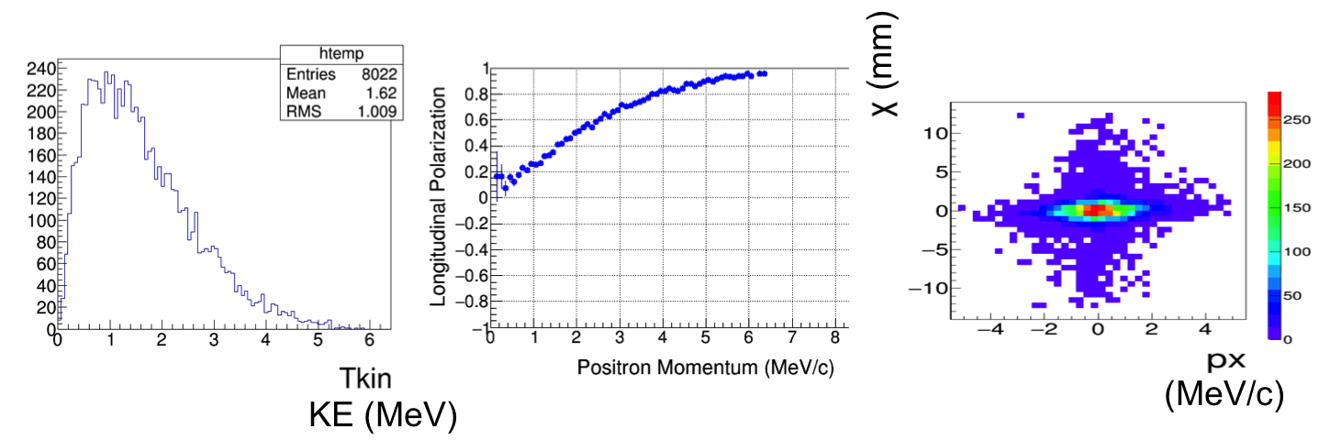

Figure 8. A Geant4 simulation exemplifies the relative energy, polarization and spatial/angular distribution resulting from, e.g. a 100% 7 MeV polarization (100%) electron beam incident on a 1 mm thick tungsten foil.

Whereas the PEPPo focus was measuring polarization transfer, in the LDRD we focus effort on the efficient collection and characterization of the positron beam. In this LDRD we will perform simulations and optimize positron distribution from possible pair-creation targets and collection with various magnetic geometries. One of the possible approaches to the target region design is based on non-linear optimization and has been studied in the context of an ERL with an internal target for isotope production [Amy Sy]. The deliverable is to develop a test bed experiment to benchmark and optimized collection of polarized positrons. Critical parameters are positron yield, momentum spread, emittance, bunch length and polarization.

Our approach to handling positrons is two-fold. We first optimize the electron beam parameters at the radiator. For any reasonable electron beam size at the target, the positron angular spread greatly dominates over the initial electron angular spread. Therefore, the rms positron emittance *εx,y* in each plane after the targer can be written as *εx,y* ≈ *σx,yθrms*, where *σx,y* is the horizontal/vertical electron beam size at the radiator. Obviously, minimizing the electron beam size at the radiator lowers the final positron emittance. The downside of reducing the beam size is that it leads to a high instantaneous power density at the beam spot location on the target. The average power of 1 mA 10 MeV electron beam at the target is also non-trivial at 10 kW. We propose to solve this problem by considering liquid metal and spinning solid radiator designs.

The fundamental limit on the beam size at the radiator comes from the requirement that the transverse Twiss *β* functions at the radiator must be greater than or equal to the radiator thickness. This ensures that the beam size does not change significantly inside the radiator. This is an effect similar to the hour-glass effect in a collider, which results in increase of the effective beam size.

The second component of our approach to positron beam handling is appropriate collection optics design. One approach involves using a solenoid-based axially-symmetric optics similar to SLAC []. A possibly more sophisticated approach has been developed for collection of electrons after they pass through a target. The same technique can be applied to positrons. The technique is illustrated below in application to electrons.

Spherical and chromatic aberrations in the collection optics introduce significant beam smear and greatly degrade the beam quality. This problem is, in fact, very similar to compensation of non-linear impact of a final focusing triplet in a collider. Figure 5 (left) shows linear optics design of the post target section. We compensate the chromatic kick of the large-*β* quadrupoles using a local Chromatic Compensation Block (CCB), as illustrated in Fig. 5 (right), without introducing significant geometric effects.

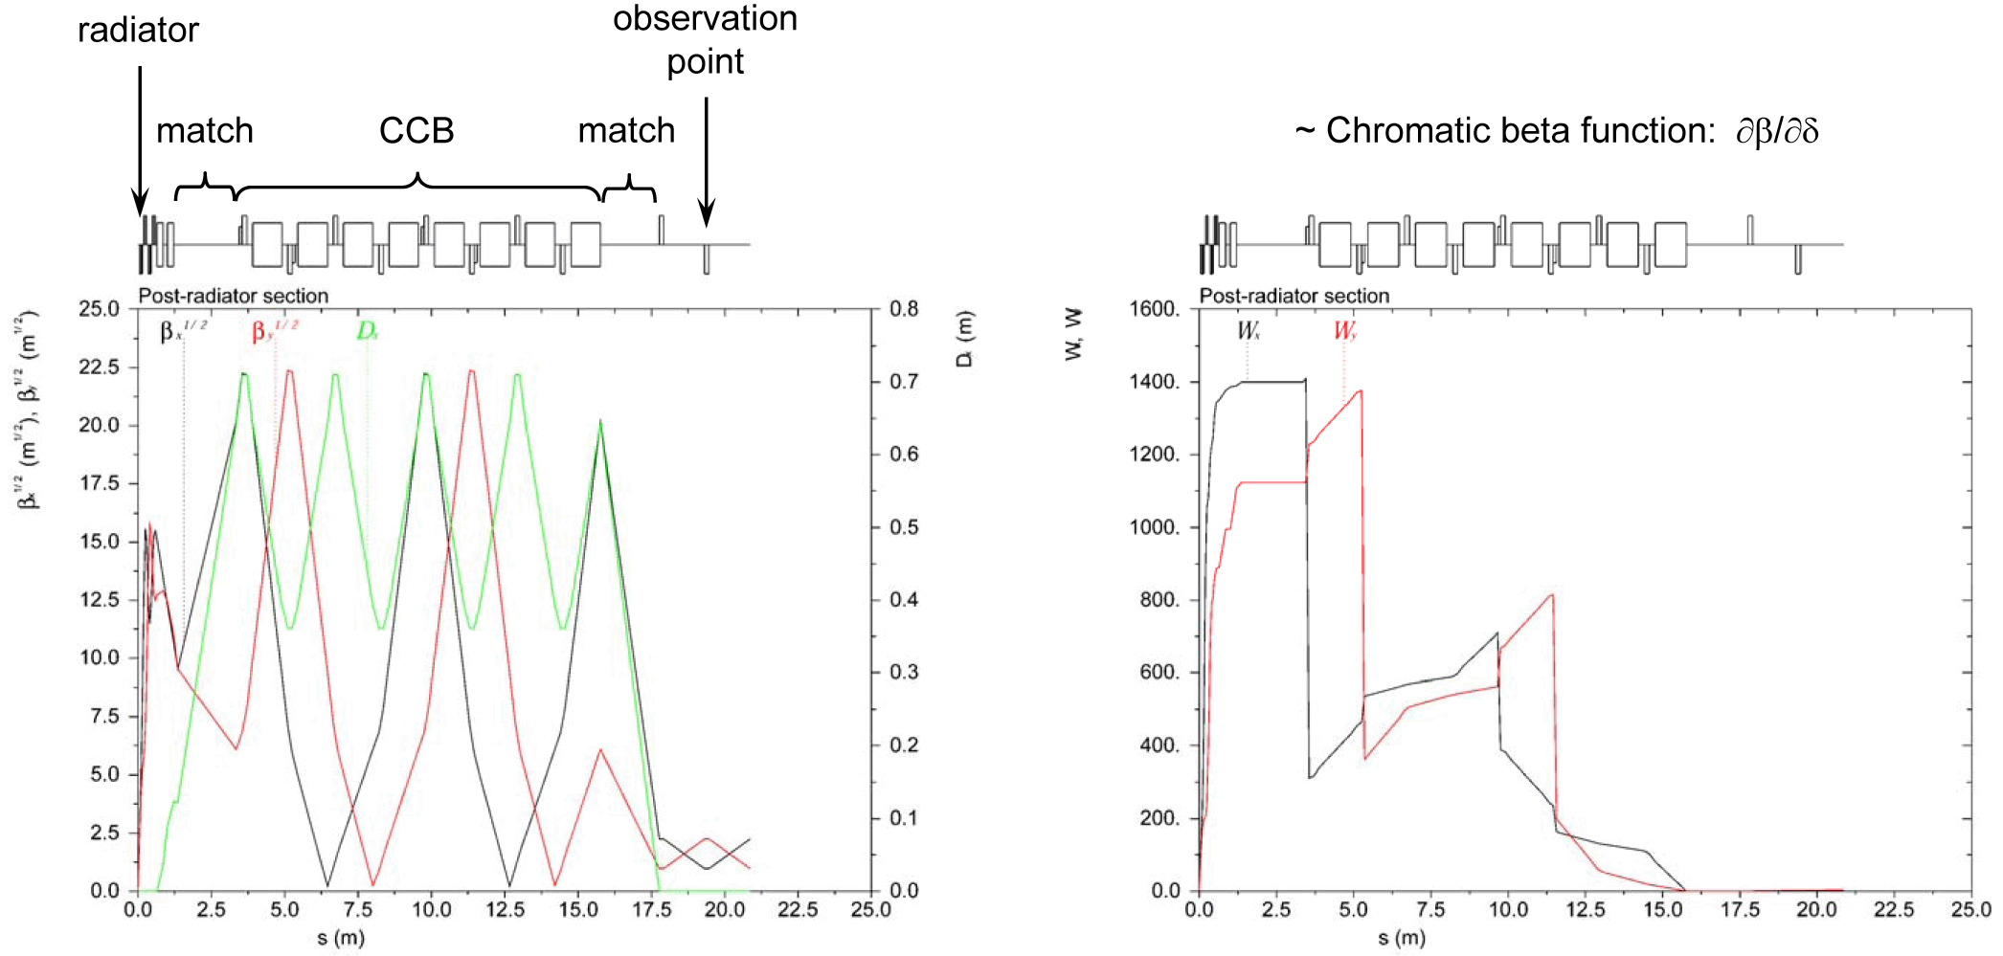

Figure 5. Linear optics design of the post-radiator section (left). Montague chromatic amplitude functions in the post-radiator section (right).

Three octupoles in the large-*β* region compensate spherical aberrations. The efficiency of the octupole compensation is illustrated in Fig. 6 by tracking a beam with zero momentum spread using *Elegant*. Setting the momentum spread to zero lets us distinguish spherical aberrations from chromatic ones. The spherical aberration effect is even more dramatic for more aggressive beam focusing designs. In addition, even though the tails of the final distributions may not look significant, filamentation would smear them all over the phase space ellipses (shown by the dashed lines in Fig. 6) that the final distributions are inscribed into. This would lead to beam loss and difficulties with collimation. Horizontal and vertical beam phase space distributions before and after compensation are shown in Fig. 7. They are obtained by tracking the beam from the target to the observation point using *Elegant*.

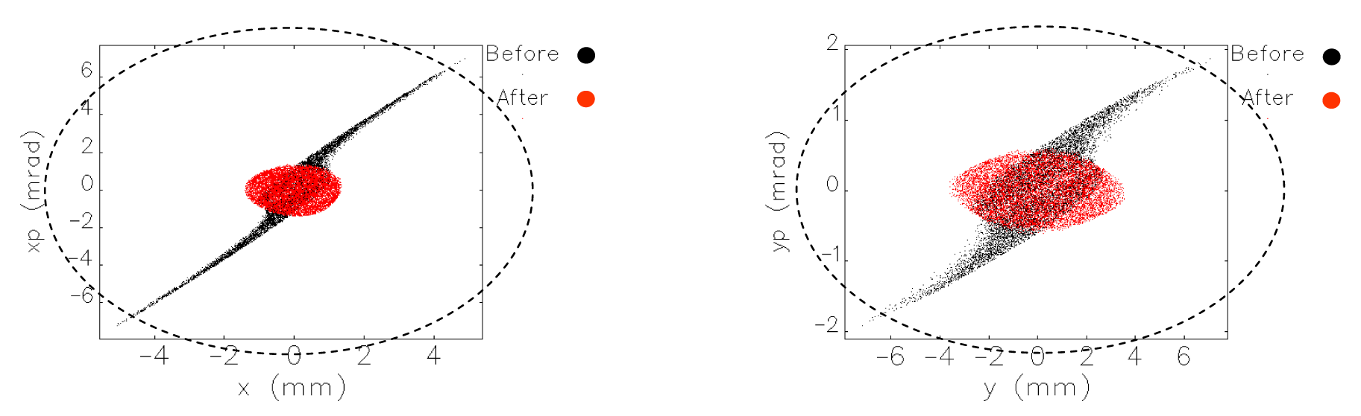

Figure 6. Horizontal (left) and vertical (right) beam phase space distributions at the observation point shown in Fig. 5 before (black) and after (red) octupole compensation.

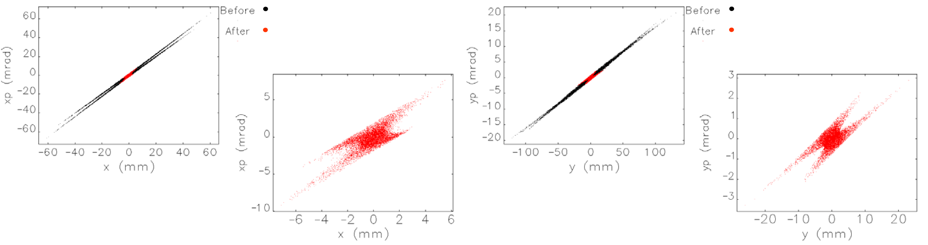

Figure 7: Horizontal (left) and vertical (right) beam phase space distributions in the post-target section before (black) and after (red) non-linear compensation.

A possible experimental test of the positron production and collection system is illustrated in Fig. 9. Figure 10 shows a conceptual element-by-element design of the experimental beam line. The electron beam is focused at the target (T) by a a pre-target focusing block, e.g. a pair of quadrupoles (Q). The beam profile near the target is measured by a wire scanner. The generated positrons are collected by a post-target focusing system, e.g. a solenoid (S). The positron beam is transversely collimated by a pair of apertures and then momentum collimated by a dipole (D) and another aperture. The beam is matched to the diagnostics section by a pair of quadrupoles (Q). The beam profile and polarization are measured using a wire scanner and a transmission polarimeter. The bunch length can be measured, for example, by imparting a chirp on the bunch and then measuring an increase in the transverse size of the bunch a dispersive location.

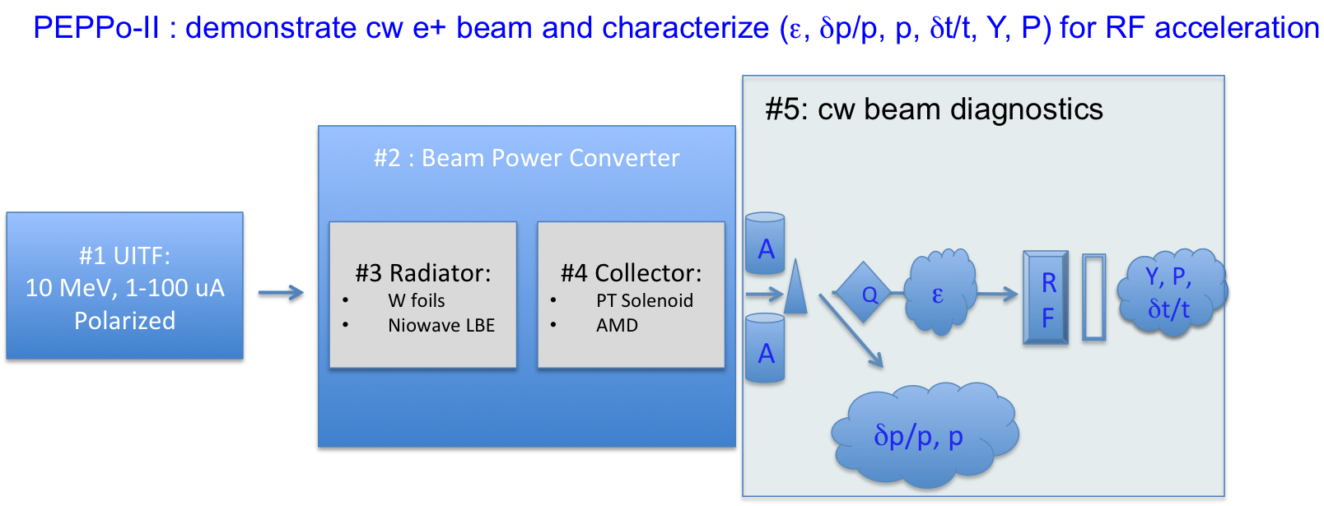

Figure 9. Schematic lists the primary components of the cw-positron test bed; (1) 10 MeV polarized electron beam, (2) shield hut, (3) pair-creation target, (4) collection solenoid and (5) diagnostic suite.



Figure 10. Schematic of a possible experimental test of a cw positron source.

High-level design of the positron production and collection system will be done during the first year by J. Guo, F. Lin and V. Morozov. More detailed design and simulations as well as proof-of-principle experiment development will be done in the two subsequent years by a newly hired postdoc who will be guided by JLab staff.

*Simulation of Polarized Positron CW Source*

Beam physics intrinsically deals with sophisticated systems of many variables and their specifications. The Genetic Algorithm is a powerful method that implements principles employed in biological evolution to optimize multi-dimensioned non-linear problems. Introduced into accelerator physics relatively recently (1992) the Multi-Object Genetic Algorithm (MOGA) has been increasingly employed, first for optimizing the design of magnets and RF cavities, and later in increasingly sophisticated problems, such as determining the operating parameters to achieve the highest brightness high-current electron photo-injector ever, at Cornell University [BA05-1], to optimize luminosity in the International Linear Collider design [BA05-2] and to optimize design and operating costs for an SRF linac [BA05-3].

The strength of this technique with respect to the proposed work is the capability to globally judge desirable or dominant traits such as positron yield, beam brightness (yield/emittance), figure of merit (yield x polarization2), and so on. While some parameters readily optimize (e.g. one may always benefit from an electron drive beam with highest polarization), it is possible with a large parameter base for design-bias or local optimization (meaning, a subset of parameters in the system) to mislead.

In this work, a MOGA optimization would be considered to evaluate candidate scenario strengths, and would be considered in the design to study and optimize the complicated phase-space relationships in regard to the spatial, temporal, momentum, and/or polarization optimization with respect to radiator configuration. While not all candidates may practically be explored this way, the MOGA approach is a powerful utility for the conceptual design to proceed pragmatically and would be used when relevant to distill optimal specifications, from a clearly broad set of “parent” parameters:

* Electron Drive Beam (energy, intensity, radiation, polarization)
* Single- & Double-Targets (bremsstrahlung and e+/e- converters)
* Electron Beam Power (radiation, activation, thermal management)
* Positron Collection (adiabatic matching, acceleration, optics)

*Experiment of Polarized Positron CW Source*

The components of the positron source experiment are described here…

*Risk mitigation*

Admittedly, the parameters of our proposal are fairly aggressive. This is mainly caused by our preliminary choice of producing positrons cleanly at 10 MeV. However, there is always an option of increasing the energy thereby increasing the positron production efficiency. A higher-energy scheme would use the same basic components as the 10 MeV scheme. Suppose the multi-turn injection of the accumulator ring allows for only 100 turns. Since we would like to keep the duty factor low for injection into the electron collider ring, the average current would drop by a factor of 10. We could recover the factor of 10 by increasing the electron energy to 100 MeV as illustrated in Fig. 10. All of the studies completed for 10 MeV would still be applicable.

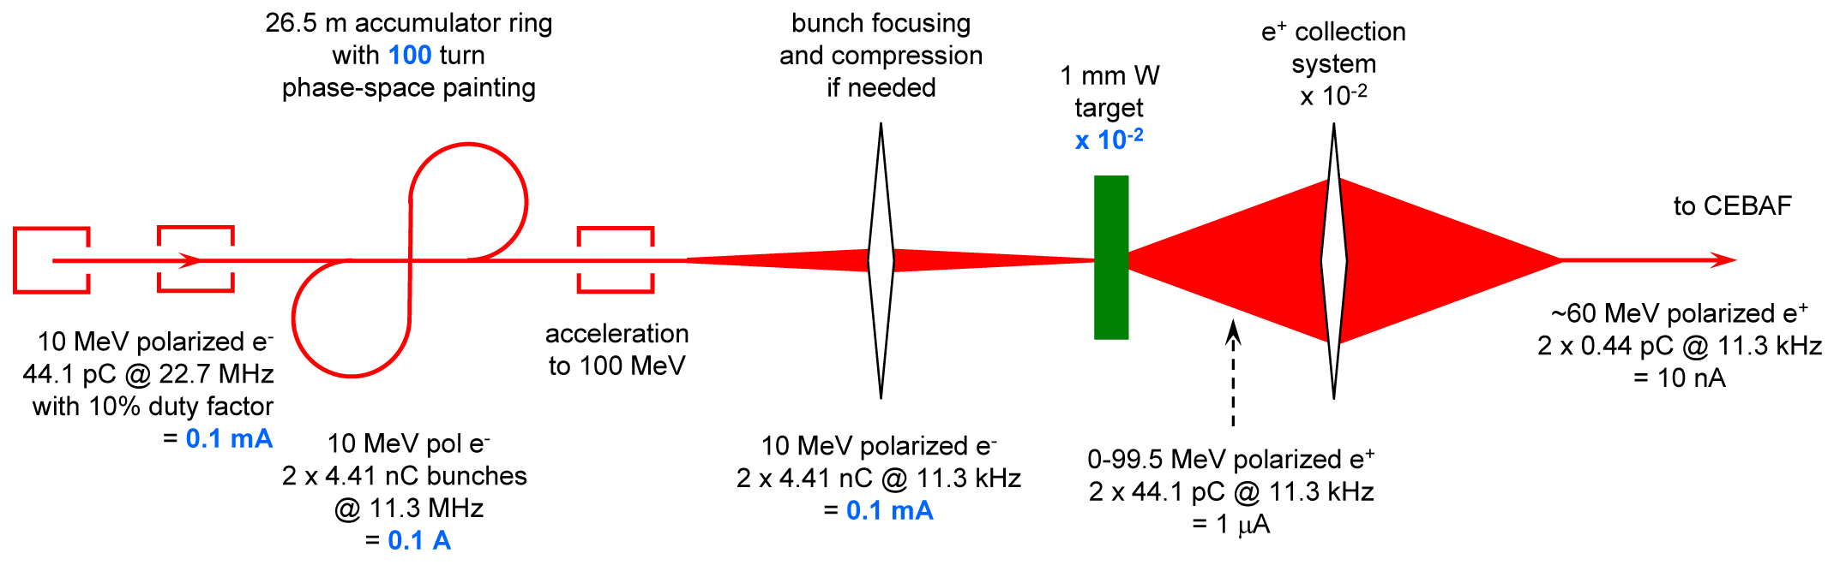

Figure 10. Positron production scheme using 100 MeV electron driver.

## Specific Location of Work

The work will be performed at Jefferson Lab. We imagine testing the spin-polarized photogun at the UITF, and will explore both UITF and LERF as options for the positron source test. The final pre-conceptual design will not be constrained to either particularly. We will explore collaboration with Niowave Inc. to test a high power pair-production target they are developing at Jefferson Lab.

## Anticipated Outcomes/Results

The ultimate deliverable of this proposal is a pre-conceptual design of a polarized positron injector for JLEIC. Three critical areas are addressed, a) 10 MeV low-frequency, high-charge polarized e- injector, b) polarized electron accumulator/extraction figure-8 ring, and c) polarized pair-creation source with efficient collection of cw-MeV polarized positron beam.

Primarily, the design effort will address the efficient conversion of polarized electron beam power to a quality positron beam that may be accelerated to higher energy and for JLEIC injection. The design goal specifications will be motivated by a physics case for a positron-ion collisions at JLEIC, but consideration will also be given to [polarized] positron beams, for example, at CEBAF for the 12 GeV Nuclear Physics Program or LERF for a Slow Positron Program.

Explicit tests to benchmark capabilities for each of these sub-systems are presented with the aim to experimentally test some or all of these as the funding profile allows. Specifically, the following are meant:

* Polarized electron source (P>80%) operating at high voltage (>300 kV) with low repetition rate (<100 MHz), high bunch charge (>1 pC) with good operating lifetime (>200C) at high average current (>1 mA)
* Optimized parameters for acceleration of bunch train to ~10 MeV
* Electron accumulation ring with high gain (>100), preservation of polarization in figure-8 constructions (P>80%), and suitable injection/extraction (<100 ns)
* PEPPo pair-creation target with collection optimized for final yield, polarization, emittance, momentum spread, and bunch length, and bunch train structure

Those tests that are not performed within this project, can be proposed subsequent to, and guided by, this LDRD. The report will conclude with recommendations on how one may proceed toward a Conceptual Design Report to the DOE, particularly highlighting the engineering, development and risks associated with the effort. As stated earlier, we believe this proposal is well aligned to the Jefferson Lab Strategic Plan and highly compatible with LDRD funding criteria, by *exploring a new avenue for future Nuclear Physics at Jefferson Lab*.

# VITA (Lead Scientist)

**Dr. JOSEPH GRAMES**

**Thomas Jefferson National Accelerator Facility**

**Newport News, VA 23606**

**Office Phone:** (757) 269-7097 **e-mail:** grames@jlab.org

**Rank:** Staff Scientist III **DISCIPLINE:** Polarized e-/e+ sources

1. **Education**

B.S., Physics, Stevens Institute of Technology, Hoboken, NJ, May 1992

M.S., Physics, University of Illinois, Urbana-Champaign, IL, May 1994

Ph.D., Physics, University of Illinois, Urbana-Champaign, IL, Dec 1999

1. **Position**

1999-present: Staff Scientist and Deputy Group Leader, Center for Injectors and Sources

1. **Recent Journal Publications**
2. M. BastaniNejad, A. A. Elmustafa, E. Forman, J. Clark, S. Covert, J. Grames, J. Hansknecht, C. Hernandez-Garcia, M. Poelker, R. Suleiman, "Improving the Performance of Stainless-Steel DC High Voltage Photoelectron Gun Cathode Electrodes via Gas Conditioning with Helium or Krypton", Nuclear Instruments and Methods in Physics Research A 762 135 (2014).
3. R. Mammei, R. Suleiman, J. Feingold, P. A. Adderley, J. Clark, S. Covert, J. Grames, J. Hansknecht, D. Machie, M. Poelker, T. Rao, J. Smedley, J. Walsh, J. McCarter, M. Ruiz-Osés,"Charge Lifetime Measurements at High Average Current Using a K2CsSb Photocathode inside a DC High Voltage Photogun", Phys. Rev. ST Accel. Beams, 16, 033401 (2013).
4. J. Grames, R. Suleiman, P. A. Adderley, J. Clark, J. Hansknecht, D. Machie, M. Poelker, and M. L. Stutzman, “Charge and fluence lifetime measurements of a dc high voltage GaAs photogun at high average current”, Phys. Rev. ST Accel. Beams 14, 043501 (2011).
5. P. A. Adderley, J. Clark, J. Grames, J. Hansknecht, K. Surles-Law, D. Machie, M. Poelker, M. L. Stutzman, and R. Suleiman, “Load-locked dc high voltage GaAs photogun with an inverted-geometry ceramic insulator”, Phys. Rev. ST Accel. Beams 13, 010101 (2010).
6. **Professional Activities**
7. Member - American Physical Society and Division of Beams
8. Referee - Phys. Rev. Accelerators and Beams and IEEE
9. **Committees**
10. Convener, Intense Electron Beam Workshop at Cornell U., Ithaca NY (2015)
11. Organizer, Int’l Workshop on Positrons at Jefferson Lab, Newport News, VA (2009)
12. Organizer, Workshop on Polarized Electrons Sources, Newport News VA (2008)

# Budget Explanation

Our budget…

References

[AB15] S. Abeyratne et al., MEIC Design Summary, arXiv:1504.07961 (2015).

[AB16] D. Abbott et al., (submitted for publication Feb. 2016) Phys. Rev. Lett.

[AD10] P. Adderley et al., Phys. Rev. ST Acc. Beams 13, 010101 (2010).

[AL08] G. Alexander et al., Phys. Rev. Lett. 100, 210801 (2008).

[AR09] J. Arrington, “Two-photon exchange measurements with positrons and electrons”, AIP Conf. Proc. 1160 (2009) p. 13-18.

[BA05-1] I.V. Bazarov, C.K. Sinclair, "Multivariate optimization of a high brightness dc gun photoinjector", Physical Review Special Topics - Accelerators and Beams, Vol. 8, 034202 (2005).

[BA05-2] I.V. Bazarov, H. Padamsee, "Multivariate optimization of ILC parameters", Proceedings of the 2005 Particle Accelerator Conference, IEEE 0-7803-8859-3 (2005) 2188-2190.

[BA05-3] I. V. Bazarov and H.S. Padamsee, in Proceedings of the 21st Particle Accelerator Conference, Knoxville, 2005, pp. 1736-1738*.*

**[BA96] V. Baronea, U. D’Alesioa and M. Genoves, “The Charm–Strange Contribution to Charged–Current DIS Structure Functions”, arXiv:hep-ph/9610211.**

[BE96] E. G. Bessonov and A. A. Mikhailichenko, in EPAC96 (JACoW, 1996) THP071L.

[BU09] V. D. Burkert, “Deeply Virtual Compton Scattering with Positron Beams at Jefferson Lab”, AIP Conf. Proc. 1160 (2009) p. 43-48.

[CH09] M. E. Christy, “Estimates of inclusive cross sections and structure functions at JLab using positron beams”, AIP Conf. Proc. 1160 (2009) p. 60-63.

[CH10] V. Chekelian, “Neutral current interactions in ep scattering with longitudinally polarized leptons at H1”, **PoS DIS2010 (2010) 187.**

[CL89] J. Clendenin, “High-Yield Positron Systems for Linear Colliders”, SLAC-PUB-4743 (1989).

[GO11] S. Golge, PhD Thesis.

[GR07] J. Grames et al., “Lifetime Measurements of High Polarization Strained Gallium Arsenide at Beam Current > 1mA using a new 100kV Load Lock Photogun”, Proceedings of the 2007 Particle Accelerator Conference, Albuquerque, NM.

[HO13] A. Hofler, et al., Phys. Rev. ST Accel. Beams 16, 010101 (2013).

[HO73] J. R. Howorth et al., “Electric field enhancement of escape probability on negative electron affinity surfaces,” Applied Physics Letters 23, 123, (1973).

[JO08] C. Jonah et al., Applied Surface Science 255 (2008) 25–28.

[KU10] E. A. Kuraev, Y. Bistritskiy, M. Shatnev, and E. Tomasi-Gustafsson, Phys. Rev. C 81, 055208 (2010).

[MU01] G. A. Mulhollan et al., “Photovoltage effects in photoemission from thin GaAs layers,” Physics Letters A 282, 309 (2001).

[OL59] H. Olsen and L. Maximon, Phys. Rev. 114, 887 (1959).

[OM06] T. Omori et al., Phys. Rev. Lett. 96, 114801 (2006).

[PO97] P. Potylitsin, Nucl. Inst. Meth. A 398, 395 (1997).

[SO64] A. Sokolov and I. M. Ternov, Sov. Phys. Dokl. 8, 1203 (1964).

**[ST05] U. Stoesslein, “Requirements for the lepton beam polarization at HERA”, ZEUS-05-003.**

[SU11] R. Suleiman et al., “CEBAF 200 kV Inverted Electron Gun”, Proceedings of the 2011 Particle Accelerator Conference, New York, NY.

[TO09] W. Thomas, “Positrons at Jefferson Lab”, AIP Conf. Proc. 1160 (2009) p. 3-7.

[WE09] L. B. Weinstein, “Electron- and positron-proton elastic scattering in CLAS”, AIP Conf. Proc. 1160 (2009) p. 24-28.

[WO09] B. Wojtsekhowski, “Searching for a U-boson with a positron beam”, AIP Conf. Proc. 1160 (2009) p. 149-154.

**[ZH13] Zhang, “New measurement and QCD analysis of DIS data from HERA”, H1 collaboration, PoS ICHEP2012 (2013) 289.**

[ZH15] Y. Zhang, F. Lin, J. Guo, V.S. Morozov, Private Communication (2015).

[ZI79] P. W. Zitzewitz, J. C. V. House, A. Rich, and D. W. Gidley, Phys. Rev. Lett. 43, 1281 (1979).

Attachments

*A1. Task List*