CIS-TN-18-01
February 27, 2018

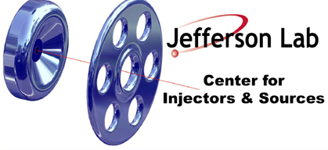

FABRICATION OF MOLYBDENUM PUCK BODY

CIS

Jefferson Lab

This note summarizes the steps for fabricating the molybdenum “PUCK BODY” as described in drawing JL0047248.

Machine and Assembly Steps
- Machine puck, key and dowel pin
- Trial fit-up of puck, key and dowel pin
- Initial cleaning of components with micro and aceton rinse (do not acid etch before key is pinned)

Acid Etch Steps
- Remove indium if needed (isopropyl + indium ball to get indium off)
- Moly Etch Aqua Regalis (1:3 HCl:Nitric), 10 seconds, rinse, check surface, repeat for 10 more seconds if needed, rinse, check surface
- Ultrasonic cleaning in DI water after (USC twice to ensure removal of acid from around ear)
- Rinse, air dry in hood, bag for heat treatment

Vacuum Bake Steps
- Use a vacuum oven to degas puck.
- Use a ramp rate of 10-15 degrees Celsius per minute.
- Ramp to 900 degrees Celsius.
- Soak for 120 minutes, recording pressure every 30 minutes.
- Ramp and cool to room temperature
- Bag puck, if possible in GN2.

