

Laboratory Directed Research and Development Proposal  
Title: Generation and Characterization of Magnetized Bunched Electron Beam from DC Photogun for JLEIC Cooler

|  |  |
| --- | --- |
| **Lead Scientist or Engineer:** | RiaD Suleiman and Matt Poelker |
| **Phone:** | (757) 269-7159 |
| **Email:** | suleiman@jlab.org |
| **Date:** | April 28, 2017 |
| **Department/Division:** | Center for Injectors and Sources / Accelerator Division |
| **Other Personnel:** |  |
| **Proposal Term:** | **From:** 10/2015  **Through:** 10/2018  **3rd year**  **If continuation, indicate year (2nd/3rd)**: |

|  |  |
| --- | --- |
| **Division Budget Analyst** | Kelly Webster |
| **Phone:** | (757) 269-7575 |
| **Email:** | hanifan@jlab.org |

This document and the material and data contained herein were developed under the sponsorship of the United States Government. Neither the United States nor the Department of Energy, nor the Thomas Jefferson National Accelerator Facility, nor their employees, makes any warranty, express or implied, or assumes any liability or responsibility for accuracy, completeness or usefulness of any information, apparatus, product or process disclosed, or represents that its use will not infringe privately owned rights. Mention of any product, its manufacturer, or suppliers shall not, nor it is intended to imply approval, disapproval, or fitness for any particular use. A royalty-free, non-exclusive right to use and disseminate same for any purpose whatsoever, is expressly reserved to the United States and the Thomas Jefferson National Accelerator Facility.

**Abstract**

This LDRD proposal aims to generate and characterize magnetized electron beams from a DC high voltage photogun. Simulations and corresponding measurements of beam magnetization as a function of laser pulse dimension and magnetic field strength at the photocathode are planned. Round-to-flat beam transformation will be performed using three skew quadrupoles and the transverse emittance ratios will be measured. Photocathode lifetime at milli-ampere currents will be compared to beam lifetimes with no magnetization, to study the effect of the solenoid field on photocathode ion-back bombardment. Afterwards, a follow-up proposal can be submitted to evaluate the merits of magnetized beam generation using a DC high voltage thermionic gun, with rf-pulsed gridded thermionic emitter. Combined, these simulations and measurements will benchmark our design tools and provide insights on ways to optimize the JLEIC electron cooler, and help us choose the appropriate electron source and injector layout.

# Summary of Proposal

## Description of Project

To achieve the required luminosity, ion beams at JLEIC must be cooled. In general, this is accomplished when an electron beam co-propagates with an ion beam moving at the same average velocity ($〈γ_{e}〉=〈γ_{i}〉$), but different temperatures ($T_{e}≪T_{i}$), where the energy of chaotic motion of the ion beam is transferred to the cold electron beam. As proposed by Derbenev [1], the cooling rate can be improved by about two orders of magnitude if the process occurs inside a solenoidal field that forces the electrons to follow small helical trajectories thereby increasing the interaction time with ions and improving the cooling efficiency. This cyclotron motion also provides suppression of electron-ion recombination. Cooling rates with magnetized electron beam are ultimately determined by electron longitudinal energy spread rather than the electron beam transverse emittance as the transverse motion of the electrons is quenched by the magnetic field.

The envisioned JLEIC magnetized cooler is part of the Collider ring and aims to counteract emittance degradation induced by intra-beam scattering (IBS), to maintain emittance during collisions and extend the luminosity lifetime. To implement cooling at relatively high energy (electron beam energy 55 MeV (γ=108)), the electron beam must be bunched and accelerated in an SRF linac. The JLEIC cooling solenoid is 30 m long providing a 2 T field. Table 1 summarizes the requirements on the electron beam with noteworthy challenges related to bunch charge and average current, 420 pC and 200 mA, respectively.

Table : Requirements on bunched electrom beam for JLEIC magnetized cooling (at the cooling section).

|  |  |
| --- | --- |
| Bunch length (full) | 60 ps (2 cm) |
| Repetition rate | 476.3 MHz |
| Bunch charge | 420 pC |
| Peak current | 7.0 A |
| Average current | 200 mA |
| Beam radius at cathode – flat-top | 1.56 mm |
| Transverse normalized emittance | 10s microns |
| Solenoid field at cathode | 2 kG |

One challenge associated with implementing cooling inside the long solenoid of the Collider, is the fringe field immediately upstream of the cooling solenoid. The field lines outside the solenoid magnet introduce very large beam rotation. Derbenev [2] suggested the ill-effects of this fringe field could be cancelled if the electron beam was born in a similar field, but producing beam rotation in the opposite direction, such that the two cancel.

Although, electron cooling with DC electron beams at low energy has been implemented at many labs, no one has yet demonstrated electron cooling with bunched electron beams, or magnetized cooling. Fermi Lab successfully demonstrated non-magnetized relativistic DC cooling at high energy (4.3 MeV) [3]. For Low Energy RHIC Electron Cooling (LEReC) non-magnetized bunched electron beam will be used and eRHIC is planning to use Coherent Electron Cooling (CeC) [4,5].

There are four electron gun options to consider: SRF gun, Normal conducting RF gun (with a photocathode or gridded thermionic cathode), DC high voltage gun (with downstream bunching, or rf-pulsed gridded thermionic emitter), and a DC high voltage photogun with rf-pulsed drive laser.

In general, RF guns are more complicated and expensive compared to DC guns. The biggest challenge for a normal conducting RF gun is thermal heat load management. Typically, normal RF guns are used for pulsed-rf applications. Groups have tried to operate normal conducting RF guns in CW mode but so far, with little success (Los Alamos), or with very low resultant beam energy, comparable to (or lower than) energy produced by DC high voltage photoguns (AES, FarTech). The quarter wave VHF gun developed at LBNL as the source for LCLSII is theoretically on the right track, but so far has had difficulty with field emission from the cathode area. Magnetizing this gun would make this problem worse. SRF guns promise CW operation and with high average current and beam energy, but to date, no effort has come close to achieving the desired high average current (Rosendorf, BNL). Moreover, no attempt has been made to produce magnetized beam from an SRF gun, because the application of a magnetic field on the photocathode is highly problematic to maintaining the superconducting condition of the SRF cavity due to the Meissner effect.

A DC high voltage rf-pulsed gridded thermionic gun, similar to that used at TRIUMF [6], is a viable option since the requirement on gun emittance is not stringent. Of all electron gun options, thermionic guns are considered the closest to “turn-key” technology, relatively simple to operate and maintain, even at very high average current. However, the beam requirements of the Energy Recovery Linac (ERL) may necessitate a smaller emittance from the gun.

Thus we are left with the DC high voltage photogun option. Compared to thermionic guns, photoguns allow for precise control of the electron bunch profile in space and time, which could help to increase the cooling efficiency. Two drawbacks of the dc high voltage photogun are field emission at high bias voltage and the reliance on a relatively delicate photocathode. The JLab gun group has made progress toward minimizing/eliminating field emission. In addition, the gun group has recently manufactured alkali-antimonide photocathodes, shown to be less sensitive to ion bombardment, and demonstrating long lifetime at milli-ampere currents. Based on these considerations, and including our expertise with photoguns, a DC high voltage photogun is the focus of this LDRD proposal.

We also note that a follow-up to this proposal could be submitted to study magnetized beam created using a DC high voltage thermionic gun, with rf-pulsed gridded thermionic emitter. We recently helped TRIUMF develop such a gun, by lending them our original 100 kV thermionic gun. They modified this gun to include the application of rf to the bias grid, and successfully produced rf-bunched beam at high average current and 650 MHz repetition rate, with 100 ps pulses. This gun could be returned to JLab for tests using the same diagnostic beamline and gun solenoid described below.

Examining Table 1, three challenging requirements can be identified. First, the average current is very large. We note that groups from other labs and universities are working hard to achieve high average current and high bunch charge for a variety of applications. The Cornell University group, for example, has recently delivered 65 mA for about 9 hours with lifetime of 2.6 days [7]. Key to this success was the re-discovery of alkali-antimonide photocathode, which is less sensitive to ion bombardment. At JLab, we have used the K2CsSb photocathode to demonstrate long-lifetime operation at 10 mA average current [8]. The second challenge relates to high bunch charge at high repetition rate. For a DC high voltage gun, this means the gun must be biased at very high voltage, to create a “stiff” beam that is less susceptible to space charge force. We have made relatively good progress developing a 350 kV gun. This work is on-going. The final challenge is the generation and transportation of magnetized bunched electron beam from a gun. Although many labs are pursuing electron cooling, to the best of our knowledge, only one group has been studying *magnetized beam*: the Piot group at the Fermilab Photoinjector Laboratory [9,10]. However, they are not making CW beam at high average current – the new Fermi Lab ASTA injector relies on a pulsed NCRF gun with a Cs2Te photocathode illuminated by an ultraviolet (UV, λ=263 nm) laser pulse at 0.5% duty factor [11]. No outside groups appear to be working to develop high average current magnetized beam. This is a very serious problem for the JLEIC and the reason we assert the proposed LDRD is essential for JLab.

When discussing magnetized electron cooling, two fundamental topics are involved. The first topic is the interaction between electrons and ions in a longitudinal magnetic field where the presence of a strong field drastically changes the dynamics of the interaction. The second topic is electron beam dynamics in a solenoid magnetic field where the effect of the fringe radial field is accounted for. There are two different motions: one is the helical cyclotron motion in the uniform longitudinal solenoid field due to the transverse velocities of the electrons arising from finite emittance. This motion has a very small radius and a very small resultant emittance. The second rotational motion is due to the azimuthal kick from the fringe radial field at the entrance or exit of a solenoid. This motion has a very large radius (the radius is half of the initial radial displacement of the electron from the solenoid axis) and a very large resultant emittance. For a focusing solenoid, the beam enters and exits the solenoid and the two azimuthal kicks cancel each other. For magnetized electron cooling, the electron beam is being used inside the cooling solenoid (where it suffers an azimuthal kick when it enters). This kick is cancelled by an earlier kick at the exit of the cathode solenoid where the electron beam was born inside it.

The narrative of magnetized electron cooling is described below using cylindrical coordinates (*r*,ɸ,*z*) with the vector momentum written as: $\vec{p}=p_{r}\hat{r}+p_{ϕ}\hat{ϕ}+p_{z}\hat{z}$. (Boltzmann constant, *kB* = 8.617x10-5 eV/K, *mec2* = 510998 eV, *c* = 299792458 m/s, *e/me* = 1.759x1011 rad/(s T) ):

1. Electrons are born in a uniform magnetic field *Bcath* = *Bz* = 0.2 T where the electron beam Gaussian sigma is *a0* = 3 mm (this is the same as the laser spot size). The K2CsSb photocathode effective temperature is about *T*eff = 1000 K (with 532 nm green laser). For this cathode the transverse thermal energy is *kBT*eff = 0.086 eV, the transverse momentum is $p_{⟘0}=\sqrt{{2m_{e}k}_{B}T_{eff}}$ = 296.8 eV/c and the thermal emittance is $ϵ_{th}=a_{0}\frac{p_{⟘0}}{2m_{e}c}=a_{0}\sqrt{\frac{k_{B}T_{eff}}{2m_{e}c^{2}}}$ = 0.87 µm.
2. For a gun HV of 350 kV, β = 0.8048, γ = 1.685 and the momentum in the z direction is *pz* = βcγme = 693 keV/c.
3. Since the electrons are born with transverse thermal momentum in magnetic field, each electron will have a helical cyclotron motion with radius $r_{c}=\frac{p_{⟘0}}{eB}$ = 4.95 µm. This cyclotron radius is very small when compared to the electron beam radius. The cyclotron frequency is $ω_{c}=\frac{eB_{z}}{γm_{e}}$ = 2.09x109 rad/s.
4. The emittance (cyclotron emittance) due to cyclotron motion is: $ϵ_{c}=\frac{k_{B}T_{eff}}{eB_{z}c}$ = 0.00144 µm; very small when compared to thermal emittance.
5. After traveling a few centimeters from the photocathode, the electrons exit the longitudinal solenoid field but they encounter a returning solenoid radial field which exerts torque on the electrons that produces a rotating trajectory. This beam rotation must be tailored to cancel out similar motion encountered when entering the field of the cooling solenoid.
6. Busch’s theorem represents the conservation of canonical angular momentum (CAM) and states that $L=γm_{e}r^{2}\dot{ϕ}+\frac{e}{2π}ψ$ is a constant, where $\dot{ϕ}≡\frac{dϕ}{dt}$ is the angular velocity and $ψ=\int{B·dS}$ is the magnetic ﬂux enclosed by the particle trajectory (i.e., the ﬂux inside a circle with radius *r* given by the radial distance *r* of the particle from the z-axis).
7. From Busch’s theorem, at the photocathode, $L=\frac{e}{2π}ψ$ and $ψ=\int{B·dS}=πr^{2}B_{z}$, that is for an electron $L=\frac{1}{2}{eB}_{z}r^{2}$. And after leaving the solenoid $L=γm_{e}r^{2}\dot{ϕ}$.
8. For cylindrically symmetric gaussian beam with sigma of *a0*, and the average canonical angular momentum for the electron beam is $〈L〉=eB_{z}a_{0}^{2}$ = 1800 (neV s) at the photocathode and $〈L〉=2γm_{e}a_{0}^{2}\dot{ϕ}$ = 1800 (neV s) after existing the solenoid. Note: For cylindrically symmetric flat-top beam with radius *a0* = 1.56 mm, and the average canonical angular momentum for the electron beam is $〈L〉=\frac{eB_{z}a_{0}^{2}}{4}$ = 122 (neV s) ($〈L〉=$ 1.85x108ħ) at the photocathode and $〈L〉=\frac{γm_{e}a_{0}^{2}\dot{ϕ}}{2}$ = 122 (neV s) after existing the solenoid.
9. For cylindrically symmetric gaussian beam with sigma of *a0*, and for cylindrically symmetric flat-top beam with radius *a0*, .
10. The average angular velocity is $\dot{ϕ}=ω_{L}=\frac{eB_{z}}{2γm_{e}}$ = 1.04x1010 rad/s (i.e., the beam rotates at the Larmor frequency, $ω_{L}=\frac{ω_{c}}{2}$). The average mechanical momentum in the ɸ direction is $p_{ɸ}=\sqrt{\frac{π}{2}}γm_{e}a_{o}\dot{ϕ}$ = 112.72 keV/c. The electron momentum now has a phi component in addition to the axial z-component.
11. The average rotational kinetic energy is $T_{ϕ}=\sqrt{{\left(m_{e}c^{2}\right)}^{2}+p_{ϕ}^{2}c^{2}}-m_{e}c^{2}$ = 12284.7 eV. This is small (only 3.51%) when compared to the maximum longitudinal kinetic energy of *Tz* = 350000 eV. The total kinetic energy is still $T_{z}+T_{ϕ}=350000$ eV (i.e., part of the longitudinal (axial) kinetic energy turns into rotational energy in the phi direction).
12. The electron beam leaves the cathode solenoid field rotating and acquires an angular momentum but once in field-free region where there is no centripetal force, the beam rotates and simultaneously expands as it propagates. As it expands, its angular velocity decreases to conserve angular momentum.
13. The beam size increases as the beam propagates such that the angular momentum of the beam is conserved. Focusing solenoids installed after the exit of the gun and throughout the injector prevent the magnetized beam from blowing up.
14. After leaving the cathode solenoid, and due to beam rotation induced by radial field the *magnetized beam* will have an emittance (called drift or magnetized emittance) of $ϵ_{d}=\frac{{eB}_{z}a_{0}^{2}}{2m_{e}c}$ = 528 µm, or in general, $ϵ_{d}$ [µm] ~ 29.3 B [kG] [mm] 2. Note: For flat-top beam with radius *a0* = 1.56 mm, the drift or magnetized emittance is $ϵ_{d}=\frac{{eB}_{z}a_{0}^{2}}{8m_{e}c}$ = 36 µm, or in general, $ϵ_{d}$ [µm] ~ 7.3 B [kG] [mm] 2.
15. The cyclotron emittance and drift emittance are related as $ϵ_{th}= \sqrt{ϵ_{c}ϵ_{d}}$ where the ratio is $\frac{ϵ_{d}}{ϵ_{th}}=\sqrt{\frac{ϵ_{d}}{ϵ_{c}}}=\frac{a_{0}}{r_{c}}$ = 606.
16. The electron beam is accelerated in SRF linac to high energy.
17. The magnetized beam is a coupled beam, and for the kicker section in the circulator-cooler ring, it is easier if the beam is transformed to a flat beam. This can be done with three skew quads (aka, Round-to-Flat Beam (RTFB) Transformer). This transformation produces a beam with very large transverse emittance ratios. For round beam, $ϵ_{x}=ϵ_{y}$, in contrast to flat beam where $ϵ_{x}≫ϵ_{y}$.
18. Bush's theorem states that CAM is preserved in any axisymmetric magnetic field. A quadrupole triplet does not do so; ultimately it can turn CAM to zero (in case when the cyclotron emittance is zero, i.e., practically very small compared with the drift one) and also restore it later when needed.
19. If the beam was transformed to flat in the kicker section, then before entering the cooling solenoid, the beam is transformed back to round beam (magnetized beam) with Flat-to-Round Beam (FTRB) Transformer that restores the initial magnetization.
20. At the entrance of the cooling solenoid, the radial field exerts a torque (opposite to cathode solenoid torque) so the beam is not rotating any more (note that the magnetic field in both solenoids must be in the same direction). This can be achieved when $B_{Cath}a_{0}^{2}=B_{cool}σ_{e}^{2}$, where *Bcool* = 2.0 T and electron beam radius in the cooling section is σe = 0.95 mm.
21. Typical radius of the ion beam in the cooling solenoid is 1.0 mm with normalized emittance of about $ϵ_{ion}^{n}$ = 0.4 µm. The cooling in the Collider ring aims to maintain this low emittance. The effect of the fringe radial field on ions is suppressed by the ratio of the ion mass to the electron mass (*mp/me =* 1836).
22. Once inside the cooling solenoid, the electrons only have a cyclotron motion with radius $r_{c}=\frac{p_{⟘0}}{eB}$ = 0.49 µm but no rotational motion due to the fringe radial field. The cyclotron emittance due to this motion is $ϵ_{c}=\frac{k_{B}T_{eff}}{eB_{cool}c}$ = 0.000144 µm.
23. If the beam is not magnetized from the gun, then the additional rotational motion when it enters the cooling solenoid will make it much hotter than the ion beam (ϵd = 528 µm). Instead the emittance will be very close the thermal emittance from the cathode – since the cyclotron emittance is very small (albeit with some degradation due to space charge emittance growth but this can be compensated with focusing solenoids in the beamline).
24. Hence: if the beam is not magnetized from the gun then no cooling can take place in a solenoid. Furthermore, magnetic shielding is now needed in the cooling section; non-magnetized cooling has very strong dependence on relative angles between electrons and ions and strict control of remnant magnetic fields is required to minimize the transverse angular spread in the cooling section.
25. In the cooling solenoid, the electron energy is 55 MeV, β = 0.999957, γ = 107.63.
26. For magnetized beam in the cooling solenoid, the cyclotron frequency is $ω_{c}=\frac{eB_{cool}}{γm_{e}}$ = 3.27x109 rad/s, or $f_{c}=\frac{ω_{c}}{2π}$ = 0.52 GHz. Over the length of the cooling solenoid of 30 m, the electron finish $n=\frac{L}{βc}f_{c}$ = 52 periods of its cyclotron rotations.
27. The helical motion of the electrons in the magnetic field increases the electron-ion interaction length, thereby significantly improving the cooling efficiency. In particular, electron-ion collisions that occur over many cyclotron oscillations and at distances larger than the cyclotron radius are insensitive to the transverse velocity of the electrons. This cyclotron motion also provides suppression of electron-ion recombination.
28. In general, electron cooling is preferred at low energy. At higher energies the cooling rate picks up a factor of $1/γ^{2}$ due to Lorentz contraction and time dilation. In the electron-ion rest frame, the length of the cooling solenoid is only 30/γ = 0.28 m. In addition, in their rest frame, the electron and ion stay together for only 30/(βcγ) = 90/γ = 0.84 ns.
29. Electron-ion collisions are described by Rutherford’s scattering formula and is determined (and hence the cooling rate) by the relative particle velocities’ spread, $Δ(\vec{v_{e}}-\vec{v_{ᵢ}})$ in the co-moving frame ($\vec{v_{⟘}}= γc\vec{θ}$, $\vec{v_{‖}}= cΔγ/γ$), where $\vec{θ}$ is the transverse angle deviations.
30. For non-magnetized beam, the cooling rate is $λ∝1/v_{e⟘}^{3}$ while for magnetized beam, the cooling rare is $λ∝1/{{(v-v}_{e‖})}^{2}$. Electron beam energy spread in JLEIC cooler is required to be10-4.
31. Cooling solenoid must have high parallelism of magnetic field lines, $\frac{{ΔB}_{⟘}}{B}≈\sqrt{\frac{ϵ_{ion}^{n}}{βγβ_{match}}}≈{10}^{-4}$, where ${ ϵ}_{ion}^{n}$ = 0.4 µm is the ions normalized emittance and $β_{match}$ = 0.18 m is the beta function in the cooling solenoid.
32. Upon exiting the cooling solenoid, the beam once again starts rotating due to canonical angular momentum conservation according to Busch’s theorem.
33. The spent electron beam enters the Energy Recovery Linac (ERL) and then dumped at low energy.

Figure 1 shows a depiction of the magnetized electron cooling process.



Figure : Depiction of magnetized electron beam generation and magnetized cooling in a solenoid.

## Expected Results

This LDRD will generate and characterize magnetized electron beams from a DC high voltage photogun. Expected results include:

* JLab will have direct experience magnetizing a high current electron beam.
* We will learn how the applied magnetic field influences the photocathode lifetime.
* We learn about challenges associated with Round-to-Flat Beam (RTFB) transformations at high bunch charge.
* We will benchmark our simulation tools in this new space-charge dominated, magnetized regime.

# Proposal Narrative

## Purpose/Goals

The goal of this LDRD is to generate a magnetized beam and measure its properties. The simulations and corresponding measurements will provide insights on ways to optimize the JLEIC electron cooler, and help us design the appropriate electron source. Below we will describe the proposed measurements and simulation plans.

## Approach/Methods

Experimental Overview:

A schematic layout of the experimental beamline is shown in Figure 2. We will use the gun and injector beamline that is being built now at the Gun Test Stand (GTS) to carry out the proposed LDRD work. Some modification to the beamline will be required, noticeably the installment of skew quadrupoles for the RTFB transform. We will follow the prescription outlined in Ref. [12] to design the three skew quadrupoles. Simulations will be used to determine the appropriate location of the diagnostic crosses.



Figure 2: Proposed beamline to generate magnetized beam and measure beam magnetization. Focusing solenoids will be installed between the gun and dump to prevent the magnetized beam from blowing up.

The gun is an inverted ceramic with a K2CsSb photocathode and a green 532 nm drive laser (with repetition rates of 15 Hz to 476.3 MHz). We have two HV supplies: Spellman 225 kV and 32 mA and Glassman 550 kV and 5 mA (with SF6 system). A new HV power supply capable of 200 mA and 300 kV costs about $600,000 (very expensive for this project). Figure 3 shows the HV chamber. For the proposed LDRD work we need to design and build a solenoid to produce 2 kG at the photocathode with uniformity over the active area to be specified as part of this project.

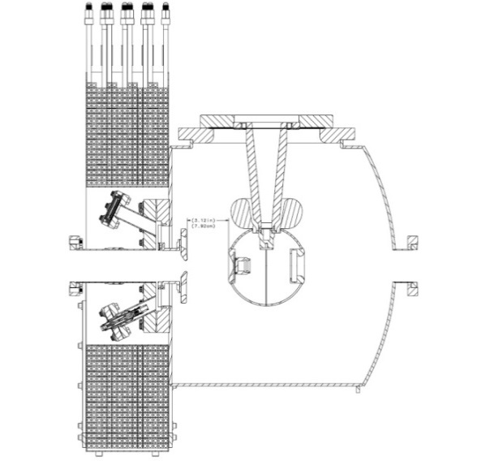

Moly and carbon steel hybrid photocathode holder

Photocathode

Cathode Solenoid Magnet

Figure 3: HV chamber with inverted ceramic and a ball cathode. A solenoid magnet will be installed in front of the chamber to generate uniform field at photocathode.

Simulation Plan:

The electron beam parameters from the injector required to meet the JLEIC cooling specification are unique. Producing low energy, magnetized beam that is space charge dominated has not been previously investigated in depth by the accelerator community. We will use simulation tools to create a physics design for the beamline so we can locate magnets and diagnostics at their optimum positions. Simulation of different operating scenarios of bunch charge, magnetization, bunch shape etc. will be benchmarked against measurements of emittance and other beam parameters (detailed below). As the beams will be space charge dominated, there will be some limit to the aspect ratio that can be achieved with the RTFB transform. Simulation will allow us to quantify how good or complete this can be made for different settings. These results will guide the design of the JLEIC injector in the future.

To speed up the benchmarking process, we would ideally like to automate the process of measurement taking and comparison to a virtual machine. This can be achieved using a free Matlab to EPICS interface (as used at SLAC and Cornell University). Matlab scripts can then be used to take measurements and simulate those conditions for comparison, using actual component settings as input.

Measurement Plan:

1. Generate magnetized beam and measure magnetization for different laser spot sizes, ( $a_{0}$ = 1 – 5 mm), bunch charges (1 – 500 pC), bunch lengths (10 – 100 ps) and solenoid fields (0 – 2 kG). The magnetization will be measured using Diagnostics Cross 1 and Diagnostic Cross 2 with the three skew quads off via

$$〈L〉=2p_{z} \frac{{σ_{1}σ}_{2}\sin{ϕ}}{D}={eB}_{z}a_{0}^{2}$$

where σ1 is the beam radius measured at Diagnostic Cross 1 and σ2 is the beam radius measured at Cross 2. The drift between the two crosses is *D* and *pz* is the longitudinal momentum of the beam (for a gun HV of 350 kV, *pz* = βcγme = 693 keV/c). The angular rotation ϕ (see Figure 4) is measured from the beam image at Diagnostics Cross 2 when the slit is inserted at Diagnostics Cross 1. Figure 5 shows an example of a mechanical measurement done at GTS.



Figure 4: Simultaneous expansion and rotation of a beam with angular momentum in a field-free region.

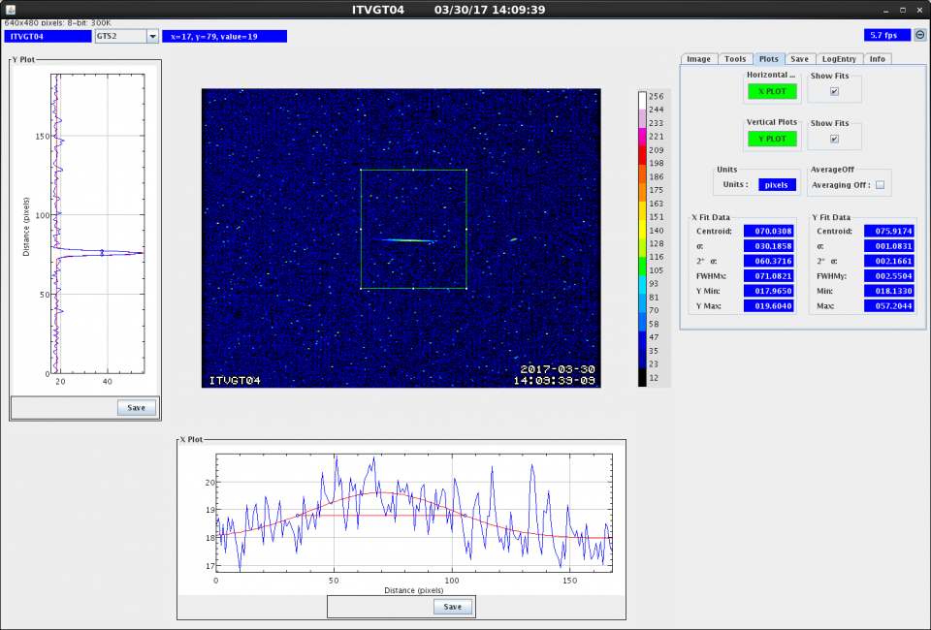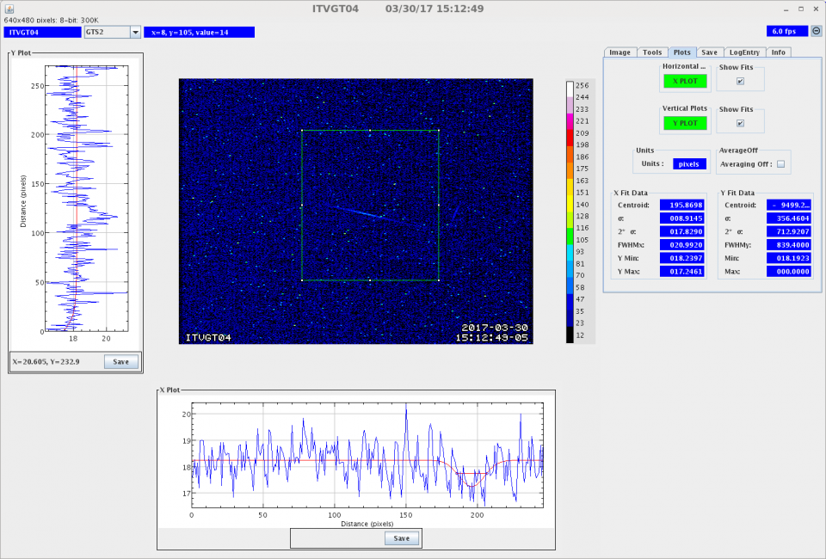

Figure 5: Measuring magnetized beam rotation using slit and viewer: with cathode solenoid off (left) and with cathode solenoid at 400 A generating 1.45 kG at photocathode (right).

1. Use the three skew quads – RTFB Transformer proposed by Derbenev [13] – to generate a flat beam with transverse emittance ratios of $\frac{ϵ_{x}^{n}}{ϵ_{y}^{n}}= \frac{ϵ_{d}}{ϵ_{c}}= \frac{r_{c}^{2}}{a_{o}^{2}}≫1$.

The horizontal and vertical emittance will be measured using the slit method. Diagnostics Cross 2 will be equipped with a horizontal and vertical slits. The size of the emittance dominated beamlets passed through the slits will be measured, after a drift distance *D*, with a YAG viewer in Diagnostics Cross 3. Assume that the horizontal beam radius measured at Diagnostics Cross 2 is σ2h and the horizontal radius of the beamlet at Diagnostics Cross 3 is σ3h when a vertical slit is inserted at Diagnostics Cross 2, then the horizontal emittance is ${ ϵ}_{x}^{n}=γσ_{2h}σ_{3h}/D$. Similarly the vertical emittance can be measured using a horizontal slit.

1. Generate very high currents magnetized beam and study beam transport and RTFB transformation versus electron bunch charge.
2. Measure magnetized photocathode lifetime at high currents (up to 32 mA) and high voltages (200 – 350 kV).
3. Study beam halo and beam loss versus magnetization. We can do that using three different techniques:
   1. Use ion pumps equipped with very sensitive current readback to monitor vacuum.
   2. Radiation will also be monitored using x-ray detectors placed around the gun and beamline.
   3. We will measure the beam intercepted at the floating anode.

## Specific Location of Work

The work will be performed in the LERF Gun Test Stand (GTS). Figure 6 shows the existing beamline that was built as part of FEL program but never used. This beamline will be modified to install the three skew quadrupoles and a beam dump.

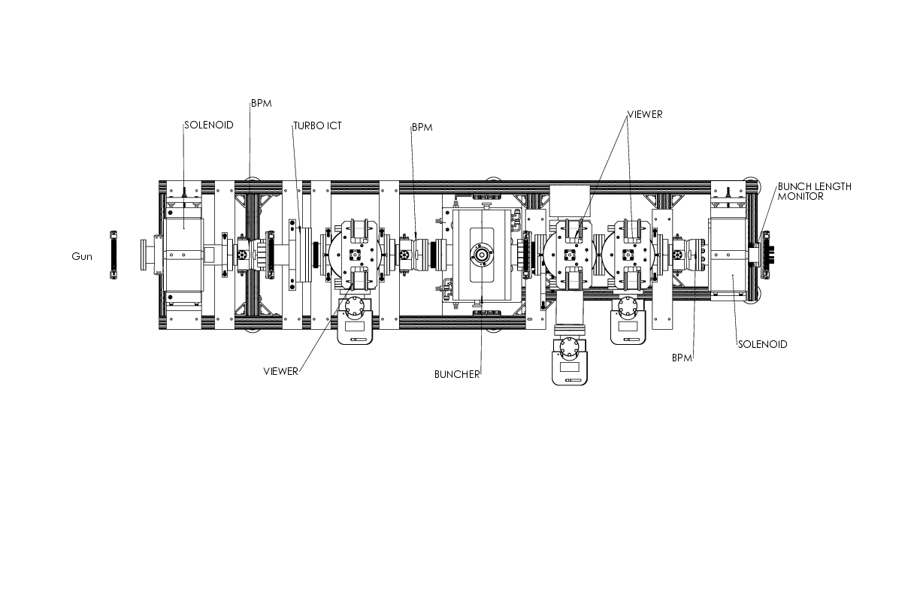

Figure 6: The existing beamline top view. There is no buncher installed; only a drift beamline, where the three skew quads will be installed.

## Anticipated Outcomes/Results

We hope to demonstrate experimentally many aspects of the magnetized bunched electron beam for the JLEIC cooler, with the notable exception of 200 mA average beam current. We are limited by the in-house HV supplies to 32 mA. A new HV power supply capable of 200 mA and 300 kV costs about $600,000 (such supplies typically cost $10 per Watt). In particular, we will:

* Demonstrate 32 mA magnetized beam at 200 kV
* Quantify any difference in lifetime of K2CsSb between magnetized and non-magnetized beam
* Measure magnetization for a variety of charge, bunch dimensions, solenoid strength etc. guided by JLEIC specifications.
* Quantify the quality of RTFB transform for a variety of charge, bunch dimensions, solenoid strength etc.
* Demonstrate reliable simulation tools and methods.
* Improve experimental techniques with new machine operation interface.

# Prior Year Accomplishments

## Preparation Chamber, Gun, Cathode Solenoid and Beamline

We finished year 1 demonstrating non-magnetized beam at maximum current of 1 mA and started implementing a long list of improvements. The cathode solenoid was mapped, installed and commissioned. Figure 7 shows a 3D depiction of the preparation chamber, gun HV chamber, cathode solenoid and fully instrumented beamline. All upgraded, commissioned and fully functional. Finally we are ready to start the experimental measurements outlined in this LDRD. **The highlight of Year 2 has been the demonstration of magnetized beam**. Numerous sub-accomplishments allowed us to reach this milestone.

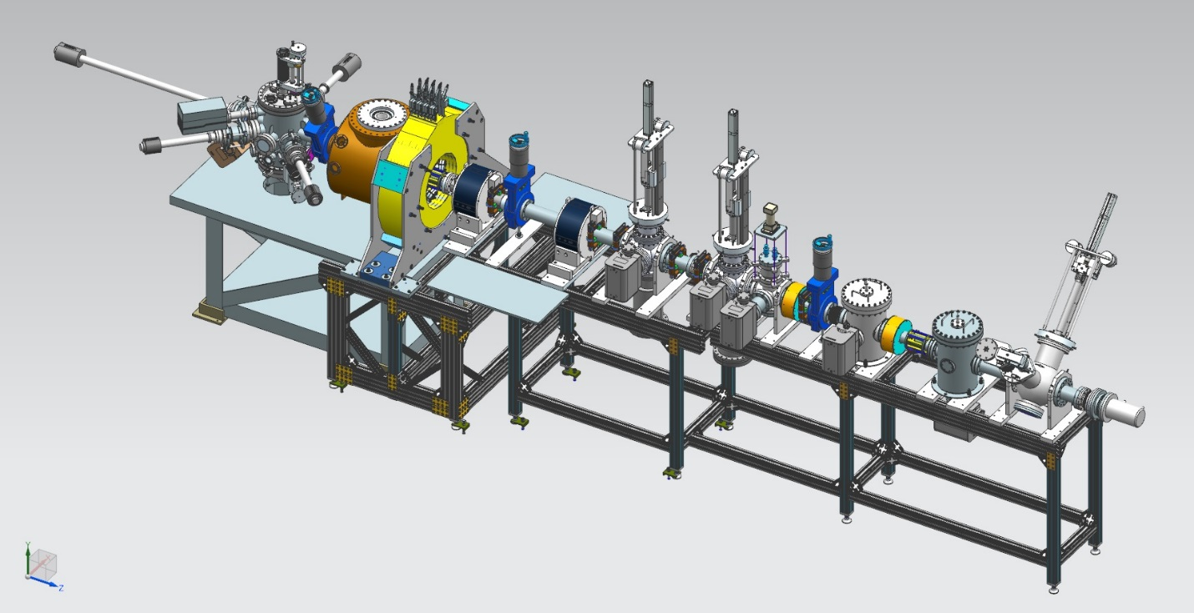

Figure 7: 3D view of the magnetized photogun and beamline – all upgraded, commissioned and fully functional.

We upgraded the photocathode preparation chamber to enable:

1. photocathode fabrication using a mask to limit the photocathode active area to reduce beam halo and eliminate high voltage arcs,
2. biased photocathode holder (puck) to allow monitoring of photocurrent during activation and to measure QE in-situ, and
3. an adjustable gap between puck and Cs-K effusion source for precise film growth.

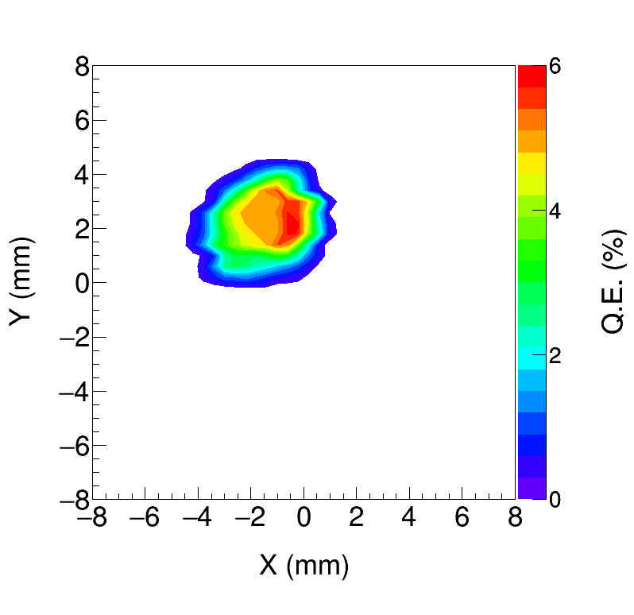

Figure 8: Quantum efficiency scan showing the 3 mm active area.

Figure 8 shows a QE scan of the K2CsSb photocathode grown with a mask to limit active area (3 mm diameter) to reduce beam halo. The active area can be offset from electrostatic center and 5 mm active area also available. The entire photocathode can be activated, too.

The photogun HV chamber was upgraded to enable reliable photogun operation at higher voltage. We replaced the conventional alumina insulator with doped-ceramic insulator – that possesses a very mild conductivity – and the original triple point shield with newly designed shield that reduces the maximum field strength inside the gun. Windows with anti-reflection coatings were installed on the gun high voltage chamber, to minimize reflections and production of stray light that can generate “halo” that strikes vacuum chamber walls, degrading vacuum and contributing to high voltage arcs.

After conditioning the gun with cathode solenoid off, we found that the solenoid can trigger field emission when gun is biased at HV. The gun was re-conditioned with solenoid currents up to 400 A, and we developed procedure to ensure solenoid does not trigger new field emission.

The beamline was rebuilt to install the slits to measure beam rotation and emittance and added an insertable Faraday Cup. The new beamline has two ion precipitators to help prevent ions from migrating to the gun and producing high voltage arcs that damaged QE and prevented operation at currents higher than 1 mA. A 2.5 kW fixed dump was added for milliampere beam tests. Differential pump chambers were added to isolate gun vacuum from dump vacuum. Figure 9 shows the magnetized photogun and beamline.

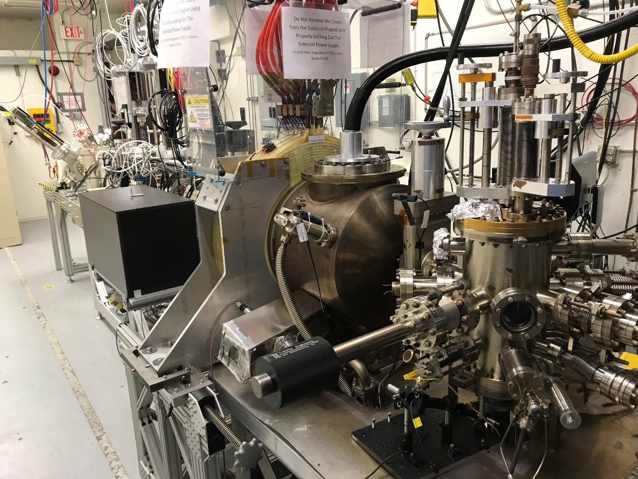

Beamline

Cathode Solenoid

Gun HV Chamber

Cathode Preparation Chamber

Figure 9: Preparation chamber, gun, cathode solenoid and beamline in the GTS.

The laser system – based on Verdi laser: DC, green, 10 W – was upgraded with the addition of laser power meters, tune-mode generator and laser attenuator. All these laser components are now controlled by EPICS.

The new beamline was commissioned and we used the solenoid-viewer method to measure beam emittance.

We delivered 20 µA magnetized beam to the Faraday Cup (Figure 10) and measured beam rotation using the slit and view screen method as shown in Figure 5. The beam size at the photocathode was 0.525 mm and magnetic field was 1.45 kG. These values were used to predicted beam magnetization. There is good agreement between prediction and measurement.

The maximum operational current of the cathode solenoid is 400 A (limited by the supply maximum voltage) which generates a magnetic field of 1.45 kG at the photocathode when the standard molybdenum pucks are used. To reach 2 kG, we designed and built new steel pucks to enhance the magnetic field at photocathode. We made two types: molybdenum and carbon steel hybrid pucks and carbon steel pucks. These special pucks have been loaded to the preparation chamber and ready to be tested later this summer.

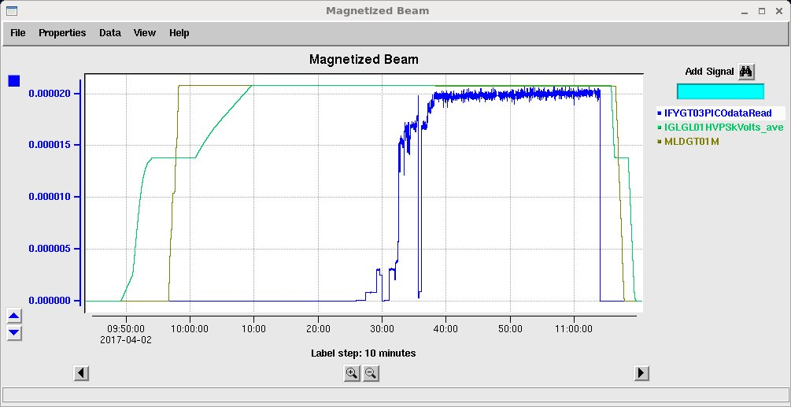

Figure 10: Magnetized beam of 20 µA (blue color) delivered to Faraday Cup.

## Non-invasive RF cavity to measure beam magnetization

To date, this LDRD proposal has relied on an invasive technique to measure beam magnetization (a slit and view screen). However, implementing an actual JLEIC electron cooler (e-cooler) will require a non-invasive beam magnetization monitor. While conducting this research, we theorized that a rotating bunched beam will excite RF fields inside a TE011 cavity producing an easily detectable signal that is proportional to the beam magnetization, while such a cavity will be insensitive to other aspects of the beam, such as beam current. For JLEIC e-cooler, the average mechanical angular momentum is expected to be of the order 108 ħ. This gives a beam with angular frequency of about 1010 rad/s which couples to the cavity RF electric field. Initial estimates predict RF power of the order 0.1 mW which represents an easily detected signal.

We hope to test this idea during Year 3 of the LDRD proposal. If proven correct, we imagine cavities distributed around the e-cooler used to non-invasively monitor magnetization. Cavities installed inside the cooling solenoid will ensure that magnetization is completely removed during the cooling process. And cavities installed outside the solenoid with ensure that magnetization is fully restored. The monitors will allow adjustment of machine parameters to optimize cooling in real-time.

A patent disclosure titled “Non-invasive RF Cavity to Measure Beam Magnetization” was filed.

# VITA (Lead Scientist)

**MATTHEW POELKER**

**Thomas Jefferson National Accelerator Facility**

**Newport News, VA 23606**

**Office Phone:** (757) 269-7357 **e-mail:** poelker@jlab.org

**Rank:** Senior Staff Scientist **DISCIPLINE:** Polarized electrons,

Photoelectron guns, Lasers, Vacuum

1. **Professional Preparation**

B.S., Engineering Physics, University of Illinois, Champaign/Urbana, IL, December 1983

M.S., Electrical Engineering, Northwestern University, Evanston, IL, June 1988

Ph.D., Electrical Engineering, Northwestern University, Evanston, IL, June 1992

Postdoctoral research associate, Physics Division, Argonne National Lab, January 1992 to May 1994

1. **Appointments**

1994-present: Staff Scientist and Group Leader Center for Injectors and Sources, Thomas Jefferson National Accelerator Facility

1. **Recent Journal Publications**
2. “Record-level quantum efficiency from a high polarization strained GaAs/GaAsP superlattice photocathode with distributed Bragg reflector.” W. Liu, Y. Chen, W. Lu, A. Moy, M. Poelker, M. Stutzman, S. Zhang, Appl. Phys. Lett. **109**, 252104 (2016).
3. “Effects of ion bombardment on bulk GaAs photocathodes with different surface-cleavage planes.” W. Liu, S. Zhang, M. Stutzman, M. Poelker, Phys. Rev. Accel. Beams **19**, 103402 (2016).
4. “Harmonically resonant cavity as a bunch-length monitor.” B. Roberts, F. Hannon, M. M. Ali, E. Forman, J. Grames, R. Kazimi, W. Moore, M. Pablo, M. Poelker, A. Sanchez, D. Speirs, Phys. Rev. Accel. Beams **19**, 052801 (2016).
5. “Effect of Sb thickness on the performance of bialkali-antimonide photocathodes.” M. A. Mamun, A. A. Elmustafa, C. Hernandez-Garcia, R. Mammei, M. Poelker, J. Vac. Sci. Technol. A **34** 021509 (2016).
6. “Outgassing Rates of Identical Stainless Steel Chambers Subjected to Different Heat Treatments and with Different Coatings.” M. A. Mamun, P. A. Adderley, M. L. Stutzman, M. Poelker and A. A. Elmustafa, Journal of Vacuum Science and Technology A **32**, 021604 (2014).
7. **Awards**
8. E. O. Lawrence Award Recipient, 2011
9. **Committees**
10. International Spin Physics Committee since 2012

**RIAD SULEIMAN**

**Jefferson Laboratory, Suite 8**

**600 Kelvin Dr., Newport News, Virginia 23606**

**Work: (757) 269-7159**

**e-mail: suleiman@jlab.org**

**Employment**

* JEFFERSON LABORATORY:

March 2012 - present. Staff Scientist III, Accelerator Division.

January 2007 - February 2012. Staff Scientist II, Accelerator Division.

* VIRGINIA POLYTECHNIC INSTITUTE AND STATE UNIVERSITY:

August 2005 - January 2007. Research Scientist.

August 2004 - July 2005. Postdoctoral Research Associate.

* MASSACHUSETTS INSTITUTE OF TECHNOLOGY:

July 2002 - July 2004. Senior Postdoctoral Research Associate at the Laboratory for Nuclear Science.

October 1999 - June 2002. Postdoctoral Research Associate at the Laboratory for Nuclear Science.

**Education**

* KENT STATE UNIVERSITY: September 1993 - October 1999.

Ph.D. student at the Center for Nuclear Research of the Physics Department.

Doctor of Philosophy degree in Physics awarded in December 1999.

Thesis project (Adviser: Professor Makis Petratos):

“Measurement of the Electric and Magnetic Elastic Structure Functions of the Deuteron at Large Momentum Transfers”.

* YARMOUK UNIVERSITY, JORDAN: February 1990 - May 1993.

Bachelor of Science degree in Physics, 1993.

**Professional Affiliation**

* American Physical Society

**Recent Journal Publications**

1. “Production of Highly Polarized Positrons Using Polarized Electrons at MeV Energies.” D. Abbott et al., Phys. Rev. Lett. **116**, 214801 (2016).
2. “Ingot niobium as candidate electrode material for Jefferson Lab 200 kV inverted electron photogun.” Mahzad BastaniNejad and Riad Suleiman, AIP Conf. Proc. **1687**, 040003 (2015).
3. “Measurement of parity violation in electron-quark scattering.” D. Wang et al., Nature 506, **67** (2014).
4. “Charge Lifetime Measurements at High Average Current Using a K2CsSb Photocathode inside a DC High Voltage Photogun.” R. Mammei, R. Suleiman et al., Phys. Rev. ST Accel. Beams, **16**, 033401 (2013).

# Budget Explanation

To be able to perform the proposed measurements, budget is required for the following procurements:

1. Purchase cathode solenoid magnet
2. Three skew quadrupoles to be used as a round-to-flat beam transformer
3. Components installed inside three diagnostics crosses
4. Beamline hardware: steering magnets and slits for beam emittance and magnetization measurements. (note, we have the big ticket items in-house: gun, HV supplies, K2CsSb preparation chamber, valves, dump, ion pumps, differential pump can and NEG modules, viewer crosses, we have 80/20 aluminum support structure)
5. Laser components
6. TE011 cavity, manufactured in house
7. postdoc

Work performed outside the gun group will need to be paid for with additional budget:

1. Cathode magnet design and procurement
2. Cathode magnet installation
3. Relocate new CEBAF spare dogleg power supply (500A/80V) and provide 480VAC and LCW
4. Mechanical designer for cathode magnet support
5. Mechanical designer for slits and beamline
6. ASTRA and GPT modeling (Fay Hannon)

The grand total cost for the first year is $339,211 (with overhead). For the second year, the grand total cost is $265,850 (with overhead).

For the third year, we are asking for an extra $20k to develop and test a new method to measure magnetization – TE011 cavity. This is very essential for JLEIC cooler and a good candidate for a patent – an inventor disclosure has already been filed. Also, we are requesting travel money ($25.9k) to present results at conferences. The new total cost for the third year is $285,966 (with overhead). Our original LDRD proposal two years ago had a third year total cost of $212,025 (with overhead).

# References

1. “Magnetization effects in electron cooling.” Ya. Derbenev and A. Skrinsky, Fiz. Plazmy **4**, 492 (1978) [Sov. J. Plasma Phys. **4**, 273 (1978)].
2. “A low emittance, flat-beam electron source for linear colliders.” R. Brinkmann, Y. Derbenev, and K. Flöttmann, Phys. Rev. ST Accel. Beams **4**, 053501 (2001).
3. “Experimental Demonstration of Relativistic Electron Cooling.” S. Nagaitsev et al., Phys. Rev. Lett. **96**, 044801 (2006).
4. “Cooling of High-Energy Hadron Beams.” M. Blaskiewicz, Annual Review of Nuclear and Particle Science **64**, 299 (2014).
5. “High-energy electron cooling in a collider.” A. V. Fedotov et al., New J. Phys. **8**, 283 (2006).
6. “The TRIUMF-ARIEL RF Modulated Thermionic Electron Source.” F. Ames, Proc. Of EIC’14, Newport News, VA (2014).
7. “Record high-average current from a high-brightness Photoinjector.” B. Dunham et al., Appl. Phys. Lett. **102**, 034105 (2013).
8. “Charge Lifetime Measurements at High Average Current Using a K2CsSb Photocathode inside a DC High Voltage Photogun.” R. Mammei, R. Suleiman et al., Phys. Rev. ST Accel. Beams **16**, 033401 (2013).
9. “Generation of angular-momentum-dominated electron beams from a Photoinjector.” Y.-E Sun et al., Phys. Rev. ST Accel. Beams **7**, 123501 (2004).
10. “Photoinjector generation of a flat electron beam with transverse emittance ratio of 100.” P. Piot et al., Phys. Rev. ST Accel. Beams **9**, 031001 (2006).
11. “The Advanced Superconducting Test Accelerator (ASTA) at Fermilab:

A User-Driven Facility Dedicated to Accelerator Science & Technology.” P. Piot et al., arXiv:1304.0311 [physics.acc-ph] (2013).

1. “Simple algorithm for designing skew-quadrupole cooling configurations.” B. Carlsten and K. Bishofberger, New J. Phys. **8** 286 (2006).
2. “Adapting Optics for High Energy Electron Cooling.” Ya. Derbenev, University of Michigan Report No. UM-HE-98-04 (1998).
3. “Magnet Design for the Magnetized Beam LDRD Proposal.” J. Benesch, Jefferson Lab Tech Note 15-043 (2015).

# Project Milestones

## Year 1 Milestones

* Q1 (Oct, Nov, Dec):

1. HV condition gun to 350 kV and build K2CsSb preparation chamber ✓
2. Design beamline, locate magnets and diagnostics at optimum positions ✓
3. Design cathode solenoid magnet ✓

* Q2 (Jan, Feb, Mar):
  + 1. Connect existing beamline to gun and instrument beamline ✓
    2. Procure cathode solenoid magnet ✓
    3. Design and procure slits ✓
* Q3 (Apr, May, Jun):
  + 1. Commission exiting beamline with beam ✓
    2. Measure photocathode lifetime at ~~5~~ 1 mA and ~~350~~ 300 kV (non-magnetized) ✓
    3. Relocate new spare CEBAF dogleg power supply to GTS ✓
* Q4 (Jul, Aug, Sep):
  + 1. Install cathode solenoid magnet ✓
    2. Assemble new beamline and commission with beam ✓

## Year 2 Milestones

* Q1 (Oct, Nov, Dec):

1. Generate magnetized beam ✓
2. Measure mechanical angular momentum vs magnetization and laser size ✓
3. Benchmark simulation against measurements ✓

* Q2 (Jan, Feb, Mar):

1. Measure mechanical angular momentum vs magnetization and laser size
2. Benchmark simulation against measurements

* Q3 (Apr, May, Jun):

1. Measure photocathode lifetime vs magnetization at 5 mA and 300 kV
2. Study beam halo and beam loss vs magnetization
3. Design TE011 cavity to measure beam magnetization

* Q4 (Jul, Aug, Sep):

1. Measure mechanical angular momentum vs bunch charge
2. Generate very high currents magnetized beam and study beam transport vs electron bunch charge
3. Design and procure three skew quads

## Year 3 Milestones

* Q1 (Oct, Nov, Dec):

1. Commission TE011 cavity with beam
2. Install three skew quads
3. Generate flat beam with skew quads – RTFB Transformer – and measure horizontal and vertical emittances using slit method

* Q2 (Jan, Feb, Mar):

1. Measure RTFB transformation versus electron bunch charge
2. Use simulation to quantify how good or complete RTFB transform

* Q3 (Apr, May, Jun):

1. Change to HV Supply of 32 mA and 200 kV

* Q4 (Jul, Aug, Sep):

1. Measure photocathode lifetime vs magnetization at 32 mA and 200 kV
2. Study beam halo and beam loss vs magnetization