UITF to-do list 3/8/2018
Details related to UITF QCM
3/2/2018 (Poelker, Larry King, Mike Drury, Chris Perry, Curt Hovater, Rick Nelson)
- Buddy Carlton had a spare CryoCon18 chassis, so we will read 8 silicon diode temperature sensors using it. Omar provided the cable, but we will chop off the end and configure it for the CryoCon18. Larry and Buddy will do this.
- John Fischer looked at the epics screen built by Cryo, the end can temperature sensors are on the screen, but noticed we are missing cavity temperature readback. Larry will work with Buddy to read these signals and put them on the epics screen.
- Chris Perry expressed interest in knowing temperatures inside the QCM. He and Larry looked at the list of available sensors (there are many, > 30) but they agreed, we will just use the end can diodes and ~ 4 diodes to monitor cavity temp. We can read more sensors later, if necessary.
- The cryodiode chassis serves three purposes: 1) temp diode readback (not using this), 2) heater control (we will use this), and 3) the RS485 connection to read decarad (we might use this)
- The heater control serves to maintain ~ constant temp when RF is turned OFF. The heater turns ON to simulate the heat related to RF.
- Curt will take care of the heater control, he knows that he will read temp via the CryoCon18 chassis. If necessary, we can use a simple dc current supply, manually controlled, to drive the heater.
- Curt will manage the cable drops and hook ups of the ARC and IR detectors
- Forgot to ask if stepper motor control is necessary for RF commissioning…
- Gary Cheng says we installed a course adjust stepper motor on QCM because we didn’t have the fine adjust, but now we do, if we find it is needed.

Question:
Are we ready to cool the QCM with helium?
Cryo done with u-tube mods, plumbing and controls?
All epics temp monitoring, pressure monitoring ready to go? Where are the epics screens?
SRF window of opportunity…
ODH/EHS&Q approval…
John Fischer and company available?
Step 2, add RF power….
Note from Curt Hovater:
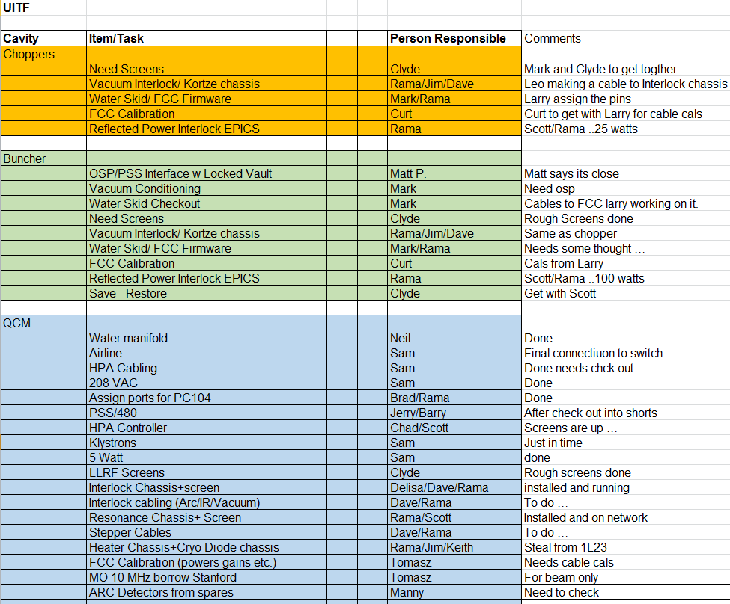

Related SSG work:
- installation of beacons on the mezzanine (almost there)
- connection of additional CARMS (jumpers and verification left)
- commissioning of PSS RF interface
- PSS Certification (full certification at the same time as RF QCM commissioning
- installation and wiring of the junction box for the BLMs for future equipment
- work on the new BCM system in partnership with I&C

Question:
Guestimate the date?

Procedural:
- OSP buncher (in progress)
- OSP: Operating the cold QCM with RF, no beam (OSP submitted for approval)
- PSS BCM progress
- Run 200kV beam….
- Design the MeV waist-height beamline with new spectrometer
  - Joe finalizing matching quad interspacing
  - Layout the MeV Spectrometer : dipole/can available now, likely other components available for simple 2D-style spectrometer
  - Need two more sections of 80/20 girder
- Metrics to decide QCM is good (Arne, Reza)
- Model today’s keV beamline with GPT? Compare measurement vs prediction (Alicia)
  - Alicia has a keV model from Ops review; time to update w/ as-is
- Wrap up design of the 200kV wien magnet, get magnets built
  - Find commercial magnet maker for coils…
- PSS interlocks for Wien!?
  - likely no problem if we limit current…
- Use the zimbra UITF calendar to schedule work
- Quick reference schematic keV beamline, correct chopper solenoid, not dipoles (Eric)
- Clear out Cave2, start lying out the beamline, organize. Ongoing
Install Group
- Fill the waveguide penetration with sand, a rigid aluminum cover
- Cable tray along the rest of the cave, mounted to wall
  - Shaun and Neil have a design, parts ordered
Cryo-related
- LN2 temp test, pressure and flow test
- LHe test
- Controls and epics page
RF (see Curt’s list above)
EES
- Need DecaRad #2, surrounding the QCM
  - Do we have the right detectors?
- BPMs
  - All 8 are cabled, upright, correctly
  - Software? When do we get to use them?
- ItoV’s, do we have them?
  - No, from Jim Kortze this is backburner
SSG/EES
- MPS/FSD system: window comparators, masking tool, destinations
- BLM at keV region
  - Jerry/PSS will install at dipole bend
- safety interlocks for klystrons/HPA and solid state amp into PSS
- Magenta beacons on top of the cave
Wien
- Make new Wien magnets
- HV power supplies for Wien
  - John testing new supplies now
- PSS interlocks for Wien?
  - Keith Welch evaluating safety
keV beamline
- Plumb in the krypton in professional manner, a permanent attachment to table (tanks and regulators ordered and will be in-house soon)
- Add GN2 manifolds, clean polyflo with covers
- Faraday cup 1 air leak?
  - Pete calls this FC#2, but yes it leaks
- Implement John’s idea to perform QE scans without grounding the cathode
  - I asked John to ALSO add capability to short/bias through the small SF6 resistor tank, as a backup plan; he already has the port, but needs to instrument
- Next opportunity, adjust mask alignment, prep chamber
- Measure lifetime
- Laser power oscillation, put seed on heater block like CEBAF?
- Need a Pockels cell and HV switch
- Lead shielding at dump, cups, apertures and master slit
- Rebuild the 350kV gun, align the electrode, button it up for installation on UITF beamline in May
MeV beamline
- Building first girder section now, need to erect “clean room”, check with Cryo about space conflict
- Finish the UHV ion pump supplies
- PSS BCM
- Order chromox view screens
- BPM prep work?
- Inventory steering magnets
All the things we discover running beam:
- QE tool won’t abort
- Beam comes out of gun low
- MDC valves seem sketchy. Sufficient air pressure?
- Beam on chopper YAG screen lost in brilliant glare of camera LED
  - I think YAG K302 is observed from below, so H corrector upstream might be backwards
- Should we devise a simple nomenclature for steering that is not in conflict with actual songsheet names? Viewer 1, lens 1, corrector 1, etc.,
- Orientation of the songsheet opposite to flow of beam from control room
- Can video change automatically when viewers are inserted, can one viewer go in and automatically retract another?
- Too long to switch picoammeter scales
  - Keith changed the scan rate; he suggests works better w/ autoscale than fixed scale – might be a software bug; we need to ask for improvements when performance isn’t good enough, let software work on it

