Comments on Slit Rotation Measurements

Geoffrey Krafft and Reza Kazimi

Recently the Jefferson Lab Magnetized beam has come on line at the Gun Test Stand. The first measurements of beam rotation using a horizontal slit and a downstream viewer led to unexpectedly large angles for the distribution rotation and to the surprising result that in some circumstances the beam looked like it rotated in the wrong direction. Through examining the following “toy” model of the propagation, it is clear that in cases indicating “counter-rotation”, a converging beam at the slit is being examined with the viewer downstream of the focal point of a converging beam.

The first data on slit measurements with the magnetized beam at the Gun Test Stand were logged on March 8, 2017. As the gun solenoid magnetic field was varied over its full range, a large range of angle changes were measured. Two typical measurements, at gun solenoid currents of 150 A and 50 A are shown in Figures 1 and 2. In these figures a horizontal slit was placed in the beam and the photo is the beam image on a viewer downstream of the slit by 50 cm. Note in particular that the images are tilted in both the first and second quadrants: the angle for Figure 1 is around 25o and for Figure 2 is around 115o. Suppose for an instant, that zero emittance rotating beam passes the slit with . As the beam propagates downstream of the slit, because the vertical velocity is linearly correlated with the horizontal position, the horizontal line image will have rotated through an angle that should increase, ultimately to 90o as the propagation distance gets larger and larger. In this situation it is impossible to measure a rotation of greater than 90 o from the slit. Clearly, because the data shows results in two quadrants, an additional effect is going on. A clue is provided by the fact that as the solenoid setting changes, the transverse optics also changes. We have found that in order to explain data in the other quadrant, the electron beam must be converging at the slit. The following simplified model demonstrates the effect.

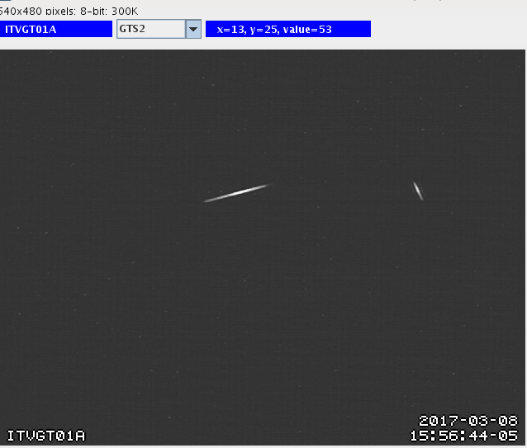

Figure 1: Slit image with gun solenoid current of 150 A

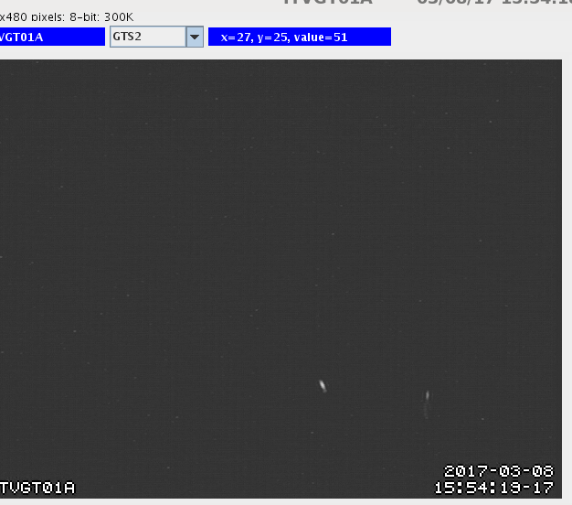

Figure 2: Slit image with gun solenoid current of 50 A

Suppose that the beam distribution passing the slit is uniform, rotating, and has convergence described by the usual *α*-parameter. Then after the slit the unit normalized distribution is



where  is the Heavyside function,  is the Dirac delta, and  is the rotation from the magnetization. Assuming the field between slit and viewer is negligible, the equations of motion are trivially integrated to yield



By the usual discussion based on the method of characteristics, the distribution in configuration space downstream of the slit is consequently



This distribution is a line distribution in configuration space extending between the limits of. The -position correlated with the boundary of the line is , which is positive before focus is achieved. The angle the line distribution makes with the -axis is simply

.

where  is the focal length due to the convergence. Because after the focus is achieved the denominator is negative, it is possible for the observed rotation angle to be in the second quadrant. Figure 3 shows the line distribution created as a function of  downstream of an initially horizontal slit when the beam at the slit is converging . At  locations beyond the focus, .

Figure 3: Rotation of slit image for initially converging beam. The succeeding line distributions are for proportionately increasing drift distances *z*.

In Figures 4 and 5, plots are provided with identical conditions where instead the beam at the slit is at the waist and diverging  respectively. It is clear that in these cases the measured tilt angle can only be in the first quadrant.

Figure 4: Rotation of slit image for beam at waist. The succeeding line distributions are for proportionately increasing drift distances *z*.

Figure 5: Rotation of slit image for initially diverging beam. The succeeding line distributions are for proportionately increasing drift distances *z*.