fa
 | Operational Safety Procedure Form  (See ES&H Manual Chapter 3310 Appendix T1 Operational Safety Procedure (OSP) and Temporary OSP Procedure for instructions.) | Click  For Word Doc

DEFINE THE SCOPE OF WORK
Title: | LERF photocathode re-cesiation (QE rejuvenation)
Location: |  |  | LERF vault (Bldg. 18). |  |  |  |  | Type: |  | X OSP  TOSP
Risk Classification  (per Task Hazard Analysis attached)  (See ESH&Q Manual Chapter 3210 Appendix T3 Risk Code Assignment.) |  |  |  |  | Highest Risk Code Before Mitigation (3 or 4): |  |  |  |  | 4
 |  |  |  |  | Highest Risk Code after  Mitigation (N, 1, or 2): |  |  |  |  | 1
Owning Organization: |  |  |  | Center for Injectors and Sources |  | Date: | December 9, 2019
Document Owner(s): |  |  |  | C. Hernandez-Garcia
Document History (Optional)
Revision: |  | Reason for revision or update: |  |  |  |  |  |  | Serial number of superseded document

ANALYZE THE HAZARDS
- Purpose of the Procedure – Describe in detail the reason for the procedure (what is being done and why).
This document describes the LERF gun photocathode re-cesiation procedure required to maintain the photocathode operational and ready to deliver electron beam when needed. A re-cesiation is performed to replenish the photocathode quantum efficiency (QE) by applying a fresh coat of Cs to the photocathode cathode under the nominal vacuum conditions inside the gun vacuum chamber.
- Scope – include all operations, people, and/or areas that the procedure will affect.
The procedure requires access to the LERF vault where the photocathode gun is located. It also requires de-energizing and LT&T the 208 VAC 3-phase knife switch that feeds the gun high voltage power supply (HVPS).

Access to the LERF vault is controlled by the PSS.
- Description of the Facility – include floor plans and layout of a typical experiment or operation.
The LERF vault is the foundation of Building 18. The photocathode gun is enclosed in an aluminum vessel filled to 10 psi of SF6 (insulating gas) that shares volume with the 600 kV DC 10 mA high voltage power supply (HVPS) SF6 vessel through a 24 inch diameter tube connecting the two vessels. Both are located in the injector pit which is located to the right of the vault main entrance.
- Authority and Responsibility:
  - Who has authority to implement/terminate
The Director of Operations. The Center for Injectors and Sources group leader or designee.
  - Who is responsible for key tasks
The Center for Injectors and Sources (electron gun group) designee performs the procedure described in this document.
  - Who analyzes the special or unusual hazards (See ES&H Manual Chapter 3210 Appendix T1 Work Planning, Control, and Authorization Procedure)
Electrical Safety: Tim Fitzgerald (tfitzger@jlab.org), x7052
  - What are the Training Requirements (See http://www.jlab.org/div_dept/train/poc.pdf)
SAF801 Radiation Worker I
SAF103 Oxygen Deficiency Hazard
SAF143kd LERF Safety Awareness
SAF603A Electrical Safety Awareness: Classes, Modes, etc.
SAF603S Switching of Electrical Equipment
This OSP
- Personal and Environmental Hazard Controls Including:
  - Shielding
N/A: The task is performed with PSS state either in Restricted or in Controlled Access
  - Interlocks
N/A
  - Monitoring systems
- 3-phase Voltage Verification Unit with needle and LED indicators mounted above the gun HVPS knife switch.
- The LERF vault has its own Radiation and ODH monitoring systems.
  - Ventilation
The LERF vault has its own ventilation and ODH monitoring system.
  - Other (Electrical, ODH, Trip, Ladder) (Attach related Temporary Work Permits or Safety Reviews as appropriate.)
The injector pit is 27 inches lower than the vault floor. Be mindful of the two steps leading down to the injector pit floor level.
- List of Safety Equipment:
  - List of Safety Equipment:
No specialized safety equipment beyond standard clothing requirements to access the LERF vault.
  - Special Tools:
None.

DEVELOP THE PROCEDURE
- Associated Administrative Controls
- Create and submit an ATLis every time the task described in this OSP is to be performed. The ATLis will have this OSP as an attachment.
- Task Hazard Analysis Worksheet.
- LERF Gun HVPS knife switch LT&T.
- A copy of this OSP (after approval signoff) posted to the photocathode instrument chassis located in the injector pit area.
- Operating Guidelines
The Center for Injectors and Sources designee submits an ATLis including this OSP as an attachment.
The person assigned with executing this OSP must be trained on this OSP and sign it. Carlos Hernandez-Garcia is responsible for training personnel on this OSP.
- Notification of Affected Personnel (who, how, and when)
This is achieved by submitting an ATLis as described above.
- List the Steps Required to Execute the Procedure: from start to finish.
Initial Conditions:
- Gun valve closed, VBV0F01
- Cathode position; inserted (for running beam)
- Light box scanning laser viewport covered with foil
- 532 nm 5 mW (total, 10 micro-w attenuated) scanning laser ON
- All 3 rods on the top right of the gun aluminum SF₆ tank fully retracted (out position)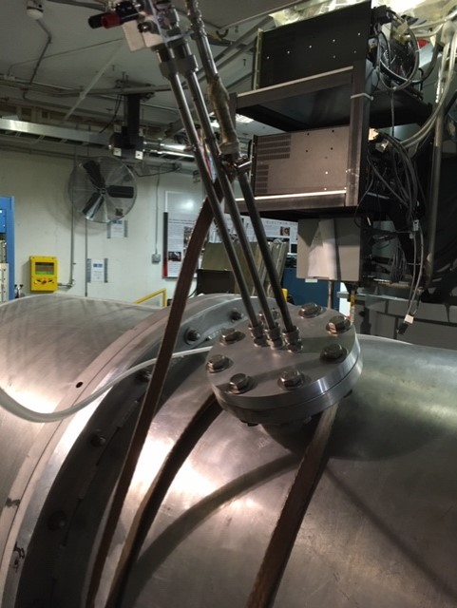

- Gun HVPS disconnect switch engaged with its VVU showing three lit green LED lights, one for each of the 3 phases.
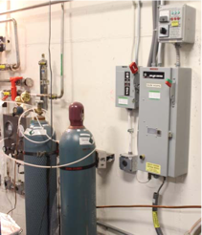
PROCEDURE
- Donn arc flash CAT 2 PPE and ask someone to be a witness standing at least 6 feet away
- Pull down the HVPS disconnect switch
- Doff arc flash CAT 2 PPE
- Apply personal LT&T. Each person who may be involved in executing this OSP must apply their personal lock. 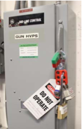
- Insert the gun tank ground rod, this is the right most of the 3 rods. In all cases the Swage fitting should be loosened by hand before inserting/retracting then re- tightened. Be sure that there is a shorted BNC connector on the end of this rod as well as a ground strap. This rod has a blunt end and need only touch inner electrodes. Remove the shorting BNC plug and connect the “SCAN” cable.
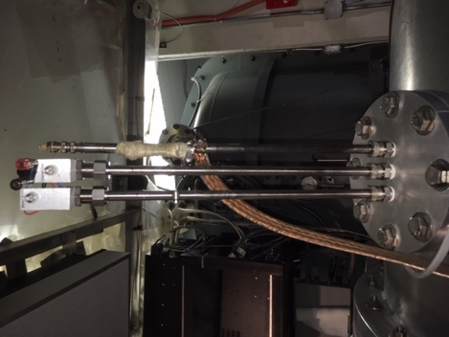
Grounding
BNC grounding rod cap
- Vacuum reported by VIP0F01 must approximately 5x10-11.
- Open the Gun Valve, VBV0F01.
- Remove the Foil from the lightbox viewport and do a QE Scan per the procedure
described at the end of this document, making a LERFLOG entry with the QE map
before continuing with the Recesiation.
- Remove the “SCAN” cable, reconnect the shorting BNC plug, and insert the remaining
two rods.
- Connect the “Motor Drive” Cable which is a BNC connection from the drive box.
Switch the drive box direction to the “Out” position and turn the box “ON”. Note the
time because it will take ~10 mins for the move to complete.
- While the motor is moving connect the two banana plugs (red and black) from the DC
power supply mounted in the injector pit rack to the Cesium channels rod.
- Connect the charge collector cable to the BNC connector just below the red/black
banana jacks of the same center rod and to the Aluminum mini-box next to chart
recorder (labeled GUN).
- Make sure the power supply is set to 0V and turn on. Ramp up the voltage until the
current reads 3 amps for warming up the cesium channels.
- Remove scanner turning mirror by loosening thumb screw on back side being VERY careful not to bump mirror. Set this assembly aside.
- Turn on White light source to position 3 and align the output light to scanner window port on light box. This is the source for photo-emission during cesiation. Place the light so that it is slightly clipping on the edge for maximizing the photocurrent.
- Turn on Keithly electrometer
  - Click “Amps”
  - Click “Zero Check” to OFF
  - Click range up to read 0.00X mircoamps
- Set “Battery Box” to position 3, Kiethly should read 0.5 to 1 microamp
- Set chart recorder to: (also turn black pen around and engage with paper)
  - 2”/min, Divide by 10
  - 1 Volt full scale
  - Chart ON
- While watching the Keithly and chart recorder, raise the CCPS current to 5 amps. The current will raise then begin to fall. SHUT OFF the CCPS when the drop is 20% of the maximum. Do this twice but the second time only 10%.
- The Keithly and chart recorder will dip further down then increase and roll over to a stable reading. Once this happens the Cesiation is complete.
- Connect the “Motor Drive” Cable which is a BNC connection from the drive box. Switch the drive box direction to the “IN” position and turn the box “ON”. Note the time because it will take ~10 mins for the move to complete.
- Turn off “Battery Box”, Keithly, and chart recorder (also cap and flip recorder pen)
- Unplug charge collection cable & CCPS banana plugs from center tank rod and retract
rod (loosen & tighten Swage fitting).
- Turn OFF white light source and remove from viewport.
- Restore scanner turning mirror, while replacing it is fitted to the upper Aluminum
plate for alignment. Tighten thumb screw.
- Once the cathode is fully in (motor drive will stop when the cathode reaches the limit
switch), disconnect that cable and shut off the drive box. Retract the motor rod fully
and tighten the fitting.
- Perform a QE scan as described above and make a LERFLOG entry with the QE map.
- Once QE scan is complete. Put the Foil back over the view port. Unplug scan cable.
Ensure all three rods are completely retracted and reconnect the shorting BNC plug. Remove personal lock from HVPS and turn the disconnect back on. Close the Gun Valve.
- The procedure is complete.

- Back Out Procedure(s) i.e. steps necessary to restore the equipment/area to a safe level.
- Special environmental control requirements:
  - Environmental impacts (See EMP-04 Project/Activity/Experiment Environmental Review)
  - Abatement steps (secondary containment or special packaging requirements)
- Unusual/Emergency Procedures (e.g., loss of power, spills, fire, etc.)
- Instrument Calibration Requirements (e.g., safety system/device recertification, RF probe calibration)
- Inspection Schedules
- References/Associated Documentation
- List of Records Generated (Include Location / Review and Approved procedure)

Distribution: Copies to: affected area, authors, Division Safety Officer
Expiration: Forward to ESH&Q Document Control

Form Revision Summary
Qualifying Periodic Review – 02/19/14 – No substantive changes required.
Revision 1.3 – 11/27/13 – Added “Owning Organization” to more accurately reflect laboratory operations.
Revision 1.2 – 09/15/12 – Update form to conform to electronic review.
Revision 1.1 – 04/03/12 – Risk Code 0 switched to N to be consistent with 3210 T3 Risk Code Assignment.
Revision 1.0 – 12/01/11 – Added reasoning for OSP to aid in appropriate review determination.
Revision 0 – 10/05/09 – Updated to reflect current laboratory operations
ISSUING AUTHORITY | FORM TECHNICAL POINT-OF-CONTACT | APPROVAL DATE | REVIEW DATE | REV.
ESH&Q Division | Harry Fanning | 02/19/14 | 02/19/17 | 1.3
This document is controlled as an on line file. It may be printed but the print copy is not a controlled document. It is the user’s responsibility to ensure that the document is the same revision as the current on line file. This copy was printed on 9/28/2020.

