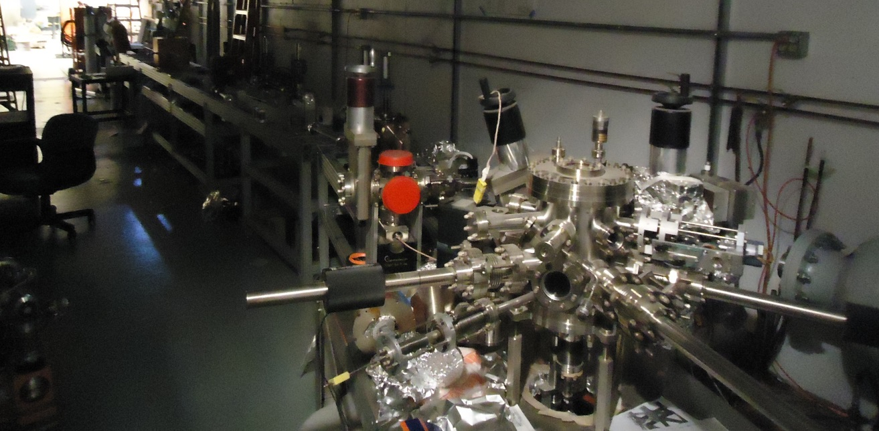

Safety Review:
Proposed PSS BCM for the
Upgrade Injector Test Facility

November 16, 2016

UITF PSS BCM

Purpose of the Review: To evaluate the possibility of using the CEBAF Personnel Safety System (PSS) Beam Current Monitor (BCM) as an approved credited control at the Upgraded Injector Test Facility (UITF). A credited control is required to ensure beam current in the MeV beamline does not exceed an approved value. By limiting MeV beam current, we thereby ensure acceptably low levels of radiation outside the UITF concrete enclosure.

A review of the CEBAF PSS BCM credited control, and its possible use at UITF, was held on Friday, October 21, 2016, at the MCC conference room from 9 – 11 am.

Reviewers were: Chris Cuevas, Paul Vasilauskis, Curt Hovater, and Steve Benson

Technical information was provided by Vashek Vylet, Henry Robertson, and Trent Allison.

Additional Experts in attendance included Omar Garza, Keith Cole, John Musson, Jim Kortze, Jerry Kowal, Hari Areti, Matt Poelker, and Bob May

The reviewers were given the following Charge:

Answer the question: “Can the CEBAF PSS BCM credited control be used at UITF as a credited control to limit MeV beam current to an acceptable level, and thereby ensure occupants of the Test Lab high bay (outside the UITF enclosure) are not subjected to dangerous levels of x-ray radiation?”

Summary Response of the Review Committee:

“The CEBAF PSS BCM system was designed to detect a minimum current of ~ 1uA. Radiation shielding calculations suggest beam current at MeV energy should not exceed ~ 200nA (sustained long-term beam delivery). The sensitivity of the CEBAF PSS BCM receiver can be improved, but not to the 200 nA level. As such, the Review Committee does not believe the CEBAF PSS BCM can be considered a viable credited control for UITF. The Committee recommends taking the necessary actions to qualify the CEBAF MPS BCM as a PSS credited control for use at UITF”

Brief description of UITF

The Upgraded Injector Test Facility represents a 10 MeV accelerator located at building 58, composed of the old Injector Test Cave (Cave1) and a new space constructed from modular concrete block (Cave2). Personnel are not allowed inside the enclosure during operation. The beam energy, beam current and the thickness of the concrete shielding determine radiation levels outside the enclosure. Beamloss at MeV energy represents a bigger radiation hazard compared to beamloss at keV beam energy. This review focused on beamloss at MeV energy.

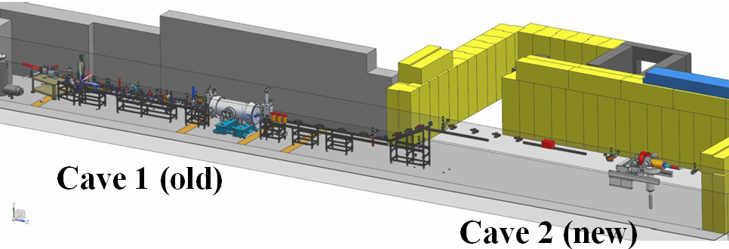

Non-invasive monitoring of beam current using a Beam Cavity Monitor is standard practice. At CEBAF, BCMs are used for machine protection, and the PSS BCM is used to protect the beam stoppers. At UITF, we envision a PSS BCM located just downstream of the quarter cryomodule, with nearby insertable Faraday cup which can be used to verify BCM calibration. Beam current excursions above an approved level will be detected by the BCM which will trigger beam shut off by approved means.

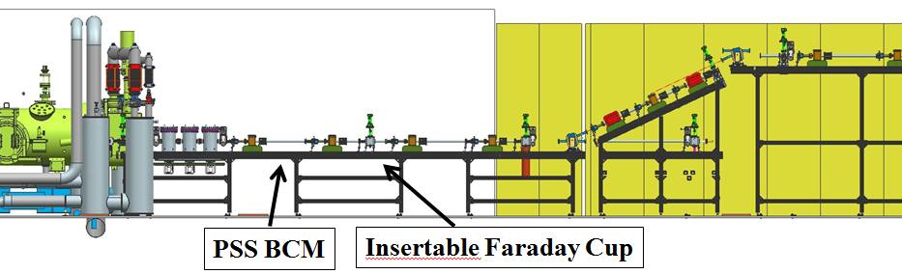

Highlights of the presentations:

M. Poelker provided a system overview of UITF, including a description of near term goals. A key goal of UITF is to commission the polarized HDIce target, which is scheduled for installation at Hall B in 2020. He described typical modes of operation, including “Tune Mode” ops that will be used to thread beam to the target. In “Tune Mode”, the beam exhibits a macropulse structure equivalent to 100 nA CW average current. When delivering beam to HDIce, we anticipate beam current of 1 nA or less.

Vashek Vylet reviewed the UITF concrete shielding and identified the locations where we could expect the most x-ray radiation to leave the enclosure, passing into the Test Lab high bay. He believes there is adequate shielding to tolerate 200 nA beam loss at 10 MeV beam energy for two minutes.

Henry Robertson described the present-day CEBAF PSS BCM system.

Trent Allison described the PSS BCM receiver and recent tests aimed at evaluating the receiver sensitivity and system limitations. The lowest reliable beam current detection threshold is ~ 400 nA.

Their presentations can be found at https://wiki.jlab.org/ciswiki/index.php/UITF_Meeting_-_October_21,_2016

Key Finding and Recommendation:
The CEBAF PSS BCM system was designed to detect minimum current of ~ 1uA. Radiation shielding calculations suggest beam current at MeV energy should not exceed ~ 200nA (sustained long-term beam delivery). The sensitivity of the CEBAF PSS BCM receiver can be improved, but not to the 200 nA level. As such, the Review Committee does not believe the CEBAF PSS BCM can be considered a viable credited control for UITF.
The Committee recommends using the CEBAF MPS BCM to limit beam current at UITF, and taking the necessary actions to qualify this system as a credited control.

Other Findings:
- Access to elevated areas of the Test Lab will need to be roped off.
- Penetrations on the roof of Cave1 need to be inaccessible. Penetrations could be filled with stone.
- Shielding will need to be added to the trenches that extend beyond the UITF enclosure.
- Use plenty of local shielding along the beamline, at locations where we intentionally expect beamloss, i.e. at apertures, cups and dumps
- Additional concrete could be added to the roof, but the walls of the UITF enclosure represent the chief limitation. Extensive radiation measurements should be undertaken when UITF is capable of making MeV beam.
- A PSS BCM should be temperature stabilized to avoid sensitivity drifts
- Whereas 2 technologies and 3 devices are required at CEBAF to protect personnel, Bob May believes 1 technology and 2 devices will be sufficient at UITF, because it is a single User facility (i.e., not four halls)

Cuevas UITF BCM Review

UITF BCM PSS Review
• Can we operate UITF with beam current loss between 100nA and 1uA? Self limiting? (i.e., we vent) NO, not practical.
• Can sensitivity of CEBAF PSS BCM be improved? NO

According to the measurements and conclusions presented by Trent Allison, the lowest reliable integration threshold is 400nA (+/- 100nA). Minor modification to the existing integrator circuit card may improve the sensitivity to 200nA(+/-50nA). This value is still not as sensitive as required to achieve the 100nA beam loss protection.

• Are Vashek’s calculations too conservative? NO

Perhaps, but his recommendation at this stage is that the BCM should reliably detect beam loss of 200nA at most. Present BCM system does not provide this sensitivity. Areas of the UITF can be improved with added steel and/or concrete, and the protection system should be built to manage other experiments that can accept the UITF beam capabilities. For instance, Vashek’s calculations showed that 200nA may be tolerated because HDIce would only run 900h/y but other experiments in UITF could be higher.

• New BCM receiver, or more concrete? Upgrade the BCM receiver

There was only mention of modern BCM electronics that could work to fulfill the 200nA (or less) sensitivity requirements of UITF. I understand that the original BCM system and supporting electronics was not designed for low beam current sensitivity, so it makes sense to use modern electronics (perhaps modified from a nA BPM?) to satisfy the UITF BCM PSS needs.
If the new receiver electronics can be tested and proved reliable AND fit into the installation schedule then this is the best solution. Adding concrete, steel or shielding at specific locations is a good practical measure given Vasheks’s calculations for Cave 1 at 100uA at 10MeV. It was mentioned that no additional shielding blocks are available for UITF at this point, so even more important to push for modernizing the BCM system
Chris Cuevas

Hovater UITF BCM Review
I don't think as it stands the CEBAF PSS BCM system can be made to work at the UITF. It was designed to monitor beam currents around 2 uA not 200 nA. As we learned Friday, 200 nA is the limit for practical operation. There is no "safety" margin.
My suggestion is to investigate using one of the newer BCM receiver systems and qualify that for the UITF. The present CEBAF system design is approaching 20 years of age and the technology has come a long way in that time. By qualifying a more modern receiver in the UITF, it may ultimately help out the CEBAF PSS when that system becomes obsolete.
Curt Hovater
Vasilauskis UITF BCM Review

I feel just as others have already stated, that the CEBAF PSS BCM is currently not able to monitor the low beam currents the UITF requires. I also have a concern with single point failure in using one cavity for both redundant systems with no automatic self-test to insure against detrimental changes in the single cavity.

Paul Vasilauskis

Benson UITF BCM Review

To me there are two options that can be pursued:

The first is to use the existing hardware, tweaked to get 200 nA detection limit. I would note that you would still need to have some certification of this system since there may be obsolete components in the old system that have to be brought up to date and the change in components might have unintended consequences. Since the detection limit would be higher than desired we would also have to have a careful measurement program by Radcon that evaluates the loss pattern and correlates it with radiation doses outside of the vault. Local shielding could then be placed to mitigate the radiation outside the limits.

The second alternative is to replace the front end of the existing system with new hardware capable of detecting far less than 100 nA accurately. This would require certifying the new hardware but you might have to do that even with the first option. Since the current could then be confidently measured as less than 100 nA the existing shielding should be fine. Some Radcon measurements would be needed to verify the shielding but they should not have to iterate.

Steve Benson

