Temperature Profile that was used on the fine Grained Nb Sample
Tom Elliot Weekend of July 31 through August 3-09
Step # (1) 150°C for 45 minutes. Ultimate Vacuum approximately 3X10-6 Torr
Step # (2) 300°C for 45 minutes. Ultimate Vacuum approximately 4X10-6 Torr
Step # (3) 450°C for 45 minutes. Ultimate Vacuum approximately 5X10-6 Torr
Step # (4) 600°C for 45 minutes. Ultimate Vacuum approximately 4X10-6 Torr
Step # (5) 700°C for 120 minutes. Ultimate Vacuum approximately 3X10-6 Torr.
On 10/20/2015 1:29 PM, Matt Poelker wrote:
FYI, here's the Big Blue heat treatment we've been using for our electrodes, Tom called it "program #17". At one point, I think there was some contamination of parts, some residual titanium inside Big Blu migrated onto electrodes. Jim and Scott addressed this by putting parts inside "garages", e.g., stainless half nipples, and/or little blocks erected around the parts to block line of sight to oven walls. I think this worked well.
Thanks,
Matt
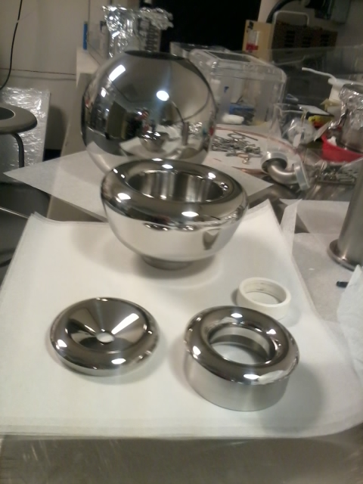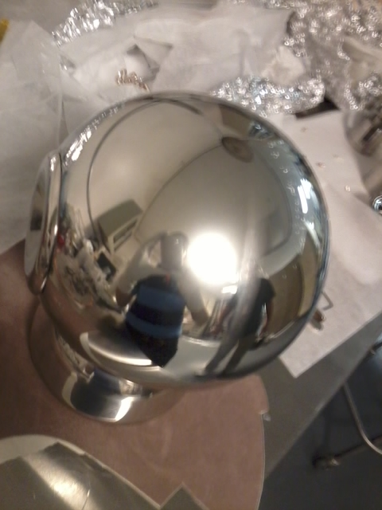
Ball and shed are very shiny after polishing, but after 950C vacuum degas they develop a haze, with the weld line clearly visible.

