VERTICAL Wien filter assembly procedure
Rev 00
C. Hernandez-Garcia
January 12, 2021

System description:

The electrodes are held in place inside the vacuum chamber with Inconel “hanger” frames. To provide electrical isolation, a 1-inch long Macor standoff is used to attach the electrodes to the hanger. Ceramic screws are used to secure the Macor standoff to the electrode on one end, and to the hanger on the other end. The ceramic screws are assembled using a flat SS washer, a spring washer, and a ceramic washer. The spring washer serves to maintain compression and to prevent stress on ceramic components during the vacuum bakeout.

Each electrode has two Macor standoffs in each end. The whole electrode set needs then 8 Macor standoffs, and 16 ceramic screws with their set of washers.

The hangers are attached to the vacuum chamber using silver-plated and vented ## bolts, and a SS spacer to prevent deforming the hanger when the bolts are tighten.
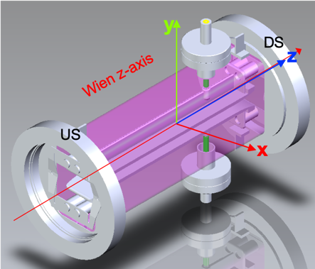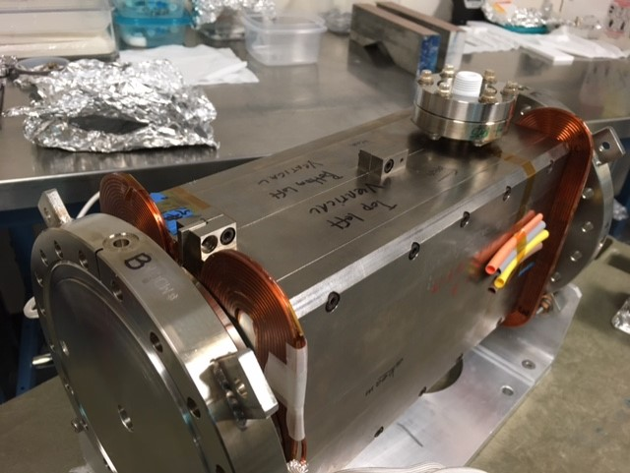

Assembly objective:
Assemble the electrode set outside the vacuum chamber to ensure best possible parallelism, followed by inserting the electrode assembly into the vacuum chamber and adjusting its position to ensure best possible centering at both upstream and downstream ends.
The electrode+hanger assembly is put together outside the vacuum chamber. The hangers determine the electrode gap and parallelism, there is no adjustment, but by pre-assembling the electrode set outside the vacuum chamber, one can tighten the screws securing the Macor standoffs to the electrodes mounting tabs as best as possible. There is no way to ensure both hangers are firmly attached to the Macor standoffs since one of the hangers must be removed for inserting the assembly into the vacuum chamber.

Procedure:
- Take one of the 8-32x0.375” socket cap ceramic screws and insert a flat SS #8 (0.169x0.204x0.032”) washer, then a four-point contact spring washer and finally a ceramic washer to make a ceramic screw sub-assembly. Repeat this step 15 more times for a total of 16 sub-assemblies.
Fig 1. Ceramic screw, flat SS washer, SS spring washer, ceramic washer, Macor standoff
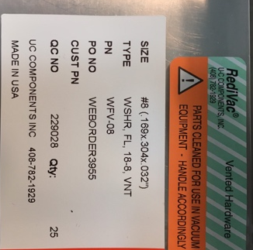 need here pic of ceramic washers
Fig 2. Components ordering info
Fig 3. Ceramic screw sub-assembly. A total of 16 of these sub-assemblies are needed to secure the electrodes to the hangers.
- Place one of the electrodes on the cloth-covered blocks, with the flat part resting on the block. The cloth will prevent scratches, but still avoid dragging the electrode once is resting on the block.
- Take one of the Macor standoffs and insert the long end into the electrode mounting tab opening. The standoff must be facing away from the electrode. Then use one of the ceramic screw subassemblies to secure it. Finger tight only. Repeat this step until all 4 Macor standoffs have been mounted to the electrode. Repeat for the other electrode.
Fig 4. LEFT: Detail showing the position of the Macor standoffs on the electrode secured with the ceramic screw subassemblies. RIGHT: The two electrodes resting on the cloth-covered blocks with all their Macor standoffs attached.

- Flip one of the electrodes on its back, resting each mounting tab on a cloth-covered block, then carefully place each of the Teflon 15 mm thick spacers on top of the electrode flat. Teflon does not seem to scratch the electrode.
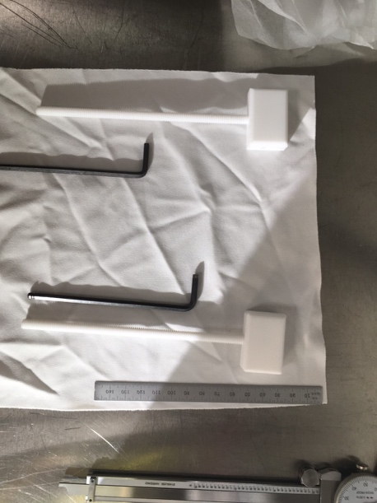
Fig 5. Teflon spacers are 15 mm thick.

- Take the other electrode, flip it and carefully place it resting on the Teflon spacers. Beware that Teflon is slippery, always keep one hand on the top electrode to keep it in place.
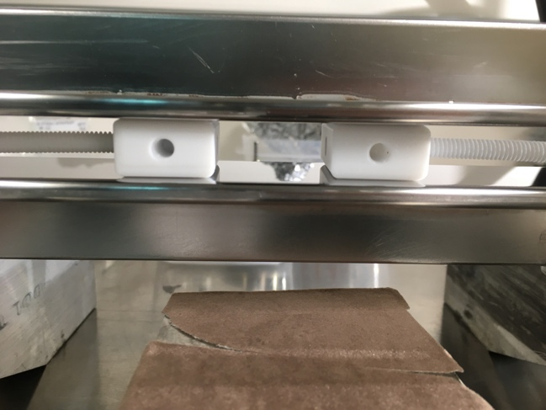
Fig. 6. Side view of the electrodes vertically resting on the cloth-covered blocks, with the Teflon spacers in between.

- Choose one end and attach the electrode hanger frame, first on the bottom electrode. Ensure thee Macor standoff inserts properly into the hanger holes. It feels ‘snapping’ when is in. Use the ceramic screw subassemblies to secure the hanger to the Macor spacers. For now, just finger tight the screws. Manipulate the top electrode so that its Macor standoffs go into the hanger holes, and secure with the ceramic screw subassemblies. Repeat on the opposite electrodes end.
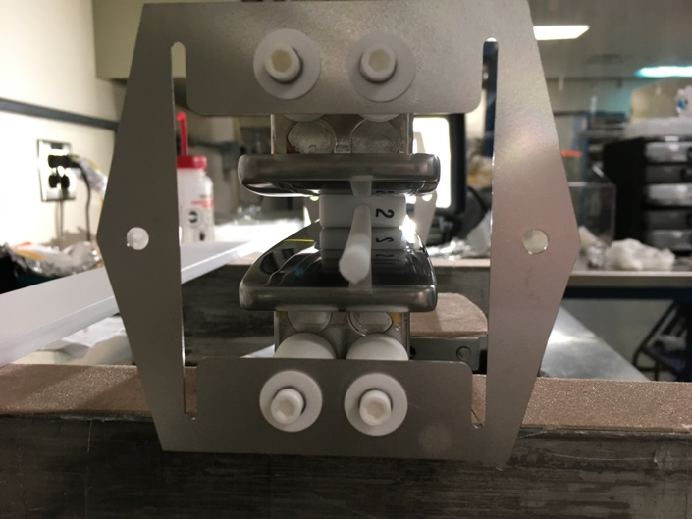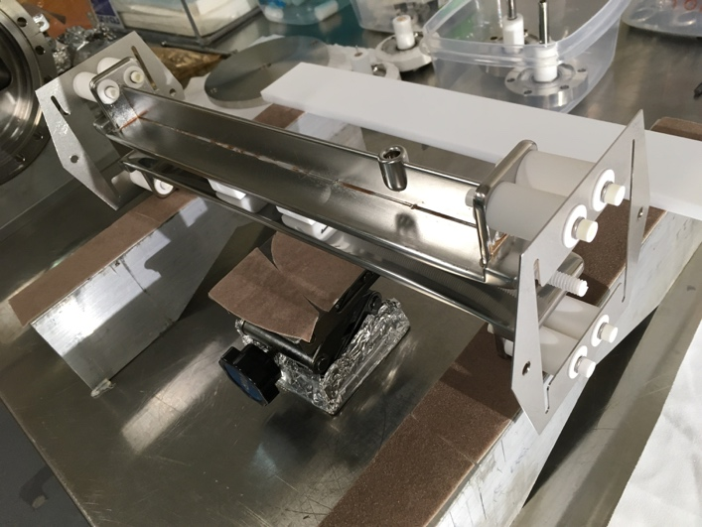
Fig. 7. LEFT: Detail showing the downstream electrode hanger frame attached to the electrodes Macor standoffs. The Teflon spacer can be seen between the electrodes. RIGHT: Isometric view of the full assembly showing both hangers attached to the electrodes.

- Using an Allen wrench, tighten all four ceramic screws on the hanger side. CAREFUL: do not overtighten. Observe the spring washer in the ceramic screw subassembly and continue to tight until it compresses to about ½ its original length. Repeat on the opposite side hanger. This step ensures the Macor standoffs are firmly attached to the hangers. The electrodes are still “floating” with respect to the hangers. See next step.
- Now tighten all four ceramic screws in the electrodes side on one end. CAREFUL: do not overtighten. Observe the spring washer in the ceramic screw subassembly and continue to tight until it compresses to about ½ its original length. Repeat on the opposite side. With this step we strive to “lock” the electrodes to the hanger frames. The tolerance between the Macor standoffs and the hanger frames holes is very tight, as is the tolerance between the opposite end of the Macor standoffs and the holes in the electrodes mounting tabs. In principle, the hanger frames lock and define the relative position between the two electrodes, ensuring parallelism and uniform gap. But this is not the actual case because the hanger frames are somewhat flexible. This is why we use Teflon spacers, and the reasoning behind steps 7 and 8.

The following steps describe how to insert the electrode assembly into the vacuum chamber. Unfortunately, one of the hanger frames must be removed, but the Macor standoffs should remain in their position described in step#8 and locked to the electrodes.

- Ensure the Wien Vacuum chamber is mounted to its brackets in the vertical position. That is, the feedthroughs should face up and down. Notice that the electrodes have a “cup” on their back rib. This “cup” is not centered along the electrode, but rather is closer to one end. Ensure the vacuum chamber is oriented in such way that the feedthrough end will lineup with the electrodes cup once they are inside the chamber.
- Remove the ceramic screws from the hanger closest to the vacuum chamber. This is the side that will be inserted.
- Set the Teflon flatbar next to the assembled electrode set, resting on the two cloth-covered blocks and lined it up with the electrode.
- Pick up the electrode assembly with both hands clamping the two electrodes to ensure the Teflon spacers remain in place between the electrode flats. Set the assembly on the Teflon flatbar with the electrode mounting tabs resting on the flatbar. Notice that the hanger is lower than the mounting tabs and thus the electrode cannot sit on the flatbar resting on the hanger, because there is only one hanger until the electrode is fully inserted in the vacuum chamber.
- Get the electrode+flatbar close to the vacuum chamber as shown in Fig. 8. The assembly will need to be raised so that the flatbar can rest on the vacuum chamber. Start sliding the electrode assembly into the vacuum chamber guiding the flatbar to avoid contact between the vacuum chamber walls and the electrode.
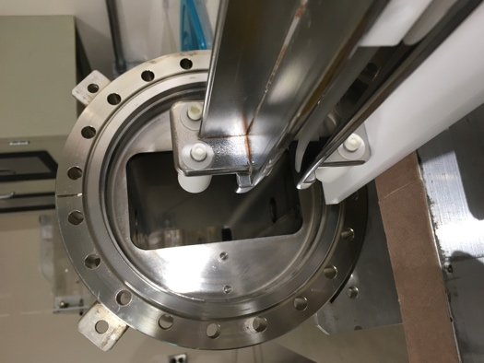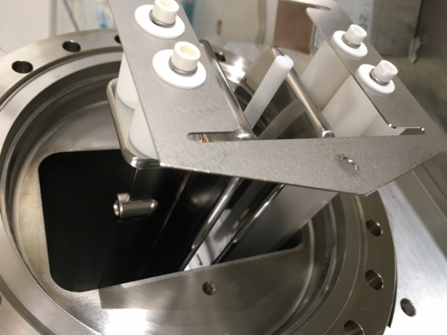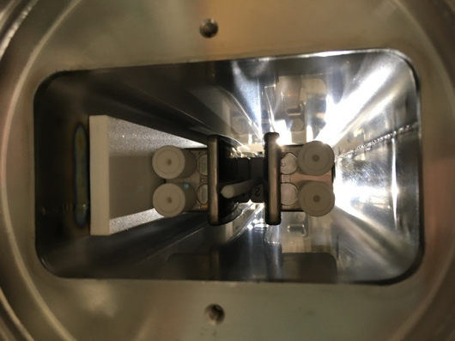
Fig. 9. LEFT: Electrode assembly with one hanger removed and resting on the Teflon flatbar ready to be insterted into the vacuum chamber. CENTER: Electrode assembly resting on the flatbar being slided into the vacuum chamber. Notice how the flatbar rests on the vacuum chamber. RIGHT: Opposite end view from that shown in the CENTER picture.

- Continue to slide the electrode assembly into the vacuum chamber until there is a gap of about ¼” between the hanger frame and the chamber wall (Fig. 10). Then Use one of the stainless-steel spacers to set the gap. Line up the spacer with the hole and insert the silver-plated socket head screw. Repeat for the other end in the same hanger. Note: The holes in the hanger are not lined up yet to the threaded holes in the vacuum chamber. See next step.
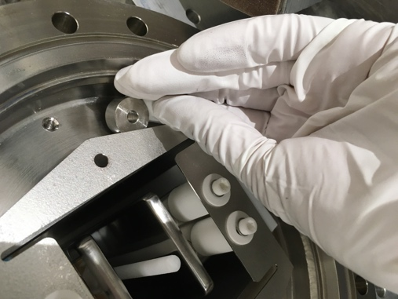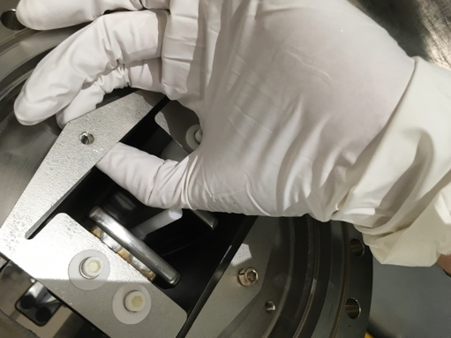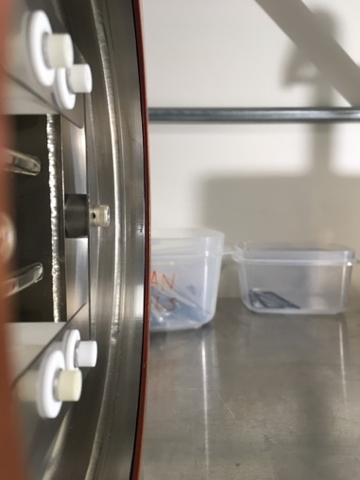
Fig. 10. LEFT: The gap between the hanger and the vacuum chamber wall with the spacer being tucked in between. CENTER. The spacer lined up with the hanger hole. Insert the screw to keep the spacer in place, but hanger still not lined up to vacuum chamber. RIGHT: Side view showing the spacers between the vacuum chamber and the hangers with the screws in.

- Lift the hanger with one hand to make the holes line up with the chamber’s threaded holes and screw in both screws but leave them loose. Notice that now the Teflon flatbar can slide under the hanger, but the hanger still is slightly low compared to the threaded holes in the chamber.
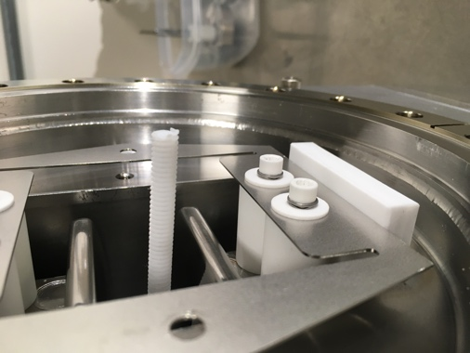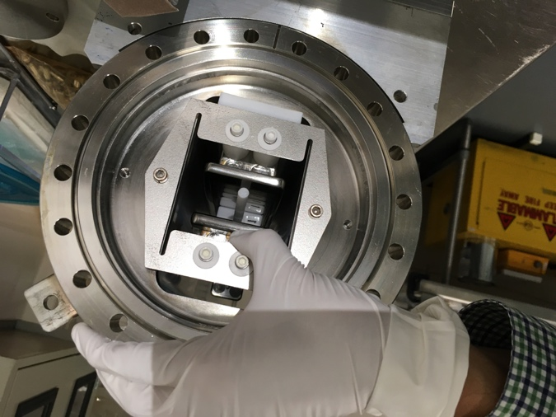
Fig. 11. LEFT. Hanger resting on Teflon flatbar. RIGHT. Electrode assembly being lifted from the hanger to line up the hanger holes with the vacuum chamber threaded holes. The silver-plated screws are inserted but loose.

- Slide the Teflon flatbar out under this hanger to make room on the opposite end of the vacuum chamber for the hanger. Watch while sliding the flatbar to ensure the electrode does not come off it on the opposite side.
- Attach the hanger to the electrode on the opposite side. Ensure the Macor standoffs snap into the hanger bottom holes, and secure it with the ceramic screws subassembly. Repeat for the top hanger holes, the electrode might have to be manipulated to ensure the Macor standoffs snap into the hanger top holes.
- Lift the hanger from this end and slide the Teflon flatbar back so that both hangers are resting on it.
- Insert the stainless steel spacers and the screws to secure the hanger to the vacuum chamber, leaving the screws loose.
- The electrode assembly is still slightly low compared to the vacuum chamber centerline, but it is now a “rigid” assembly kept in place by the tight tolerance between the hangers, the electrode mounting tabs and the Macor standoffs.
- To center the electrode assembly, insert two ceramic washers (Part number goes here) between the Teflon flatbar and the hangers, on both ends.
- Tighten firmly the silver-plated socket head screws on both hangers to secure them to the vacuum chamber.
- Look down into the vacuum chamber to observe for gaps between the electrodes and the Teflon spacers. There should be no gaps or at least the gap should be as small as possible. There is no adjustment to correct for any gaps other than taking everything apart and repeating the procedure. Using the Teflon spacers and “locking” the electrodes to the hangers is the best option up to now for ensuring uniform gap and parallelism. REMOVE THE TEFLON SPACERS. This step concludes the electrode assembly.
- The feedthroughs subassembly consists of a CeramTec 40kV DC 2-3/4” CF flange feedthrough, a polished stainless-steel spring guide, and a non-magnetic spring. Figure 12 shows the assembled feedthroughs.
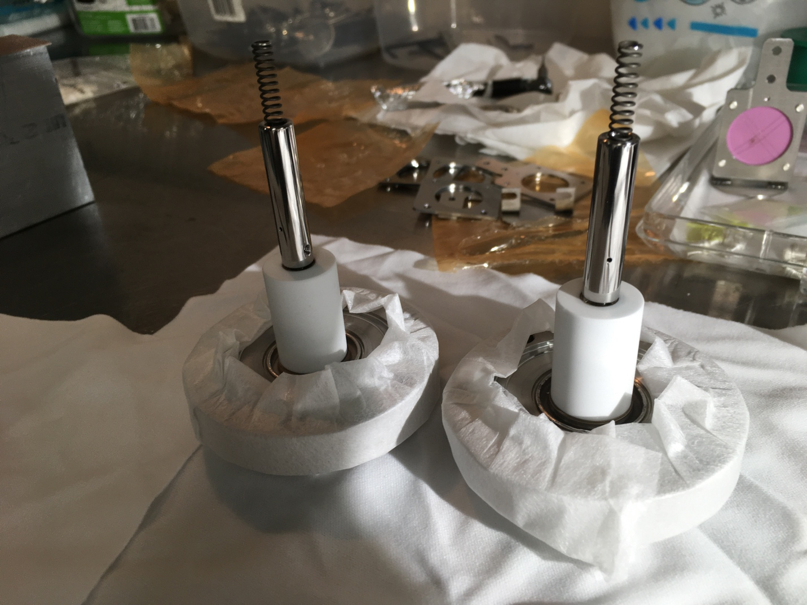
Fig. 12. Feedthrough subassemblies. NOTE: the polished spring guide cylinder is attached to the feedthrough, but not spring itself.

- With the electrode assembly firmly secured inside the vacuum chamber, rotate the vacuum chamber 90 degrees until the feedthrough 2-3/4” CF flanges are horizontal. It is easier to install the feedthroughs this way.
- Insert a silver-plated Cu gasket to the feedthrough flange, and carefully guide assembly through the feedthrough flange in the vacuum chamber, being careful to keep the spring lined up with the electrode cup. When the spring is inside the cup, push the flange and lineup the gasket. Keep it in place (the spring will push back) while bolts with Bevell washer and nuts are inserted and finger tighten.
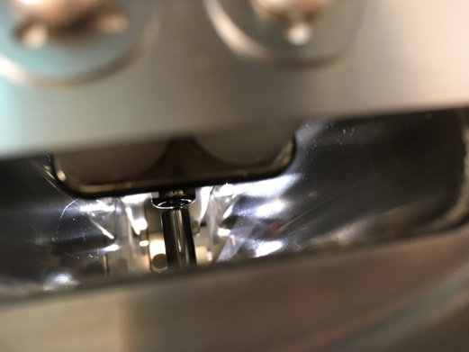
Fig. 13. View of one of the feedthrough assemblies fully installed in the vacuum chamber. Notice the spring between the spring guide and the electrode cup.

- Repeat step 25 for the opposite end feedthrough.
- Vacuum tight all bolts on both feedthrough flanges.
- Rotate the vacuum chamber back 90 degrees to its original vertical position with the feedthroughs facing up and down. Secure the vacuum chamber to its brackets tightening the screws.
- Install the magnet ensuring it is mounted in the same orientation as that used for magnetic field mapping.
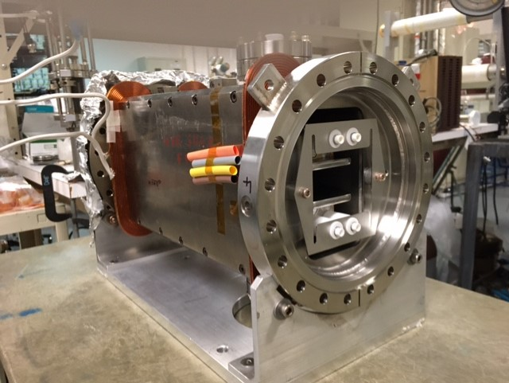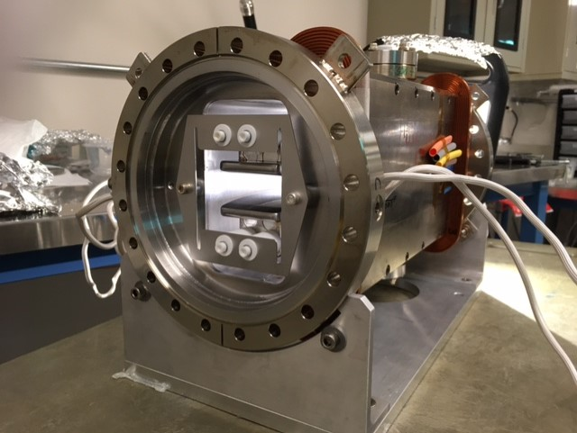
Fig. 14. V-Wien w/o the nickel plates and with the magnet installed. The feedthroughs are lined up facing up and down. LEFT: Downstream side. RIGHT. Upstream side.

- Install the nickel plates on each end of the vacuum chamber and secure using the silver-plated and vented socket head screws.

Fig. 15. V-Wien with nickel plates and magnet ready for Survey.

For survey and alignment purposes, the Wien filter consists of 4 sub-assemblies:

- Steel electromagnet
- Nickel endplates
- Electrodes
- Vacuum chamber end flanges

For the VERTICAL Wien filter:

The magnetic field X-axis is defined by the steel electromagnet YZ plane.
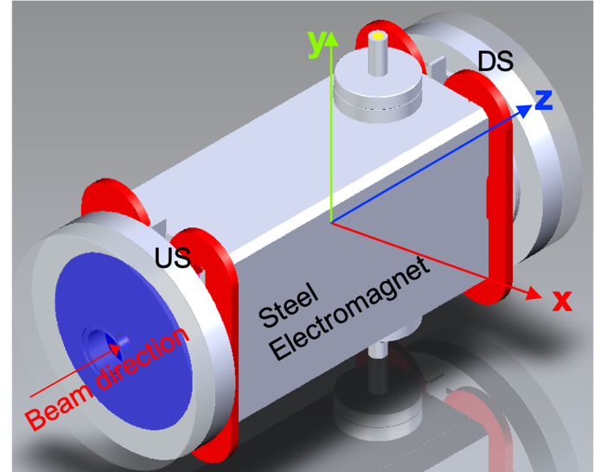

The Wien Z-axis is defined by 15 mm diameter holes in nickel end plates, they are nominally at the X,Y=(0,0) of vacuum chamber flanges,
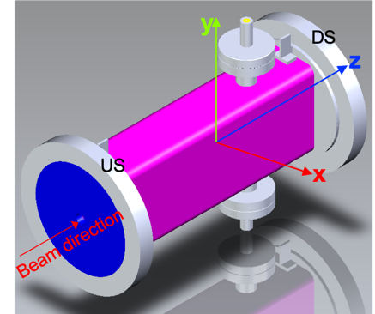

The electric field Y-axis is defined by electrodes XZ plane.

The electrode flat faces should be parallel to one another (not skew), and normal to the XZ plane.

Establish coordinates of at least three points in each corner indicated by the yellow dots in Figure 2 in the coordinate system relative to the electrode centerline. This will tell us:
    - The electrode parallelism along the Z-axis
    - The electrode parallelism along the X-axis at two positions: upstream and downstream.

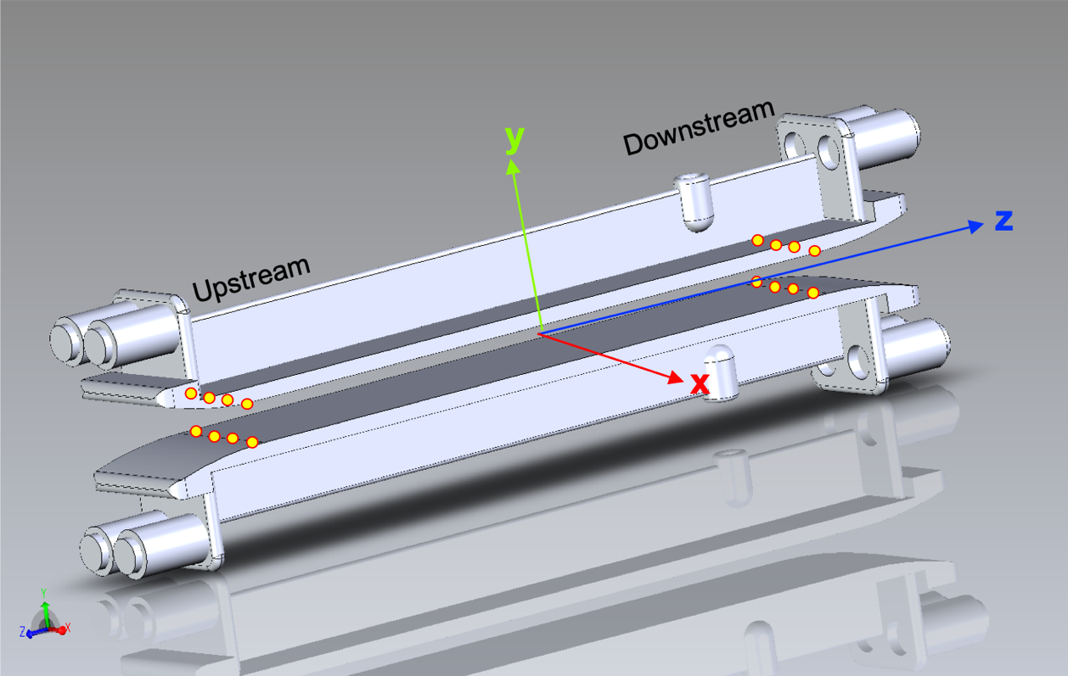
Electrode assembly with the vacuum chamber removed and in the Wien z-axis with positive z towards the electrical feedthrough. The yellow dots suggest the positions for surveying, where the electrode transitions to flat. The top electrode may be used to define the top plane, similarly the bottom electrode may be used to define the bottom plane.

The S&A results are summarized in the table and figure below and in https://wiki.jlab.org/ciswiki/index.php/AIPINJ_-_S%26A_Transmittals
Under: V-Wien optimized assembly procedure using teflon spacers to set electrode gap Media:V-Wein S&A Ni plates + magnet 01-08-2021.xlsx

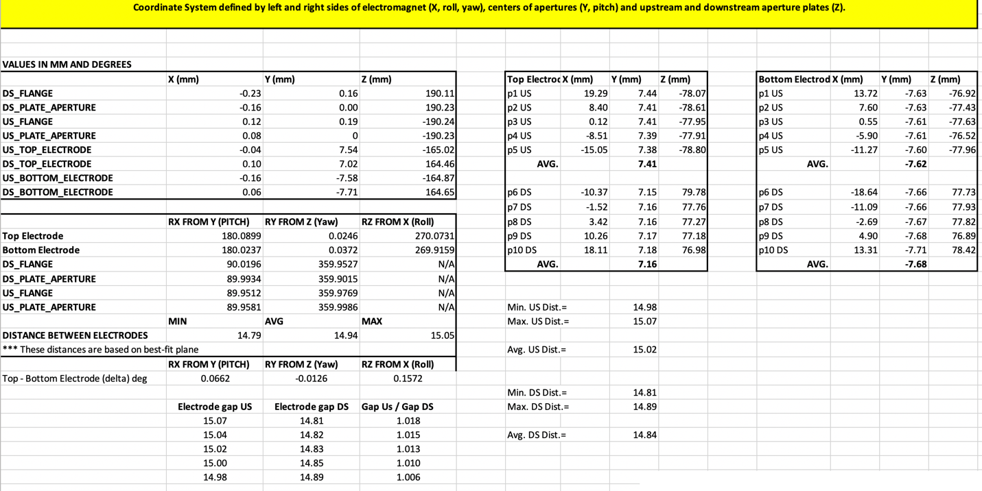
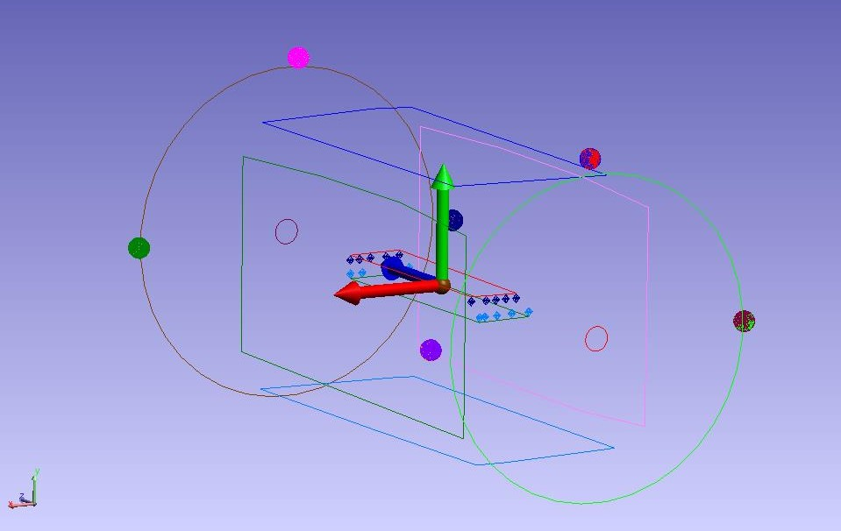
Coordinate system from S&A report gap Media:V-Wein S&A Ni plates + magnet 01-08-2021.xlsx

