Physical Description of the CEBAF Mott Polarimeter and Detector Chain

J. Grames, D. Machie, M. Stutzman, R. Suleiman

JLAB-TN-16-xxx

July 12, 2016

*Introduction*

This note describes the CEBAF Mott polarimeter construction, specifically as installed and used during Mott experiment Runs I and II in 2015. Drawings and images shown in this technical note may be found at */group/mottgrp/Upgrade2013*.

*CEBAF Injector*

A -130 kV dc high-voltage gun produces spin-polarized electrons from a GaAs/GaAsP superlattice photocathode via photoemission. The laser repetition rate and pulse length determine the electron characteristics, sub-harmonics of 499Mhz and 50 ps respectively. The spin polarization of the electrons is set by the circular polarization state of the laser and may be right- or left- handed and the sign (helicity) reversed at frequencies up to 1 kHz. The electron spin polarization of the electron beam may be oriented in 4 relative to the beam momentum by three successive spin rotators (Rx Wien filter, Rz solenoid, Rx Wien filter) described as the “Two Wien Spin Flipper”. The electron bunch train is deflected within a TM010 chopping system where the longitudinal acceptance may be defined, as large as 60° at the fundamental of the chopping cavities 499 MHz. The electron bunches are compressed by a drift-buncher system to about 1 ps and accelerated by a 5-cell graded  cavity to 500 keV. The relativistic beam is then accelerated by two 5-cell niobium superconducting cavities submersed in liquid helium within a cryostat. The beam passes through a beam current monitor cavity and then goes to the CEBAF accelerator, or may be deflected by a dipole magnet to one of three dedicated extracted lines; a spectrometer (-30 deg), Mott polarimeter (-12.5 deg) or spectrometer (+25 deg).

Macintosh HD:Users:grames:Downloads:sheet1july12-2.pdf

Fig. 1. CEBAF injector shows photogun, spin manipulator, chopping-bunching-accelerating and extraction lines to spectrometers or Mott polarimeter.

*Mott Polarimeter Beam Line*

The polarimeter beam line begins at the dipole magnet. A short length of 1.375” ID beam pipe connects to the polarimeter. Along this length a pair of X/Y steering coils, a vacuum isolation valve interlocked to the main beam line vacuum pressure, a view screen and 45 L/s DI ion pump are located. The beam pipe connects by a 2-3/4” CF flange to entrance of Mott polarimeter. The polarimeter itself is composed of three (scattering, spool, tube) functional sections.

Macintosh HD:Users:grames:Downloads:sheet2july12-2.pdf

Fig. 2. Mott polarimeter beam line indicating beam line components, scattering chamber, extension spool, beam tube and beam dump.

The scattering chamber vacuum vessel chamber is composed of 304 stainless steel. The main tube is 8.0” ID and about 20” long with two opposing vertical ports to support a target ladder assembly and allow it to pass along the chamber diameter to position a target on centerline. A viewport is bolted by CFF to a tube welded to the chamber radius; a fixture within the tube supports a stainless steel disc polished to a mirror surface which reflects light from the target location to an air-side camera in order to view the target ladder and collect optical transition radiation (OTR) when the electron beam passes through the target foil. The mirror is X” upstream of the target foil and inserts to Y” of beam line. The upstream chamber flange is welded to the chamber body; four ports (spaced 90 apart) with CF flanges are welded to the upstream flange and point at the scattering angle (reference -173°) to the target location. Each detector port is terminated by a 0.050mm Al window epoxied to copper gaskets to make a CF vacuum seal. Internal to the scattering chamber is an aluminum baffle with ID 6.5” and 0.5” thick along the last 11.56” of the scattering chamber. An adjustable aluminum collimator 1.0” thick mounted to a fixed aluminum baffle 0.5” thick define a single central cylindrical aperture 1.0” ID on chamber centerline for the incoming electron beam, and four conic apertures (90 apart) defining the detector acceptances for scattered electrons. The conic aperture is 1.0” thick with upstream ID 0.314” and downstream ID 0.192” centered on scattering angle of 172.6°.

mottgrp:Upgrade2013:Drawings_2013:Al_Baffle:39300-0202.pdf 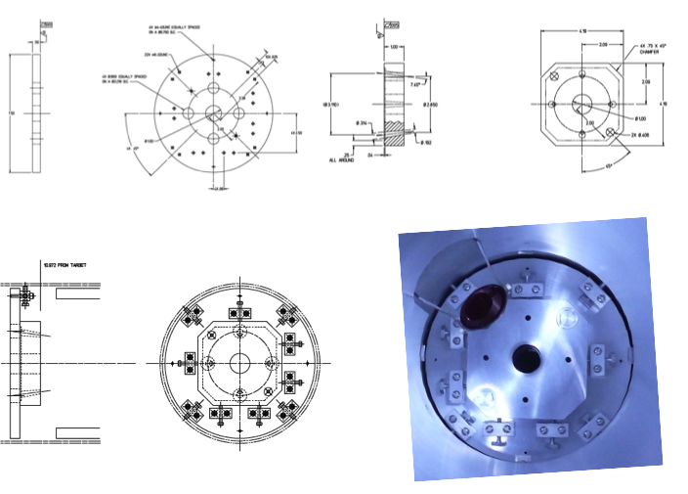

Fig. 3. Adjustable aluminum collimator parts and image looking upstream from target ladder location.

The extension chamber is composed of 304 stainless steel components. The main tube is 8.0” ID and about 11” long. A tee with CF flange is attached to a single port welded to the top of the extension chamber. The tee is used to attach both a 45 L/s DI ion pump and a GP100 NEG getter. Similar to the main scattering chamber an aluminum baffle with ID 6.5” and 0.5” thick and 9.85” long spans inner surface of the vacuum walls.

The tube chamber is composed of aluminum. It is 8.0” ID and X’ long. The flanges are X. A horizontal dipole magnet straddles the beam tube and may be rolled on a movable sled along the length of the tube; it is typically positioned at the end of the tube.

The beam dump is composed of a beryllium disc 0.25” thick and X” OD bolted to the vacuum side of a copper end flange 0.75” thick and rear surface of ID 7.5”. A Kalrez o-ring fit into a machine groove in copper makes the vacuum joint to end flange of tube chamber. A copper tube brazed to a copper plate is clamped to the the 8.5” OD surface of the copper dump flange and cooled by the CEBAF LCW system using a flowmeter interlocked to the fast shutdown system. A small 4” thick wall of stacked lead bricks is tabled behind the copper dump to suppress prompt gamma radiation.

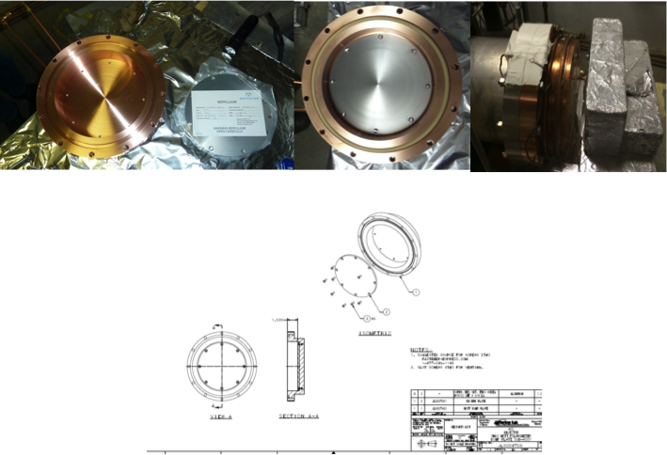

Fig. 4. Beryllium and cooled copper dump images are shown.

*Mott Target Ladder*

* (Joe) Ladder types, ladder motion, view screen, adaptors
* (Marcy) Targets used, vendor information, thickness results

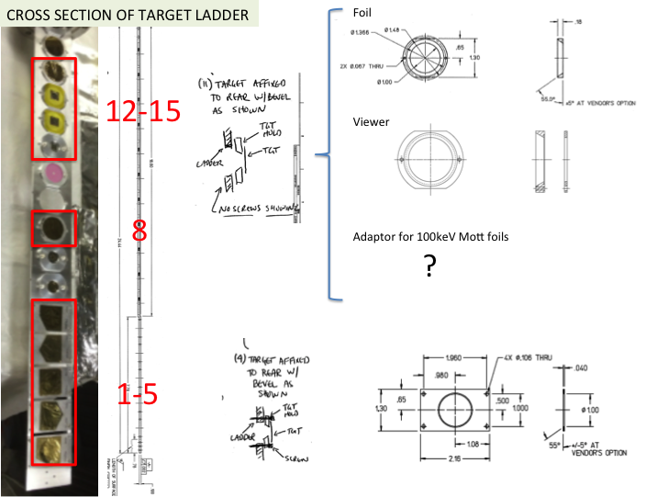

Fig. 5. Mott detector package details collimators, charged trigger (E) and full energy (E) detectors in support can (left), and image of detector package (right).

*Mott Detectors*

There are four Mott detector packages; each is contained within a stainless steel cylinder and mounted to one of the four detector ports spaced azimuthally 90 apart; they are named Left, Right, Up and Down looking downstream as the electron beam enters the scattering chamber.

Each package consists of a pair of detectors, E and an E detector. The E detector is made of EJ-212 plastic scintillator of 1 mm x 1 inch x 1 inch. The detector is glued to an acrylic light guide 0.125” thick x 1” wide x 2” long. The light guide is glued to 1” Hamamatsu R6427 photomultiplier tube in an H7415 assembly. The E detector is made of EJ-200 plastic scintillator cylinder 3” diameter x 2.5” long painted with reflective EJ-510 on external surfaces and the end clear which is glued to a 3” Hamamatsu R6091 photomultiplier tube in an H6559 assembly).

The E detectors is contained with the non-magnetically shield stainless steel tube behind a 2” thick lead collimator with a 0.5” ID hole. The DE detector scintillator is inserted in a slot 0.5” in front of the E detector. A portion of an aluminum nose collimator with 0.38” ID and 0.49” OD section penetrates 0.75” into the 0.5” lead hole; the remaining portion with 0.38” ID and extends 0.25” thick in front of the hole. When the detector package is attached to the detector port the face of the aluminum nose presses lightly against the air-side of the detector vacuum window.

Macintosh HD:Users:grames:Downloads:sheet3july12.pdf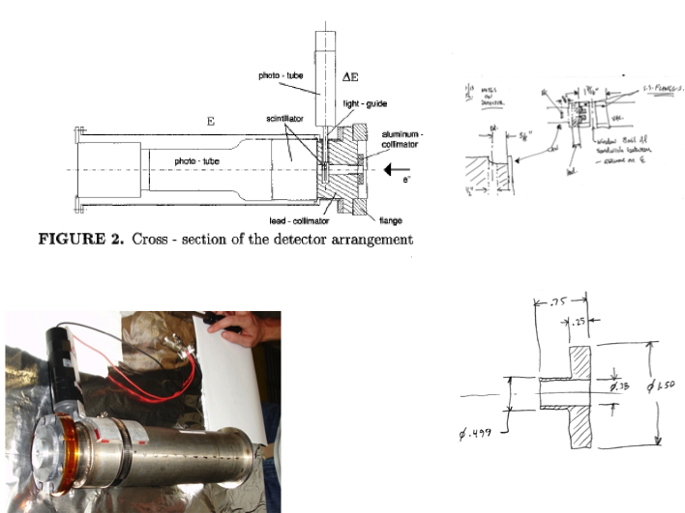

Fig. 6. Mott detector package details collimators, charged trigger (E) and full energy (E) detectors in support can (left), and image of detector package (right).

*Mott Data Acquisition*

* (Riad) Signal, HV, DAQ (NIM), DAQ (VME), CODA, Decoder, Analysis