15 Degree Dipole
HV Gun Interlock and Window Comparator

The new controls for the 15 degree dipole magnet include a Current Transducer for an FSD Window Comparator and a Current Sensing relay for Gun HV interlock.
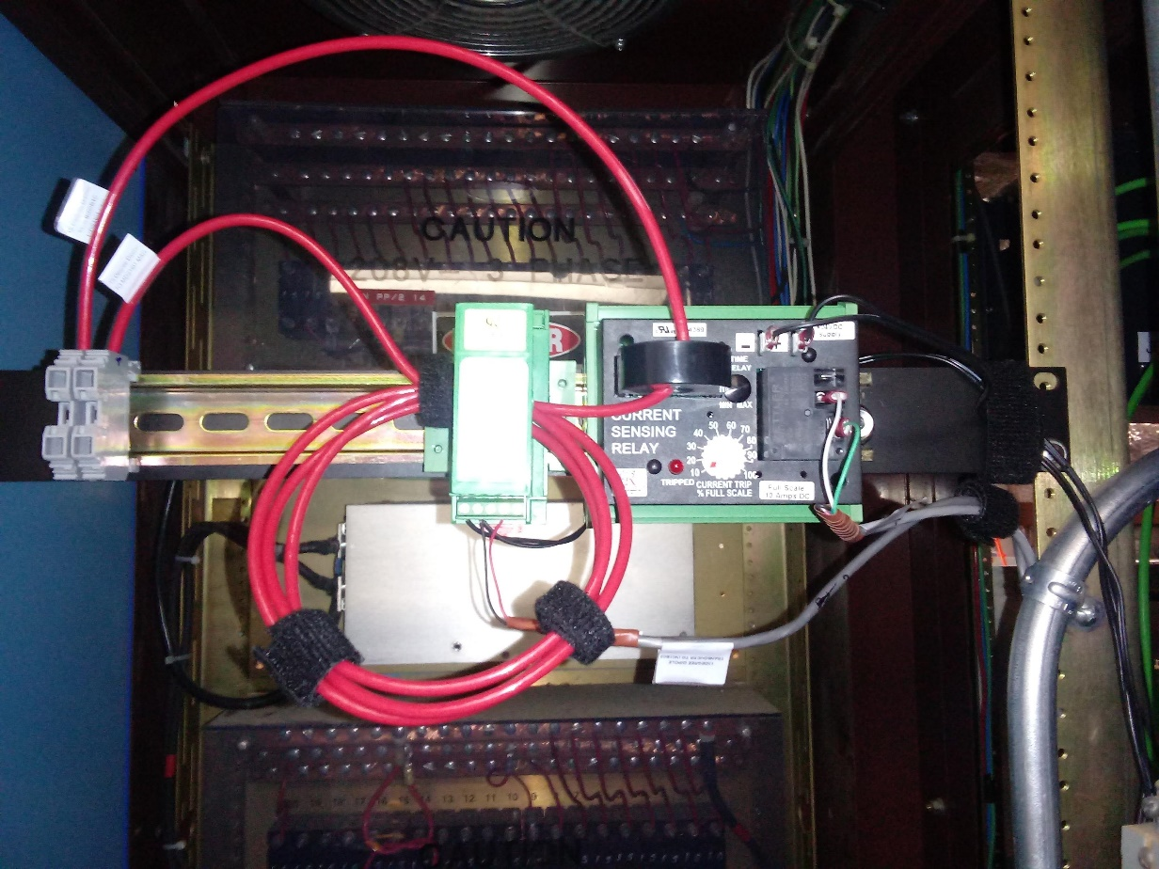
(Fig1) Rack IN01B11

Gun HV Permission:
The Glassman Interlock Chassis sends out 24VDC on pin-A of connector J6 and receives the signal back on pin-B (Dipole Mag On). The Current Sensing Relay provides a contact closure based on the Current Trip %. The current trip level can be adjusted using a flat blade screwdriver (Fig2). Full scale is 0-10A, therefore switch setting of 30% would result in a trip threshold of about 3A.
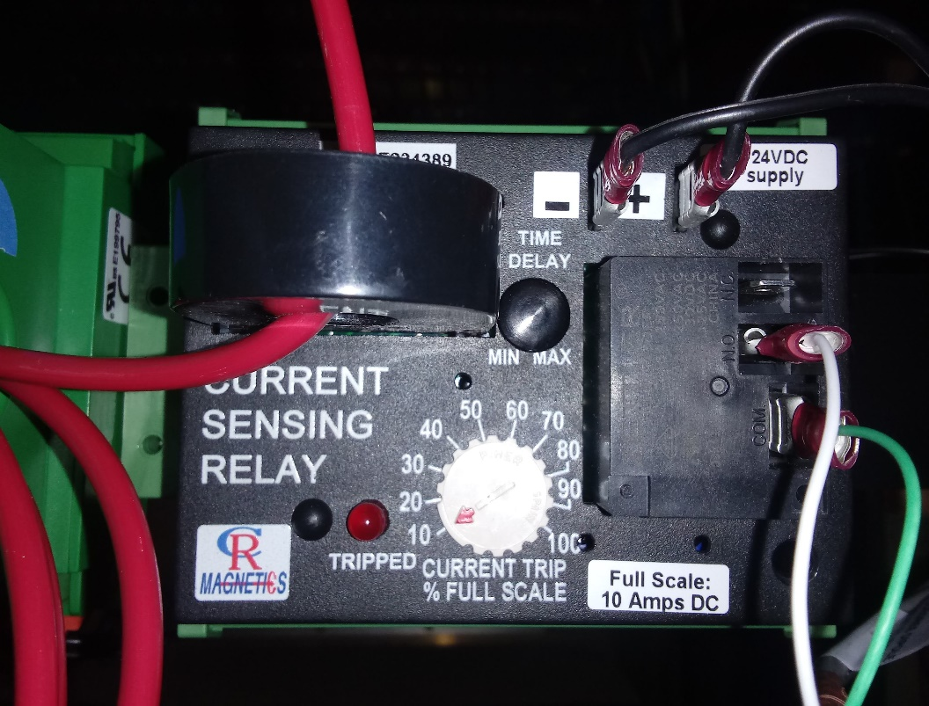
(Fig2) CR5395-24D in IN01B11

FSD Window Comparator
The DC Current Transducer provides a current to analog DC voltage to the FSD ADC board in IOCIN3 (Fig3). The transducer has been scaled from 0-10A to 0-5A = +-10VDC by routing the magnet cable 4 times through the opening. The FSD ADC board converts the analog voltage from the transducer to an ADC count used by EPICS. The FSD node can be found on the FSD_Overview screen (INJ01_4 bit2).

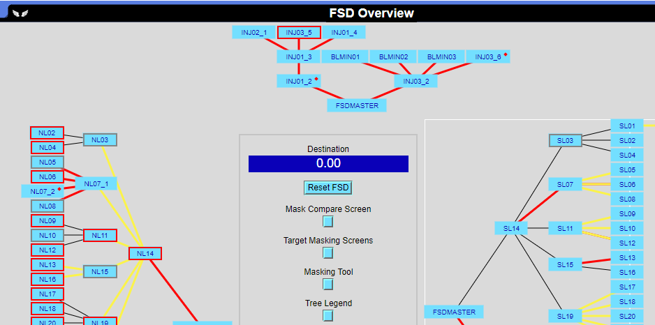
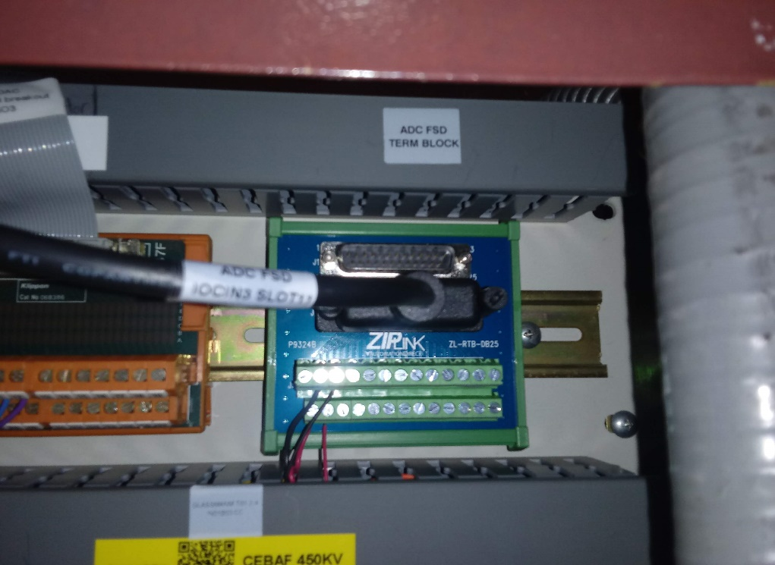
(Fig3) FSD ADC Term Block IN01B03

