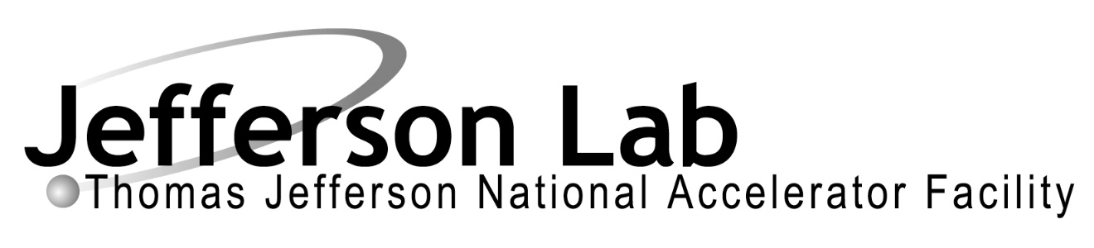

Statement of Work

Document Title: Statement of work for Test of the Bubble Chamber Spring 2018
Document Number: TGT-SOW-18-002
Date: 5/3/2018 | Revision: 0
Author: David Meekins, Riad Suleiman

- Revision History
Revision: 0 | 5/3/2018 | Original
- Definitions
- ANL: Argonne National Laboratory
- CEBAF: Continuous Electron Beam Accelerator Facility
- COO: Conduct of Operations
- The detector: the ANL bubble chamber with can be considered both a target and a detector.
- JLAB: Thomas Jefferson National Accelerator Facility
- E-log: JLAB standard Bubble Chamber electronic logbook available at: https://logbooks.jlab.org/book/bubblelog
- ERG: Emergency Response Guidelines
- JLAB: Thomas Jefferson National Accelerator Facility
- MCC: Machine Control Center
- PPE: Personnel Protective Equipment
- PSS: Personnel Safety System
- RCG: Radiation Control Group
- RWP: Radiological Work Permit
- SOW: Statement of work
- Wiki: Bubble chamber wiki: https://wiki.jlab.org/ciswiki/index.php/Bubble_Chamber
- Purpose and Scope
This document is a SOW for a test run of the ANL Bubble Chamber in the CEBAF Injector on the 5D beam line. The test is planned for the May 2018 and has two main purposes.
- Test performance of the ANL bubble chamber with a single fluid (no buffer fluid).
  - Test using $C_{3}F_{8}$ refrigerant. Note that fluorine has only one isotope in natural abundance.
  - Compare measured cross section for the reaction ¹⁹F(γ,α)¹⁵N in the energy range where the cross section is large ~ 100 nb.
  - To determine if the detector is capable of measuring smaller cross sections, attempt to measure the cross section for the reaction ¹⁹F(γ,α)¹⁵N near threshold of 5.5 MeV. See Figure 1 below.
- Study and develop beam line performance characteristics required for the experiment
  - Energy measurement
  - Energy change step size resolution and width
  - Dispersion, Emittance, position, etc.

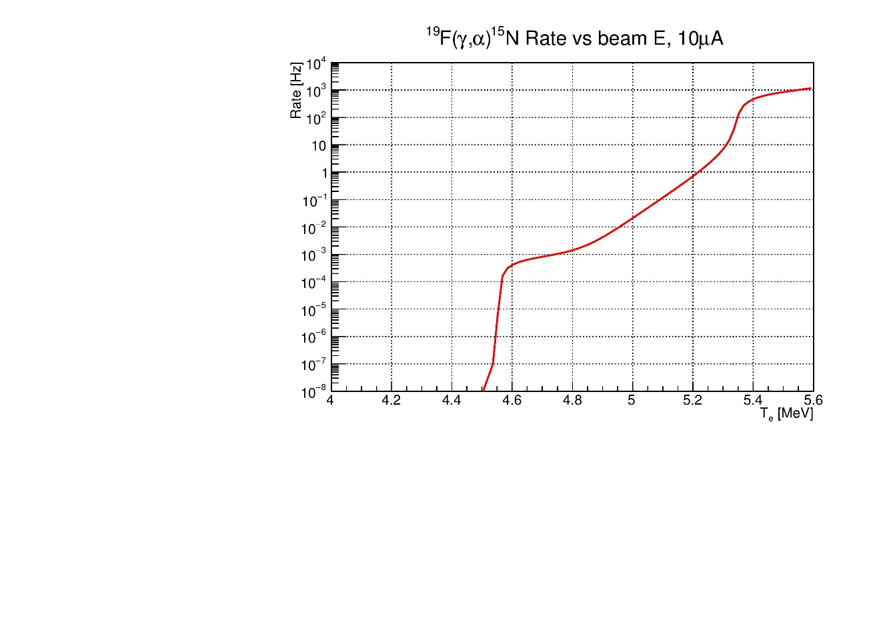
Figure 1: Expected rate for the reaction ¹⁹F(γ,α)¹⁵N as a function of beam energy.
  - Overview and Motivation
The lessons learned from the September 2015 test run showed that two fluid configuration (active fluid plus mercury buffer fluid) was not effective. Therefore, a single fluid configuration has been developed.
The bubble chamber operates by exposing an active superheated fluid to an impinging photon beam. Reactions induced by the photons then cause bubble nucleation in the fluid which are observed with a camera. Other sources of instability, such as sharp corners, nozzle protrusions, and other surface discontinuities, can also cause bubble nucleation and must be supressed for the chamber to function properly. The buffer fluid provided a method for ensuring that the active fluid did not touch these surface discontinuities.
The single fluid configuration does not have a buffer fluid to prevent nucleation near surface discontinuities. Thus, there must be at least two fluid regions:
- Active region where the fluid is superheated
- Inactive region where the fluid is stable
This has been accomplished by inducing a temperature gradient in the fluid such that these two fluid regions are realized. This configuration was tested in the laboratory using a neutron source but, it has not been tested in actual beam conditions.
Another feature of the previous test involved the use of $N_{2}O$ with the oxygen in the fluid being of natural isotopic abundance. This isotopic configuration was used because the active fluid is vented to atmosphere and not recovered after operation of the bubble chamber and enriched (for ${}_{ }^{16}O$) is difficult to obtain and expensive. While the concentrations of ${}_{ }^{18}O$ and ${}_{ }^{17}O$ are small relative that of ${}_{ }^{16}O$ in natural abundance, the they are nonetheless an important source of background as can be see from Figure 2.
In contrast, natural fluorine has only one isotope ${}_{ }^{19}F$ making background subtraction simpler see Figure 1. This allows measurements made a JLAB to be compared with world data for ¹⁹F(γ,α)¹⁵N. It also allows testing of the bubble chamber for both high and low rate configurations to be understood more easily.
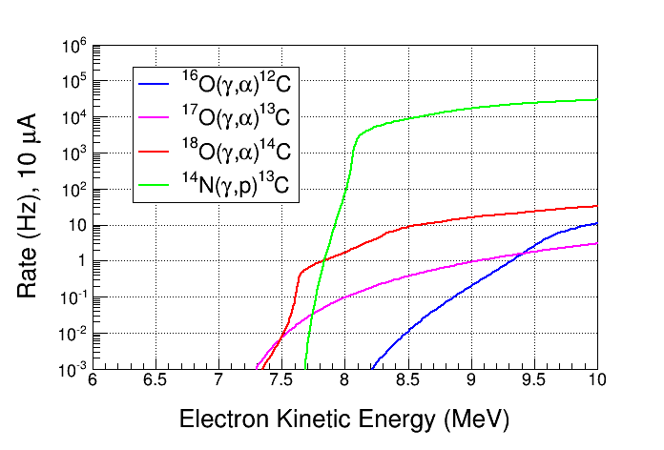
Figure 2: Rates from background reactions compared to the ${}_{ }^{16}O$ channel.
An additional motivation for completing the beam tests proposed is to develop a low energy spread injector configuration and measurement process.
  - Previous Beam Testing at Jefferson Lab
A series of tests were performed in September 2015 using the bubble chamber with $N_{2}O$ as a target fluid and mercury as a buffer fluid. While this test yielded some very useful results, it also highlighted problems with mercury. After a short period of beam operations, deposits on the surface of the mercury buffer fluid caused instabilities in the superheated $N_{2}O$ which rendered the detector inoperable.
The results of these tests have been summarized in the report TGT-RPT-18-002 which can be found on the Bubble Chamber wiki.
Report for September 2015 tests can be found here:
https://wiki.jlab.org/ciswiki/index.php/File:TGT-RPT-18-002.docx
Data/Results from the September 2015 test can be found here:
https://wiki.jlab.org/ciswiki/index.php/Bubble_Chamber_Beam_Test_September_2015
The log book scan can found here:
https://wiki.jlab.org/ciswiki/images/9/94/Bubble_Chamber_Sept_2015_Runs_List.pdf
  - Operational Limits
The following table details the operational limits for selected quantities.
Parameter | Limits
Bubble Chamber Pressure | 0 to 1000 psig
Bubble Chamber Metal Temperature | -15 to 30 C
Total Beam Energy | 4 to 10 MeV
Beam Current | 0 to 50 µA
Detector Fluids | C3F8
Active fluid temperature | -30 to 30 C
Bubble quenching pressure difference | 500 psi max

In actuality, the operating pressures of the chamber will be far less than those listed in the above table.
- Test Plan
This section details a run plan for the bubble chamber test.
  - Pre Beam
    - Bubble Chamber Operational Checks
- Place neutron source about 1 m from chamber
  - Enable bubble chamber and count for 30 min
- Place neutron source about 2 m from chamber
  - Enable bubble chamber and count for 30 min
- Counts should be about factor 4 different
    - Background Rates
Background rates need to be established to δR ∼ 0.25 counts/hour to be a perturbation on the statistical error for the lowest point. For a background rate of 4 counts/hour, this will require 40-60 hours. 10 hours is sufficient for the highest four points.
- No beam
- Enable bubble chamber and count
  - Commissioning
    - High Rate Checkout
High rate checkout beam is T = 5.25 MeV, 1 µA. This should produce a rate of 1 event per 5 seconds (∼ 240/hour with 10 s recovery time).
- Beam width is σx,y = 1 mm
- Beam is centered on radiator
- Beam energy width is ∼3 keV
- Beam energy is 5.250 ± 0.005 MeV
- Bubble chamber recovery time 10 s 2.1
    - Establish Fiducial Region
- Bubble chamber active
- Establish high rate checkout beam for 20 min
- Adjust chamber height so fiducial region is in center of glass
    - Inactivity Test
- Bubble chamber set inactive
- Establish high rate checkout beam for 30 min
- No events should be observed on CCD
    - Establish Rate and Variation with Position
- Bubble chamber active
- Establish high rate checkout beam for 1 hour
- Move beam 3 mm in one direction
- Establish high rate checkout beam for 1 hour
- Rate should be nominally 10-15% lower
    - Width (also divergence) scan? TBD
- Bubble chamber active
- Increase width to σx,y = 2 mm
- Establish high rate checkout beam for 1 hour
- Rate should be nominally 30% lower
    - Recovery Time Scan
- Recovery time set to 8 s
- Bubble chamber active
- Establish high rate checkout beam for 1 hour
  - Normalized rate should be the same as initial rate
- Recovery time set to 10 s
- Establish high rate checkout beam for 1 hour
  - Normalized rate should be the same as initial rate
    - Current Scan
- Bubble chamber active
- Establish 5.25 MeV, 2 µA beam for 1 hour
  - Normalized rate should be the same as initial rate
- Establish 5.25 MeV, 1 µA beam for 2 hours
  - Normalized yield should be the same as initial rate
  - Test Running
- Start with 5.25, 5.15, 5.05 MeV
- Spend shift on 4.75 MeV to see if signal can be identified
- If not revert to 5 point plan
    - 6 Point Plan

Shift | Energy | current | time
May 10 swing | Comm | N/A | 8
May 11 swing | Comm | N/A | 16
May 12 day | 5.25 | 1.5 | 3
 | 5.15 | 4 | 3
May 12 swing | 5.05 | 8 | 6
 | 4.75 | 19 | 8
May 13 Day | 4.95 | 19 | 16
May 14 Owl | 4.85 | 50 | 48
May 16 Day | 4.75 | 50 | 24

