Magnetized Beam Cathode Solenoid Operational Safety Procedure

(MLDGT01 OSP)

October 25, 2016
The cathode solenoid provides a magnetic field of about 1400 Gauss at the photocathode with a maximum operational current of 400 A and operational voltage of 77 V. The magnet and leads resistance was measured to be 0.183 Ohms, the cable adds an additional 0.01 Ohms. With 73 V of applied voltage across the magnet, the power is about 30 kW. The magnet is bare copper coil (no steel around it) and is made of 8 double pancakes (16 layers) by 20 turns with an ID of 12 inches, OD of 28 inches and a thickness of 6 inches. The magnet weighs about 560 pounds and sits in a cradle (weighs 150 pounds) with a hand-driven mechanical motion to move magnet on a stand.

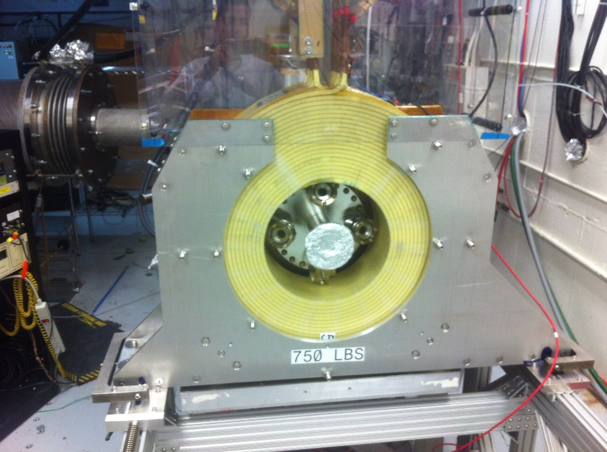
Figure 1: Cathode solenoid magnet positioned in front of the gun chamber.
Hazards
The hazards related to solenoid operation include the following:
- Electrical hazard
- Magnetic field
- Magnet Heating
Mitigation
Electrical Hazard
The power supply for the solenoid operates with input voltage of 480 VAC. The power supply over voltage trip level is set to 79 V. Maintenance and servicing of the power supply can only be conducted by “Qualified Electrical Workers". The supply is located at the GTS mezzanine and is cooled with LCW with flow interlocked.
During normal operation, connections at the power supply are made inside the cabinet that has interlocked doors. Insulated cables carrying current to the magnet are routed with cable tray with all exposed leads covered by nonconductive 0.125" thick Lexan enclosure.
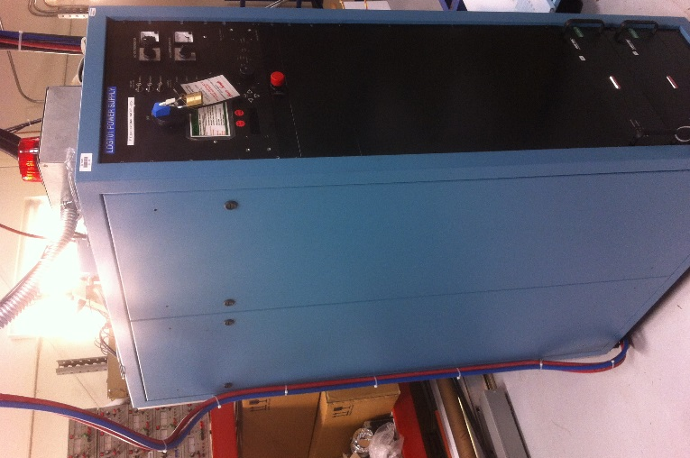
Strobe Light
Crash Button
Figure 2: Magnet power supply at the GTS mezzanine. There is a crash button on the front panel.
Magnetic Field
When powered up to 400 A, the solenoid can generate about 3200 Gauss field inside the bore. The 5 Gauss boundary restricting access by personnel with surgical implants and bioelectric devices and the 600 Gauss whole body boundary were surveyed by Industrial Hygiene. When the solenoid is at 400 A, the medical boundary of 5 Gauss is 7 feet from the solenoid. The highest measurement of 2000 Gauss was taken within 6" of the solenoid. A 5 Gauss boundary sign is posted at the GTS enclosure door and a 600 Gauss boundary is posted near the solenoid.
Strong magnetic field will attract loose ferromagnetic objects, possibly injuring body parts or striking fragile components. Prior to energizing the magnet, a sweep of cordoned area will be performed for any loose magnetic objects. All personnel entering the 600 Gauss area will also be trained to remove ferromagnetic objects from themselves including wallet.
A Concrete Door Interlock will prevent access to the magnet when it is energized. However, there will be a Concrete Door Interlock bypass key to be able to enter GTS with magnet ON. When door interlock is bypassed, to prevent personnel with surgical implants and bioelectric devices from entering the 5 Gauss boundary, strobe light indicators are installed on the top of power supply and at the access door down stairs to show solenoid is energized as well as flashing red beacons and personnel barricades are installed at the actual 5 Gauss contour.

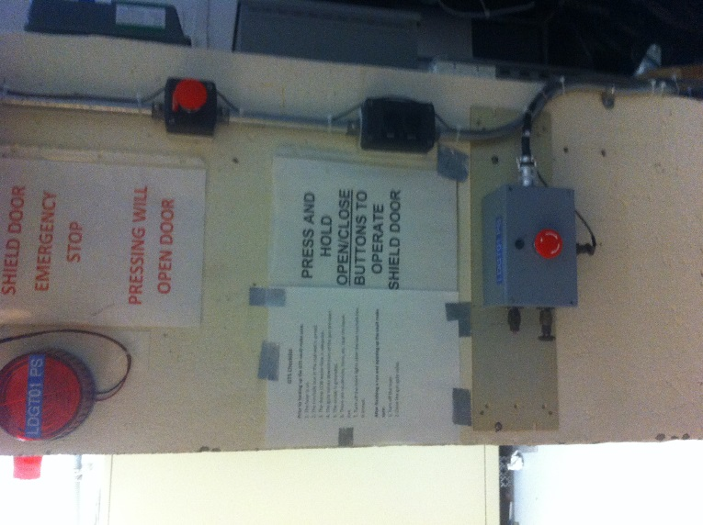
Strobe Light
Crash Button
Figure 3: Magnetic field strobe light indicator at the access door. Also shown, the magnet power supply crash button.
Magnet Heating
At 400 A, the total power deposited in the magnet is about 30 kW. LCW is used to cool the magnet with flow rate of about 4.7 GPM. Before connecting the magnet, the LCW flow was measured to be about 6.8 GPM. The flow to the magnet is interlocked to the power supply with a trip level of 4.00 GPM. The temperature of the magnet is interlocked to the power supply using 8 Asahi US-602S Thermal Switches (65 C) mounted on each of the 8 return conductors (one for each of the double pancakes). These switches are normally closed and open when temperature exceeds 65 C and automatically reset when temperature drops below 49 C. With magnet at 400 A, the hottest temperature measured is about 58 C (136 F) with the 4.7 GPM LCW flow rate.
Figure 4: Cathode magnet LCW flow rate monitor chassis at the GTS mezzanine.

Power Supply Operation

To be able to turn on the magnet power supply, these inlocks must be green:
- Magnet LCW (>4.00 GPM)
- Magnet temperature (<65 C)
- Power Supply Voltage (<79 V)
- Power Supply LCW flow (>1.25 GPM) – nominal flow is 2.2 GPM
- Concrete Door Interlock – unless bypassed by key
There are three power supply crash buttons located at:
- Power supply front panel
- GTS enclosure access door
- PS Interlock chassis in GTS control room

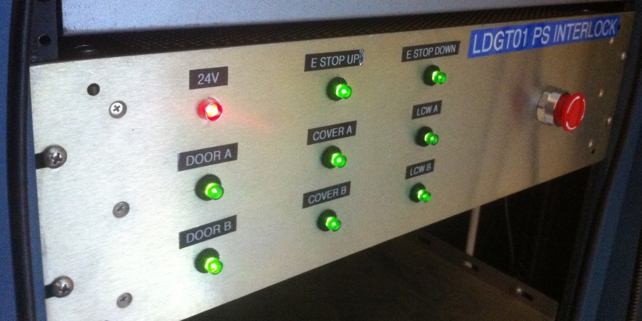
Crash Button
Figure 5: Cathode magnet power supply interlock box in the GTS control room.
The PSS Interlock chassis displays the status of the power supply interlock. All interlocks must be green to be able to turn the supply ON. LCW A: LCW B: …

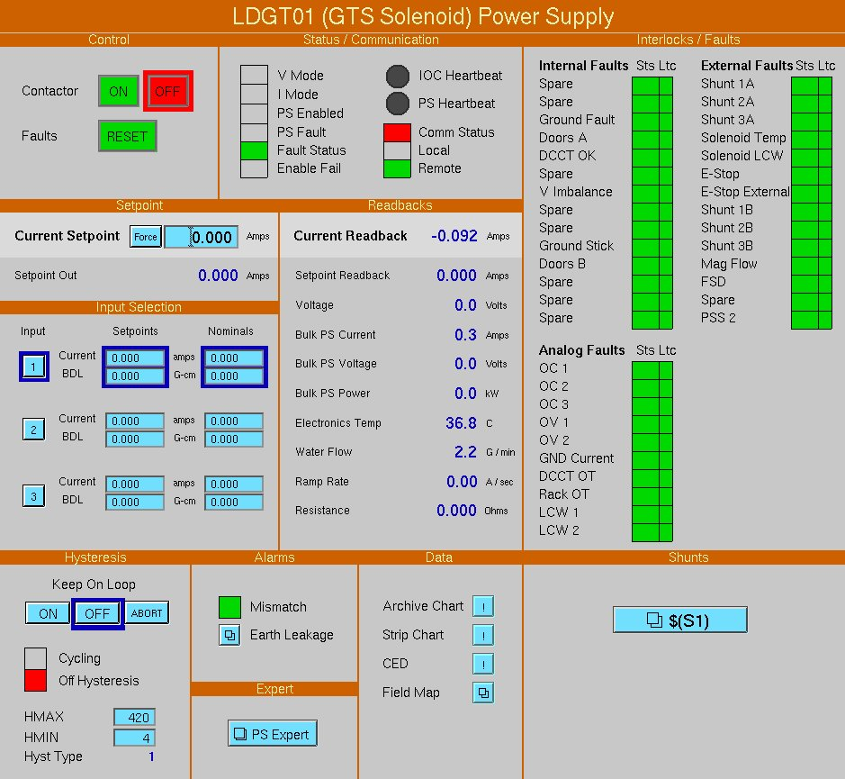
Figure 6: Cathode Solenoid power supply control screen
Responsible Personnel
The individuals responsible for the operation of the solenoid will be trained and listed here.
Mark Augustine | augustin@jlab.org | 7103
Kevin Banks | banks@jlab.org | 7418
Riad Suleiman | suleiman@jlab.org | 7159
Carlos Hernandez-Garcia | chgarcia@jlab.org | 6862
Md Abdullah Mamun | mamun@jlab.org

