MOLLER Helicity Magnets Upgrade –

Requirement Document

Joe Grames, Paul King, Caryn Palatchi, Kent Paschke, Riad Suleiman

November 25, 2022

The MOLLER experiment anticipates making use of corrector magnets installed in the low energy injector region, referred to as “Helicity Magnets”. There should be two magnets for each dimension (x, y), physically separated by >1 m and independently controlled to allow for independent control of beam angle and position. This system should be capable of use for a couple of different purposes. The primary purpose is helicity-correlated feedback correction. For this, the magnets should deflect the beam synchronous with the real-time helicity of the electron beam. This may be used for a real-time feedback (similar to the charge feedback performed with the Pockels cell voltage), with helicity-dependent corrections updated on a slow (few minute - few hour) time scale. The system will also need to support a calibration mode, creating a much larger modulation of the beam which will be measurable in the experimental hall in a reasonable amount of time. The calibration mode can be used to measure the adiabatic damping in injector and Hall A.

# Functional requirements for Helicity Magnet Control:

1. Disabled state: The magnets should have a “disabled” state in which the controllers do not process the real-time helicity signal (or, process only in an entirely electrically isolated system). In this state, the magnets should be unpowered and, preferably, terminated in a way that minimizes noise due to electronic pickup near the kHz frequency scale. One way to achieve this is to divert the output to a resistor.
2. Transition speed: The applied beamline magnetic field should be stable within 5% within 10 μsec of the start of a new helicity state, and within 2% within 30 μsec, and remain within that range through the end of each helicity state.
3. Differential control: Only a single control parameter is needed: the difference between the two helicity states. The magnet setpoints between the two states should then be +/- half of this difference, or else zero for one state and the full value of the difference for the other state.
4. Real-time helicity: The magnets should be controlled between two set points using the real-time helicity signal.
5. Electrical isolation: Great care is required to maintain security of the real-time helicity signal. The controls and magnets should be electrically isolated in the same manner as the helicity generator board.
6. Precision: Bit resolution in “Operation Mode” of 1 nrad deflection at each magnet. Random noise at the 1 kHz frequency range can be 5x higher without degrading the system performance. These requirements can be relaxed by 10x in a separate “Calibration Mode”, if required.

[To translate to the expected beam measurements in the hall: assume 10x damping, 1-10 m characteristic length scale, corresponds to 0.1-1 nm position differences in the hall.]

1. Dynamic range - calibration mode should allow up to 20 μrad deflection, with >1 m between the magnet pair. If required, a separate operation mode with a 10x smaller dynamic range would be sufficient.

[To translate to the expected beam measurements in the hall: this spec allows for 20 μm position difference, and should create visible effects in Hall at few minute measurement times. Specifically, for roughly 2 μm position difference in the hall (in the case of 10x damping), with an angle difference from 1-10x smaller.]

1. Linearity: the beam deflection vs. setpoint should be linear within about 5%, so that the response measured in calibration is accurate for small excursions in operation mode.
2. Stability: the beam deflection gain vs setpoint should be stable within 5% at time scales of 1 week or more.
3. Data logging: the setpoints and state (active, disabled) should be logged and archived with about 1 second time resolution for the full length of the MOLLER run (about 4 calendar years). Alternatively, the changes and times of the changes can be logged, with that resolution.

# Magnets Properties:

Each of the four identical air-core magnets is made of ? m long Litz wire (7x24/30) with a inductance of 5 µH and resistance of ?Ω (0.655 Ω/MFT or 1000 ft). The field profile will be measured at the Magnet Test Facility and compared to a model. Peak fields from these magnets are much less than 1 Gauss.

# Description of Current Controls:

## Control system Fibers (5 fibers):

1. Tx and Rx for ethernet communication.
2. Both nHelicity Flip and T_Settle fibers are available at the control system. nHelicity Flip is used to control the current output to the magnets. T_Settle is not used in the control system but rather to check signals on Oscilloscope for diagnostic purposes.
3. 30 Hz PZT Booster System fiber. This system will be removed. FOpt (in Custom Mode) will be used instead.

## Outputs and Beam Response:

1. DAC of -8000 → 8000 gives -50 mA → 50 mA.
2. Output current can be dumped in a resistor or to power magnet
3. Slopes of about 0.1 µm/DAC in the 5 MeV region

Note: the above slopes were found to be rather large during QWeak experiment in 2012. To reduce the slopes, we added 220 mΩ resistor in parallel with each channel of magnet and series load resistors (approximately 3.8 Ω). Current through a given magnet was reduced to 2.5 - 3% of the total amplifier output current.



Figure 1: Helicity magnets control crate in CEBAF injector.

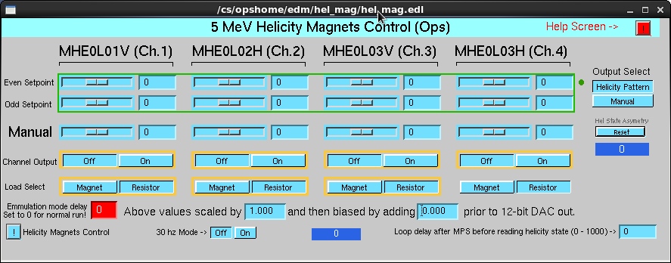

Figure 2: Helicity magnets control screen. For the upgrade, the “Manual Mode” will be used, too. The 30 Hz Mode was used as a PZT booster system to measure adiabatic damping in the Injector. This sys is not in use anymore. FOPT system will be used instead..

# Known Problems:

### Overshoot, Rise Time and Delay to Respond – see Figure 3.



Figure 3: Measurement of helicity magnet overshoot, rise-time and response to the nHelicity Flip.

### Noisy Output – see Figure 4.



Figure : Measurement of output noise.

# Changes to Control System:

These are the changes to the control system:

1. Change to 16-bit DAC to reduce slopes to be about 1 nm/DAC in the 5 MeV region
2. Reduce amplifier output current from 50 mA to 5 mA (or use 50 mA amplifier with shunt resistor). DAC of -65000 → 65000 should give -5 mA → 5 mA.
3. Reduce overshoot to be less than 5% of the setpoint
4. Increase rise time from about 4 µs to 10 µs (to reduce overshoot)
5. Reduce the delay between the nHelicity Flip and magnet output from 17 µsec to less than 1 µsec
6. Output Noise: Reduce output noise to less than 1% of the setpoint at all frequencies
7. Add additional 6 output channels for possible future use (e.g., Helicity Quadrupole Magnets). Right now, we have only 4 outputs.
8. Each channel will have its range of amplifier current output
9. Two output current ranges for each channel (low and high) for Operational and Calibration Modes.
10. For a quadrupole, currents as high as 250 mA might be needed.