- Generation and Characterization of Magnetized Bunched Electron Beam from a DC Photogun for JLEIC Cooler
Principal Investigators: Riad Suleiman and Matt Poelker

Project Status
We finished year 1 demonstrating non-magnetized beam at maximum current 1 mA and started implementing a long list of improvements. The gun solenoid was installed and commissioned. The highlight of Year 2 has been the demonstration of magnetized beam. Numerous sub-accomplishments in the past 6 months allowed us to reach this milestone. Accomplishments include:
- Upgraded the photocathode preparation chamber to:
  - Enable photocathode fabrication using a mask to limit the photocathode active area to reduce beam halo and eliminate high voltage arcs,
  - Biased photocathode holder (puck) to allow monitoring of photocurrent during activation and to measure QE in-situ, and
  - Adjustable gap between puck and Cs-K effusion source for precise film growth.
- Upgraded the photogun HV chamber: replaced the conventional alumina insulator with doped-ceramic insulator – that possesses a very mild conductivity – and replaced the original triple point shield with newly designed shield that reduces the maximum field strength inside the gun, which will enable reliable photogun operation at higher voltage.
- Installed windows on the gun high voltage chamber with anti-reflection coatings, to minimize reflections and production of stray light that can generate “halo” that strikes vacuum chamber walls, degrading vacuum and contributing to high voltage arcs.
- Learned that the gun solenoid can trigger field emission when gun is biased at HV. Re-conditioned the gun with solenoid currents to 400 A, and developed procedure to ensure solenoid does not trigger new field emission.
- Rebuilt the beamline to install the slits to measure beam rotation and emittance and added an insertable Faraday Cup. The new beamline has two ion precipitators to help prevent ions from migrating to the gun and producing high voltage arcs that damaged QE and prevented operation at currents higher than 1 mA. A 2.5 kW fixed dump was added for milliampere beam tests. Differential pump chambers were added to isolate gun vacuum from dump vacuum. Figure 1 shows the magnetized beamline.
- Upgraded the laser system by adding laser power meters, tune-mode generator and steering mirrors.
- Commissioned the method to measure beam emittance using viewers.
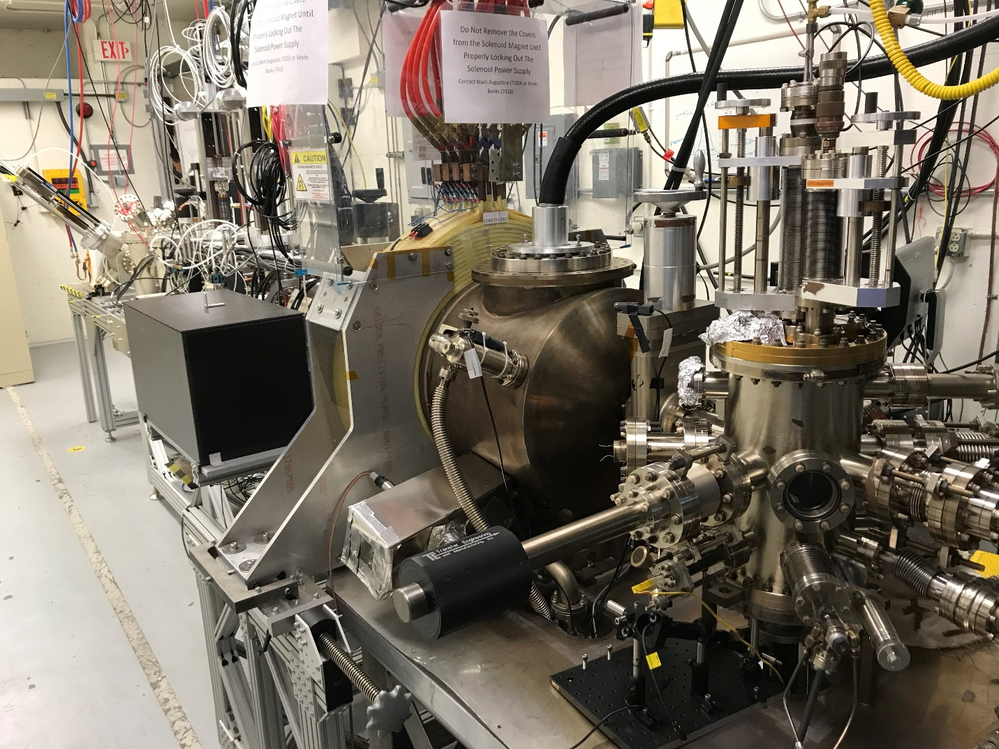
Figure 1: Magnetized beamline at the Gun Test Stand (GTS).

- Delivered 20 µA magnetized beam to the Faraday Cup. Measured beam rotation using the slit and view screen method as shown in Figure 2. The beam size at the photocathode was 0.525 mm and magnetic field was 1.45 kG. These values were used to predicted beam magnetization. There is good agreement between prediction and measurement.
- Conceived an idea to non-invasively measure beam magnetization with TE₀₁₁ RF cavity and filed a patent disclosure titled “Non-invasive RF Cavity to Measure Beam Magnetization”. Non-invasive monitoring techniques will be required to implement cooling using the circulator ring.
- ODU graduate student Yan Wang (advisor: Prof. Geoffrey Krafft) has started making thesis measurements using the GTS photogun and beamline. His thesis is not related to magnetized beam but his work at the GTS greatly facilitates the magnetized beam project. For example, he designed the new triple point shield that has allowed us to operate the new photogun at 300 kV, and later (we hope) at higher voltages. Operation at higher voltage is an important requirement for demonstrating beam production at nC bunch charge.
- Sajini Wijethunga, student from ODU, has started her Ph.D. thesis on magnetized beam (advisor: Prof. Jean Delayen, funded by 75% JLab + 25% ODU).
- Hired postdoc – Dr. Mamun Md Abdullah – who recently graduated from ODU. Mamun was instrumental in developing the alkali-antimonide photocathode deposition chamber.

Figure 2: Measuring magnetized beam rotation using slit and viewer: with gun solenoid off (left) and with gun solenoid at 400 A generating 1.45 kG at photocathode (right).

Project Plan
Work during the remainder of FY17 will focus on generating magnetized beam at currents up to 5 mA, with RF structure, and to study magnetization versus gun solenoid field and laser size. This includes:
- Generate non-magnetized beam and commission the new beamline to fixed dump.*
- Work with Radiation Control Group for approval at high currents.*
- Measure thermal beam emittance using the solenoid-viewer method. Use the beam to evaluate the electrostatic features of the inverted insulator gun geometry. Correlate thermal emittance values to different alkali-antimonide photocathode recipes, which can produce widely varying photocathode surface morphologies.*
- Measure photocathode lifetime at currents up to 5 mA (non-magnetized).*
- Determine if biased precipitators serve to improve the photogun lifetime.*
- Measure magnetization vs gun solenoid field and laser size.
- Benchmark simulation against measurements.
- Measure photocathode lifetime vs magnetization at 5 mA and 300 kV.
- Measure magnetization with steel/hybrid pucks.
- Study beam halo and beam loss vs magnetization.
- Install RF laser.
- Design TE₀₁₁ cavity for non-invasive measurement of beam magnetization.
- Modify OSPs to allow operation with 225 kV Spellman high voltage power supply capable of beam production at current up to 32 mA.

* Only partially funded by this LDRD. Nevertheless, part of the milestones and pre-requisite to LDRD work.

Note: Plan to submit LDRD proposal for 3rd year funding that includes commissioning of TE₀₁₁ cavity with magnetized beam.

Budget
During the first half of the year, we have spent 30% of our budget. The spending will ramp up, in particular, to enable beam production with RF structure.

Publications
N/A

Workshops/Conferences
R. Suleiman, M. Poelker, J. Benesch, F. Hannon, C. Hernandez-Garcia, Y. Wang and S. Zhang, Magnetized Bunched Electron Beam from DC High Voltage Photogun, Physics of Photocathodes for Photoinjectors (P3) Workshop, Newport News, VA, October 17–19, 2016.
https://www.jlab.org/indico/event/124/

