# https://www.jlab.org/div_dept/dir_off/public_affairs/logo/JLab_logo_text_white_bw1.jpg

# Report

|  |  |
| --- | --- |
| Document Title: September 2015 Test of Argonne Bubble Chamber | |
| Document Number: TGT-RPT-18-002 | |
| Date: 5/3/2018 | Revision: 0 |
| Authors: B. Digiovine, A. Freyberger, J. Grames, R. Holt, D. Meekins, M. Poelker, K. E. Rehm, Y. Roblin, R. Suleiman, C. Ugalde | |

Description: Report of results from Argonne Bubble Chamber testing performed 10 to 18 September 2015 on the 5D beamline in the CEBAF Injector.

1. Revision History

|  |  |  |
| --- | --- | --- |
| Revision: 0 | 5/3/2018 | Original |

1. Definitions

* ANL: Argonne National Laboratory
* CEBAF: Continuous Electron Beam Accelerator Facility
* COO: Conduct of Operations
* JLAB: Thomas Jefferson National Accelerator Facility
* E-log: JLAB standard Target Group electronic logbook available at: <https://logbooks.jlab.org/book/targetlog>
* ERG: Emergency Response Guidelines
* JLAB: Thomas Jefferson National Accelerator Facility
* MCC: Machine Control Center
* PPE: Personnel Protective Equipment
* PSS: Personnel Safety System
* RCG: Radiation Control Group
* RWP: Radiological Work Permit

1. Overview

The carbon-helium fusion reaction is considered to be the key reaction in the helium burning of stars because it determines not only the carbon and oxygen abundances in stars and, ultimately, in the universe, but also the nucleosynthesis of all heavier elements. Stellar evolution models in which nuclear reaction networks are implemented in detail still do not yield consistent results. The cross section for the 12C(α, γ)16O reaction is probably one of the most important nuclear physics input parameter uncertainties that needs to resolved. Extensive work regarding this reaction has been done both by theorists and experimentalists. However, the tiny cross sections involved have proven to be a major obstacle in constraining the size of its error bar. Much work is still needed to improve the situation. Experiment E12-13-005 seeks to determine the reaction rate of 12C(α,γ)16O by measuring the inverse reaction 16O(γ,α)12C.

1. Scope of Test

The intent of the test was to use the injector test area with a maximum total beam energy of 10 MeV (9.5 MeV kinetic) to test the operational characteristics of the ANL Bubble Chamber. The electron beam was fully stopped by a water cooled copper dump/radiator. The purpose of the test at JLAB is to determine the photon detection effectiveness in a low neutron background environment. Operating parameters (e.g. pressure, temperature, fluid, event rate, buffer fluid level) shall be adjusted within a safety envelope to improve photon detection and chamber recovery times. The active fluids planned for the test are $N_{2}O$ and $C_{3}F_{6}$; the chosen buffer fluid was mercury. The oxygen used in the $N_{2}O$ was of natural isotopic abundance. Background reaction channels from other isotopes of oxygen and nitrogen are therefore present in main reaction channel. Figure 1 below shows various background contributions and their thresholds.

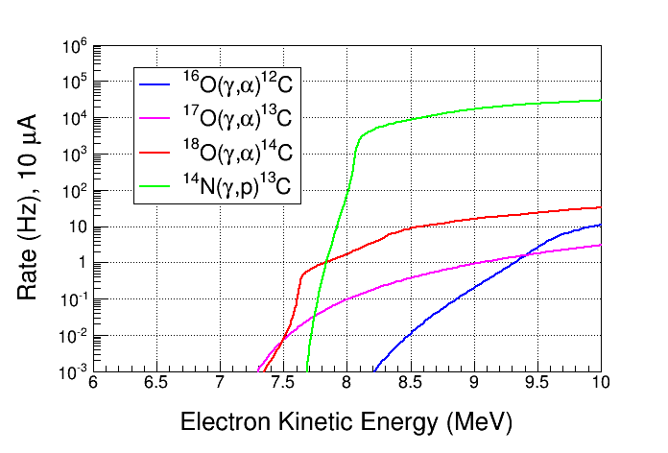

Figure 1: Background contributions to the main reaction channel (shown in blue). Note the varied thresholds for these channels.

The following table details the operational limits for the test.

|  |  |
| --- | --- |
| Parameter | Limits |
| Bubble Chamber Pressure | 0 to 1000 psig |
| Bubble Chamber Metal Temperature | -15 to 30 C |
| Total Beam Energy | 4 to 10 MeV |
| Beam Current | 0 to 10 µA |
| Detector Fluids | C2F6 and N2O |
| Active fluid temperature | -30 to 30 C |
| Bubble quenching pressure difference | 500 psi max |
|  |  |

Table 1: Operational limits for selected parameters during the test.

* 1. Test Plan

The test plan shall consist of two phases. The first where the chamber is filled with N2O as the active fluid and the second where this fluid is C2F6. The following is an outline plan for the test:

* Phase 1:
  + Ensure that the DAQ and hydraulic systems are functioning properly.
  + With beam on the dump operate the detector.
    - Check counting rates especially multiple bubble production
  + Measure bubble distribution in the chamber.
  + Background measurements:
    - Measure beam off background
    - Measure beam on background by examining outside the fiducial volume
    - Measure background with beam on Faraday Cup.
    - Measure neutron events in chamber when beam energy is above kinetic 8.5 MeV. Use neutron detectors in Injector area to measure neutron production rate.
  + Measure electron beam parameters.
    - Momentum, beam charge at different currents, etc.
* Phase 2:
  + Ensure that the DAQ and hydraulic systems are functioning properly.

Measure rate to calibrate detector using Penfold-Leiss unfolding analysis. This can be compared to the neutron rich data from Duke.

1. The ANL Bubble Chamber Detector
   1. General Description

The Argonne Bubble Chamber was developed and tested at Argonne National Lab (ANL) by Brad DiGiovine et. al. The Chamber may be adapted for use with various super-heated target fluids. These fluids are contained in a glass vessel with a fluid volume of 40-60 ml depending on the fill configuration. There is an additional 150 ml of mercury that serves as a buffer fluid. The purpose of the buffer fluid is to “lift” the active fluid away from sharp protrusions that could cause nucleation in the superheated fluid. The small bubble chamber vessel is contained in a larger (~7.5 liter) pressure vessel. The space between the two vessels is filled with a mineral oil based heat transfer liquid pressurized to a maximum of 1000 psi. The pressure in the glass vessel and the pressure vessel are commuted via a bellows assembly such that the differential pressure across the glass is very small. Should the inner vessel fail all fluids would be contained in the outer pressure vessel. See the figures below for more details. The system has two copper collimator/beam ports and two commercially supplied viewports. See Figure 2 below.

COPPER WINDOW

BUBBLE CHAMBER

PRESSURE VESSEL

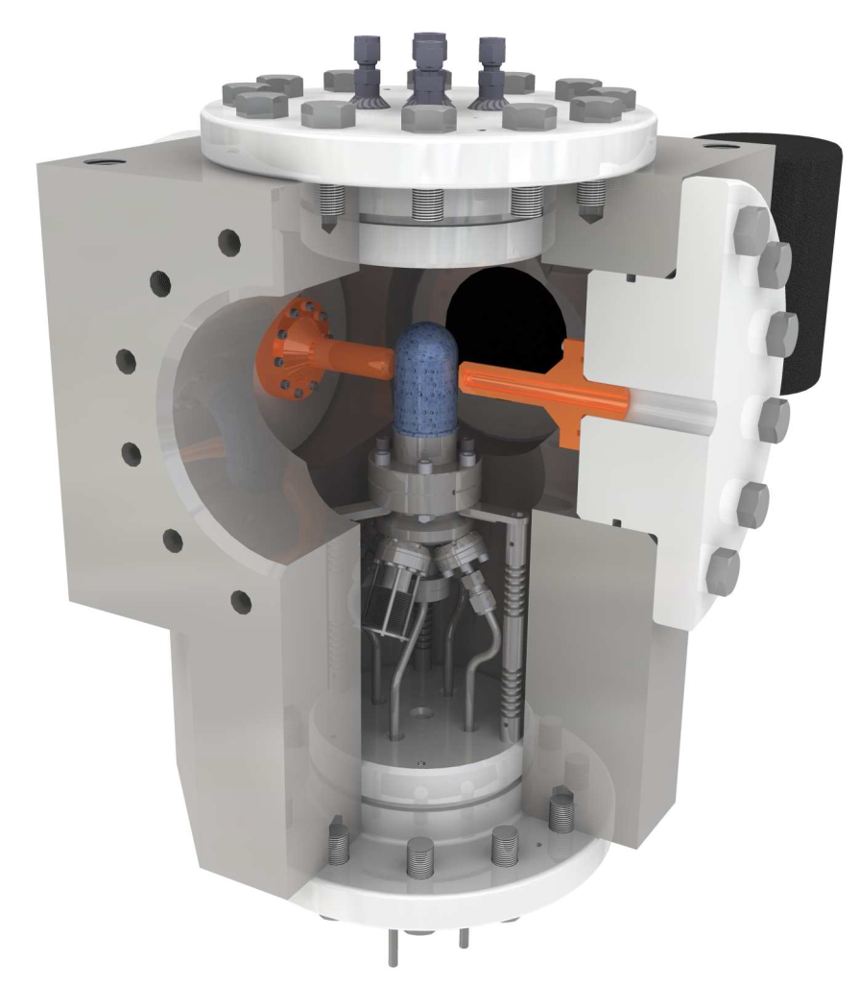

Figure 2: Bubble chamber and pressure vessel cut away view

* 1. Basic Theory of Operation



Figure 3: Basic Components

This system is designed to prepare the active fluid of choice into a metastable superheated state to act as an active target for low energy nuclear astrophysics research. There are two main volumes, the first is a small clean volume containing the active fluid and buffer fluid. This volume is built of stainless steel and glass and is contained within the heavy wall stainless steel pressure vessel. An edge welded bellows is incorporated into this clean volume to facilitate volumetric changes due to changes in operating temperature, as well as to equalize pressure between this clean volume and the outer hydraulic volume. Surrounding this clean volume within the heavy wall vessel is a hydraulic working fluid. This fluid provides for thermal stability of the active fluid, and is directly connected to the pressure supply system external to the vessel. The pressure supply system is a hydraulic system which controls the system pressure by the actuation of solenoid valves allowing the system to cycle between superheat pressure (low) and recovery (high) pressure (points 3 and 2 in the Figure 4). The active volume is backlit and observed by a fast machine vision camera operating at 100Hz. The data acquisition and control computer analyzes these images, determines if an event has occurred, stores the event, logs instrumentation data, and signals the system to pressurize to the default recovery state from the active superheated state. Once the system recovers, the computer signals to decompress to the superheated state and the system goes live again. The bubble evolution and quench are shown in Figure 5. Temperature control is accomplished via an external chiller and flow control system which is manually operated. This system feeds heat exchange coils within the hydraulic volume, this has replaced an existing heating system which is no longer present, but sometimes referenced in older documentation.

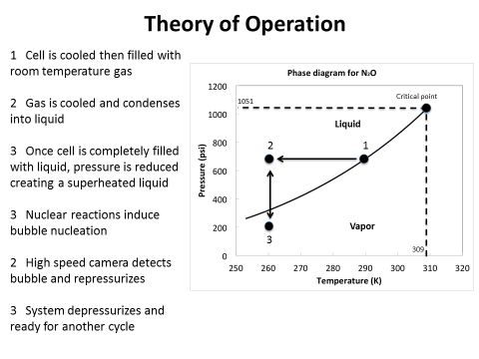

Figure 4: Phase Diagram and Theory of Operation

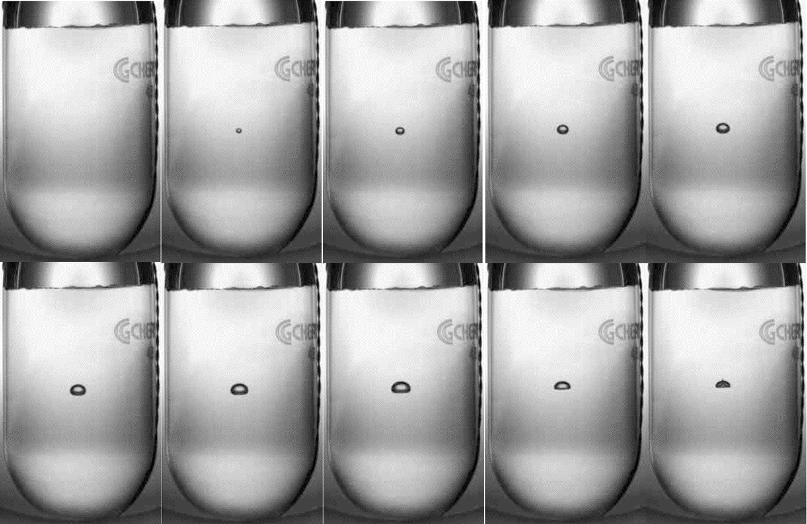

Figure 5: Evolution of bubble with time step of 10 ms. The bubble forms and is then quenched by the application of pressure.

1. Installation

The ANL Bubble Chamber was installed at the end of the 5D beam line in the CEBAF Injector. The installation is shown in Figure 5 below. A schematic representation of the beam line is shown in Figure 6. Figure 7 shows the reaction chamber with $N_{2}O$ as the active fluid and mercury as the buffer fluid.

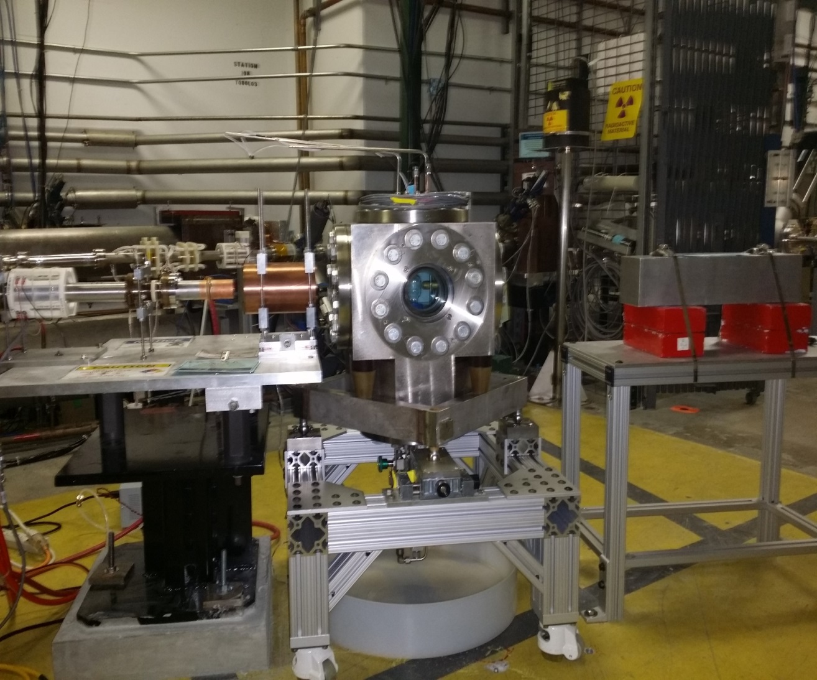

Figure 6: Installation or ANL Bubble Chamber in 5D beam line.

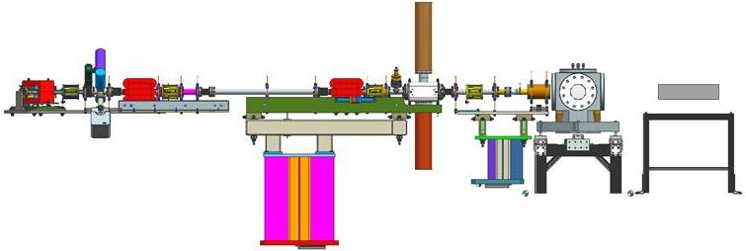

Figure 7: Schematic representation of the beam line for the test.

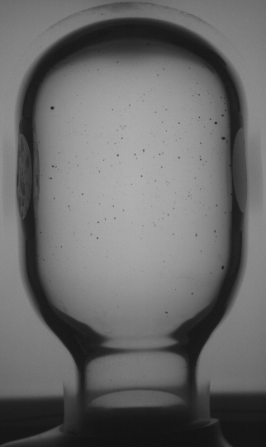

**Hg**

**N2O**

Figure 8: Reaction chamber with $N_{2}O$ as the active fluid and mercury as the buffer fluid.

1. Beam Test Results

Several elements of the test plan were completed. The detector hydraulics and controls operated as designed. Relevant beam parameters were measured as well. Three measurements at the higher energies were made using the Cu beam dump/radiator and the ANL Bubble Chamber. These are summarized in the table below.

|  |  |  |
| --- | --- | --- |
| Energy Measured  (MeV) | Superheat Pressure  (atm) | Beam Current  (µA) |
| 7.7 | 2.8 | 0.4 |
| 8 | 2.8 | 0.4 |
| 8 | 2.8 | 0.04 |
| 8 | 3.8 | 0.035 |

Table 2: Summary of measurements made with superheat temperature of -8 deg C.

The detector was successfully tuned to be insensitive to the ${}_{ }^{14}N\left(γ,p\right){}_{ }^{13}C$ reaction. Background rates for cosmic triggers were measured. Note that the highest beam energy used was below the threshold for 16O(γ,α)12C.

When attempting to make measurements at lower beam energies, it was noticed that the bubble chamber would trigger as soon as it achieved the superheated condition. Upon investigation this was attributed to black deposits observed on the surface of the mercury buffer fluid, which created bubble nucleation sites. See Figure 8. Attempts were made to remove these deposits but they were unsuccessful and further testing was aborted.

**Hg**

**N2O**

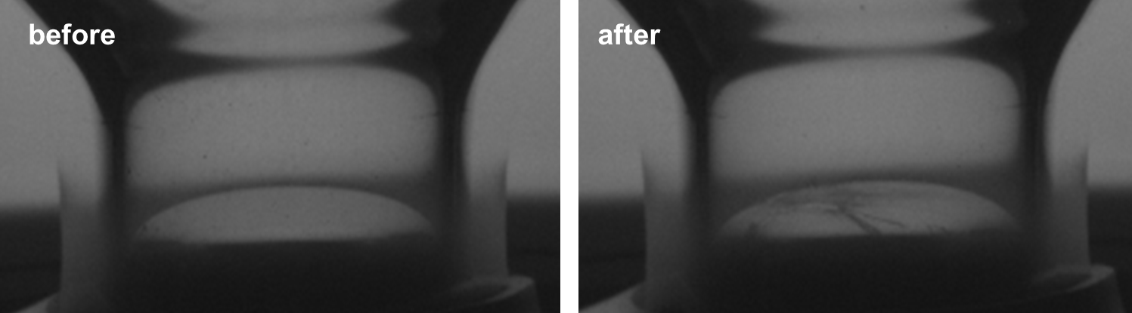

Figure 9: Bubble chamber before and after many hours of beam exposure. The after picture shows a skim of black deposits on the surface of the mercury.

The plot in Figure 10 shows the measurements made with model predictions of the applicable background channels. Unfortunately no data were taken of the 16O(γ,α)12C channel.

Figure 10: Measurements made during test shown with scaled model predictions of the rates of background channels. Note the threshold for 16O(γ,α)12C is above 8.2 MeV.

1. Conclusions

The mercury buffer fluid proved to be problematic and any other choice would likely have similar problems. The decision has been made to remove the buffer fluid and operate in single fluid mode only. A single fluid bubble chamber has been developed and tested with neutrons using $C_{3}F_{8}$ as a superheated fluid. A test with Fluorine is planned for the future. Fluorine has the advantage of only a single isotope in natural abundance. Thus, measurements of the 19F(γ,α)15N reaction made using the ANL Bubble Chamber could be compared to world data in the ~ 100 nb region. Extending these measurements in the picobarn region would show that the detector is capable of measuring cross sections of the size expected for the reaction 16O(γ,α)12C in the energy region of interest.

1. References
2. Bubble Chamber Wiki: <https://wiki.jlab.org/ciswiki/index.php/Bubble_Chamber>
3. PAC Proposal for E12-13-005: <https://wiki.jlab.org/ciswiki/images/e/e3/PAC40_proposal.pdf>
4. Bubble Chamber E-log: <https://logbooks.jlab.org/book/bubblelog>
5. Bubble Chamber paper logbook scan: <https://wiki.jlab.org/ciswiki/images/9/94/Bubble_Chamber_Sept_2015_Runs_List.pdf>
6. Procedure TGT-PROC-18-001 - Argonne Bubble Chamber Operations for Engineering Runs <https://misportal.jlab.org/jlabDocs/document.seam?id=103474>