- Generation and Characterization of Magnetized Bunched Electron Beam from a DC Photogun for JLEIC Cooler
Principal Investigators: Riad Suleiman and Matt Poelker

Project Status
The list below summarizes proposed goals for the LDRD project, grouped by year. Check marks () indicate subtask complete, and “Xs” indicate work in progress. Strikethrough lines represent tasks no longer deemed worth pursuing. Specifically, round-to-flat beam transformation - originally an important feature of the proposed JLEIC recirculator-cooler ring design – is no longer required for the JLEIC recirculator-cooler. We seek permission to remove related tasks from the remainder of the LDRD project, and instead focus more attention on non-invasive measurements of beam magnetization using TE₀₁₁ RF cavities.
Related to Year 3 mid-year progress, we report a significant ~ three-month long delay associated with a recent photogun insulator failure. After more than 1400 hours of reliable operation at 300 kV, the photogun insulator suffered a high voltage arc that punctured the insulator and necessitated complete replacement. The photogun was repaired and is presently being baked to achieve acceptable vacuum conditions. We expect to resume the planned LDRD program in the coming weeks. Despite this delay, we expect to accomplish all of the listed goals within the allotted time, albeit not the subtasks related to round-to-flat beam transformation.

Year 1 project goals:
- HV condition gun to 350 kV and build K₂CsSb preparation chamber
- Design beamline, locate magnets and diagnostics at optimum positions
- Design cathode solenoid magnet
- Connect existing beamline to gun and instrument beamline
- Procure cathode solenoid magnet
- Design and procure slits
- Commission exiting beamline with beam
- Measure photocathode lifetime at 1 mA and 300 kV (non-magnetized)
- Relocate new spare CEBAF dogleg power supply to GTS
- Install cathode solenoid magnet
- Assemble new beamline and commission with beam
Year 2 project goals:
- Generate magnetized beam
- Measure mechanical angular momentum vs magnetization and laser size
- Benchmark simulation against measurements
- Measure mechanical angular momentum vs magnetization and laser size
- Benchmark simulation against measurements
- Measure photocathode lifetime vs magnetization at 5 mA and 300 kV
- Study beam halo and beam loss vs magnetization (low bunch charge)
- Design TE₀₁₁ cavity to measure beam magnetization
- Measure mechanical angular momentum vs bunch charge X
- Generate very high current magnetized beam and study beam transport vs electron bunch charge X
- Design and procure three skew quads
Year 3 project goals:
- Commission TE₀₁₁ cavity with beam X
- Install three skew quads
- Generate flat beam with skew quads RTFB Transformer –and measure horizontal and vertical emittances using slit method
- Measure RTFB transformation versus electron bunch charge
- Use simulation to quantify how good or complete RTFB transform
- Change to HV Supply capable of 32 mA and 200 kV X
- Measure photocathode lifetime vs magnetization at 32 mA and 200kV X
- Study beam halo and beam loss vs magnetization (high bunch charge) X

Beyond the official project goal subtasks listed above, we state in slightly more detail some of the highlights of the first half of Year 3. Accomplishments include:
- Measured electron beam sizes and magnetization rotation angles along the beamline for different laser spot sizes at photocathode, and for a wide range of magnetic fields.
- Developed ASTRA and GPT simulations and now there is very good agreement between measurement and prediction – see Figure 2.
- Constructed and installed a green-light laser with rf structure that relies on a gain switched master oscillator and powerful enough to generate tens of millampere beam current. Laser has operated stably for the last six months without any intervention.
- Completed design of the TE₀₁₁ cavity for non-invasive measurement of beam magnetization. Drawings and 3D models are ready, procured copper blocks and shipped to an off-site machine shop.
- SBIR Phase II awarded to sbir-partner Electrodynamic, “Resonant Polarimetry and Magnetometry”. This partnership will provide another TE₀₁₁ cavity for us to test.

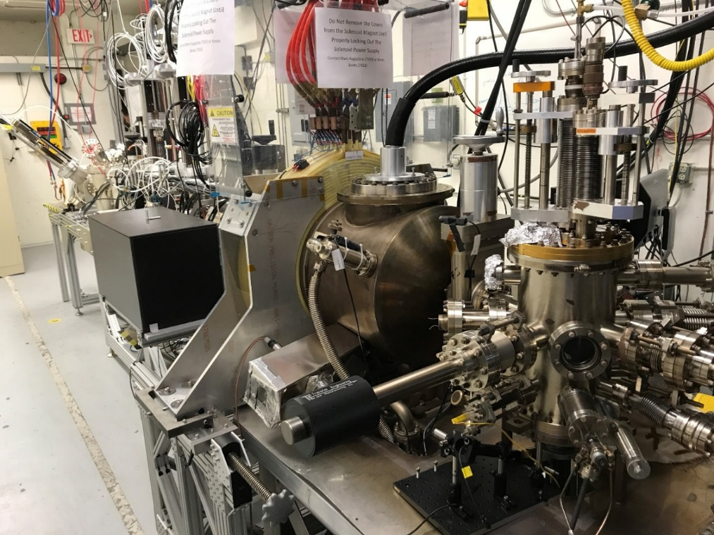
Figure 1: Magnetized photogun and beamline at the GTS

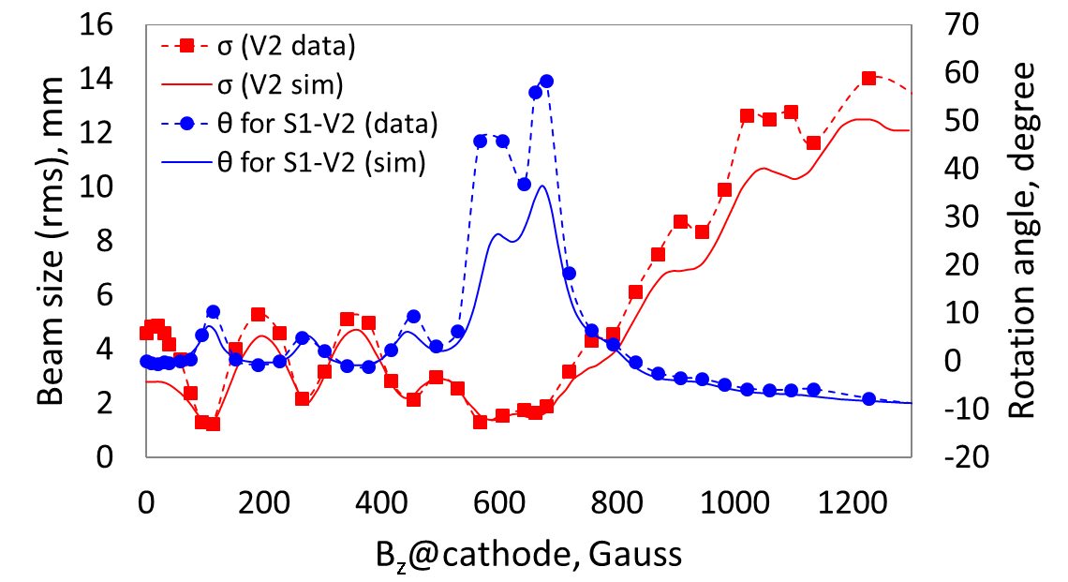
Figure 2: Experimental measurements of beam size at second viewer (red) as a function of magnetic field at photocathode compared to ASTRA simulation (solid line). The discrepancy at zero Gauss is due to inadequate 3D electrostatic field map. Blue: Rotation angle measured with slit and viewer compared to simulation.

Project Plan
Work during the remainder of FY18 (Year 3 and last funding year) will focus on completing the proposed goals of this LDRD. Tasks include:
- Measure beam emittance versus magnetic fields and beam sizes at photocathode (April - May).
- Switch to 225 kV Spellman high voltage power supply and measure magnetized beam lifetime at 32 mA (May – June). Bunch charge approaching 0.5 nC.
- Use regenerative laser amplifier to characterize the effect of space charge (up to 3 nC) on beam magnetization (July).
- Install and test the two TE₀₁₁ cavities (August – September).

Budget
Spending has gone largely to plan, with most of the budget devoted to paying the salary of the postdoctoral scientist. Procurements were submitted for a new ceramic insulator (to replace the damaged one), laser components to build the regenerative amplifier for nanoCoulomb demonstrations, and for copper Electrodynamics to build the RF cavity beam magnetometer. See attached spending report for first half of FY18.

Publications
Three in progress: 1) 300kV DC High Voltage Photogun with Inverted Insulator Geometry, 2) Magnetized Beam from DC High Voltage Photogun, 3) Green Light RF-Pulsed Laser with Gain-Switched Diode Master Oscillator

Workshops/Conferences
M. Poelker, P. Adderley, J. Benesch, B. Bullard, J. Grames, F. Hannon, J. Hansknecht, C. Hernandez-Garcia, R. Kazimi, G. Krafft, M. A. Mamun, R. Suleiman, M. Tiefenback, S. Zhang, Y. Wang, S. Wijiethunga and J. Yoskovitz, Magnetized Electron Beam for JLEIC Re-circulator Cooler Ring, Invited Talk presented at XVII International Workshop on Polarized Sources, Targets & Polarimetry, Kaist, South Korea October 10 – 20, 2017.

Md Abdullah A Mamun, Philip Adderley, Jay Benesch, Don Bullard, Jean Roger Delayen, Joseph Michael Grames, Jiquan Guo, Fay Elizabeth Hannon, John Hansknecht, Carlos Hernandez-Garcia, Reza Kazimi, Geoffrey Arthur Krafft, Matt Poelker, Riad Suleiman, Michael George Tiefenback, Yan Wang, Shukui Zhang (JLab, Newport News, Virginia), Sajini Anushika Kumari Wijethunga (ODU, Norfolk, Virginia), Production of Magnetized Electron Beam from a DC High Voltage Photogun, Poster to be presented at IPAC’18, Vancouver, Ca, April 29 – May 4, 2018.

Yan Wang, Carlos Hernandez-Garcia, Md Abdullah A Mamun, Matt Poelker, Riad Suleiman, Michael George Tiefenback, Shukui Zhang (JLab, Newport News, Virginia), Geoffrey Arthur Krafft (JLab, Newport News, Virginia; ODU, Norfolk, Virginia), 300 kV DC high voltage photogun with Inverted Insulator Geometry and CsxKySb, Poster to be presented at IPAC’18, Vancouver, Ca, April 29 – May 4, 2018.

Sajini Anushika Kumari Wijethunga, Jean Roger Delayen (ODU, Norfolk, Virginia), Jay Benesch, Fay Elizabeth Hannon, Md Abdullah A Mamun, Matt Poelker, Riad Suleiman (JLab, Newport News, Virginia), Geoffrey Arthur Krafft (JLab, Newport News, Virginia; ODU, Norfolk, Virginia), Simulation Study of Magnetized Electron Beam, Poster to be presented at IPAC’18, Vancouver, Ca, April 29 – May 4, 2018.

Jiquan Guo, Gary Guangfeng Cheng, Fredrik Fors, James Henry, Matt Poelker, Robert Rimmer, Riad Suleiman, Haipeng Wang (JLab, Newport News, Virginia), A Non-Invasive Magnetic Momentum Monitor Using a TE011 Cavity, Poster to be presented at IPAC’18, Vancouver, Ca, April 29 – May 4, 2018.

