MOLLER Laser Table Ground – Requirement Document

Joe Grames, Paul King, Caryn Palatchi, Kent Paschke, Riad Suleiman

July 1, 2023

When conducting PV experiments it is vital to prevent electronic cross-talk that could transmit real-time helicity information to the “outside world” (e.g., experiment hall counting house, polarimeter DAQs), including via ground loops, that could produce false raw (detector) asymmetries. In designing the helicity-control board and laser table devices, the following precautions were taken (with many illustrated in Figure 4):
- The helicity-control board is located within an electrically-isolated VME crate at the Injector Service Building, powered by an isolation transformer and floating at 62 VAC.
- The helicity-control board generates two real time helicity signals called Helicity Flip and its opposite, nHelicity Flip. In this manner, the current drawn by the board does not depend on the helicity state.
- The Pockels cell and so-called IA charge-asymmetry controllers at the injector drive-laser table are the only devices that receive a real-time helicity signal (Helicity Flip). The setpoint voltages for these devices pass through a galvanic-isolation card and there are no readbacks of these setpoint voltages. This card uses a precision isolation amplifier (ISO-124) to isolate signals from -10 V to +10 V with a bandwidth of up to 50 kHz.
- The helicity magnets are powered using an independent electrically-isolated VME crate powered by an isolation transformer that receives one of the two real-time helicity signals (nHelicity Flip).
- The beam helicity signal is generated by a pseudo-random bit generator, to prevent a correlation between the helicity signal and any other signal at the accelerator or experiment hall.
- The “outside world” receives only a delayed helicity signal (Delayed Helicity) so there is no knowledge of real time helicity.
- During the experiment, all helicity-correlated beam asymmetries (position, angle, charge, energy, and size – and thus beam scraping) are minimized so that helicity is the only real time property of the beam that is changing.

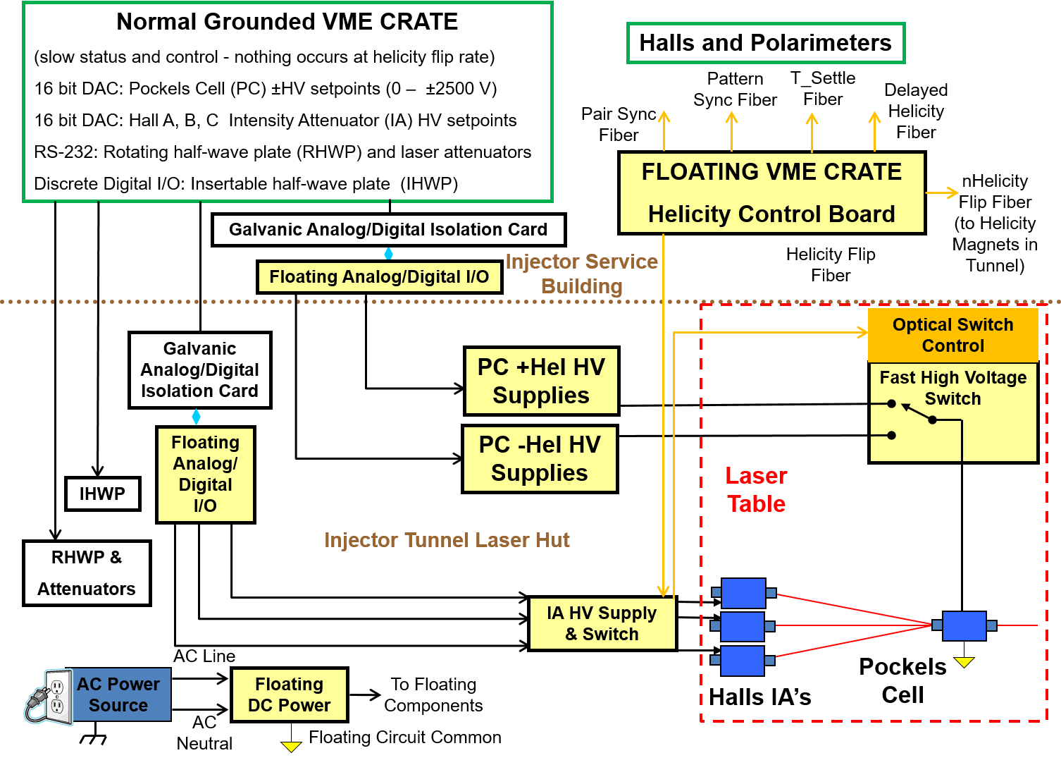
Figure 4: Electrical ground isolation.

