Max’s comments on beam size and momentum spread:
I asked Elegant what will happen if you minimize the beta function in both planes at the COMTRA dump using only the four matching quads so as to prevent M603 and M604 from steering the kicked beam. As shown in the attachment, there is a solution that gives betas of about 3 m in both planes without any function becoming excessive anywhere. Now, at 5 MeV, we expect the geometric emittance to be 50 nm at the quads, which gives a 1-sigma beam size of 0.4 mm at the dump if preserved. So there should be plenty of error margin if you are aiming for 1 mm. The alpha is very small in this configuration, so same beam size at the aperture.
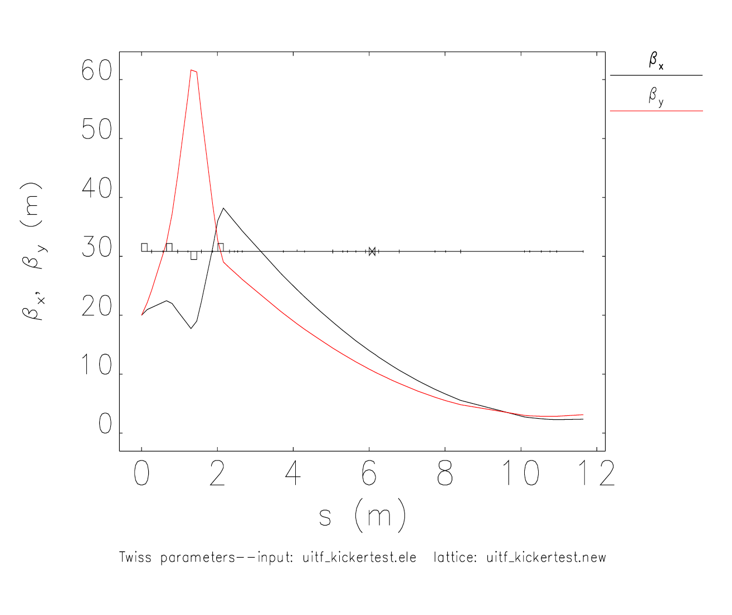
There are two caveats:
- This calculation assumes my default alpha/beta values of 20 m and -5, respectively, upstream of MQJM501. Because we have never fully resolved the quad scan puzzle, these values are unreliable even for the energy I measured them at, which I think was 8 MeV. The numbers will be different at 5 MeV, and I don't know them. But the degrees of freedom in the matching section suggest other numbers would work just as well unless they are outrageously high for some reason (unlikely).
- Related to the unsolved quad scan puzzle, there is a chance the emittance increases along the beam line. I am still riding the momentum spread + dispersion train to some extent but have yet to prove it. This effect could be bad enough to blow up the beam size at the end.
We will know more when we do an emittance scan with the 603/604 quads, but I think we can be optimistic about the target beam size even with them off. I think the beam sizes are perfectly reasonable; the achievable range should be larger than that. For this test, we can use the 603/604 quads as well, so plenty of options even if the emittance is not ideal.

dp/p = 5e-3 is already very high, not sure if it can be done (and measured). On the other hand, the problem with small spreads is reproducibility because they are swamped by microphonics, which change over time. The machine should be able to make about 1e-4, but the lowest you can actually go is about 4e-4 due to field regulation. So I suggest let's start with that and try to increase it to 1.2e-3. Note it probably won't be Gaussian.

Joes comments on beam setup.
Steps to test phi spin rotation:
- check laser polarization
- put beam in mott
- test daq once with beam
- set Wien=90
- measure asymmetry
- to extent possible ... flip sign of each downstream solenoid, does spin change
- summarized results and options

Steps to setup beam for polarimeter:
- HCO of the new MeV beam line
- set beam energy (5 MeV), spread (minimum), and size (~1 mm) upstream of dump
- w/ beam to dump, cross-calibrate current on cup, dump, aperture? up to 25 nA
- centering e-beam on new dump (using x-ray target, harp, bpm, cup to reference orbit)
- repeat "c" but with collimator installed, to check and save a good orbit
- ...then, I would say to explore and "save in the can" conditions for sensitivity studies
  - at 5 MeV, small dp/p, quad settings to make 1, 1.5, 2, 2.5 (~few)
  - at 5 MeV, small spot, booster settings to increase dp/p by 10%,20%,30% (~few)
  - (if allowed) energy scan 4, 5, 6 MeV

