IMPROVING THE OPERATIONAL LIFETIME OF THE CEBAF PHOTO-GUN BY ANODE BIASING*
J. T. Yoskowitz†, G. A. Krafft, G. Palacios-Serrano, S. Wijethunga
Old Dominion University, Norfolk, Virginia, 23529, USA
J. Grames, J. Hansknecht, C. Hernandez-Garcia, M. Poelker, M. Stutzman, R. Suleiman
Thomas Jefferson National Accelerator Facility, Newport News, Virginia 23606, USA
S. B. van der Geer, Pulsar Physics, Burghstraat 47, 5614 BC Eindhoven, The Netherlands
Abstract
The operating lifetime of GaAs-based photocathodes in DC high voltage electron photo-guns is dominated by the ionization rate of residual beamline gas molecules. In this work, experiments were performed to quantify the improvement in photocathode charge lifetime by biasing the photo-gun anode with a positive voltage, which repels ions generated downstream of the anode. The experiment results and conclusions supported by GPT simulations will be presented.

Introduction
The charge lifetime of GaAs photocathodes used in DC high voltage photo-guns may be improved by limiting ion-back-bombardment [1-3]. Residual gas molecules within the cathode-anode gap can be ionized by the electron beam and then accelerate towards and strike the negatively-biased GaAs photocathode. Upon impact, these ions can desorb gas, generate secondary electrons, and X-rays. If they reach the GaAs photocathode they may also sputter away activating materials or implant into the working volume of the photo-emitting semi-conductor, all of which increase the work function of the photocathode and thus decrease its quantum efficiency (QE) [4, 5]. Experiments have previously been performed to investigate ion generation, QE degradation and mitigation of back-bombarding ions [6, 7].
In this work we demonstrated a successful method to improve the lifetime by applying an unobtrusive positive voltage to the DC gun anode, to repel ions generated downstream of the anode from reaching the photocathode.
To test this hypothesis, the charge lifetime for a biased anode configuration was periodically compared with the lifetime for the usual grounded anode configuration over more than one year of CEBAF operations. To understand and explain the results, simulations were performed using the simulation code General Particle Tracer (GPT) with custom elements developed to model electron impact ionization of residual gas [8].

Experiment
The biased anode technique was tested in experiments parasitic to three run periods at the CEBAF accelerator at Jefferson Lab. During each run period, CEBAF delivered electron beams to end-stations A, B, and C, as well as D during the latter two runs. Electron beams were created using four lasers (A, B, C, and D), each having a wavelength close to 780 nm and a repetition rate of 249.5 or 499 MHz. The lasers are coincident on a strained superlattice GaAs/GaAsP photocathode with a 5 mm diameter active area. The transverse size of the lasers were 0.5 mm rms. The cathode voltage was -130 kV, while the anode voltage was changed between grounded (0 kV) and biased (1 kV). The laser spot position on the photocathode remained fixed throughout the first and third run periods. After about two months of running beam during the second run period, the laser spot was shifted to a location on the photocathode with higher QE.
Every day during each run period, the QE at the laser spot location was measured by recording the laser power required to produce typically 10-20 μA in a Faraday cup. The QE measurements were partitioned by whether the anode was grounded or biased and were fit with exponential functions to determine the charge lifetime in each region. Table 1 shows these calculated charge lifetime values for each run period. The uncertainty values in the charge lifetime values correspond to fit errors.
Table 1: Charge Lifetime Values For Laser A.
Run  Period | Anode Bias (V) | Extracted Charge (C) | Charge  Lifetime (C)
1  06/15/2019-  09/09/2019 | 0  961  0  961 | 65  62  50  68 | 181 ± 8  424 ± 53  288 ± 39  303 ± 18
2  01/07/2020-  03/24/2020 | 0  961  961  0  1000 | 13  206  79  33  60 | 85.9 ± 0.1  211 ± 9  401 ± 10  208 ± 4  370 ± 29
3  07/09/2021-  09/21/2021 | 1000 | 247 | 350 ± 14

QE scans of the photocathode active area were periodically made during each run period, in which QE measurements are taken in a grid of points encompassing the active area. These measurements are interpolated to create smooth contour plots of QE. By subtracting consecutive QE scans, the QE degradation can be visualized throughout a given run period. Figure 1 shows the QE scans and difference scans taken during run period 2.
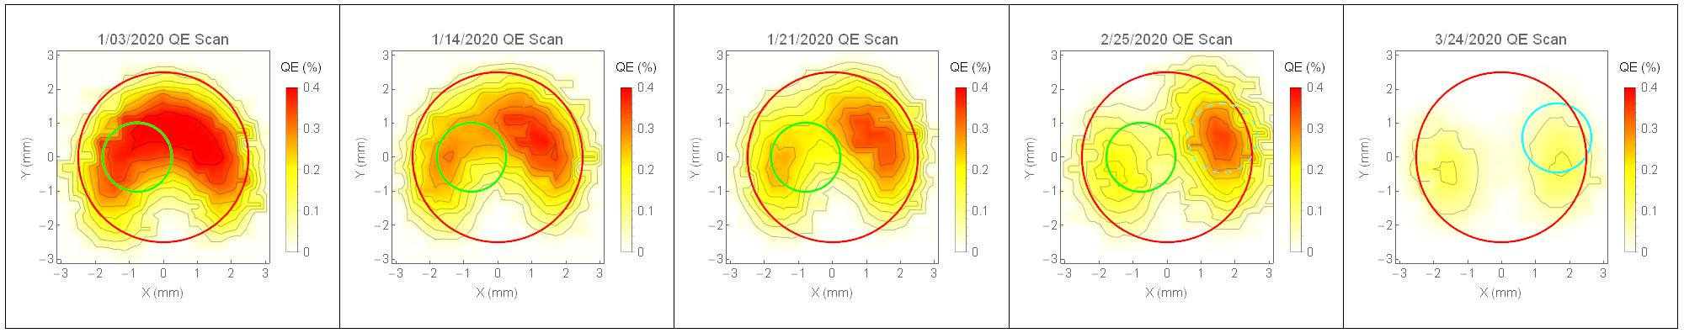
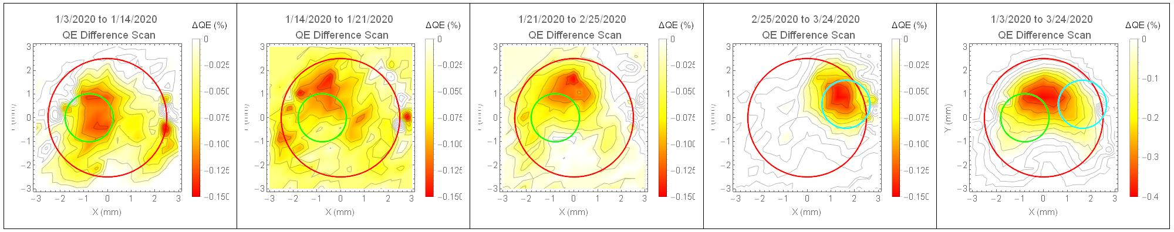
Figure 1: QE scans (top) and difference scans (bottom) of the photocathode active area taken during run period 2. The red circle denotes the 5 mm active area, and the green and cyan circles denote the two 0.5 mm rms laser spots used during the run period.

GPT Simulations

Simulation Description
The particle tracking code General Particle Tracer (GPT) was used to simulate the ion generation and photocathode back-bombardment for each case in Table 2. For brevity, only the five simulations for run period 2 are discussed. In each simulation, an electron bunch with a 0.5 rms transverse size and 50 ps rms bunch length is tracked from the photocathode to the first viewer, located 1.54 m away from the photocathode. The trajectory of the electron bunch is governed by the electric field of the photo-gun, the magnetic fields of three steering coil pairs (horizontal and vertical), and a solenoid. Through the use of a GPT custom element, developed to model electron impact ionization and subsequent tracking of ions and secondary electrons [9], the electron bunch ionizes H₂ gas, the predominant residual gas in the gun vacuum with a measured partial pressure of 10⁻¹² torr, along its trajectory.
Figure 2 shows a layout of the CEBAF photo-gun and beamline denoting the locations of the field maps used in the simulations. Electric field maps of grounded and biased anode configurations were created using CST Microwave Studio software [9]. Figure 3 shows a snapshot of simulation 1. The beam experiences an initial downward kick due to the cathode-anode geometry [10]. The beam is then re-centered by the steering coils.

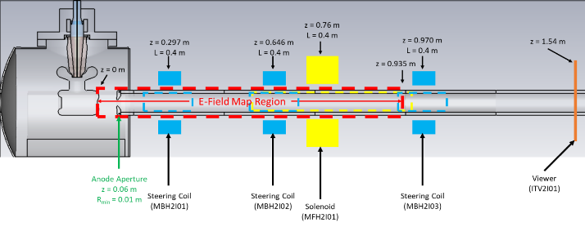
Figure 2: Field map layout of the CEBAF photo-gun and beamline from the photocathode to the 1st viewer.
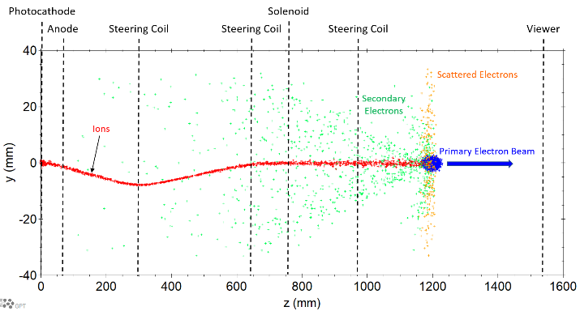
Figure 3: Snapshot of GPT simulation #1 depicting a side-view of the primary electron beam traveling through the CEBAF injector beamline and creating H₂⁺ ions

Discussion
Figure 4 shows the accumulation of all ions reaching the photocathode during run period 2 (both biased and grounded cases) distinguished by whether the ions originate (upstream or downstream of the anode). The distribution of ions created upstream of the anode potential hit the photocathode at the laser spot, while the distribution of ions created downstream of the peak anode potential is spread out over a larger area. Figure 5 shows these distributions weighted by kinetic energy.
Experimentally the QE scan damage (Fig. 1) bears a striking resemblance to the energy-weighted distribution of ions generated upstream of the anode. This correlation suggests that QE degradation may not be solely due to the number of back-bombarding ions, but rather their energies as well, regardless of anode bias.
Table 2 shows ratios of back-bombarding ions distinguished by either striking the laser spot or the entire active area of the photocathode. In Table 1, the measured charge lifetimes at the location of the laser spot improved by about a factor of ~2 when the anode was biased. However, as Table 2 demonstrates, there is essentially no difference in the number of ions at the location of the laser spot between the biased and grounded conditions, even when weighting by energy. Yet, the energy weighted distribution of all ions reaching the photocathode is closer to this factor of ~2 improvement. Interestingly, the simulations suggest that the back-bombarding ions outside of the laser spot may be indirectly affecting the QE at the location of the laser spot. Further simulation studies are currently being performed to explore a) the role of other residual gases such as CO and CH₄ may have and b) possible mechanisms for back-bombarding ions indirectly affecting the QE far from the location of incidence.
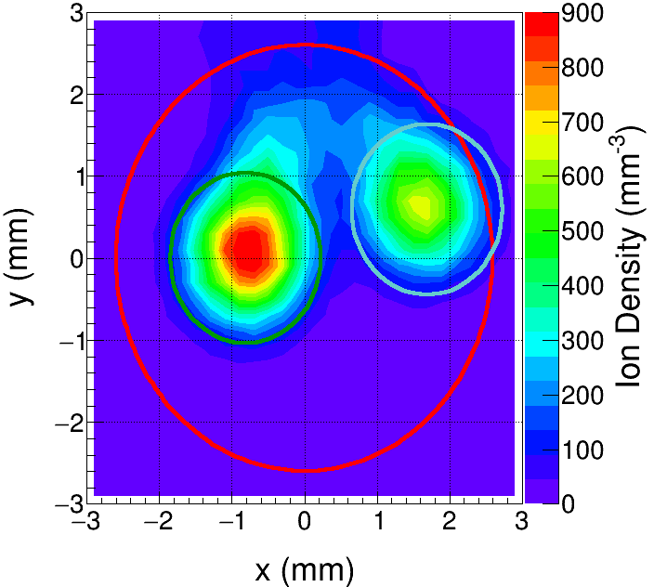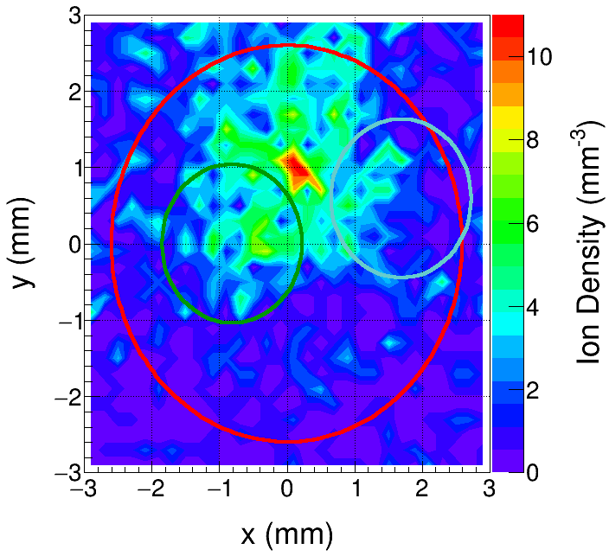
Figure 4: Density plots of back-bombarding ions originating from upstream (left) or downstream (right) of the peak anode potential in run period 2.
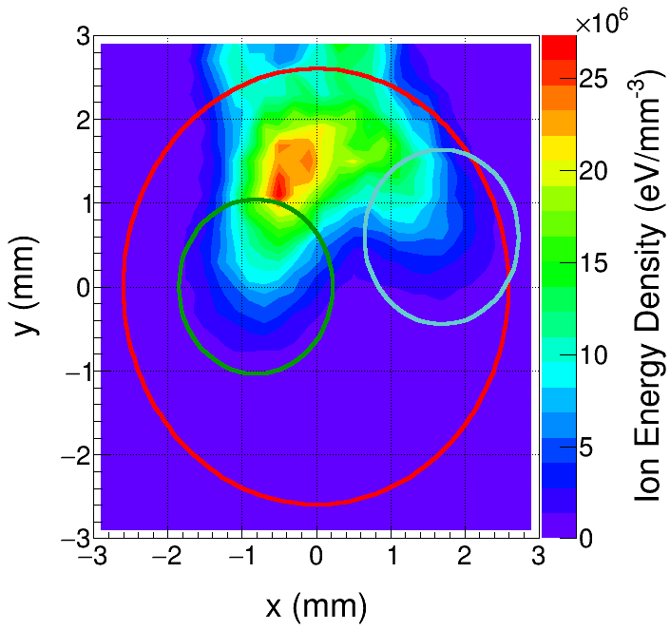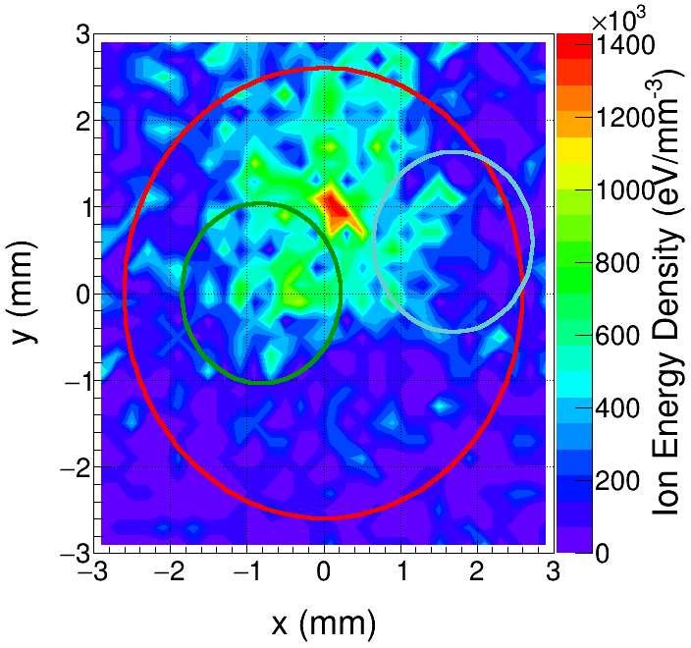
Figure 5: Energy density plots of back-bombarding ions originating upstream (left) and downstream (right) of the peak anode potential in run period 2.
Table 2: Back-Bombarding Ion Ratios (Grounded:Biased)
Laser Spot | (-0.78,0) | (1.63, 0.57) | (1.63, 0.57)
Periods | 1:2 | 4:3 | 4:5
# Ions at PC | 1.22 | 1.20 | 1.21
# Ions at PC, weighted by energy | 1.88 | 1.84 | 1.87
# Ions at laser spot | 1.02 | 1.00 | 1.00
# Ions at laser spot, weighted by energy | 1.15 | 1.08 | 1.10

Conclusion
The charge lifetime of the CEBAF photo-gun was reliably improved by a factor of 2 by simply biasing the anode. The ion damage to the photocathode at the laser spot and over the photocathode active area was carefully measured over this period for comparison with simulation. A GPT custom element was developed and applied to explain the experiment results. The simulation results show a striking resemblance to the QE degradation of the photocathode, and interestingly to the energy-weighted impact away from the laser spot location. There is also a quantitative agreement between the measured lifetime improvement at the laser spot location and the simulated energy-weighted ion reduction over the active area. These results are being explored with further experimental and simulation studies.

References
[1] W. Liu et al., “Record-level quantum efficiency from a high polarization strained GaAs/GaAsP superlattice photocathode with distributed Bragg reflector”, Appl. Phys. Lett., vol. 109, no. 25, p. 252104, 2016. doi: 10.1063/1.4972180
[2] T. Maruyama et al., “A very high charge, high polarization gradient-doped strained GaAs photo-cathode”, Phys. Rev. A, vol. 492, pp. 119-211, 2002. doi: 10.1016/S0168-9002(02)01290-1
[3] J. Xiuguang et al., “High-performance spin-polarized photocathodes using a GaAs/GaAsP strain-compensated superlattice”, Appl. Phys. Express, vol. 6, p. 015801, 2012. doi: 0.7567/APEX.6.015801
[4] J. Grames, et al., “Ion back-bombardment of GaAs photocathodes inside DC high voltage electron guns”, in Proc. of 2005 Particle Accelerator Conference, p. 2875, 2005. doi: 10.1109/PAC.2005.1591299
[5] V. Shutthanandan, et al., “Surface science analysis of GaAs photocathodes following sustained electron beam delivery”, Phys. Rev. ST Accel. Beams, vol 15, no. 6, p. 063501, 2012. doi: 10.1103/PhysRevSTAB.15.063501
[6] E. Pozdeyev, “Ion trapping and cathode bombardment by trapped ions in DC photoguns”, Phys. Rev. ST Accel. Beams, vol 10, no. 8, p. 083501, 2007. doi: 10.1103/PhysRevSTAB.10.083501
[7] J. Grames et al., “A biased anode to suppress ion back-bombardment in a DC high voltage photoelectron gun”, AIP Conf. Proc., vol 980, no. 10, p. 110, 2008. doi: 10.1063/1.2888075
[8] General Particle Tracer, http://www.pulsar.nl/gpt
[8] J. T. Yoskowitz, “Simulating Electron Impact Ionization Using a General Particle Tracer (GPT) Custom Element”, presented at IPAC ’21, May 2021, this conference.
[9] CST Microwave Studio Suite, http://www.cst.com
[10] G. Palacios-Serrano, F. Hannon, C. Hernandez-Garcia, M. Poelker and H. Baumgart, “Electrostatic design and conditioning of a triple point junction shield for a -200 kv dc high voltage photogun”, Rev. Sci. Instrum., vol. 89, no. 10, p. 104703, 2018. doi: 10.1063/1.5048700

